SUPPLEMENTARY INFORMATION

S1 Table. Barcodes used with primers sequences to distinguish samples
Direction | Name | Sequence | Direction | Name | Sequence
Forward | BC1N | CTATCACG | Reverse | BC11N | ATGGCTAG
Forward | BC2N | TCCAGTGT | Reverse | BC12N | GACTTGGT
Forward | BC3N | GATCAGTA | Reverse | BC13N | TCGATCAC
Forward | BC4N | AGTGTCGG | Reverse | BC14N | ACACGTCA
Forward | BC5N | GTAGCGCT | Reverse | BC15N | CAATGTGC
Forward | BC6N | CATCTAAC | Reverse | BC16N | GGGACTAC
Forward | BC7N | TACAGATC | Reverse | BC17N | ACGTACTG
Forward | BC8N | CGTCTTGT | Reverse | BC18N | TGATTGCC
Forward | BC9N | TATGATCA | Reverse | BC19N | AACTCTAC
Forward | BC10N | GGTAGCTT | Reverse | BC20N | TGACTCAA

S2 Table. Amp-seq assay primers used in multiplex 1 and 2 combinations
Multiplex 1
Forward Name | Forward | Reverse Name | Reverse
DomainIV_F1 | GCGATCTSATCGAGAAGTA | DomainIV_R1 | ATGCTAGCAARTACGTGATG
DomainII_F5 | ACAATGTGGATCGCTTCCCG | DomainII_NR1 | TGAACCGAAATTGGACAAAAG
Ace_NF1 | TGGGGAACGCTRGGAATCTGCG | ACE_NR1 | GCATATCGCTGGGCAAACTC
LCO1490 | GGTCAACAAATCATAAAGATATTGG | HCO2198 | TAAACTTCAGGGTGACCAAAAAATCA*
GSTE_111_F | ATGACGAAGCTCATTTTGTACACG | GSTE_111_R | ACAAAAATAAGCCACACACTACTG
Multiplex 2
Forward Name | Forward | Reverse Name | Reverse
DomainIIS4_F1 | TCTAGATTTAGYGACTCCAR | DomainIIS4_R1 | TACCGATGTAGTTCTTGCC
DomainI_F1 | TTTCGTCTAATGACCCAAGA | DomainI_R1_N | ARAGAWTTCGCTCACCCG
DomainIIIExon35_F2 | GGATCCAGATCATGAACGA | DomainIIIExon35_R1 | CATGTCGAACTTCTTATTGGT
RDL_NF1 | CTTCTAATTTCTCTCATCAC | Primer-Aeg-R1 | CTGGTTATTTGTACAAGTAGCA
GSTE_150_F | GAACCAATCCTTTTCGCC | GSTE_150_R | TGCCTTTTGAGCATTCTTCT
*(16)

S3 Table. Average coverage per amplicon, amplicon length, and described mutations found in that amplicon.
Forward Amplicon Name | Reverse Amplicon Name | Mean Coverage | Amplicon Size | Insecticide Resistance mutations
Ace_NF1 | Ace_NR3 | 550.8 | 468 | G119S
DomainIIIExon35_F2 | DomainIIIExon35_R1 | 304.3 | 474 | T1520I, F1534C
DomainIIS4_F1 | DomainIIS4_R1 | 284.9 | 444 | G923V
DomainII_F5 | II_NR1 | 61.2 | 466 | L982W, S989P, I1011V/M, V1016I/G
DomainIV_F1 | DomainIV_R1 | 149.3 | 495 | D1763Y
DomainI_F1 | Domain1_R1_N | 244.5 | 464 | V410L
GSTE2_111 | GSTE2_111_R1 | 7.3 | 462 | L111S (Ae. aegypti), C155F
GSTE2_150 | GSTE2_150_R | 256.0 | 321 | L119F, I150V (Ae. aegypti)
RDL_NF1 | Primer-Aeg-R1 | 40.4 | 482 | A301S
LCO1490 | HCO1298 | 6.5 | 709 | -

S4 Table. Summary of synonymous mutations detected in the 178 samples screened
Chrom. | Gene | Position | Nucleic acid change | Annotation | Genotype |  |  | Alt. Allele Frequency
 |  |  |  |  | Homo. ref | Hetero | Homo.  alt | Alt. Allele Frequency
3 | ace-1 | 161500076 | T > A | 506T† | 0 | 7 | 97 | 201
3 | ace-1 | 161500136 | C > T | 486L† | 102 | 4 | 0 | 4
3 | ace-1 | 161500262 | G > A | 444D† | 100 | 4 | 0 | 4
3 | ace-1 | 161500301 | G > A | 431P† | 100 | 4 | 0 | 4
3 | ace-1 | 161500361 | T > C | 411I† | 45 | 100 | 0 | 100
3 | vgsc | 315931749 | T > C | 1847Y‡ | 16 | 91 | 0 | 91
3 | vgsc | 315932072 | G > A | 1762L‡ | 179 | 1 | 0 | 1
3 | vgsc | 315932184 | G > A | 1724V‡ | 88 | 2 | 0 | 2
3 | vgsc | 315932226 | G > C | 1710L‡ | 80 | 80 | 0 | 80
3 | vgsc | 315984096 | C > T | 978L‡ | 60 | 0 | 60 | 120
3 | vgsc | 315984129 | A > G | 967F‡ | 0 | 0 | 62 | 124
3 | vgsc | 315984159 | C > T | 957K‡ | 0 | 0 | 61 | 122
3 | vgsc | 316080738 | C > T | 402L‡ | 225 | 10 | 1 | 12
3 | vgsc | 316081058 | G > A | 375D‡ | 0 | 1 | 118 | 237
†As per transcript AAEL000511-RG; ‡As per transcript AAEL023266-RL

S5 Table. Filtered linked SNP position with R² > 0.5
Position 1 | Position 2 | R² | Position 1 | Position 2 | R²
161500301 | 161500136 | 1 | 316080942 | 316080895 | 0.855948
315984129 | 315983809 | 1 | 316080950 | 316080895 | 0.855948
315984130 | 315983956 | 1 | 316080942 | 316080896 | 0.855948
315998782 | 315998609 | 1 | 316080950 | 316080896 | 0.855948
316080916 | 316080895 | 1 | 316080942 | 316080903 | 0.855948
315983956 | 315983809 | 0.9855 | 316080950 | 316080903 | 0.855948
315983973 | 315983809 | 0.9855 | 316080942 | 316080916 | 0.855948
315984159 | 315983809 | 0.9855 | 316080950 | 316080916 | 0.855948
315984129 | 315983956 | 0.9855 | 316080895 | 316080847 | 0.844488
315984129 | 315983973 | 0.9855 | 316080896 | 316080847 | 0.844488
315984159 | 315984129 | 0.9855 | 316080903 | 316080847 | 0.844488
315984159 | 315984096 | 0.971503 | 316080916 | 316080847 | 0.844488
315984159 | 315983956 | 0.971102 | 316080895 | 316080722 | 0.816282
315984159 | 315983973 | 0.971102 | 316080896 | 316080722 | 0.816282
315984096 | 315983809 | 0.957416 | 316080903 | 316080722 | 0.816282
315984129 | 315984096 | 0.957416 | 316080916 | 316080722 | 0.816282
316080942 | 316080722 | 0.953658 | 316080983 | 316080895 | 0.816282
316080950 | 316080722 | 0.953658 | 316080983 | 316080896 | 0.816282
316080983 | 316080942 | 0.953658 | 316080983 | 316080903 | 0.816282
316080983 | 316080950 | 0.953658 | 316080983 | 316080916 | 0.816282
316080895 | 316080830 | 0.944566 | 316080942 | 316080830 | 0.808499
316080896 | 316080830 | 0.944566 | 316080950 | 316080830 | 0.808499
316080903 | 316080830 | 0.944566 | 316080942 | 316080845 | 0.808499
316080916 | 316080830 | 0.944566 | 316080950 | 316080845 | 0.808499
316080895 | 316080845 | 0.944566 | 316080830 | 316080722 | 0.771032
316080896 | 316080845 | 0.944566 | 316080845 | 316080722 | 0.771032
316080903 | 316080845 | 0.944566 | 316080983 | 316080830 | 0.771032
316080916 | 316080845 | 0.944566 | 316080983 | 316080845 | 0.771032
315984096 | 315983956 | 0.943215 | 316080942 | 316080847 | 0.721305
315984096 | 315983973 | 0.943215 | 316080950 | 316080847 | 0.721305
315932226 | 315931749 | 0.93374 | 316080847 | 316080722 | 0.687386
316080983 | 316080722 | 0.909198 | 316080983 | 316080847 | 0.687386
316081058 | 316080952 | 0.856823

S1 Figure. The log coverage of each amplicon sequenced separated by the multiplex reaction in which they were combined (see Table 1).
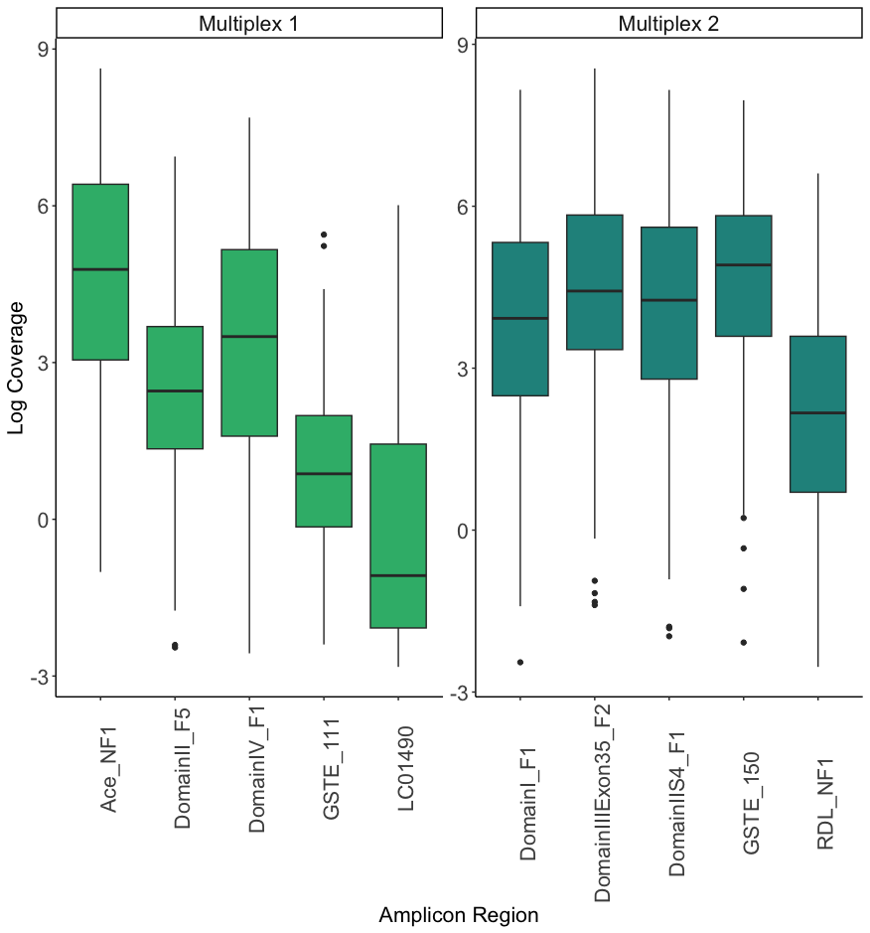

SI Figure 2. Alignment of protein for voltage gated sodium channel for Triatoma infestans (sensitive AGW21773.1 and resistant AWG21772.1 forms), Bemisia tabaci and two isoforms of Aedes aegypti and Drosophia melanogaster showing position of L921I mutation described to be associated with pyrethroid insecticide resistance (28,29).
