Uranium Electrodeposition at Boron Doped Diamond Electrodes
Alexis J. Acevedo-González¹, Armando Peña-Duarte^{2,3}, Richard M Lagle⁴, Mebougna Drabo⁴, Andrew C. Jones⁵, and Carlos R Cabrera³
¹Department of Chemistry, University of Puerto Rico at Río Piedras, San Juan, Puerto Rico 00926
²MPA11: Materials Synthesis and Integrated Devices, Materials Physics and Applications Division, Los Alamos National Laboratory, Los Alamos, NM 87545
³Department of Chemistry and Biochemistry, The University of Texas at El Paso, El Paso, Texas 79968
⁴Department of Mechanical Engineering, Alabama A&M University, Huntsville, Alabama 35762
⁵Center for Integrated Nanotechnologies, Materials Physics and Applications Division, Los Alamos National Laboratory, Los Alamos, New Mexico 87545
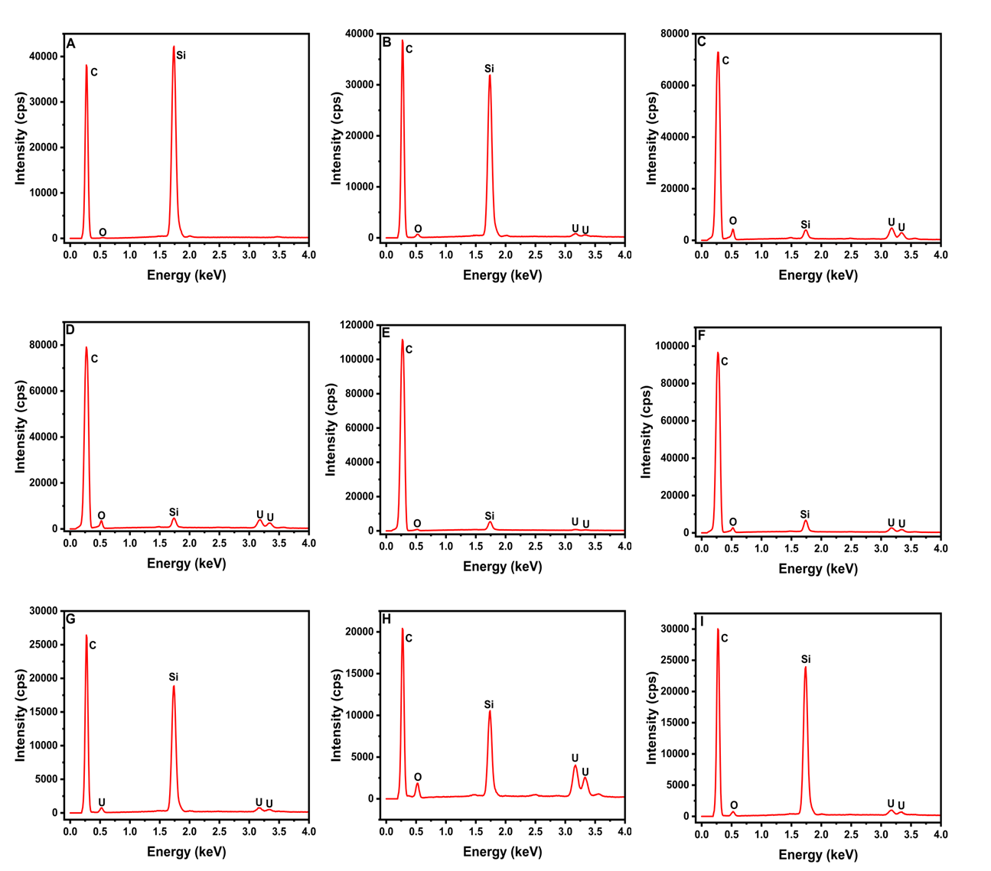
Figure S1. X-ray fluorescence (EDS) of uranium before and after electrodeposition process at boron doped diamond (BDD) at different potentials vs. RHE: (A) Bare BDD electrode (B) -0.60V, (C) -0.80V, (D) -1.00V, (E) -1.20V, (F) -1.40V, (G) -1.60V, (H) -1.75, and (I) -2.00V.
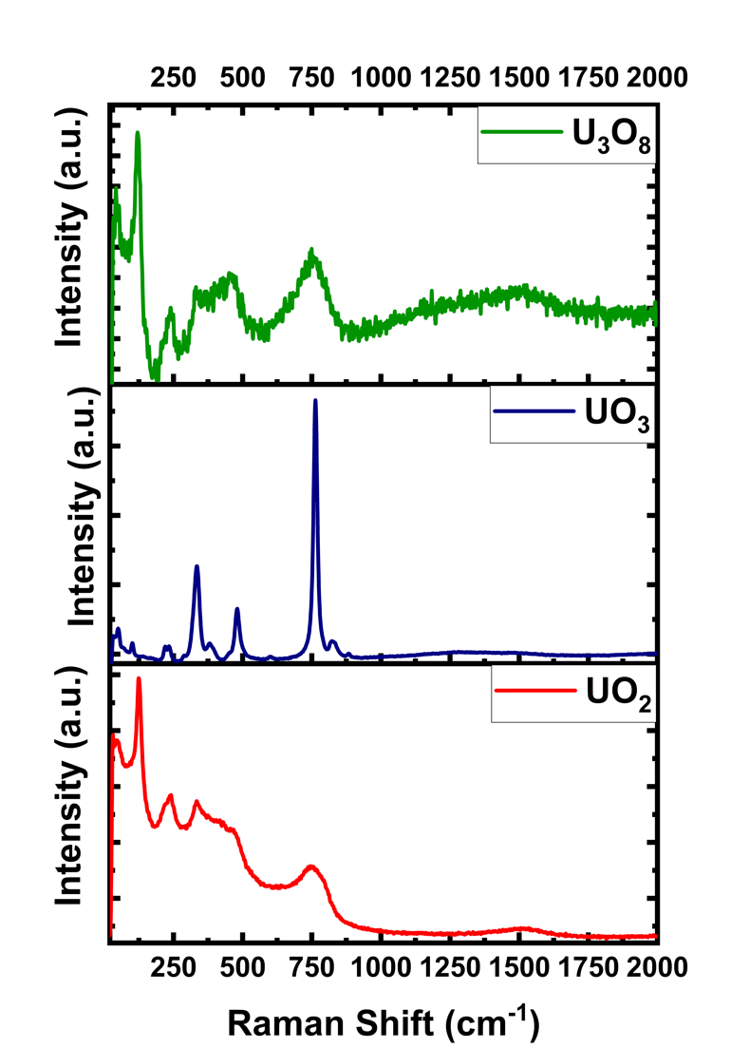
Figure S2. Raman spectroscopy analysis of uranium oxides standards: UO₂, UO₃, and U₃O₈.

