Supplementary Materials
Table. S1. This table represents the one-way ANOVAs analyses for each sex analyzed separately, as well as the two-way ANOVAs analyses, both including F (DFn,DFd) and p values, for data represented in Fig. 2-4. Green-shadow boxes represent statistically significant comparisons.
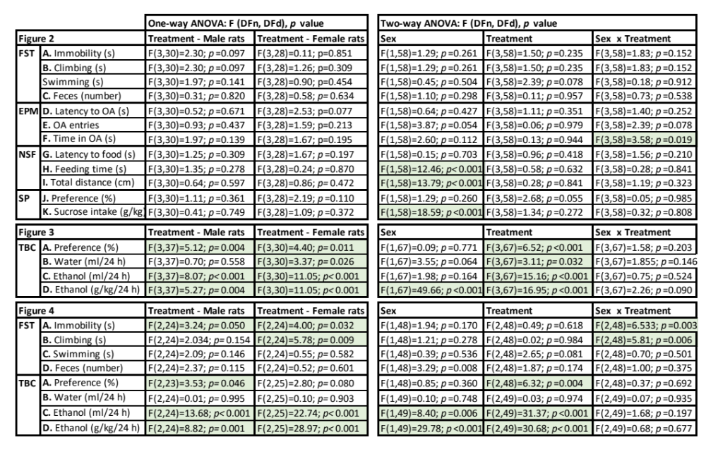
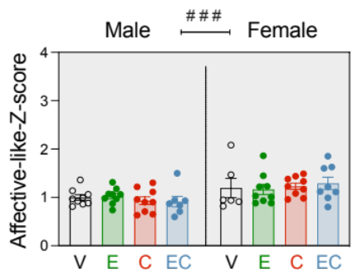
Fig. S1. Affective-like state in adulthood following prolonged drug withdrawal. An affective-like state Z-score was calculated with all the individual measurements recorded from all behavioral tests (FST, EPM, NSF, SP; see von Mücke-Heim et al., 2023). The results showed a lack of significant effect of Treatment (F_{3, 58}=0.02, p=0.997), but a significant effect of Sex (F_{1, 58}=12.77, ###p<0.001), in line with some of the differences already reported in Fig. 2, suggesting females showed overall better affective-like responses than males (+0.25 ± 0.1-fold-increase in affective-like-Z-score females as compared to males). This result supported a lack of a negative affective-like state induced by the adolescent drug treatment in adulthood during prolonged forced-withdrawal.

