Supplementary information
First human study of D6-[¹⁸F]FP-(+)-DTBZ, a novel VMAT2 tracer: whole-body biodistribution and brain PET comparison with [¹⁸F]FP-(+)-DTBZ (AV-133)
Ruiyue Zhao¹, Jinhua Chen^{3,4}, Ting Ye¹, Jianmin Chu³, Jingwen Li¹, Yan Zhang¹, Siran Xu¹, Shaoyu Liu¹, Ling Chen³, Karl Ploessl^{5,6}, David Alexoff⁵, Hank F. Kung^{5,6*}, Lin Zhu^{2, 1*}and Xinlu Wang^{1*}

¹Department of Nuclear Medicine, The First Affiliated Hospital of Guangzhou Medical University, Guangzhou, Guangdong, 510120, China
²College of Chemistry, Beijing Normal University, Beijing, 100875, China
³Department of Neurology, National Key Clinical Department and Key Discipline of Neurology, The First Affiliated Hospital of Sun Yat-sen University, Guangzhou, Guangdong, 510080, China
⁴Department of Neurology, Jiangxi Provincial People's Hospital, The First Affiliated Hospital of Nanchang Medical College, Nanchang, Jiangxi, 33006, China
⁵Five Eleven Pharma Inc., Philadelphia, PA, 19104, USA
⁶Department of Radiology, University of Pennsylvania, Philadelphia, PA, 19104, USA

*Correspondence author: Xinlu Wang, Lin Zhu and Hank F. Kung
E-mail: 71lu@163.com
zhulin111@gmail.com
kunghf@gmail.com

Contents

Table S1 Basic information of 5 elder healthy volunteers and 5 PD patients 3
Table S2 Dosimetry of each patient calculated from OLINDA/EXM 4
Figure S1 The biodistribution data (SUVmean) of D6-[¹⁸F]FP-DTBZ 10
Figure S2 The biodistribution data (SUVmax) of D6-[¹⁸F]FP-DTBZ 11
Figure S3 The linear results between BPnd and SUVRs 12

Table S1 Basic information of 5 elder healthy volunteers and 5 PD patients
Subject | Age (years) | Injected dose (MBq) | Course of PD (Year) | Sex | Group
1 | 53 | 374.1 | -- | Female | HC
2 | 58 | 376.3 | -- | Female | HC
3 | 67 | 374.4 | -- | Female | HC
4 | 62 | 375.9 | -- | Female | HC
5 | 75 | 375.9 | -- | Male | HC
1 | 68 | 368.9 | 4 | Female | PD
2 | 71 | 370.4 | 2.5 | Male | PD
3 | 62 | 367.8 | 6 | Male | PD
4 | 56 | 378.5 | 3 | Male | PD
5 | 54 | 374.4 | 3 | Male | PD
Average | 62.6 | 373.6 | 3.7 | -
SD | 7.5 | 3.5 | 1.4 | -

Table S2 Dosimetry results of each patient calculated from OLINDA/EXM 1.0.
Patient 1 (F)
Target Organ | Alpha |  | Beta |  | Gamma |  | Total | ED Cont.
Adrenals | 0.00E+00 |  | 2.24E-03 |  | 2.23E-02 |  | 2.45E-02 | 1.23E-04
Brain | 0.00E+00 |  | 3.37E-02 |  | 1.09E-02 |  | 4.46E-02 | 2.23E-04
Breasts | 0.00E+00 |  | 2.24E-03 |  | 6.13E-03 |  | 8.37E-03 | 4.18E-04
Gallbladder wall | 0.00E+00 |  | 3.37E-02 |  | 3.93E-02 |  | 7.30E-02 | 0.00E+00
LLI wall | 0.00E+00 |  | 2.47E-02 |  | 1.22E-02 |  | 3.68E-02 | 4.42E-03
Small intestine | 0.00E+00 |  | 7.05E-02 |  | 1.92E-02 |  | 8.97E-02 | 4.48E-04
Stomach wall | 0.00E+00 |  | 2.24E-03 |  | 1.42E-02 |  | 1.65E-02 | 1.98E-03
ULI wall | 0.00E+00 |  | 2.90E-02 |  | 2.18E-02 |  | 5.09E-02 | 2.54E-04
Heart wall | 0.00E+00 |  | 4.03E-02 |  | 1.77E-02 |  | 5.80E-02 | 0.00E+00
Kidneys | 0.00E+00 |  | 2.24E-03 |  | 1.67E-02 |  | 1.90E-02 | 9.49E-05
Liver | 0.00E+00 |  | 2.54E-01 |  | 7.10E-02 |  | 3.25E-01 | 1.62E-02
Lungs | 0.00E+00 |  | 1.68E-02 |  | 1.35E-02 |  | 3.04E-02 | 3.64E-03
Muscle | 0.00E+00 |  | 1.11E-02 |  | 8.16E-03 |  | 1.93E-02 | 9.64E-05
Ovaries | 0.00E+00 |  | 1.55E-02 |  | 1.44E-02 |  | 2.98E-02 | 5.96E-03
Pancreas | 0.00E+00 |  | 1.69E-01 |  | 3.53E-02 |  | 2.05E-01 | 1.02E-03
Red marrow | 0.00E+00 |  | 2.07E-02 |  | 1.08E-02 |  | 3.16E-02 | 3.79E-03
Osteogenic cells | 0.00E+00 |  | 2.18E-02 |  | 9.02E-03 |  | 3.08E-02 | 3.08E-04
Skin | 0.00E+00 |  | 2.24E-03 |  | 4.68E-03 |  | 6.92E-03 | 6.92E-05
Spleen | 0.00E+00 |  | 4.75E-02 |  | 1.62E-02 |  | 6.37E-02 | 3.19E-04
Thymus | 0.00E+00 |  | 2.24E-03 |  | 7.56E-03 |  | 9.80E-03 | 4.90E-05
Thyroid | 0.00E+00 |  | 4.43E-02 |  | 7.02E-03 |  | 5.13E-02 | 2.57E-03
Urinary bladder | 0.00E+00 |  | 3.45E-02 |  | 1.35E-02 |  | 4.80E-02 | 2.40E-03
Uterus | 0.00E+00 |  | 3.29E-02 |  | 1.57E-02 |  | 4.86E-02 | 2.43E-04
Total body | 0.00E+00 |  | 1.52E-02 |  | 9.87E-03 |  | 2.50E-02 | 0.00E+00
Effective Dose (mSv/MBq) |  |  |  |  |  | 4.47E-02

Patient 2 (F)
Target Organ | Alpha |  | Beta |  | Gamma |  | Total | ED Cont.
Adrenals | 0.00E+00 |  | 1.80E-03 |  | 2.32E-02 |  | 2.50E-02 | 1.25E-04
Brain | 0.00E+00 |  | 3.56E-02 |  | 1.13E-02 |  | 4.69E-02 | 2.34E-04
Breasts | 0.00E+00 |  | 1.80E-03 |  | 6.16E-03 |  | 7.96E-03 | 3.98E-04
Gallbladder wall | 0.00E+00 |  | 1.01E-02 |  | 3.75E-02 |  | 4.76E-02 | 0.00E+00
LLI wall | 0.00E+00 |  | 9.89E-03 |  | 1.03E-02 |  | 2.02E-02 | 2.42E-03
Small intestine | 0.00E+00 |  | 6.14E-02 |  | 1.75E-02 |  | 7.89E-02 | 3.95E-04
Stomach wall | 0.00E+00 |  | 1.80E-03 |  | 1.37E-02 |  | 1.55E-02 | 1.86E-03
ULI wall | 0.00E+00 |  | 1.54E-02 |  | 1.93E-02 |  | 3.47E-02 | 1.73E-04
Heart wall | 0.00E+00 |  | 3.41E-02 |  | 1.74E-02 |  | 5.16E-02 | 0.00E+00
Kidneys | 0.00E+00 |  | 3.90E-02 |  | 2.12E-02 |  | 6.02E-02 | 3.01E-04
Liver | 0.00E+00 |  | 2.69E-01 |  | 7.45E-02 |  | 3.43E-01 | 1.72E-02
Lungs | 0.00E+00 |  | 2.41E-02 |  | 1.44E-02 |  | 3.85E-02 | 4.62E-03
Muscle | 0.00E+00 |  | 1.12E-02 |  | 8.08E-03 |  | 1.92E-02 | 9.62E-05
Ovaries | 0.00E+00 |  | 1.89E-02 |  | 1.31E-02 |  | 3.20E-02 | 6.40E-03
Pancreas | 0.00E+00 |  | 1.22E-01 |  | 3.16E-02 |  | 1.54E-01 | 7.68E-04
Red marrow | 0.00E+00 |  | 2.24E-02 |  | 1.09E-02 |  | 3.34E-02 | 4.00E-03
Osteogenic cells | 0.00E+00 |  | 2.26E-02 |  | 9.02E-03 |  | 3.16E-02 | 3.16E-04
Skin | 0.00E+00 |  | 1.80E-03 |  | 4.64E-03 |  | 6.44E-03 | 6.44E-05
Spleen | 0.00E+00 |  | 4.44E-02 |  | 1.59E-02 |  | 6.03E-02 | 3.02E-04
Thymus | 0.00E+00 |  | 1.80E-03 |  | 7.50E-03 |  | 9.30E-03 | 4.65E-05
Thyroid | 0.00E+00 |  | 3.76E-02 |  | 6.54E-03 |  | 4.42E-02 | 2.21E-03
Urinary bladder | 0.00E+00 |  | 4.74E-02 |  | 1.60E-02 |  | 6.34E-02 | 3.17E-03
Uterus | 0.00E+00 |  | 2.92E-02 |  | 1.48E-02 |  | 4.40E-02 | 2.20E-04
Total body | 0.00E+00 |  | 1.52E-02 |  | 9.88E-03 |  | 2.51E-02 | 0.00E+00
Effective Dose (mSv/MBq) |  |  |  |  |  | 4.53E-02

Patient 3
Target Organ | Alpha |  | Beta |  | Gamma |  | Total | ED Cont.
Adrenals | 0.00E+00 |  | 4.26E-03 |  | 1.58E-02 |  | 2.00E-02 | 1.00E-04
Brain | 0.00E+00 |  | 2.16E-02 |  | 8.34E-03 |  | 2.99E-02 | 1.50E-04
Breasts | 0.00E+00 |  | 4.26E-03 |  | 5.45E-03 |  | 9.71E-03 | 4.85E-04
Gallbladder wall | 0.00E+00 |  | 1.36E-02 |  | 2.52E-02 |  | 3.88E-02 | 0.00E+00
LLI wall | 0.00E+00 |  | 1.26E-02 |  | 1.01E-02 |  | 2.27E-02 | 2.73E-03
Small intestine | 0.00E+00 |  | 8.60E-02 |  | 1.61E-02 |  | 1.02E-01 | 5.11E-04
Stomach wall | 0.00E+00 |  | 4.26E-03 |  | 1.12E-02 |  | 1.54E-02 | 1.85E-03
ULI wall | 0.00E+00 |  | 2.02E-02 |  | 1.83E-02 |  | 3.86E-02 | 1.93E-04
Heart wall | 0.00E+00 |  | 1.46E-02 |  | 1.13E-02 |  | 2.59E-02 | 0.00E+00
Kidneys | 0.00E+00 |  | 2.56E-02 |  | 1.50E-02 |  | 4.07E-02 | 2.03E-04
Liver | 0.00E+00 |  | 1.31E-01 |  | 4.22E-02 |  | 1.73E-01 | 8.64E-03
Lungs | 0.00E+00 |  | 1.76E-02 |  | 9.49E-03 |  | 2.71E-02 | 3.25E-03
Muscle | 0.00E+00 |  | 4.60E-03 |  | 6.80E-03 |  | 1.14E-02 | 5.70E-05
Ovaries | 0.00E+00 |  | 4.26E-03 |  | 1.22E-02 |  | 1.65E-02 | 3.30E-03
Pancreas | 0.00E+00 |  | 1.26E-01 |  | 2.53E-02 |  | 1.51E-01 | 7.55E-04
Red marrow | 0.00E+00 |  | 2.06E-02 |  | 9.49E-03 |  | 3.00E-02 | 3.61E-03
Osteogenic cells | 0.00E+00 |  | 1.87E-02 |  | 8.04E-03 |  | 2.67E-02 | 2.67E-04
Skin | 0.00E+00 |  | 4.26E-03 |  | 4.16E-03 |  | 8.41E-03 | 8.41E-05
Spleen | 0.00E+00 |  | 2.52E-02 |  | 1.14E-02 |  | 3.65E-02 | 1.83E-04
Testes | 0.00E+00 |  | 3.04E-04 |  | 3.95E-03 |  | 4.25E-03 | 0.00E+00
Thymus | 0.00E+00 |  | 4.26E-03 |  | 6.45E-03 |  | 1.07E-02 | 5.35E-05
Thyroid | 0.00E+00 |  | 2.07E-02 |  | 6.06E-03 |  | 2.68E-02 | 1.34E-03
Urinary bladder | 0.00E+00 |  | 1.07E-02 |  | 7.70E-03 |  | 1.84E-02 | 9.21E-04
Uterus | 0.00E+00 |  | 4.26E-03 |  | 1.13E-02 |  | 1.56E-02 | 7.79E-05
Total body | 0.00E+00 |  | 1.18E-02 |  | 7.99E-03 |  | 1.98E-02 | 0.00E+00
Effective Dose (mSv/MBq) |  |  |  |  |  | 2.87E-02

Patient 4
Target Organ | Alpha |  | Beta |  | Gamma |  | Total | ED Cont.
Adrenals | 0.00E+00 |  | 9.16E-04 |  | 1.94E-02 |  | 2.03E-02 | 1.02E-04
Brain | 0.00E+00 |  | 2.62E-02 |  | 8.91E-03 |  | 3.52E-02 | 1.76E-04
Breasts | 0.00E+00 |  | 9.16E-04 |  | 4.86E-03 |  | 5.77E-03 | 2.89E-04
Gallbladder wall | 0.00E+00 |  | 1.28E-02 |  | 3.35E-02 |  | 4.64E-02 | 0.00E+00
LLI wall | 0.00E+00 |  | 1.06E-02 |  | 8.00E-03 |  | 1.86E-02 | 2.23E-03
Small intestine | 0.00E+00 |  | 6.32E-02 |  | 1.38E-02 |  | 7.70E-02 | 3.85E-04
Stomach wall | 0.00E+00 |  | 9.16E-04 |  | 1.11E-02 |  | 1.20E-02 | 1.44E-03
ULI wall | 0.00E+00 |  | 1.76E-02 |  | 1.71E-02 |  | 3.47E-02 | 1.74E-04
Heart wall | 0.00E+00 |  | 3.26E-03 |  | 1.13E-02 |  | 1.46E-02 | 0.00E+00
Kidneys | 0.00E+00 |  | 3.17E-02 |  | 1.81E-02 |  | 4.98E-02 | 2.49E-04
Liver | 0.00E+00 |  | 2.09E-01 |  | 6.40E-02 |  | 2.73E-01 | 1.37E-02
Lungs | 0.00E+00 |  | 2.02E-02 |  | 1.09E-02 |  | 3.12E-02 | 3.74E-03
Muscle | 0.00E+00 |  | 8.46E-03 |  | 6.55E-03 |  | 1.50E-02 | 7.50E-05
Ovaries | 0.00E+00 |  | 9.16E-04 |  | 9.95E-03 |  | 1.09E-02 | 0.00E+00
Pancreas | 0.00E+00 |  | 1.37E-01 |  | 2.94E-02 |  | 1.67E-01 | 8.33E-04
Red marrow | 0.00E+00 |  | 1.61E-02 |  | 8.77E-03 |  | 2.49E-02 | 2.99E-03
Osteogenic cells | 0.00E+00 |  | 1.09E-02 |  | 6.72E-03 |  | 1.76E-02 | 1.76E-04
Skin | 0.00E+00 |  | 9.16E-04 |  | 3.80E-03 |  | 4.71E-03 | 4.71E-05
Spleen | 0.00E+00 |  | 3.58E-02 |  | 1.29E-02 |  | 4.87E-02 | 2.43E-04
Testes | 0.00E+00 |  | 1.11E-02 |  | 3.93E-03 |  | 1.51E-02 | 3.01E-03
Thymus | 0.00E+00 |  | 9.16E-04 |  | 5.71E-03 |  | 6.63E-03 | 3.31E-05
Thyroid | 0.00E+00 |  | 3.28E-02 |  | 6.11E-03 |  | 3.89E-02 | 1.94E-03
Urinary bladder | 0.00E+00 |  | 9.16E-04 |  | 5.44E-03 |  | 6.35E-03 | 3.18E-04
Uterus | 0.00E+00 |  | 9.16E-04 |  | 8.72E-03 |  | 9.64E-03 | 4.82E-05
Total body | 0.00E+00 |  | 1.19E-02 |  | 8.22E-03 |  | 2.01E-02 | 0.00E+00
Effective Dose (mSv/MBq) |  |  |  |  |  | 3.22E-02

Patient 5
Target Organ | Alpha |  | Beta |  | Gamma |  | Total | ED Cont.
Adrenals | 0.00E+00 |  | 2.17E-03 |  | 1.96E-02 |  | 2.17E-02 | 1.09E-04
Brain | 0.00E+00 |  | 2.57E-02 |  | 8.99E-03 |  | 3.47E-02 | 1.73E-04
Breasts | 0.00E+00 |  | 2.17E-03 |  | 5.22E-03 |  | 7.39E-03 | 3.70E-04
Gallbladder wall | 0.00E+00 |  | 4.22E-02 |  | 3.56E-02 |  | 7.78E-02 | 0.00E+00
LLI wall | 0.00E+00 |  | 1.09E-02 |  | 7.94E-03 |  | 1.88E-02 | 2.26E-03
Small intestine | 0.00E+00 |  | 5.33E-02 |  | 1.33E-02 |  | 6.67E-02 | 3.33E-04
Stomach wall | 0.00E+00 |  | 2.17E-03 |  | 1.16E-02 |  | 1.38E-02 | 1.65E-03
ULI wall | 0.00E+00 |  | 1.77E-02 |  | 1.64E-02 |  | 3.41E-02 | 1.70E-04
Heart wall | 0.00E+00 |  | 1.92E-02 |  | 1.30E-02 |  | 3.22E-02 | 0.00E+00
Kidneys | 0.00E+00 |  | 4.13E-02 |  | 1.91E-02 |  | 6.04E-02 | 3.02E-04
Liver | 0.00E+00 |  | 2.00E-01 |  | 6.16E-02 |  | 2.61E-01 | 1.31E-02
Lungs | 0.00E+00 |  | 1.60E-02 |  | 1.06E-02 |  | 2.66E-02 | 3.19E-03
Muscle | 0.00E+00 |  | 5.47E-03 |  | 6.53E-03 |  | 1.20E-02 | 6.00E-05
Ovaries | 0.00E+00 |  | 2.17E-03 |  | 9.65E-03 |  | 1.18E-02 | 0.00E+00
Pancreas | 0.00E+00 |  | 1.91E-01 |  | 3.41E-02 |  | 2.25E-01 | 1.12E-03
Red marrow | 0.00E+00 |  | 1.85E-02 |  | 9.04E-03 |  | 2.76E-02 | 3.31E-03
Osteogenic cells | 0.00E+00 |  | 1.43E-02 |  | 7.14E-03 |  | 2.14E-02 | 2.14E-04
Skin | 0.00E+00 |  | 2.17E-03 |  | 3.85E-03 |  | 6.03E-03 | 6.03E-05
Spleen | 0.00E+00 |  | 2.88E-02 |  | 1.25E-02 |  | 4.13E-02 | 2.06E-04
Testes | 0.00E+00 |  | 9.72E-03 |  | 3.90E-03 |  | 1.36E-02 | 2.72E-03
Thymus | 0.00E+00 |  | 2.17E-03 |  | 5.97E-03 |  | 8.14E-03 | 4.07E-05
Thyroid | 0.00E+00 |  | 2.09E-02 |  | 5.30E-03 |  | 2.62E-02 | 1.31E-03
Urinary bladder | 0.00E+00 |  | 1.69E-02 |  | 7.81E-03 |  | 2.47E-02 | 1.23E-03
Uterus | 0.00E+00 |  | 2.17E-03 |  | 8.93E-03 |  | 1.11E-02 | 5.55E-05
Total body | 0.00E+00 |  | 1.18E-02 |  | 8.20E-03 |  | 2.00E-02 | 0.00E+00
Effective Dose (mSv/MBq) |  |  |  |  |  | 3.20E-02

Patient 6
Target Organ | Alpha |  | Beta |  | Gamma |  | Total | ED Cont.
Adrenals | 0.00E+00 |  | 1.62E-03 |  | 1.88E-02 |  | 2.04E-02 | 1.02E-04
Brain | 0.00E+00 |  | 2.82E-02 |  | 9.68E-03 |  | 3.79E-02 | 1.90E-04
Breasts | 0.00E+00 |  | 1.62E-03 |  | 5.08E-03 |  | 6.70E-03 | 3.35E-04
Gallbladder wall | 0.00E+00 |  | 3.40E-02 |  | 3.34E-02 |  | 6.73E-02 | 0.00E+00
LLI wall | 0.00E+00 |  | 9.83E-03 |  | 8.05E-03 |  | 1.79E-02 | 2.15E-03
Small intestine | 0.00E+00 |  | 5.74E-02 |  | 1.33E-02 |  | 7.08E-02 | 3.54E-04
Stomach wall | 0.00E+00 |  | 1.62E-03 |  | 1.12E-02 |  | 1.28E-02 | 1.53E-03
ULI wall | 0.00E+00 |  | 1.53E-02 |  | 1.62E-02 |  | 3.15E-02 | 1.58E-04
Heart wall | 0.00E+00 |  | 2.21E-02 |  | 1.31E-02 |  | 3.52E-02 | 0.00E+00
Kidneys | 0.00E+00 |  | 3.92E-02 |  | 1.85E-02 |  | 5.77E-02 | 2.88E-04
Liver | 0.00E+00 |  | 1.88E-01 |  | 5.83E-02 |  | 2.46E-01 | 1.23E-02
Lungs | 0.00E+00 |  | 2.10E-02 |  | 1.08E-02 |  | 3.18E-02 | 3.82E-03
Muscle | 0.00E+00 |  | 7.53E-03 |  | 6.59E-03 |  | 1.41E-02 | 7.06E-05
Ovaries | 0.00E+00 |  | 1.62E-03 |  | 9.84E-03 |  | 1.15E-02 | 0.00E+00
Pancreas | 0.00E+00 |  | 1.45E-01 |  | 2.97E-02 |  | 1.75E-01 | 8.74E-04
Red marrow | 0.00E+00 |  | 1.77E-02 |  | 8.94E-03 |  | 2.67E-02 | 3.20E-03
Osteogenic cells | 0.00E+00 |  | 1.29E-02 |  | 7.05E-03 |  | 2.00E-02 | 2.00E-04
Skin | 0.00E+00 |  | 1.62E-03 |  | 3.88E-03 |  | 5.50E-03 | 5.50E-05
Spleen | 0.00E+00 |  | 4.19E-02 |  | 1.40E-02 |  | 5.60E-02 | 2.80E-04
Testes | 0.00E+00 |  | 1.04E-02 |  | 4.09E-03 |  | 1.45E-02 | 2.90E-03
Thymus | 0.00E+00 |  | 1.62E-03 |  | 6.13E-03 |  | 7.75E-03 | 3.88E-05
Thyroid | 0.00E+00 |  | 2.19E-02 |  | 5.65E-03 |  | 2.76E-02 | 1.38E-03
Urinary bladder | 0.00E+00 |  | 1.06E-02 |  | 7.00E-03 |  | 1.76E-02 | 8.79E-04
Uterus | 0.00E+00 |  | 1.62E-03 |  | 8.96E-03 |  | 1.06E-02 | 5.29E-05
Total body | 0.00E+00 |  | 1.19E-02 |  | 8.16E-03 |  | 2.00E-02 | 0.00E+00
Effective Dose (mSv/MBq) |  |  |  |  |  | 3.12E-02

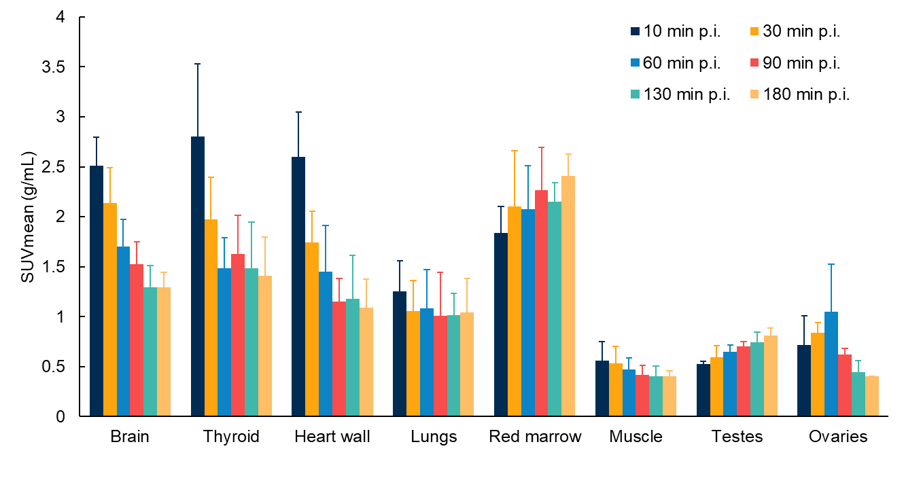

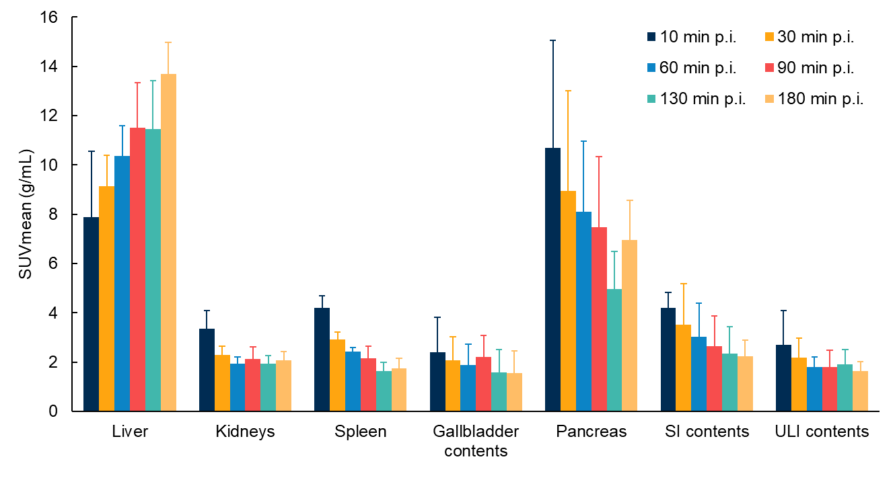
Figure S1 The biodistribution data (SUVmean) of D6-[¹⁸F]FP-DTBZ in six healthy subjects.

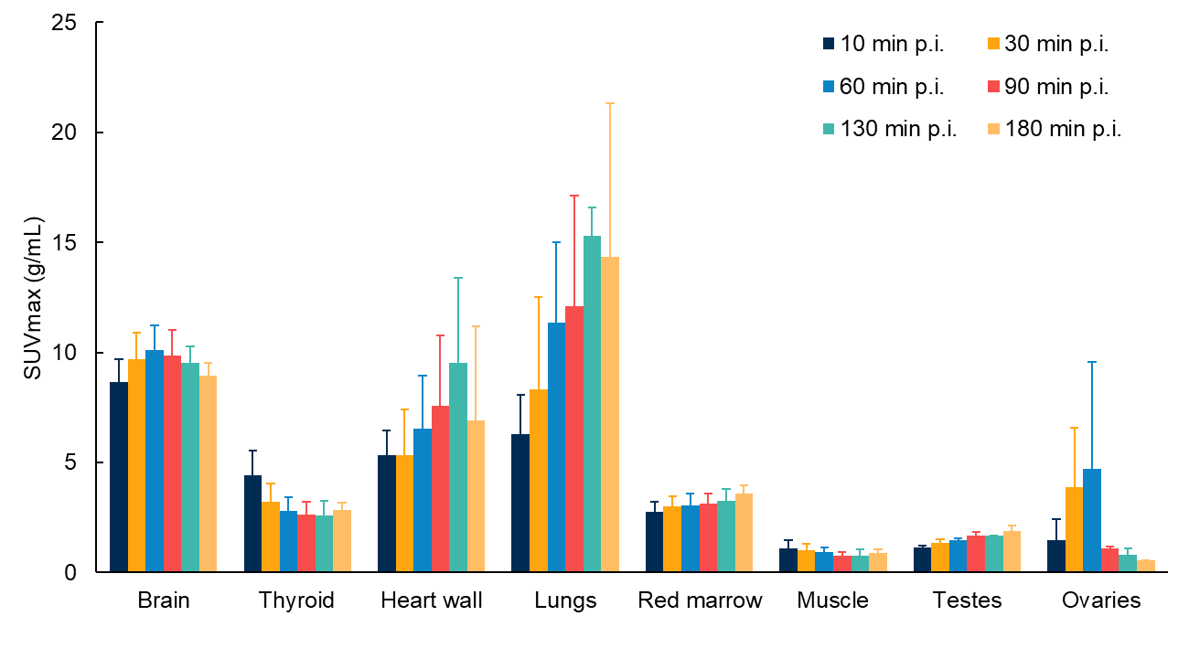

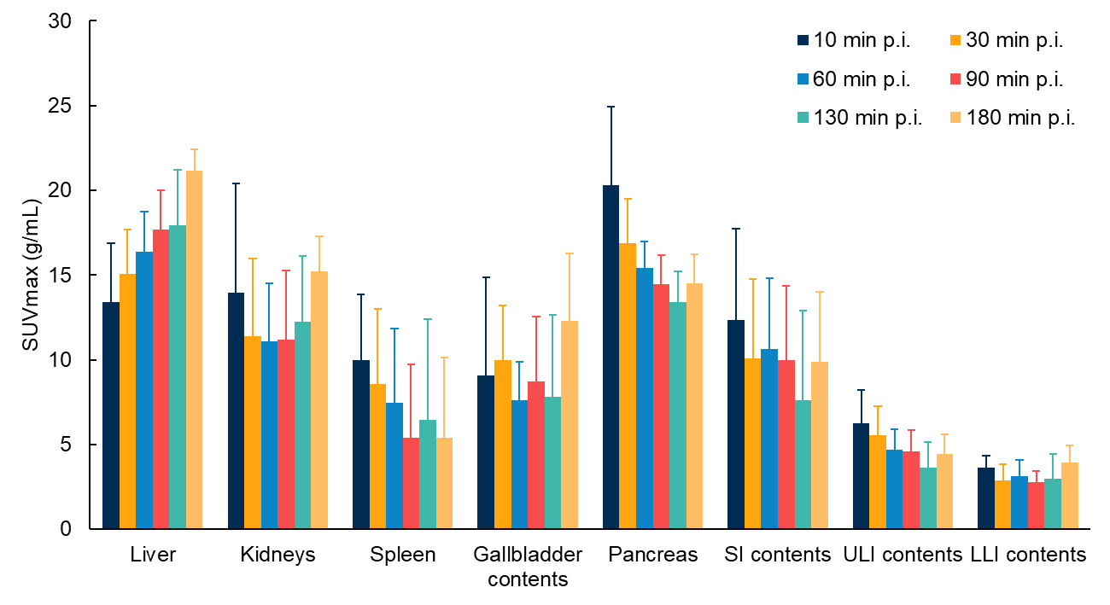
Figure S2 The biodistribution data (SUVmax) of D6-[¹⁸F]FP-DTBZ in six healthy subjects.

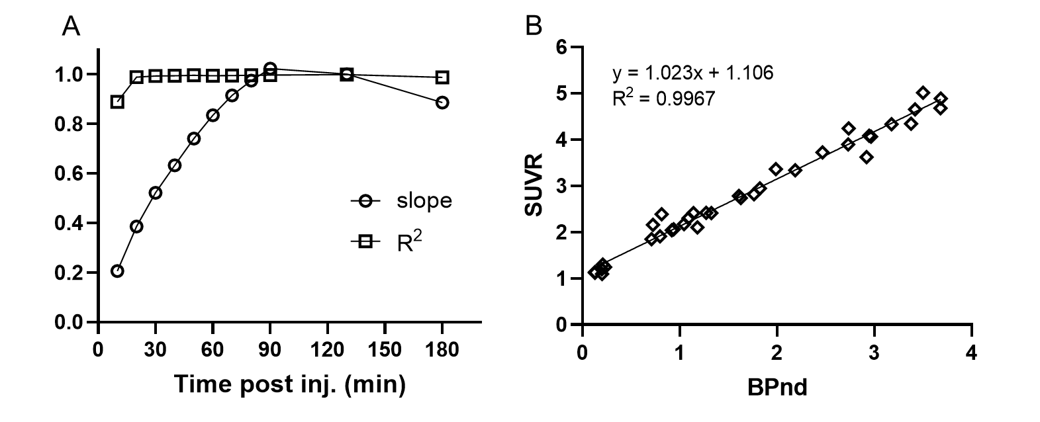
Figure S3 (A) The linear regression results of slope and R² values between BPnd and SUVRs at all frames across 0~180 min. (B) Scatter plots of BPnd and SUVRs for all VOIs with regression analysis results from time frame of 90 min.

