Supplementary data

From water molecules mobility to water-resistance of swollen oriented and non-oriented cellulose nanofibrils cryogels
Rouillon Charlie ª, Foucat Loïc ^{b}, Chaunier Laurent ª, Maigret Jean-Eudes ª, El Maana Sana ^{c}, Duchemin Benoit ^{c}, Cathala Bernard ª, Villares Ana ª, Moreau Celine ^{a,}*
ª UR1268 BIA, INRAE, 44300 Nantes, France;
^{b} UR1268 BIA, BIBS Facility, INRAE, 44300 Nantes, France
^{c} Université Le Havre Normandie, CNRS, Normandie Univ, LOMC UMR 6294, F-76600 Le Havre, France

Supplementary figures and Tables

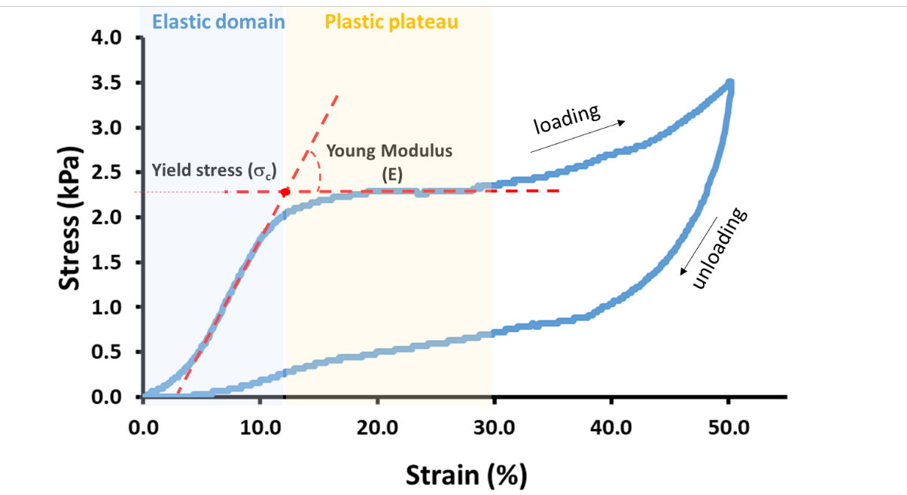
Figure S1. Scheme illustrating the determination of the compressive Young’s modulus (E), i.e., cryogels stiffness, and the critical stress (σ_{c}) at the onset of the cellular structure’s collapse, i.e., the transition between the elastic initial domain and the plastic plateau (stress-strain curve of CNFt-UD cryogels for the first loading-unloading compression cycle).

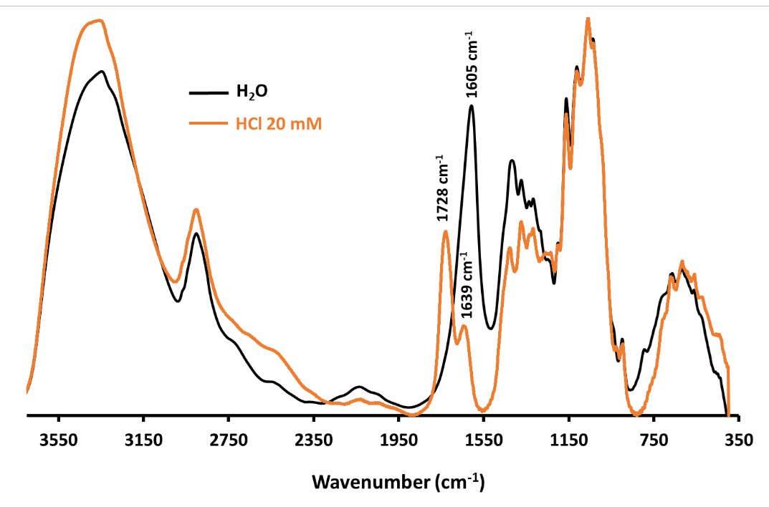
Figure S2. Typical FTIR spectra of freeze-dried CNFt-ND cryogel after immersion in water (black curve) or in aqueous 20 mM HCl solution (orange curve). The bands at 1605 cm⁻¹, 1636 cm⁻¹ and 1728 cm⁻¹ correspond to the stretching vibration of the carbonyl (C=O) from the deprotonated carboxylate groups (-COO⁻), to the adsorbed water, and to the carbonyl (C=O) stretching frequency of the carboxylic acid groups (-COOH).

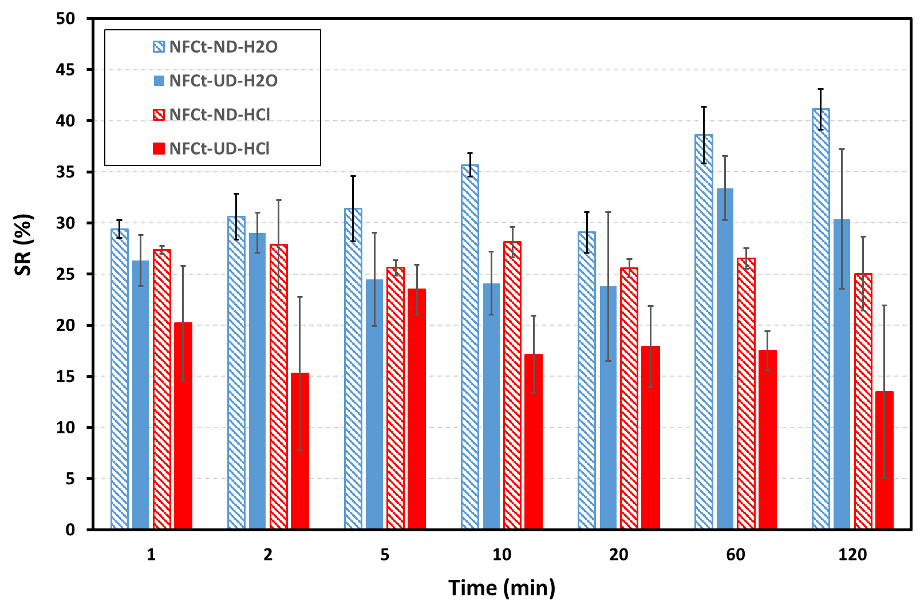
Figure S3. Swelling degree, SR (%), of CNFt-ND and -UD cryogels after immersion in H₂O (blue bars) or HCl solution (red bars) as function of time.

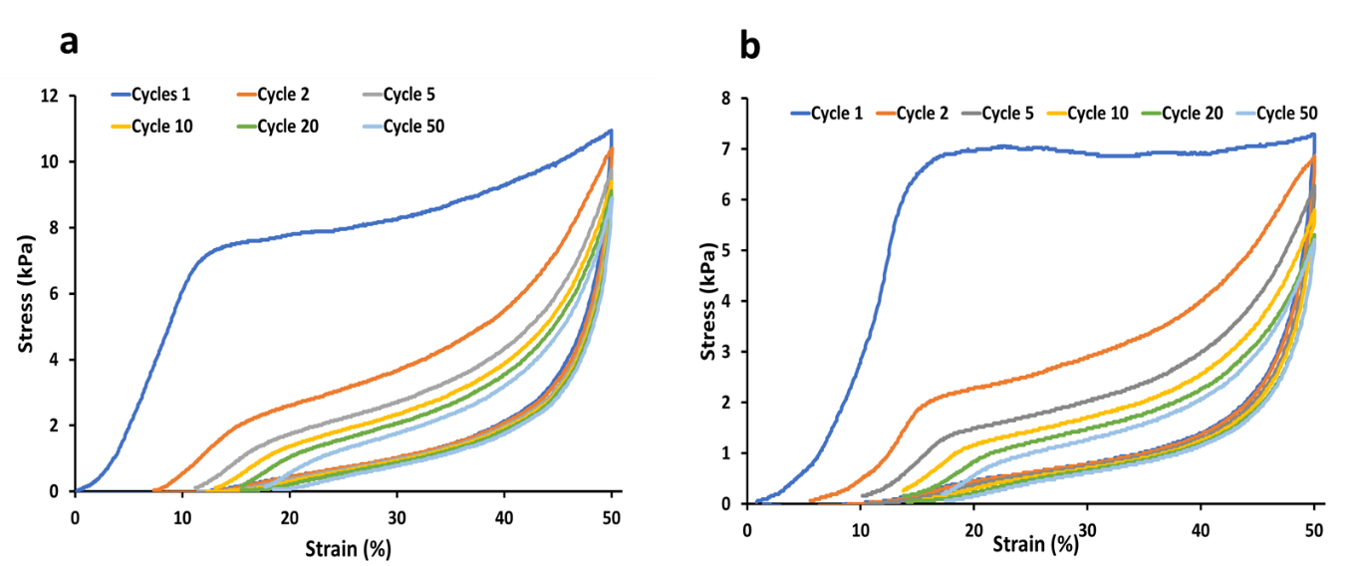

Figure S4. Compressive stress-strain curves for (a) CNFt-ND cryogels and (b) CNFt-UD cryogels after immersion in HCl 20 mM then in H₂O during compression cycles up to 50.

Table S1: $T_{2i}$ relaxation times and associated populations (proportions) $P_{2i}$ for CNFt gel, and CNFt-ND and CNFt-UD cryogels treated with H₂O or HCl. The letters a, b, c, d and e denote the “i” water component having $T_{2i}$ relaxation time value, from the longest (a) to the shortest (f), and are associated to the mobility domains as defined in Figure 5. Values in parentheses are standard errors; n=3.
CNFt sample |  |  | T_{2i} (ms) |  |  |  |  |  |  | P_{2i} (%)
 |  |  | T_{2a} | T_{2b} | T_{2c} | T_{2d} |  | T_{2e} |  | P_{2a} | P_{2b} | P_{2c} | P_{2d} |  | P_{2e}
Gel |  |  | - | 540 (6) | - | - |  | 5 (1) |  | - | 98.8 (0.5) | - | - |  | 1.2 (0.5)
ND | (H₂O) |  | 1022 (74) | 504 (41) | 153 (12) | - |  | 1.2 (0.2) |  | 44 (4) | 41 (3) | 12 (1) | - |  | 3.3 (0.4)
ND | (HCl) |  | 1065 (141) | 451 (37) | 160 (12) | 66* (6) | 28* (3) | 6 (1) |  | 26 (1) | 36 (1) | 19 (1) | 6* (1) | 7* (1) | 6 (1)
UD | (H₂O) |  | 915 (65) | 481 (40) | 164 (12) | - |  | 3 (2) |  | 32 (2) | 59 (5) | 7 (1) | - |  | 3 (2)
UD | (HCl) |  | 890 (65) | 403 (55) | 143 (14) | 43 (7) |  | 6 (3) |  | 21 (5) | 47 (5) | 20 (5) | 7 (2) |  | 4 (1)
* For the mobility domain “d” of cryogel CNFt-ND(HCl), two values of $T_{2d}$ are distinguished.

Table S2. Values of compression modulus E (kPa) and critical stress σ_{c} (kPa) extracted from stress-strain curves (as exemplified in Fig.S1) of CNFt-ND and CNFt-UD cryogels at different compression cycles.
 |  | CNFt-ND |  |  | CNFt-UD
E (kPa) | H₂O | HCl | HCl-H₂O | H₂O | HCl | HCl-H₂O
Cycle 1 | 21.2 ±8.8 | 135.5 ±24.2 | 110.6 ±33.8 | 51.8 ±6.1 | 158.6 ±17.3 | 113.3 ±20.3
Cycle 2 | 11.9 ±4.6 | 31.1 ±0.9 | 34.6 ±3.6 | 14.9 ±3.2 | 22.1 ±1.3 | 34.1 ±2.0
Cycle 5 | 9.1 ±2.6 | 26.2 ±4.0 | 26.2 ±1.7 | 9.0 ±1.7 | 14.8 ±1.9 | 20.1 ±1.3
Cycle 10 | 6.7 ±2.1 | 25.3 ±4.5 | 24.3 ±1.5 | 6.6 ±1.1 | 14.3 ±0.5 | 16.9 ±0.5
Cycle 20 | n.m. | 24.9 ±3.1 | 20.8 ±1.6 | 3.1 ±0.5 | 13.3 ±1.2 | 15.1 ±1.4
Cycle 50 | - | 24.6 ±4.9 | 19.2 ±1.4 | - | 13.8 ±0.7 | 13.3 ±1.5
σ_{c} (kPa) | H₂O | HCl | HCl-H₂O | H₂O | HCl | HCl-H₂O
Cycle 1 | 1.9 ±0.5 | 8.5 ±1.2 | 8.1 ±0.8 | 2.4 ±0.3 | 8.7 ±0.5 | 8.1 ±1.2
Cycle 2 | 0.9 ±0.3 | 1.8 ±0.1 | 2.2 ±0.1 | 0.7 ±0.2 | 1.5 ±0.1 | 1.9 ±0.4
Cycle 5 | 0.7 ±0.2 | 1.3 ±0.1 | 1.5 ±0.0 | 0.5 ±0.1 | 1.0 ±0.3 | 1.2 ±0.3
Cycle 10 | n.m. | 1.3 ±0.1 | 1.3 ±0.0 | 0.4 ±0.1 | 0.9 ±0.1 | 1.0 ±0.1
Cycle 20 | n.m. | 1.1 ±0.1 | 1.1 ±0.0 | 0.2 ±0.1 | 0.8 ±0.1 | 0.9 ±0.2
Cycle 50 | - | 1.0 ±0.0 | 1.0 ±0.1 | - | 0.7 ±0.1 | 0.7 ±0.2
n.m.: not measurable

Supplementary Video
Evaluation of shape-recovery performance by manual compression of acid-swollen CNFt cryogel.

Supplementary information
X-ray tomography: Anticorrelation
Materials and methods: anticorrelation
Prior analysis, image stacks taken at low resolution were cropped in order to maintain the field of view in the samples only. The images were then optimized in brightness and contrast by setting the minimum gray level at the histogram maximum. The data was then thresholded using the IJ_isodata routine. The autocorrelation was performed in imageJ with the help of freely available macro (https://imagejdocu.list.lu/macro/radially_averaged_autocorrelation) on image stacks. The data is presented in the form of normalized autocorrelation as a function of the distance; the result is the average of more than 700 images contained in each stack. A strength of this technique lies in its spatial resolution: in the present case, the voxel size was ~5 µm for the high-resolution scans and ~13 µm for the global scans, meaning that the autocorrelation “scans” for characteristic sizes and periodicities at different scales. For instance, a high-resolution scan rather “sees” the small local characteristics. On the opposite, a low-resolution scan “sees” the spatial microstructure aperiodicities near the edges of the samples and the general orientations, at the expense of noise-limited small-scale characteristics.

Results
In addition to the main points about size and anisotropy that are mentioned in the main core of the article, it is interesting to pinpoint that the UD structure appeared less compact near the axis of symmetry of the cylinder, and also away from the free top surface of the sample (Figure 3a and g). In particular, the longitudinal cross-section revealed that the top of the UD sample has a different morphology than its center, with the elongated pores curving parallel to the top surface (Figure 3). This might be explained by differential freezing kinetics near the wall and away from it due to spatial temperature gradients.
It is relatively difficult to obtain quantitative data on such foam structures using conventional methods such as particle analysis or direct size measurements because the data is relatively noisy and the measurement is very operator-dependent. A common method used to address such an issue lies in the autocorrelation analysis and, more specifically, in the calculation of the radial average autocorrelation. This method is useful to assess parameters such as particle diameter or average spacing between similar domains such as pore centers (presence of an absolute minimum or slope change), packing pseudo-periodicity (presence of periodic oscillations), statistical size distributions (absolute minimum versus slope change), etc. (Thissen & Brandon, 2015) The calculation was performed on both high and low-resolution scans. It is important to remember that the use of two resolutions means that the calculations did not exactly probe the same dimensional windows; in particular, due to resolution limitations, it is generally expected that the low-resolution scans give larger estimates of the characteristic dimensions because they do not capture low dimensional signal with the same accuracy.
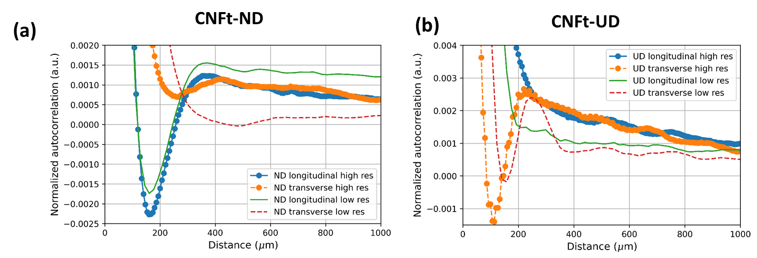
Figure S5. Average autocorrelations of the CNFt-ND (a) and CNFt- UD (b) microstructures from longitudinal and transverse directions on the high resolution (local information, curves with circle symbols) and low resolution (global information, curves without symbol) scans.

Regarding the NFCt-ND cryogels in the longitudinal direction (Figure S5 a), the minimum was an estimate of the average pore length and it was found to lie near 160 µm for both high- and low-resolution scans. An estimate of the transverse pore width was found from the inflection of the curves near 265 µm for the high-resolution scan and near 482 µm for the low-resolution scan. More importantly, the shape of the autocorrelation curves demonstrates a more scattered arrangement in the transverse direction, probably due to the exacerbated importance of edge effects along this direction. The relative size distribution, with transverse domains further spaced apart than the longitudinal domains, seems in agreement with Figure 3 (main text).
The CNFt-UD cryogels show an opposite trend in terms of packing regularity since autocorrelation in the transverse directions show clear minima whereas the longitudinal signal only produces a slope change; a mere slope change can be simulated with a broader size distribution of the coherent domains, i.e. a lower periodicity (Fig. S5 b). The transverse signal translates to average domains (pores) of about 113 µm (low-resolution) and 158 µm (high-resolution) in width. These sizes are therefore in good agreement with the smaller dimension of the pseudo rectangular pores or, equivalently, with the minimum pore interspacing distance in these transverse cross-sections. The longitudinal signal shows larger domains, in the order of 186 µm (high-resolution) and 223 µm (low-resolution) in length, but these values need to be understood in the light of the above-mentioned aperiodic tiling. This metric scaling seems in good agreement with Figure 3 (main article) too, as the longitudinal sections are less dense in terms of intercellular distances.

Reference
Thissen, C. J., & Brandon, M. T. (2015). An autocorrelation method for three-dimensional strain analysis. Journal of Structural Geology, 81, 135-154. https://doi.org/10.1016/j.jsg.2015.09.001

