Supporting Information
Design of anthracyclines with extremely high cytotoxic properties.
Aleksandra A. Moiseeva,ª Oleg I. Artyushin,ª Lada V. Anikina,^{b} Anastasiya A. Globa,^{b} Zinaida S. Klemenkova,ª Maxim V. Andreev,ª Eugene V. Radchenko,^{c*} Vladimir A. Palyulin^{c*} and Valery K. Brelª*
ª Nesmeyanov Institute of Organoelement Compounds, Russian Academy of Sciences, Vavilova St. 28, bld. 1, Moscow, 119991, Russia.
^{b} Institute of Physiologically Active Compounds of the FSBIS of the Federal Research Center for Problems of Chemical Physics and Medicinal Chemistry of the RAS, 1 Severnyi Proezd, Chernogolovka, 142432, Russia
^{c} Department of Chemistry, Lomonosov Moscow State University, Leninskie Gory, Moscow, 119991, Russia
E-mail: genie@qsar.chem.msu.ru; vap@qsar.chem.msu.ru; v_brel@mail.ru.

Table of contents
General Synthetic Information 2
General procedure of synthesis of amines 4b-f 3
X-ray diffraction data 10
Molecular docking 11
Determination of cytotoxicity 13
Determination of the influence on the cell cycle 13
Determination of the influence on apoptosis 16
Determination of the acute toxicity 16
References 17
NMR spectra of all compounds 18
MS spectra of all compounds 26
IR spectra of all compounds 48

General Synthetic Information
Multinuclear ¹H and ¹³C NMR spectra were recorded on a Bruker Avance 400 and Inova 400 spectrometers (at 400.13 and 100.61 MHz operating frequencies, respectively), and a Bruker Avance 300 spectrometer (at 300.13 MHz operating frequency) in CDCl₃ solutions using residual proton signals of deuterated solvent (¹H, ¹³C) as internal references. ¹³C NMR spectra were recorded mostly in ¹³C{¹H} jmod mode, the signals of carbon atoms with even and odd number of protons have opposite polarity. The signals of daunorubicin derivatives were assigned in accordance with the literature data [1].
IR spectra were obtained for sample pellets in KBr on a FT-IR spectrometer (InfraRed Bruker Tensor 37) in the 400–4000 cm⁻¹ range with 2 cm⁻¹ resolution, 32 scans.
Liquid chromatography–mass spectrometry (LC–MS) measurements were performed on a Shimadzu LCMS-2020 (Japan) instrument using electrospray ionization (ESI) and a single quadrupole mass detector. Data were collected between m/z 50 and m/z 2000 in a positive ion mode. The potential difference between the spray capillary and the injection capillary was 4.5 kV. The value of scan speed was set to 5000 u/sec. The following settings were used: nebulizing gas (99.999% nitrogen) flow 1,5 L/min, drying gas (99.999% nitrogen) flow 15 L/min, interface temperature 350°C, desolvation line temperature 250°C, heat block temperature 400°C, pump LC-20ADXR flow 0,4 mL/min, pump pressure 7,5 MPa. Acetonitrile as a mobile phase was of HPLC grade.
HPLC-MS analysis was perfomed on a Shimadzu LCMS-2020 (Japan) instrument using electrospray ionization (ESI) or DUIS mode ionization (ESI and atmospheric pressure chemical ionization (APCI) together), and a single quadrupole mass detector. Data were collected between m/z 100 and m/z 1500 in a positive ion mode. The potential difference between the spray capillary and the injection capillary was 4.5 kV. The value of scan speed was set to 1500 u/sec. The above settings of main blocks temperature and gas flow were used. The oven temperature was 40°C. A Shim-pack GIST 3 μm С18 3×150 mm column was used as a stationary phase. The gradient elution parameters were changed from the 1st minute to the 9th minute (from 30 to 80 vol % of acetonitrile (99.9%) and from 70 to 20 vol % of formic acid (0.1 vol %) solution in water (Milli-Q), respectively), total flow rate was 0.8÷1.0 mL/min.
High resolution mass spectra (HRMS) were measured on a Bruker micrOTOF II instrument using electrospray ionization (ESI) [2]. The measurements were performed in a positive ion mode (interface capillary voltage – 4500 V) or in a negative ion mode (3200 V); mass range from m/z 50 to m/z 3000; external or internal calibration was performed with ESI Tuning Mix, Agilent. A syringe injection was used for solutions in acetonitrile, methanol, or water (flow rate 3 μL/min). Nitrogen was applied as a dry gas; interface temperature was set at 180 °C.
Sample preparation for all MS methods consisted of dissolving 1 mg of each compound in 1 mL of acetonitrile, from which 0.1-5 μL was injected into the system.
X-ray diffraction data were collected at 100 K with a Bruker D8 Quest CMOS diffractometer using the graphite monochromated Mo-Kα radiation (λ = 0.71073 Å, ω-scans).
Reactions were monitored by TLC on alumina TLC plates w/UV254. The chromatographic purification of the compounds was carried out on a Macherey-Nagel silica gel (MN Kieselgel 60, 70–230 mesh) using the solvent system CHCl₃ : MeOH from 100 : 0.1 to 100 : 10. Daunorubicin hydrochloride was purchased from Aldrich. Commercially available starting materials were used without further purification. All obtained daunorubicin derivatives are decomposed when heated above 200 °C. All products form strong complexes with CHCl₃, which do not decompose even after prolonged exposure to P₂O₅ in an oil pump vacuum. Daunorubicin derivatives 4a, 4g and 4h were obtained previously using the same method [3].
The structure of all the obtained compounds was studied using the equipment of the Center for the Study of the Molecular Structure of the INEOS RAS, Moscow. Elemental analysis was performed in the Laboratory for Microanalysis of INEOS RAS, Moscow. High resolution mass spectra were recorded in the Department of Structural Studies of Zelinsky Institute of Organic Chemistry, Moscow. The biological testing of anticancer activity was performed in the Institute of Physiologically Active Compounds, Russian Academy of Sciences, Chernogolovka. The molecular docking was provided in the Department of Chemistry, Lomonosov Moscow State University, Moscow.

General procedure of synthesis of amines 4b-f
A mixture of the corresponding carboxaldehyde (8.0 mmol) and daunorubicin hydrochloride (0.23 g, 0.4 mmol) in a CH₃CN–H₂O mixture (3:1, 9 mL) was stirred for 0.5 h at ambient temperature in the dark. Next, NaCNBH₃ (0.08 g, 1.2 mmol) was added, the resultant reaction mixture was stirred for 0.5 h, 5 mL of water was added, and the mixture was extracted with CHCl₃ (3×10 mL). The organic layer was washed with H₂O (15 mL) and the aqueous layer was extracted with CHCl₃ (15 mL). The combined organic extracts were dried with Na₂SO₄, filtered, and the solvent was removed under reduced pressure (10 mm Hg). The residue was purified by column chromatography on silica gel.
(8S,10S)-8-Acetyl-6,8,11-trihydroxy-10-([(2R,4S,5S,6S)-5-hydroxy-6-methyl-4-(((4-methoxybenzo[d][1,3]dioxol-5-yl)methyl)amino)tetrahydro-2H-pyran-2-yl]oxy)-1-methoxy-7,8,9,10-tetrahydrotetracene-5,12-dione (4b).
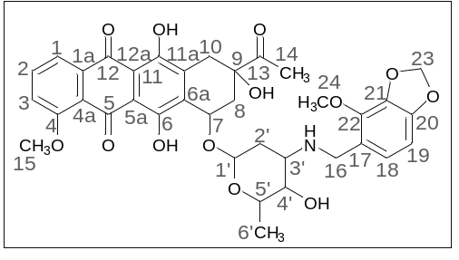
Dark red powder (0.19 g, 78%); mp: (decomp.) > 200°C; Found: C, 56.28; H, 5.17; N, 2.21. Calc. for C₃₆H₃₇NO₁₃·0.8CHCl₃: C, 56.15; H, 4.84; N, 1.78%; IR (KBr, cm⁻¹): 3476brm (OH), 2972shm, 2935m and 2845shw (three CH), 1716s (C=O), 1618s and 1579s (both C=C), 1469s, 1446s and 1414s (both OH), 1379m, 1352m, 1286vs, 1260s, 1232s and 1210s (both C–O), 1122s, 1068shm and 1036vs, 984s (C=C), 875w, 793m, 764w, 730w, 465vw; ¹H NMR (400 MHz; CDCl₃; Me₄Si): δ 13.96 (br. s, 1H, C⁶OH), 13.21 (br. s, 1H, C¹¹OH), 8.05 (d, 1H, ³J_{HH} = 7.3, C¹H), 7.81 (t, 1H, ³J_{HH} = 8.0, C²H), 7.42 (d, 1H, ³J_{HH} = 8.3, C³H), 6.66 (d, 1H, ³J_{HH} = 8.0, C¹⁹H), 6.44 (d, 1H, ³J_{HH} = 7.8, C¹⁸H), 5.90 (s, 2H, C²³H₂), 5.54 (br. s, 1H, OH), 5.32 (br. s, 1H, C^{1’}H), 4.73 (br. s, 1H, OH), 4.11 (br. s, 4H, C³⁵H₃, C^{5’}H), 4.00 (s, 3H, C²⁴H₃), 3.92 (br. s, 1H, C⁷H), 3.75–3.72 (m, 2H, C^{4’}H, C¹⁶H_{eq}), 3.61 (d, 1H, ²J_{HH} = 11.9, C¹⁶H_{ax}), 3.25 and 2.99 (d, both 1H, ²J_{HH} = 19.9, C¹⁰H₂), 2.98–2.95 (m, 1H, C^{3’}H), 2.46 (s, 3H, C¹⁴H₃), 2.40 (d, 1H, ²J_{HH} = 15.7, C⁸H_{eq}), 2.14–2.10 (m, 1H, C⁸H_{ax}), 1.83 (dt, 1H, ²J_{HH} = 13.0, ³J_{HH} = 4.0, C^{2’}H_{ex}), 1.64 (dd, 1H, ²J_{HH} = 13.0, ³J_{HH} = 4.8, C^{2’}H_{ax}), 1.42 (d, 3H, ³J_{HH} = 6.5, C^{6’}H₃) ppm; ¹³C{¹H} NMR (100 MHz; CDCl₃; Me₄Si): δ 211.76 (C¹³), 186.39, 186.04 (C⁵, C¹²), 160.64 (C⁴), 156.09, 155.37 (C⁶, C¹¹), 148.66, 141.46 (C²⁰, C²¹), 135.73 (C²²), 135.42 (C²), 135.98 (C^{1a}), 134.09, 134.01 (C^{6a}, C^{11a}), 123.87 (C¹⁷), 122.44 (C¹⁸), 120.33 (C^{4a}), 119.43, 118,13 (C¹, C³), 110.90, 110.75 (C^{5a}, C^{12a}), 101.92 (C¹⁹), 100.83 (C^{1’}), 100.62 (C²³), 76.58 (C⁹), 69.62, 66.31, 66.17 (C⁷, C^{4’}, C^{5’}), 59.29 (C²⁴), 56.37 (C¹⁵), 51.31 (C^{3’}), 44.98 (C¹⁶), 34.62, 32.89, 29.99 (C⁸, C¹⁰, C^{2’}), 24.61 (C¹⁴), 16.96 (C^{6’}) ppm; HPLC-MS (DUIS) m/z 692.45 ([M + H]⁺, 55%), 858.55 (13%), 856.55 (24%); Retention time = 4.54, 5.75, 6.33; HRMS (ESI) m/z calc’d C₃₆H₃₇NO₁₃ [M + H]⁺ 692.2338, found 692.2337.

(8S,10S)-8-Acetyl-6,8,11-trihydroxy-10-([(2R,4S,5S,6S)-5-hydroxy-6-methyl-4-(((2,3,4-trimethoxybenzyl)amino)tetrahydro-2H-pyran-2-yl]oxy)-1-methoxy-7,8,9,10-tetrahydrotetracene-5,12-dione (4c).
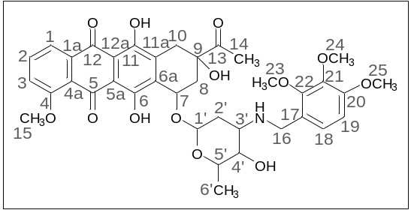
Red powder (0.06 g, 24%); mp: (decomp.) > 200°C; Found: C, 58.24; H, 5.61; N, 1.81. Calc. for C₃₇H₄₁NO₁₃·0.5CHCl₃: C, 58.69; H, 5.45; N, 1.83%; IR (KBr, cm⁻¹): 3489brm (OH), 2939m and 2839shw (both CH), 1751s and 1719shs (both C=O), 1618s and 1579s (both C=C), 1496s, 1470s, 1445s and 1415s (both OH), 1382m, 1352m, 1286vs, 1261s, 1233s and 1209s (both C–O), 1153w, 1122shm, 1098vs and 1069shw, 1016brs (C=C), 949w, 912w, 842shw, 792m, 761w, 698vw, 614vw; ¹H NMR (400 MHz; CDCl₃; Me₄Si): δ 13.88 (br. s, 1H, C⁶OH), 13.18 (br. s, 1H, C¹¹OH), 7.97 (d, 1H, ³J_{HH} = 7.6, C¹H), 7.77 (t, 1H, ³J_{HH} = 8.2, C²H), 7.39 (d, 1H, ³J_{HH} = 8.4, C³H), 7.04 and 6.66 (d, both 1H, ³J_{HH} = 8.6, C¹⁸H, C¹⁹H), 5.41–5.38 (m, 1H, OH), 5.23 (br. s, 1H, C^{1’}H), 4.69 (br. s, 1H, OH), 4.61 (br. s, 1H, C⁷H), 4.35 (dd, 1H, ²J_{HH} = 11.4, ⁴J_{HH} = 1.7, C¹⁶H_{eq}), 4.15–4.11 (m, 1H, C¹⁶H_{ax}), 4.07 (br. s, 4H, C¹⁵H₃, C^{5’}H), 3.95 (br. s, 1H, C^{4’}H), 3.91, 3.86, 3.84 (s, all three 3H, C²³H₃, C²⁴H₃, C²⁵H₃), 3.14 (dd, 1H, ²J_{HH} = 19.0, ³J_{HH} = 2.1, C¹⁰H_{eq}), 2.84 (d, 1H, ²J_{HH} = 18.7, C¹⁰H_{ax}), 2.47 (d, 1H, ²J_{HH} = 15.2, C⁸H_{eq}), 2.40 (s, 3H, C¹⁴H₃), 2.37–2.35 (m, 1H, C^{3’}H), 2.07 (dd, 1H, ²J_{HH} = 14.8, ³J_{HH} = 4.1, C⁸H_{ax}), 1.55 (ddd, 2H, ²J_{HH} = 15.9, ³J_{HH} = 8.6, ³J_{HH} = 8.3, C^{2’}H₂), 1.37 (d, 3H, ³J_{HH} = 6.4, C^{6’}H₃) ppm; ¹³C{¹H} NMR (100 MHz; CDCl₃; Me₄Si): δ 211.90 (C¹³), 186.65, 186.32 (C⁵, C¹²), 160.76 (C⁴), 156.12, 155.55 (C⁶, C¹¹), 153.73 (C²⁰), 151.85 (C²²), 141.68 (C²¹), 135.56 (C²), 135.17 (C^{1a}), 134.45, 133.60 (C^{6a}, C^{11a}), 124.80 (C¹⁸), 120.76 (C¹⁷), 120.53 (C^{4a}), 119.56, 118,25 (C¹, C³), 111.10, 110.97 (C^{5a}, C^{12a}), 107.22 (C¹⁹), 98.70 (C^{1’}), 76.59 (C⁹), 73.07, 68.95, 64.42 (C⁷, C^{4’}, C^{5’}), 61.03, 60.61, 56.45, 55.81 (C¹⁵, C²³–C²⁵), 49.97 (C^{3’}), 40.47 (C¹⁶), 35.07, 32.86, 26.17 (C⁸, C¹⁰, C^{2’}), 24.58 (C¹⁴), 15.36 (C^{6’}) ppm; HPLC-MS (DUIS) m/z 399.20 (4%), 708.45 ([M + H]⁺, 9%), 756.45 ([M + CH₃CN]⁺, 18%); Retention time = 4.02, 7.93; HRMS (ESI) m/z calc’d C₃₇H₄₁NO₁₃ [M + H]⁺ 708.2651, found 708.2664.

(8S,10S)-8-Acetyl-6,8,11-trihydroxy-10-([(2R,4S,5S,6S)-5-hydroxy-6-methyl-4-(((2,3-dimethoxybenzyl)amino)tetrahydro-2H-pyran-2-yl]oxy)-1-methoxy-7,8,9,10-tetrahydrotetracene-5,12-dione (4d).
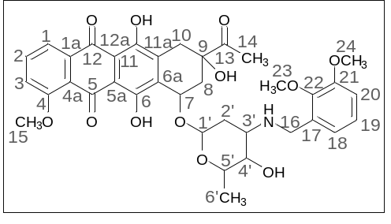
Red powder (0.06 g, 56%); mp: (decomp.) > 200°C; Found: C, 60.18; H, 5.62; N, 2.13. Calc. for C₃₆H₃₉NO₁₂·0.3CHCl₃: C, 60.82; H, 5.53; N, 1.95%; IR (KBr, cm⁻¹): 3476brm (OH), 2969shw, 2935m and 2838shw (three ν_{CH}), 1717m (C=O), 1618s and 1585s (both C=C), 1474s, 1445s and 1414s (both OH), 1379m, 1352m, 1285vs, 1231s and 1209s (both C–O), 1124m, 1082m, 1034m, 1006shs and 987vs (C=C), 875m, 818m, 791m, 763m, 696vw, 467w; ¹H NMR (400 MHz; CDCl₃; Me₄Si): δ 13.87 (br. s, 2H, C⁶OH, C¹¹OH), 7.95 (d, 1H, ³J_{HH} = 7.4, C¹H), 7.74 (t, 1H, ³J_{HH} = 8.1, C²H), 7.35 (d, 1H, ³J_{HH} = 8.4, C³H), 6.94 (t, 1H, ³J_{HH} = 7.9, C¹⁹H), 6.80–6.76 (m, 2H, C¹⁸H, C²⁰H), 5.48 (br. s, 1H, OH), 5.22 (br. s, 1H, C^{1’}H), 4.67 (br. s, 2H, OH, C⁷H), 4.05 (br. s, 4H, C¹⁵H₃, C^{5’}H), 3.78 and 3.77 (s, both 3H, C²³H₃, C²⁴H₃), 3.74–3.65 (m, 3H, C^{4’}H, C¹⁶H₂), 3.12 (dd, 1H, ²J_{HH} = 18.9, ⁴J_{HH} = 2.0, C¹⁰H_{eq}), 2.82 (d, 1H, ²J_{HH} = 18.8, C¹⁰H_{ax}), 2.94–2.90 (m, 1H, C^{3’}H), 2.41 (s, 3H, C¹⁴H₃), 2.34 (dd, 1H, ²J_{HH} = 14.8, ³J_{HH} = 2.6, C⁸H_{eq}), 2,09–2.03 (m, 1Н, C⁸H_{ax}), 1.78 (dt, 1Н, ²J_{HH} = 12.9, ³J_{HH} = 4.0, C^{2’}H_{eq}), 1.63 (dd, 1Н, ²J_{HH} = 13.2, ³J_{HH} = 4.8, C^{2’}H_{ax}), 1.39 (d, 3H, ³J_{HH} = 6.5, C^{6’}H₃) ppm; ¹³C{¹H} NMR (100 MHz; CDCl₃; Me₄Si): δ 211.96 (C¹³), 186.77, 186.44 (C⁵, C¹²), 160.91 (C⁴), 156.36, 155.71 (C⁶, C¹¹), 152.56, 147.15 (C²², C²¹), 135.64 (C²), 135.31 (C^{1a}), 134.34, 134.27 (C^{6a}, C^{11a}), 132.98 (C¹⁷), 124.04 (C¹⁸), 121.56 (C¹⁹), 120.67 (C^{4a}), 119.68, 118.35 (C¹, C³), 111.70, 111.22, 111.07 (C^{5a}, C^{12a}, C²⁰), 100.98 (C^{1’}), 77.28 (C⁹), 69.77 (C⁷), 66.52, 66.44 (C^{4’}, C^{5’}), 60.82 (C²³), 56.62, 55.68 (C¹⁵, C²⁴), 52.07 (C^{3’}), 45.02 (C¹⁶), 34.85, 33.19, 30.22 (C⁸, C¹⁰, C^{2’}), 24.86 (C¹⁴), 17.18 (C^{6’}) ppm; HPLC-MS (DUIS) m/z 678.45 ([M + H]⁺, 95%), 1355.85 ([2M + H]⁺, 5%); Retention time = 4.49; HRMS (ESI) m/z calc’d C₃₆H₃₉NO₁₂ [M + H]⁺ 678.2545, found 678.2551.

(8S,10S)-8-Acetyl-6,8,11-trihydroxy-10-([(2R,4S,5S,6S)-5-hydroxy-6-methyl-4-(((2,4-dimethoxybenzyl)amino)tetrahydro-2H-pyran-2-yl]oxy)-1-methoxy-7,8,9,10-tetrahydrotetracene-5,12-dione (4e).
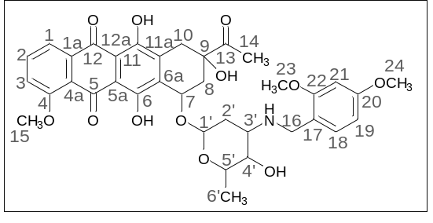
Dark red powder (0.04 g, 36%); mp: (decomp.) > 200°C; Found: C, 60.29; H, 5.63; N, 2.14. Calc. for C₃₆H₃₉NO₁₂·0.3CHCl₃: C, 60.82; H, 5.53; N, 1.95%; IR (KBr, cm⁻¹): 3475brm (OH), 2936m and 2837shw (both CH), 1718m (C=O), 1615m and 1587s (both C=C), 1507s, 1438shs and 1414s (both OH), 1379m, 1352m, 1288vs, 1262s, 1232s and 1209vs (both C–O), 1157m, 1127m, 1068w, 1035s and 1015shs, 988s (C=C), 830w, 793m, 764w, 464vw; ¹H NMR (400 MHz; CDCl₃; Me₄Si): δ 13.88 (br. s, 1H, C⁶OH), 13.22 (br. s, 1H, C¹¹OH), 7.98 (d, 1H, ³J_{HH} = 8.0, C¹H), 7.75 (t, 1H, ³J_{HH} = 8.0, C²H), 7.37 (d, 1H, ³J_{HH} = 8.0, C³H), 7.01 (d, 1H, ³J_{HH} = 7.8, C¹⁸H), 6.35 (s, 1H, C²¹H), 6.32 (d, 1H, ³J_{HH} = 7.8, C¹⁹H), 5.48 (br. s, 1H, OH), 5.25 (br. s, 1H, C^{1’}H), 4.80 (br. s, 1H, OH), 4.07 (br. s, 4H, C¹⁵H₃, C^{5’}H), 3.81–3.78 (br. s, 2H, C⁷H, C^{4’}H), 3.74 (br. s, 6H, C²³H₃, C²⁴H₃), 3.66–3.58 (m, 2H, C¹⁶H₂), 3.17 and 2.88 (d, both 1H, ²J_{HH} = 20.7, C¹⁰H₂), 2.92 (br. s, 1H, C^{3’}H), 2.43 (s, 3H, C¹⁴H₃), 2.36 (d, 1Н, ²J_{HH} = 14.0, C⁸H_{eq}), 2,07 (dd, 1Н, ²J_{HH} = 14.0, ³J_{HH} = 4.0, C⁸H_{ax}), 1.92 (dt, 1Н, ²J_{HH} = 13.1, ³J_{HH} = 3.8, C^{2’}H_{eq}), 1.75 (dd, 1Н, ²J_{HH} = 12.9, ³J_{HH} = 4.5, C^{2’}H_{ax}), 1.40 (d, 3H, ³J_{HH} = 6.4, C^{6’}H₃) ppm; ¹³C{¹H} NMR (100 MHz; CDCl₃; Me₄Si): δ 211.97 (C¹³), 186.64, 186.38 (C⁵, C¹²), 160.79 (C⁴), 159.57 (C²⁰), 158.07 (C²¹), 156.30, 155.65 (C⁶, C¹¹), 135.45 (C²), 135.26 (C^{1a}), 134.35, 134.25 (C^{6a}, C^{11a}), 130.93 (C¹⁸), 120.66 (C^{4a}), 120.16 (C¹⁷), 119.52, 118.19 (C¹, C³), 111.09, 110.96 (C^{5a}, C^{12a}), 103.54 (C¹⁹), 101.36 (C²¹), 98.21 (C^{1’}), 76.71 (C⁹), 69.49 (C⁷), 68.02, 66.87 (C^{4’}, C^{5’}), 56.59, 56.46 (C²³, C²⁴), 55.10 (C¹⁵), 54.99 (C^{3’}), 48.10 (C¹⁶), 34.67, 33.15, 27.81 (C⁸, C¹⁰, C^{2’}), 24.69 (C¹⁴), 17.18 (C^{6’}) ppm; HPLC-MS (DUIS) m/z 828.55 ([M + R + H]⁺, 42%); Retention time = 6.36; HRMS (ESI) m/z calc’d C₄₅H₅₀NO₁₄ [M + R + H]⁺ 828.3231, found 828.3302 (see fig. 35, 36).

(8S,10S)-8-Acetyl-6,8,11-trihydroxy-10-([(2R,4S,5S,6S)-5-hydroxy-6-methyl-4-(((2,4,5-trimethoxybenzyl)amino)tetrahydro-2H-pyran-2-yl]oxy)-1-methoxy-7,8,9,10-tetrahydrotetracene-5,12-dione (4f).
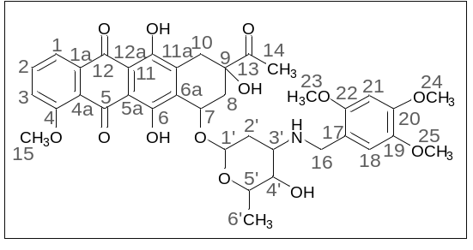
Dark red powder (0.09 g, 51%); mp: (decomp.) > 200°C. Found: C, 58.21; H, 5.64; N, 1.84. Calc. for C₃₇H₄₁NO₁₃·0.5CHCl₃: C, 58.69; H, 5.45; N, 1.83%; IR (KBr, cm⁻¹): 3475brm (OH), 2934m and 2839shw (both CH), 1717m (C=O), 1617m and 1578m (both C=C), 1513s, 1445s and 1413s (both OH), 1378m, 1352m, 1287vs, 1231s and 1207s (both C–O), 1124m, 1069m, 1034s, 986s (C=C), 873w, 818w, 763w, 764vw, 464w; ¹H NMR (400 MHz; CDCl₃; Me₄Si): δ 13.82 (br. s, 2H, C⁶OH, C¹¹OH), 7.97 (d, 1H, ³J_{HH} = 8.0, C¹H), 7.75 (t, 1H, ³J_{HH} = 8.0, C²H), 7.37 (d, 1H, ³J_{HH} = 8.0, C³H), 6.71 and 6.44 (s, both 1H, C¹⁸H, C²¹H), 5.49 (br. s, 1H, OH), 5.23 (br. s, 1H, C^{1’}H), 4.69 (br. s, 1H, OH), 4.07 (br. s, 4H, C¹⁵H₃, C^{5’}H), 3.84, 3.76, 3.75 (s, all three 3H, C²³H₃, C²⁴H₃, C²⁵H₃), 3.74–3.67 (m, 3H, C⁷H, C^{4’}H, C¹⁶H_{eq}), 3.61 (d, 1H, ²J_{HH} = 14.4, C¹⁶H_{ax}), 3.13 and 2.84 (d, both 1H, ²J_{HH} = 18.8, C¹⁰H₂), 2.95–2.90 (m, 1H, C^{3’}H), 2.42 (s, 3H, C¹⁴H₃), 2.37 (d, 1H, ²J_{HH} = 15.0, C⁸H_{eq}), 2.09 (dd, 1H, ²J_{HH} = 14.6, ³J_{HH} = 4.0, C⁸H_{ax}), 1.80 (dt, 1H, ²J_{HH} = 12.7, ³J_{HH} = 3.8, C^{2’}H_{eq}), 1.63 (dd, 1H, ²J_{HH} = 13.1, ³J_{HH} = 4.8, C^{2’}H_{ax}), 1.41 (d, 3H, ³J_{HH} = 6.4, C^{6’}H₃) ppm; ¹³C{¹H} NMR (100 MHz; CDCl₃; Me₄Si): δ 211.68 (C¹³), 186.62, 186.24 (C⁵, C¹²), 160.74 (C⁴), 156.18, 155.54 (C⁶, C¹¹), 151.56 (C²²), 148.65 (C¹⁹), 142.51 (C²⁰), 135.47 (C²), 135.15 (C^{1a}), 134.09 (C^{6a}, C^{11a}), 120.49 (C^{4a}), 119.51 (C¹⁷), 118.51, 118,17 (C¹, C³), 113.87 (C¹⁸), 111.04, 110.89 (C^{5a}, C^{12a}), 100.90 (C²¹), 97.06 (C^{1’}), 76.64 (C⁹), 69.70, 68.01, 66.34 (C⁷, C^{4’}, C^{5’}), 55.79, 55.93, 56.35 (C¹⁵, C²³–C²⁵), 51.53 (C^{3’}), 44.71 (C¹⁶), 34.66, 33.01, 30.07 (C⁸, C¹⁰, C^{2’}), 24.61 (C¹⁴), 16.98 (C^{6’}) ppm; HPLC-MS (DUIS) m/z 708.45 ([M + H]⁺, 100%), 1416.80 ([2M + 2H]⁺, 6%); Retention time = 4.34; HRMS (ESI) m/z calc’d C₃₇H₄₁NO₁₃ [M + H]⁺ 708.2651, found 708.2632.

(8S,10S)-8-Acetyl-6,8,11-trihydroxy-10-([(2R,4S,5S,6S)-5-hydroxy-6-methyl-4-((3,4-dimethoxybenzyl)amino)tetrahydro-2H-pyran-2-yl]oxy)-1-methoxy-7,8,9,10-tetrahydrotetracene-5,12-dione (4a).
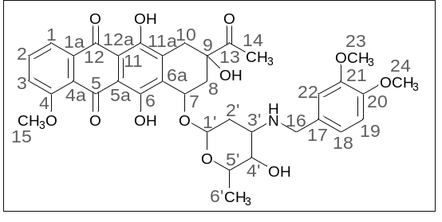
Dark red powder [3] (0.17 g, 56%); mp: (decomp.) > 200°C; IR (KBr, cm⁻¹): 3469brm (OH), 2968m, 2935m and 2837m (three CH), 2251vw, 1717m (C=O), 1617s and 1578s (both C=C), 1516s, 1446s and 1415s (both OH), 1378m, 1352m, 1286vs, 1263s, 1234s, 1209s (C–O), 1124s, 1083m, 1069m, 1032s, 988vs (C=C), 948m, 875m, 813m, 764m, 729w, 465w; ¹H NMR (400 MHz; CDCl₃; Me₄Si): δ 14.02 (s, 1H, C⁶OH), 13.35 (s, 1H, C¹¹OH), 8.07 (d, 1H, ³J_{HH} = 7.8, C¹H), 7.82 (t, 1H, ³J_{HH} = 8.0, C²H), 7.42 (d, 1H, ³J_{HH} = 8.0, C³H), 6.81 (br. s, 3H, C²²H, C¹⁸H, C¹⁹H), 5.55 (br. s, 1H, OH), 5.34 (br. s, 1H, C^{1'}H), 4.73 (br. s, 1H, OH), 4.11 (br. s, 5H, C¹⁵H₃, C^{5'}H, C⁷H), 3.86 (br. s, 6H, C²³H₃, C²⁴H₃), 3.78 and 3.64 (d, both 1H, ²J_{HH} = 12.4, C¹⁶H₂), 3.69 (br. s, 1H, C^{4'}H), 3.27 and 3.02 (d, both 1H, ²J_{HH} = 19.1, C¹⁰H₂), 3.02–2.98 (br. s, 1H, C^{3'}H), 2.45 (s, 3H, C¹⁴H₃), 2.40 and 2.13 (d, both 1H, ²J_{HH} = 15.2, C⁸H₂), 1.83 (dt, 1H, ²J_{HH} = 13.1, ³J_{HH} = 4.2, C^{2’}H_{eq}), 1.70 (dd, 1H, ²J_{HH} = 13.3, ³J_{HH} = 4.8, C^{2’}H_{ax}), 1.41 (d, 3H, ³J_{HH} = 5.6, C^{6'}H₃) ppm; ¹³C{¹H} NMR (100 MHz; CDCl₃; Me₄Si): δ 211.67 (C¹³), 186.81, 186.43 (C⁵, C¹²), 160.85 (C⁴), 156.27, 155.67 (C⁶, C¹¹), 148.84, 148.06 (C²⁰, C²¹), 135.57 (C²), 135.29 (C^{1a}), 134.26, 134.12 (C^{6a}, C^{11a}), 132.02 (C¹⁷), 120.66 (C^{4a}), 120.62, 120,06 (C¹, C³), 118.24 (C¹⁸), 111.19, 111.13 (C^{5a}, C^{12a}), 111.04, 110.94 (C¹⁹, C²²), 100.83 (C^{1'}), 76.70 (C⁹), 69.72 (C⁷), 66.72, 66.47 (C^{4'}, C^{5'}), 56.51 (C¹⁵), 55.74, 55.66 (C²³, C²⁴), 52.39 (C^{3'}), 50.14 (C¹⁶), 34.73, 33.15, 30.17 (C⁸, C¹⁰, C^{2'}), 24.65 (C¹⁴), 16.97 (C^{6'}) ppm; HPLC-MS (DUIS) m/z 678.50 ([M + H]⁺, 94%), 1355.80 ([2M + H]⁺, 7%); Retention time = 4.98.

(8S,10S)-8-Acetyl-6,8,11-trihydroxy-10-([(2R,4S,5S,6S)-5-hydroxy-6-methyl-4-((2,5-dimethoxybenzyl)amino)tetrahydro-2H-pyran-2-yl]oxy)-1-methoxy-7,8,9,10-tetrahydrotetracene-5,12-dione (4g).
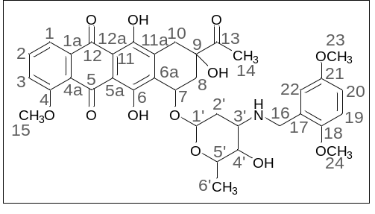
Dark red powder [3] (0.15 g, 47%); mp: (decomp.) > 200°C; IR (KBr, cm⁻¹): 3475brm (OH), 2935m and 2836m (both CH), 1717m (C=O), 1618s and 1579s (both C=C), 1500s, 1445s and 1414s (both OH), 1379m, 1352m, 1286vs, 1230s, 1210s (C–O), 1122s, 1084m, 1069m, 1034s, 987vw (C=C), 874m, 796m, 763w, 464w; ¹H NMR (400 MHz; CDCl₃; Me₄Si): δ 13.95 (br. s, 2H, C⁶OH, C¹¹OH), 8.01 (d, 1H, ³J_{HH} = 7.8, C¹H), 7.89 (t, 1H, ³J_{HH} = 8.0, C²H), 7.40 (d, 1H, ³J_{HH} = 8.0, C³H), 6.80–6.72 (m, 3H, C¹⁹H, C²⁰H, C²²H), 5.52 (br. s, 1H, OH), 5.27 (br. s, 1H, C^{1'}H), 4.69 (br. s, 1H, OH), 4.09 (br. s, 5H, C¹⁵H₃, C^{5'}H, C⁷H), 3.80–3.67 (m, 3H, C¹⁶H₂, C^{4'}H), 3.74 and 3.71 (s, both 3H, C²³H₃, C²⁴H₃), 3.20 and 2.92 (d, both 1H, ²J_{HH} = 19.0, C¹⁰H₂), 2.99(br. s, 1H, C^{3'}H), 2.44 (s, 3H, C¹⁴H₃), 2.37 and 2.14 (d, both 1H, ²J_{HH} = 15.0, C⁸H₂), 1.88–1.80 and 1.69–1.66 (m, both 1H, C^{2'}H₂), 1.41 (d, 3H, ³J_{HH} = 5.6, C^{6'}H₃) ppm; ¹³C{¹H} NMR (100 MHz; CDCl₃; Me₄Si): δ 211.77 (C¹³), 186.52, 186.19 (C⁵, C¹²), 160.73 (C⁴), 156.16, 155.49 (C⁶, C¹¹), 153.22, 151.47 (C¹⁸, C²¹), 135.44 (C²), 135.11 (C^{1a}), 134.16, 134.08 (C^{6a}, C^{11a}), 127.71 (C¹⁷), 120.47 (C^{4a}), 119.49, 118,18 (C¹, C³), 115.91 (C²²), 112.65, 111.01 (C¹⁹, C²⁰), 110.97, 110.85 (C^{5a}, C^{12a}), 100.82 (C^{1'}), 76.61 (C⁹), 69.64 (C⁷), 66.43, 66.27 (C^{4'}, C^{5'}), 56.42 (C¹⁵), 55.46 (C²³, C²⁴), 51.71 (C^{3'}), 45.07 (C¹⁶), 34.67, 32.98, 29.88 (C⁸, C¹⁰, C^{2'}), 24.63 (C¹⁴), 16.95 (C^{6'}) ppm; HPLC-MS (DUIS) m/z 678.50 ([M + H]⁺, 61%); Retention time = 5.07.

(8S,10S)-8-Acetyl-6,8,11-trihydroxy-10-([(2R,4S,5S,6S)-5-hydroxy-6-methyl-4-(((3,4,5-trimethoxybenzyl)amino)tetrahydro-2H-pyran-2-yl]oxy)-1-methoxy-7,8,9,10-tetrahydrotetracene-5,12-dione (4h).
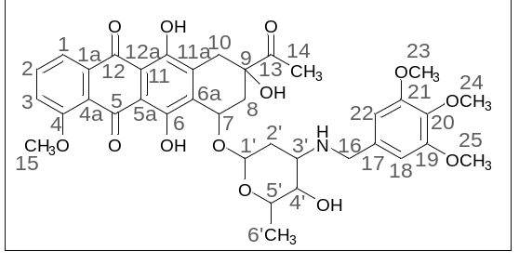
Red powder [3] (0.18 g, 63%); mp: (decomp.) > 200°C; IR (KBr, cm⁻¹): 3481brm (OH), 2969m, 2936m and 2839m (three CH), 1717m (C=O), 1617s and 1588s (both C=C), 1458s, 1447shs and 1416s (both OH), 1379m, 1352m, 1287s, 1233s and 1209s (both C–O), 1127s, 1069m, 1034s, 989vs (C=C), 820m, 793brm, 764m, 464m; ¹H NMR (400 MHz; CDCl₃; Me₄Si): δ 13.90 (br. s, 2H, C⁶OH, C¹¹OH), 7.95 (d, 1H, ³J_{HH} = 7.8, C¹H), 7.75 (t, 1H, ³J_{HH} = 8.0, C²H), 7.37 (d, 1H, ³J_{HH} = 7.8, C³H), 6.47 (br. s, 2H, C¹⁸H, C²²H), 5.50 (br. s, 1H, OH), 5.23 (br. s, 1H, C^{1’}H), 4.61 (br. s, 1H, OH), 4.06 (br. s, 4H, C¹⁵H₃, C^{5’}H), 3.85 (br. s, 2H, C⁷H, C^{4’}H), 3.77 (s, 9H, C²³H₃, C²⁴H₃, C²⁵H₃), 3.71 и 3.62 (d, both 1H, ²J_{HH} = 12.6, C¹⁶H₂), 3.11 and 2.80 (d, both 1H, ²J_{HH} = 18.0, C¹⁰H₂), 3.00–2.95 (m, 1H, C^{3’}H), 2.41 (s, 3H, C¹⁴H₃), 2.35 and 2.10 (dd, both 1H, ²J_{HH} = 12.0, ³J_{HH} = 4.2, C⁸H₂), 1.84 (dt, 1H, ²J_{HH} = 13.2, ³J_{HH} = 4.0, C^{2’}H_{eq}), 1.74 (dd, 1H, ²J_{HH} = 12.9, ³J_{HH} = 4.9, C^{2’}H_{ax}), 1.37 (d, 3H, ³J_{HH} = 6.5, C^{6’}H₃) ppm; ¹³C{¹H} NMR (100 MHz; CDCl₃; Me₄Si): δ 211.63 (C¹³), 186.67, 186.30 (C⁵, C¹²), 160.83 (C⁴), 156.22, 155.56 (C⁶, C¹¹), 153.15 (C²⁰), 135.60 (C²), 135.19 (C^{1a}), 134.69 (C¹⁹, C²¹), 134.24 (C^{6a}, C^{11a}), 134.10 (C¹⁷), 120.54 (C^{4a}), 119.62, 118,32 (C¹, C³), 111.12, 110.97 (C^{5a}, C^{12a}), 104.99 (C¹⁸, C²²), 100.84 (C^{1’}), 76.66 (C⁹), 69.80, 66.88, 66.63 (C⁷, C^{4’}, C^{5’}), 60.55 (C¹⁵), 56.50 (C²⁴), 55.90 (C²³, C²⁵), 52.49 (C^{3’}), 50.49 (C¹⁶), 34.71, 33.09, 30.04 (C⁸, C¹⁰, C^{2’}), 24.63 (C¹⁴), 17.00 (C^{6’}) ppm; HPLC-MS (DUIS) m/z 708.45 ([M + H]⁺, 53%); Retention time = 5.20.

X-ray diffraction data
A saturated solution of anthracycline derivative 4d was prepared in a mixture of toluene: acetone = 1:2. A five-fold volume of MTBE, saturated with hydrogen chloride, was added to the red solution filtered into a test tube without mixing. The tube was loosely sealed and kept at room temperature for 2 weeks until cubic single crystals formed.
Using Olex2 [4], the structures were solved with the ShelXT [5] structure solution program using Intrinsic Phasing and refined with the XL refinement package [6] using Least Squares minimization against F² in anisotropic approximation for non-hydrogen atoms.
Hydrogen atoms of NH and OH groups were found in the difference Fourier synthesis while the positions of other hydrogen atoms were calculated, and they all were refined in the isotropic approximation within the riding model. Crystal data and structure refinement parameters are given in Table 1. CCDC 2174639 contain the supplementary crystallographic data for of 4d.
Table 1. Crystal data and structure refinement parameters for 4d.
Parameter | 4d
Formula unit | C_{40.12}H_{48.66}ClNO_{14.12}
Formula weight | 806.41
Temperature, K | 100
Crystal system | Orthorhombic
Space group | P2₁2₁2₁
Z | 8
a, Å | 12.5828(5)
b, Å | 25.1898(9)
c, Å | 25.4948(10)
α, ° | 90
β, ° | 90
γ, ° | 90
V, Å³ | 8080.8(5)
D_{calc} (g cm⁻³) | 1.326
Linear absorption, μ (cm⁻¹) | 1.63
F(000) | 3411
2Θ_{max}, ° | 50
Reflections measured | 110069
Independent reflections | 14209
Observed reflections [I > 2σ(I)] | 12122
Parameters | 1128
R1 | 0.0453
wR2 | 0.1196
GOF | 1.073
Δρ_{max}/Δρ_{min} (e Å⁻³) | 0.671 / -0.345

Molecular docking
The structure of the self-complementary DNA duplex (ACGTACGT)₂ was obtained from the Protein Data Bank (PDB: 1AL9) [7]. The ligand structures were converted to 3D and preoptimized in the MMFF94 force field using Avogadro 1.2.0 software, [8] and then the ligand and DNA structures (upon removal of the bound bis-daunorubicin ligand) were prepared for molecular docking using AutoDock Tools 1.5.6. [9] Molecular docking into the intercalator binding sites was performed with AutoDock Vina 1.1.2 software [10] (grid box size 18 Å × 18 Å × 19.5 Å, exhaustiveness = 16) or (if necessary) manually using the USCF Chimera 1.15 software. [11] The unmodified daunorubicin molecule was docked into one of the symmetrical binding sites with the sugar residue oriented outwards the double helix. This allowed to stabilize the complex structure and avoid potential artifacts caused by the interaction between the ligands bound in the two sites. The compounds under study (DRB - daunorubicin, 4a, 4c, 4d, 4e, 4f) were then docked into the second binding site in the approximately correct pose. The poses with the best scoring function values and ligand positions were selected and the complex model was built using the USCF Chimera 1.15 software.
The molecular dynamics simulations were performed using the CHARMM36 / CGenFF 4.4 force field [12, 13] in the GROMACS 2021.2 software. [14] The initial models of the systems were built using the Ligand Reader & Modeler and Solution Builder modules of the CHARMM-GUI web service. [15, 16] The protein molecule was inserted into a rectangular periodic boundary box of water in the TIP3P model; the distance from the protein to the box border was no less than 10 Å. Individual randomly selected water molecules were replaced with potassium and chlorine ions to ensure electrical neutrality of the system and the total concentration of KCl about 0.15 M. For each system, the molecular mechanics minimization (up to 5000 steps) was performed on the CPU, followed by equilibration for 125 ps with integration timestep of 1 fs at the temperature of 300 K and constant volume using the v-rescale thermostat on the NVIDIA GeForce RTX 3080 GPU. The production simulation was performed on the GPU with integration timestep of 2 fs at the temperature of 300 K and the constant pressure of 1 atm using the v-rescale thermostat and the Parrinello–Rahman barostat. The hydrogen atom movements were constrained using the LINCS algorithm. In addition, the flat-bottom potential restraints were imposed on the distances between the terminal base pairs to prevent duplex unwinding due to the edge effects. For the analysis and visualization of the results, the cpptraj software [17] in the AmberTools 21 package [18] and UCSF Chimera were used.
The plots of the root mean square deviations (RMSD) of the DNA and ligand non-hydrogen atoms (Fig. 1) as well as the visual inspection of the trajectories confirm that the stability of the systems and the basic binding mode of the ligands are retained throughout the entire course of the production simulation (200 ns).

DRB | RMSD, Å  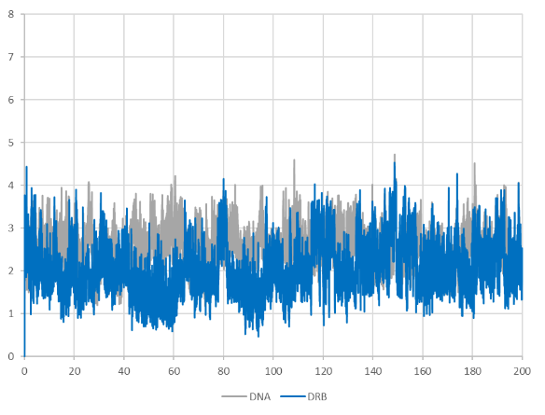 | 4a | RMSD, Å  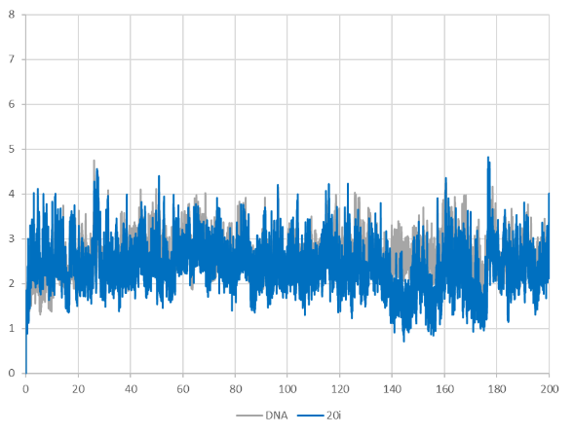
4e | 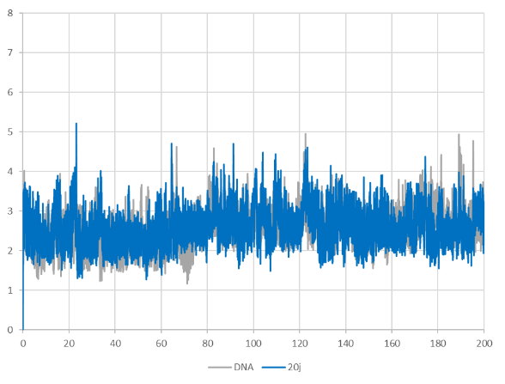 | 4d | 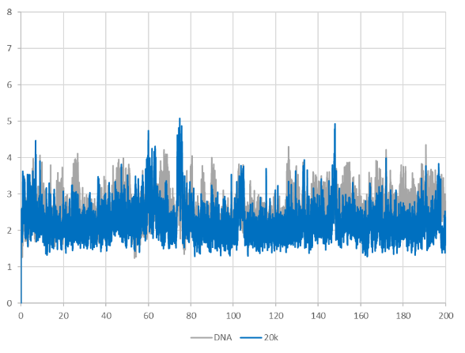
4f | 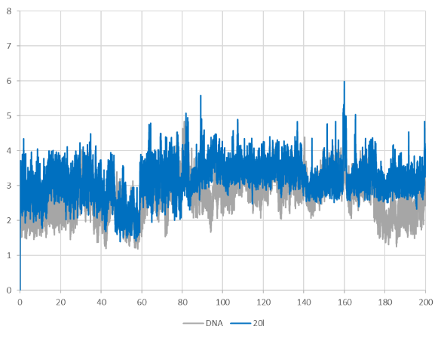  Time, ns | 4c | 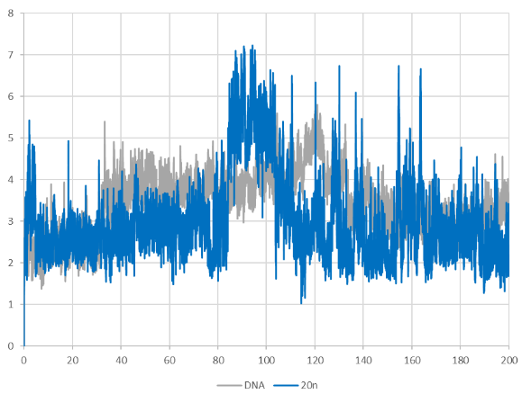  Time, ns
Figure 1. RMSD of the DNA and ligand non-hydrogen atoms during molecular dynamics simulation of their complexes.

Determination of cytotoxicity
Cell lines were provided by the Institute of Cytology, Russian Academy of Sciences (St. Petersburg, Russia). Human cell cultures A549 (ATCC® CCL-185 ™), RD (ATCC® CC-136 ™), HCT116 (ATCC® CCL-247 ™) and HEK293 (ATCC® CRL-1573 ™) are grown in DMEM (NLP PanEko), cell culture MCF7 (ATCC® HTB-22 ™) was grown in EMEM (NLP PanEko), cell culture Jurkat (ATCC® HIB-152 ™) was grown in RPMI-1640 (NLP PanEko). In growth medium 10% fetal calf serum (HyClone®, Thermo Scientific), 2 mmol L-glutamine (NLP PanEco), 1% gentamicin (JSC Biochemist) were added as antibiotic and incubated at 37 °C in an atmosphere of 5% CO₂ and 95% air.
Cytotoxicity of the compounds was determined by the MTT test method [19]. Cells A549, RD, HCT116, MCF7 and HEK293 were seeded in a 96-well plate (Costar®) in an amount of 1 × 10⁴ cells / 200 μl and cultured at 37 °C in a humid environment containing 5% CO₂. After 24 hours of incubation, solutions of different concentrations (from 100 to 0.0012 μM) were added to the cell culture and then the cells were cultured under the same conditions for 72 hours. For each concentration, the experiments were performed in triplicate. All compounds were dissolved in DMSO (PANREAC QUIMICA S.L.U). The final concentration of DMSO in the well did not exceed 0.1% and was not toxic to the cells. The control wells were added to the solvent in an amount of 0.1%. After incubation, 20 μl of a solution of 5 mg/ml of MTT [bromide 3-(4,5-dimethylthiazol-2-yl)-2,5-diphenyltetrazolium] (Sigma Aldrich) in PBS (Phosphate Buffered Saline) and additionally incubated for 2 hours. Then the medium was removed and 100 μL DMSO was added to each well to dissolve formed formazan crystals. Using a BioTek Instruments Cytation 3 Imager plate analyzer, the optical density at 536 nm was determined. The concentration value, which causes a 50% inhibition of cell population growth (IC₅₀), was estimated on the basis of dose-dependent curves using the software GraphPad Prism 7 software.
Cytotoxicity of the compounds 4e and 4f was determined by the Alamar Blue test [20]. The Jurkat cells were seeded in a 96-well plates in a concentration of 7 × 10⁴ cells/200 μL. The tested compounds (10–0.0012 μM) were added into each well, and these cells were incubated under similar conditions for 72 h. The experiments were carried out in triplicate. All the substances were dissolved in DMSO. The final DMSO concentration in one well was less than or equal to 0.1% and was nontoxic for the cells. The solvent in the final concentration of 0.1% was added to the control wells. After the incubation with the compounds, resazurin (7-hydroxy-3H-phenoxazine-3-on-10-oxide sodium salt, 22 μL per one well) (Sigma-Aldrich) with the final concentration of 50 μM was added to each well. The plates were incubated for 2 h. The fluorescence of the reduced dye was determined using the Cytation3 (BioTek Instruments, Inc) microplate reader at the excitation at 530 nm and emission at 590 nm. The concentration that caused the 50% inhibition of the growth of the cell population (IC₅₀) was determined from the dose-dependent curves using the software GraphPad Prism 7 software.

Determination of the influence on the cell cycle
Evaluation of the effect on the cell cycle was determined using flow cytometry by measuring the DNA content. The cells were seeded in a 12-well plate (0,5x10⁶ cells in 1000 μl) and solutions of the test compounds were added (final concentrations are shown in the Results and discussion), then incubated for 24, 48 and 72 hours. Cell material was prepared according to the reagent manufacturer's instructions, cells were fixed with cold ethanol (70%) for 15 minutes and washed with PBS. It was then analyzed with an Attune NxT Acoustic Focusing Cytometer (Thermo Fisher Scientific, USA) using a 405 nm laser with a 440/50 bandpass filter, after reaching 50,000 events with a standard flow rate of 12.5 μL/min.

Figure 2. The histograms show that when incubated with daunorubicin for 24 and 48 hours, the effect of accumulation of cells in the G2/M phase of the cell cycle is detected, and after 72 hours the effect of the compound was established in all phases of the cell cycle. However, derivatives 4e and 4f do not show any effect either 24 hours after incubation or even 72 hours, but a slight effect on the G0/G1 phase is visible (the percentage of cells is higher than in the control).

Figure 3. Since no effect of the compounds on different phases of the cell cycle was detected at a dose comparable to the IC₅₀, it was suggested to use a higher dose (to determine whether there is any effect on the cell cycle). The compounds were tested at a dose of 0.2 μM with 24 hours of incubation. The histogram shows that daunorubicin affects all phases of the cell cycle after 24 hours of incubation, and the distribution of cells relative to the phases of the cell cycle when treated with compounds 4e and 4f, even at a higher dose, is comparable to the control.

Figure 4. Histograms of the Jurkat cell line showing the distribution of DNA content after exposure to the compounds after 24, 48 and 72 hours. In contrast to daunorubicin, which induces cell cycle arrest in the G2/M phase, compounds 4e and 4f causes cell accumulation in the G0/G1 phase, which needs to be clarified in further studies.

Determination of the influence on apoptosis
Flow cytometry was used to detect apoptosis in cells. The externalization of phosphatidylserine was assessed using the annexin V test, and the SYTOX Blue dye was used to determine the necrotic population. The cells were seeded in a 12-well plate (0,5x106 cells in 1000 μl), solutions of the test compounds were added (final concentrations are shown in the Results and discussion) and incubated for 24, 48 and 72 hours. Samples were prepared according to the reagent manufacturer's instructions and then analyzed with an Attune NxT Acoustic Focusing Cytometer using 638 and 405 nm lasers with 670/14 and 440/50 band pass filters, respectively, after reaching 50,000 events at standard rate flow rate 100 μL/min.

Figure 5. Methods to induce apoptosis in the extent of phosphatidylserine externalization and preparation of the cell plasma membrane were also evaluated in Jurkat cell lines. There are histograms of the percentage of different cell populations, where: V - viable cells, A - cells undergoing apoptosis, N - necrotic cells. From the data presented in the histograms it is clear that when cells are treated with daunorubicin, the number of defective, apoptotic and necrotic cells increases over time, but not sharply. The initiation of apoptosis occurs as a result of the interruption of the cell in the G2/M phase of the cell cycle and later the main cytostatic effect appears (cells cannot proliferate and the genetic material is gradually degraded, which leads to the loss of genetic material). Derivatives 4e and 4f, as in the case of the cell cycle, did not show any shifting effects with daunorubicin and were close to the control in percentage of cell populations.

Figure 6. To assess the effect on apoptotic cell death, compounds were also used at a dose of 0.2 uM during incubation for 24 hours. However, in this case, the derivatives did not show effects comparable to daunorubicin.

Determination of the acute toxicity
The acute toxicity of compounds 4e and 4f was determined by the method of V.B. Prozorovsky in CD-1 white male mice weighing 22-24 g using the intraperitoneal route of administration [21].

References
1. I. González-Méndez, R. Aguayo-Ortiz, K. Sorroza-Martínez, J. D. Solano, P. Porcu, E. Rivera and L. Dominguez, Bioorg. Med. Chem., 2020, 28, 115510.
2. A. M. Tsedilin, A. N. Fakhrutdinov, D. B. Eremin, S. S. Zalesskiy, A. O. Chizhov, N. G. Kolotyrkina and V. P. Ananikov, Mend. Comm., 2015, 25, 454—456.
3. O. I. Artyushin, E. V. Sharova, N. M. Vinogradova, G. K. Genkina, A. A. Moiseeva, A. A. Khodak and V. K. Brel, Russ. J. Gen. Chem., 2017, 87, 1323–1326.
4. O. V. Dolomanov, L. J. Bourhis, R. J. Gildea, J. a. K. Howard and H. Puschmann, J. Appl. Cryst., 2009, 42, 339–341.
5. G. M. Sheldrick, Acta Crystallogr. A, 2015, 71, 3–8.
6. G. M. Sheldrick, Acta Crystallogr. A, 2008, 64, 112–122.
7. H. Robinson, W. Priebe, J. B. Chaires and A. H. Wang, Biochemistry 1997, 36, 8663–8670.
8. M. D. Hanwell, D. E. Curtis, D. C. Lonie, T. Vandermeersch, E. Zurek and G. R. Hutchison, J. Cheminform., 2012, 4, 17.
9. G. M. Morris, R. Huey, W. Lindstrom, M. F. Sanner, R. K. Belew, D. S. Goodsell and A. J. Olson, J. Comput. Chem., 2009, 30, 2785–2791.
10. O. Trott and A. J. Olson, J. Comput. Chem., 2010, 31, 455–461.
11. E. F. Pettersen, T. D. Goddard, C. C. Huang, G. S. Couch, D. M. Greenblatt, E. C. Meng and T. E. Ferrin, J. Comput. Chem., 2004, 25, 1605–1612.
12. K. Vanommeslaeghe, E. Hatcher, C. Acharya, S. Kundu, S. Zhong, J. Shim, E. Darian, O. Guvench, P. Lopes, I. Vorobyov and A. D. M. Jr., J. Comput. Chem., 2010, 31, 671–690.
13. J. Huang and A. D. MacKerell, J. Comput. Chem., 2013, 34, 2135–2145.
14. M. J. Abraham, T. Murtola, R. Schulz, S. Páll, J. C. Smith, B. Hess and E. Lindahl, SoftwareX, 2015, 1–2, 19–25.
15. S. Jo, T. Kim, V. G. Iyer and W. Im, J. Comput. Chem., 2008, 29, 1859–1865.
16. J. Lee, X. Cheng, J. M. Swails, M. S. Yeom, P. K. Eastman, J. A. Lemkul, S. Wei, J. Buckner, J. C. Jeong, Y. Qi, S. Jo, V. S. Pande, D. A. Case, C. L. B. III, A. D. M. Jr., J. B. Klauda and W. Im, J. Chem. Theory Comput., 2016, 12, 405–413.
17. D. R. Roe and T. E. Cheatham, J. Chem. Theory Comput., 2013, 9, 3084–3095.
18. R. Salomon-Ferrer, D. A. Case and R. C. Walker, WIREs Comput. Mol. Sci., 2013, 3, 198–210.
19. T. Mosmann, J. Immunol. Methods, 1983, 65, 55–63.
20. J. O’Brien, I. Wilson, T. Orton and F. Pognan, Eur. J. Biochem., 2000, 267, 5421–5426.
21. V. B. Prozorovsky, M. P. Prozorovskaya and V. M. Demchenko, Pharmacol. and toxicol., 1978, 4, 497-502 [in Russian].

NMR spectra of all compounds
Figure 7. ¹H NMR spectrum of amine 4a (400 MHz, CDCl₃).
Figure 8. ¹³C NMR spectrum of amine 4a (100 MHz, CDCl₃).
Figure 9. ¹H NMR spectrum of amine 4b (400 MHz, CDCl₃).
Figure 10. ¹³C NMR spectrum of amine 4b (100 MHz, CDCl₃).
Figure 11. ¹H NMR spectrum of amine 4c (400 MHz, CDCl₃).
Figure 12. ¹³C NMR spectrum of amine 4c (100 MHz, CDCl₃).
Figure 13. ¹H NMR spectrum of amine 4d (300 MHz, CDCl₃).
Figure 14. ¹³C NMR spectrum of amine 4d (100 MHz, CDCl₃).
Figure 15. ¹H NMR spectrum of amine 4e (400 MHz, CDCl₃).
Figure 16. ¹³C NMR spectrum of amine 4e (100 MHz, CDCl₃).
Figure 17. ¹H NMR spectrum of amine 4f (400 MHz, CDCl₃).
Figure 18. ¹³C NMR spectrum of amine 4f (100 MHz, CDCl₃).
Figure 19. ¹H NMR spectrum of amine 4g (400 MHz, CDCl₃).
Figure 20. ¹³C NMR spectrum of amine 4g (100 MHz, CDCl₃).
Figure 21. ¹H NMR spectrum of amine 4h (400 MHz, CDCl₃).
Figure 22. ¹³C NMR spectrum of amine 4h (100 MHz, CDCl₃).

MS spectra of all compounds
Figure 23. LC-MS spectrum of amine 4a.
Figure 24. HPLC-MS spectrum and chromatogram of amine 4a.
Figure 26. LC-MS spectrum of amine 4b.
Figure 27a. HPLC-MS spectrum and chromatogram of amine 4b.
Figure 27b. HPLC-MS spectra of amine 4b.
Figure 28. HRMS spectrum of amine 4b.
Figure 29. LC-MS spectrum of amine 4c.
Figure 30. HPLC-MS spectrum and chromatogram of amine 4c.
Figure 31. HRMS spectrum of amine 4c.
Figure 32. LC-MS spectrum of amine 4d.
Figure 33. HPLC-MS spectrum and chromatogram of amine 4d.
Figure 34. HRMS spectrum of amine 4d.
Figure 35a. LC-MS spectrum of amine 4e. Here and below the formation of an atypical ion in the mass spectrum was observed. Instead of the usual one [M + H]⁺ under these conditions, the ion shown in the Figure 35b was formed. A similar picture was observed in the MS spectra of 4b, 4c, 4f.

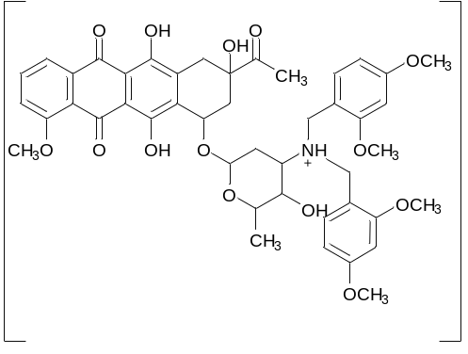
Figure 35b. The previously shown ion [M + R + H]⁺.
Figure 36. HPLC-MS spectrum and chromatogram of amine 4e.
Figure 37. HRMS spectrum of amine 4e.
Figure 38. LC-MS spectrum of amine 4f.
Figure 39. HPLC-MS spectrum and chromatogram of amine 4f.
Figure 40. HRMS spectrum of amine 4f.
Figure 41. LC-MS spectrum of amine 4g.
Figure 42. HPLC-MS spectrum and chromatogram of amine 4g.
Figure 44. LC-MS spectrum of amine 4h.
Figure 45. HPLC-MS spectrum and chromatogram of amine 4h.

IR spectra of all compounds
Figure 46. IR spectrum of amine 4a.
Figure 47. IR spectrum of amine 4b.
Figure 48. IR spectrum of amine 4c.
Figure 49. IR spectrum of amine 4d.
Figure 50. IR spectrum of amine 4e.
Figure 51. IR spectrum of amine 4f.
Figure 52. IR spectrum of amine 4g.
Figure 53. IR spectrum of amine 4h.

