Supplementary Materials
Scalable Glassy X-Ray Scintillators with Bright Singlet-Triplet Hybrid Self-Trapping Excitons

Shi-Yu Song^{1,#}, Chao-Jun Gao^{1,#}, Rui Zhou¹, Bing-Zhe Wang²,Wen-Bo Zhao¹, Qing Cao¹, Yan-Wei Hu¹, Lin Dong¹, Kai-Kai Liu^{1,✉} and Chong-Xin Shan^{1,✉}

¹Henan Key Laboratory of Diamond Optoelectronic Materials and Devices, Key Laboratory of Material Physics Ministry of Education, School of Physics and Microelectronics, Zhengzhou University, Zhengzhou, P. R. China.
² Joint Key Laboratory of the Ministry of Education, Institute of Applied Physics and Materials Engineering, University of Macau, Taipa, Macau SAR 999078, China
#These authors contributed equally to this work.
✉e-mail: liukaikai@zzu.edu.cn; cxshan@zzu.edu.cn.

Contents
Figure S1 The optical performance of the ZnO QD scintillator 3
Figure S2 TEM images of the vitreous QD scintillator in cross-section and top-view 3
Figure S3 ZnO QDs' size distribution 4
Figure S4 Absorption spectrum for the ZnO QDs 4
Figure S5 The theoretical calculation of Rayleigh scattering cross-section (σ) for the ZnO QDs at various wavelengths in water, ethanol, and SiO₂ 5
Figure S6 Photographs of the scintillator from opaque to transparent and by a schematic diagram elucidating the varied scattering effects 5
Figure S7 The surface of the ZnO QD vitreous scintillator captured in the SEM image 6
Figure S8 XRD pattern of the ZnO QD powders and ZnO QD vitreous scintillator 6
Figure S9 SEM images of the ZnO QD vitreous scintillator captured at various formation processes 7
Figure S10 TEM image of the ZnO QD vitreous scintillator 7
Figure S11 Absorbance, PL, and PL excitation spectra of ZnO QDs. Temperature-dependent PL spectra and FWHM emission of ZnO QDs 8
Figure S12 PL QY measurement spectra for the ZnO QD powders and the ZnO QD vitreous scintillator 8
Figure S13 Excitation-Emission Characteristics of the ZnO QD vitreous scintillator 9
Figure S14 Exciton binding energy fitting results of the ZnO QDs 9
Figure S15 The PL spectra of the ZnO QDs under varying laser powers 10
Figure S16 3D time-resolved emission spectra and the PL lifetime changes of the ZnO QDs 10
Figure S17 The analysis results of temperature-dependent PL lifetime for the ZnO QDs 11
Figure S18 Temperature-dependent average lifetimes of the ZnO QDs 11
Figure S19 Global analysis TA spectra of the ZnO QDs 12
Figure S20 Calculated X-ray attenuation efficiencies for BGO, CsI:Tl, and ZnO with varying thicknesses. Also, absorption spectra of ZnO, Zn, Si, and O concerning X-ray energy 13
Figure S21 Simulated light intensity and measured light intensity in different directions at the same X-ray dose rate 13
Figure S22 RL stability of the ZnO QD vitreous scintillator 14
Figure S23 Cost/price comparison of the ZnO QD and other scintillators 14
Figure S24 Digital photograph and corresponding X-ray images using the ZnO QD scintillator 15

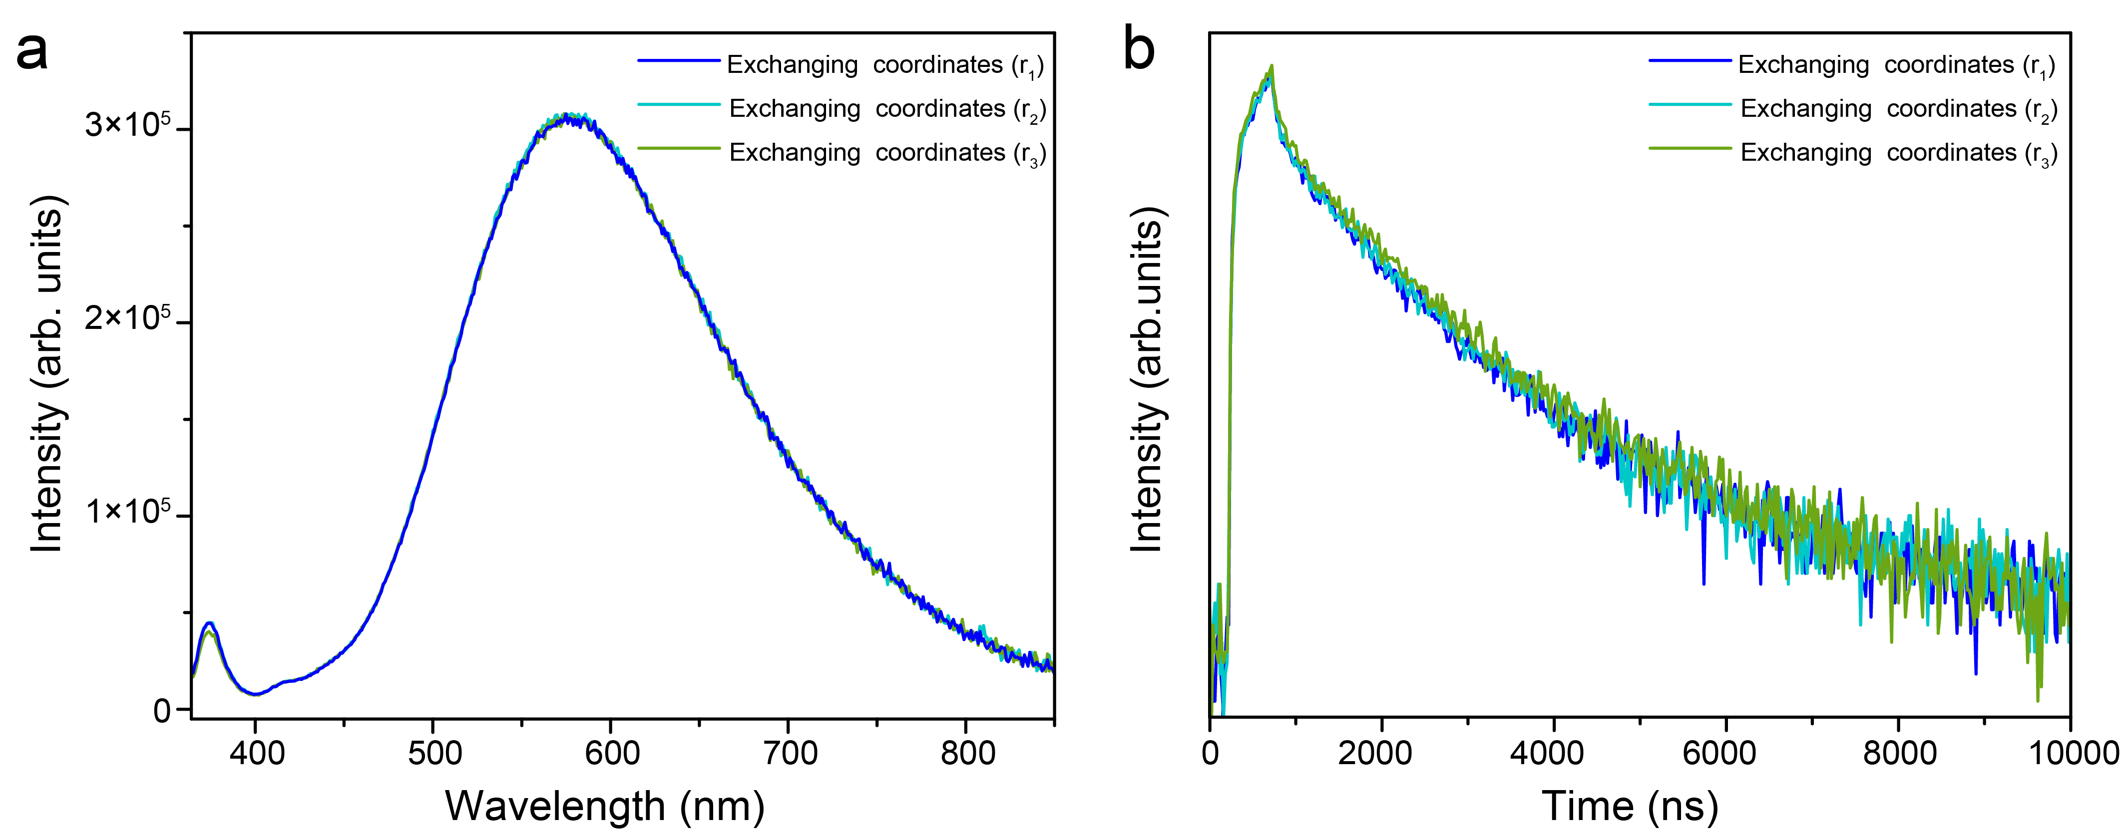

Figure S1. (a) PL and (b) PL lifetime decay spectra of the ZnO QD scintillator after exchanging their coordinates (r).

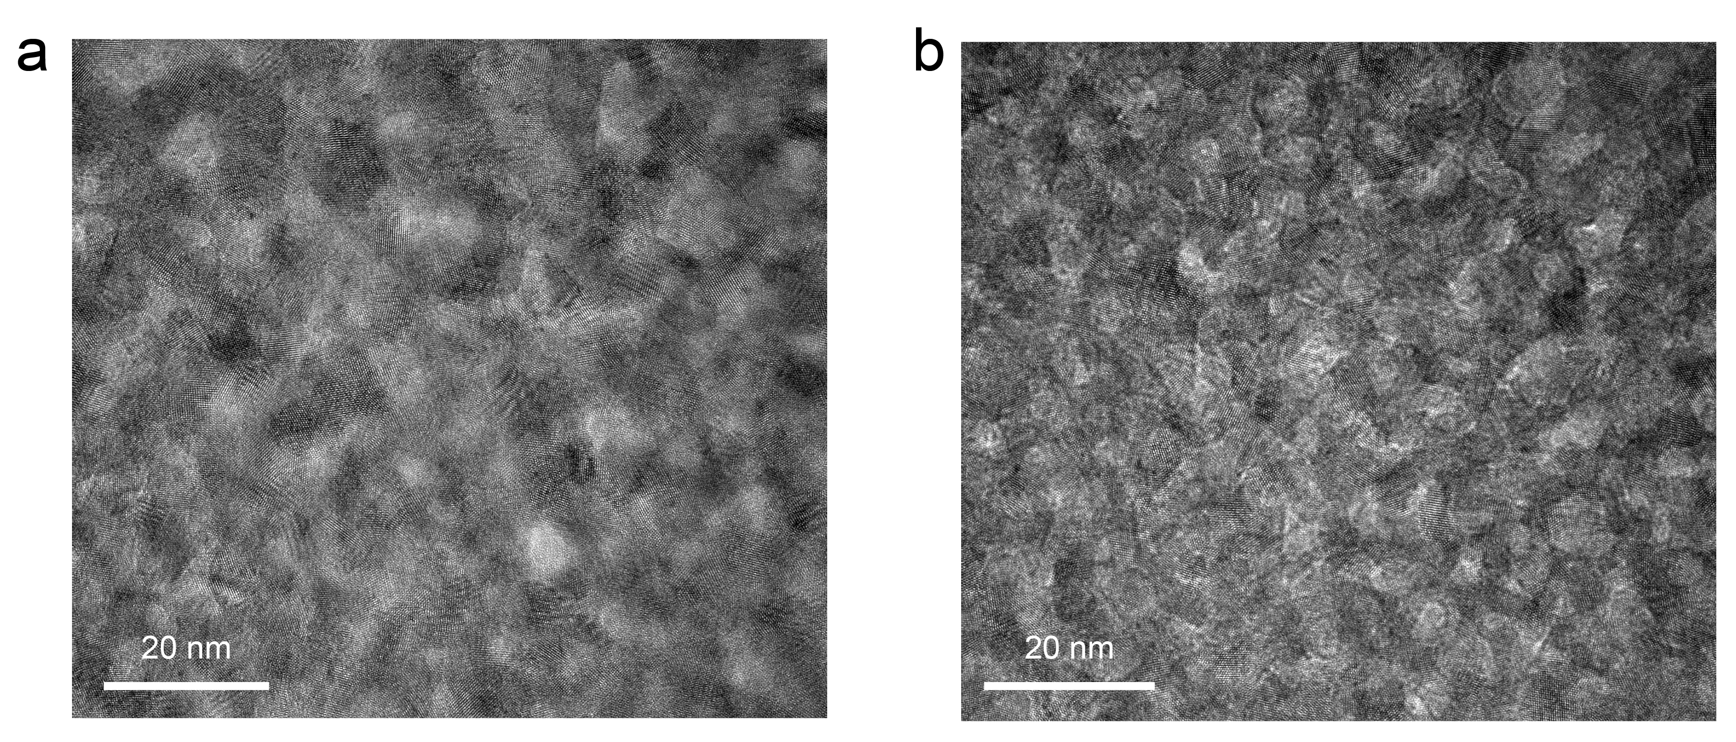

Figure S2. (a) The cross-section and (b) top-view TEM images of the vitreous QD scintillator.

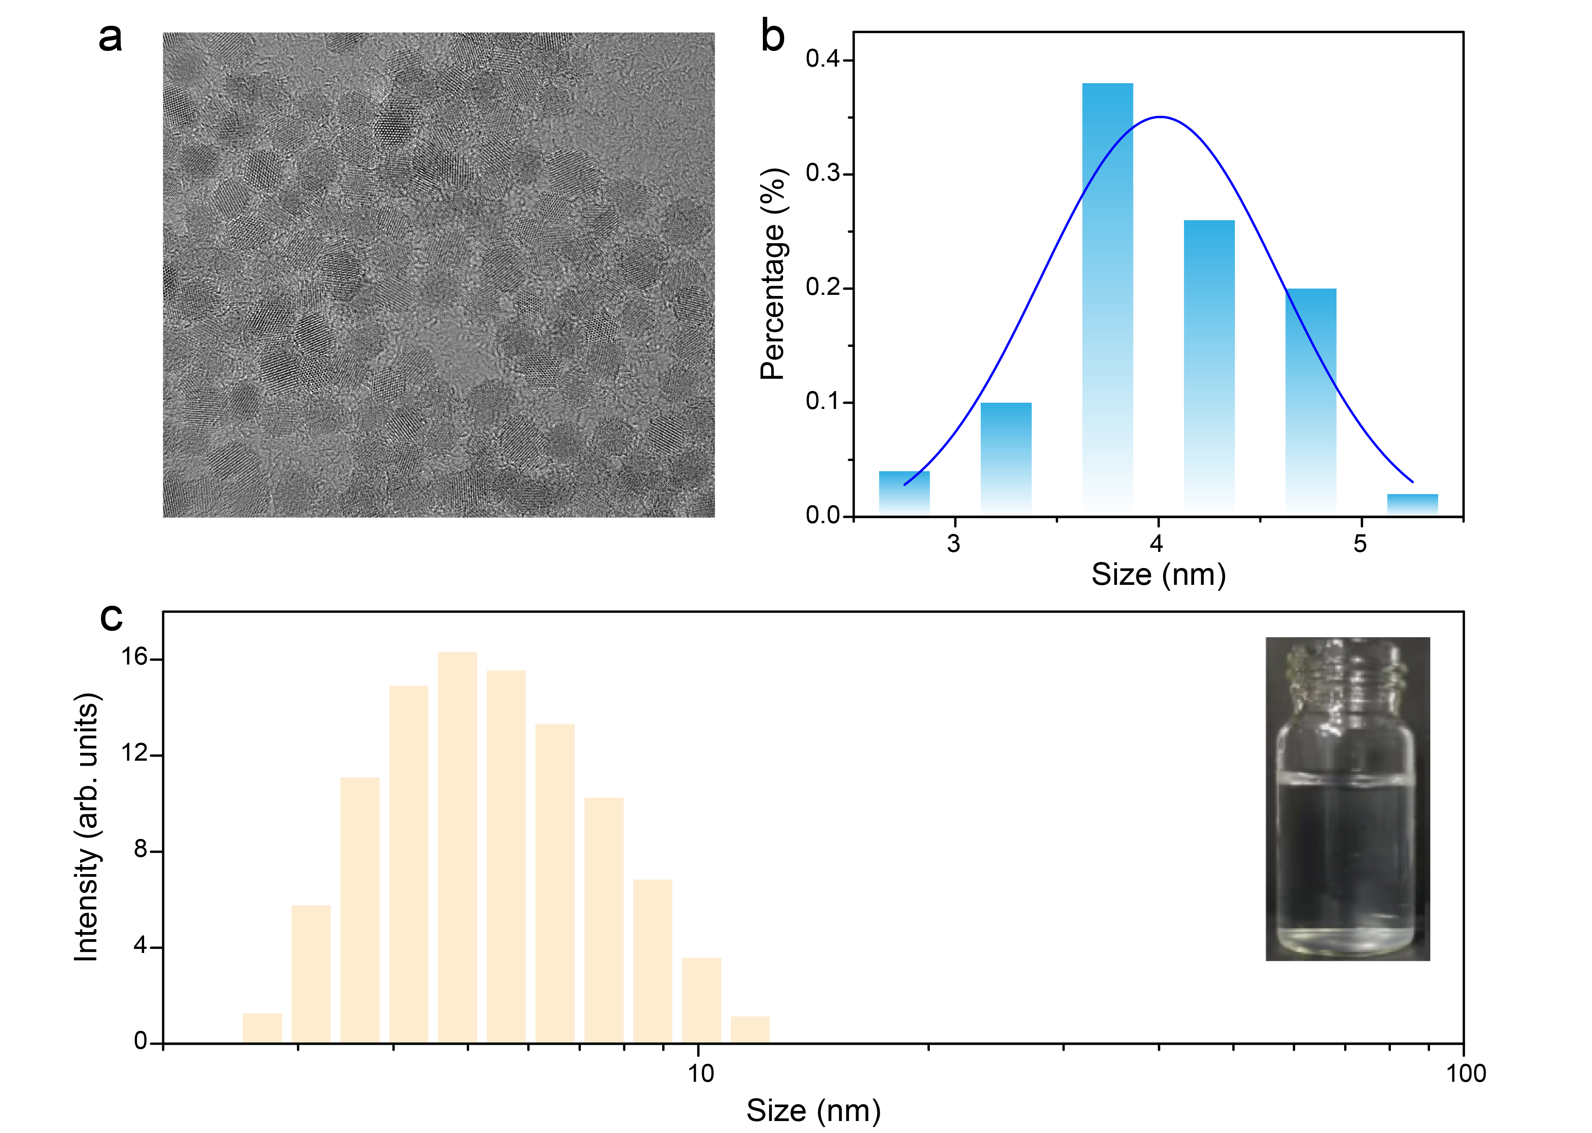

Figure S3. (a) TEM image and (b) the size distribution of the ZnO QDs. (c) The size distribution of the ZnO QDs monitored by dynamic light scattering.

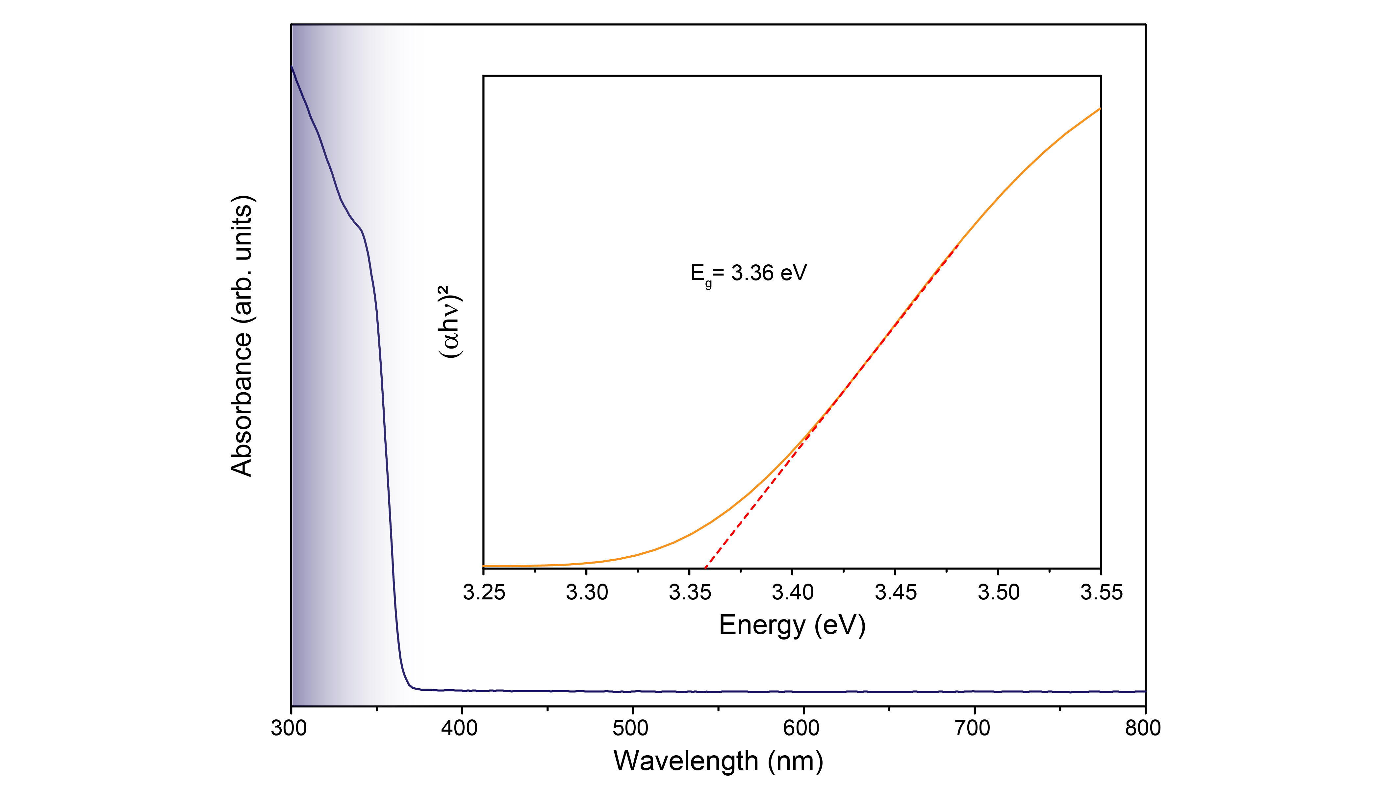

Figure S4. Absorption spectrum for the ZnO QDs, the insert shows the band gap of the ZnO QDs.

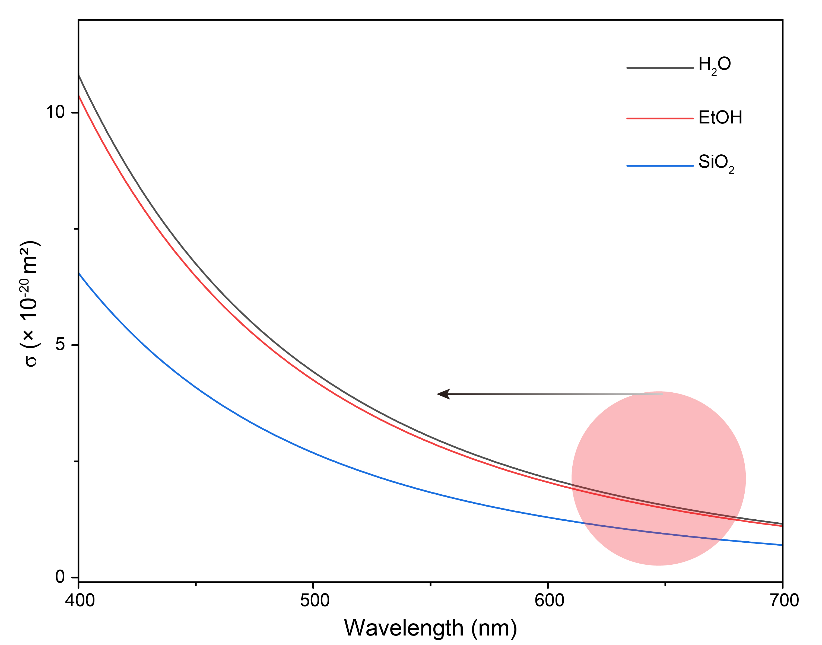

Figure S5. Calculated Rayleigh scattering cross-section (σ) of the ZnO QDs versus wavelength, in water, ethyl alcohol and SiO₂ matrix.

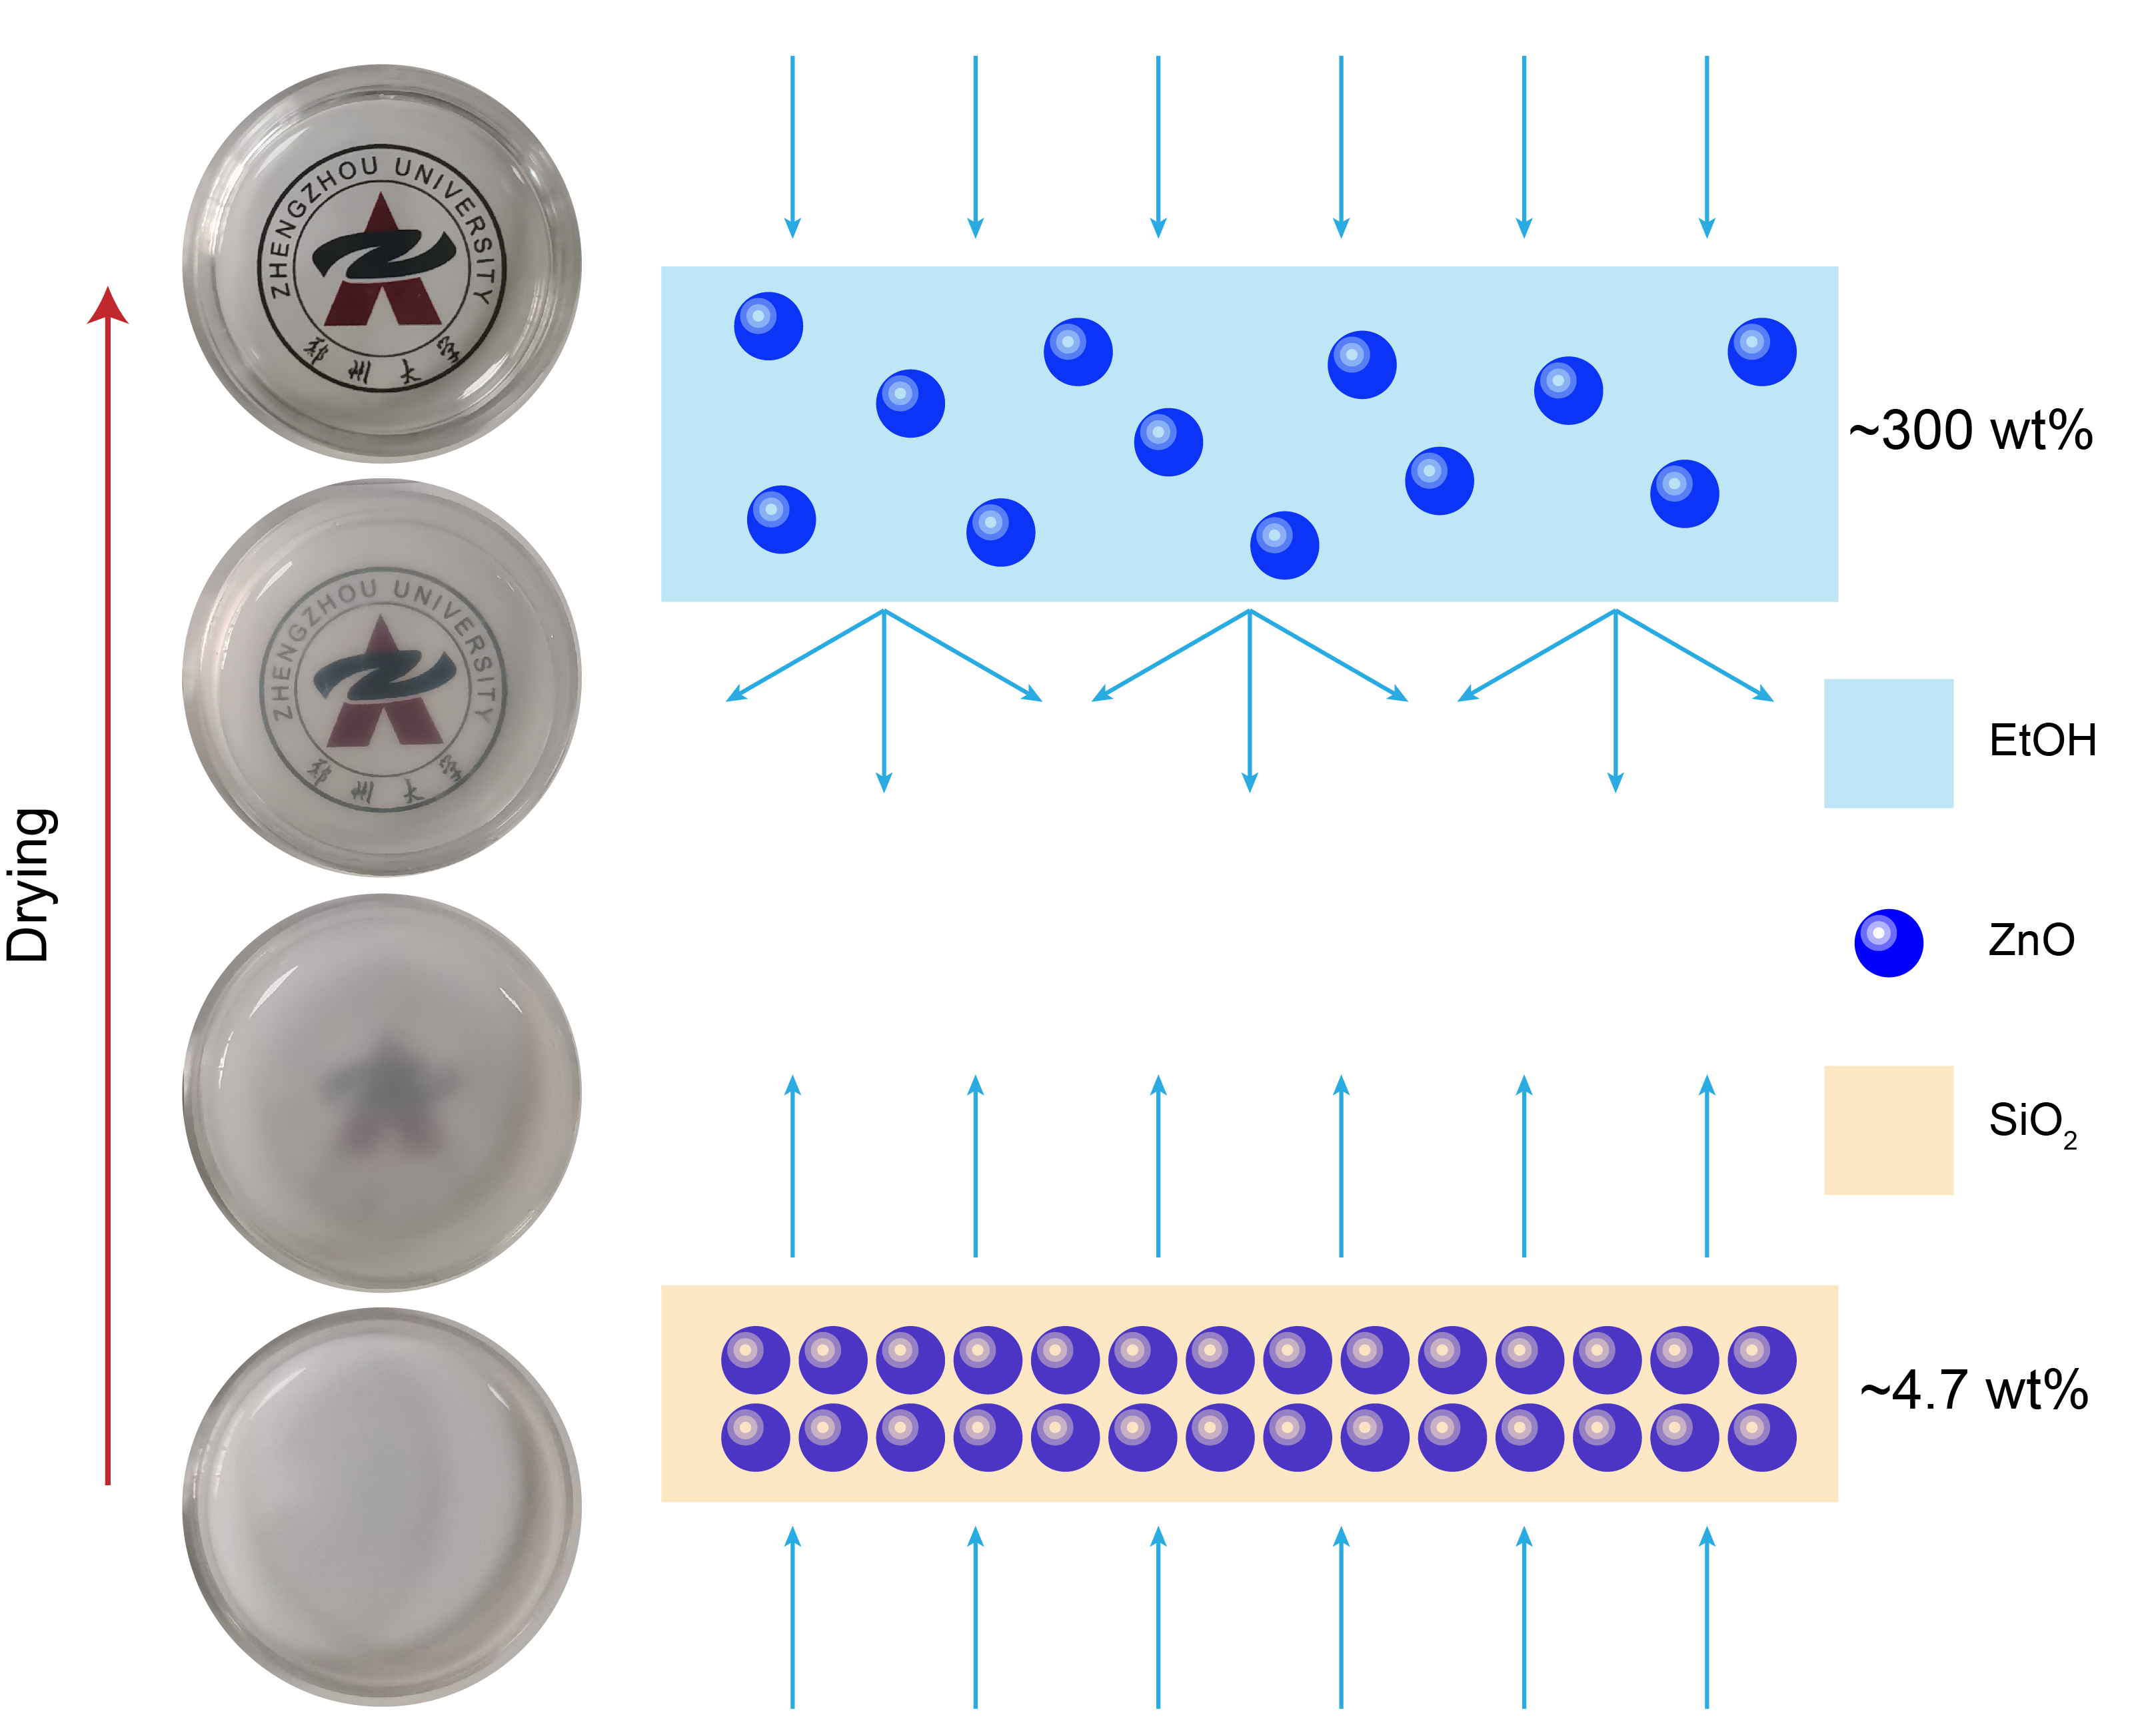

Figure S6. Photographs of the scintillator from opaque-to-transparent (left), and the schematic diagram (right) of the varied scattering effect from two interfaces: EtOH/QDs and SiO₂/ QDs.

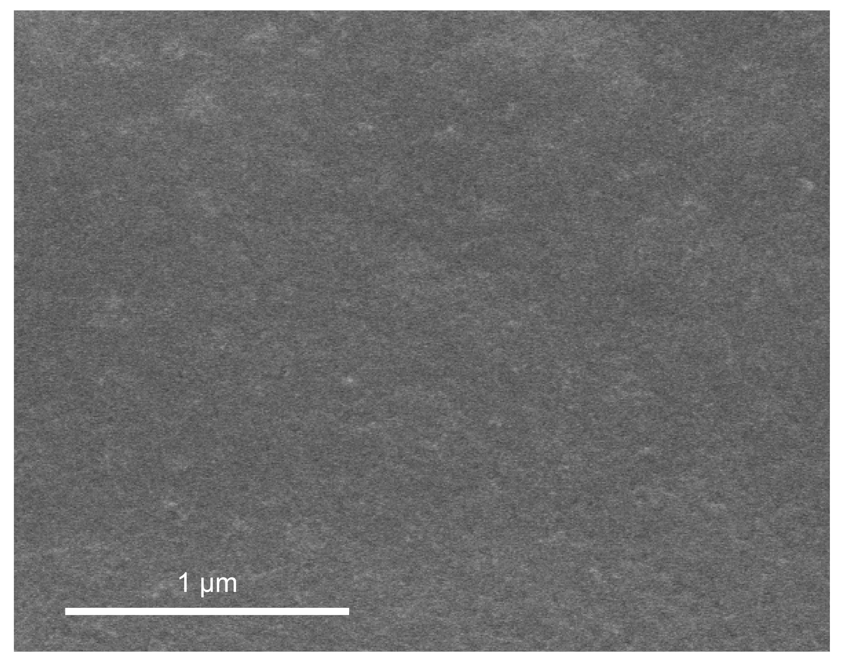

Figure S7. Top-view scanning electron microscopy (SEM) image of the ZnO QD vitreous scintillator.

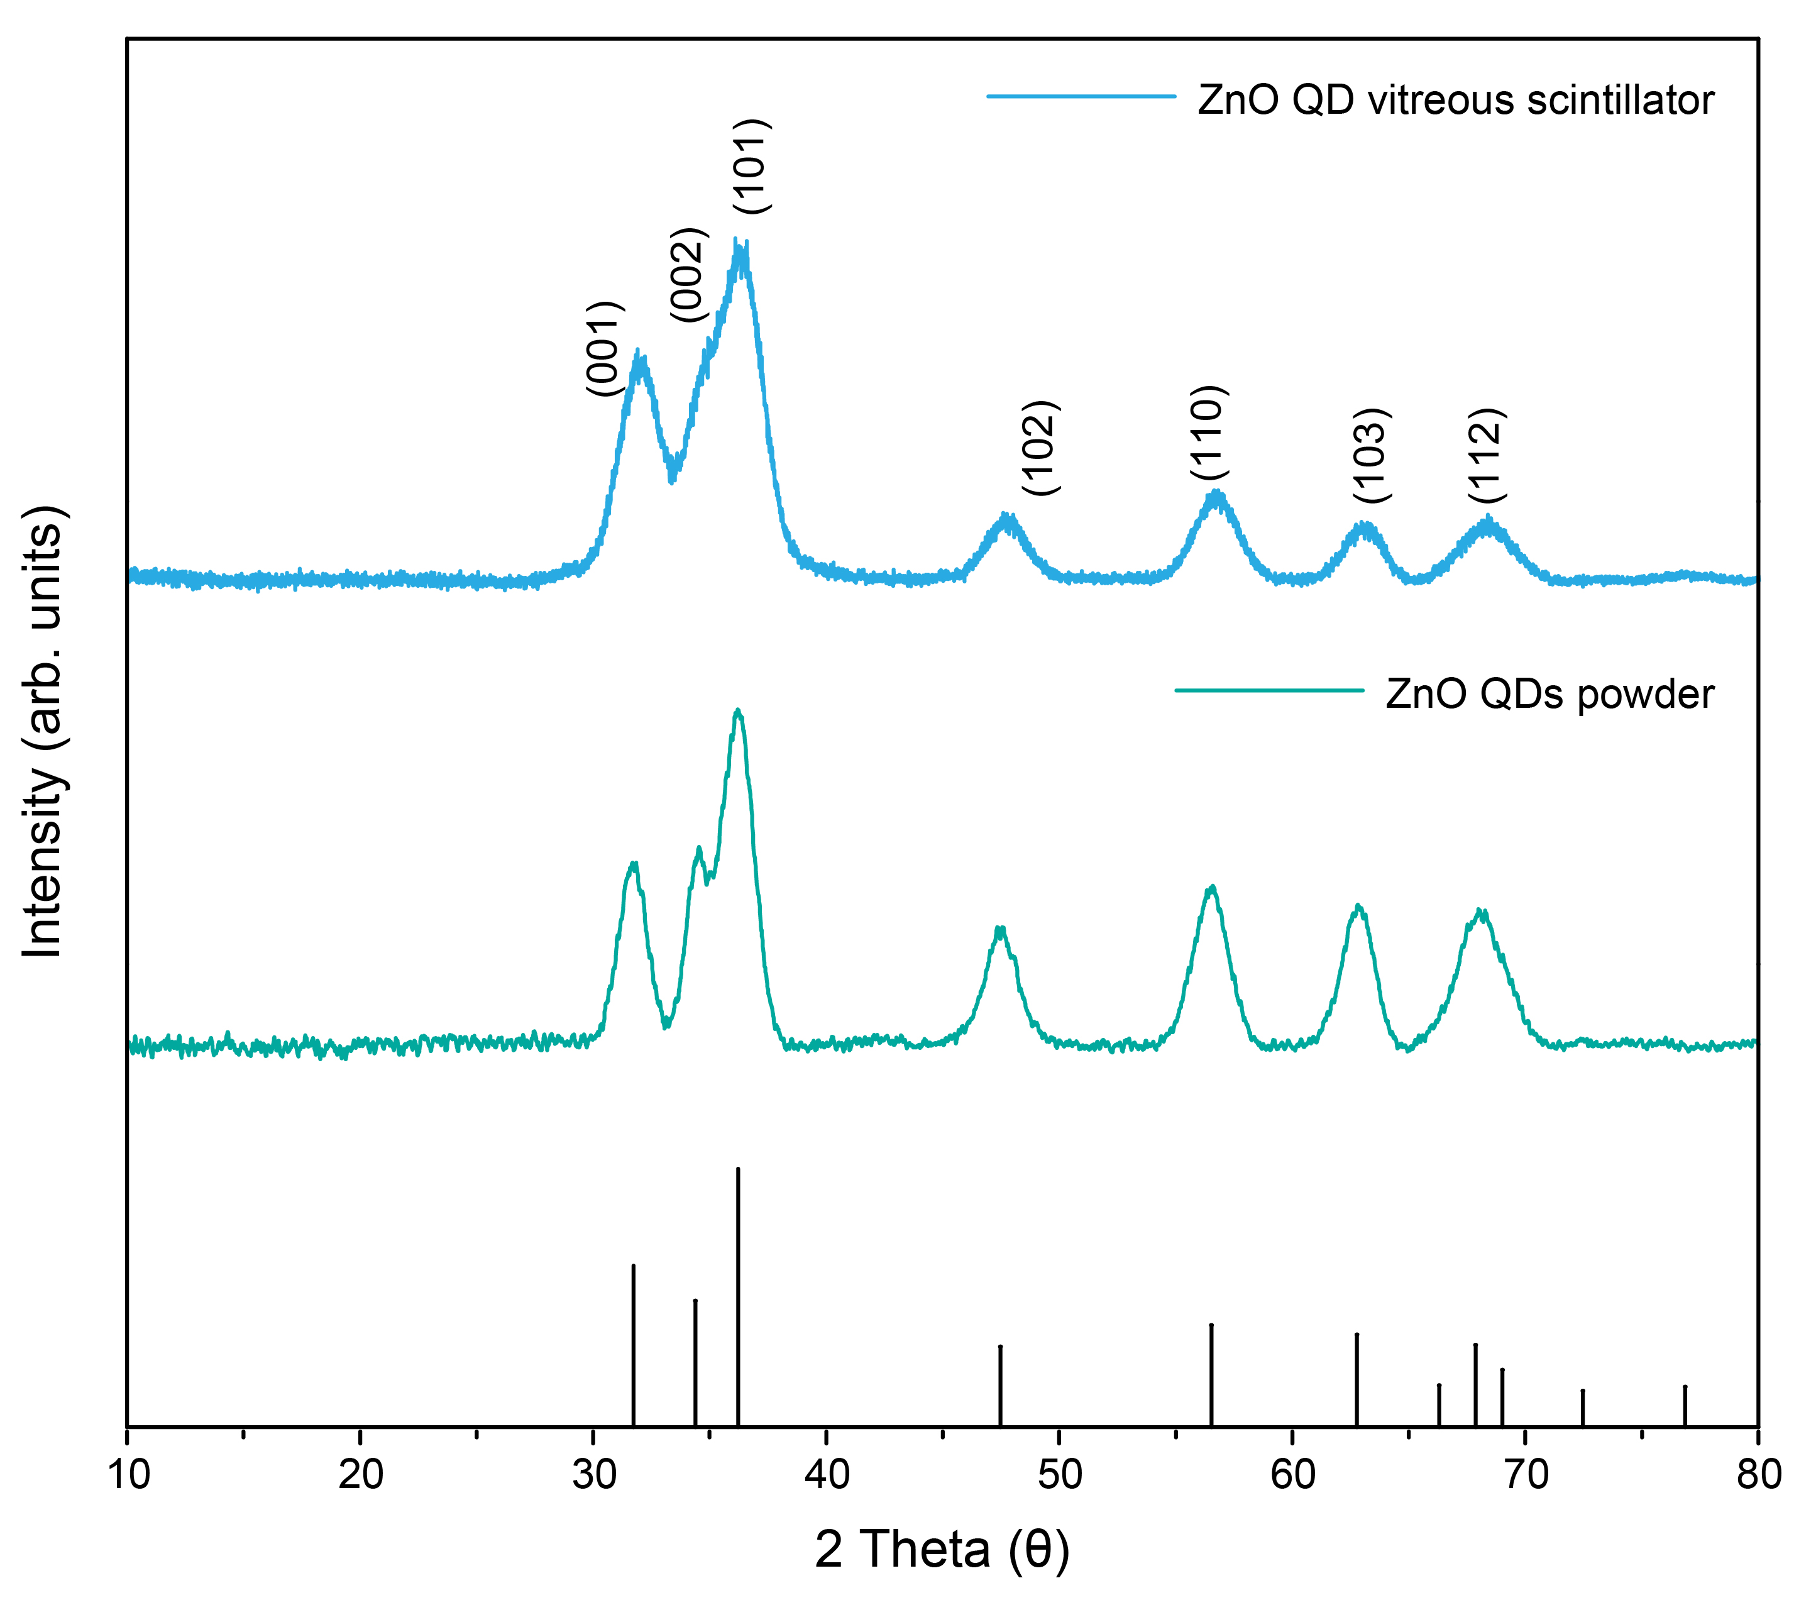

Figure S8. XRD pattern of the ZnO QD powders and ZnO QD vitreous scintillator.

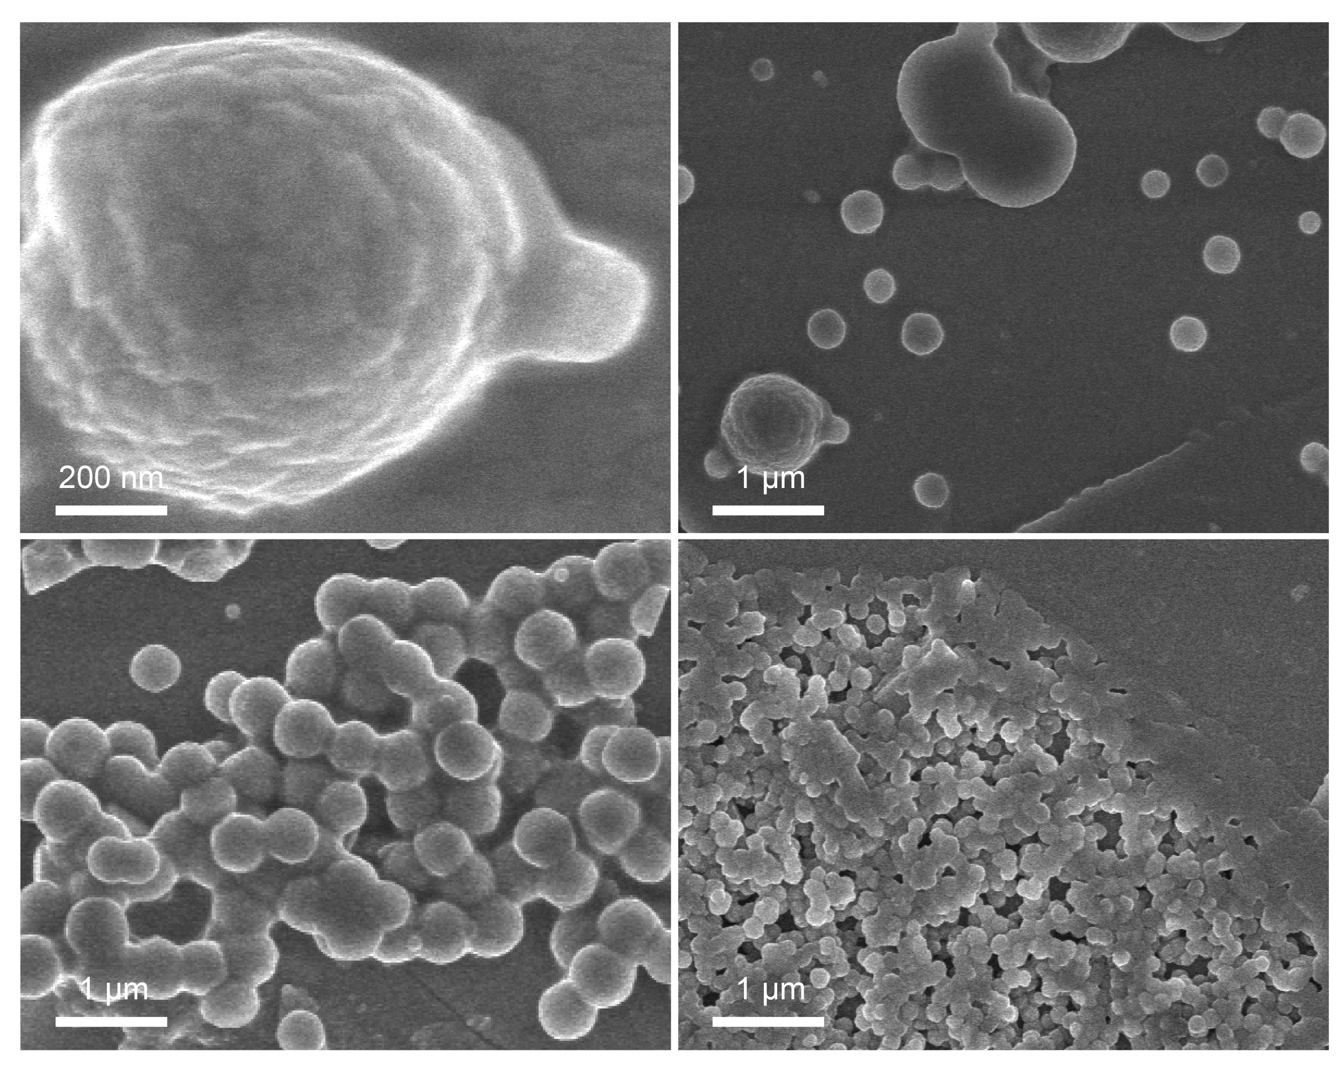

Figure S9. SEM images of the ZnO QD vitreous scintillator captured at various formation processes.

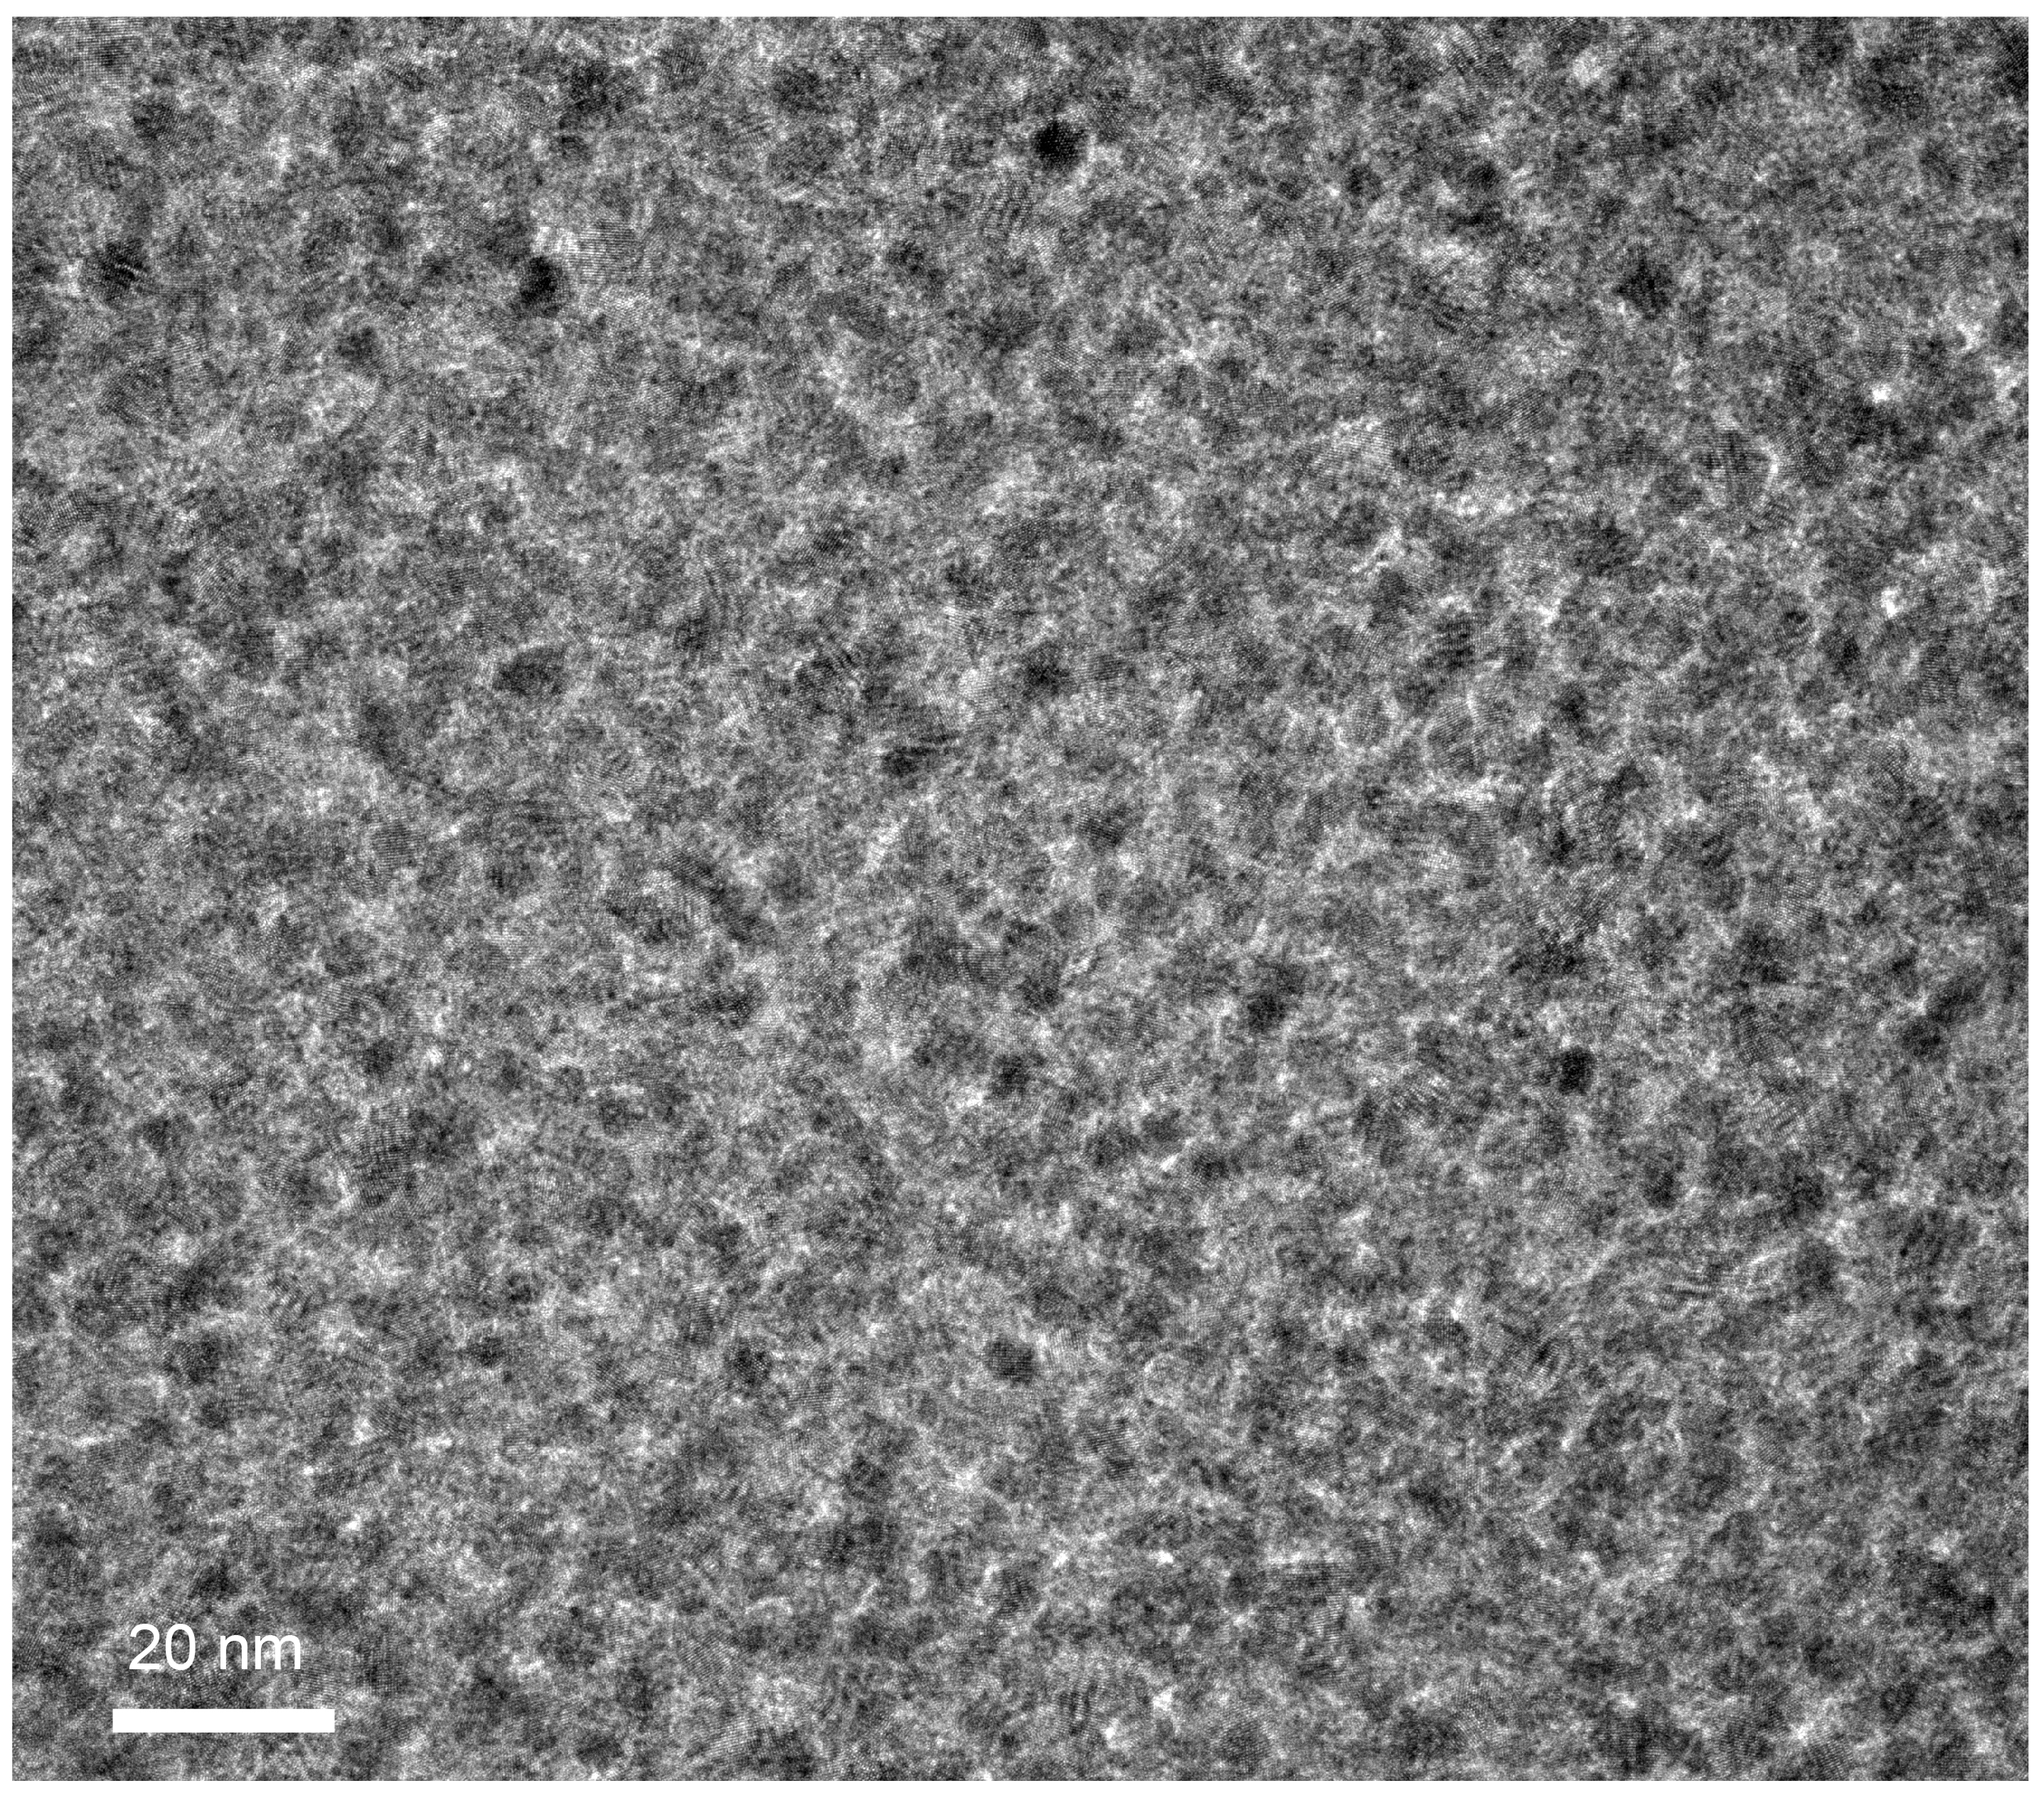

Figure S10. TEM image of the ZnO QD vitreous scintillator.

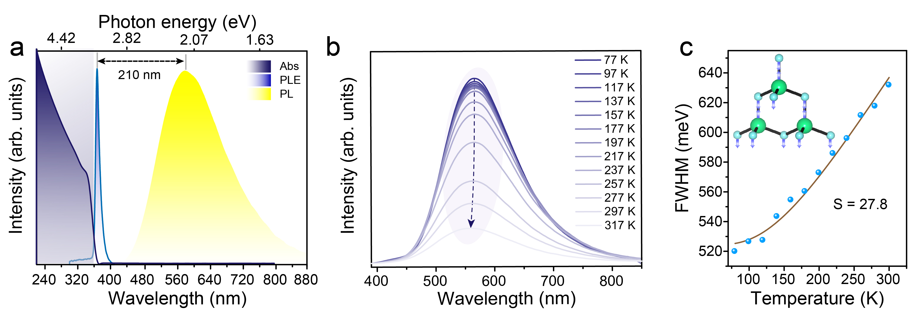

Figure S11. (a), Absorbance, PL, and PL excitation spectra of ZnO QDs. (b) Temperature-dependent PL spectra of ZnO QDs measured from 77 to 317 K. (c) Temperature-dependent FWHM emission spectrum, and the corresponding fitting curve result (insert: schematic diagram of optical phonon vibration in ZnO QDs).

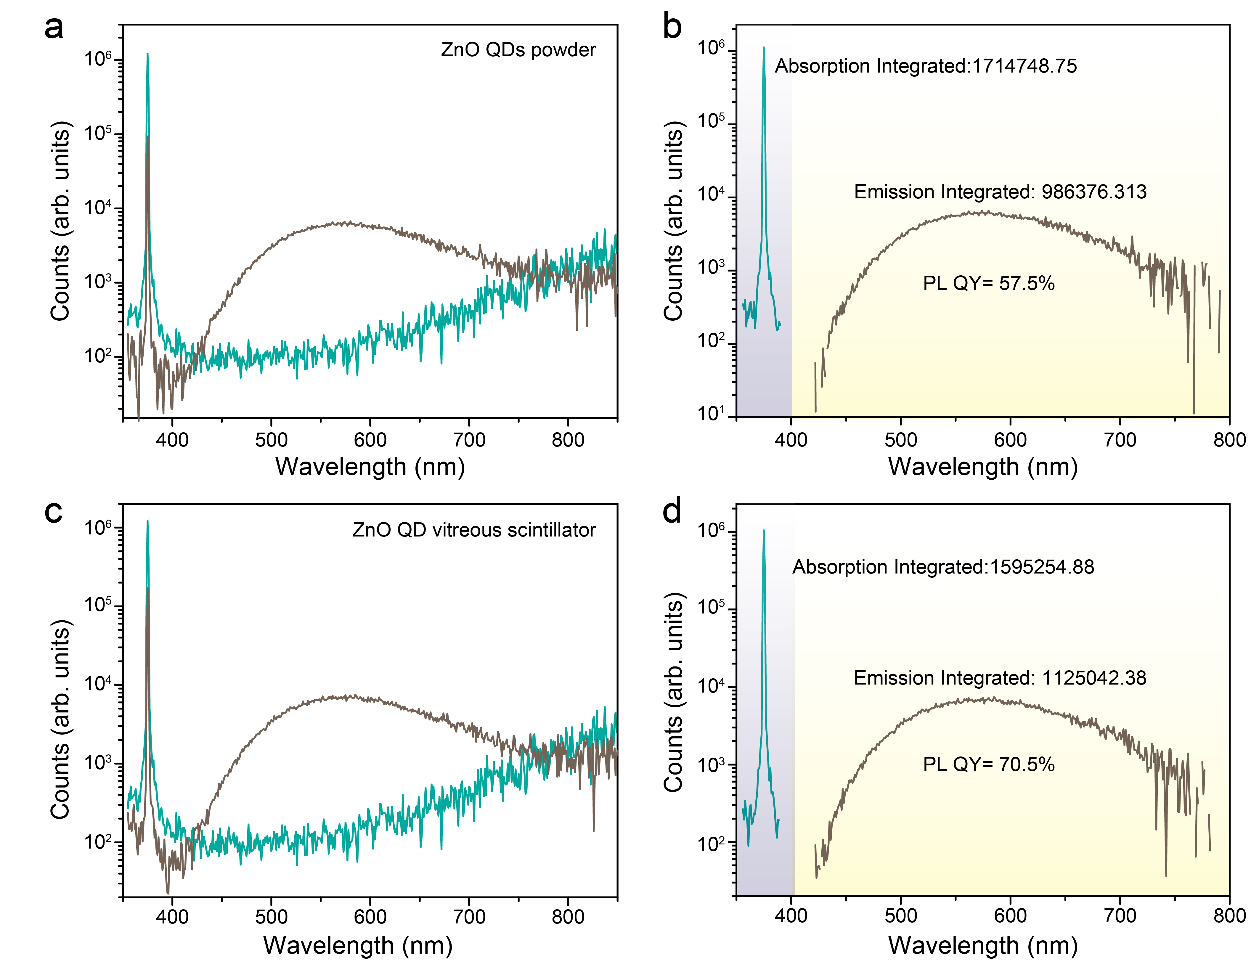

Figure S12. (a-b) PL QY measurement spectra for the ZnO QD powders, (c-d) PL QY spectra for the ZnO QD vitreous scintillator.

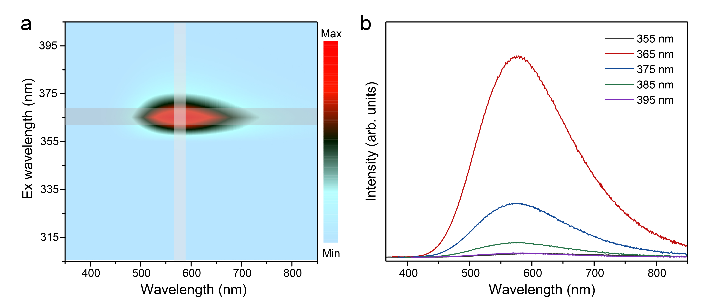

Figure S13. (a) Excitation-Emission mapping of the ZnO QD vitreous scintillator. (b) The PL spectra of the ZnO QD vitreous scintillator under different excitation wavelengths.

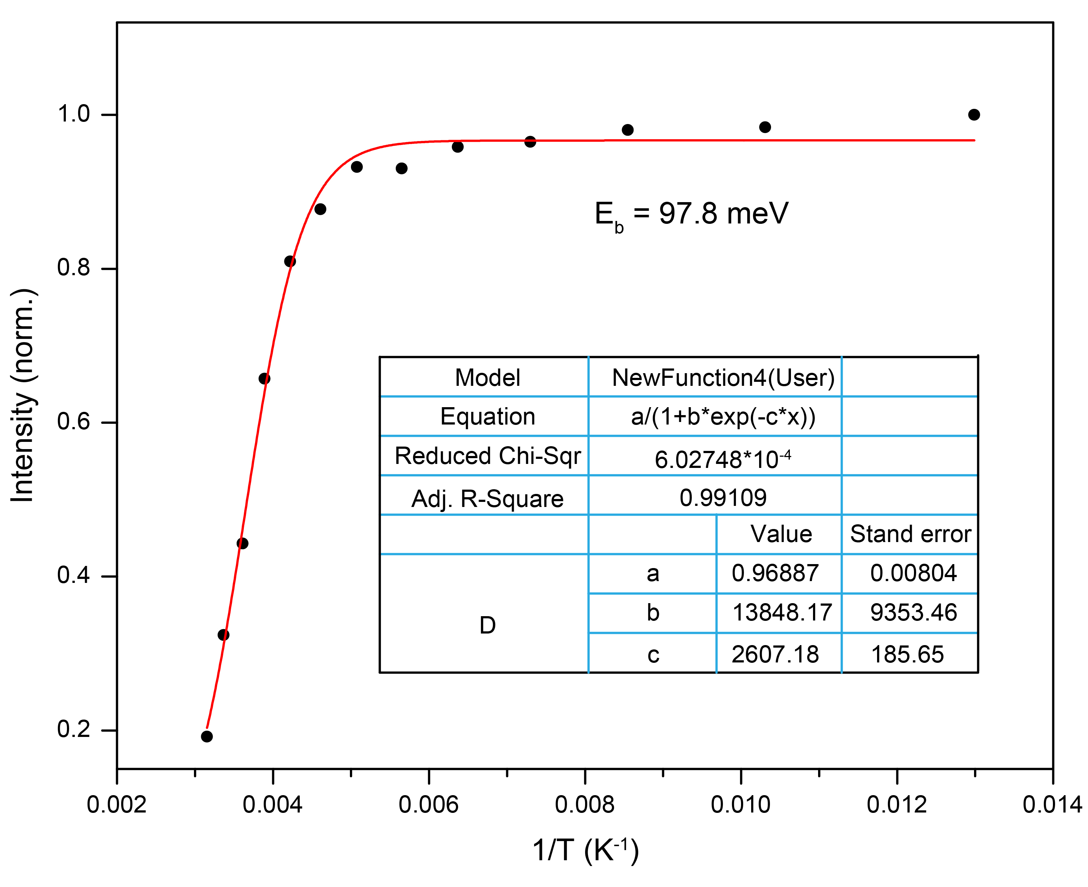

Figure S14. Temperature-dependent integrated STE emission intensity of the ZnO QDs from 77 K-297 K.

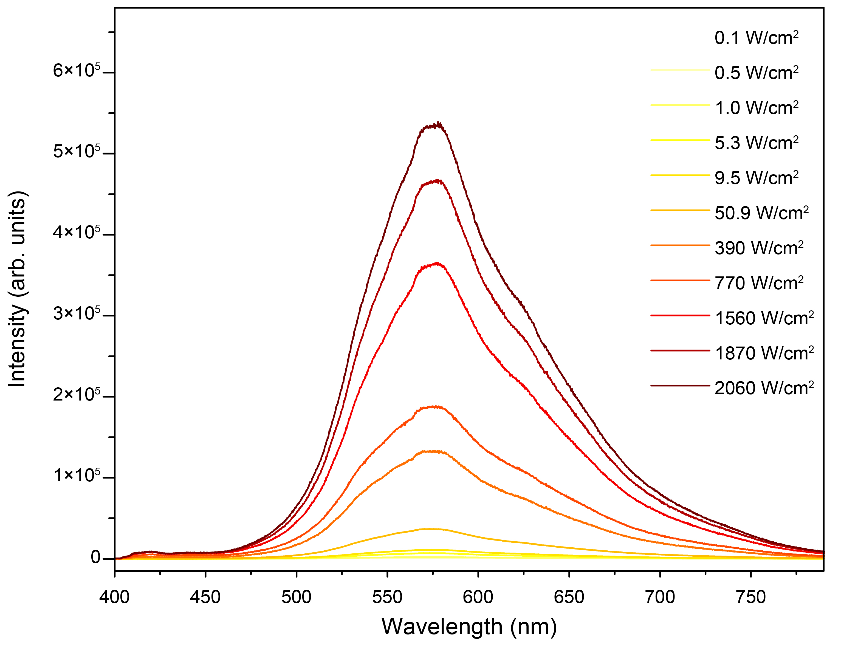

Figure S15. The PL spectra of the ZnO QDs under excitation of laser with varying powers.

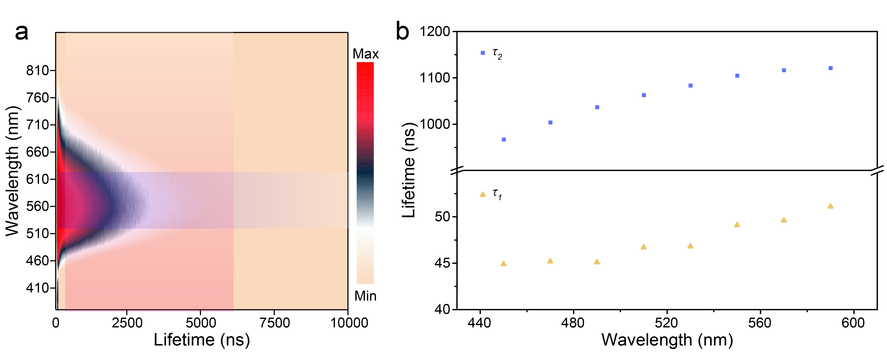

Figure S16. (a) Contour plots of time-resolved emission spectra of the ZnO QDs. (b) The PL lifetime changes of the ZnO QDs at selected wavelength (450 nm-590 nm) under 340 nm excitation.

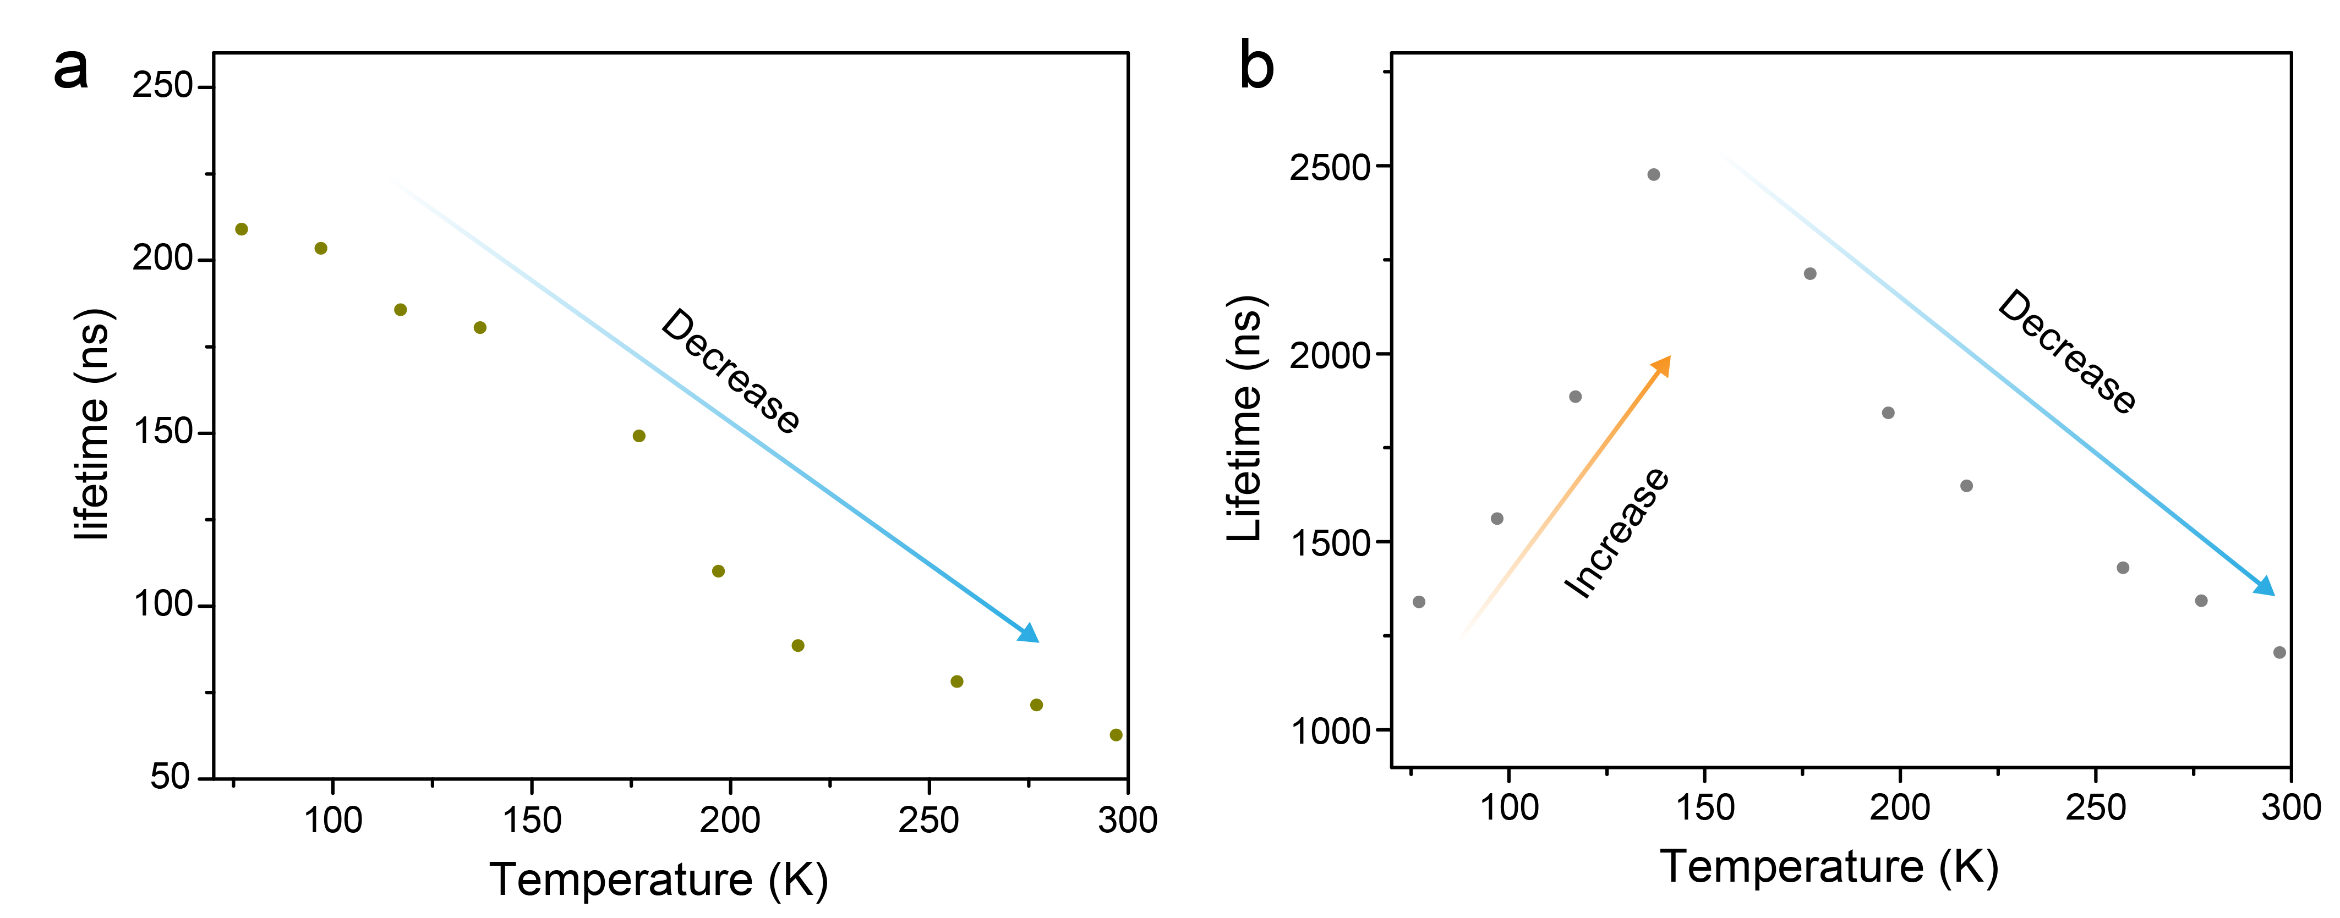

Figure S17. (a) The temperature-dependent PL short lifetime and (b) long lifetime for the ZnO QDs.

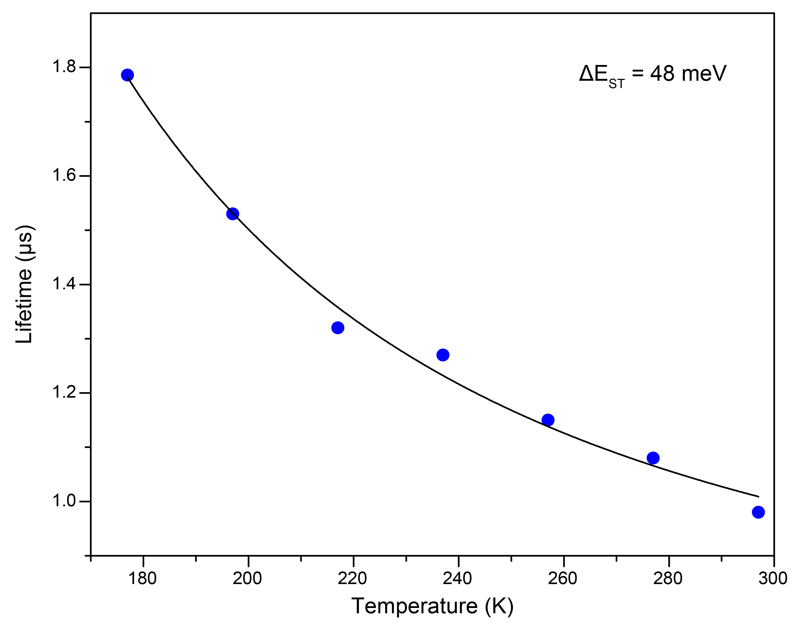

Figure S18. Temperature-dependent average lifetimes of the ZnO QDs.

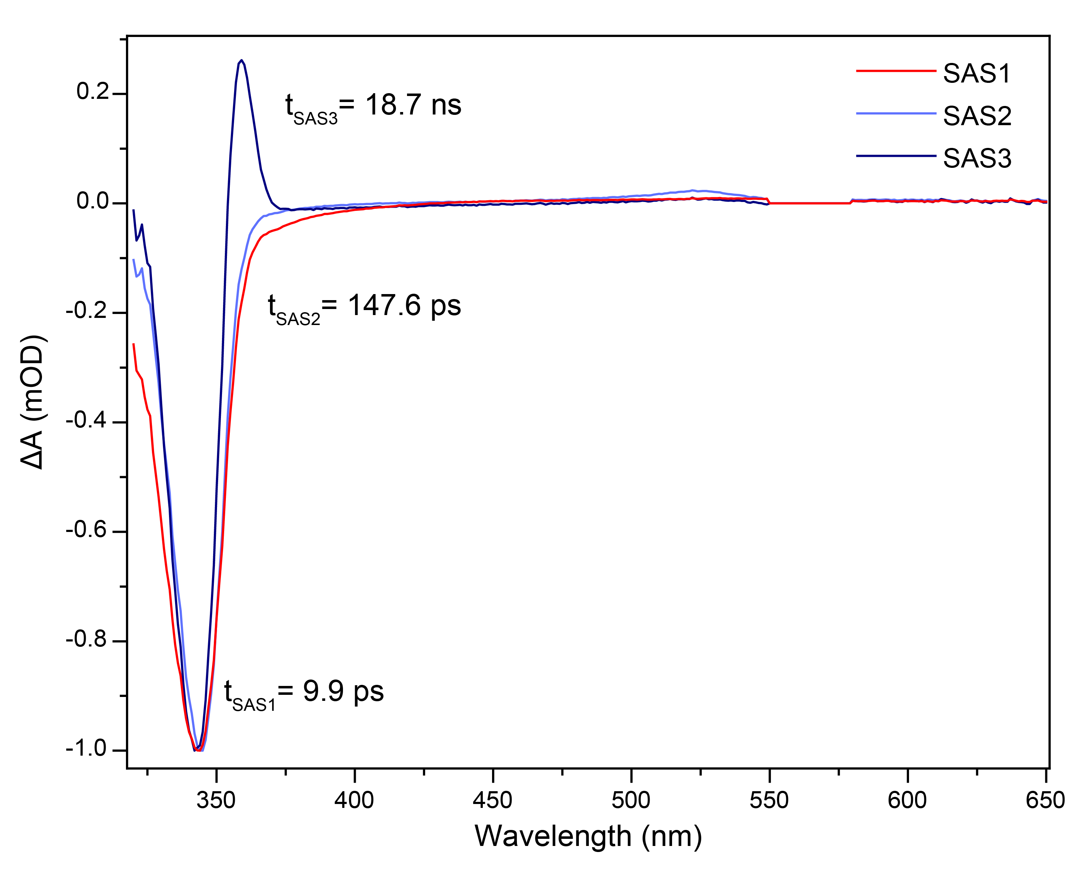

Figure S19. Global analysis TA spectra of the ZnO QDs

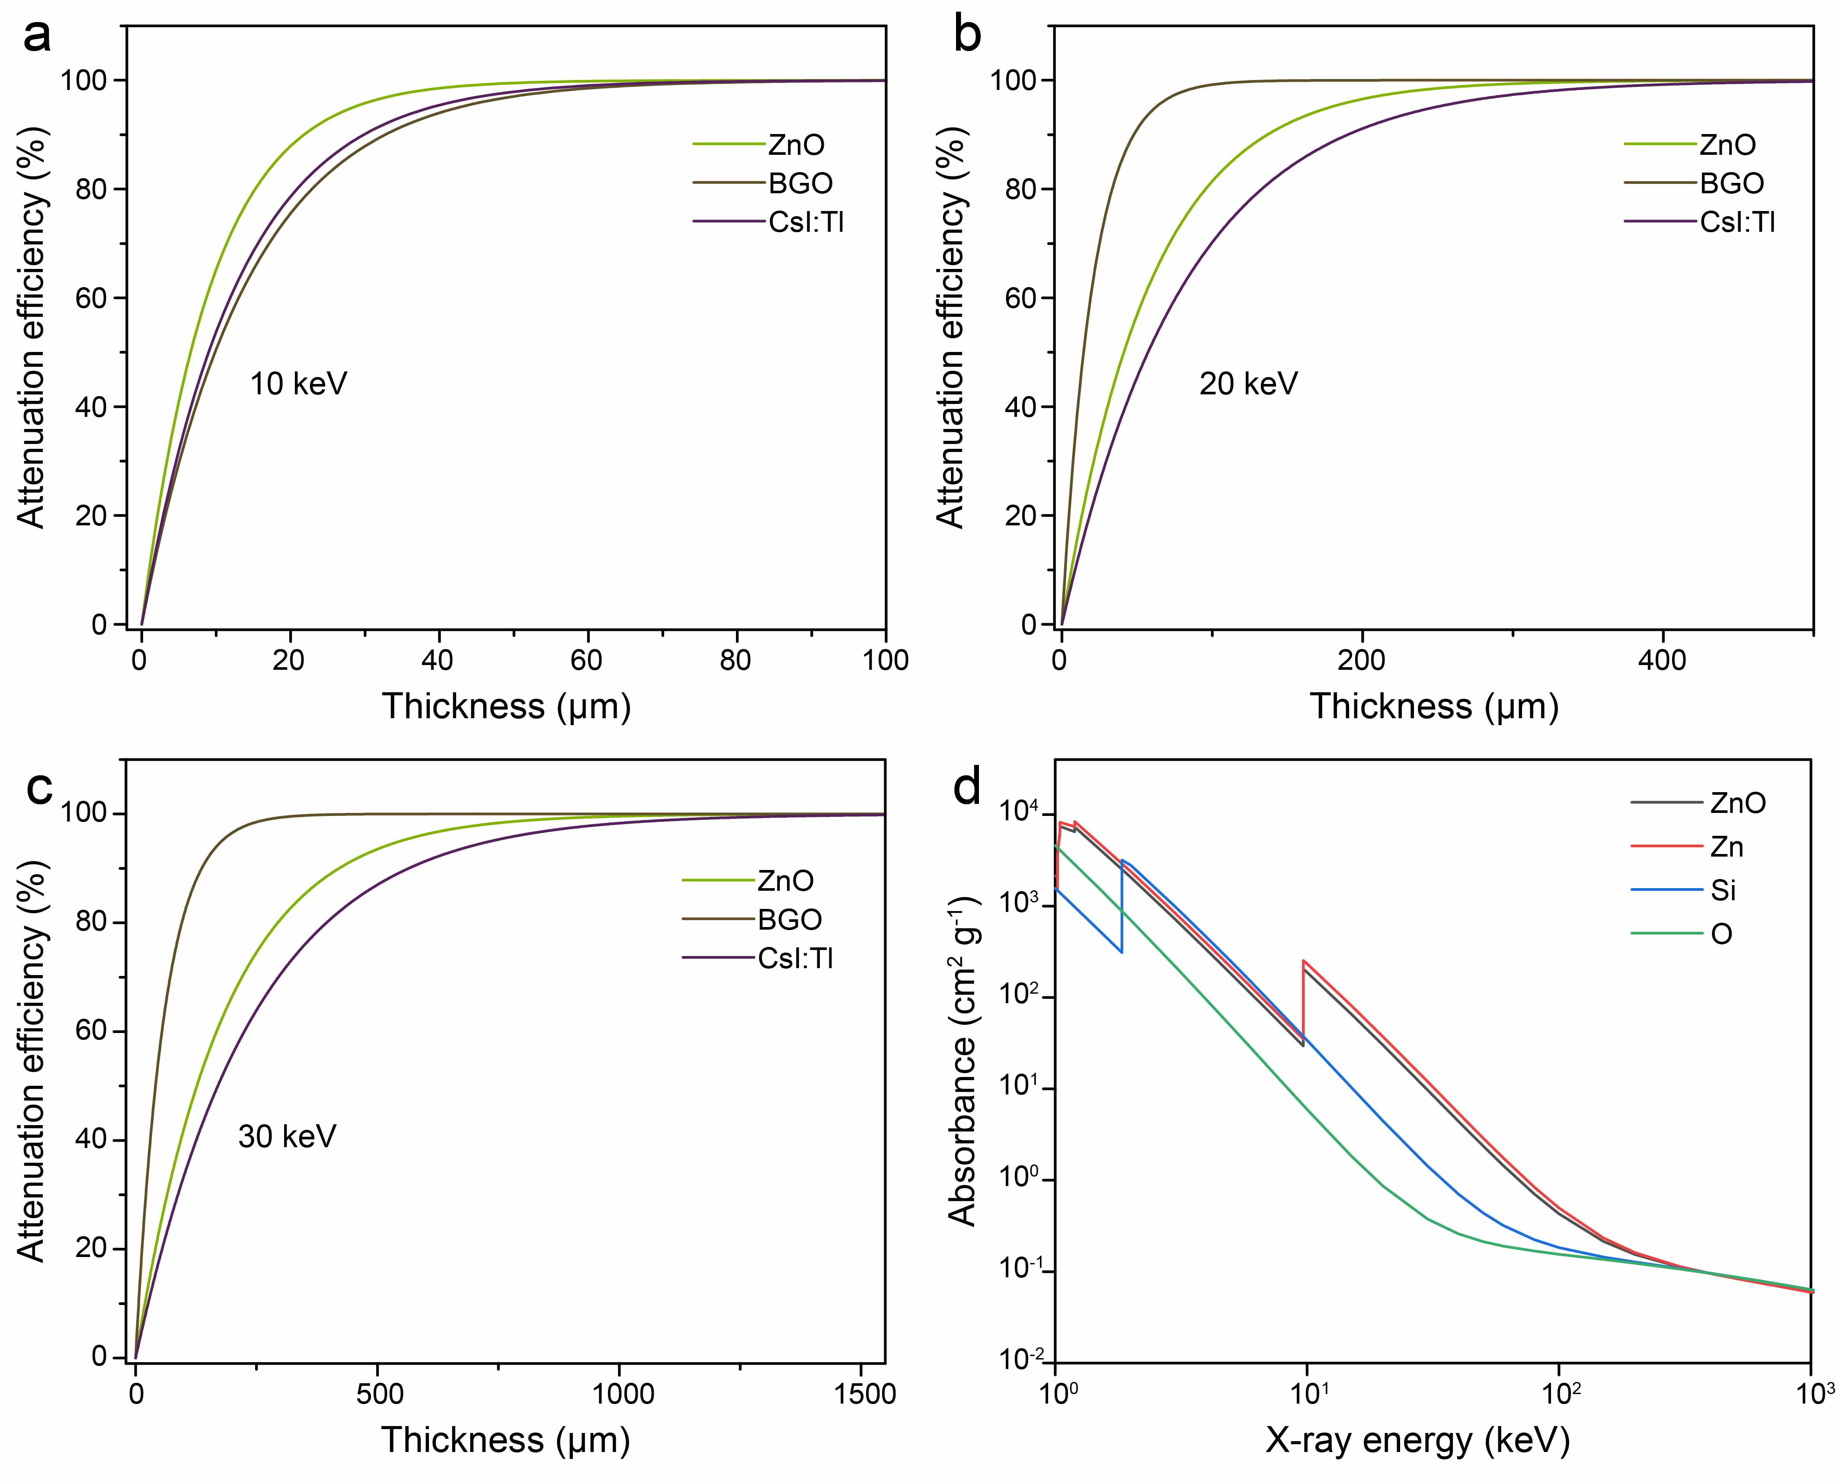

Figure S20. (a-c) Calculated X-ray attenuation efficiencies of BGO, CsI:Tl and ZnO versus their thickness. (d) Absorption spectra of ZnO, Zn, Si and O as a function of X-ray energy. The attenuation coefficients were obtained from the photon cross-section database.

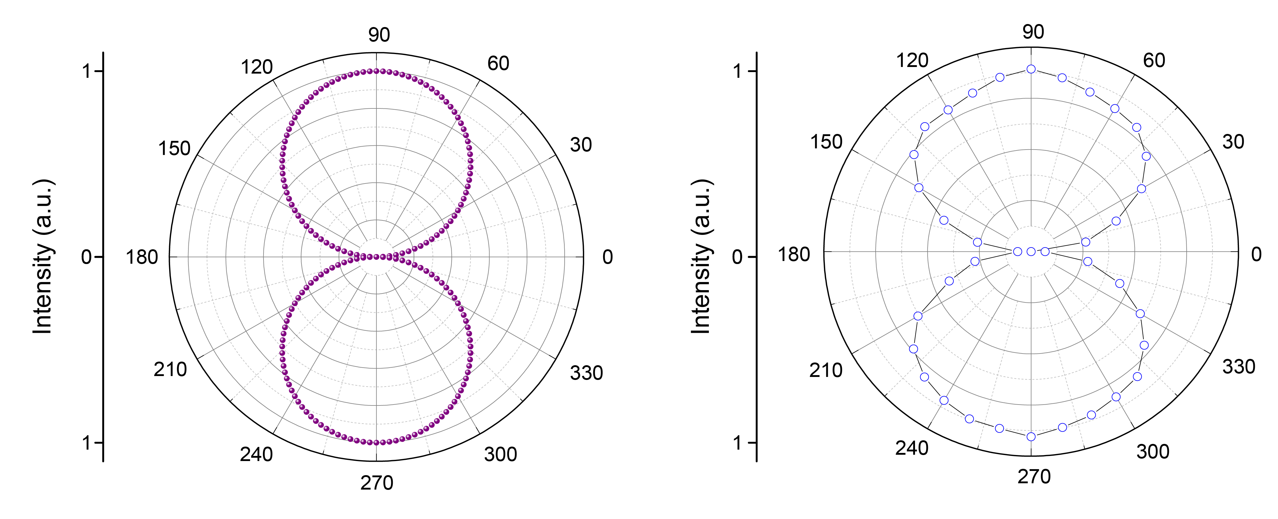

Figure S21. Simulated light intensity in different directions at the same dose rate (left) and measured light intensity in different directions (right).

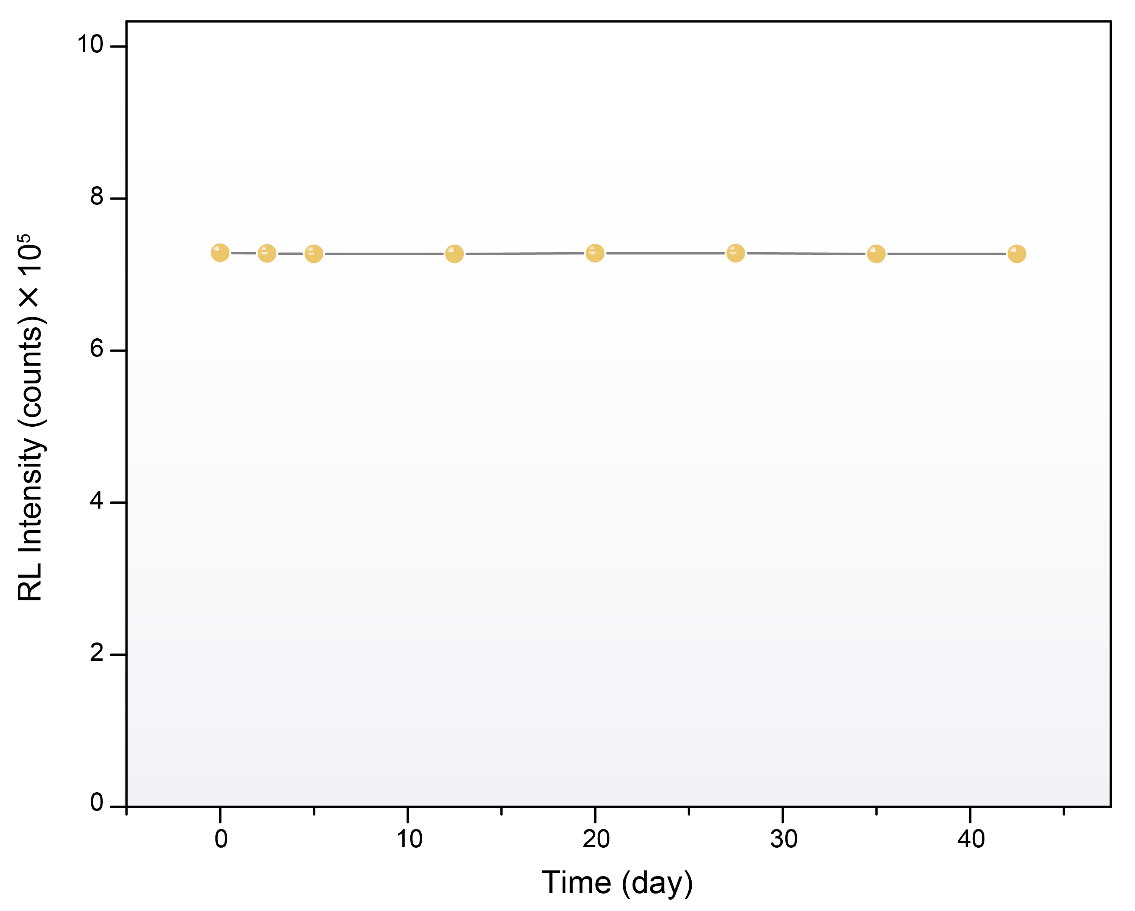

Figure S22. RL stability of the ZnO QD vitreous scintillator under X-ray irradiation versus times.

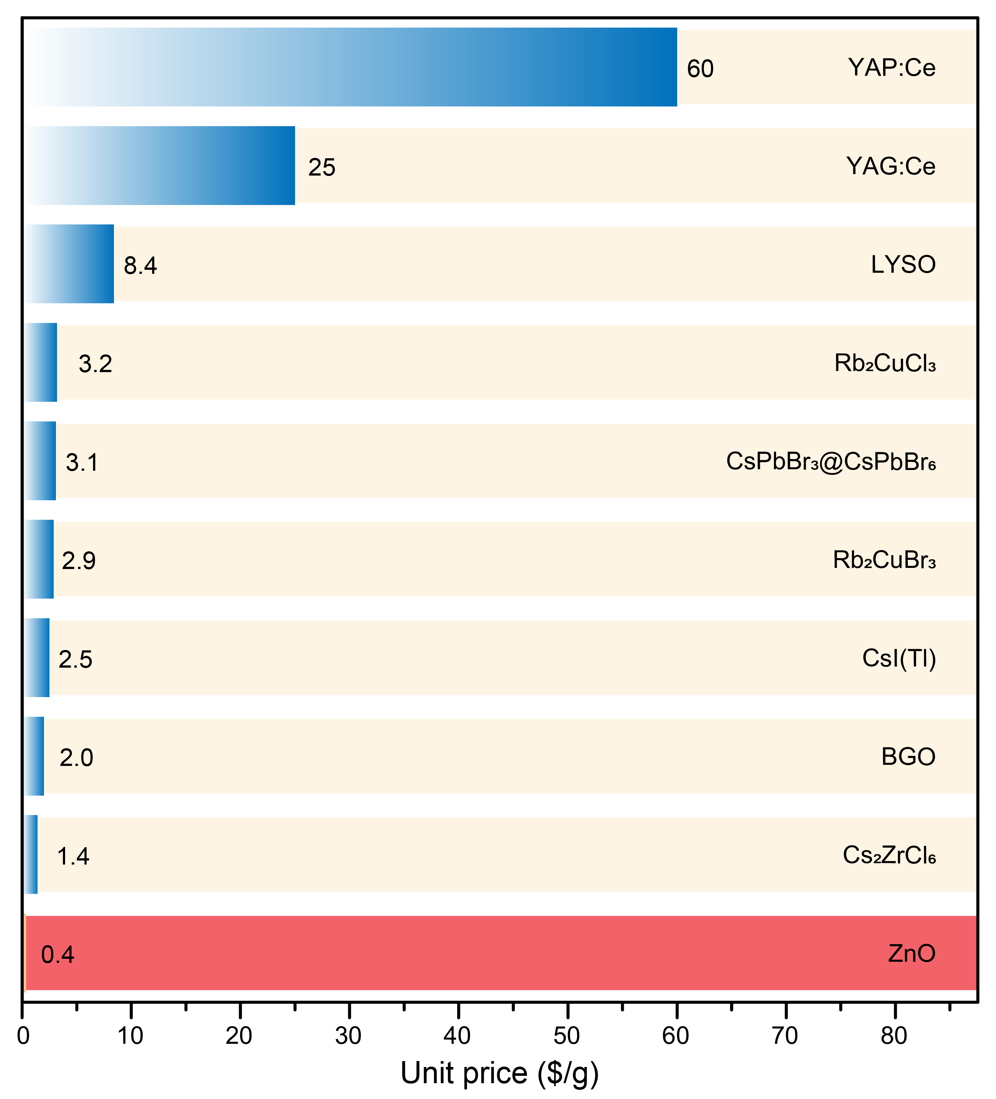

Figure S23. Cost/price comparison of the ZnO QD and other scintillators.

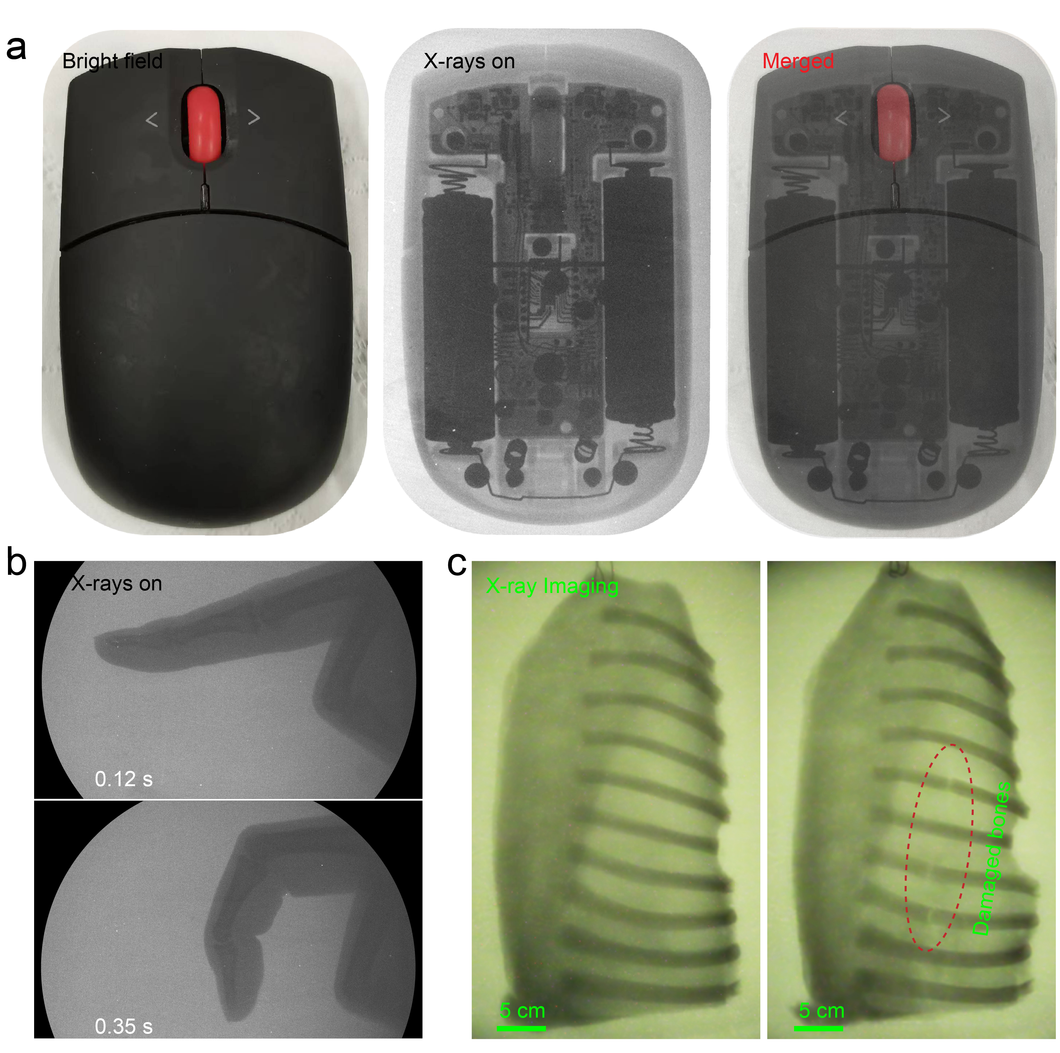

Figure S24. (a) Digital photograph of a computer mouse and corresponding X-ray images obtained using ZnO QD vitreous scintillator (50 kV and 258 μGy s⁻¹ exposure for 200 ms). (b) Real-time X-ray images of finger bending. (c)X-ray imaging of pork rib using the large area ZnO QD scintillator.

