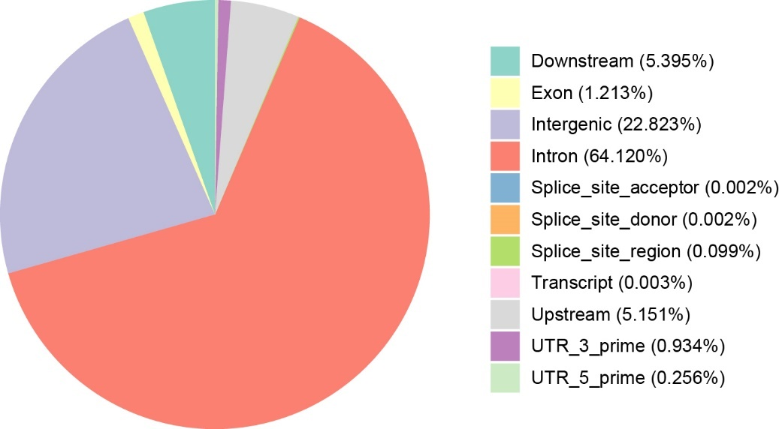
Fig. S1 Distribution of SNPs on the genome in this study.

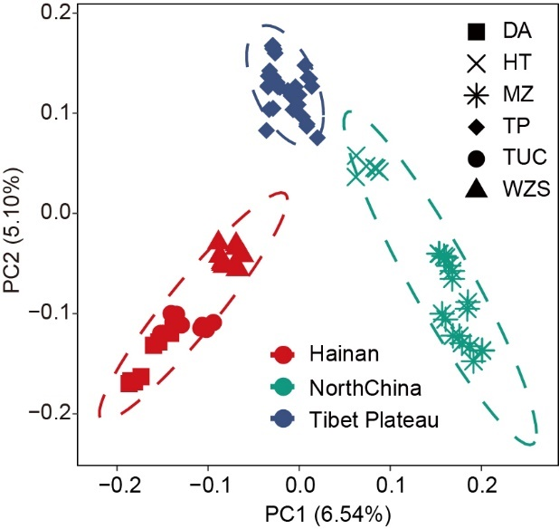
Fig. S2 A principal component plot of the 82 individuals.

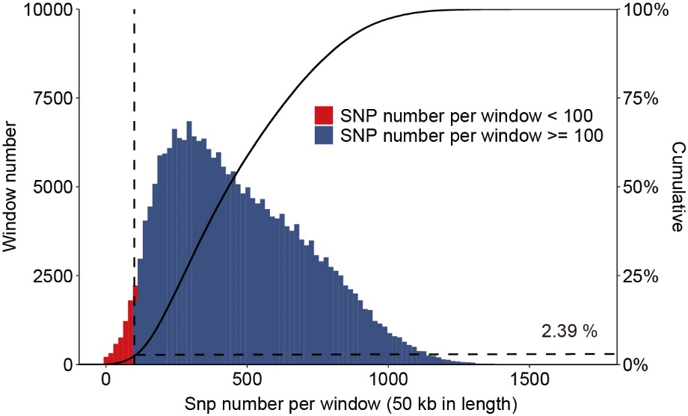
Fig. S3 Genome-wide distribution of SNPs. Out of 226,375 windows of 50 kb in length sliding in 10 kb steps across the domestic pig genome, 5,413 windows contain < 100 SNPs (red bars) and cover 2.39% of the genome (dashed lines). 220,096 windows contain ≥ 100 SNP (blue bars) and cover 97.61% of the genome, and these were used to detect signatures of selective sweeps. The cumulative % in whole genome length (black line) is also charted.

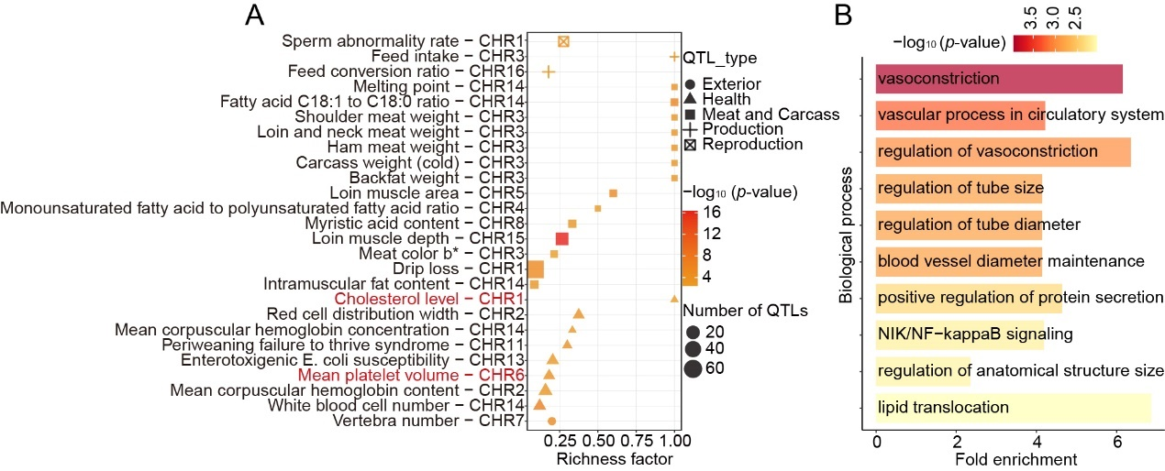
Fig. S4 Annotation of the regions and genes detected by tropical adaptation-specific selection based on the Animal QTLdb and the Gene Ontology Resource, respectively. A Significantly enriched QTL terms of tropical-specific selection. B Significantly enriched GO terms (Biological process, top 10) of tropical-specific selection.

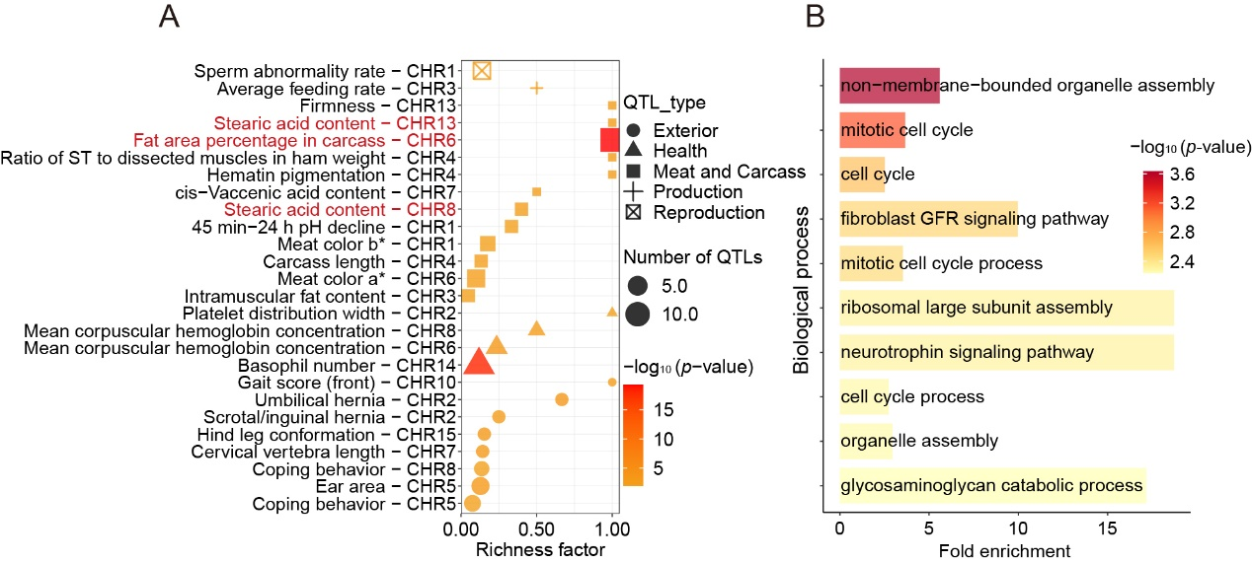
Fig. S5 Annotation of the regions and genes detected by frigid adaptation-specific selection based on the pig QTLdb and the Gene Ontology Resource, respectively. A Significantly enriched QTL terms of frigid-specific selection. B Significantly enriched GO terms (Biological process, top 10) of frigid-specific selection.

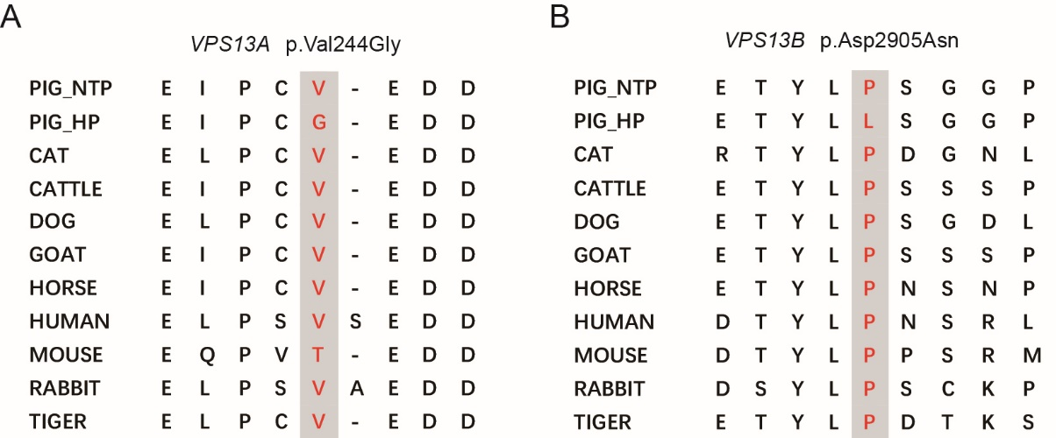
Fig. S6 Multispecies alignment of the protein sequences around putative promising variants. A p.Val244Gly in VPS13A gene. B p.Asp2905Asn in VPS13B gene.

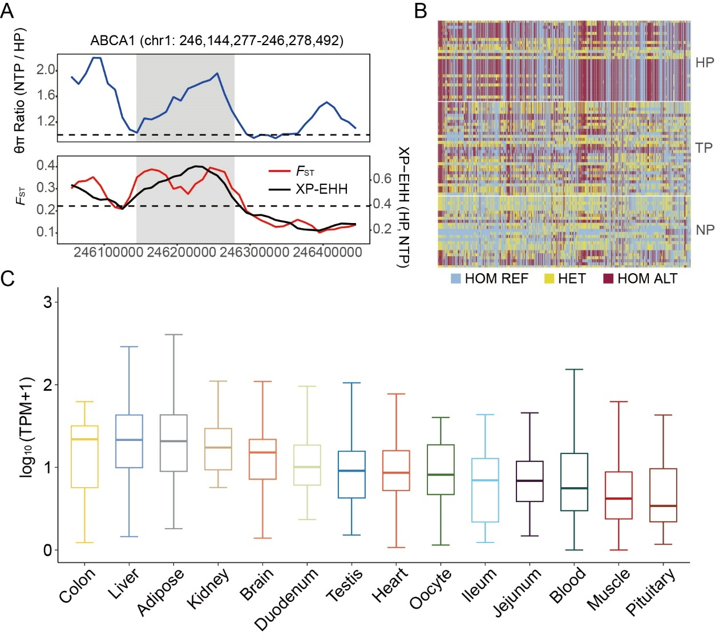
Fig. S7 Distinct genomic landscape around ABCA1 gene. A θπ ratios (50kb-window, 10kb-step), F_{ST} values, and XP-EHH values around the ABCA1 gene locus. The blue line represents θπ ratios. The red and black lines represent FST and XP-EHH values, respectively. B Haplotype pattern in the genomic region of ABCA1 among HP, TP, and NP. C The ABCA1 gene shows predominant expression in liver tissues.

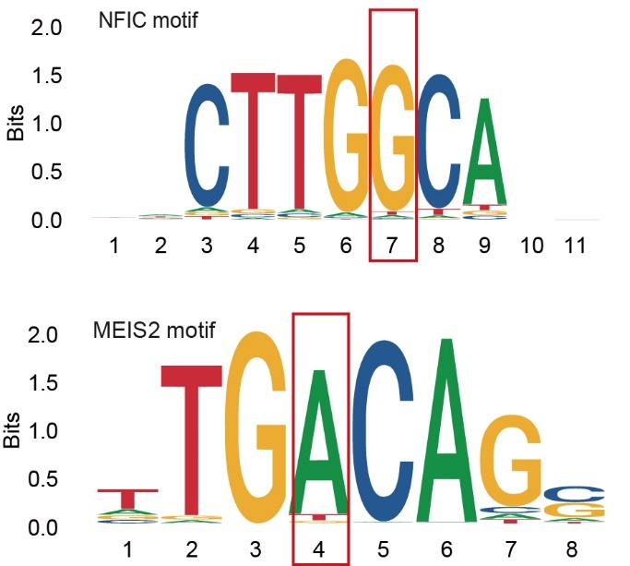
Fig. S8 Sequence logos of NFIA and MEIS2. Site 7 (G allele) of NFIA and site 4 (A allele) of MEIS2 are the binding sites of chr1: 246,175,129.

