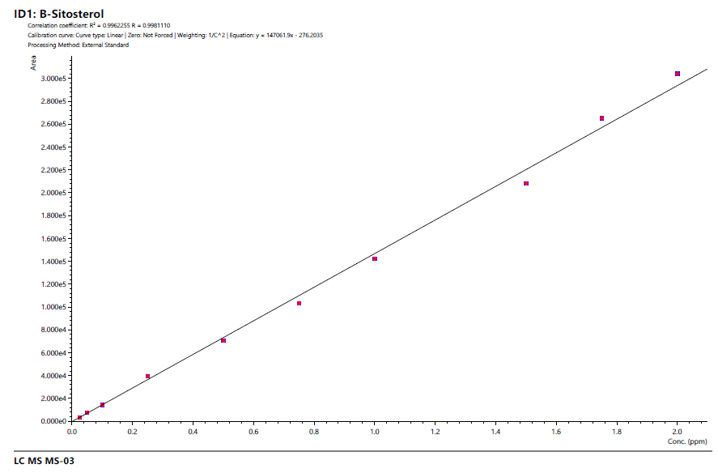
β-SITOSTEROL
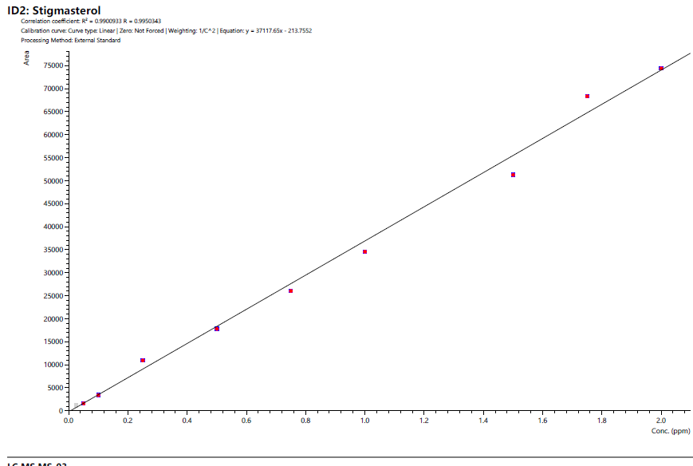
STIGMASTEROL

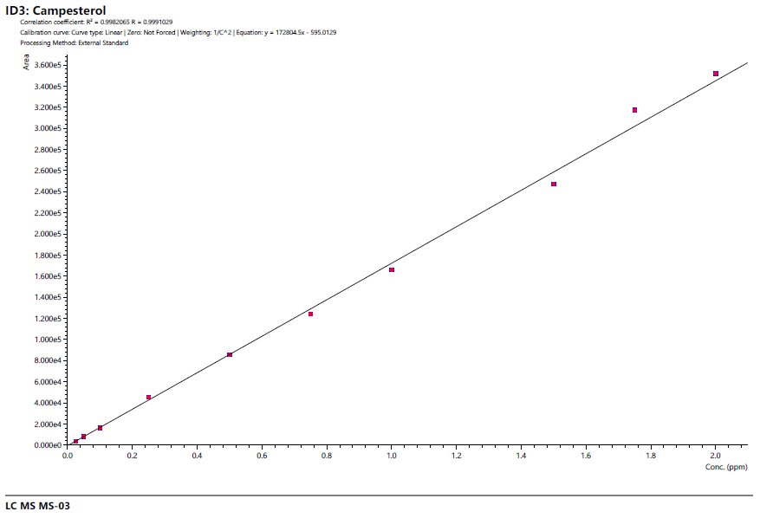
CAMPESTEROL

Fig S1: Standard curve of phytosterols used in the quantification

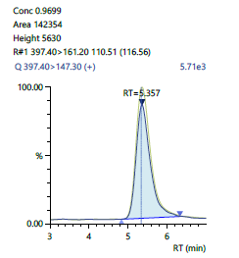 | 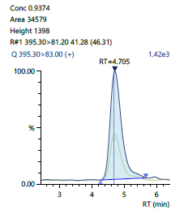 | 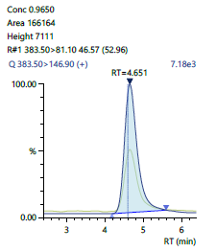
β-Sitosterol | Stigmasterol | Campesterol
Fig. S2: Mass spectra of standard phytosterols

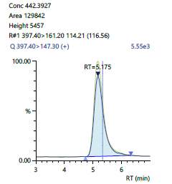 | 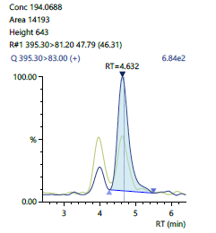 | 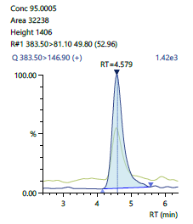
β-Sitosterol | Stigmasterol | Campesterol
Fig. S3: Representative chromatogram of different phytosterols present in dry leaves of jivanti

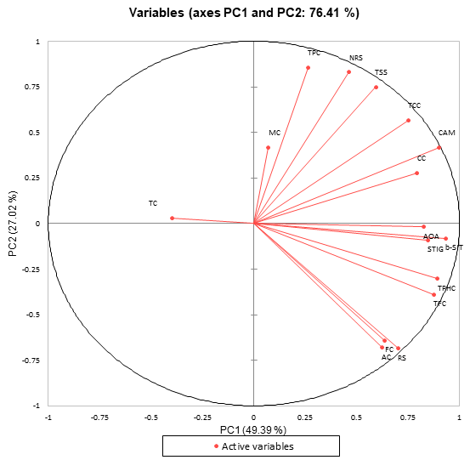
Fig. S4: PCA analysis of biochemical parameters and phytosterols contents of jivanti dried by different drying methods (#Active variables: Biochemical parameters and phytosterols)

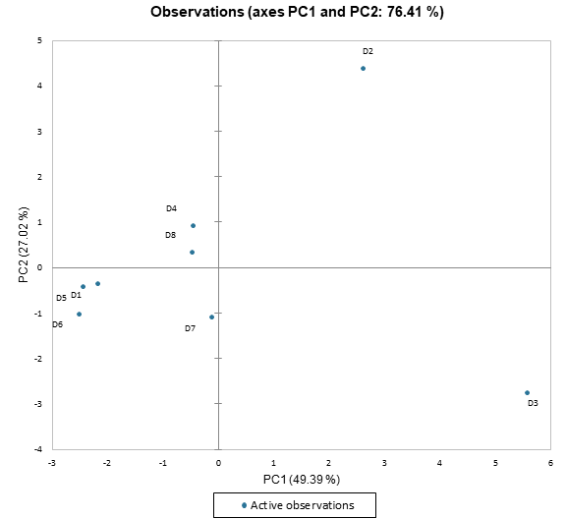
Fig S5: PCA analysis of biochemical parameters and phytosterols contents of jivanti dried by different drying methods (#Active observation: Drying methods which included D1: Sun drying, D2; Shade drying, D3: Vacuum driing, D4: Oven drying, D5: Tray drying, D6: microwave continuous drying, D7: Microwave vacuum drying, D8: Fluidized bed drying)

