Supporting Information:
Surface functionalization of cellulose derived from hemp by tetraethyl orthosilicate (TEOS) and poly vinylidene fluoride-based composite separator membrane for of lithium-ion batteries (LIBs)

Thanakrit Sirichaibhinyo ª, Satita Thiangtham ^{b, *}, Nagahiro Saito ^{c}, Sarute Ummartyotin ^{a,b,*}

ª Department of Materials and Textile Technology, Faculty of Science and Technology, Thammasat University, Patumtani, 12120, Thailand
^{b} Center of Excellence on Petrochemical and Materials Technology, Chulalongkorn University, Bangkok 10330, Thailand
^{c} Department of Chemical Systems Engineering, Graduate School of Engineering, Nagoya University, Nagoya 464-8603, Japan

*Corresponding author
Satita Thiangtham (Email: satita@mut.ac.th)
Sarute Ummartyotin (Email: sarute@tu.ac.th)

Experimental Sections

Isolation of MCC from Hemp Fiber

Initially, hemp-based pulp fiber was dried in an oven at 80°C for 24 h to remove moisture. Then, it was ground to small pieces by using a nano-grinder machine, which operated at 800 rpm for 15 min. After that, the small pieces of dried hemp fibers (2.0 g) were soaked in 18% (w/v) of NaOH solution (100 mL). The mixture was heated at 80°C for 2 h. After that, the suspension was bleached with 10% (v/v) of H2O2 and then stirred at 80°C for 2 h, filtered and washed with distilled water to remove any impurities. In order to obtain MCC, the samples were treated with 10% (v/v) of 12M HCl at 60°C for 30 min. The suspension was filtered and dialyzed with distilled water for 3 days until a neutral pH was achieved. Finally, the MCC product was dried at 60°C and stored in a desiccator to prevent moisture absorption.

Incorporation of TEOS into MCC

1.0 g of microcrystalline cellulose (MCC) product was combined with a 2 wt% tetraethyl orthosilicate (TEOS) solution (10 mL). The mixture was stirred at 60°C for 4 h. Then, 1 mL of HCl was poured into the suspension and stirred to ensure homogeneity. Then, the suspension was filtered to remove the solvent using a suction flask connected to a removal pump. It was dialyzed with DI water for 3 days until the products were neutral. The obtained MCC/TEOS product was dried by subjecting into an oven at 60°C overnight and stored in a desiccator for further utilization and characterizations. Thus, the process of isolation of MCC from hemp fiber and incorporation of TEOS into MCC preparation was illustrated in Fig. S1.
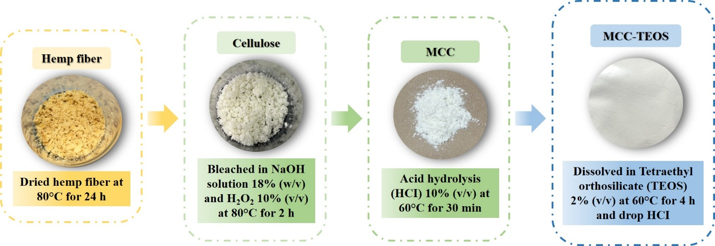
Fig. S1 Diagram of MCC from hemp fiber and incorporation of TEOS into MCC preparation

Characterization of Hemp and MCC

Cellulose fiber was successfully isolated from hemp. The color was changed from brownish to whitish color due to lignin removal. The alkaline treatment can be ensured that lignin was completely removed from cellulose fiber. The size of cellulose and hemp fiber were in the similar level. Fig. S2(a) reports the FTIR spectra of microcrystalline cellulose. Hemp fiber was provided for comparison. Both of characteristic peaks were presented in the similar feature. The broad region of absorption peak at 3373 cm⁻¹ was observed. It was assigned to -OH stretching lignin. It was related to inter- and intramolecular H-bonding. Then, the characteristic peak at 2917 cm⁻¹ was observed. It was typically involved to symmetric C-H stretching vibration of cellulose (Reddy et al., 2009). After that, the absorption band at 1750 cm⁻¹ was observed due to C=O stretching. It was related to the presence of carbonyl group. It was involved to carbonyl aldehyde group of hemicellulose. The peak at 1500 cm⁻¹ was observed. It was attributed to C-H deformation of lignin. However, the absorption bands at 1376 cm⁻¹, 1250 cm⁻¹, 1060 cm⁻¹ and 895 cm⁻¹ were observed. These peaks were belonged to functional group of carbohydrate. No significant peaks were detected after purification (Gandolfi et al., 2013).
The crystalline structure of hemp fiber and MCC were investigated by XRD analysis and reported in Fig. S2(b). The XRD pattern of hemp fiber exhibited two diffraction peaks. The strongest peak at 22.5° was observed. It was corresponded to (002) diffraction plane. It was attributed to the distance between hydrogen bond in cellulose I domains. After that, the peak at 16.3 was prevented. It was indexed to (101) diffraction plane. It was attributed to ordering along the fiber direction and alignment of chain into the fibrils (Besbes, 2011). Furthermore, it was observed that three peak were prevented at the diffraction angle of 12.1°, 20° and 21.7°. These characteristic peaks were typically indexed to diffraction plane of (100), (110) and (002), respectively. These features were attributed to transformation of cellulose I to cellulose II structure. This structure was considered as a stack sheet bound together by a hydrogen bond linkage throughout network, as suggested by (Luzi et al., 2014) The present of crystallinity was then enhanced due to alkali treatment and acid hydrolysis. This chemical modification to allow hemicellulose and lignin removal. The crystalline was show then when amorphous part was disappeared.

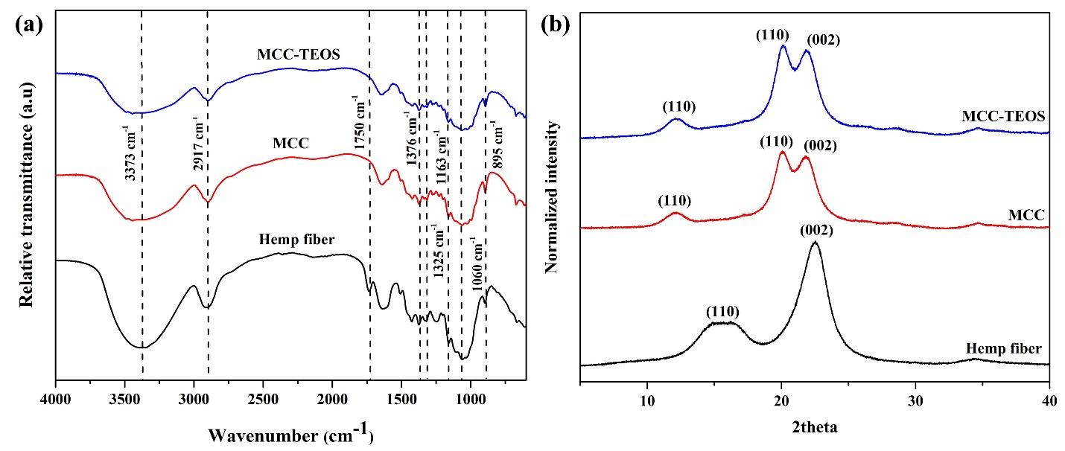
Fig. S2 FTIR spectra (a) and XRD patterns (b) of hemp fiber, microcrystalline cellulose (MCC) and microcrystalline cellulose-tetraethyl orthosilicate (MCC-TEOS)

Fig. S3 shows the morphological properties of hemp fiber, microcrystalline cellulose (MCC) and microcrystalline cellulose-tetraethyl orthosilicate (MCC-TEOS). They were prevented in Figure S3(a), S3(b) and S3(c), respectively. The morphology of hemp fiber was randomly distributed. The orientation of fiber was difficult to control. It prevented as a steak fiber due to presence of lignin and wax, as suggest by Ma et al. These chemicals were considered as impurities exists alongside of cellulose fiber. They ahead onto cellulose surface. Next to hemp fiber, the right-hand side image was presented as a morphology of fiber after chemical modification. The fiber exhibited as an individual chain. The surface of fiber become smother. This was probably due to impurity removal during alkaline treatment process. Furthermore, amorphous part was then removal during acid hydrolysis. The absence of lignin and hemicellulose were occurred. It consequently resulted in disintegrated of cellulose fiber.
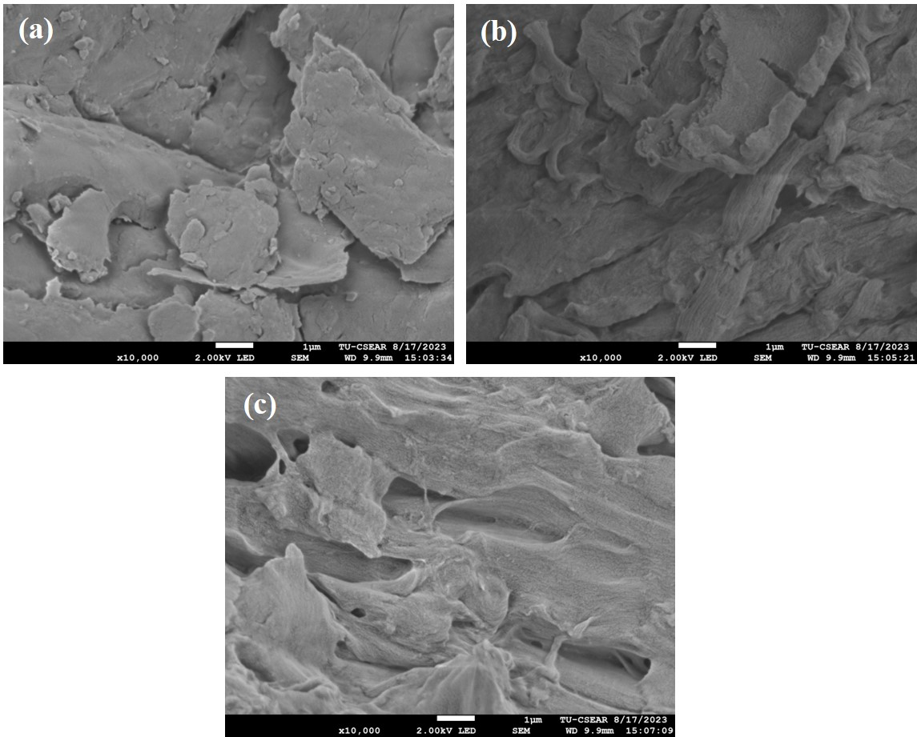
Fig. S3 FE-SEM micrographs of (a) hemp fiber and (b) MCC.

