Supplementary Information
Change of Mechanical Properties of e-PTFE Support by Electrochemical Degradation in PEMFC

Donggeun Yooª, Sohyeong Ohª, Yuhan Hanª, Jihong Jeong^{b}, Sunggi Jung^{b} and Kwonpil Park^{a†}

ª Department of Chemical Engineering, Sunchon National University 255, Jungang-ro, Suncheon-si, Jeollanam-do, 57922, Korea
^{b} SANG-A FRONTEC CO.Ltd, 369 Route 18, Namdong-ro, Namdong-gu, Incheon, 21629, Korea
† Corresponding author. E-mail: parkkp@scnu.ac.kr

The supplementary material illustrates the changes observed when extracting the e-PTFE support from an undegraded MEA. The method for extracting the support is as follows. The MEA was immersed in 2-propanol solution for 30 minutes to eliminate ionomer and catalyst. Subsequently, the e-PTFE support was extracted and air-dried for approximately 6 hours at room temperature and atmospheric pressure.

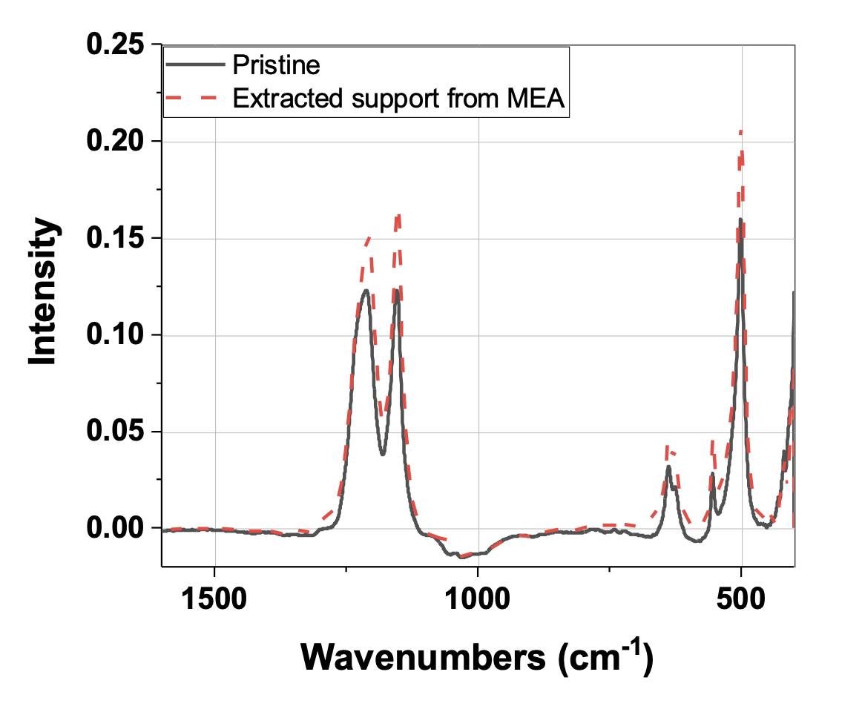
Fig. S1. Changes in FT-IR spectrum of the extracted e-PTFE support

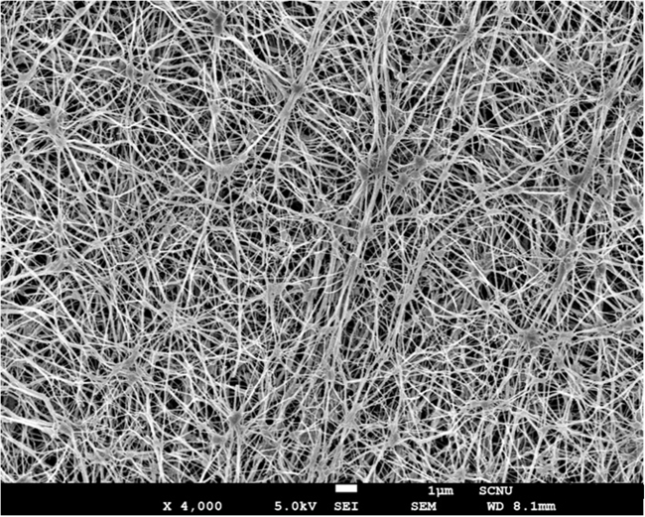 | 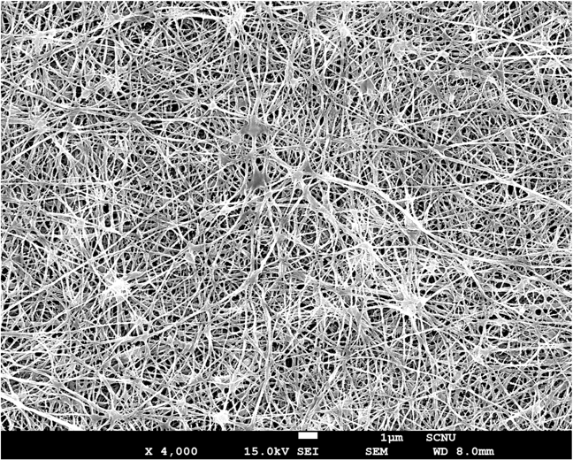
(a) | (b)
Fig. S2. SEM images of e-PTFE support (a) pristine (b) after extraction from MEA
Discussions about Figure S2 (SEM):
After the extraction of e-PTFE support, the micropores became smaller, and the spacing between nodes and fibrils narrowed, forming an even denser structure. This shrinkage occurs because propanol causes a shrinkage in the morphology of the e-PTFE [30]. Propanol solution can wet the e-PTFE support, and make the support thickness and microstructure shrinkage. Therefore, unavoidable morphological changes in the e-PTFE occur after the support extraction process.

References for e-PTFE shrinkage (S2):
[30] Wang Z, Tang H, Li J, Pan M. Morphology change of biaxially oriented polytetrafluoroethylene membranes caused by solvent soakage. J Appl Polym sci 2011;121(3):1464-1468 https://doi.org/10.1002/app.33670

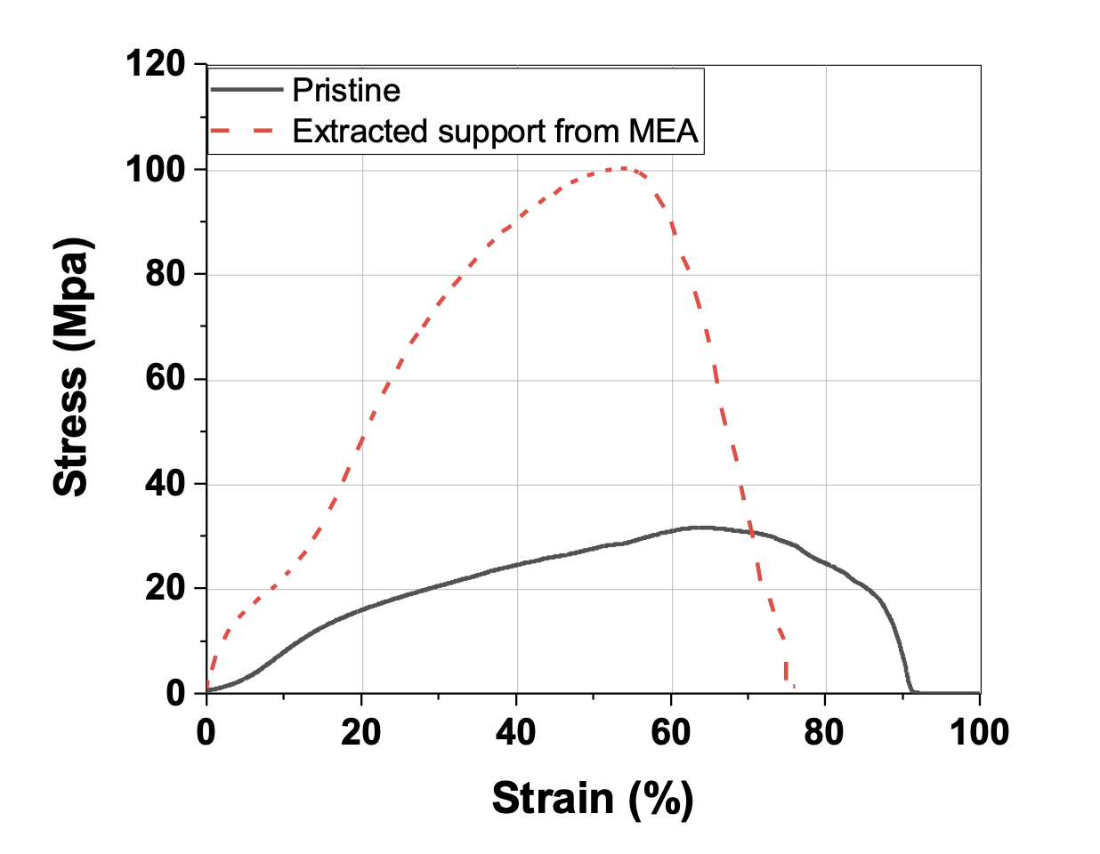
Fig. S3. Stress-Strain curve variation of e-PTFE support after extraction.

Table S1. Tensile mechanical properties.
 | Young’s Modulus  (MPa) | Yield Stress  (MPa) | Yield Strain (%) | Ultimate Stress (MPa) | Ultimate Strain (%)
Pristine | 40.8 | 1.7 | 3.2 | 31.6 | 64.4
Extracted e-PTFE | 382 | 11.3 | 2.5 | 100.2 | 54.8

Discussions about Figure S3 (Stress-strain curve):
The contraction of the support after extraction led to significant changes in the physical characteristics of the support. The overall elasticity and toughness of the support increased, and the cause of these results appears to be associated with a denser microstructure after the extraction of the support.

