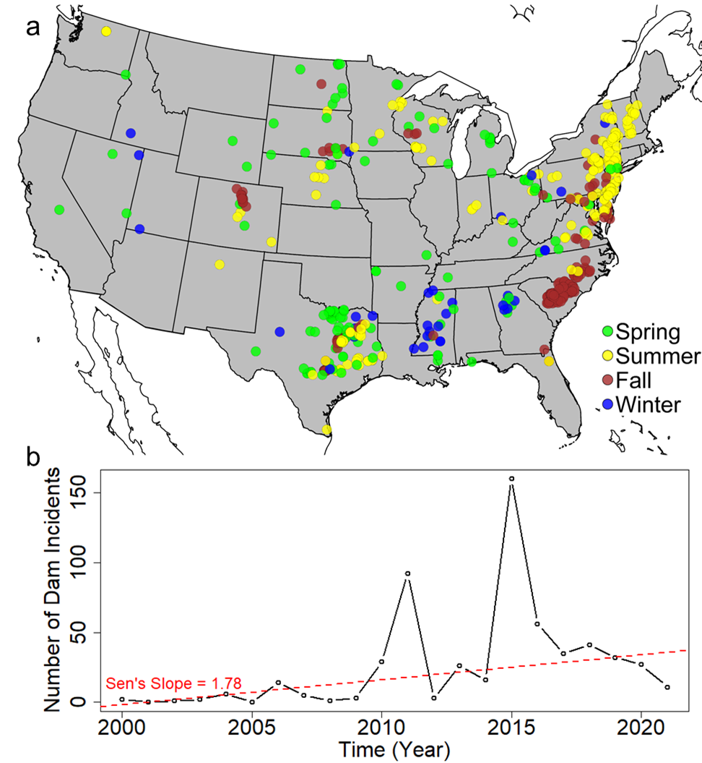
Supplementary
Figure S1. (a) Spatial distribution of dam incidents categorized by season. Incidents occurred during March – May are categorized as spring incidents, June – August as summer incidents, September – November as fall incidents, and December – January as winter season, and (b) annual number of dam incidents reported. The red dashed line indicates the robust linear trend in the annual number of dam incidents (Sen’s slope = 1.78, p-value = 0.001).

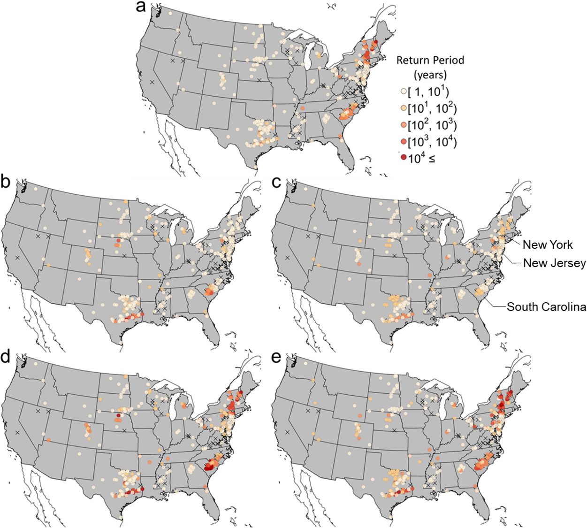
Figure S2. Return periods of (a) one-day maximum precipitation, A* (b) 5-day precedent precipitation total, K₅* (c) 30-day precedent precipitation total, K₃₀* (d) joint occurrence of one-day maximum precipitation and 5-day precedent precipitation total, (A*,K₅*) and (e) joint occurrence of one-day maximum precipitation and 30-day precedent precipitation total (A*,K₃₀*) observed during the incidents. The exceedance probabilities are evaluated from the local model at each dam’s construction year. Dams lacking construction-year information are marked with an 'X' symbol.
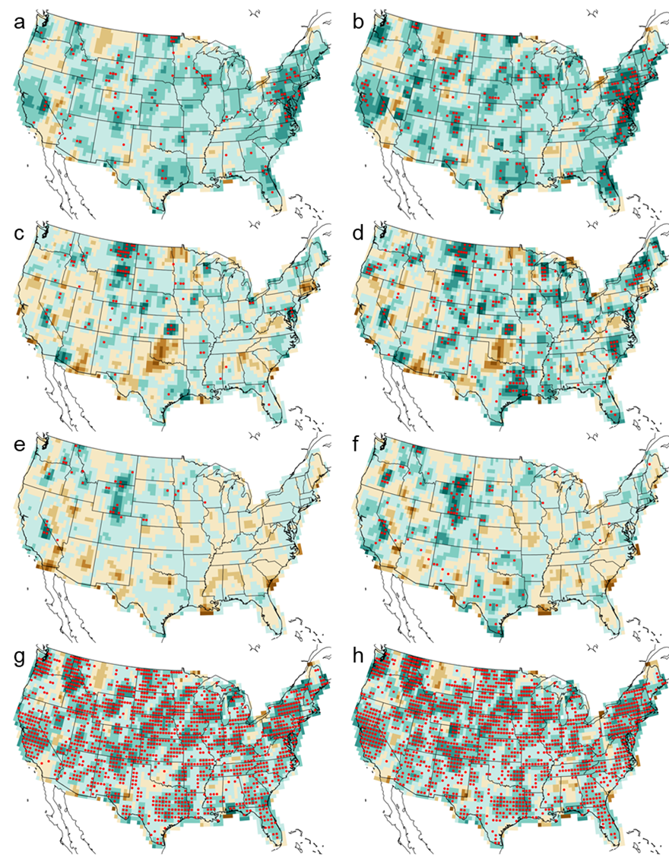
Figure S3. Same as Figures 3 and 4 but showing the spatial distribution of significant trends. The color schemes in (a) – (f) are same as figure 3, and (g) – (h) corresponds to those of Figure 4. Trends that are statistically significant at p-value < 0.05 are marked with a red circle.
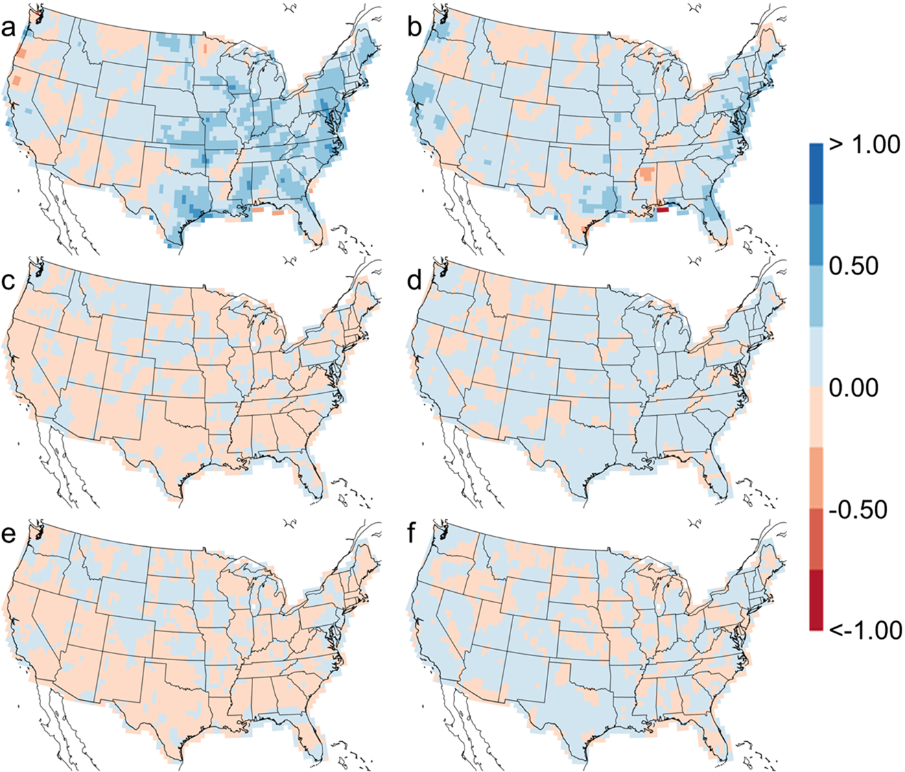
Figure S4. Linear trends in the (a) location and (b) scale parameters of the GEV distribution for annual maximum daily precipitation, A, and in the (c) location and (d) scale parameters of the G2 distribution for k-day precedent precipitation total, K, observed across the timespan from 1979 to 2021.

