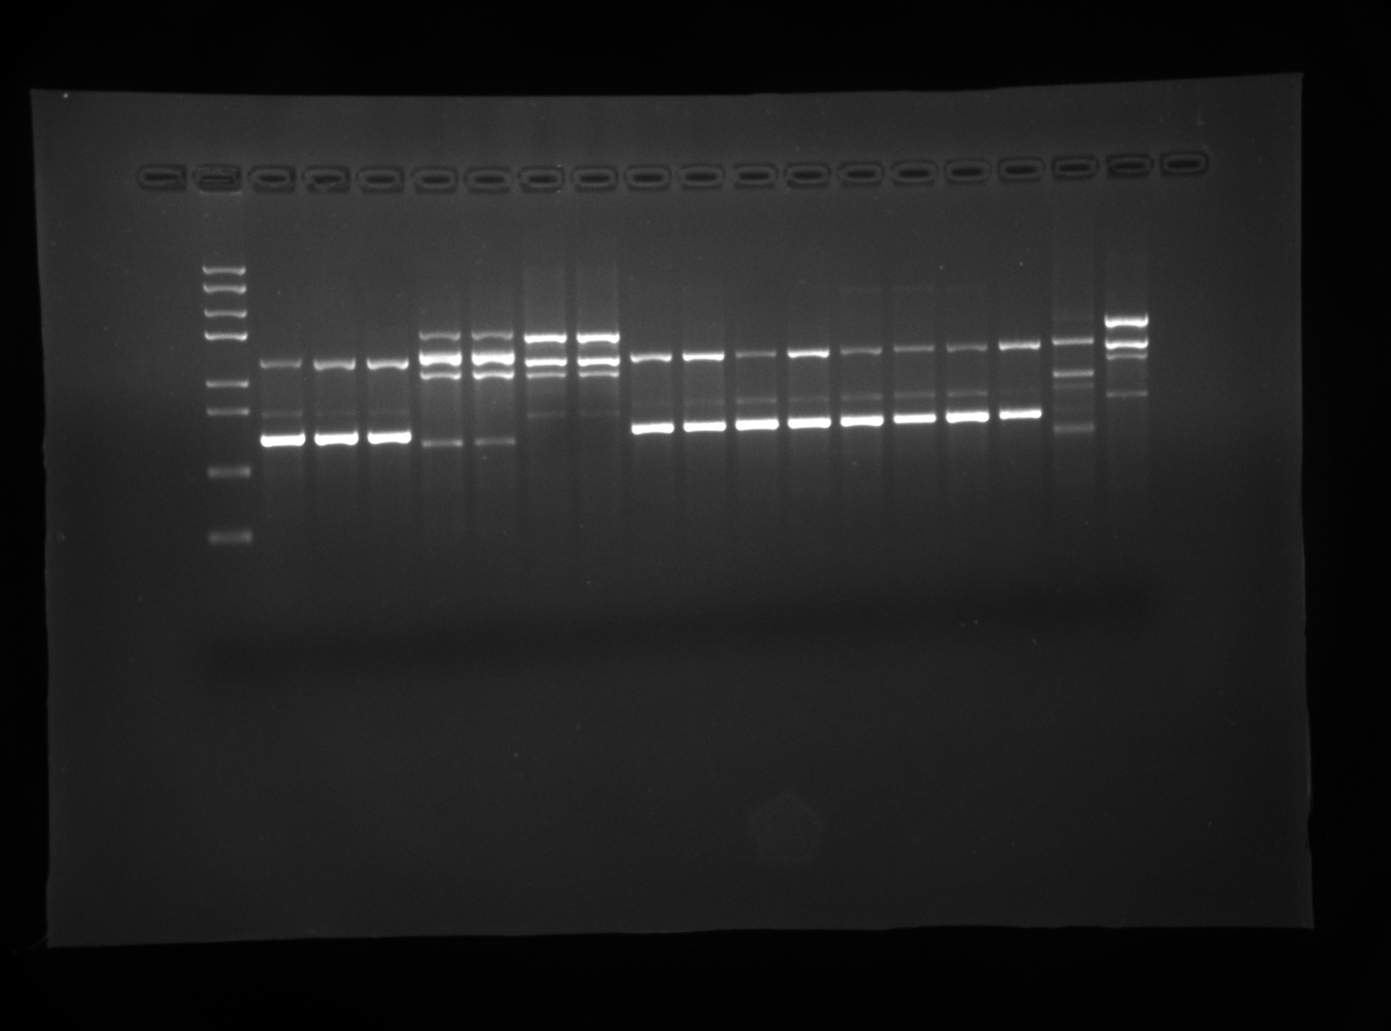
Marker
DD8
KXG-918
KXG-927
GERBILLI
EJNI-154
SD
GL
9044
KXG-XU
SC6
KXG-65
Cy
WenChuan
801
KXG-LIU
K27
SC10H2
300
800
1500
5000
L. donovani complex
L. donovani complex
Fig. 1 The RAPD profiles of 17 Leishmania strains with primer OP-AD17.
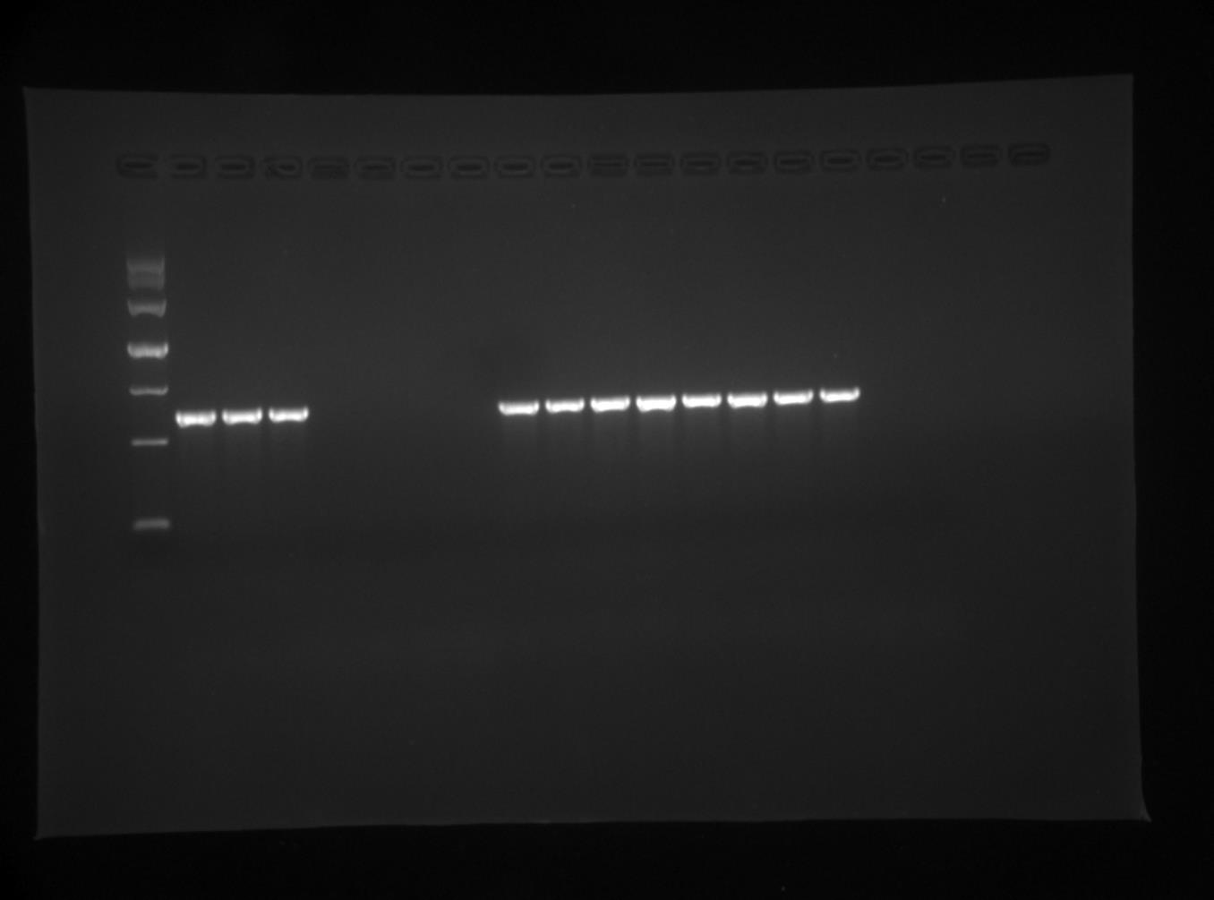
Marker
DD8
KXG-918
KXG-927
GERBILLI
EJNI-154
SD
GL
9044
KXG-XU
SC6
KXG-65
Cy
WenChuan
801
KXG-LIU
K27
SC10H2
500
800
1200
L. donovani complex
L. donovani complex
Fig. 3A. Species-specific amplification of the SCAR marker 1-AD17 to L. donovani complex.
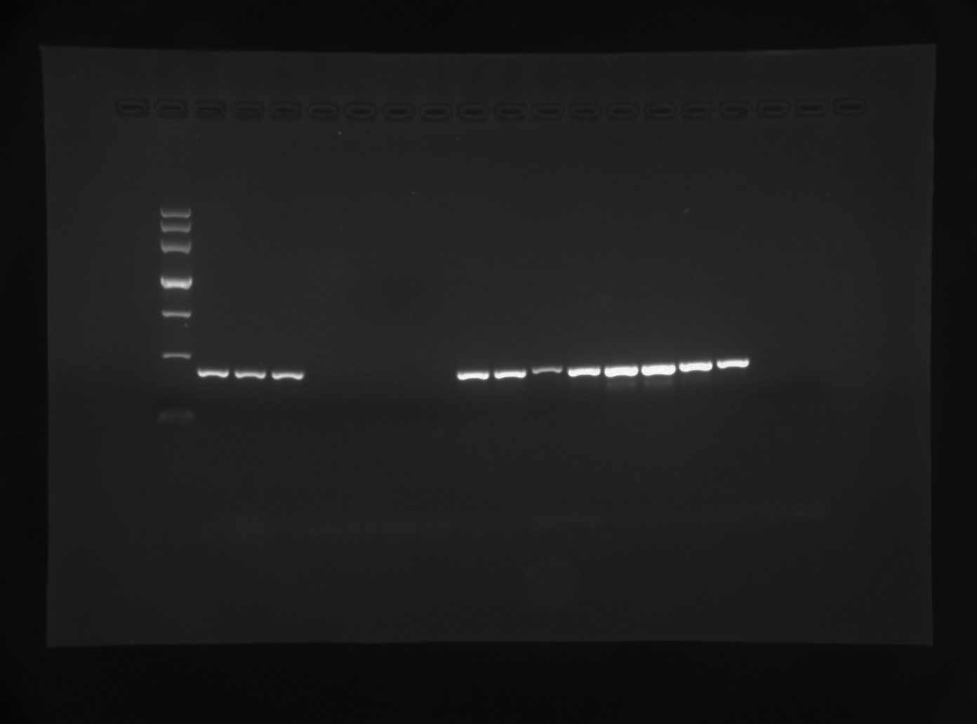
Marker
DD8
KXG-918
KXG-927
GERBILLI
EJNI-154
SD
GL
9044
KXG-XU
SC6
KXG-65
Cy
WenChuan
801
KXG-LIU
K27
SC10H2
200
500
800
L. donovani complex
L. donovani complex
Fig. 3B. Species-specific amplification of the SCAR marker 2-A816 to L. donovani complex.
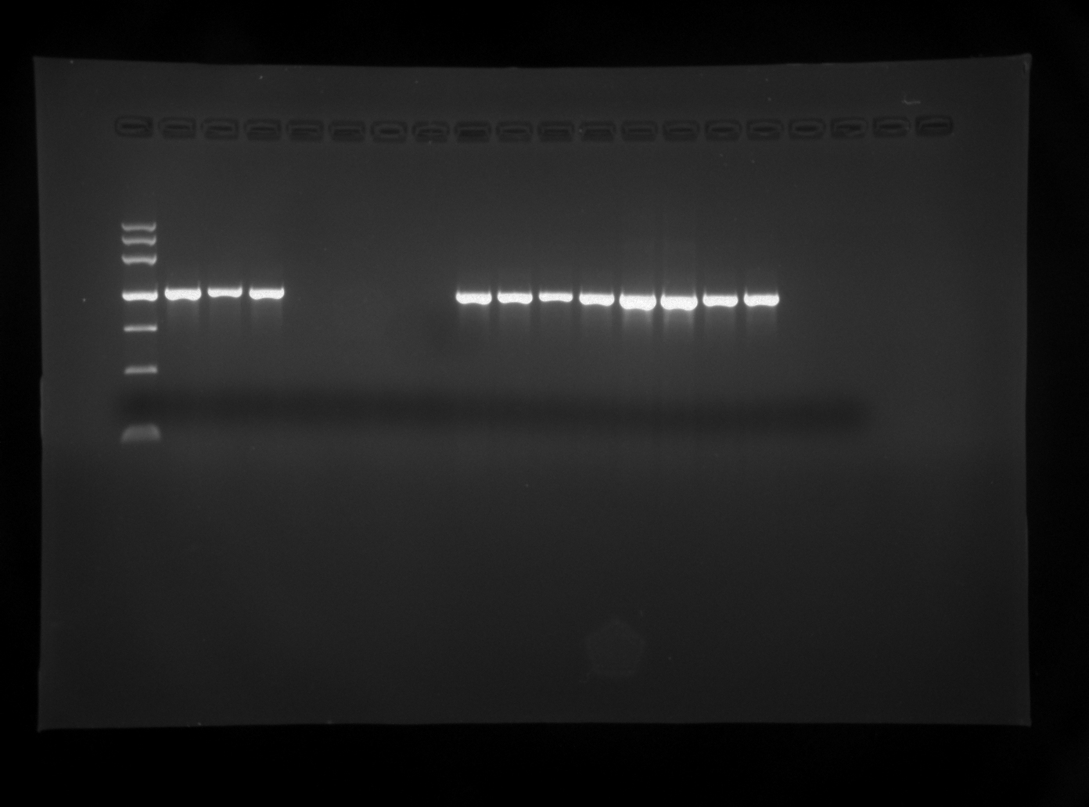
Marker
DD8
KXG-918
KXG-927
GERBILLI
EJNI-154
SD
GL
9044
KXG-XU
SC6
KXG-65
Cy
WenChuan
801
KXG-LIU
K27
SC10H2
800
1200
2000
L. donovani complex
L. donovani complex
Fig. 3C. Species-specific amplification of the SCAR marker 3-O13 to L. donovani complex.

