Table 1SPNs used for MR analysis
Breakfast skipping on AD
SNP | effect_allele | other_allele | beta | se | Pvalue
rs10123348 | T | C | 0.0140465 | 0.00269281 | 1.90E-07
rs10783243 | A | G | 0.0137171 | 0.00268422 | 2.80E-07
rs136519 | T | C | 0.0145331 | 0.00272997 | 9.50E-08
rs1461224 | T | G | -0.0139123 | 0.00268473 | 2.80E-07
rs2232648 | T | C | 0.0148869 | 0.00287024 | 2.00E-07
rs35107470 | G | A | 0.0185142 | 0.00295277 | 3.50E-10
rs4410790 | C | T | 0.0152078 | 0.00278119 | 6.10E-08
rs4797242 | A | C | -0.0153949 | 0.00292983 | 1.40E-07
rs610758 | C | T | -0.0140288 | 0.00273 | 2.80E-07
rs637174 | A | G | 0.0160872 | 0.00286341 | 1.80E-08
rs6986473 | T | C | 0.0174778 | 0.00321128 | 4.20E-08
rs8097544 | G | A | 0.0325517 | 0.00382144 | 1.80E-17
rs9320747 | G | T | -0.0146306 | 0.00270045 | 6.90E-08
rs953754 | A | G | 0.0138289 | 0.00268895 | 2.40E-07
Breakfast skipping on ADHD
rs10123348 | T | C | 0.0140465 | 0.00269281 | 1.90E-07
rs10783243 | A | G | 0.0137171 | 0.00268422 | 2.80E-07
rs136519 | T | C | 0.0145331 | 0.00272997 | 9.50E-08
rs1461224 | T | G | -0.0139123 | 0.00268473 | 2.80E-07
rs2232648 | T | C | 0.0148869 | 0.00287024 | 2.00E-07
rs35107470 | G | A | 0.0185142 | 0.00295277 | 3.50E-10
rs4410790 | C | T | 0.0152078 | 0.00278119 | 6.10E-08
rs4797242 | A | C | -0.0153949 | 0.00292983 | 1.40E-07
rs610758 | C | T | -0.0140288 | 0.00273 | 2.80E-07
rs8097544 | G | A | 0.0325517 | 0.00382144 | 1.80E-17
rs9320747 | G | T | -0.0146306 | 0.00270045 | 6.90E-08
rs953754 | A | G | 0.0138289 | 0.00268895 | 2.40E-07
Breakfast skipping on BD
rs10123348 | T | C | 0.0140465 | 0.00269281 | 1.90E-07
rs10783243 | A | G | 0.0137171 | 0.00268422 | 2.80E-07
rs136519 | T | C | 0.0145331 | 0.00272997 | 9.50E-08
rs1461224 | T | G | -0.0139123 | 0.00268473 | 2.80E-07
rs2232648 | T | C | 0.0148869 | 0.00287024 | 2.00E-07
rs35107470 | G | A | 0.0185142 | 0.00295277 | 3.50E-10
rs4410790 | C | T | 0.0152078 | 0.00278119 | 6.10E-08
rs4797242 | A | C | -0.0153949 | 0.00292983 | 1.40E-07
rs610758 | C | T | -0.0140288 | 0.00273 | 2.80E-07
rs637174 | A | G | 0.0160872 | 0.00286341 | 1.80E-08
rs6986473 | T | C | 0.0174778 | 0.00321128 | 4.20E-08
rs8097544 | G | A | 0.0325517 | 0.00382144 | 1.80E-17
rs953754 | A | G | 0.0138289 | 0.00268895 | 2.40E-07
Breakfast skipping on MDD
rs10783243 | A | G | 0.0137171 | 0.00268422 | 2.80E-07
rs136519 | T | C | 0.0145331 | 0.00272997 | 9.50E-08
rs1461224 | T | G | -0.0139123 | 0.00268473 | 2.80E-07
rs193084249 | G | A | -0.0472742 | 0.00891598 | 1.10E-07
rs2232648 | T | C | 0.0148869 | 0.00287024 | 2.00E-07
rs35107470 | G | A | 0.0185142 | 0.00295277 | 3.50E-10
rs4410790 | C | T | 0.0152078 | 0.00278119 | 6.10E-08
rs4797242 | A | C | -0.0153949 | 0.00292983 | 1.40E-07
rs610758 | C | T | -0.0140288 | 0.00273 | 2.80E-07
rs6986473 | T | C | 0.0174778 | 0.00321128 | 4.20E-08
rs8097544 | G | A | 0.0325517 | 0.00382144 | 1.80E-17
rs9320747 | G | T | -0.0146306 | 0.00270045 | 6.90E-08
rs953754 | A | G | 0.0138289 | 0.00268895 | 2.40E-07
Breakfast skipping on narcolepsy
rs10783243 | A | G | 0.0137171 | 0.00268422 | 2.80E-07
rs11570072 | G | A | 0.0181333 | 0.00358926 | 4.60E-07
rs136519 | T | C | 0.0145331 | 0.00272997 | 9.50E-08
rs1461224 | T | G | -0.0139123 | 0.00268473 | 2.80E-07
rs193084249 | G | A | -0.0472742 | 0.00891598 | 1.10E-07
rs2232648 | T | C | 0.0148869 | 0.00287024 | 2.00E-07
rs4797242 | A | C | -0.0153949 | 0.00292983 | 1.40E-07
rs610758 | C | T | -0.0140288 | 0.00273 | 2.80E-07
rs637174 | A | G | 0.0160872 | 0.00286341 | 1.80E-08
rs6986473 | T | C | 0.0174778 | 0.00321128 | 4.20E-08
rs73046569 | A | G | -0.0343799 | 0.00653188 | 1.50E-07
rs8097544 | G | A | 0.0325517 | 0.00382144 | 1.80E-17
rs9320747 | G | T | -0.0146306 | 0.00270045 | 6.90E-08
rs953754 | A | G | 0.0138289 | 0.00268895 | 2.40E-07
Breakfast skipping on cognitive performance
rs10123348 | T | C | 0.0140465 | 0.00269281 | 1.90E-07
rs10783243 | A | G | 0.0137171 | 0.00268422 | 2.80E-07
rs1461224 | T | G | -0.0139123 | 0.00268473 | 2.80E-07
rs2232648 | T | C | 0.0148869 | 0.00287024 | 2.00E-07
rs35107470 | G | A | 0.0185142 | 0.00295277 | 3.50E-10
rs4410790 | C | T | 0.0152078 | 0.00278119 | 6.10E-08
rs4797242 | A | C | -0.0153949 | 0.00292983 | 1.40E-07
rs610758 | C | T | -0.0140288 | 0.00273 | 2.80E-07
rs6986473 | T | C | 0.0174778 | 0.00321128 | 4.20E-08
rs8097544 | G | A | 0.0325517 | 0.00382144 | 1.80E-17
rs953754 | A | G | 0.0138289 | 0.00268895 | 2.40E-07
Breakfast skipping on frailty
rs10123348 | T | C | 0.0140465 | 0.00269281 | 1.90E-07
rs10783243 | A | G | 0.0137171 | 0.00268422 | 2.80E-07
rs136519 | T | C | 0.0145331 | 0.00272997 | 9.50E-08
rs1461224 | T | G | -0.0139123 | 0.00268473 | 2.80E-07
rs2232648 | T | C | 0.0148869 | 0.00287024 | 2.00E-07
rs35107470 | G | A | 0.0185142 | 0.00295277 | 3.50E-10
rs4410790 | C | T | 0.0152078 | 0.00278119 | 6.10E-08
rs4797242 | A | C | -0.0153949 | 0.00292983 | 1.40E-07
rs610758 | C | T | -0.0140288 | 0.00273 | 2.80E-07
rs637174 | A | G | 0.0160872 | 0.00286341 | 1.80E-08
rs6986473 | T | C | 0.0174778 | 0.00321128 | 4.20E-08
rs8097544 | G | A | 0.0325517 | 0.00382144 | 1.80E-17
rs9320747 | G | T | -0.0146306 | 0.00270045 | 6.90E-08
rs953754 | A | G | 0.0138289 | 0.00268895 | 2.40E-07

Fig 1 Seven outcome datasets's forest map

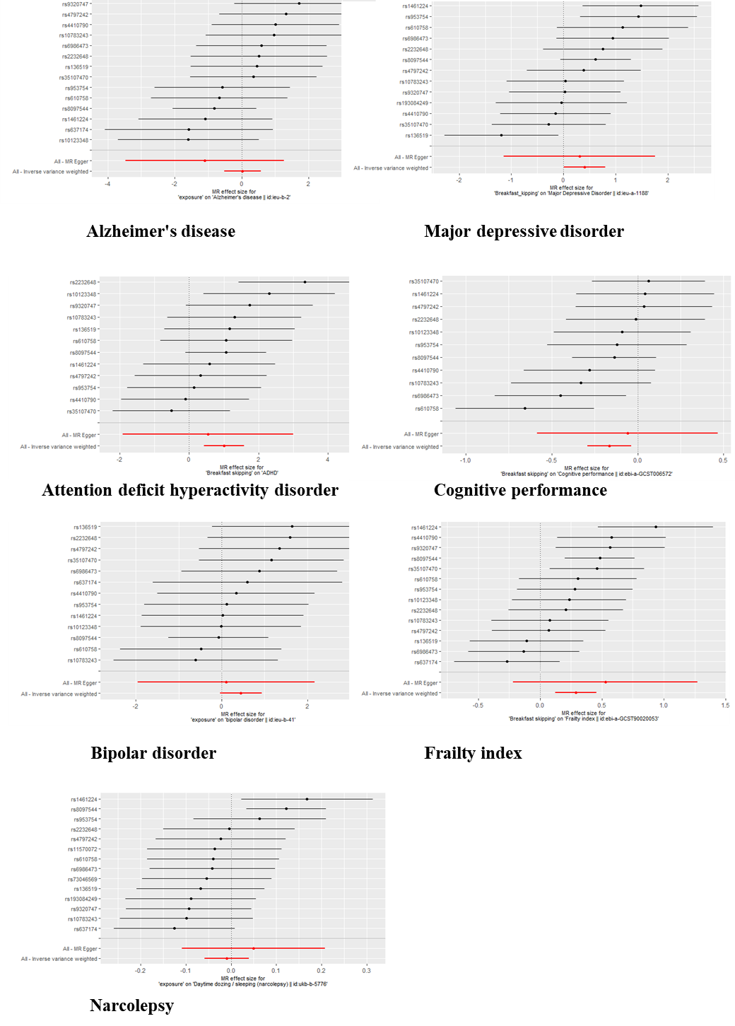

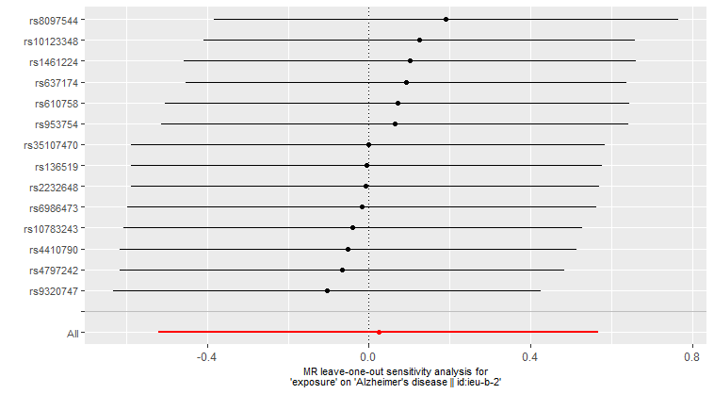
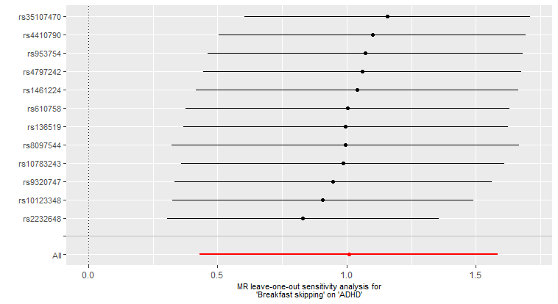
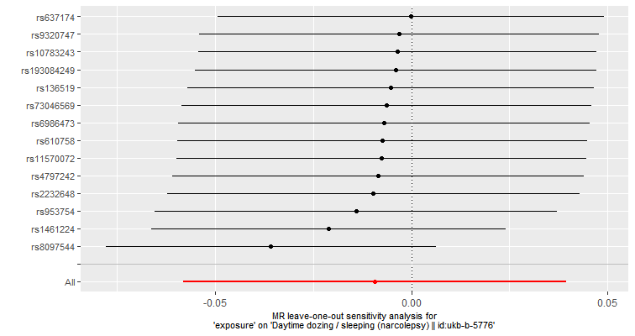
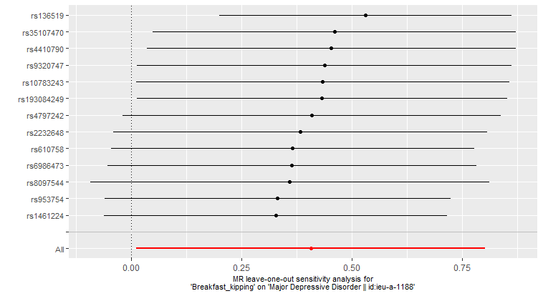
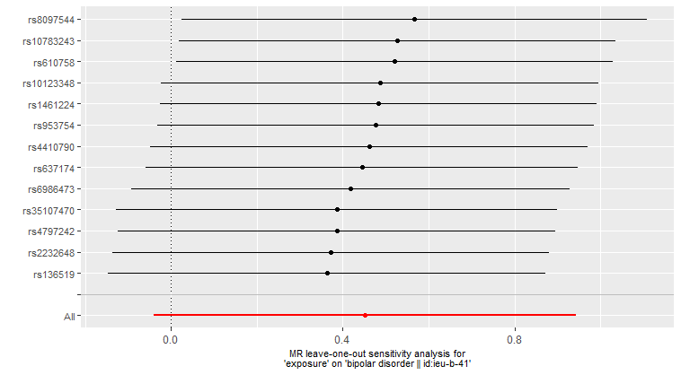
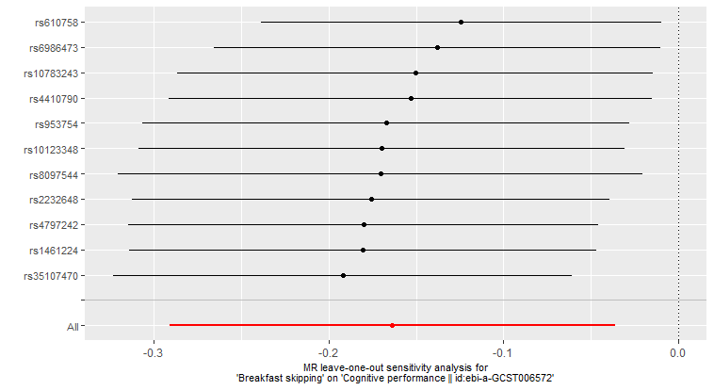
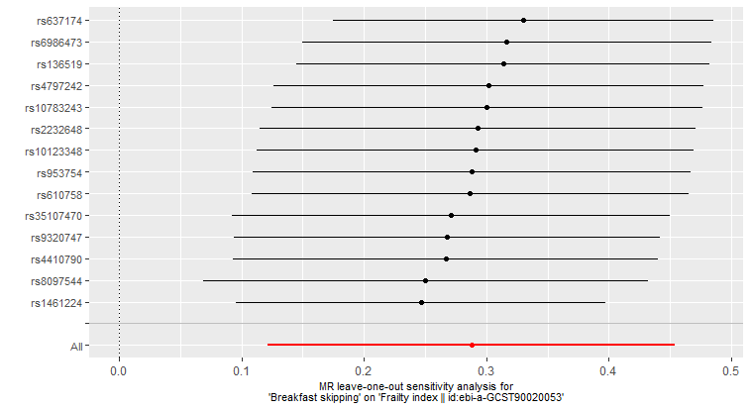
Fig 2 The Leave one method diagram of seven outcome datasets

Alzheimer's disease
Major depressive disorder
Attention deficit hyperactivity disorder
Cognitive performance
Bipolar disorder
Frailty index
Narcolepsy

