Impact of mechanical power on mortality in ventilated critically ill patients. A retrospective study with continuous real-life data
Manrique S^{1,2#*}, Ruiz-Botella M^{1,3*}, Natalia M¹, Canelles S¹, Victoria ID¹, Samper MA^{1,} Plans O¹, Claverias L¹ ,Magret M¹, Gordo F⁴, Roca O^{5,6} and Bodí M^{1,2,6}.

Supplementary material

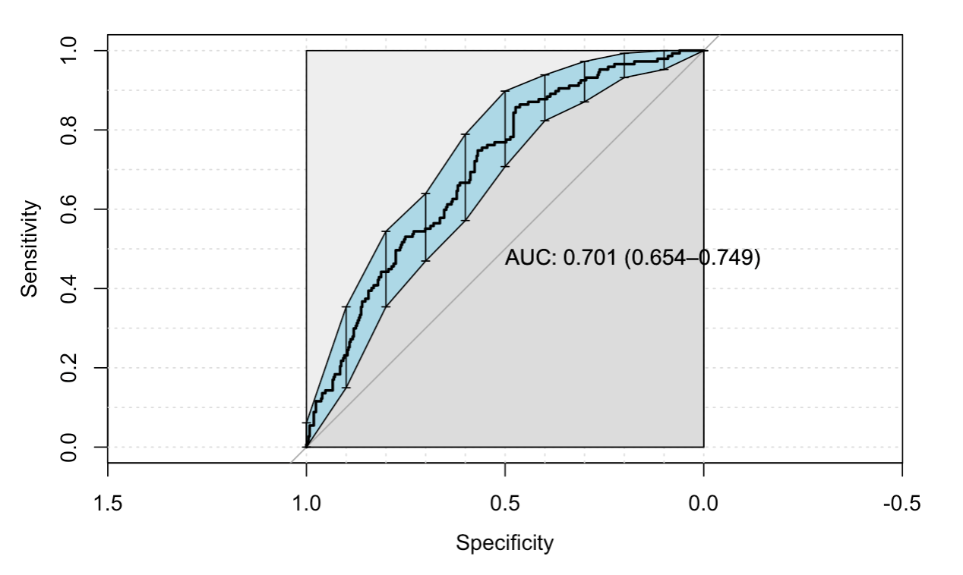
e-Figure 1. Area under the curve multivariate model of mortality. Total study population

e-Figure 2. Pearson correlation between hours of mechanical power >18J/min and invasive mechanical ventilation days
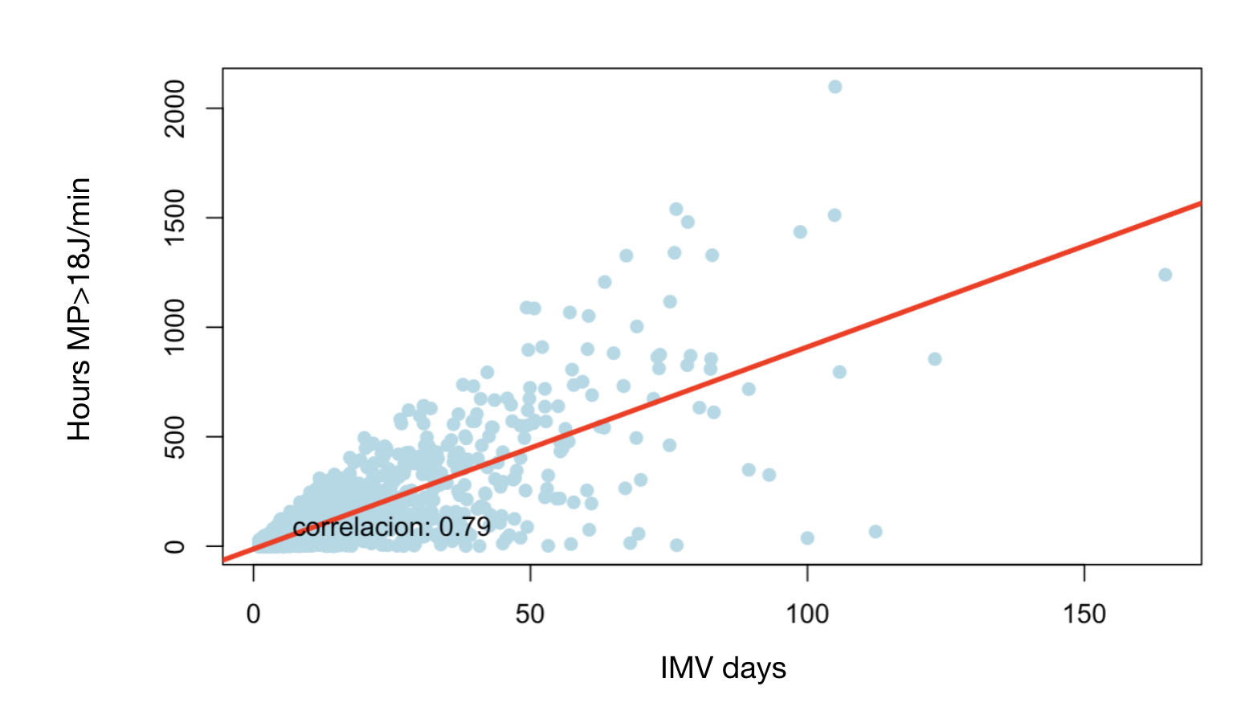
MP = Mechanical Power; IMV = Invasive Mechanical Ventilation

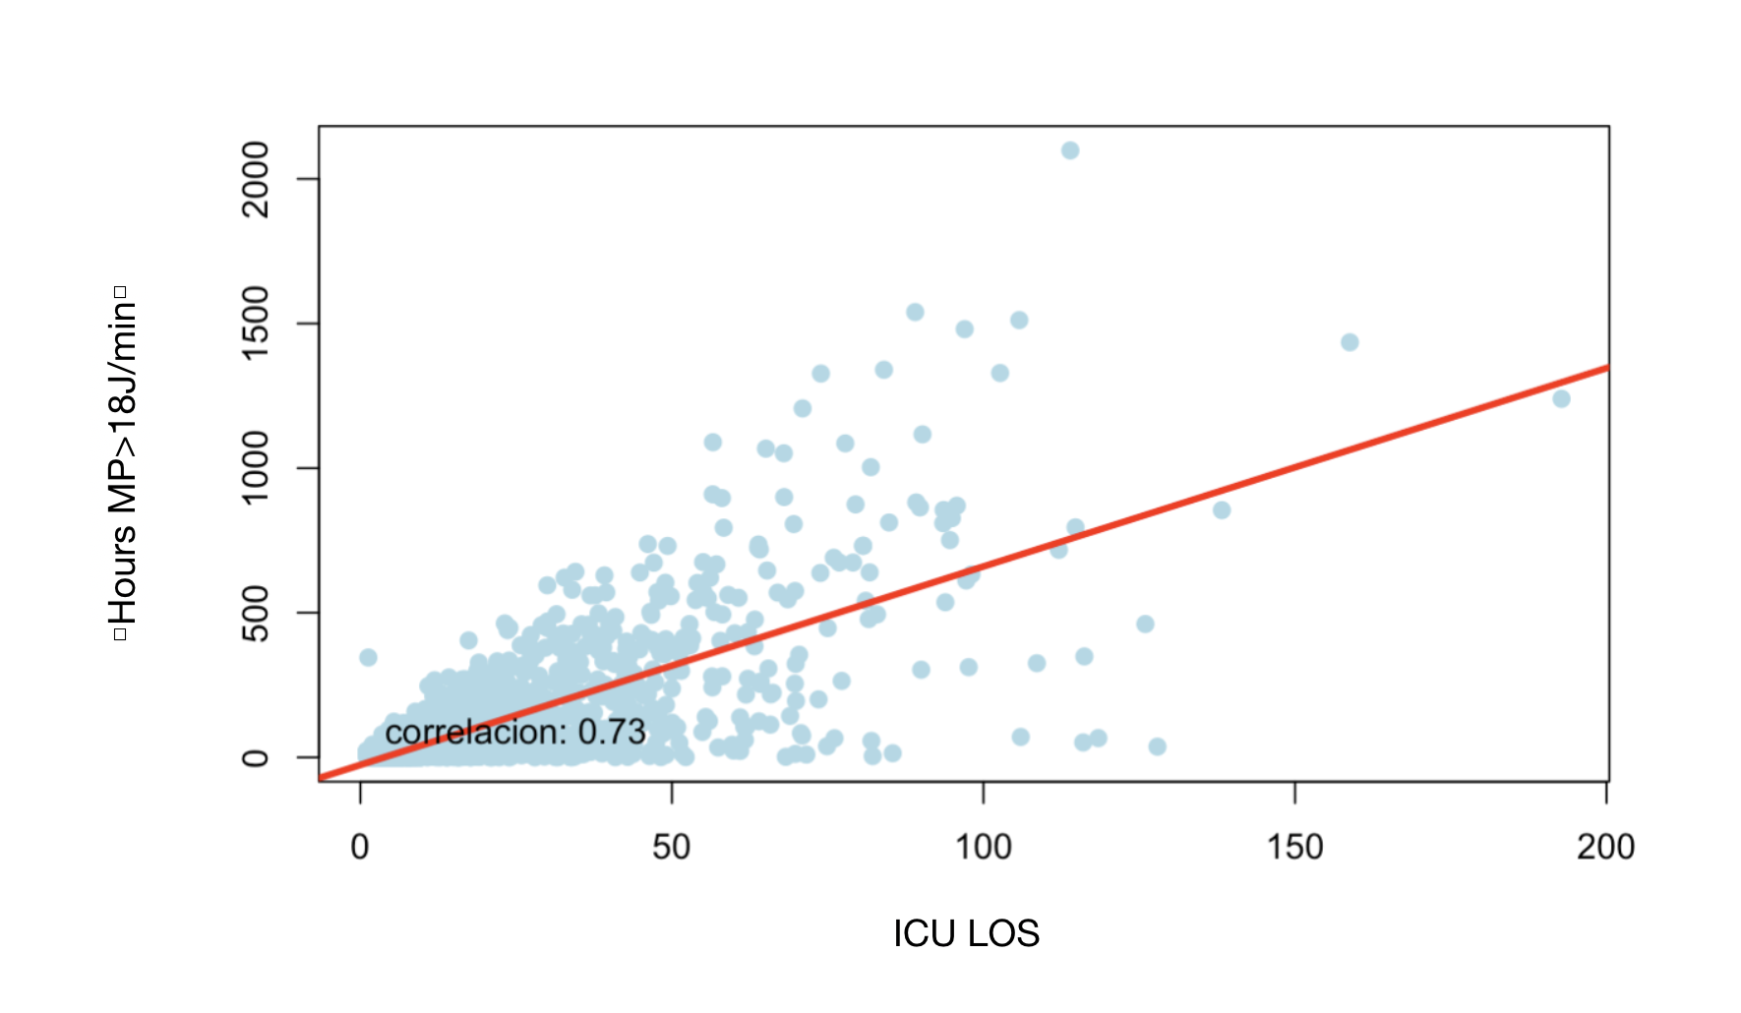
e-Figure 3. Pearson correlation between hours of mechanical power >18J/min and intensive care unit length of stay
MP = mechanical power, ICU LOS= intensive care unit length of stay

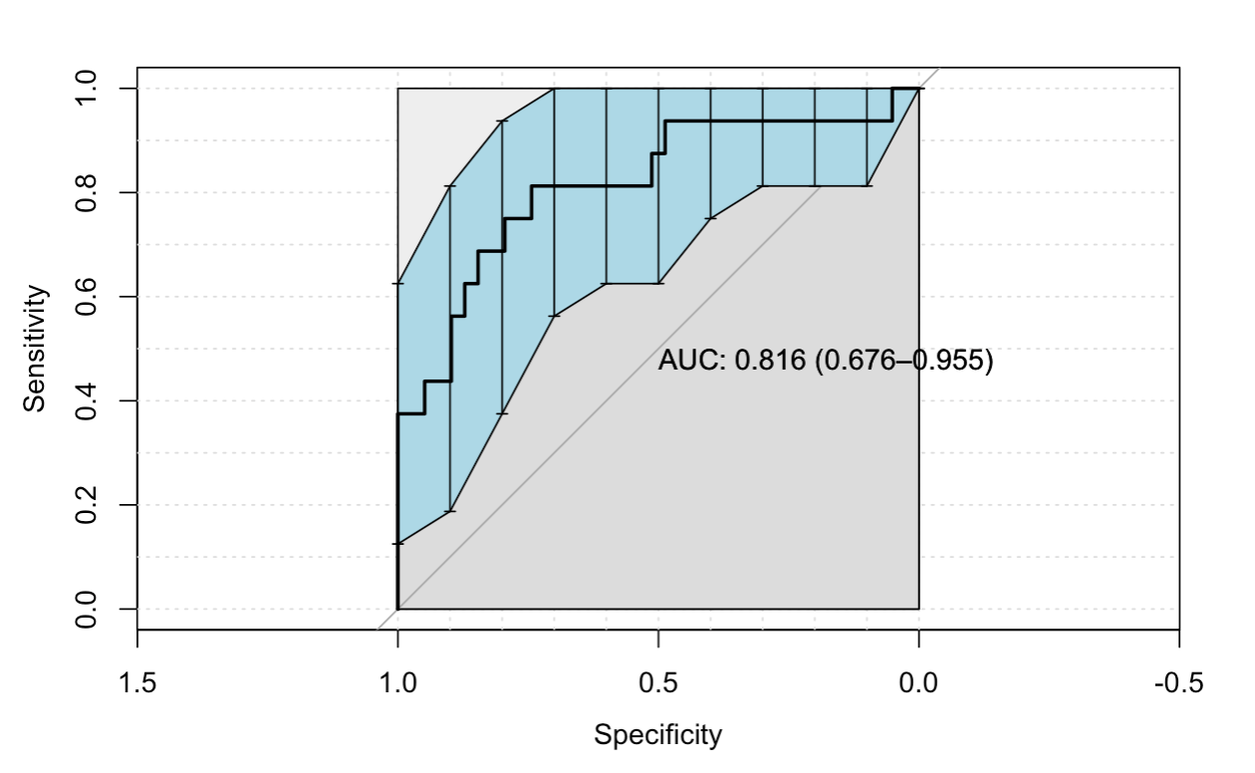
e-Figure 4. Area under the curve multivariate model of mortality. Patients with SARS CoV 2 pneumonia

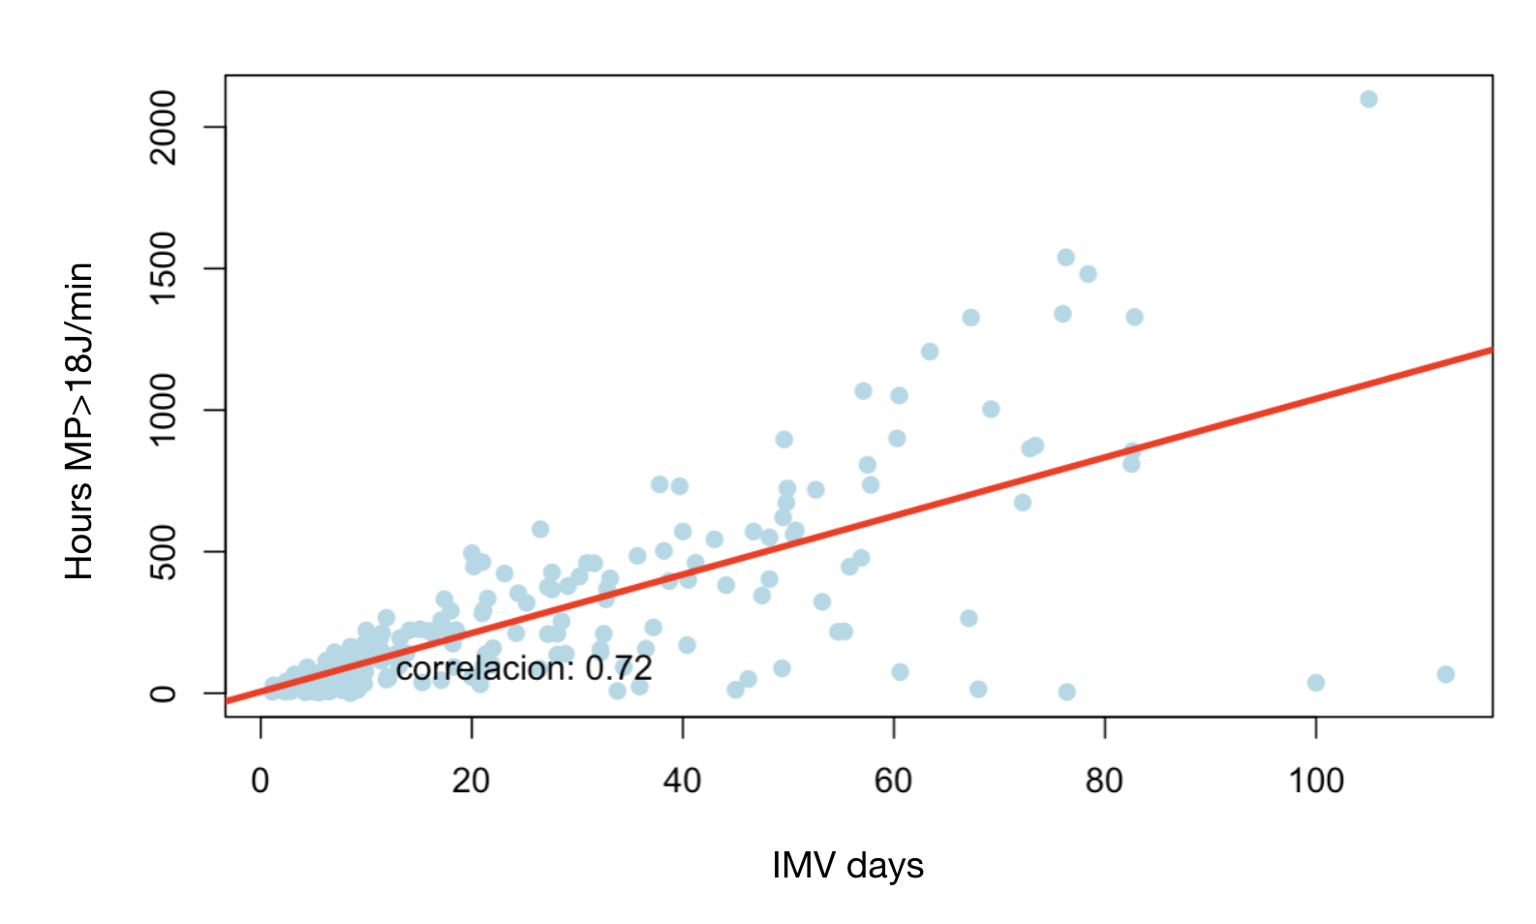
e-Figure 5. Pearson correlation between hours of mechanical power >18 J/min and invasive mechanical ventilation days. Patients with SARS CoV-2 pneumonia

MP = mechanical power, IMV= invasive mechanical ventilation
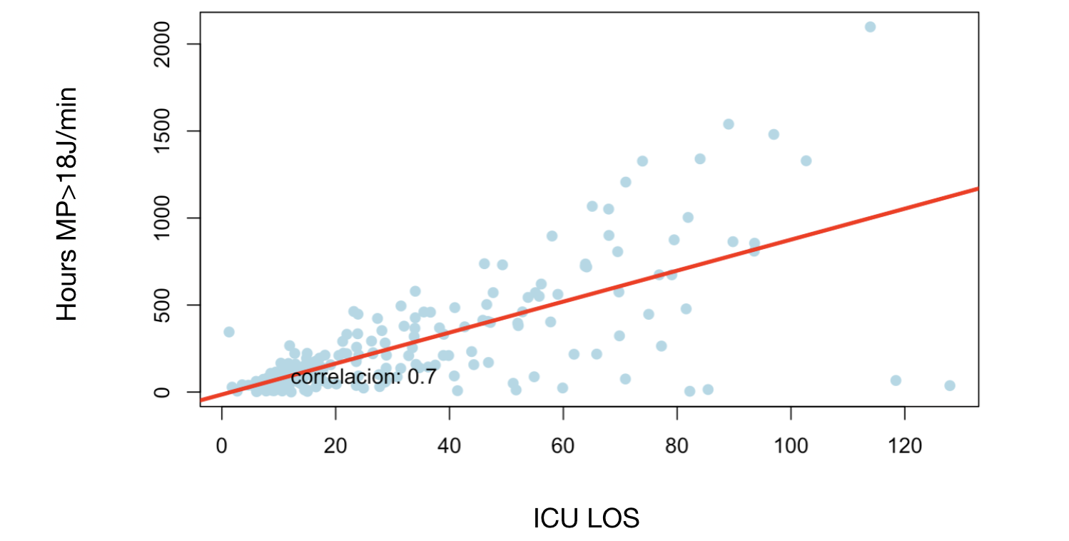
e-Figure 6. Pearson correlation between hours of mechanical power >18 J/min and intensive care unit days of stay

MP = mechanical power, ICU LOS = intensive care unit length of stay
e-Table 1. Univariate mortality analysis- Non-hypoxemic patients

Variable | Died in the ICU  (n=17) | Survived in the ICU  (n=50) | P values
General characteristics and severity of the illness
Male, n (%) | 9 (53) | 32 (64) | 0.6
Age, in years, median (p25-75) | 64 (59-72) | 59 (48-65) | 0.1
BMI, median (p25-75) | 26 (23-28) | 25 (24-27) | 0.8
SOFA, median (p25-75) | 5 (4-6) | 4 (3-5) | 0.03
APACHE II, median (p25-75) | 21 (14-25) | 19 (14-25) | 0.8
Reason for admission, n (%) | Medical 12 (71)  Surgical 5 (29) | Medical 26 (52)  Surgical 24 (48) | 0.3
Type of admission, n (%) | Urgent 17 (100)  Scheduled 0 (0) | Urgent 46 (92)  Scheduled 4 (8) | 0.6
Comorbidities
Hypertension, n (%) | 5 (29) | 11 (22) | 0.5
Diabetes, n (%) | 1 (6) | 6 (12) | 0.7
Chronic heart failure, n (%) | 1 (6) | 1 (2) | 0.4
Chronic lung disease, n (%) | 1 (6) | 1 (2) | 0.4
Asthma, n (%) | 0 (0) | 1 (2) | 1
Chronic kidney disease, n (%) | 1 (6) | 1 (2) | 0.4
Reintubation, n (%) | 2 (12) | 4 (8) | 0.6
Ventilatory variables
Hours with MP >18 J/min, median (p25-p75) | 56 (6-222) | 7 (1-35) | 0.02
Hours with TV >8 ml/KgPBW, median median (p25-p75) | 58 (39-218) | 25 (5-70) | 0.01

BMI = body mass index; SOFA = Sequential Organ Failure Assessment; APACHE = Acute Physiology and Chronic Health Evaluation; ICU= intensive care unit, MP = mechanical power; Vt = tidal volume; PBW = predicted body weight
e-Table 2. Univariate mortality analysis. Mild hypoxemic patients
Variable | Died in the ICU  (n=305) | Survived in the ICU  (n=954) | P values
General characteristics and severity of the illness
Male, n (%) | 206 (67) | 630 (66) | 0.7
Age (years) median median (p25-p75) | 68 (59-74) | 61 (48-71) | < 0.001
BMI, median median (p25-p75) | 26 (24-29) | 26 (24-29) | 0.2
SOFA, median (p25-75) | 6 (5-8) | 5 (3-6) | < 0.001
APACHE II, median (p25-75) | 24 (19-29) | 19 (14-24) | < 0.001
Reason for admission, n (%) | Medical 204 (67)  Surgical 101 (33) | Medical 525 (55)  Surgical 429 (45) | < 0.001
Type of admission, n (%) | Urgent 296 (97)  Scheduled 9 (3) | Urgent 884 (93)  Scheduled 70 (7) | 0.01
Comorbidities
Hypertension, n (%) | 107 (35) | 241 (25) | 0.001
Diabetes, n (%) | 44 (14) | 103 (11) | 0.1
Chronic heart failure, n (%) | 14 (5) | 34 (4) | 0.5
Chronic lung disease, n (%) | 15 (5) | 40 (4) | 0.7
Asthma, n (%) | 3 (1) | 15 (2) | 0.6
Chronic kidney disease, n (%) | 26 (8) | 28 (3) | < 0.001
Reintubation, n (%) | 23 (8) | 87 (9) | 0.5
Ventilatory variables
Hours with MP >18 J/min, median (p25-p75) | 17 (4-61) | 22 (7-93) | 0.005
Hours with TV >8 ml/KgPBW, median (p25-p75) | 62 (16-161) | 50 (18-135) | 0.4

BMI = body mass index; SOFA = Sequential Organ Failure Assessment; APACHE = Acute Physiology and Chronic Health Evaluation; ICU= intensive care unit, MP = mechanical power; Vt = tidal volume; PBW = predicted body weight
e-Table 3. Univariate mortality analysis. Moderate hypoxemic patients
Variable | Died in the ICU  (n=408) | Survived in the ICU  (n=878) | P values
General characteristics and severity of illness
Male, n (%) | 296 (73) | 644 (73) | 0.8
Age (years), median (p25-75) | 67 (58-74) | 63 (51-71) | < 0.001
BMI, median (p25-75) | 28 (24-31) | 28 (25-31) | 0.1
SOFA, median (p25-75) | 7 (5-8) | 5 (4-7) | < 0.001
APACHE II, median (p25-75) | 23 (17-28) | 20 (14-25) | <0.001
Reason for admission, n (%) | Medical 358 (88)  Surgical 50 (12) | Medical 732 (83)  Surgical 146 (17) | 0.05
Type of admission, n (%) | Urgent 395 (97)  Scheduled 13 (3) | Urgent 857 (97)  Scheduled 24 (3) | 0.8
Comorbidities
Hypertension, n (%) | 162 (40) | 253 (29) | <0.001
Diabetes, n (%) | 100 (24) | 130 (15) | <0.001
Chronic heart failure, n (%) | 30 (7) | 38 (4) | 0.03
Chronic lung disease, n (%) | 48 (12) | 43 (4) | <0.001
Asthma, n (%) | 4 (1) | 14 (2) | 0.5
Chronic kidney disease, n (%) | 44 (11) | 30 (3) | <0.001
Reintubation, n (%) | 22 (5) | 73 (8) | 0.1
Ventilatory variables
Hours with MP >18 J/min, median (p25-p75) | 69 (24-223) | 61 (19-181) | 0.05
Hours with TV >8 ml/KgPBW, median (p25-p75) | 60 (17-156) | 72 (23-188) | 0.01

BMI = body mass index; SOFA = Sequential Organ Failure Assessment; APACHE = Acute Physiology and Chronic Health Evaluation; ICU= intensive care unit, MP = mechanical power; Vt = tidal volume; PBW = predicted body weight
e-Table 4: Univariate mortality analysis- Severe hypoxemic patients
Variable | Died in ICU  (n=3) | Survived in ICU  (n=8) | P Values
General characteristics and severity of illness
Male, n (%) | 3 (100) | 6 (75) | 1
Age (years), median (p25-75) | 71 (69-76) | 56 (52-74) | 0.3
BMI, median (p25-75) | 31 (28-35) | 31 (28-29) | 0.4
SOFA, median (p25-75) | 5 (4-7) | 7 (5-10) | 0.5
APACHE II, median (p25-75)a | 28 (23-33) | 19 (17-31) | 0.5
Reason for admission, n (%) | Medical 3 (100)  Surgical 0 (0) | Medical 8 (100)  Surgical 0 (0) | -
Type of admission, n (%) | Urgent 3 (100)  Scheduled 0 (0) | Urgent 8 (100)  Scheduled 0 (0) | -
Comorbidities
Hypertension, n (%) | 1 (33) | 2 (25) | 1
Diabetes, n (%) | 1 (33) | 1 (12) | 0.4
Chronic heart failure, n (%) | 0 (0) | 1 (12) | 1
Chronic lung disease, n (%) | 1 (33) | 0 (0) | 0.3
Asthma, n (%) | 0 (0) | 0 (0) | -
Chronic kidney disease, n (%) | 1 (33) | 0 (0) | 0.3
Reintubated, n (%) | 1 (33) | 1 (12) | 0.5
Ventilatory variables
Hours with MP>18 J/min, median (p25-p75) | 183 (178-264) | 79 (65-147) | 0.1
Hours with TV >8ml/KgPBW, median (p25-p75) | 106 (81-105) | 52 (11-105) | 0.3

BMI = body mass index; SOFA = Sequential Organ Failure Assessment; APACHE = Acute Physiology and Chronic Health Evaluation; ICU= intensive care unit, MP = mechanical power; Vt = tidal volume; PBW = predicted body weight
e-Figure 7. Pearson correlation hours with mechanical power >18 J/min and invasive mechanical ventilation days. Non-hypoxemic patients

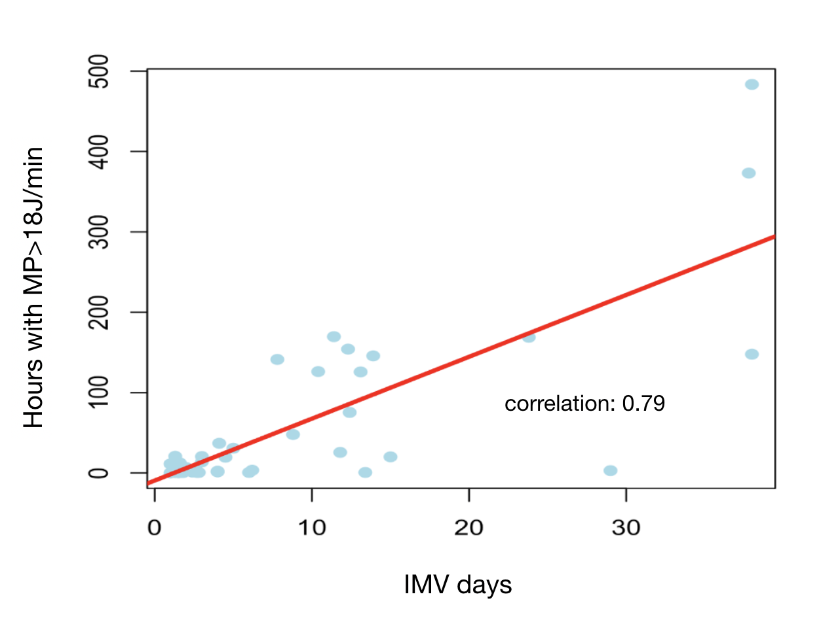
MP = mechanical power, IMV = invasive mechanical ventilation

e-Figure 8. Pearson correlation hours with mechanical power >18 J/min and invasive mechanical ventilation days. Mild hypoxemic patients
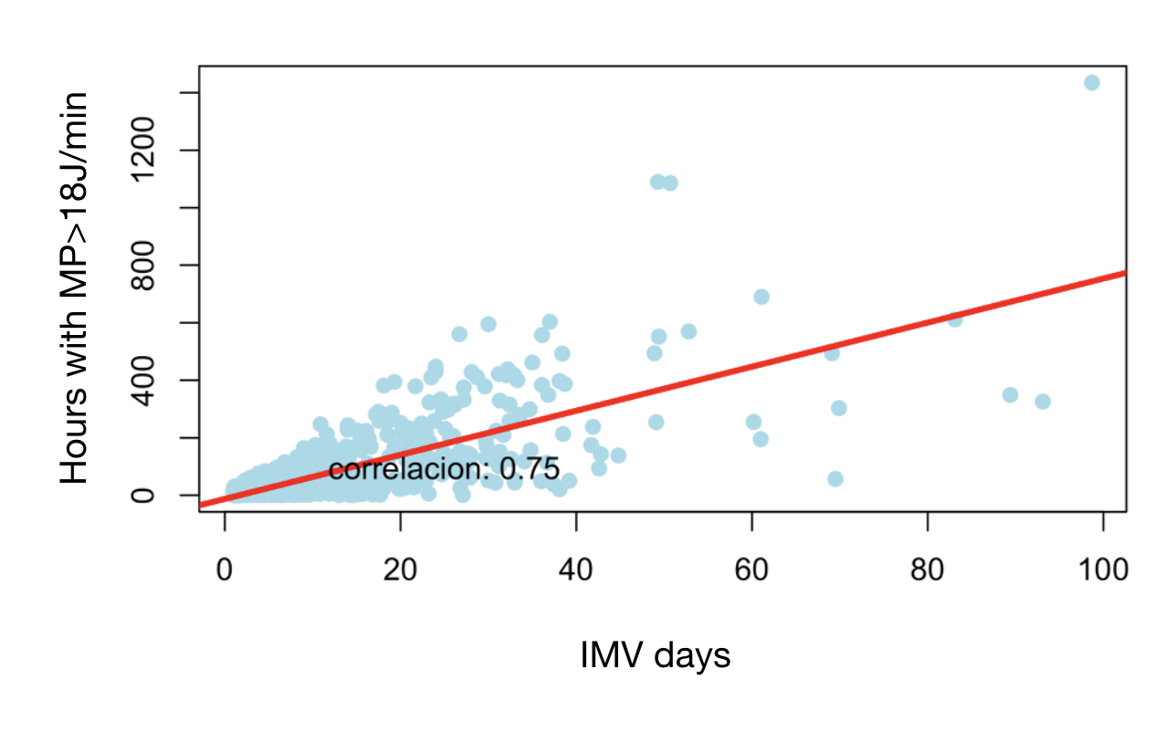
MP = mechanical power, IMV = invasive mechanical ventilation
e-Figure 9. Pearson correlation hours with mechanical power >18 J/min and invasive mechanical ventilation days. Moderate hypoxemic patients

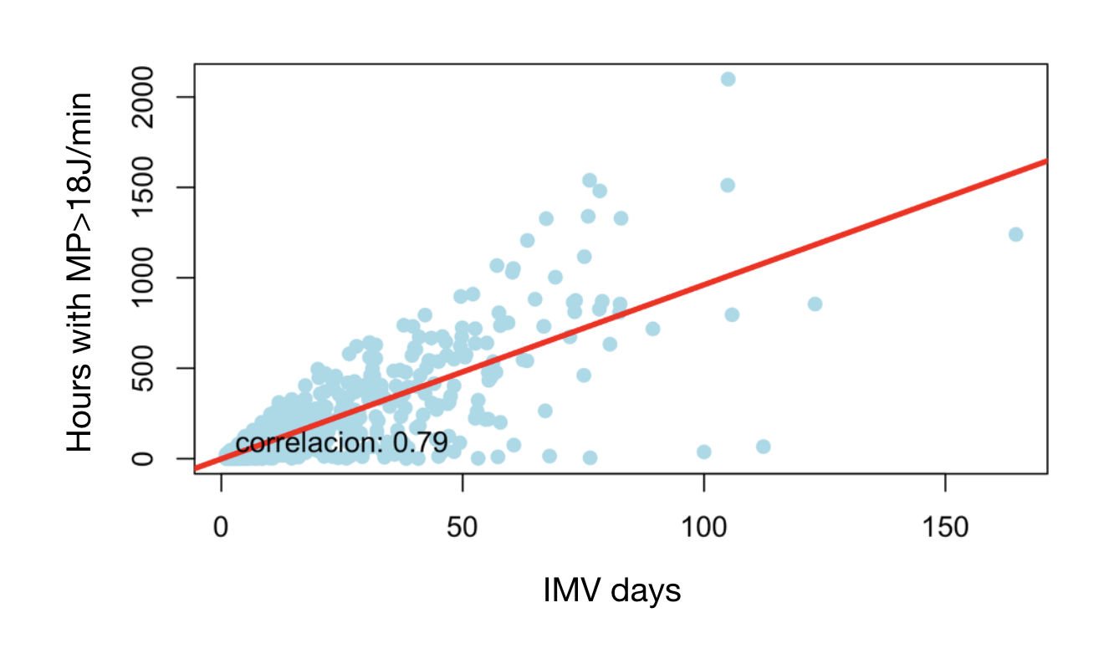

MP = mechanical power, IMV = invasive mechanical ventilation

e-Figure 10. Pearson correlation hours with mechanical power >18 J/min and invasive mechanical ventilation days. Severe hypoxemic patients.

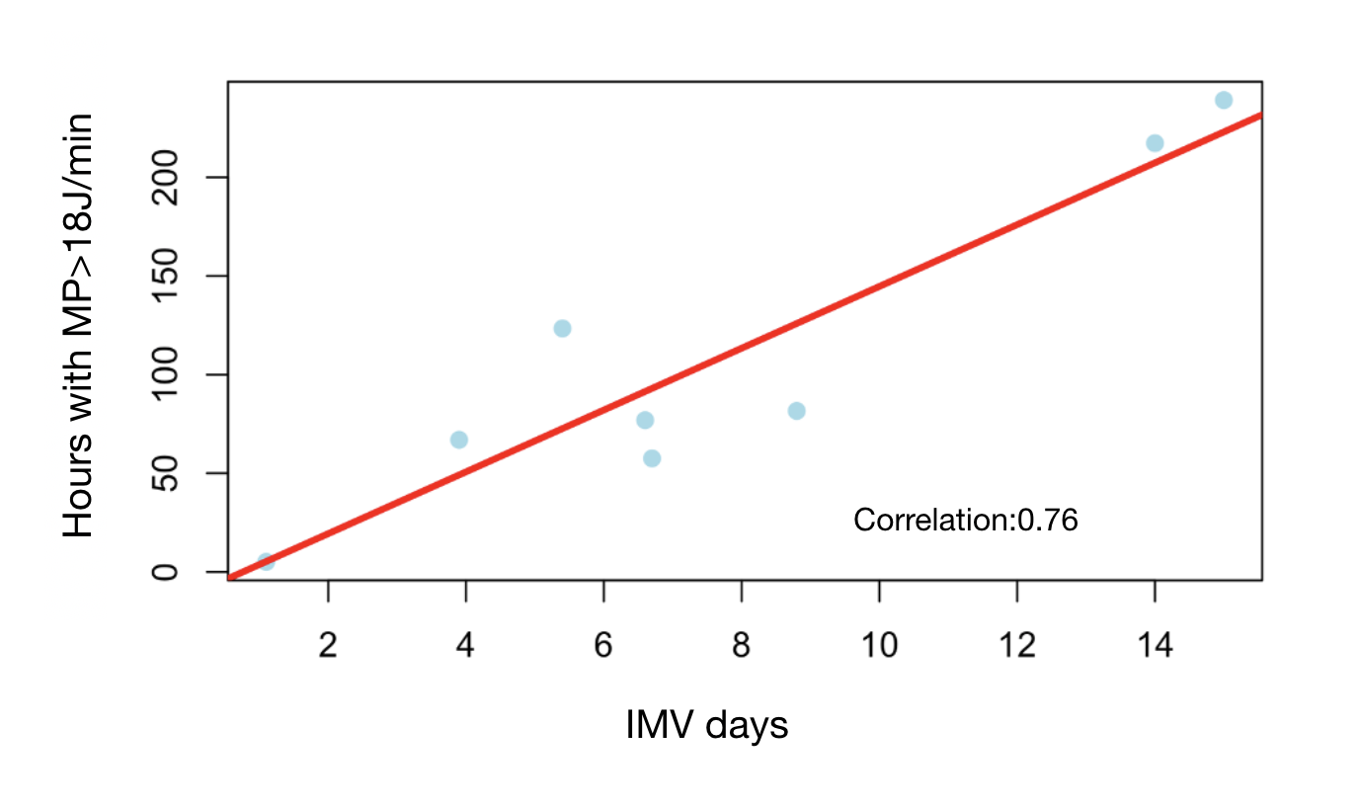

MP = mechanical power, ICU LOS = intensive care unit length of stay

e-Figure 11. Pearson correlation hours with mechanical power >18 J/min and intensive care unit length of stay. Non-hypoxic patients
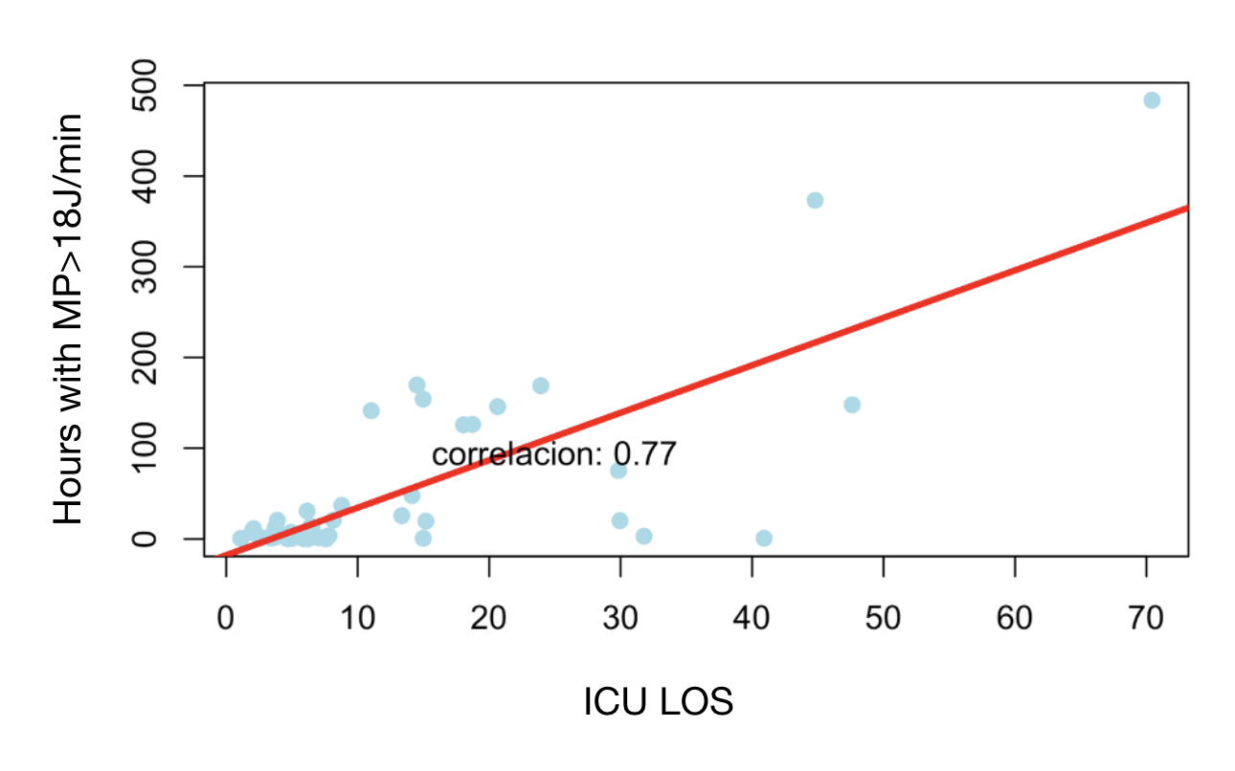
MP = mechanical power, ICU LOS = intensive care unit length of stay

e-Figure 12. Pearson correlation hours with mechanical power >18 J/min and intensive care unit length of stay. Mild hypoxic patients

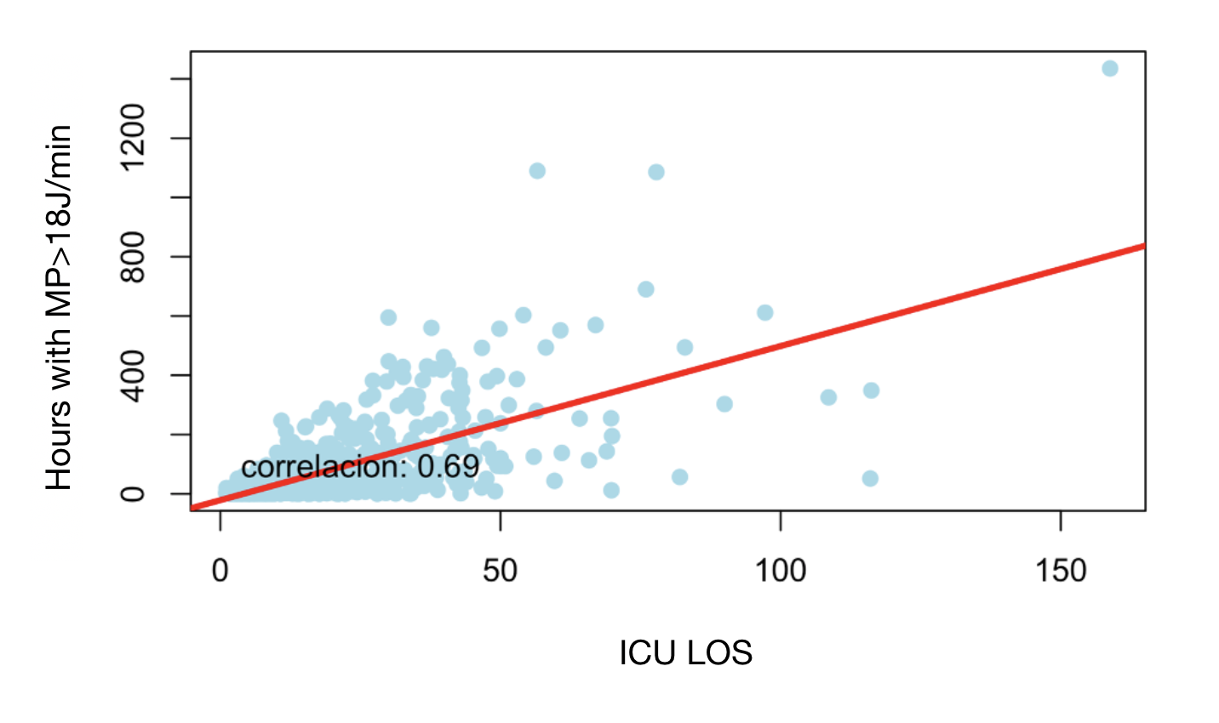

MP = mechanical power, ICU LOS = intensive care unit length of stay

e-Figure 13. Pearson correlation hours with mechanical power >18 J/min and intensive care unit length of stay. Moderate hypoxic patients

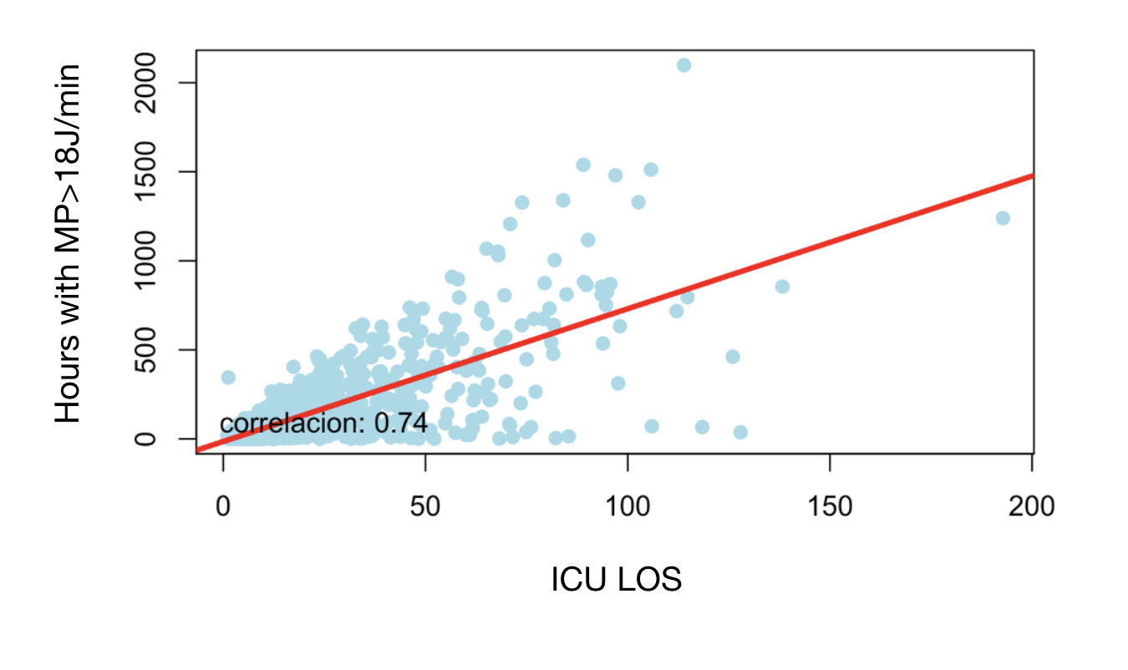

MP = mechanical power, ICU LOS = intensive care unit length of stay

e-Figure 14. Pearson correlation hours with mechanical power >18 J/min and intensive care unit length of stay. Severe hypoxic patients.
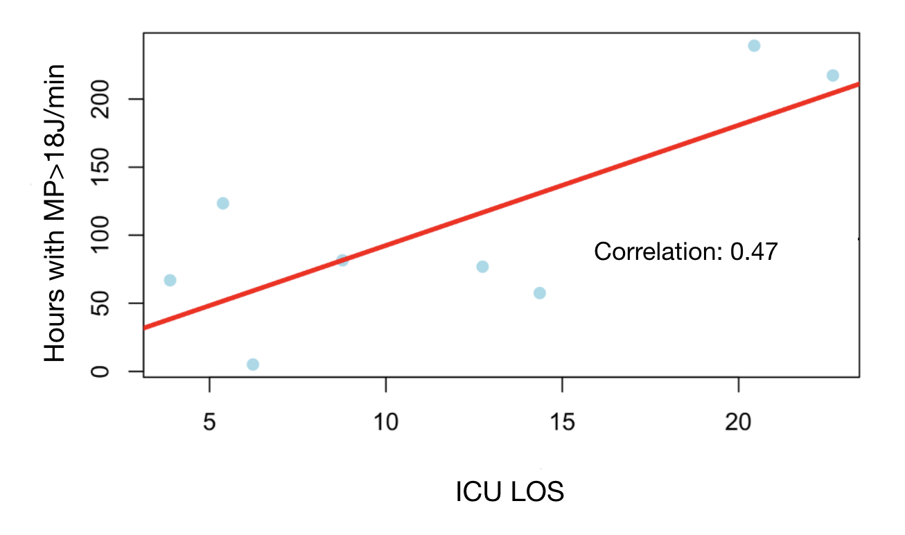

MP = mechanical power, ICU LOS = intensive care unit length of stay

