Appendix 1
Two studies reported the effect of FO on peak first metatarsophalangeal joint (MTPJ) dorsiflexion (Bishop, Arnold, & May, 2016; Nawoczenski & Ludewig, 2004). The subgroup analysis revealed no significant effect of FO in the study that assessed foot posture with arch height index (Bishop et al., 2016). However, meta-analysis showed a significant and moderate effect of FO in the other study (Nawoczenski & Ludewig, 2004) with two types of FO that used forefoot varus in order to determine pronated foot (Fig 1). Overall, results from the meta-analysis indicated a significant and moderate effect on peak MTPJ when using FO compared to control (moderate SMDs=-0.65, 95% CI -1.09 to -0.21, p=0.004) (Fig 1). On average, the peak MTPJ was found to be 2.04° (95% CI −3.26 to −0.83) greater in FO compared with control. There was a trivial level of between study heterogeneity (I²=22%).

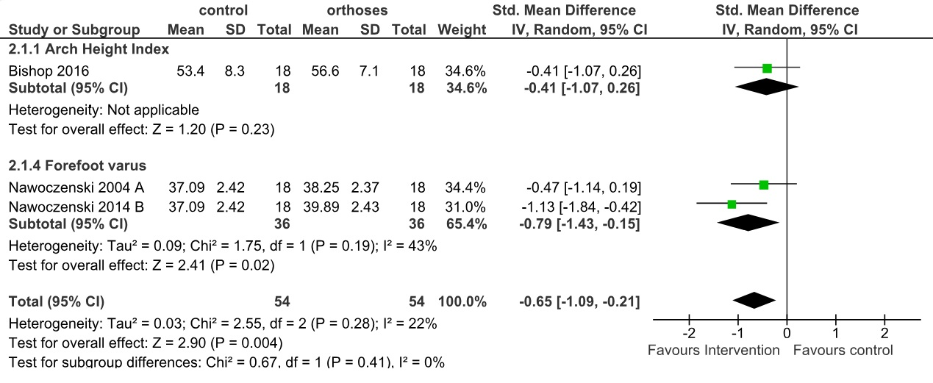
Appendix. Fig 1. Forest plot illustrating short-term effects of foot orthoses on peak first metatarsophalangeal joint dorsiflexion during walking in individuals with pronated feet. The subtotal effect for each parameter and the total effect were calculated as standardized mean difference (95% CI). SD: Standard deviation; Std: Standardized; CI: Confidence interval.

Appendix 2
Authors from one study (Cobb, Tis, Johnson, Wang, & Geil, 2011) with two types of FO reported the first metatarsophalangeal joint abduction excursion and showed no significant difference between the FO and control condition (Fig 2).

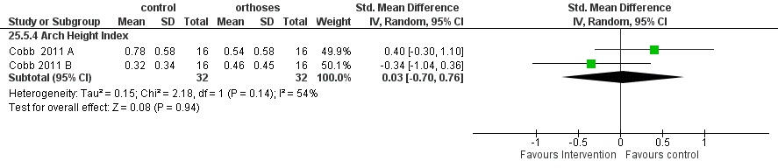
Appendix. Fig 2. Forest plot illustrating short-term effects of foot orthoses on peak first metatarsophalangeal joint abduction excursion during walking in individuals with pronated feet. The subtotal effect for each parameter and the total effect were calculated as standardized mean difference (95% CI). SD: Standard deviation; Std: Standardized; CI: Confidence interval.

Appendix 3
The authors from one study with three degree of FO posting reported the effects of FO on peak forefoot abduction (Telfer, Abbott, Steultjens, & Woodburn, 2013). The meta-analysis revealed a significant and moderate effect on peak FF abduction when using FO compared to control (moderate SMDs=0.67, 95% CI 0.16 to 1.19, p=0.01) (Fig 3). On average, the peak forefoot abduction in control condition was found to be 0.8° (95% CI 0.1 to 1.72) greater compared to FO condition.

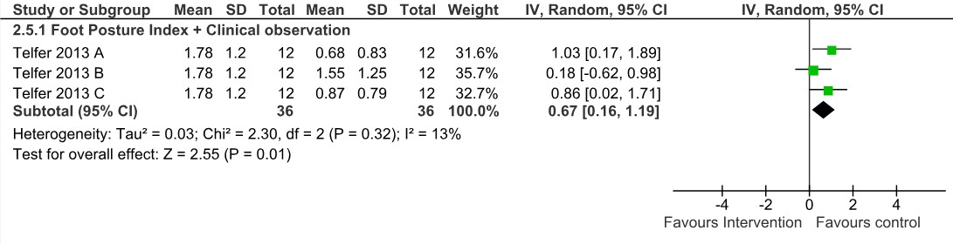
Appendix. Fig 3. Forest plot illustrating short-term effects of foot orthoses on peak forefoot abduction during walking in individuals with pronated feet. The subtotal effect for each parameter and the total effect were calculated as standardized mean difference (95% CI). SD: Standard deviation; Std: Standardized; CI: Confidence interval.

Appendix 4
Two studies reported the effects of FO on peak forefoot eversion (Hurd, Kavros, & Kaufman, 2010; Kosonen, Kulmala, Müller, & Avela, 2017). At a total, meta-analysis with moderate level of heterogeneity indicated no significant effect of FO (small SMDs=0.20, 95% CI -0.56 to 0.96, p=0.60, I²=65%). Subgroup meta-analysis showed significant effect of FO in the study that used arch height index for foot posture assessment (Kosonen et al., 2017) (large SMDs=0.91, 95% CI 0.03 to 1.80, p=0.04). So that the peak forefoot eversion was 3.40° (95% CI 0.41 to 6.39) lower in FO condition compared to control condition (Fig 4).
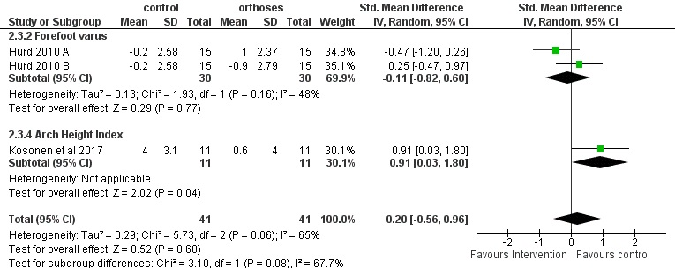
Appendix. Fig 4. Forest plot illustrating the short-term effects of foot orthoses on peak forefoot eversion during walking in individuals with pronated feet. The subtotal effect for each parameter and the total effect were calculated as standardized mean difference (95% CI). SD: Standard deviation; Std: Standardized; CI: Confidence interval.

Appendix 5
Authors from four studies reported the effects of FO on peak rearfoot inversion (Han, Bae, Levine, Yang, & Lee, 2019; Stacoff et al., 2007; Telfer et al., 2013; Zifchock & Davis, 2008). At a total, meta-analysis indicated no effect of FO (SMDs=-0.27, 95% CI -0.60 to 0.05, p=0.1, I²=47%). (Fig 5). However, subgroup meta-analysis showed significant effect of FO in the studies that used FPI-6 or clinical observation for foot posture assessment (Stacoff et al., 2007; Telfer et al., 2013) (moderate SMDs=-0.62, 95% CI -1.04 to -0.20, p=0.004, I²=22%). Peak rearfoot inversion was 2.54° lower in FO condition compared to control condition (95% CI -3.73 to -1.35). At the other side, subgroup analysis showed no significant effect of FO in the studies (Han et al., 2019; Zifchock & Davis, 2008) that assessed foot posture with arch height index (SMDs=0.06, 95% CI -0.22 to 0.35, p=0.67, I²=22%).

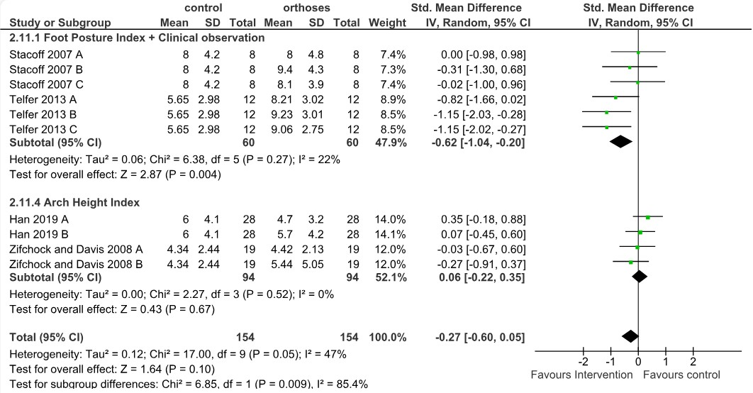
Appendix. Fig 5. Forest plot illustrating short-term effects of foot orthoses on peak rearfoot inversion during walking in individuals with pronated feet. The subtotal effect for each parameter and the total effect were calculated as standardized mean difference (95% CI). SD: Standard deviation; Std: Standardized; CI: Confidence interval.
Appendix 6
Four studies reported the effect of FO on rearfoot eversion excursion (Bishop et al., 2016; Cobb et al., 2011; Stacoff et al., 2007; Zifchock & Davis, 2008). Total and subtotal meta-analysis indicated no significant effect of FO (Fig 6). One single study in arch height index group (Kosonen et al., 2017) focused on the peak rearfoot dorsiflexion and showed no significant difference between the FO and control condition (SMDs=-0.67, 95% CI -1.53, 0.20).

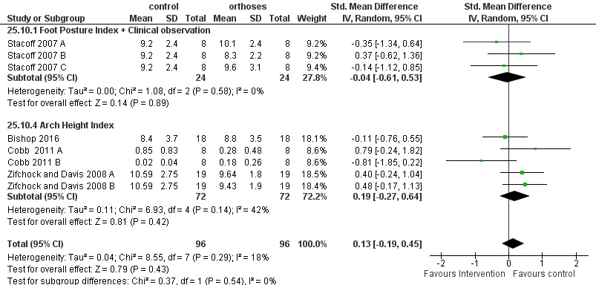
Appendix. Fig 6. Forest plot illustrating short-term effects of foot orthoses on rearfoot eversion joint excursion during walking in individuals with pronated feet. The subtotal effect for each parameter and the total effect were calculated as standardized mean difference (95% CI). SD: Standard deviation; Std: Standardized; CI: Confidence interval.

Appendix 7
Researchers from two studies reported the effects of FO on rearfoot frontal plane joint excursion (Han et al., 2019; Permsombat & Pensri, 2021). At a total, meta-analysis indicated moderate effect of FO with small level of heterogeneity (moderate SMDs=0.51, 95% CI 0.04 to 0.97, p=0.03, I²=43%). So that the rearfoot frontal plane excursion was 2.01° (95% CI -0.73 to 4.76) lower in FO condition compared to control condition (Fig 7). The subgroup meta-analysis showed a significant effect of FO only in the one study (Han et al., 2019) with two type of FO that used arch height index for foot posture assessment (moderate SMDs=0.70, 95% CI 0.32 to 1.09, p=0.0003).

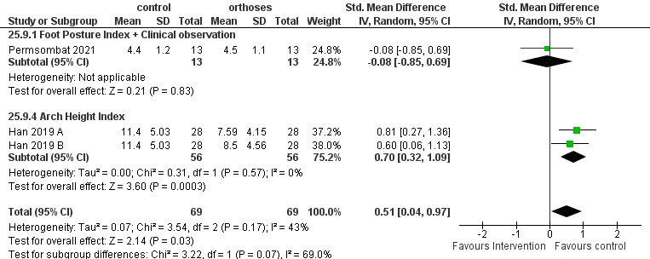
Appendix. Fig 7. Forest plot illustrating short-term effects of foot orthoses on rearfoot frontal plane joint excursion during walking in individuals with pronated feet. The subtotal effect for each parameter and the total effect were calculated as standardized mean difference (95% CI). SD: Standard deviation; Std: Standardized; CI: Confidence interval.

Appendix 8
Peak ankle plantarflexion was reported in four studies (Alsaafin, Saad, Mohammad Zadeh, & Hegazy, 2023; Chen, Lou, Huang, & Su, 2010; Desmyttere, Hajizadeh, Bleau, Leteneur, & Begon, 2021; Peng et al., 2020). Total and subgroup meta-analysis showed no significant difference between control and FO conditions (Fig 8). There was no heterogeneity between study results (I²=0%).

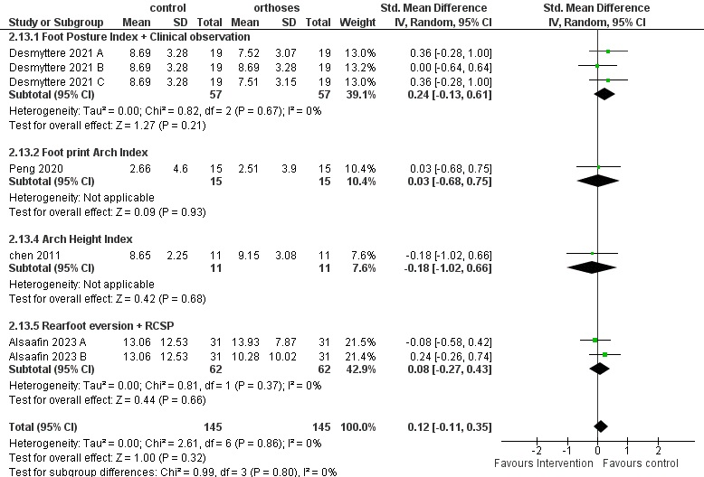
Appendix. Fig 8. Forest plot of the short-term effects of foot orthoses on peak ankle plantarflexion during walking in individuals with pronated feet. The subtotal effect for each parameter and the total effect were calculated as standardized mean difference (95% CI). SD: Standard deviation; Std: Standardized; CI: Confidence interval.

Appendix 9
Also, peak ankle inversion, was reported in four studies (Costa et al., 2021; Desmyttere et al., 2021; Lourenço et al., 2022; Peng et al., 2020). As like as peak plantarflexion, total and subgroup meta-analysis showed no significant difference between control and FO conditions (Fig 9). There was small level of heterogeneity between study results (I²=43%).

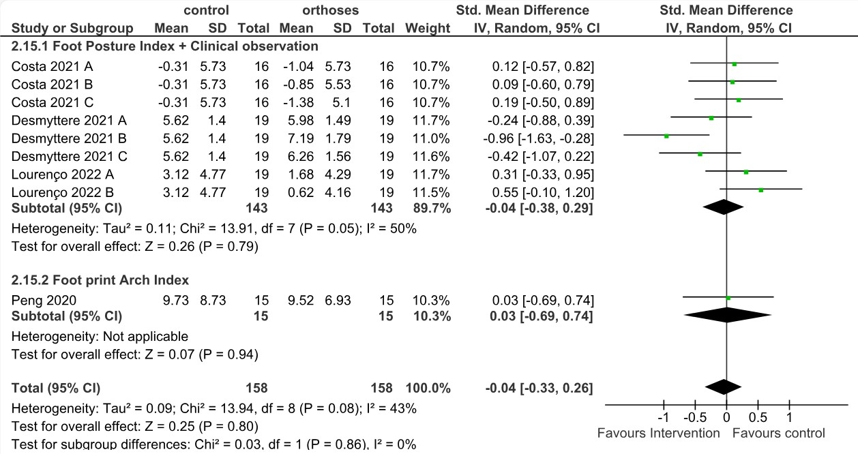
Appendix. Fig 9. Forest plot of the short-term effects of foot orthoses on peak ankle inversion during walking in individuals with pronated feet. The subtotal effect for each parameter and the total effect were calculated as standardized mean difference (95% CI). SD: Standard deviation; Std: Standardized; CI: Confidence interval.

Appendix 10
Two studies showed effect of FO on peak ankle adduction. Subgroup analysis showed no significant effect of FO in the study that assessed foot posture with FPI-6 or clinical observation (Desmyttere et al., 2021) (SMDs=0.21, 95% CI -0.28 to 0.70, p=0.39). However, subgroup meta-analysis showed significant effect of FO in the other studies that used rearfoot eversion or RCSP (moderate SMDs=-0.55, 95% CI -0.91 to -0.19, p=0.003) for determine foot pronation. The peak ankle adduction was 1.73° (95% CI 0.58 to 1.62) greater in FO condition compared to control condition. But at total, meta-analysis indicated no significant effect of FO (trivial SMDs=-0.12, 95% CI -0.58 to 0.34, p=0.61) (Fig 10). The moderate level of heterogeneity also was observed (I²=68%).

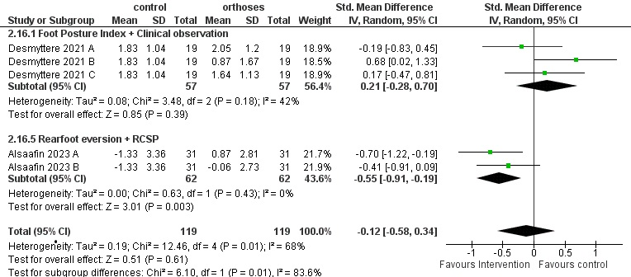
Appendix. Fig 10. Forest plot of the short-term effects of foot orthoses on peak ankle adduction during walking in individuals with pronated feet. The subtotal effect for each parameter and the total effect were calculated as standardized mean difference (95% CI). SD: Standard deviation; Std: Standardized; CI: Confidence interval.

Appendix 11
Two studies reported the effect of FO on peak ankle abduction (Alsaafin et al., 2023; Desmyttere et al., 2021). Subgroup meta-analysis showed conflicting results. In the study that used FPI-6 or clinical observation ankle abduction was 0.74° (95% CI -1.28 to -0.19) greater in FO condition. But the results were opposite with rearfoot eversion or RCSP (moderate SMDs=0.55, 95% CI 0.19 to 0.91, p=0.003). So that, peak rearfoot abduction was 1.72° (95% CI 0.63 to 2.80, p=0.002) lower in FO condition compared to the control condition (95% CI -3.73 to -1.35). Overall, there was no significant effect of FO (SMDs=-0.12, 95% CI -0.72 to -0.48, p=0.97, I²=81%) (Fig 11).
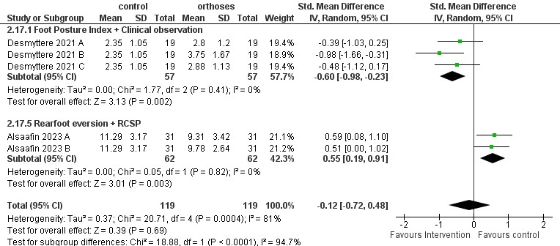
Appendix. Fig 11. Forest plot of the short-term effects of foot orthoses on peak ankle abduction during walking in individuals with pronated feet. The subtotal effect for each parameter and the total effect were calculated as standardized mean difference (95% CI). SD: Standard deviation; Std: Standardized; CI: Confidence interval.

Appendix 12
Peak knee flexion was assessed in three studies (Alsaafin et al., 2023; Chen et al., 2010; Peng et al., 2020). Study heterogeneity was low with an I² value of 0%. The total and subgroup meta-analysis indicated no significant difference between FO and control conditions (Fig 12).

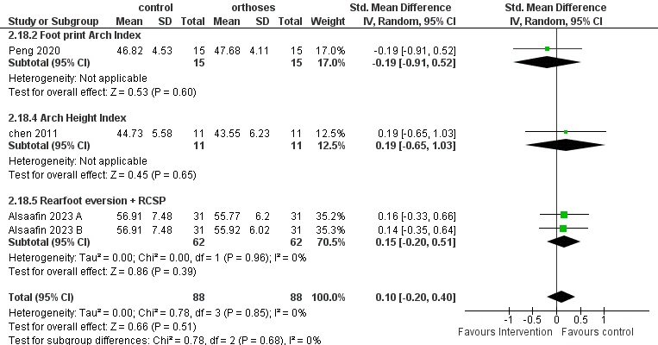
Appendix. Fig 12. Forest plot illustrating the short-term effects of foot orthoses on peak knee flexion angle during walking in individuals with pronated feet. The subtotal effect for each parameter and the total effect were calculated as standardized mean difference (95% CI). SD: Standard deviation; Std: Standardized; CI: Confidence interval.

Appendix 13
Two studies reported the effect of FO on peak knee adduction (Costa et al., 2021; Lourenço et al., 2022). Meta-analysis indicated no effect of FO (SMDs=-0.10, 95% CI -0.40 to 0.20, p=0.5, I²=0%) (Fig 13).
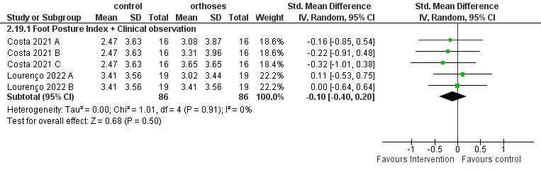
Appendix. Fig 13. Forest plot illustrating the short-term effects of foot orthoses on peak knee adduction angle during walking in individuals with pronated feet. The subtotal effect for each parameter and the total effect were calculated as standardized mean difference (95% CI). SD: Standard deviation; Std: Standardized; CI: Confidence interval.

Appendix 14
Three studies reported the effect of FO on peak knee abduction (Alsaafin et al., 2023; Costa et al., 2021; Lourenço et al., 2022). Total and subgroup meta-analysis indicated no effect of FO (Fig 14).

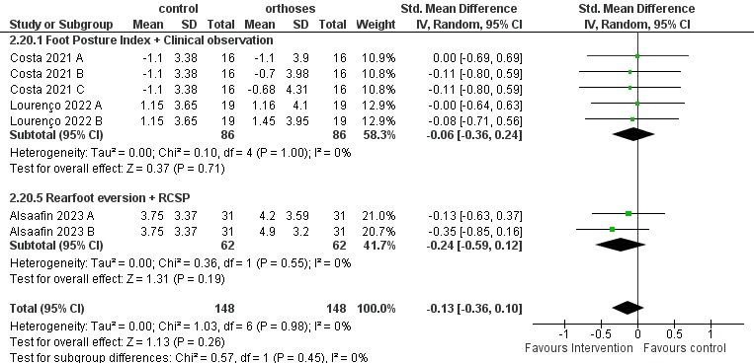
Appendix. Fig 14. Forest plot illustrating the short-term effects of foot orthoses on peak knee abduction angle during walking in individuals with pronated feet. The subtotal effect for each parameter and the total effect were calculated as standardized mean difference (95% CI). SD: Standard deviation; Std: Standardized; CI: Confidence interval.

Appendix 15
Two studies reported the effect of FO on peak knee external rotation (Alsaafin et al., 2023; Prachgosin, Leelasamran, Smithmaitrie, & Chatpun, 2017). Total and subgroup meta-analysis indicated no effect of FO (Fig 15).

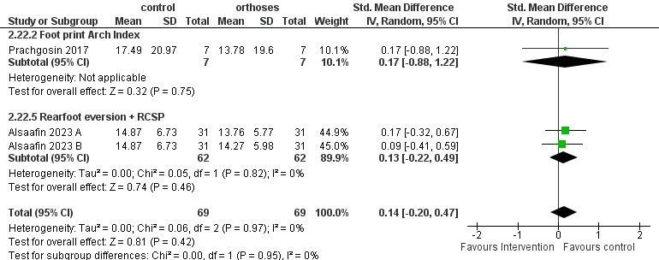
Appendix. Fig 15. Forest plot illustrating the short-term effects of foot orthoses on peak knee external rotation angle during walking in individuals with pronated feet. The subtotal effect for each parameter and the total effect were calculated as standardized mean difference (95% CI). SD: Standard deviation; Std: Standardized; CI: Confidence interval.

Appendix 16
One study (Alsaafin et al., 2023) with two type of FO reported peak knee internal rotation. There was no significant difference between FO and control conditions (Fig 16).

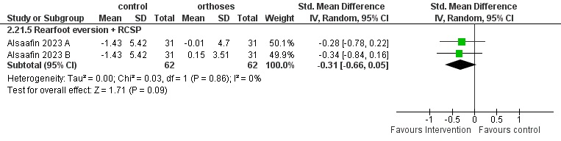
Appendix. Fig 16. Forest plot illustrating the short-term effects of foot orthoses on peak knee internal rotation angle during walking in individuals with pronated feet. The subtotal effect for each parameter and the total effect were calculated as standardized mean difference (95% CI). SD: Standard deviation; Std: Standardized; CI: Confidence interval.

Appendix 17
Two studies evaluated peak hip extension (Alsaafin et al., 2023; Peng et al., 2020) (Fig 17), abduction (Costa et al., 2021; Peng et al., 2020) (Fig 18). Also, three study reported peak hip adduction (Alsaafin et al., 2023; Costa et al., 2021; Peng et al., 2020) (Fig 19). These studies did not yield any significant differences for the above-mentioned parameters. In terms of study heterogeneity, there was no indication of variation (I²=0%).

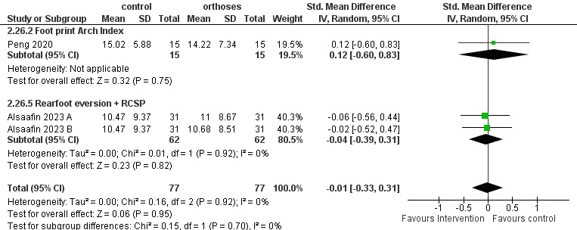
Appendix. Fig 17. Forest plot illustrating the short-term effects of foot orthoses on peak hip extension during walking in individuals with pronated feet. The subtotal effect for each parameter and the total effect were calculated as standardized mean difference (95% CI). SD: Standard deviation; Std: Standardized; CI: Confidence interval.

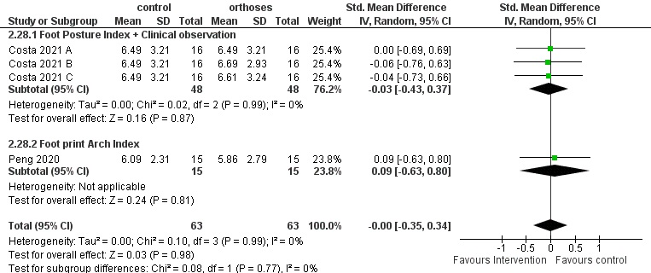
Appendix. Fig 18. Forest plot illustrating the short-term effects of foot orthoses on peak hip abduction during walking in individuals with pronated feet. The subtotal effect for each parameter and the total effect were calculated as standardized mean difference (95% CI). SD: Standard deviation; Std: Standardized; CI: Confidence interval.

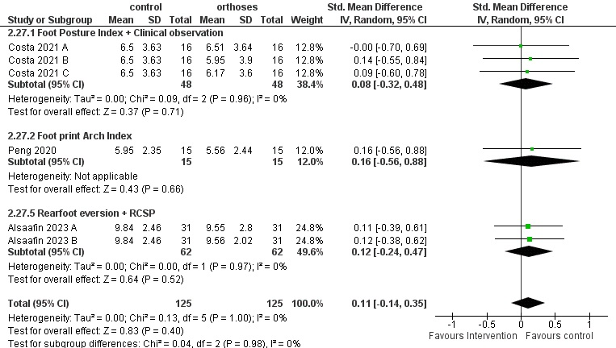
Appendix. Fig 19. Forest plot illustrating the short-term effects of foot orthoses on peak hip adduction during walking in individuals with pronated feet. The subtotal effect for each parameter and the total effect were calculated as standardized mean difference (95% CI). SD: Standard deviation; Std: Standardized; CI: Confidence interval.

Appendix 18
Peak hip external rotation was reported in four studies. Overall, meta-analysis indicated no significant effect of FO (SMDs=-0.12, 95% CI -0.38 to 0.13, p=0.034, I²=24%). Nonetheless, subgroup meta-analysis showed significant effect of FO in the studies that used rearfoot eversion or RCSP (Alsaafin et al., 2023) for pronated foot assessment (moderate SMDs=-0.58, 95% CI -0.94 to -0.22, p=0.001, I²=0%) (Fig 20). So that the Peak hip external rotation was 3.11° (95% CI -4.96 to -1.26) lower in FO condition compared to control condition (Fig 20).

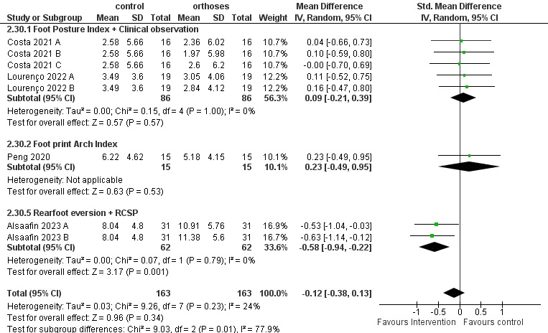
Appendix. Fig 20. Forest plot illustrating the short-term effects of foot orthoses on peak hip external rotation during walking in individuals with pronated feet. The subtotal effect for each parameter and the total effect were calculated as standardized mean difference (95% CI). SD: Standard deviation; Std: Standardized; CI: Confidence interval.

Appendix 19
One study reported a peak eversion moment in %BW*H and also another single study reported a peak eversion moment in Nm (Stacoff et al., 2007). Results indicated no significant difference between FO and control (Telfer et al., 2013) (Fig 21).
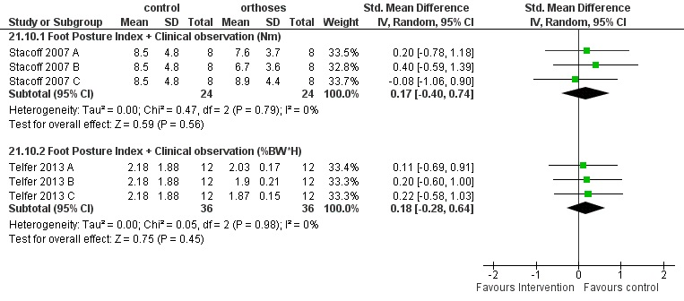
Appendix. Fig 21. Forest plot illustrating the short-term effects of foot orthoses on peak rearfoot eversion moment during walking in individuals with pronated feet. The subtotal effect for each parameter and the total effect were calculated as standardized mean difference (95% CI). SD: Standard deviation; Std: Standardized; CI: Confidence interval.

Appendix 20
Two studies indicated the effect of FO on knee abduction moment (Costa et al., 2021; Desmyttere et al., 2021). Results of meta-analysis, there was significant difference in peak knee abduction moment between FO and control conditions (SMDs=-0.30, 95% CI -0.50 to -0.10, p=0.004, I²=0%) (Fig 22). Peak knee abduction moment was 0.03 Nm/kg (95% CI 0.00 to 0.06) greater in FO conditions. Also, Telfer et al. (Telfer et al., 2013) reported effect of FO on the knee abduction moment in the %BW*H. Results of meta-analysis showed no significant effects of FO (Fig 22)
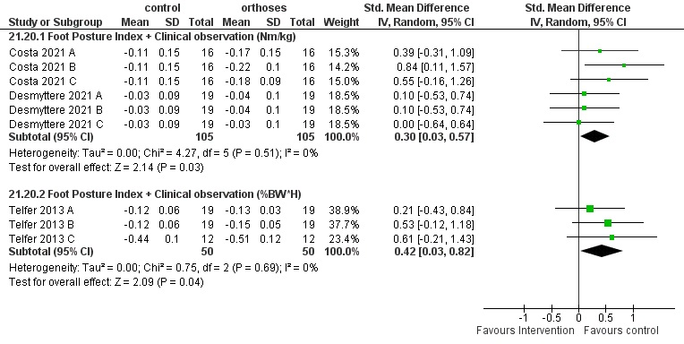
Appendix. Fig 22. Forest plot illustrating the short-term effects of foot orthoses on peak knee abduction moment during walking in individuals with pronated feet. The subtotal effect for each parameter and the total effect were calculated as standardized mean difference (95% CI). SD: Standard deviation; Std: Standardized; CI: Confidence interval.

Appendix 21
One study (Costa et al., 2021) with three types of FO reported peak hip abduction moment (Nm/kg). There was significant difference between FO and control conditions (Fig 23). Peak hip abduction moment was 0.1 Nm/kg (95% CI -0.19 to -0.01) greater in FO condition.

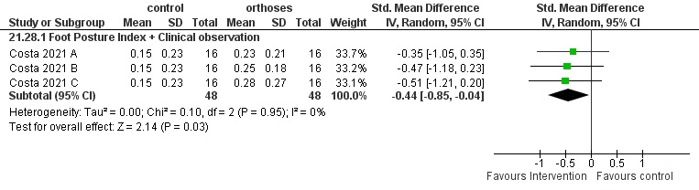
Appendix. Fig 23. Forest plot illustrating the short-term effects of foot orthoses on peak hip abduction moment during walking in individuals with pronated feet. The subtotal effect for each parameter and the total effect were calculated as standardized mean difference (95% CI). SD: Standard deviation; Std: Standardized; CI: Confidence interval.

Appendix 22
Two studies with different foot posture assessment methods reported the effect of FO on peak hip adduction moment (Costa et al., 2021; Kosonen et al., 2017). Total and subgroup meta-analysis indicated no significant effect of FO (Fig 24).

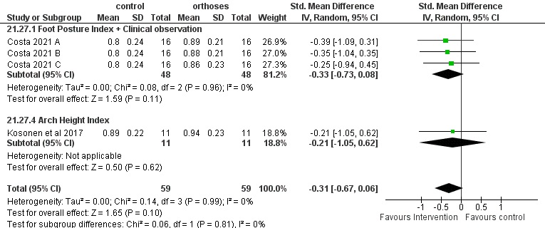
Appendix. Fig 24. Forest plot illustrating the short-term effects of foot orthoses on peak hip adduction moment during walking in individuals with pronated feet. The subtotal effect for each parameter and the total effect were calculated as standardized mean difference (95% CI). SD: Standard deviation; Std: Standardized; CI: Confidence interval.

Appendix 23
Two studies reported the effect of FO on peak hip internal rotation moment (Costa et al., 2021; Kosonen et al., 2017). Results of meta-analysis indicated no significant effect of FO (Fig 25).

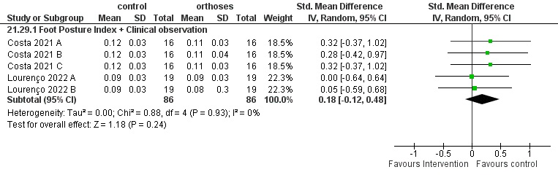
Appendix. Fig 25. Forest plot illustrating the short-term effects of foot orthoses on peak hip internal rotation moment during walking in individuals with pronated feet. The subtotal effect for each parameter and the total effect were calculated as standardized mean difference (95% CI). SD: Standard deviation; Std: Standardized; CI: Confidence interval.

Appendix 24
The effect of FO on peak hip external rotation moment reported in two studies (Costa et al., 2021; Kosonen et al., 2017). Based on meta-analysis results there was significant with small effect of FO (small SMDs=-0.35, 95% CI -0.65 to -0.05, p=0.02, I²=0%) (Fig 26). Peak hip external rotation moment was 0.01 Nm/kg (95% CI -0.02 to -0.00) greater in FO condition.

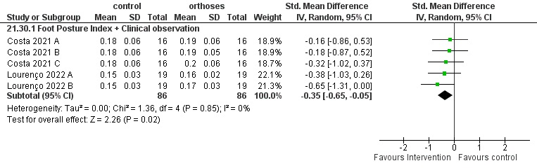
Appendix. Fig 26. Forest plot illustrating the short-term effects of foot orthoses on peak hip external rotation moment during walking in individuals with pronated feet. The subtotal effect for each parameter and the total effect were calculated as standardized mean difference (95% CI). SD: Standard deviation; Std: Standardized; CI: Confidence interval.

Appendix 25
One single study (Dedieu, Drigeard, Gjini, Dal Maso, & Zanone, 2013) reported the mean rearfoot eversion and showed significant difference between the FO and control condition (large SMDs=-3.01, 95% CI -4.24, -1.78). Results showed that the mean rearfoot eversion was 1.62° (95% CI -2.04, -1.20) smaller in FO (Dedieu et al., 2013). The rearfoot joint excursion in sagittal and horizontal planes was assessed by a single moderate quality study (Permsombat & Pensri, 2021). No significant differences were found between FO and control for rearfoot plantarflexion/dorsiflexion and internal/external rotation (Permsombat & Pensri, 2021) (Table 1).
Only one study reported the mean ankle angle in the sagittal plane and joint excursion in three planes (Permsombat & Pensri, 2021) and found no significant difference (p>0.05) between the FO and control conditions for these parameters (Table 1).
A study examined knee joint excursion (Permsombat & Pensri, 2021) in 3D and found no significant difference (p>0.05) between the FO and control conditions for these parameters (Table 1).
Hip joint excursion (Permsombat & Pensri, 2021) in the sagittal, frontal, and horizontal plane were reported by single study. Nevertheless, no significant difference was found between FO and control for these variables (Table 1).

Appendix 26
Appendix. Table 1. Summary of statistical analyses for kinematic parameters explored in a single study.
Outcome measure | Included study, quality (methodological), and sample size (n) | P value | Effect size (95% CI)
Rearfoot
Mean eversion angle | Dedieu et al (2013) (Dedieu et al., 2013), MQ, n=12 | < 0.0001 | SMDs -3.01 [-4.24, -1.78]
Joint excursion dorsi/plantarflexion | Permsombat and Pensri (2021) (Permsombat & Pensri, 2021), MQ, n=13 | 0.32 | SMDs 1.00 [-0.97, 2.97]
Joint excursion inter/external | Permsombat and Pensri (2021) (Permsombat & Pensri, 2021), MQ, n=13 | 0.58 | SMDs -0.50 [-2.27, 1.27]
Peak rearfoot dorsiflexion | Kosonen et al (2017) (Kosonen et al., 2017), HQ, n=11 | 0.13 | SMDs -0.66 [-1.53, 0.20]
Peak external rotation
Ankle
Mean dorsi/plantarflexion | Dedieu et al (2013) (Dedieu et al., 2013), MQ, n=12 | 0.78 | SMDs 0.11 [-0.69, 0.91]
Joint excursion dorsi/plantarflexion | Permsombat and Pensri (2021) (Permsombat & Pensri, 2021), MQ, n=13 | 0.16 | SMDs 1.30 [-0.53, 3.13]
Joint excursion ever/inversion | Permsombat and Pensri (2021) (Permsombat & Pensri, 2021), MQ, n=13 | 0.72 | SMDs 0.50 [-2.19, 3.19]
Joint excursion inter/external | Permsombat and Pensri (2021) (Permsombat & Pensri, 2021), MQ, n=13 | 0.45 | SMDs -0.80 [-2.89, 1.29]
Knee
Joint excursion flexion/extension | Permsombat and Pensri (2021) (Permsombat & Pensri, 2021), MQ, n=13 | 0.44 | SMDs -1.50 [-5.31, 2.31]
Joint excursion abduction/adduction | Permsombat and Pensri (2021) (Permsombat & Pensri, 2021), MQ, n=13 | 0.07 | SMDs 1.00 [-0.08, 2.08]
Joint excursion inter/external rotation | Permsombat and Pensri (2021) (Permsombat & Pensri, 2021), MQ, n=13 | 0.73 | SMDs -0.30 [-1.99, 1.39]
Hip
Joint excursion flexion/extension | Permsombat and Pensri (2021) (Permsombat & Pensri, 2021), MQ, n=13 | 0.38 | SMDs -0.90 [-2.90, 1.10]
Joint excursion abduction/adduction | Permsombat and Pensri (2021) (Permsombat & Pensri, 2021), MQ, n=13 | 0.69 | SMDs 0.40 [-1.54, 2.34]
Joint excursion inter/external rotation | Permsombat and Pensri (2021) (Permsombat & Pensri, 2021), MQ, n=13 | 0.92 | SMDs -0.10 [-2.12, 1.92]
HQ: High Quality; MQ: Moderate Quality; CI: Confidence Interval. Effect size is standardized mean difference (SMDs). A negative value shows an “increase”, and a positive value shows a “decrease” for that parameter during wearing orthosis compared to no orthosis.
Bold numbers indicate significance at P value < 0.05.

Appendix 27
One study (Peng et al., 2020) reported peak ankle plantarflexion, dorsiflexion, inversion, eversion, and internal and external moment in body weight times the body height (BW*BH) and indicated a significant difference between FO and control for peak inversion and external rotation (Table 2). Also another study (Chen et al., 2010) reported peak ankle dorsiflexion moment in Nm/kg. Results showed no significant difference between conditions (Table 2).
Peng (Peng et al., 2020) assessed peak knee flexion, extension, abduction, and internal and external rotation moment and indicated no significant difference between FO and control (Table 2). Prachgosin et al (Prachgosin et al., 2017) studied peak knee extension moments during walking both with and without FO. We could not find any differences between study conditions (Table 2).
A study assessed peak hip flexion, extension, abduction, and internal and external rotation moment (Peng et al., 2020), with no significant difference and limited evidence for FO vs control (Table 2).

Appendix. Table 2.
Summary of statistical analyses for kinetic parameters explored in a single study.
Outcome measure | Included study, quality [methodological], and sample size (n) | P value | Effect size (95% CI)
Rearfoot
Ankle
Peak dorsiflexion moment | Peng et al 2020 (Peng et al., 2020), HQ, n=15 | 0.56 | SMDs 0.21 [-0.50, 0.93]
Peak plantar moment | Peng et al 2020 (Peng et al., 2020), HQ, n=15 | 0.56 | SMDs -0.21 [-0.93, 0.50]
Peak eversion moment | Peng et al 2020 (Peng et al., 2020), HQ, n=15 | 0.05 | SMDs 0.73 [-0.01, 1.47]
Peak inversion moment | Peng et al 2020 (Peng et al., 2020), HQ, n=15 | 0.01 | SMDs -0.97 [-1.74, -0.21]
Peak internal moment | Peng et al 2020 (Peng et al., 2020), HQ, n=15 | 0.45 | SMDs -0.28 [-0.99, 0.44]
Peak external moment | Peng et al 2020 (Peng et al., 2020), HQ, n=15 | 0.01 | SMDs -0.97 [-1.74, -0.21]
Peak dorsiflexion moment | Chen et al 2010 (Chen et al., 2010), HQ, n=11 | 0.57 | SMDs -0.24 [-1.08, 0.60]
Knee
peak extension moment | Prachgosin et al (2017), HQ, n=7 | 0.83 | SMDs -0.11 [-1.16, 0.93]
Peak flexion moment | Peng et al 2020 (Peng et al., 2020), HQ, n=15 | 1.00 | SMDs 0.00 [-0.72, 0.72]
Peak extension moment | Peng et al 2020 (Peng et al., 2020), HQ, n=15 | 1.00 | SMDs 0.00 [-0.72, 0.72]
Peak adduction moment | Peng et al 2020 (Peng et al., 2020), HQ, n=15 | 0.19 | SMDs -0.49 [-1.21, 0.24]
Peak internal moment | Peng et al 2020 (Peng et al., 2020), HQ, n=15 | 1.00 | SMDs 0.00 [-0.72, 0.72]
Peak external moment | Peng et al 2020 (Peng et al., 2020), HQ, n=15 | 1.00 | SMDs 0.00 [-0.72, 0.72]
Hip
Peak flexion moment | Peng et al 2020 (Peng et al., 2020), HQ, n=15 | 0.63 | SMDs -0.18 [-0.89, 0.54]
Peak extension moment | Peng et al 2020 (Peng et al., 2020), HQ, n=15 | 0.54 | SMDs -0.23 [-0.94, 0.49]
Peak adduction moment | Peng et al 2020 (Peng et al., 2020), HQ, n=15 | 0.58 | SMDs 0.20 [-0.51, 0.92]
Peak internal moment | Peng et al 2020 (Peng et al., 2020), HQ, n=15 | 1.00 | SMDs 0.00 [-0.72, 0.72]
Peak external moment | Peng et al 2020 (Peng et al., 2020), HQ, n=15 | 0.30 | SMDs -0.38 [-1.10, 0.34]
HQ: High Quality; MQ: Moderate Quality; CI: Confidence Interval. Effect size is standardized mean difference (SMDs). A negative value shows an “increase”, and a positive value shows a “decrease” for that parameter during wearing orthosis compared to no orthosis.
Bold numbers indicate significance at P value < 0.05.

References
Alsaafin, N., Saad, N., Mohammad Zadeh, S. A., & Hegazy, F. A. (2023). Effect of Different Foot Orthosis Inverted Angles on Walking Kinematics in Females with Flexible Flatfeet. Journal of Multidisciplinary Healthcare, 2613-2623.
Bishop, C., Arnold, J. B., & May, T. (2016). Effects of taping and orthoses on foot biomechanics in adults with flat-arched feet. Medicine and science in sports and exercise, 48(4), 689-696.
Chen, Y.-C., Lou, S.-Z., Huang, C.-Y., & Su, F.-C. (2010). Effects of foot orthoses on gait patterns of flat feet patients. Clinical biomechanics, 25(3), 265-270.
Cobb, S. C., Tis, L. L., Johnson, J. T., Wang, Y. T., & Geil, M. D. (2011). Custom-molded foot-orthosis intervention and multisegment medial foot kinematics during walking. In (Vol. 46, pp. 358-365): National Athletic Trainers' Association, Inc.
Costa, B. L., Magalhães, F. A., Araujo, V. L., Richards, J., Vieira, F. M., Souza, T. R., & Trede, R. (2021). Is there a dose-response of medial wedge insoles on lower limb biomechanics in people with pronated feet during walking and running? Gait & posture, 90, 190-196.
Dedieu, P., Drigeard, C., Gjini, L., Dal Maso, F., & Zanone, P.-G. (2013). Effects of foot orthoses on the temporal pattern of muscular activity during walking. Clinical biomechanics, 28(7), 820-824.
Desmyttere, G., Hajizadeh, M., Bleau, J., Leteneur, S., & Begon, M. (2021). Anti-pronator components are essential to effectively alter lower-limb kinematics and kinetics in individuals with flexible flatfeet. Clinical biomechanics, 86, 105390.
Han, K., Bae, K., Levine, N., Yang, J., & Lee, J.-S. (2019). Biomechanical effect of foot orthoses on rearfoot motions and joint moment parameters in patients with flexible flatfoot. Medical science monitor: international medical journal of experimental and clinical research, 25, 5920.
Hurd, W. J., Kavros, S. J., & Kaufman, K. R. (2010). Comparative biomechanical effectiveness of over-the-counter devices for individuals with a flexible flatfoot secondary to forefoot varus. Clinical Journal of Sport Medicine, 20(6), 428-435.
Kosonen, J., Kulmala, J.-P., Müller, E., & Avela, J. (2017). Effects of medially posted insoles on foot and lower limb mechanics across walking and running in overpronating men. Journal of biomechanics, 54, 58-63.
Lourenço, B. M., Magalhães, F. A., Vieira, F. M., Reis, C. K., Costa, H. S., Araújo, V. L., . . . Trede, R. (2022). An exploration of the effects of prefabricated and customized insoles on lower limb kinetics and kinematics during walking, stepping up and down tasks: A time series analysis. Gait & posture, 98, 297-304.
Nawoczenski, D. A., & Ludewig, P. M. (2004). The effect of forefoot and arch posting orthotic designs on first metatarsophalangeal joint kinematics during gait. Journal of Orthopaedic & Sports Physical Therapy, 34(6), 317-327.
Peng, Y., Wong, D. W.-C., Wang, Y., Chen, T. L.-W., Tan, Q., Chen, Z., . . . Zhang, M. (2020). Immediate effects of medially posted insoles on lower limb joint contact forces in adult acquired flatfoot: a pilot study. International journal of environmental research and public health, 17(7), 2226.
Permsombat, P., & Pensri, P. (2021). Effects of customized foot orthoses on lower limbs kinematics in adults with highly pronated foot. Chulalongkorn Medical Journal, 65(2), 195-205.
Prachgosin, T., Leelasamran, W., Smithmaitrie, P., & Chatpun, S. (2017). Effect of total-contact orthosis on medial longitudinal arch and lower extremities in flexible flatfoot subjects during walking. Prosthetics and orthotics international, 41(6), 579-586.
Stacoff, A., Kramers-de Quervain, I., Dettwyler, M., Wolf, P., List, R., Ukelo, T., & Stüssi, E. (2007). Biomechanical effects of foot orthoses during walking. The Foot, 17(3), 143-153.
Telfer, S., Abbott, M., Steultjens, M. P., & Woodburn, J. (2013). Dose–response effects of customised foot orthoses on lower limb kinematics and kinetics in pronated foot type. Journal of biomechanics, 46(9), 1489-1495.
Zifchock, R. A., & Davis, I. (2008). A comparison of semi-custom and custom foot orthotic devices in high-and low-arched individuals during walking. Clinical biomechanics, 23(10), 1287-1293.

