Supplementary Figure 1. Direction of winds (aout 2021 to mai 2022)

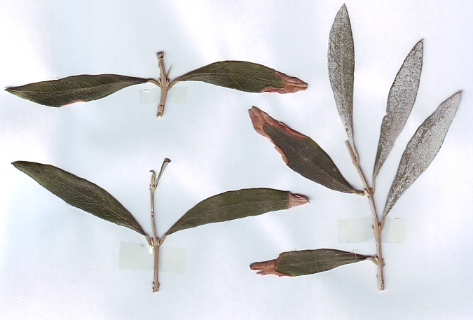
Supplementary Figure 2. Necrotic spots in leaves

