Table1 The major identified glycans and their structure diagrams at N83 site.
Number | Glycans | Glycan structure diagram*
1 | A4G4F1S3Sg1_OAc1OMe1 | 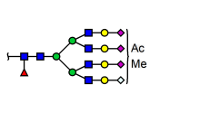
2 | A4G4F1S2Sg1_OAc1OMe1 | 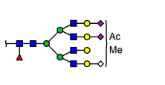
3 | A4G4F1S3 | 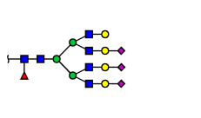
4 | A3G3F1S2Sg1_OAc1OMe1 | 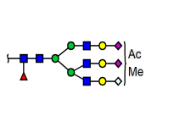
5 | A4G4F1S4 | 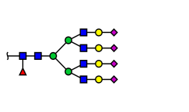
6 | A4G4F1S1Sg1_OAc1OMe1 | 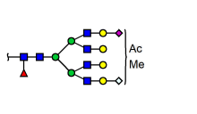
7 | A3G3F1S1Sg1_OAc1OMe1 | 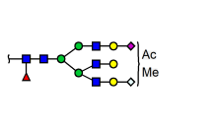
8 | A5G5F1S3_OAc1 | 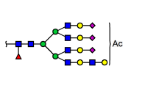
9 | A4G4F1S3_OAc1 | 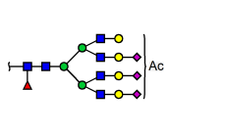
10 | A6G6F1S3_OAc1 | 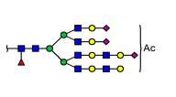
11 | A4G4F1S2_OAc1 | 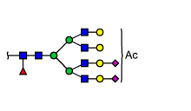
12 | A4G4F1S4_OAc2 | 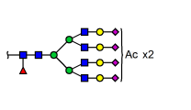
*: A represented N-acetylglucosamine (); F represented fucose (); G represented galactose (); S represented Neu5Ac (); Sg for Neu5Gc ();

Table 2 O-glycosylation of S126 at the intact protein and glycopeptide levels, including identified O-glycans and their structure, the relative content of glycosylation and non-glycosylation rhEPO, O-glycosylation ratio.
Level | O-glycans* | O-glycans structure | Relative content* / % | O-glycosylation ratio /%
Intact protein | Core1_S1 | 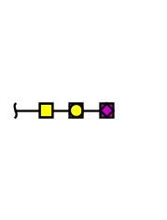 | 42.2 | 80.2
Intact protein | Core1_S2 | 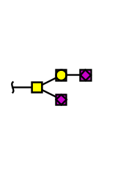 | 38.0 | 80.2
Glycopeptide | Core1_S1 |  | 41.2 | 80.3
Glycopeptide | Core1_S2 |  | 39.1 | 80.3
*At the intact protein level, N-Glycans were removed by PNGase F, and only O-glycans were preserved. At intact protein level, the relative content was the area percent of EPO with Core1_S1 or Core1_S2 in total area of rhEPO. At the glycopeptide level, the relative content was the area percent of all identified O-glycopeptides containing Core1_S1 or Core1_S2 in all peptides with S126 site.

Table 3 Comparison of the total average number of sialic acids, Neu5Gc and O-acetylation on sialic acids in three different batches of rhEPO samples.
Sample ID | Total Average Number*
Sample ID | Sialic acid | Neu5Gc | O-acetylation
EPO_1 | 7.28 | 4.21 | 0.66
EPO_2 | 6.98 | 4.05 | 0.75
EPO_3 | 7.24 | 4.24 | 0.64
*The number shown in this table was the sum of the number at three different N-glycosylation sites.

