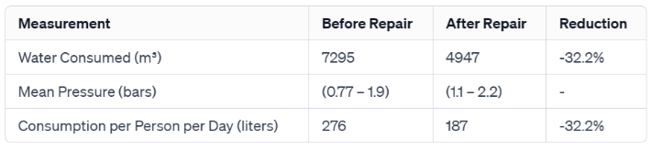
Table 1. The measurements

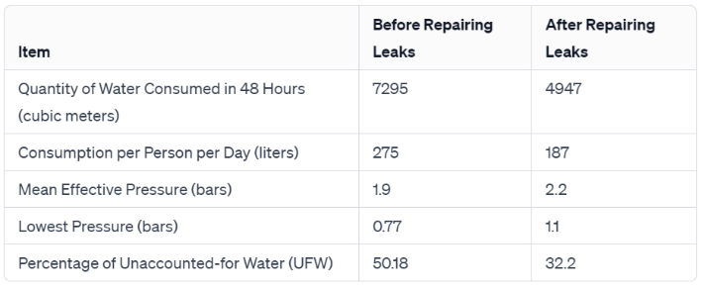
Table 2. Water Measurements

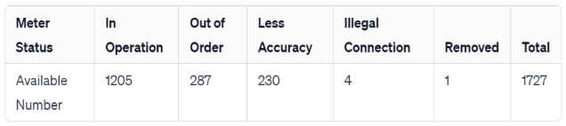
Table 3. Water Customers
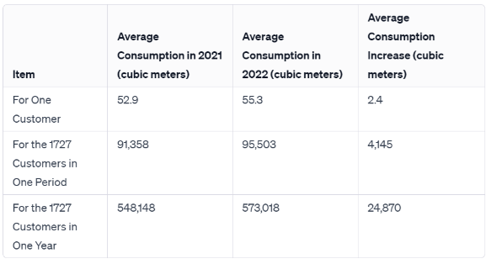
Table 4. Average consumption

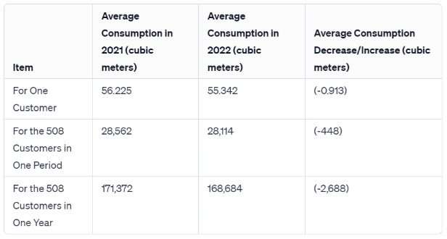
Table 5. Reduction of UFW

