Appendix
- Example Prompt of RLS, BFOP and 2POP
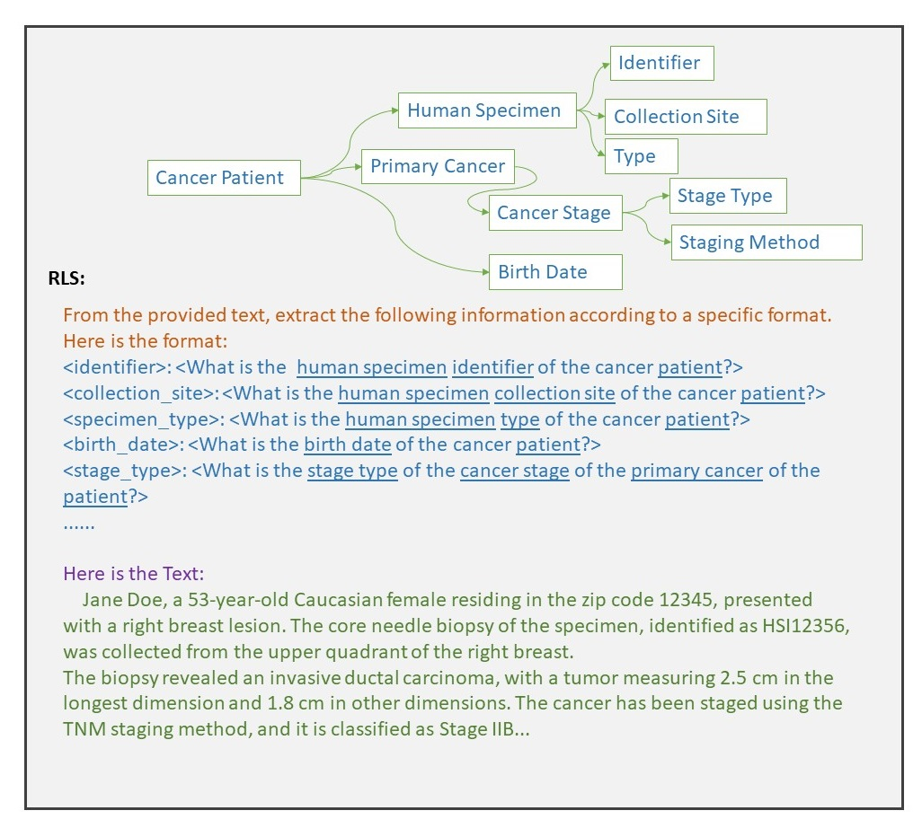
Figure S1. Example prompt of the Root-to-Leaf Streamliner (RLS). method. The upper is the ontology graph $G$ and lower is the prompt generated using RLS. Each leaf named entity generates a query that incorporates all background information from root to this root, indicated by the underlines.
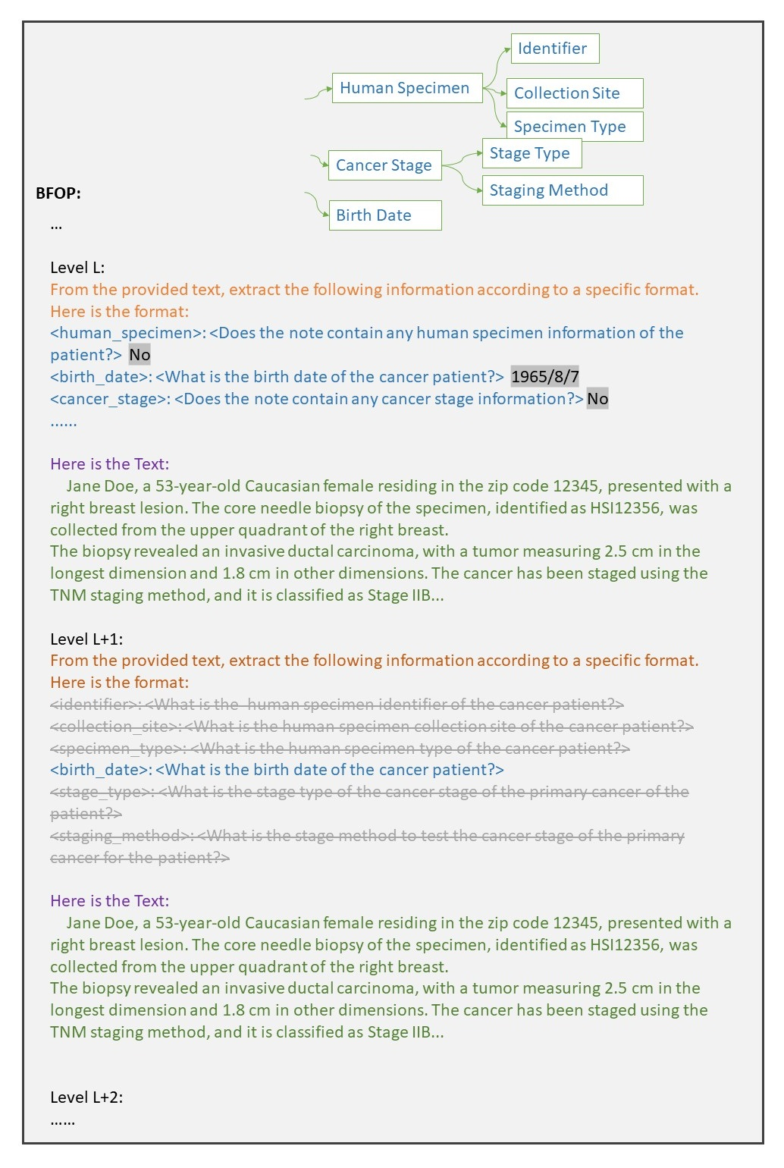
Figure S2. Example prompt of the Breadth-First Ontology Pruner (BFOP) method. Also see Appendix F. After each named entity at level L get a result (highlighted in gray background), based on these results, the L+1 level named entities can be trimmed down. Certain queries do not need to be performed as this information is deemed not available from round L.
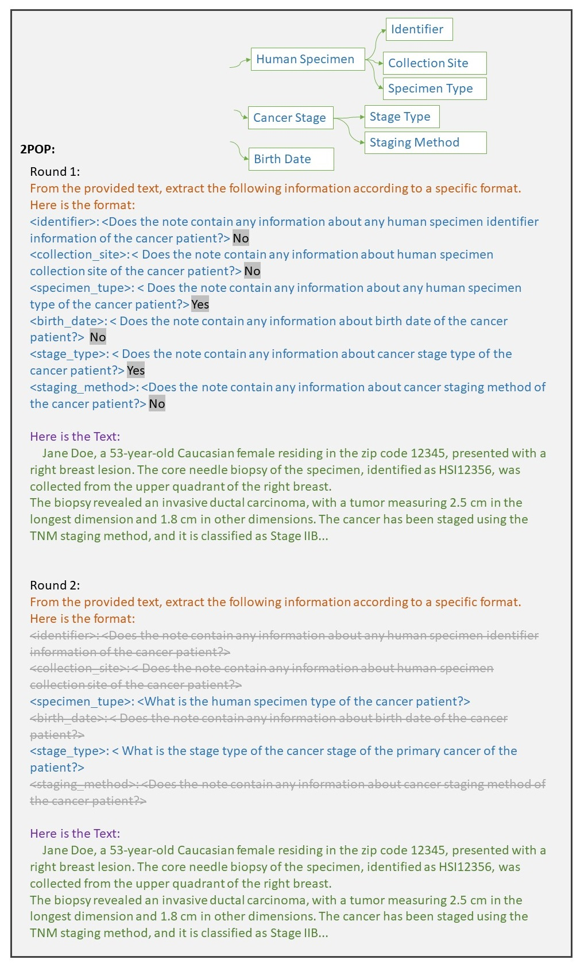
Figure S3. Example prompt of the Two-Phase Ontology Parser (2POP) method. Similar to RLS, prompts are generated from all leaf named entities. The second rounds prompts will be adjusted based on the result (highlighted in gray) of the first round.
- List of Common abbreviations in medical notes
Table S1. Common abbreviations of metical terms used in the experiments.
Medical terms: abbreviations
Activating: Act | Death: Dth | Leukemia: Leuk | Protein: Prot | system: sys
Administration: Admin | Description: Desc | Level: Lvl | Radiotherapy: RT | System: Sys
Allelic: Allel | Diabetes: DM | Location: Loc | Ranges: Rngs | Technique: Tech
Amino: Aa | Dimension: Dim | Lymphoma: Lympho | Reason: Rsn | Transplant: Transpl
applicable: App | Disease: Dz | Marker: Mrk | Reference: Ref | treatment: Tx
Attribute: Attr | Ethnicity: Ethn | Medication: Med | Region: Reg | Tumor: Tum
Binet: Binet | Evidence: Evd | Melanoma: Mel | related: rel | Type: Typ
Breslow: Breslow | Examined: Exam | Metastatic: Mets | Related: Rel | Value: Val
Cancer: CA | fetoprotein: fetoprotein | Method: Meth | Report: Rpt | Variant: Var
Caucasian: Cau | Frequency: Freq | Missense: Miss | Request: Req | Variation: Var
Center: Ctr | Gender: Gen | Modality: Mod | Result: Rslt | Volume: Vol
Change: Chg | Genomic: Gen | Molecular: Mol | Secondary: Sec
Class: Cls | Gleason: Gleason | Morphology: Morph | Sequence: Seq
Code: Code | Gynecologic: Gyn | mutation: mut | Sessions: Sess
Coding: Cng | Hepatocellular: HepatoCA | Mutations: Mut | Somatic: Som
Collection: Coll | Heterozygous: HetZ | Myeloma: Myelo | Sorafenib: Sorafenib
Comorbidities: Comorb | HGVS: HGVS | Nomenclature: Nomen | Source: Src
Conditions: Conds | Hispanic: Hisp | Normal: Norm | Specimen: Spec
Consequence: Conseq | Histology: Hist | Number: Num | Stage: Stg
Contact: Cont | History: Hist | Palliative: Pall | Staging: Stg
control: ctrl | Hypertension: HTN | Patient: Pt | State: St
Coordinate: Coord | Identifier: ID | preference: pref | Status: Stat
Copy: Cpy | Imaging: Img | Primary: Prim | Studied: Stud
Cytogenetic: Cytogen | Information: Info | Procedure: Proc | Substitution: Subst
Date: Dt | Intent: Intent | Prostate: Prostate | Summary: Summ

- Formatting and Prompt Completion
The output of the LLM is also free text by default, unless specific instructions about format is provided to constrain the output text. In order to convert the unstructured free-text output into a more organized and structured format, for the prompts generated from the graph $G$, we enforce the following format:
\tab Label$\left(v_{i}\right)$: <Description$\left(v_{i}\right)$> \n
where each named entity $v_{i}$ form a single line, and all named entities will be concatenated together as multiple lines. The final prompt to be fed into LLM for named entity extraction will be of the following format:
prompt$\left(G\right)$=Leading-Question + Formatted-Prompt + Background-Info + Input-Text
where
- Leading-Question: a concise task description to instruct the LLM of what specific task it needs to perform, e.g., “Please extract the following information from the text.”.
- Formatted-Prompt: a line-by-line prompt generated from graph $G$ in the format of (6).
- Background-Info: this is the indication of the beginning of the provided free text, it can be “Here is the text:”.
- Input-Text: the provided free text to extract information from.
D. Pseudocode for the algorithm

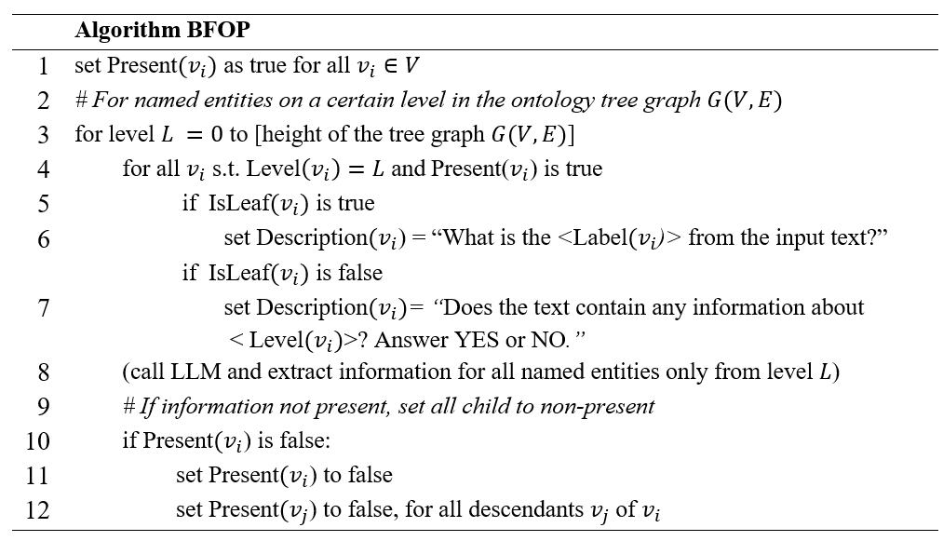
Figure S4. Pseudocode for the algorithm BFOP

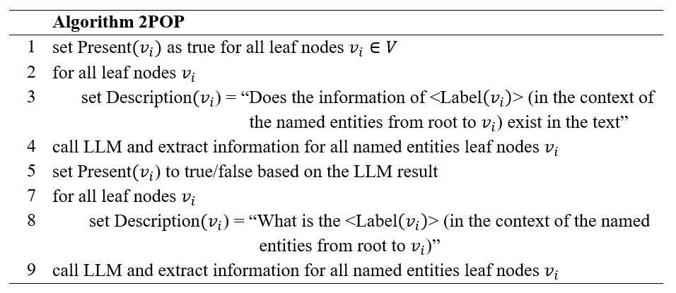
Figure S5. Pseudocode for the algorithm 2POP. In lines 3 and 8, the “(in the context of the named entities from root to $v_{i}$)” should be replaced with the information of ancestors of $v_{i}$ as background information.

