Dimethyl sulfate as methylation agent in highly regioselective synthesis of methyl salicylate using sodium bicarbonate as a base in solvent-free medium
Milton de Souza Freitas ¹, David Lee Nelson ¹, João Victor G. de Sousa ¹, Alexandre P. Wentz ¹, Dayane B. Tada ², Rafaela C. Queiroz ^{2,3}, Carolina R. Hurtado ^{2,3}, Erenilda F. de Macedo ², Katia Conceição ⁴, Gabriela R. Hurtado ^{5,6}, Fernando L. P. Pessoa ⁷, Yan Valdez S. Rodrigues ⁷, Gabriel de P. Bueno ⁸, Giuliano C. Clososki ⁸, Sandro L. Barbosa ^{1*}

¹Department of Pharmacy, Universidade Federal dos Vales do Jequitinhonha e Mucuri-UFVJM, Campus JK, Rodovia MGT 367 - Km 583, nº 5.000, Alto da Jacuba, CEP 39100-000, Diamantina/MG, Brazil. e-mail: freitas.milton@hotmail.com (M.d.S.F.); dleenelson@gmail.com (D.L.N.); sousa.joao@ufvjm.edu.br (J.V.S.); wentzap@hotmail.com (A.P.W.); sandro.barbosa@ufvjm.edu (S.L.B.)
²Nanomaterials and Nanotoxicology Laboratory, Institute of Science and Technology, Federal University of São Paulo (UNIFESP), R. Talim, 330, Vila Nair, CEP 12231-280, São José dos Campos/SP, Brazil. e-mail: d.tada@unifesp.br (D.B.T.); rafaelacamposqueiroz003@gmail.com (R.C.Q.); carolina.hurtado@ifsp.edu.br (C.R.H.); erenildafm@gmail.com (E.F.M.)
³Federal Institute of São Paulo (IFSP), Rod. Pres. Dutra, km 145, Jardim Diamante, CEP 12223-201, São José dos Campos/SP, Brazil. e-mail: carolina.hurtado@ifsp.edu.br (C.R.H.); rafaelacamposqueiroz003@gmail.com (R.C.Q.)
⁴Peptide Biochemistry Laboratory, Institute of Science and Technology, Federal University of São Paulo (Unifesp), R. Talim, 330, Vila Nair, CEP 12231-280, São José dos Campos/SP, Brazil. e-mail: katia.conceicao@unifesp.br (K.C.)
⁵Institute of Science and Technology, São Paulo State University (UNESP), Rod. Pres. Dutra, km 137,8, Eugênio de Melo, CEP 12247-004, São José dos Campos/SP, Brazil. e-mail: gabriela.hurtado@ict.unesp.br (G.R.H.)
⁶Institute of Advanced Sea Studies (IEAMAr), São Paulo State University (UNESP), Rod. Pres. Dutra, km 137,8, Eugênio de Melo, CEP 12247-004, São José dos Campos/SP, Brazil. e-mail: gabriela.hurtado@ict.unesp.br (G.R.H.)
⁷Centro Universitário SENAI-CIMATEC, Av. Orlando Gomes, 1845, Piatã, Salvador 41650-010, Brazil; e-mail: fernando.pessoa@fieb.org.br (F.L.P.P.); yanvaldez@gmail.com (Y.V.S.R.)
⁸Research Center for Natural and Synthetic Products, Faculty of Pharmaceutical Sciences of Ribeirão Preto, University of São Paulo (USP), Av. do Café, CEP 14040-903, Ribeirão Preto/SP, Brazil. e-mail: gclososki@usp.br (G.C.C.); gabrieldepaulabueno@hotmail.com (G.P.B.)
*Corresponding author. Tel.: +55-38-35321234; fax: +55-38-35321234; e-mail: sandro.barbosa@ufvjm.edu.br

____________________________________________________________________________________
Abstract: Methyl salicylate (MS), the principal constituent of Wintergreen oil (WO), was obtained from salicylic acid (SA) by regioselective methylation of the carboxyl group. A new procedure involved exclusive capture of carboxylic hydrogen (-COOH) through the use of the selective base, NaHCO₃. and methylation via an S_{N}2 mechanism employing the previously formed carboxylate as a nucleophile and the dimethyl sulfate [(CH₃)₂SO₄ or DMS] as the electrophilic reagent or substrate in a solvent-free reaction process. The reagents were added separately. SA and NaHCO₃ was added, followed by DMS after 30 min. The reaction involved the esterification by nucleophilic substitution in Csp³ with heating by a heating mantle. The reaction was accompanied by thin layer chromatography and gas chromatography. The conversion rate via GC was 100%, and the MS yield was 96%. The DMS used in excess was transformed into MeOH and H₂SO₄ during the washing with water. The MeOH was stored, and H₂SO₄ was transformed in Na₂SO₄ by neutralization with NaOH. Na₂SO₄ can be used as a desiccant. The simplicity of the procedure, readily available MS, short reaction times, excellent yield and mild reaction condition are other advantages of this protocol. Cytotoxicities of 50% and 64% for cultured S. aureus and metastatic melanoma cells, respectively, were observed for a concentration of 0.6 mg/mL of the MS produced, whereas no cytotoxicity against non-tumor cells was observed at this concentration, and this is considered to be the optimum concentration.

Keywords: Wintergreen oil; methylation; solvent-free substitution nucleophilic bimolecular; antimicrobial activity; cytotoxicity; S. aureus.
____________________________________________________________________________________
1. List of Chemicals
Reagents | CAS
Acetylsalicylic acid | 50-78-2
Methyl salicylate | 119-36-8
Methanol | 67-56-1
Sodium sulfate | 7757-82-6
Dulbecco’s Modified Eagle Medium (DMEM) (Gibco) | was prepared in deionized water, buffered with sodium bicarbonate (Synth, Brazil) and supplemented with fetal bovine serum (FBS) (Vitrocell Embriolife).
Streptomycin | 57-92-1
ampicillin | 69-53-4
3-(4,5-dimethylthiazol-2-yl)-2,5-diphenyltetrazolium bromide (MTT) | 298-93-1
Dimethyl sulfoxide | 67-68-5
Mueller Hinton Broth Medium (MHB) (Kasvi) | was prepared in deionized water.
Dimethyl sulfate | 99.5 77-78
Mouse Fibroblast L929 cells and Murine melanoma B16F10-Nex2 cells | were obtained from the collection of the Laboratory of Nanomaterials and Lanotoxicology, where they were stored at -80 ºC

2. NMR spectra, interpretation of ¹H NMR Spectrum and characterization data of MS (WO) compound.
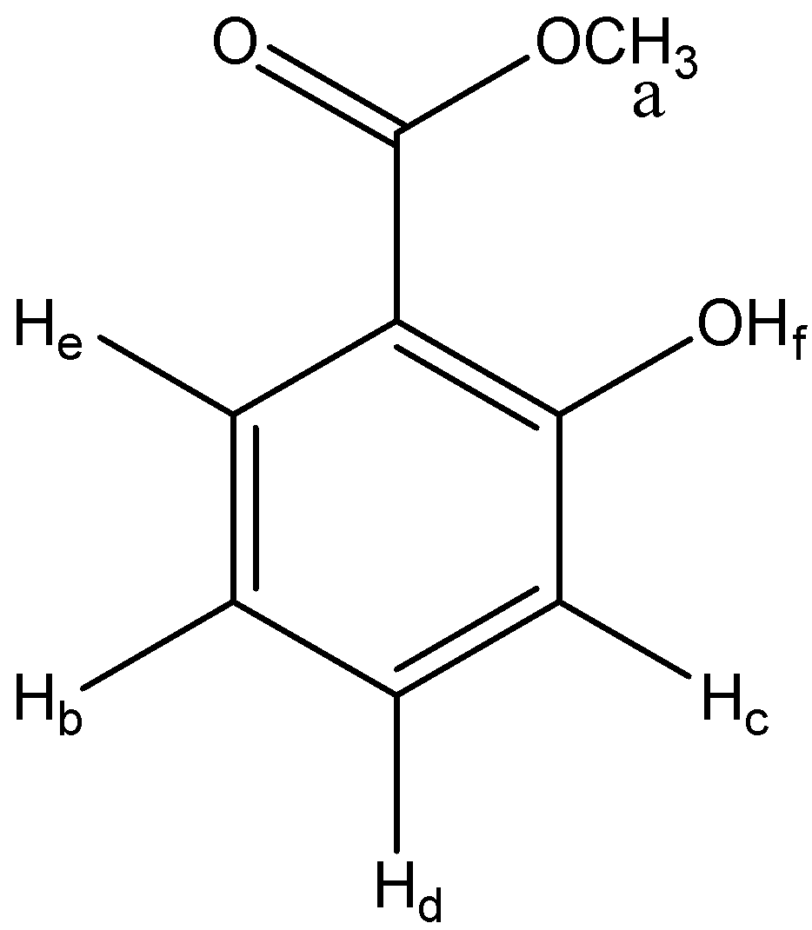
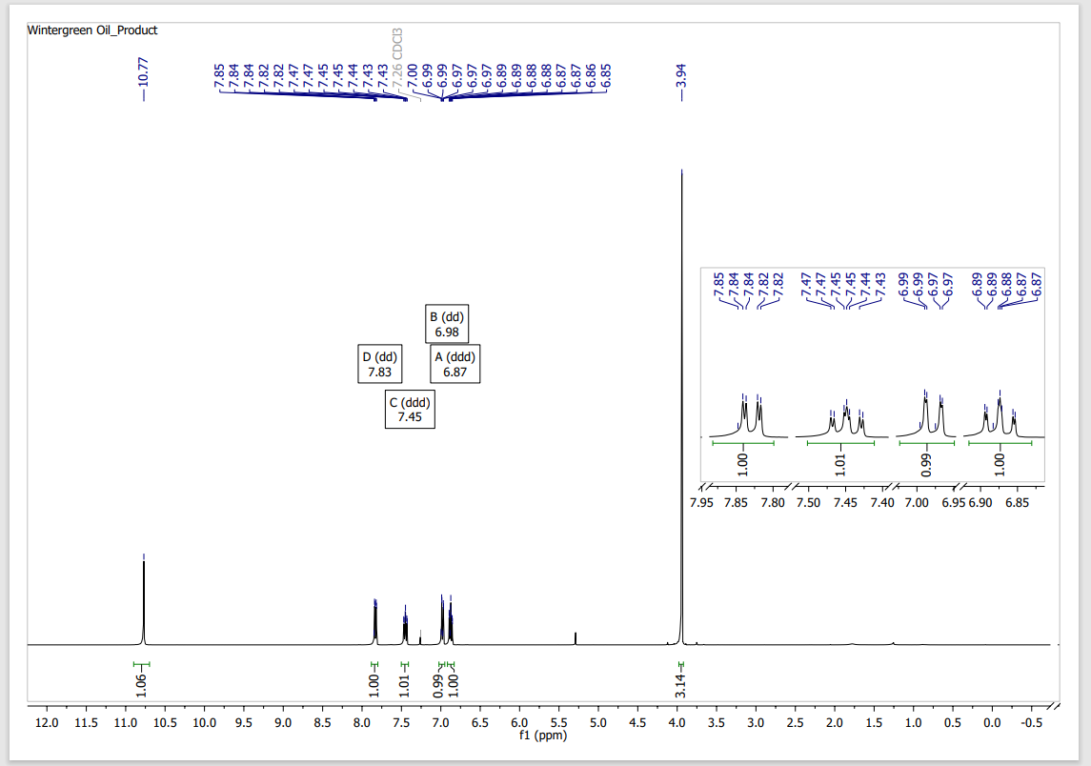
Figure S1. ¹H-NMR [400 MHz, CDCl₃, δ (ppm)] of MS: 3.94, s, 3H (CH₃); 6.88, ddd, 1H (H_{b}) (J_{be} = 8.0 Hz, J_{bd} = 7.1 Hz and J_{bc} = 1.1 Hz); 6.98, dd, 1H (H_{c}) (J_{cd} = 8.5 Hz, J_{cb} = 1.1 Hz); 7.45, ddd, 1H (H_{d}) (J_{dc} = 8.5 Hz, J_{db} = 7.1 Hz, J_{de} =1.7 Hz); 7.84, dd, 1H (H_{e}) (J_{eb} = 8.0 Hz, J_{ed} = 1.7 Hz) and 10.75, s, 1H (phenolic proton).

2.2. Interpretation of ¹H NMR Spectrum.
a This methyl group (δ 3.94, s, 3 H) is unsplit and deshielded by the electronegative oxygen.
b This aromatic proton (δ 6.88, ddd, 1 H) is coupled through 3 bonds with proton e (J_{be} = 8.0 Hz) and proton d (J_{bd} = 7.1 Hz) and 4 bonds with proton c (J_{bc} = 1.1 Hz).
c This aromatic proton (δ 6.98, dd, 1 H) is coupled through 3 bonds with proton d (J_{cd} = 8.5 Hz) and 4 bonds with proton b (J_{cb} = 1.1 Hz).
d This aromatic proton (δ 7.45, ddd, 1 H) is coupled through 3 bonds with proton c (J_{dc} = 8.5 Hz) and proton b (J_{db} = 7.1 Hz) and 4 bonds with proton e (J_{de} =1.7 Hz).
e This aromatic proton (δ 7.84, dd, 1 H) is coupled through 3 bonds with proton b (J_{eb} = 8.0 Hz) and 4 bonds with proton d (J_{ed} = 1.7 Hz).
f This phenolic proton (δ 10.75, s, 1 H) is unsplit and is farther downfield than is typical for other phenols. This can be attributed to the hydrogen bonding that occurs with the carbonyl oxygen of the ester.

Note the much smaller coupling constants for the long range (4-bond) couplings. The coupling constants, splitting patterns and chemical shifts can be used to match each resonance to the corresponding proton of the compound. Proton a integrates as 3H, is unsplit and modestly deshielded by the neighboring oxygen methyl group. Identifying this as the methyl group of the ester is straightforward. Proton f integrates as 1H, is unsplit and far downfield, identifying this as the phenolic hydrogen. Identifying the aromatic protons is more involved. The hydroxyl group should shield protons b and c through electron donation to its ortho and para positions. The carbonyl should deshield protons d and e through electron withdrawal from its ortho and para positions. Proton b and proton e share a 3-bond coupling constant (J_{be} = J_{eb} = 8.0 Hz) and are thus adjacent. Proton c and proton d share a 3-bond coupling constant (J_{cd} = J_{dc} = 8.5 Hz) and are thus adjacent. Proton b and proton d share a 3-bond coupling constant (Jbd = Jdb = 7.1 Hz) and are thus adjacent. The smaller 4-bond coupling constants reinforce these identifications.
Proton b and proton c share a 4-bond coupling constant (Jbc = Jcb = 1.1 Hz) and thus are meta to each other. Proton d and proton e share a 4-bond coupling constant (Jde = Jed = 1.7 Hz) and thus are meta to each other.

3. NMR spectra, interpretation of ¹³C NMR Spectrum and characterization data of MS (WO) compound.
3.1. NMR spectra
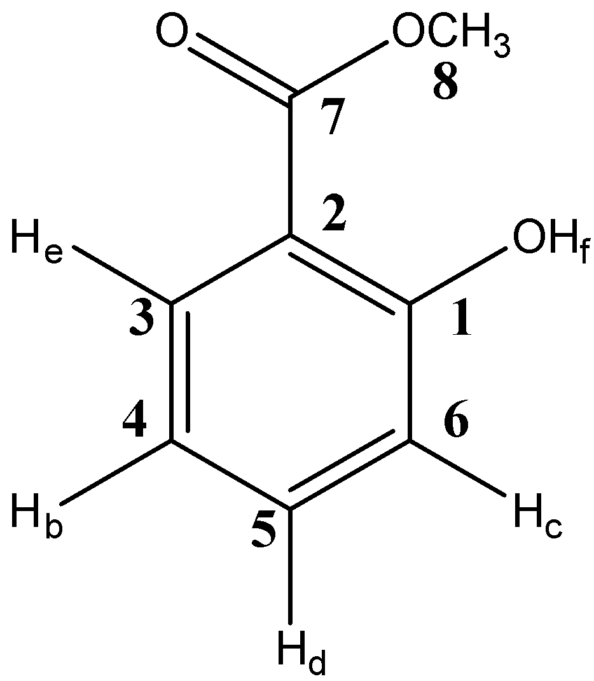
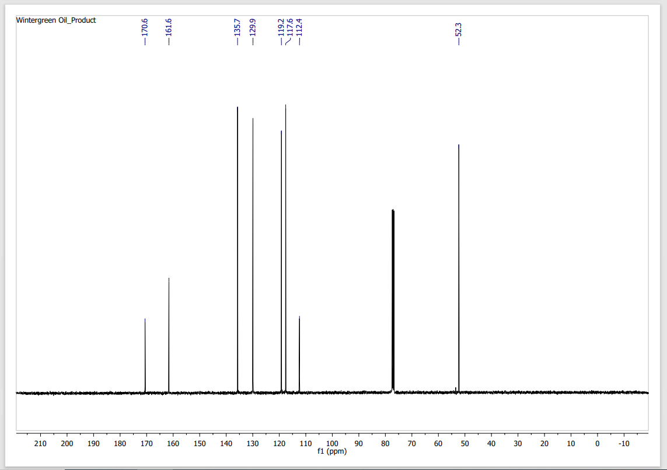
Figure S2. ¹³C NMR [100 MHz, CDCl₃, δ (ppm)] of MS: 170.6 C=O or Ar quaternary, 161.6 C=O or Ar quaternary, 135.7 Ar CH, 129.9 Ar CH, 119.2 Ar CH, 117.6 Ar CH, 112.4 Ar quaternary and 52.3 CH₃.

3.2. Interpretation of ¹³C NMR Spectrum.
Decoupled, eight peaks are observed, (ignoring the solvent peaks!). The methyl carbon is immediately recognizable due to its high field chemical shift. The carbonyl group is typically down field and could be either 170.6 or 161.6 ppm. Since quaternary carbons do not relax as quickly as tertiary, secondary and primary carbons then the peak intensities (and the chemical shifts!) indicate which peaks correspond to Ar CH and which to Ar quaternary carbons.

4. NMR spectra, interpretation of ¹H NMR Spectrum and characterization data of Acetylsalicylic acid (ASA) compound.
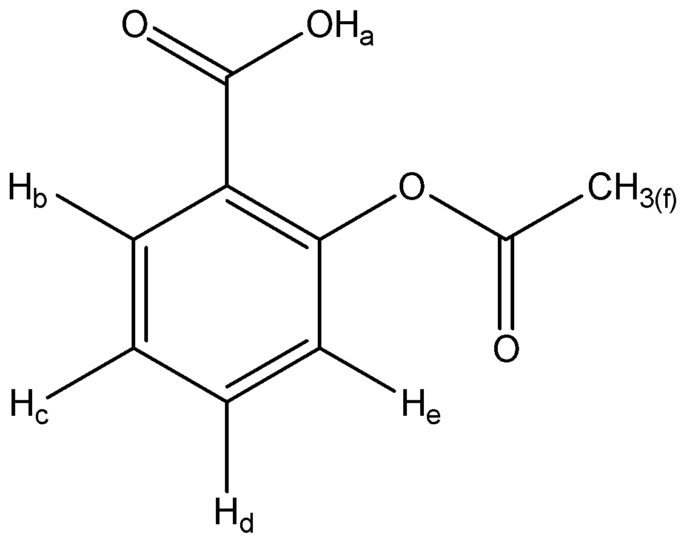

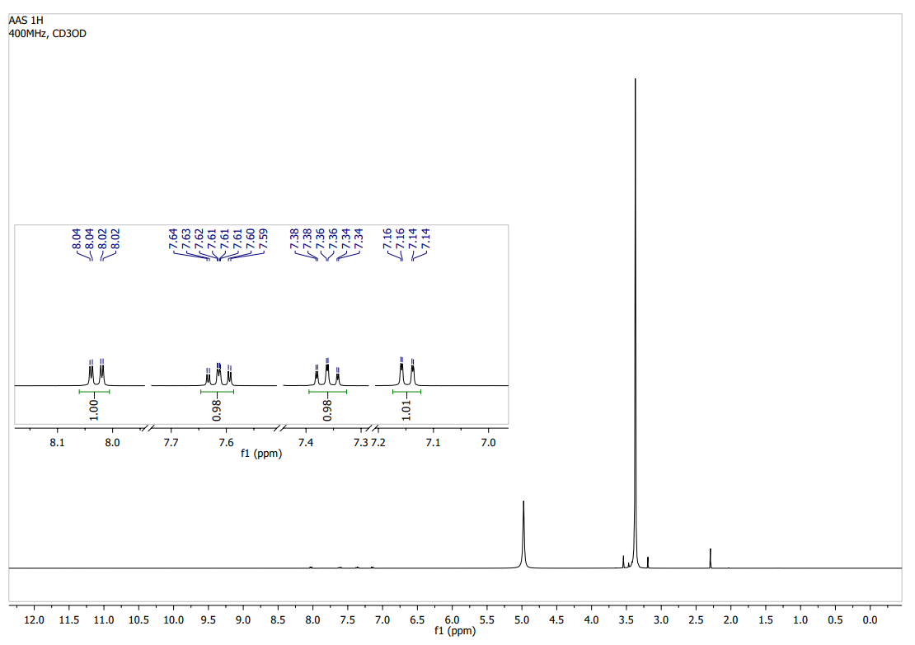
4.1. Figure S3. ¹H-NMR [400 MHz, CDCl₃, δ (ppm)] of Acetylsalicylic acid (ASA): 2.30, s, 3H (CH₃); 8.125, ddd, 1H (H_{b}) (J_{be} = 8.0 Hz, J_{bd} = 7.1 Hz and J_{bc} = 1.1 Hz); 7.624, dd, 1H (H_{c}) (J_{cd} = 8.5 Hz, J_{cb} = 1.1 Hz); 7.356, ddd, 1H (H_{d}) (J_{dc} = 8.5 Hz, J_{db} = 7.1 Hz, J_{de} =1.7 Hz); and 7.142, dd, 1H (H_{e}) (J_{eb} = 8.0 Hz, J_{ed} = 1.7 Hz).

4.2. Interpretation of ¹H NMR Spectrum.

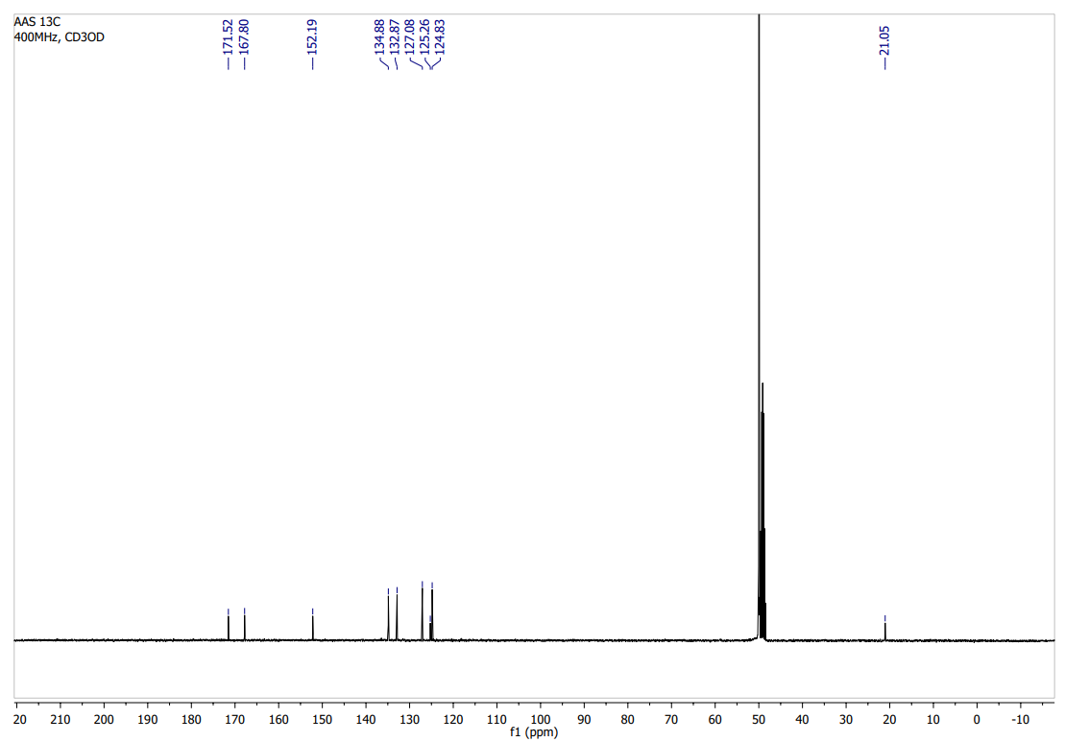
Fig. S4. ¹³C NMR [100 MHz, CDCl₃, δ (ppm)] of ASA: 171.5 C=O (CH₃C=O), 167.8 C=O, 152.1 Ar quaternary, 134.8 Ar, 132.8 Ar CH, 127.0 Ar CH, 125.2 Ar CH, 124.8 Ar quaternary, and 49.9 CH₃.

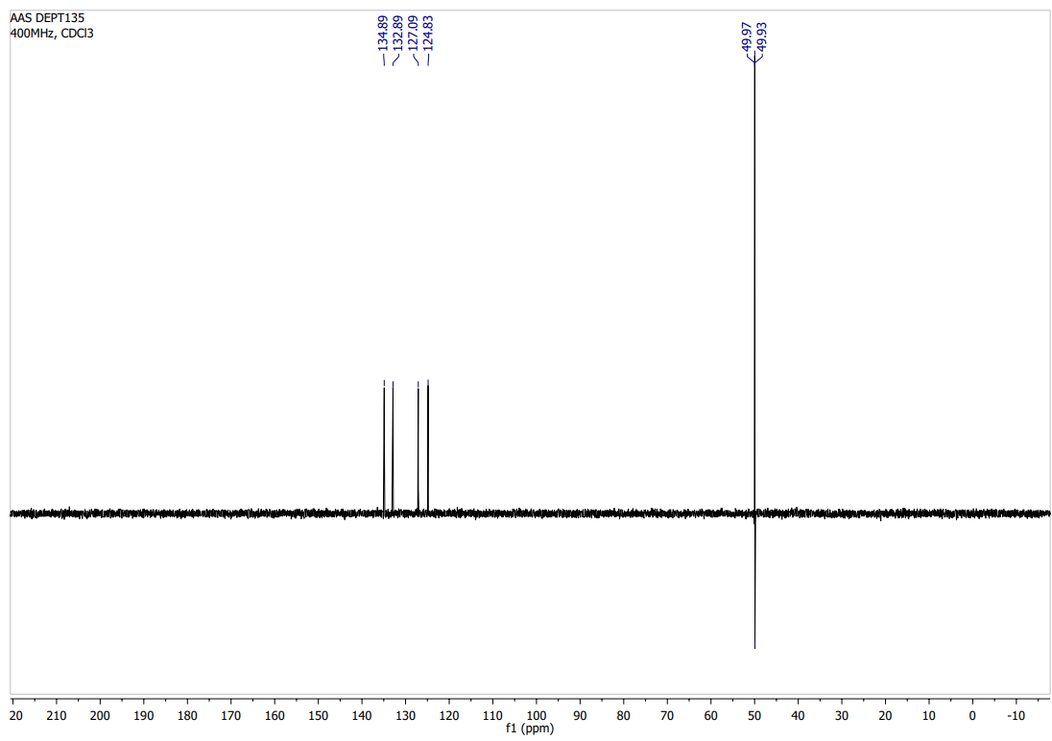
Figure S5. DEPT 135 [400 MHz (¹H), CDCl₃, δ (ppm)] of ASA: 132.8 Ar CH (methine group - tertiary), 127.0 Ar CH, 125.2 Ar CH, 124.8 Ar CH, and 49.9 CH₃.

5. GC Chromatogram of MS compound.
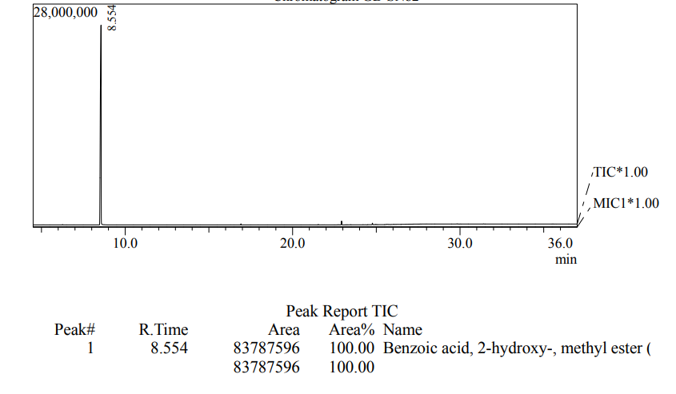
4.1. Figure S3. GC Chromatogram of MS (WO) compound.

