Supplementary materials
Note: In all figures and tables of supplementary material, XP1, YP2 and SG1 represent Xintai poplar propolis, Yanggu poplar propolis and poplar gum, respectively.

Table S1. Common differential metabolites in poplar propolis and poplar gum. Class I, primary classification of substances. Class II, secondary classification of substances. cpd_ID, the metabolite number in KEGG database. kegg_map, the KEGG database pathway number.
Table S2. Table S2. Common differential metabolites in poplar propolis. Class I, primary classification of substances. Class II, secondary classification of substances. cpd_ID, the metabolite number in KEGG database. kegg_map, the KEGG database pathway number.
Table S3. The key active differential metabolites of poplar propolis and poplar gum. Class I, primary classification of substances. Class II, secondary classification of substances. cpd_ID, the metabolite number in KEGG database. kegg_map, the KEGG database pathway number.
Figure captions:
Figure S1 Multi-peak diagram of metabolite identified based on MRM. A represents positive ion mode. B represents negative ion mode.
Figure S2 Quantification integral correction diagram of metabolite. A represents positive ion mode. B represents negative ion mode.
Figure S3 Total ion flow diagram for mass spectrometry analysis of QC samples. A represents positive ion mode. B represents negative ion mode.
Figure S4 Differential metabolite KEGG classification of SG1 vs. XP1.
Figure S5 Differential metabolite KEGG classification of SG1 vs. YP2.
Figure S1

Figure S2
Figure S3

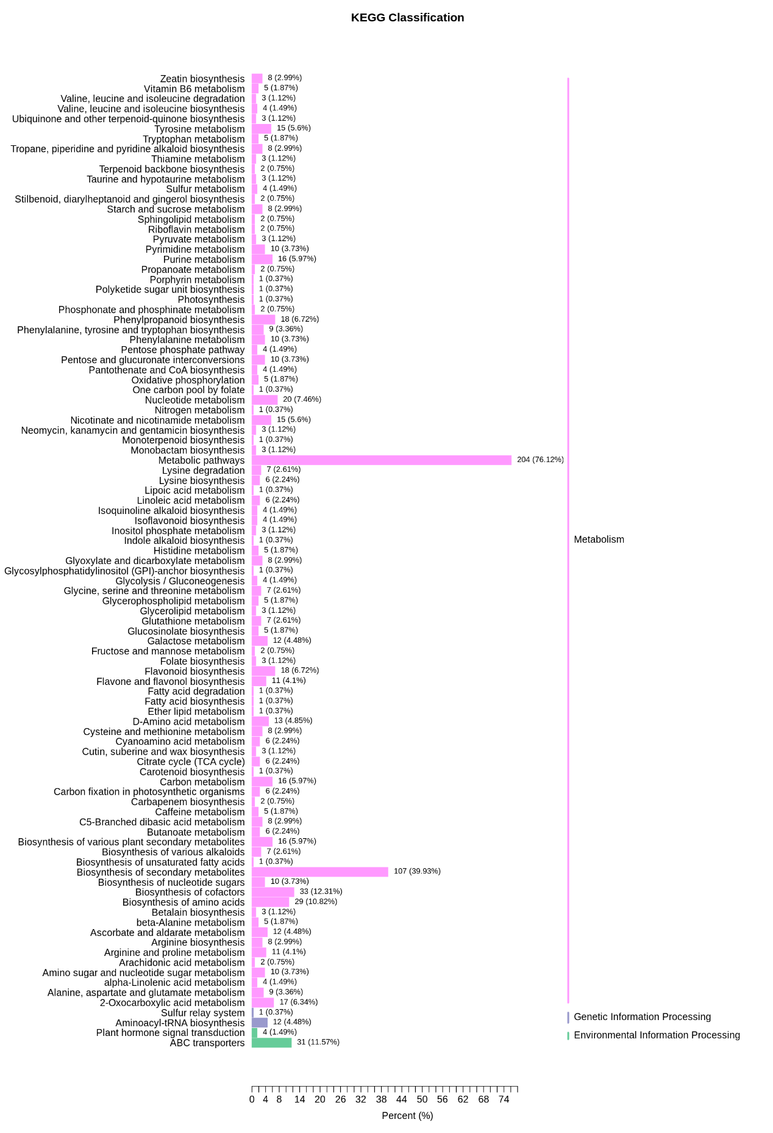
Figure S4
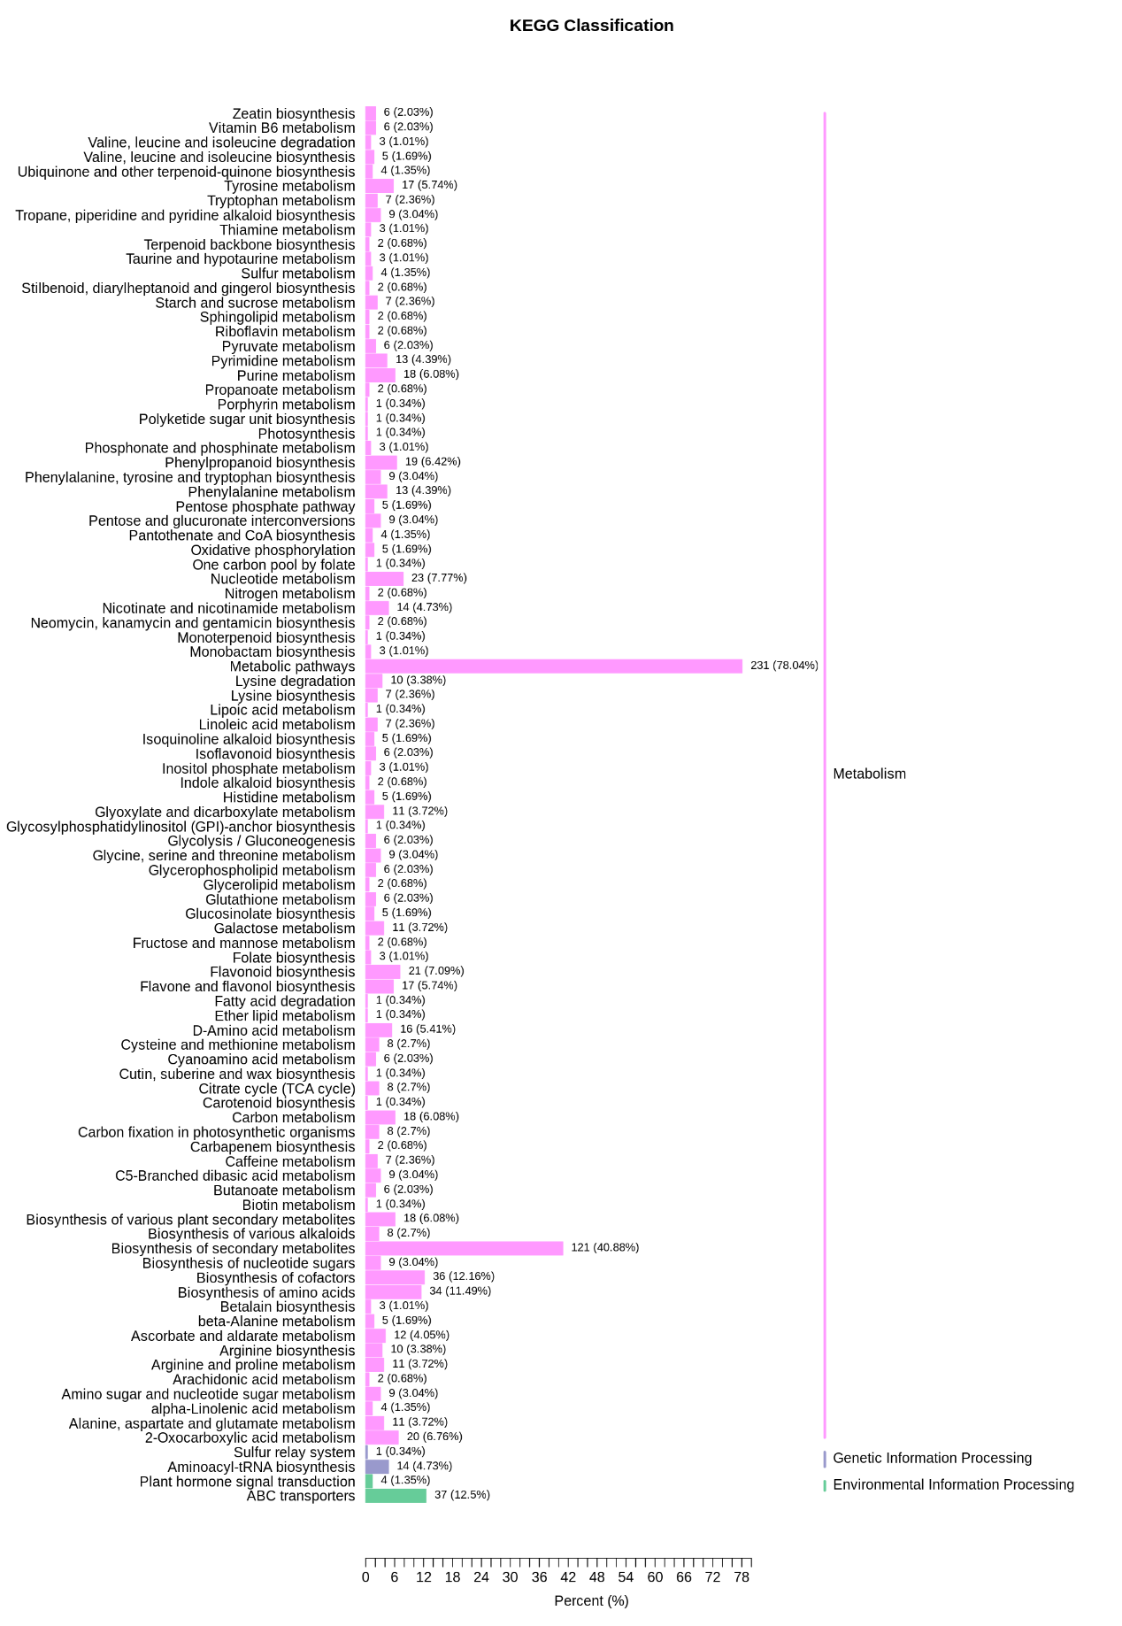
Figure S5

