Supplementary Information

Poly(_{L}-glutamic acid) based composites for improved dual immune checkpoint blockade therapy

Fuxin Xue^{†a}, Haochen Yao^{†d}, Jiali Sun^{b,c}, Xitong Ren^{b,c}, Junli Hu^{a,*}, Na Shen^{b,c,*} Zhaohui Tang ^{b,c}

Table S1. The molecular weight of αPD1, αPDL1 and BsAb_{αPD1&αPDL1} determined by asymmetric flow field-flow fractionation coupled with muti-angle laser light scattering at a wavelength of 658 nm.
Simple | PD1 | PDL1 | BsAb
Mw | 2.477 × 10⁵ ( ± 0.049%) | 1.597 × 10⁵ ( ± 1.598%) | 1.470 × 10⁶ ( ± 0.865%)

Table S2. The element analysis of PGLU-Fc-III-4C.
Element | S% | C% | H%
Percentage composition | 3.9 ± 0.6 | 42.1 ± 0.8 | 6.0 ± 0.07

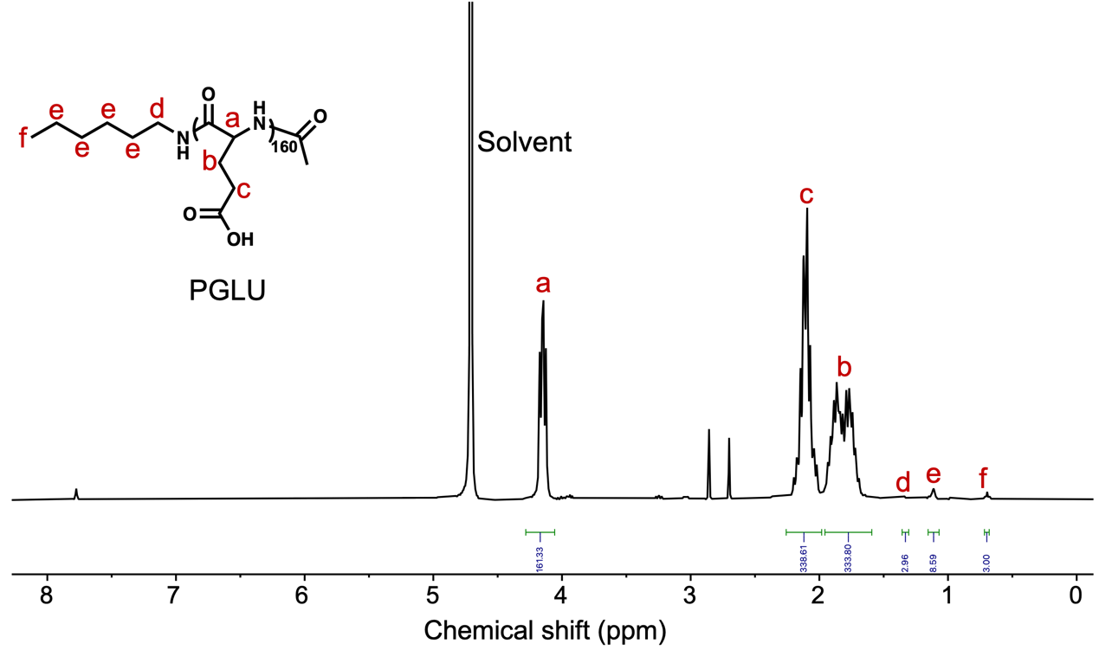Figure S1. ¹H NMR spectrum of PGLU.
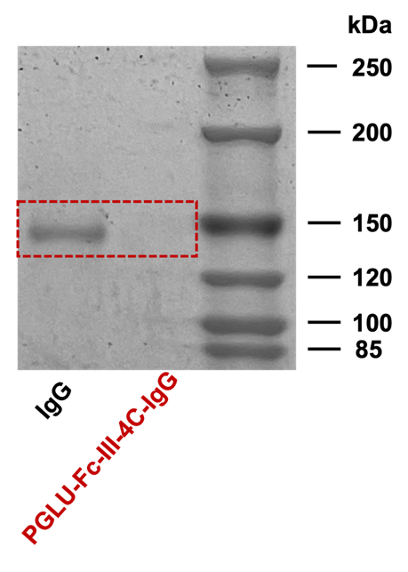
Figure S2. Image showing the IgG band before and after IgG loading onto PGLU-Fc-III-4C.

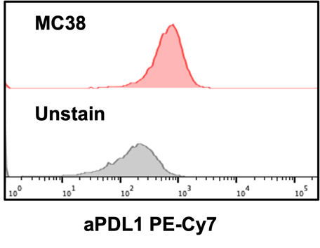
Figure S3. The expression of αPDL1 on MC38 was analyzed by flow cytometry.
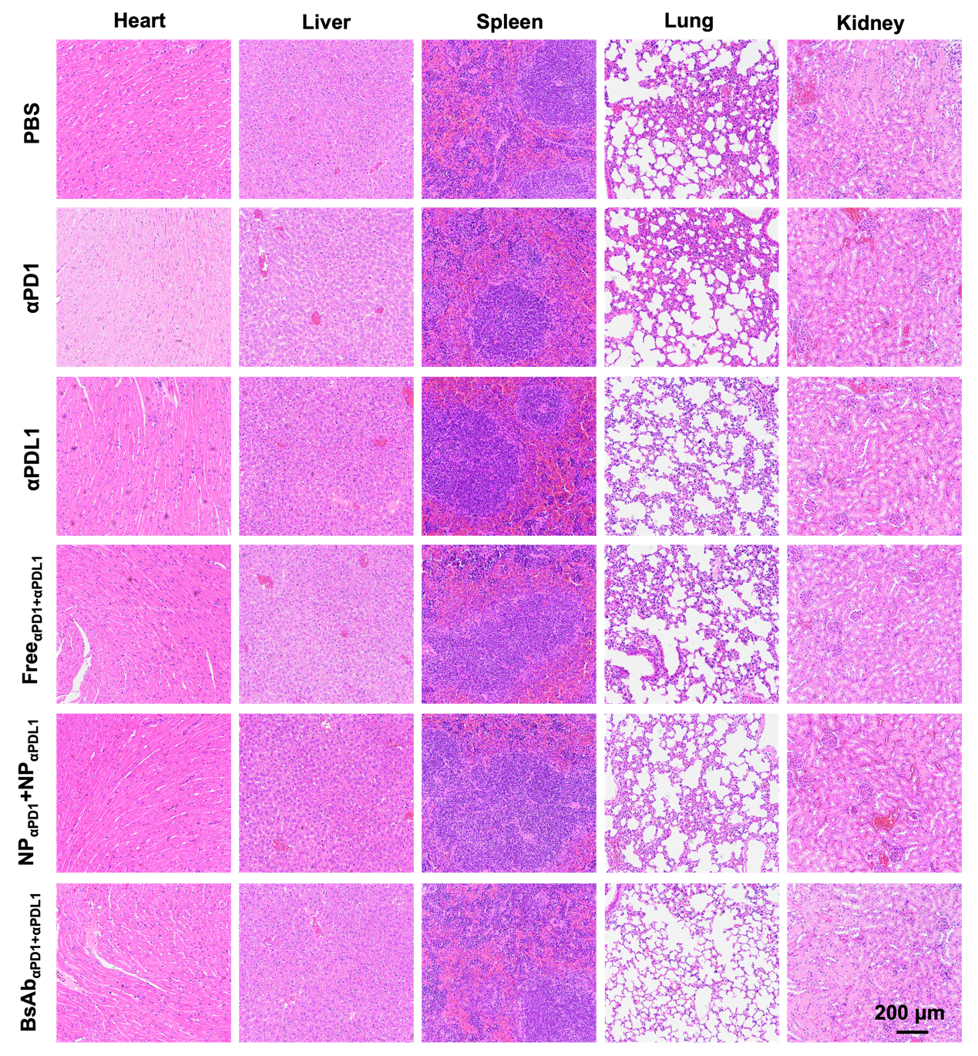
Figure S4. H&E staining of heart, liver, spleen, lung, kidney after different drugs treatment.

Figure S5. Pharmacokinetics of BsAb_{αPD1+αPDL1}/Cy5, PGLU-Fc-III-4C-IgG/Cy5 and IgG/Cy5 (n = 3).
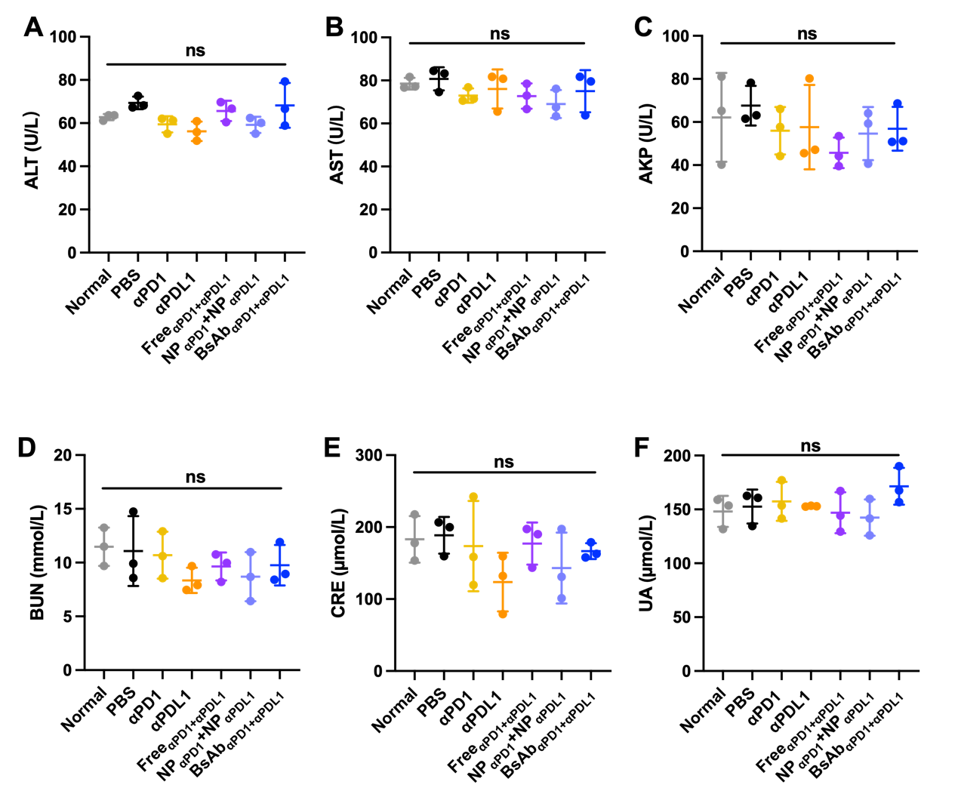
Figure S6. Alteration of (A) ALT, (B) AST, (C) AKP, (D) BUN, (E) CRE, (F) UA.

Antibody | Catalog No.
FITC anti-mouse CD3 Antibody | 100203
PE/Cy7 anti-mouse CD4 Antibody | 100422
APC anti-mouse CD8a Antibody | 100712
FITC anti-mouse PD1 antibody | ab93579
PE/Cy7 anti-mouse CD274 Antibody | 124313
Table S3. Antibodies used in flow cytometry experiments.

Note: All antibodies were purchased from United States BioLegend Co.

