Supplementary Items for
Temperature-Dependent Variations in Under-Canopy Herbaceous Foliar Diseases Following Shrub Encroachment in Grasslands
Yilin Dang^{1, 2}, Peng Zhang¹, Peixi Jiang¹, Junsheng Ke¹, Yao Xiao¹, Mu Liu¹, Jianquan Liu^{1, *}, Bin Tian^{2*}, Xiang Liu^{1†}
*Corresponding Author: liujq@nwipb.cas.cn
*Corresponding Author: tianbin@swfu.edu.cn
†Corresponding Author: lx@lzu.edu.cn

Supplementary Figures and Tables
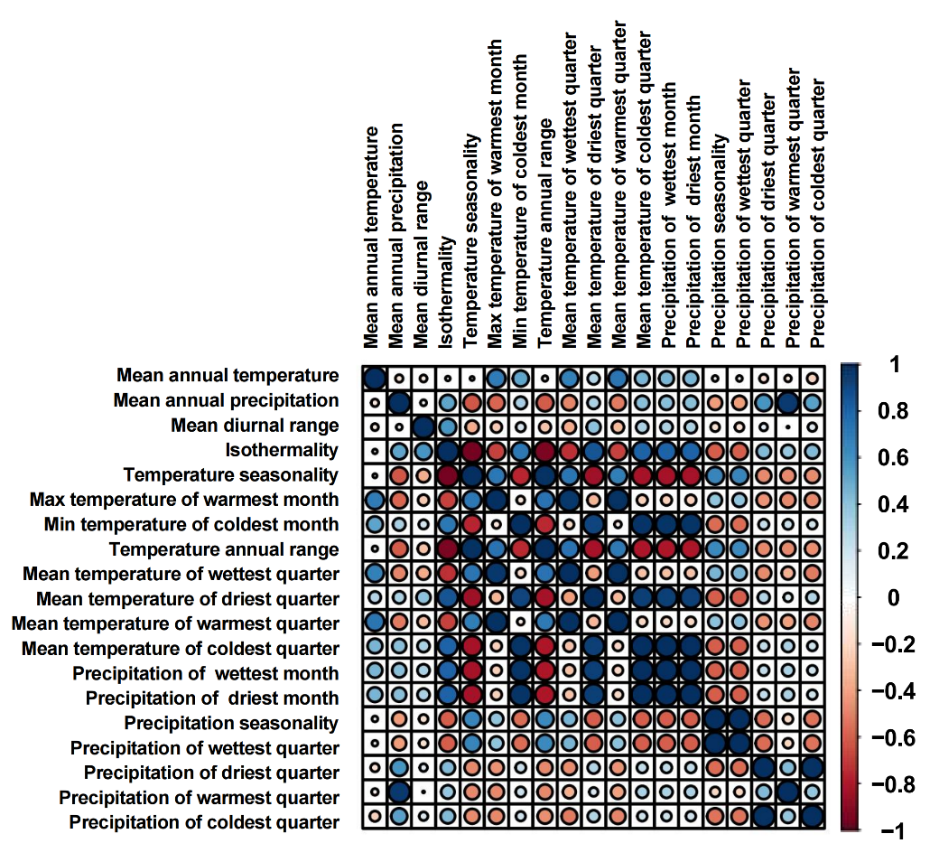

Supplementary Fig. 1 | The correlation matrix of 19 variables related to climate factors. Numbers represent the correlation coefficients, ranging from -1 to 1. Colour depth and direction of the circles indicate the correlation strength and direction. Shown are the mean annual temperature, mean diurnal range, isothermally, temperature seasonality, max temperature of warmest month, min temperature of coldest month, temperature annual range, mean temperature of wettest quarter, mean temperature of driest quarter, mean temperature of warmest quarter, mean temperature of coldest quarter, mean annual precipitation, precipitation of wettest month, precipitation of driest month, precipitation seasonality, precipitation of wettest quarter, precipitation of driest quarter, precipitation of warmest quarter and precipitation of coldest quarter.

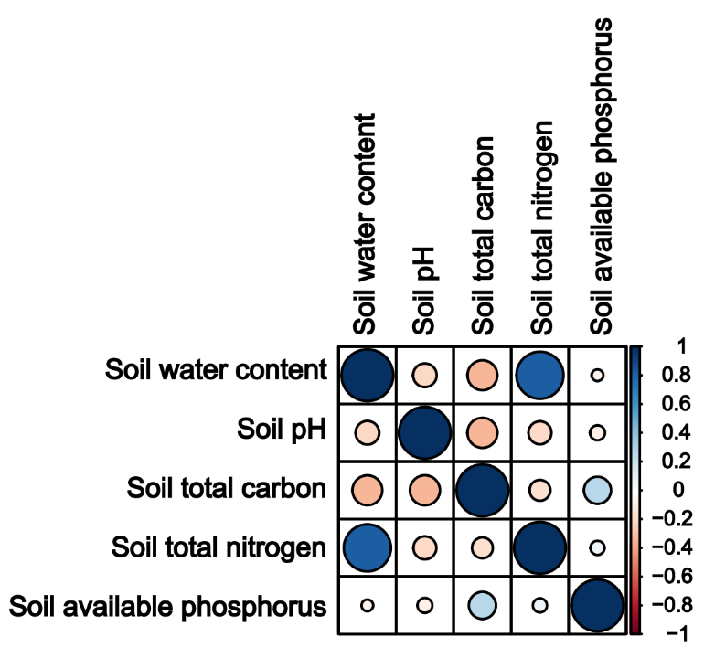

Supplementary Fig. 2 | The correlation matrix of 5 variables related to soil properties. Numbers represent the correlation coefficients, ranging from -1 to 1. Colour depth and direction of the circles indicate the correlation strength and direction. Shown are the soil total carbon, soil total nitrogen, soil available phosphorus, soil pH and soil water content.

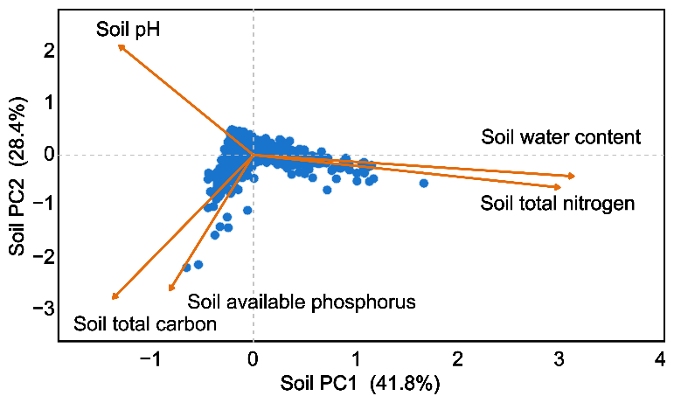

Supplementary Fig. 3 | Principal component analysis (PCA) of soil properties. Soil total carbon, soil total nitrogen, soil available phosphorus, soil pH and soil water content were included.

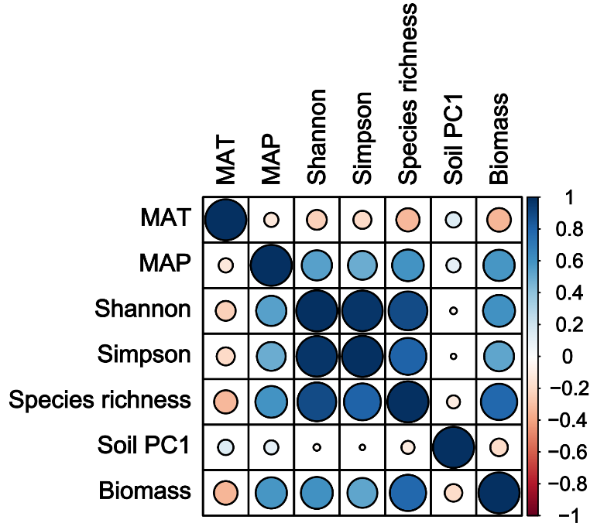

Supplementary Fig. 4 | The correlation matrix of 10 explanatory variables. Numbers represent the correlation coefficients, ranging from -1 to 1. Colour depth and direction of the circles indicate the correlation strength and direction. Shown are the mean annual temperature (MAT), mean annual precipitation (MAP), grassland patches’ plots herbaceous plant community species richness (Species richness), Shannon diversity index (Shannon), Simpson diversity index (Simpson), aboveground biomass (Biomass) and the first principal component of grassland patches’ plots soil variables (Soil PC1).

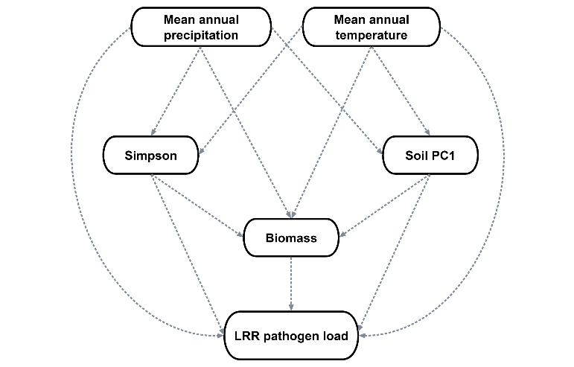

Supplementary Fig. 5 | A priori of the structural equation models on log-transformed response ratio of herbaceous community foliar fungal pathogen load between shrub patches and grassland patches’ plots (i.e., LRR pathogen load).

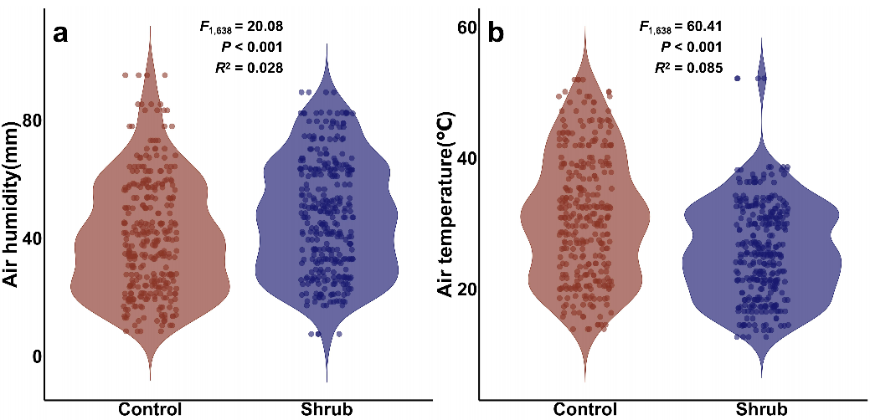

Supplementary Fig. 6 | The effects of shrub and grassland treatments on a air temperature, b air humidity. Blue and orange data points represent the shrub and grassland treatment of original data.

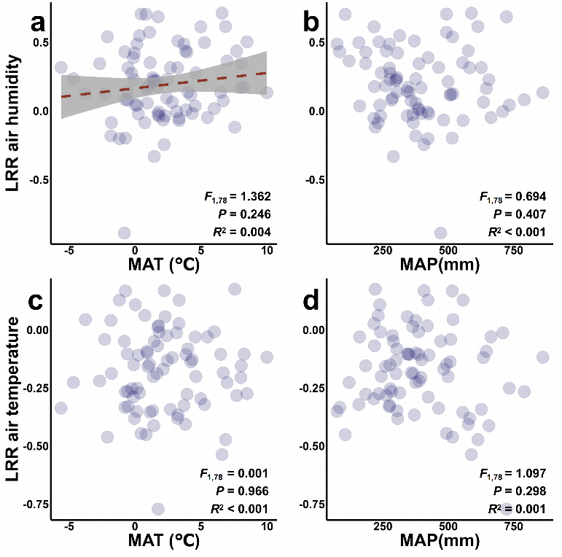

Supplementary Fig. 7 | The linear mixed-effects models show the effects of a, c mean annual temperature (MAT), b, d mean annual precipitation (MAP) on log-transformed response ratio of air humidity and air temperature between shrub patches and grassland patches’ plots (i.e., LRR air humidity and LRR air temperature, respectively).

Supplementary Table 1 | The effect of abiotic and biotic factors on herbaceous plant community aboveground biomass, and effect of shrubs on LRR herbaceous biomass and LRR pathogen load. Response variables include mean annual temperature (MAT), mean annual precipitation (MAP) and LRR pathogen load (i.e., log-transformed response ratio of herbaceous community foliar fungal pathogen load between shrub patches and grassland patches’ plots). Predictor variables include LRR pathogen load and LRR herbaceous biomass (i.e., log-transformed response ratio of herbaceous plant community aboveground biomass between shrub patches and grassland patches’ plots). Shown are the results of linear mixed-effects models with ‘site’ as a random effect. numDF and denDF denote the numerator and denominator degrees of freedom, the levels of significance for corresponding pathways (P value), respectively. Significant results (P < 0.05) are given in bold.
Predictor | Response | numDF | denDF | F | P
LRR pathogen load | MAT | 1 | 240 | 8.960 | 0.003
LRR pathogen load | MAP | 1 | 240 | 2.316 | 0.132
LRR herbaceous biomass | MAT | 1 | 240 | 14.644 | <0.001
LRR herbaceous biomass | MAP | 1 | 240 | 10.722 | 0.001
LRR herbaceous biomass | LRR pathogen load | 1 | 239 | 21.828 | <0.001

Supplementary Table 2 | Results of parameter estimation by using Bayesian mixed-effects models. The effects of mean annual temperature (MAT), mean annual precipitation (MAP), grassland patches’ plots herbaceous plant community species richness (Species richness), Shannon diversity index (Shannon), Simpson diversity index (Simpson), aboveground biomass (Biomass) and the first principal component of grassland patches’ plots soil variables (Soil PC1) on log-transformed response ratio of herbaceous community foliar fungal pathogen load between shrub patches and grassland patches’ plots (i.e., LRR pathogen load).
Response | Predictors | Estimate | Est. Error | 95%CI
LRR pathogen load | MAT | 0.20 | 0.12 | -0.03~0.42
LRR pathogen load | MAP | -0.01 | 0.15 | -0.30~0.27
LRR pathogen load | Shannon | -0.49 | 0.47 | -1.39~0.44
LRR pathogen load | Simpson | 0.42 | 0.34 | -0.25~1.09
LRR pathogen load | Species richness | 0.06 | 0.24 | -0.43~0.53
LRR pathogen load | Soil PC1 | <0.01 | 0.12 | -0.23~0.24
LRR pathogen load | Biomass | -0.26 | 0.13 | -0.53~-0.01

Supplementary Table 3 | Results of estimate contribution by using Bayesian mixed-effects models. The effects of mean annual temperature (MAT), mean annual precipitation (MAP), grassland patches’ plots herbaceous plant community Shannon diversity index (Shannon), Simpson diversity index (Simpson), species richness (Species richness), aboveground biomass (Biomass) and the first principal component of grassland patches’ plots soil variables (Soil PC1) on log-transformed response ratio of herbaceous community foliar fungal pathogen load between shrub patches and grassland patches’ plots (i.e., LRR pathogen load).
Response | Predictors | Estimate | Est. Error | 95%CI
LRR pathogen load | MAT | 5.91 | 0.04 | 5.82~5.99
LRR pathogen load | MAP | 2.72 | 0.05 | 2.63~2.82
LRR pathogen load | Shannon | 18.54 | 0.17 | 18.20~18.89
LRR pathogen load | Simpson | 15.45 | 0.12 | 15.21~15.69
LRR pathogen load | Species richness | 5.53 | 0.06 | 5.40~5.65
LRR pathogen load | Soil PC1 | 2.34 | 0.04 | 2.26~2.41
LRR pathogen load | Biomass | 7.55 | 0.04 | 7.46~7.64

Supplementary Table 4 | Coefficient estimates from the structural equation model examining how mean annual temperature (MAT), mean annual precipitation (MAP), grassland patches’ plots herbaceous plant community aboveground biomass (Biomass), Simpson diversity index (Simpson) and the first principal component of grassland patches’ plots soil variables (Soil PC1) affect log-transformed response ratio of herbaceous community foliar fungal pathogen load between shrub patches and grassland patches’ plots (i.e., LRR pathogen load) via plausible pathways. Shown are estimate, standard error (Std.Error), the levels of significance for corresponding pathways (P value) and standard estimate (Std.Estimate). Significant results (P < 0.05) are given in bold.
Response | Predictor | Estimate | Std.Error | P | Std.Estimate
LRR pathogen load | MAT | 0.070 | 0.034 | 0.043 | 0.153
LRR pathogen load | MAP | <-0.001 | <0.001 | 0.809 | -0.021
LRR pathogen load | Biomass | -0.009 | 0.003 | 0.014 | -0.187
LRR pathogen load | Simpson | -0.033 | 0.392 | 0.932 | -0.005
LRR pathogen load | Soil PC1 | -0.057 | 0.399 | 0.886 | -0.010
Biomass | MAT | -2.539 | 0.742 | 0.001 | -0.281
Biomass | MAP | 0.077 | 0.014 | <0.001 | 0.461
Biomass | Simpson | 7.593 | 5.203 | 0.145 | 0.064
Biomass | Soil PC1 | -20.782 | 7.783 | 0.008 | -0.200
Simpson | MAT | -0.0152 | 0.006 | 0.017 | -0.197
Simpson | MAP | <0.001 | <0.001 | <0.001 | 0.380
Soil PC1 | MAT | 0.004 | 0.008 | 0.616 | 0.051
Soil PC1 | MAP | <0.001 | <0.001 | 0.001 | 0.388

Supplementary Table 5 | The effects of mean annual temperature (MAT), mean annual precipitation (MAP), grassland patches’ plots herbaceous plant community aboveground biomass (Biomass), Simpson diversity index (Simpson) and the first principal component of grassland patches’ plots soil variables (Soil PC1) on log-transformed response ratio of herbaceous community foliar fungal pathogen load between shrub patches and grassland patches’ plots (i.e., LRR pathogen load) residuals. Shown are the results of linear mixed-effects models with ‘site’ as a random effect; numDF and denDF denote the numerator and denominator degrees of freedom and the levels of significance for corresponding pathways (P value). Significant results (P < 0.05) are given in bold. Blue shades indicate significant positive effects and orange shades indicate significant negative effects.
Predictor | Response | numDF | denDF | F | P
LRR pathogen load | others | MAT | others | 1 | 318 | 6.885 | 0.009
LRR pathogen load | others | MAP | others | 1 | 318 | 0.001 | 0.969
LRR pathogen load | others | Biomass | others | 1 | 318 | 8.898 | 0.003
LRR pathogen load | others | Simpson | others | 1 | 318 | 0.050 | 0.822
LRR pathogen load | others | Soil PC1 | others | 1 | 318 | 0.454 | 0.500

Supplementary Table 6 | The effect of shrub and grassland treatment on air humidity and air temperature. Shown are the results of general linear models. NumDF and denDF denote the numerator and denominator degrees of freedom, the levels of significance for corresponding pathways (P value), respectively. Significant results (P < 0.05) are given in bold.
Predictor | Response | numDF | denDF | F | P
Treatment | Air humidity | 1 | 638 | 60.41 | <0.001
Treatment | Air temperature | 1 | 638 | 20.08 | <0.001

Supplementary Table 7 | The effect of mean annual temperature (MAT), mean annual precipitation (MAP) on log-transformed response ratio of air humidity and air temperature between shrub patches and grassland patches’ plots (i.e., LRR air humidity and LRR air temperature, respectively). Shown are the results of linear mixed-effects models with ‘site’ as a random effect; numDF and denDF denote the numerator and denominator degrees of freedom, and the levels of significance for corresponding pathways (P value). Significant results (P < 0.05) are given in bold.
Predictor | Response | numDF | denDF | F | P
LRR air humidity | MAT | 1 | 78 | 1.362 | 0.246
LRR air humidity | MAP | 1 | 78 | 0.694 | 0.407
LRR air temperature | MAT | 1 | 78 | 0.001 | 0.966
LRR air temperature | MAP | 1 | 78 | 1.097 | 0.298

