Supporting Information
Pros and Cons in The Delivery of Doxorubicin Using Renal-clearable Gold Nanoparticles
Lang Liu ^{a,1}, Shanshan Qiao ^{a,1}, Meiyu Sun ª, Yusheng Mao ª, Hai Huang ª, Yemei Wang ª, Shasha Sun ^{a, c,} *, Xianzhi Chai ^{a,} *, Shaoheng Tang ^{a,} *, and Aihua Gong ^{b,} *
ª School of Environmental and Chemical Engineering, Jiangsu University of Science and Technology, Zhenjiang, China
^{b} School of Medicine, Jiangsu University, Zhenjiang, China
^{c} Department of Medical Oncology, Jiangsu Cancer Hospital& Jiangsu Institute of Cancer Research& The Affiliated Cancer Hospital of Nanjing Medical University, Nanjing, China
E-mail: sunshasha@just.edu.cn; chaixianzhi@just.edu.cn; shtang@just.edu.cn; ahg5@mail.ujs.edu.cn
Materials and Equipment
Materials: HAuCl₄·4H₂O was purchased from Sinophelic Pharmaceutical Group Chemical Reagent Co., Ltd. mPEG-SH(5K) was purchased from Hunan Huateng Pharmaceutical Co., Ltd. PDPH-linker was purchased from Xi 'an Ruixi Biotechnology Co., LTD. LysoTracker® Green DND-26 stain and Hoechst 33342 stain were purchased from Shanghai Yisheng Biotechnology Co., Ltd. Reduced glutathione (GSH), Sephadex LH-20 and agarose were all purchased from Aladdin Chemical Reagent Co., Ltd. The whole experiment uses deionized water with resistivity ≥ 18.2 MΩ*cm.
Equipment: High-resolution transmission electron microscopy (HR-TEM) was performed on a JEM 2011(200 kV) transmission electron microscope (JEOL, Japan). The fluorescence spectra were collected by an Edinburgh instrument spectrofluorometer FS5. UV-Vis spectra were taken using a Shimadzu UV-2550 UV-Vis spectrophotometer. Cell fluorescence imaging was performed using OLYMPUS biological microscopy. Cytotoxicity was determined with a SpectraMax® i3 microplate reader.
Supporting figures

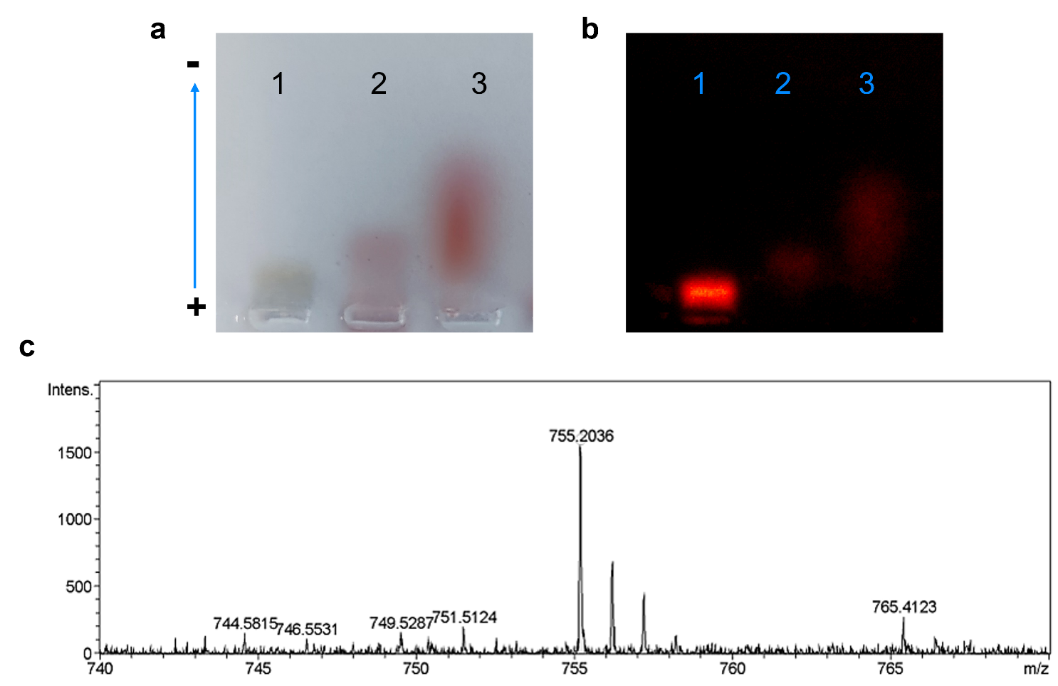
Figure S1. (a) Agarose gel electrophoresis of Au-PEG (1), Au-DOX (2), and free DOX (3). (b) Fluorescence imaging of the agarose gel. (c) The mass spectrum of DOX-PDPH.

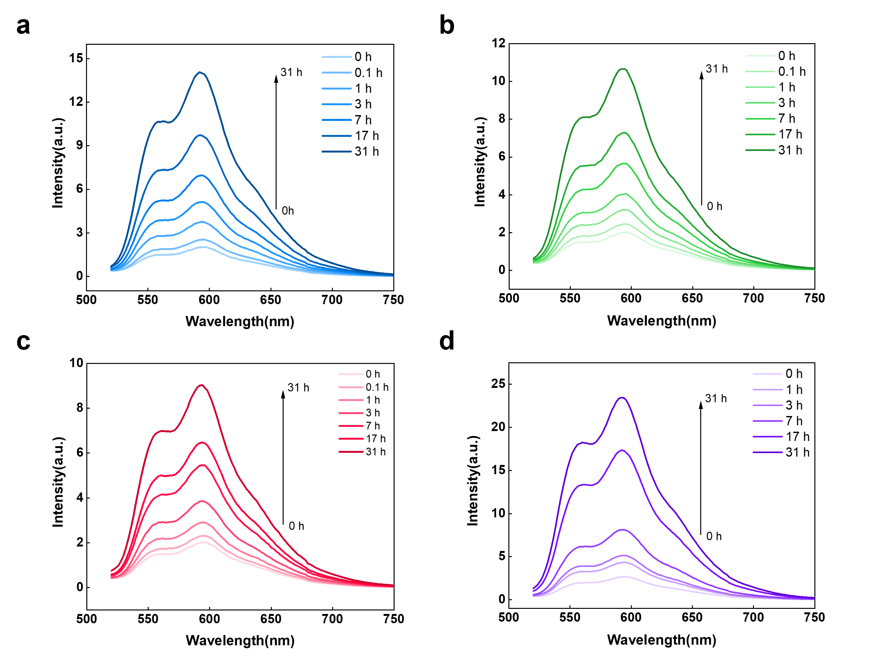
Figure S2. (a) Fluorescence spectrum of Au-DOX in 48h under (a) pH 7.4, (b) pH 6.5, and (c) pH 5.5. (d) Fluorescence spectrum of Au-DOX within 31h after adding 5 mM GSH.
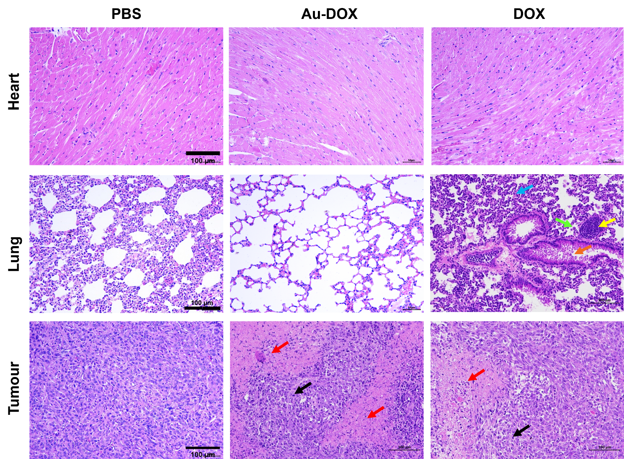
Figure S3. H&E images of organs and tumors in mice after PBS, Au-DOX (2 days) and DOX (3 days) treatment.
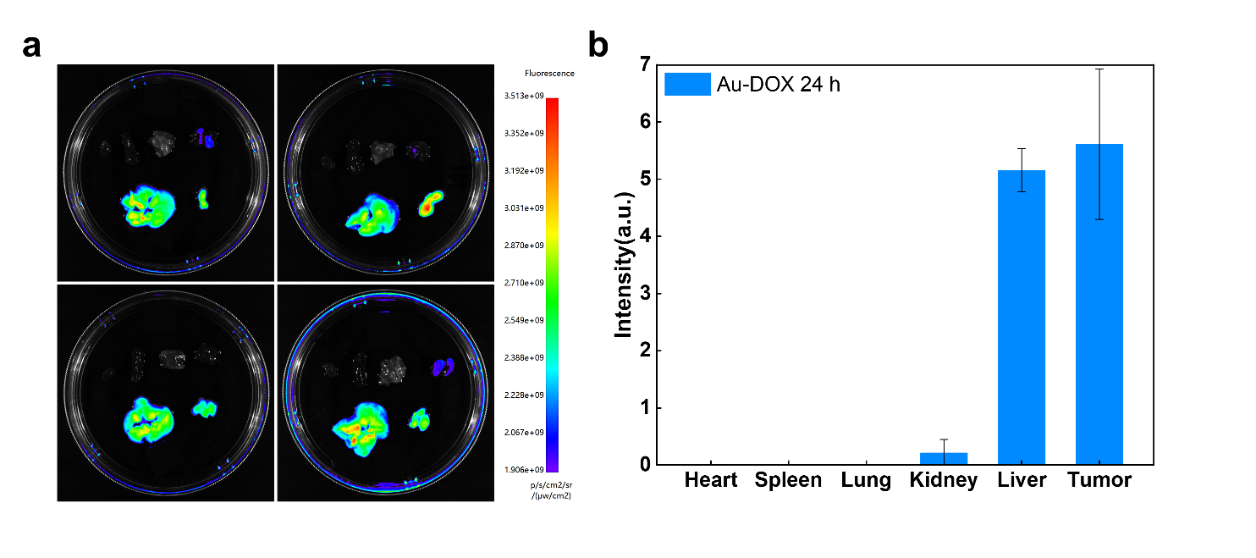
Figure S4. (a) Organ fluorescence imaging of BALB/c mice after post i.v. injection of Au-DOX after 24h. (b) Comparison of fluorescence intensity in different organs after injection of Au-DOX.
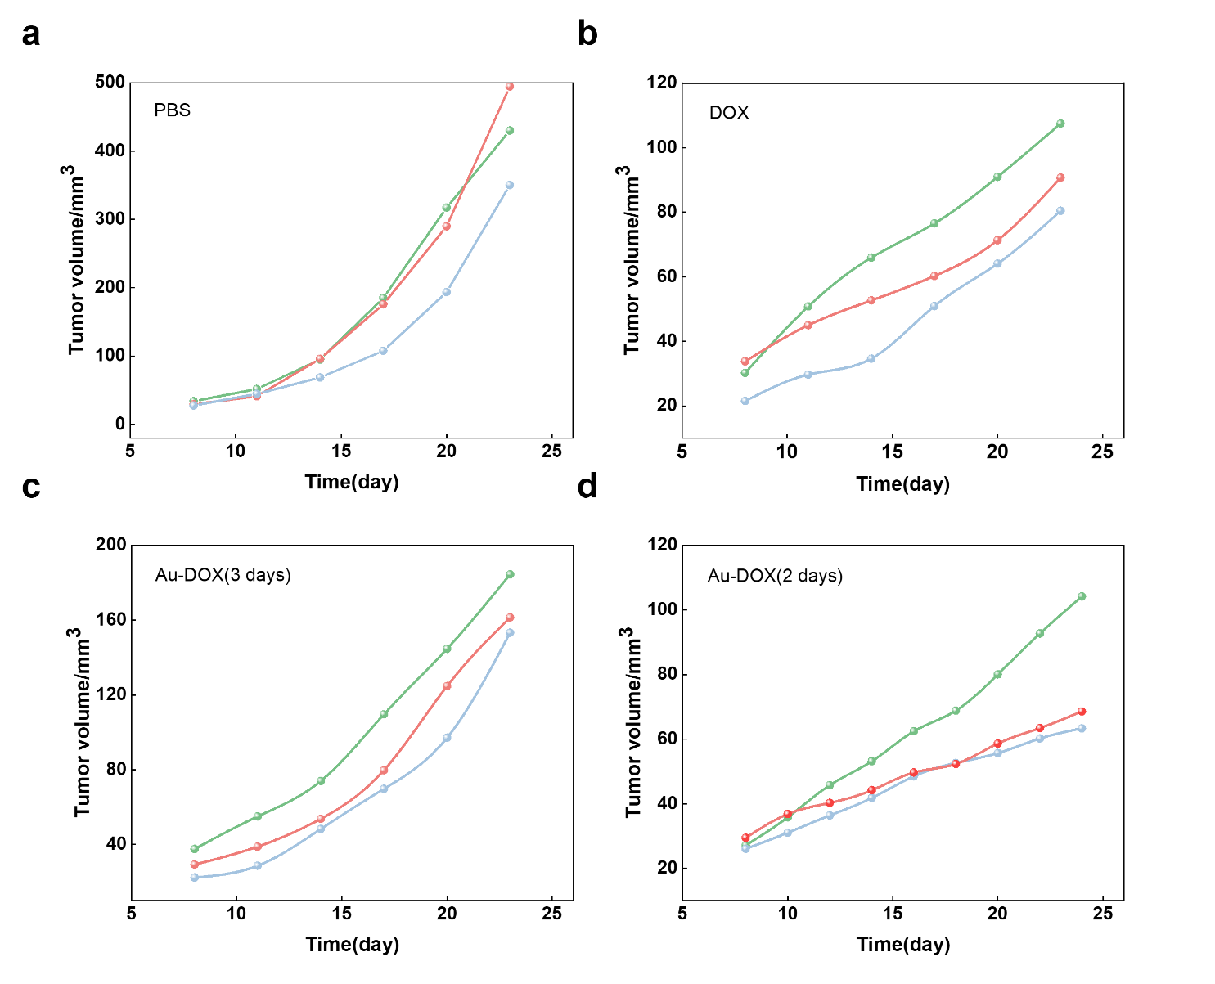
Figure S5. Tumor volume growth curve of 4T1 tumor-bearing mice in different drug injection groups. (a) , (b) , (c) , (d) were PBS group, DOX group, Au-DOX (3 days) group and Au-DOX (2 days) group.

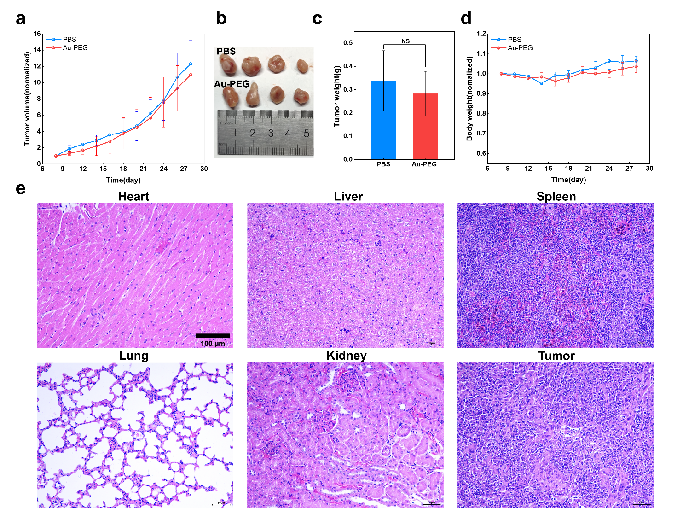
Figure S6. Effect of Au-PEG carrier on anti-tumor efficacy. (a) Tumor volume growth curve of 4T1 tumor-bearing mice. (b) Tumor size and (c) tumor weight after 6 treatments. (d) Body weight changes curve of 4T1 tumor-bearing mice. (e) H&E images of organs and tumors in mice after PBS and Au-PEG treatment.
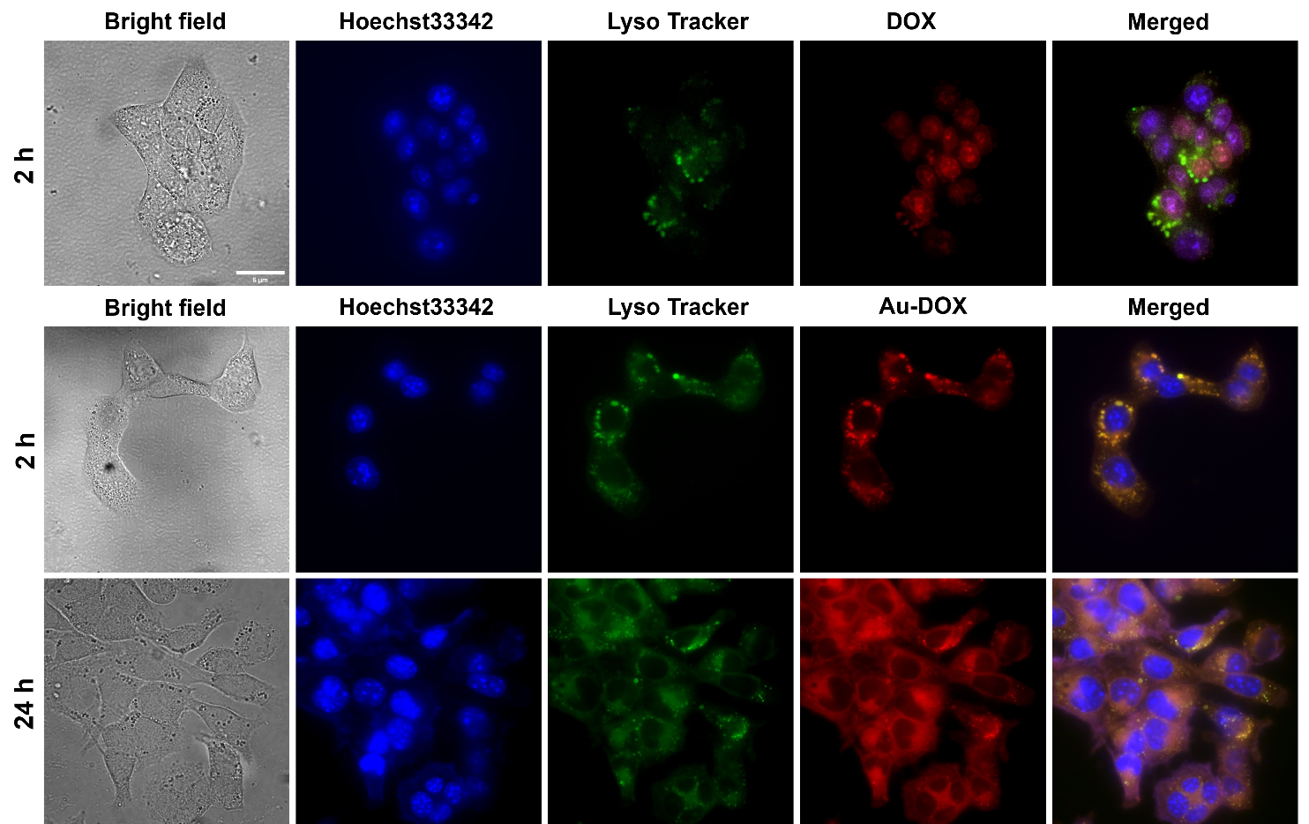

Figure S7. Fluorescence images of 4T1 cells for intracellular tracking of DOX and Au-DOX. The scale bar is 5 um.

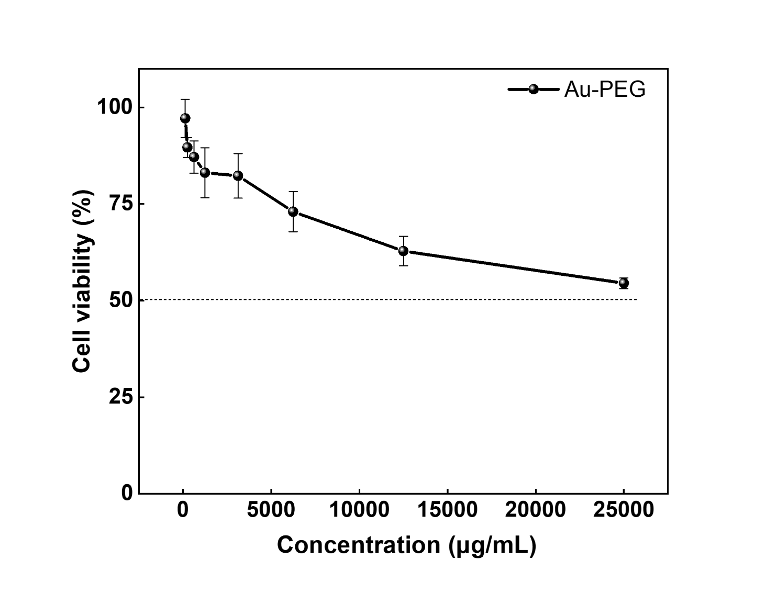
Figure S8. Cytotoxicity of Au-PEG on Hela cancer cells.
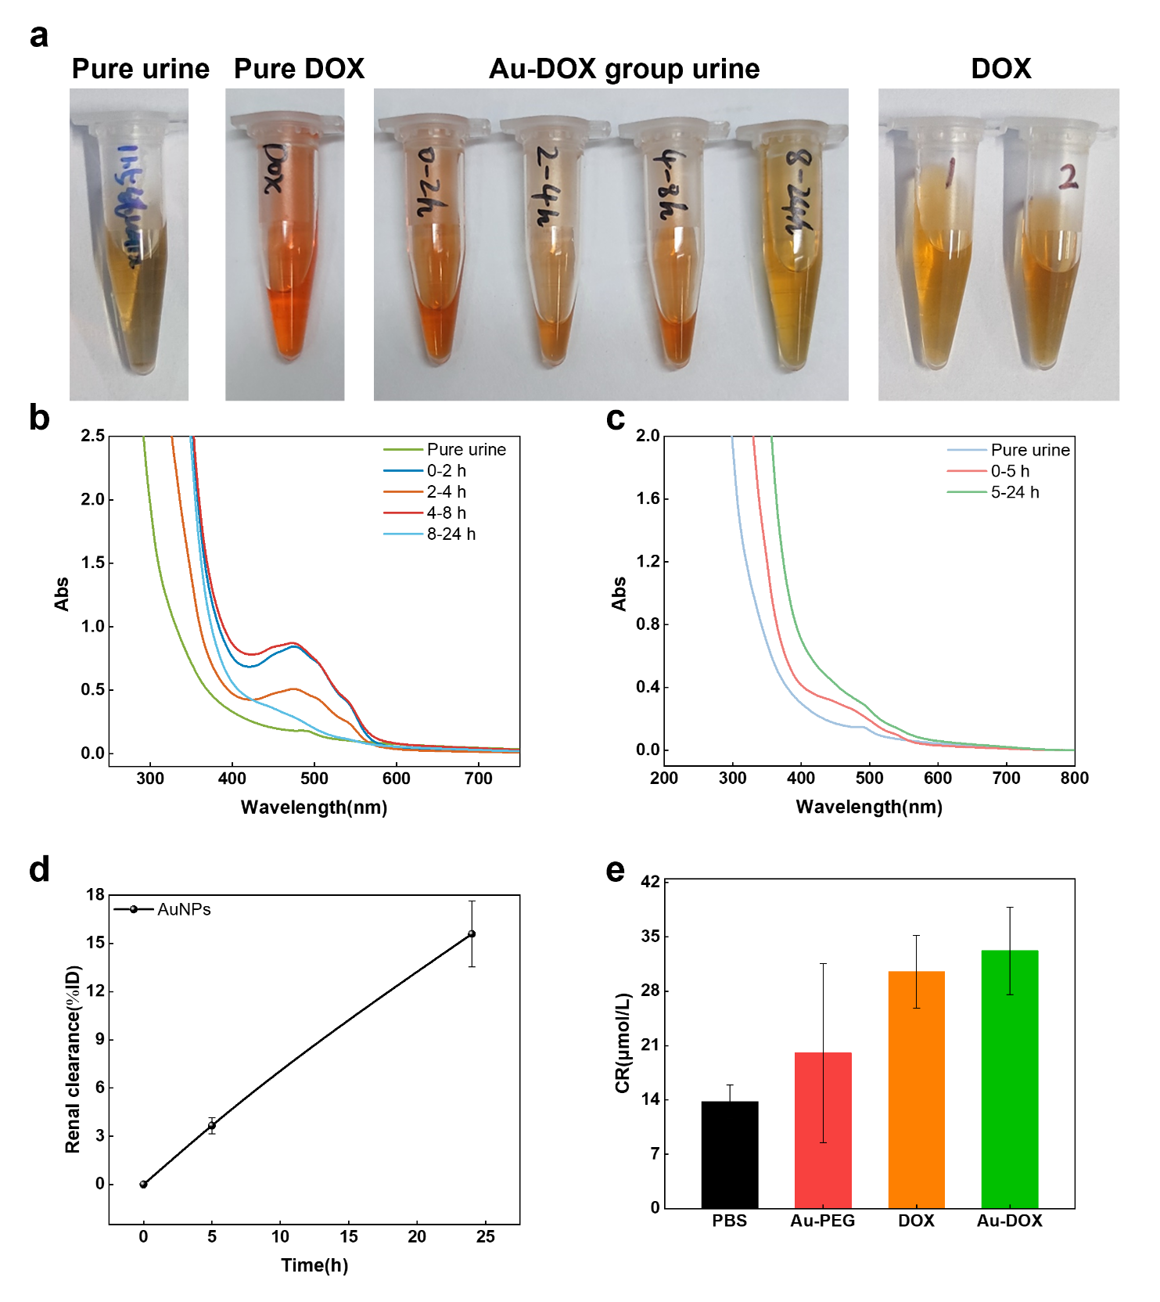
Figure S9. (a) Urine was collected at different time points after injection of Au-DOX and DOX within 24 h under natural light. (b) Uv-vis spectra of urine collected at different time points within 24h after intravenous injection of Au-DOX and (c) DOX. (d) Renal clearance in terms of AuNPs amounts. (e) Blood tests for renal function CREA.

