Supplementary Information
A novel push-pull strategy-based aphid control agent: repellency on Myzus persicae and attraction towards Eupeodes corollae from laboratory to field
Yan Liu, Yimeng Zhang, Shixiang Pan, Ruihong Sun*, Zhuo Shi, Xingxing Lu, Zhaokai Yang,
Bing Wang, Xuesheng Li, Ganyu Zhang, Yaoguo Qin, Zhengxin Zhou, Xinling Yang*

Contents

1. Figure S1. Experimental design 3
2. Table S1. Repellency proportion of compound 3e against M. persicae 4
3. Table S2. The population of M. persicae in the greenhouse experiment of 2021 5
4. Table S3. The population of M. persicae in the greenhouse experiment of 2023 6
5. Table S4. The population of M. persicae in the field trial 7
6. The method of EAG Recording 8
7. The method of field attraction experiments 9
8. The method of honeybee toxicity experiment 10

1. Figure S1. Experimental design
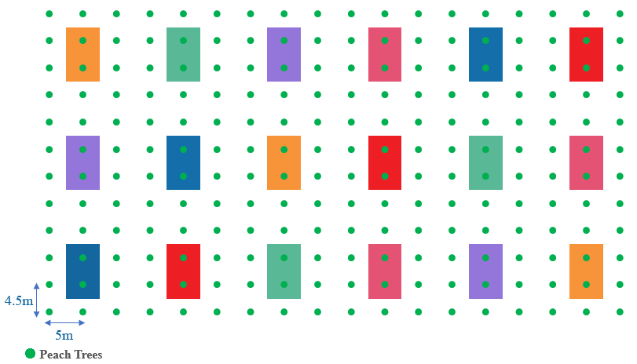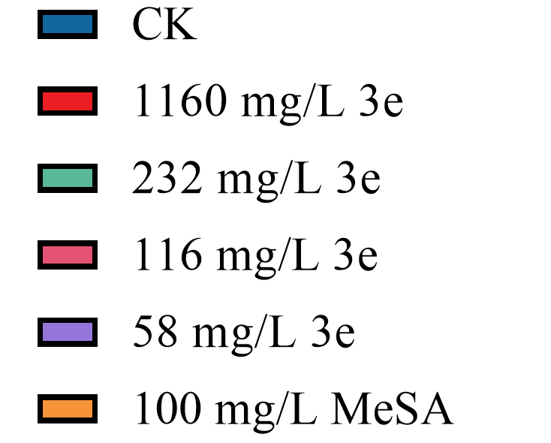
The colored regions represent the respective treatment plots, with a 9 m × 10 m buffer zone separating plots within blocks. Each test solution was placed at the center of its corresponding treatment plot during the experiment.

2. Table S1. Repellency proportion of compound 3e against M. persicae
Dose (μg) | RP (%) * | Time (min) | RP (%) *
0.1 | 26.94 ± 2.49e | 0 | 0.00 ± 0.00
1 | 32.21 ± 5.00e | 1 | 18.10 ± 1.56d
2 | 37.63 ± 1.70de | 2 | 19.76 ± 2.53d
4 | 48.05 ± 4.71cd | 5 | 36.19 ± 2.63c
5 | 70.02 ± 2.74ab | 10 | 39.88 ± 3.51bc
6 | 58.20 ± 5.11bc | 15 | 67.24 ± 2.05a
8 | 51.87 ± 5.51cd | 20 | 50.00 ± 2.62b
10 | 47.37 ± 1.11cd | 30 | 48.95 ± 1.86b
*The repellent activity of compound 3e was estimated by the RP, calculated by the formula RP (%) = (C-T)/(C+T)×100, where C represents the number of aphids in the control arm, and T represents the number of aphids in the treatment arm. Values are the mean ± SE. A one-way analysis of variance (ANOVA) was performed followed by Duncan's multiple range test (P < 0.05). The significant differences were represented by lowercase letters and different letters indicate significant differences.

3. Table S2. The population of M. persicae in the greenhouse experiment of 2021
Treatments | Concentration of Components (mg/L) | Number of M. persicae
Treatments | Concentration of Components (mg/L) | D-1 | D1 | D5 | D10
CK | / | 30.00 ± 0.00 | 57.00 ± 3.40a | 73.33 ± 7.31a | 100.33 ± 11.14a
3e | 116 | 30.00 ± 0.00 | 28.33 ± 3.54b | 26.67 ± 5.44b | 30.67 ± 5.89b
3e | 58 | 30.00 ± 0.00 | 25.33 ± 2.23b | 20.33 ± 1.52b | 22.67 ± 3.31b
Data are mean ± SE. Different lowercase letters indicate significant differences among the treatments (one-way ANOVA, P < 0.05).

4. Table S3. The population of M. persicae in the greenhouse experiment of 2023
Treatments | Concentration of Components (mg/L) | Number of M. persicae
Treatments | Concentration of Components (mg/L) | D-1 | D1 | D3 | D7 | D14
CK | / | 10.00 ± 0.00 | 15.33 ± 1.19a | 15.67 ± 3.84a | 20.00 ± 3.68a | 33.00 ± 4.99a
beta-cypermethrin | 69 | 10.00 ± 0.00 | 2.33 ± 0.27c | 0.33 ± 0.27b | 7.00 ± 3.27b | 24.33 ± 4.82a
3e | 232 | 10.00 ± 0.00 | 8.33 ± 1.96b | 2.33 ± 1.19b | 0.67 ± 0.54b | 3.33 ± 2.72b
3e | 116 | 10.00 ± 0.00 | 5.33 ± 1.09bc | 2.33 ± 1.52b | 2.67 ± 2.18b | 3.33 ± 2.33b
3e | 77 | 10.00 ± 0.00 | 4.67 ± 1.44bc | 1.33 ± 0.54b | 4.00 ± 0.47b | 1.00 ± 0.82b
3e | 58 | 10.00 ± 0.00 | 2.33 ± 0.27c | 2.00 ± 1.63b | 0.67 ± 0.27b | 0.00 ± 0.00b
3e | 46 | 10.00 ± 0.00 | 5.33 ± 0.98bc | 3.67 ± 1.52b | 2.00 ± 0.94b | 0.00 ± 0.00b
Data are mean ± SE. Different lowercase letters indicate significant differences among the treatments (one-way ANOVA, P < 0.05).

5. Table S4. The population of M. persicae in the field trial
Treatments | Concentration of Components (mg/L) | Number of M. persicae
Treatments | Concentration of Components (mg/L) | D-1 | D1 | D3 | D7 | D14
CK | / | 0.00 | 7.00 ± 3.86a | 20.33 ± 4.53a | 479.67 ± 66.18a | 861.00 ± 113.58a
beta-cypermethrin | 69 | 0.00 | 2.00 ± 1.63a | 17.00 ± 2.16a | 142.67 ± 34.08b | 846.67 ± 118.97a
3e | 232 | 0.00 | 2.00 ± 1.63a | 1.33 ± 1.09b | 1.67 ± 1.36c | 0.00 ± 0.00b
3e | 116 | 0.00 | 0.00 ± 0.00a | 0.00 ± 0.00b | 15.67 ± 12.79c | 21.33 ± 17.42b
3e | 77 | 0.00 | 0.00 ± 0.00a | 0.00 ± 0.00b | 9.67 ± 7.89c | 15.33 ± 12.52b
3e | 58 | 0.00 | 0.00 ± 0.00a | 3.00 ± 2.45b | 37.33 ± 18.44bc | 55.00 ± 22.99b
3e | 46 | 0.00 | 0.00 ± 0.00a | 0.00 ± 0.00b | 31.67 ± 25.86bc | 193.33 ± 157.86b
The data are presented as mean ± SE. Different lowercase letters indicate significant differences (one-way ANOVA, P < 0.05).

6. The method of EAG Recording
The hoverflies (Eupeodes corollae) were provided by the Laboratory of State Key Laboratory for Biology of Plant Diseases and Insect Pests, IPP, CAAS. Compound 3e and MeSA were dissolved in n-hexane at a concentration of 100 μg/μL. Subsequently, 10 μL of each solution was applied onto a 0.5 cm × 5 cm filter paper strip, which was then inserted into a Pasteur pipette. Filter paper containing 10 μL of n-hexane was used as a blank stimulus. All Pasteur pipettes were sealed with parafilm. For each assay, new Pasteur pipettes were prepared, and each of them was used for no more than 10 stimulations.
The antennae of 3-day-old male and female E. corollae were excised at their base. Glass electrodes equipped with a silver filament were filled with 0.1 mol/L KCl solution. The reference electrode was inserted into the base of the antenna, while the recording electrode was connected to the tip segment. A constant airflow of 30 mL/s, generated by a stimulus controller (CS-55, Syntech, The Netherlands), was charcoal-filtered and humidified before being delivered over the prepared antenna through a steel tube at a distance of approximately 1 cm. The Pasteur pipette tip was inserted through a 2 mm diameter hole in the steel tube. Stimuli were applied by 0.2 s pulses at 10 mL/s air flow and at intervals of 30 s, thus allowing the antenna to recover between two applications. Each antenna was stimulated twice with n-hexane, and the test compounds were presented in a randomized order.
The pulse signals were amplified by a 10× AC/DC Headstage Preamplifier (Syntech, The Netherlands) and acquired by an Intelligent Data Acquisition Controller (IDAC-4-USB; Syntech, The Netherlands). Then, they were sent to a PC via a digital-to-analog converter and recorded with Syntech EAG software 2.0 (Syntech, The Netherlands).
EAG response values were calculated by subtracting the average response values elicited by n-hexane. Ten biological replicates were tested for each sex.

7. The method of field attraction experiments
The field attraction experiments were carried out in a peach orchard in Feicheng, Shandong Province, China (36°09′35′′ N, 116°42′28′′ E) during the summer in three consecutive years (2021, 2022, and 2023). The experimental site, which covered an area of 80 acres, was planted with peach trees.
The experiment was conducted following a randomized block design, and each treatment was replicated three times. In 2021, 12.5% 3e ME was diluted to concentrations of 100, 500, 1000, and 2000 times. Subsequently, 1 mL of each solution was applied onto a 7cm diameter filter paper, which was then attached to a white sticky trap (Xiangchen Technology Co., Ltd., Shandong, China, 19 cm × 23 cm) without any chemical agents. Finally, the aforementioned sticky trap was affixed to a white ground stake (120 cm in height, with a signboard surface measuring 19 cm × 23 cm) to assemble the trapping device. The trapping device without any chemical treatment was used as the blank control in the experiment. The number of hoverflies lured was recorded at 7 days after treatment.
Based on the results obtained in 2021, an additional treatment of 100 mg/L MeSA was introduced as a positive control in 2022. Following the same experimental protocol employed in the previous year, the efficacy of hoverfly attraction was evaluated 7 days post-treatment. Building upon the findings from the first two years, a comprehensive assessment was conducted in 2023 to evaluate the attractant effect on hoverflies. The same experimental procedures and treatments employed in 2022 were applied. The count of attracted hoverflies was conducted at 1, 7, and 14 days after treatment.

8. The method of honeybee toxicity experiment
Apis mellifera worker bees were collected from a healthy colony that was maintained in the laboratory at Guangxi University, China. All the test bees were reared in the incubator at 25 ± 2 °C and a relative humidity of 50–70%, in darkness.
To obtain a high-concentration solution, compound 3e was initially dissolved in 1 mL of dimethyl sulfoxide and then diluted to a total volume of 10 mL using acetonitrile. Two toxicities to A. mellifera including the oral and contact toxicity of 3e were evaluated. For the oral toxicity test, the above-mentioned solution was further diluted with 50% sucrose water to achieve a concentration of 200 mg/L. The bees were fed this solution for 72 h, and the mortality rate was recorded. For the contact toxicity test, the bees were anesthetized with carbon dioxide, and 2 µL of the solution (at a concentration of 5000 mg/L) was applied to their mid-chest. After the solution evaporated, the bees were fed with 50% sucrose water for 72 h and their mortality was recorded. Under the same conditions, sucrose water and the solvent were used as the blank control and negative control, respectively. Each experiment was repeated three times, with 10 bees in each replicate.

