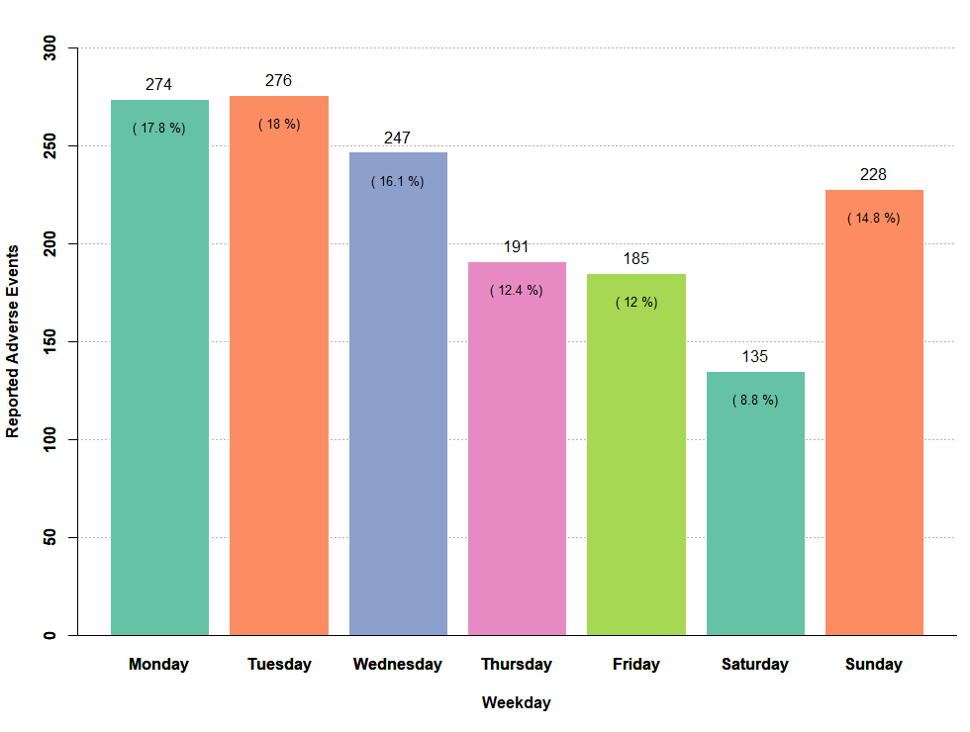
Supplementary Figure 3. The number of Reported Adverse Events by Weekday
This figure presents the reported adverse events distribution based on the corresponding weekdays.

