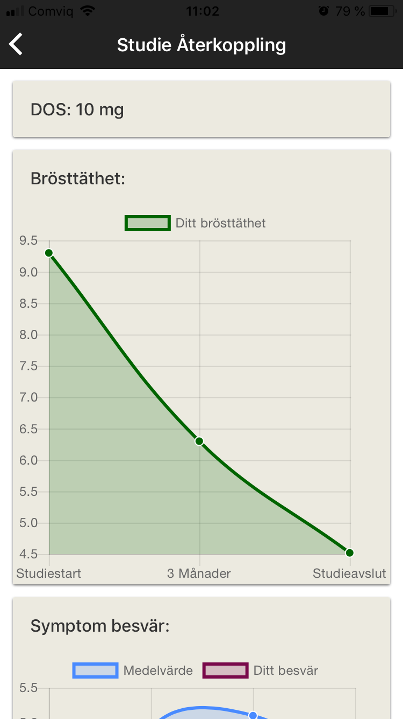
Dose: 10 mg
Breast density
Your breast density
Study start
3 months
6 months
Supplementary Figure 2. Example of Post-Study Feedback
After study completion participants can view personalized information.
This shows an example of post-study feedback including details on assigned
dose and change in mammographic breast density over time.

