Supplementary figures:
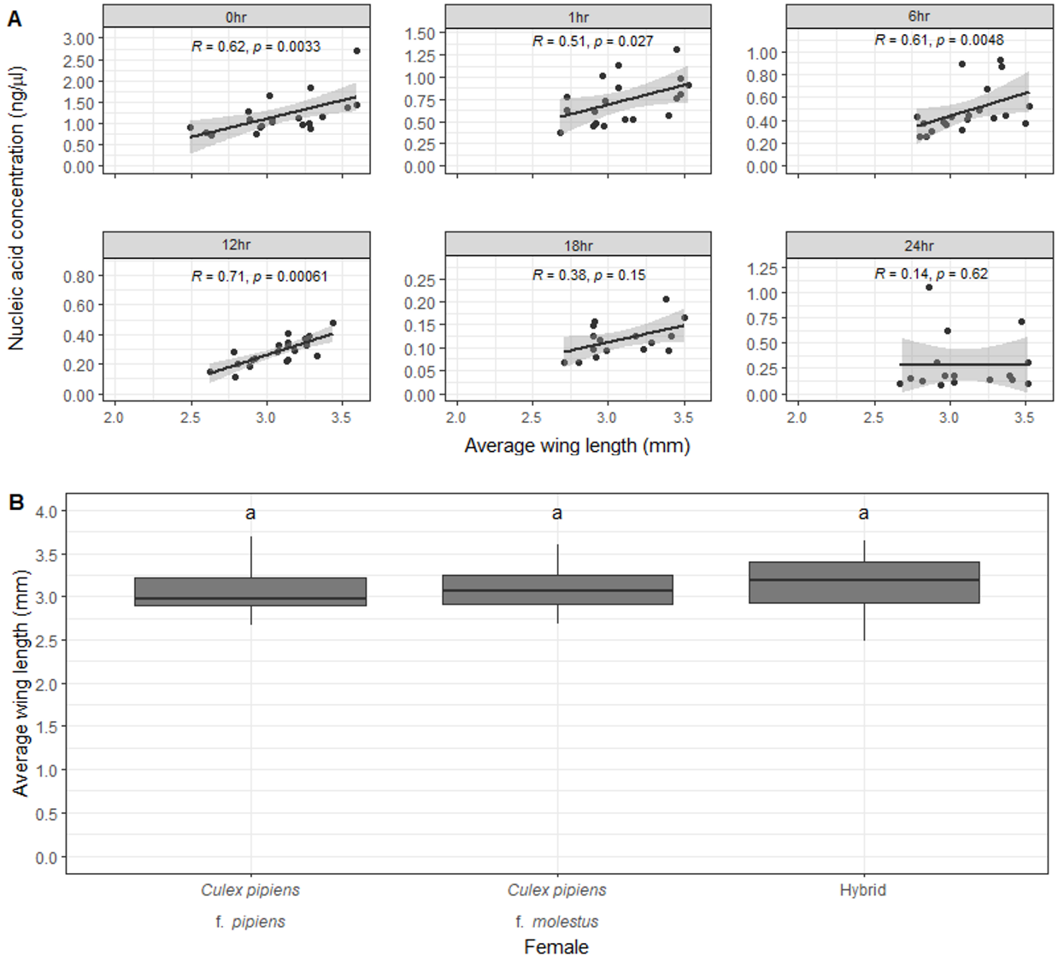
Figure S1. Wing length measurements of adult colony Culex pipiens used within time trial experiments A) Comparison of wing length measurements (mm) for each of the Culex pipiens biotypes, according to the CQ11 assay. Horizontal black lines indicate median, 25th and 75th percentiles, whiskers extend to the largest and smallest values within 1.5 times the interquartile range from the 25th and 75th percentiles. The letters above the boxplots indicate which groups differ significantly (P < 0.05) from one another. Specifically, groups which share a common letter are not significantly (P < 0.05) different from one another. B) Comparison of nucleic acid concentrations (ng/µl) with mean wing length (mm) for DNA extracts obtained from individual Culex pipiens pupal exuviae at six different time points post-eclosion. Grey shaded area indicates the 95% confidence interval.

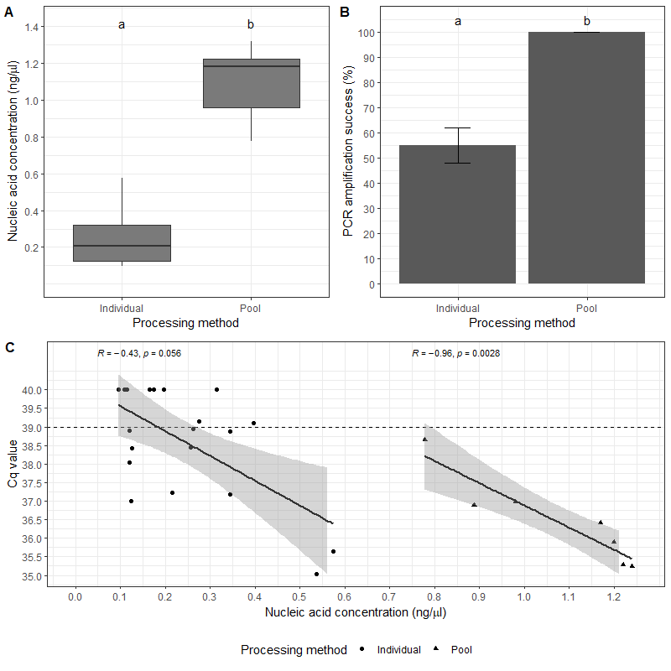
Figure S2. Comparison between individually and pooled processed field collected Culex pipiens pupal exuviae. A) DNA quantity (ng/µl) from DNA extracts obtained from individual and pooled field collected Culex pipiens pupal exuviae. Horizontal black lines indicate median, 25th and 75th percentiles, whiskers extend to the largest and smallest values within 1.5 times the interquartile range from the 25th and 75th percentiles. B) Comparison of PCR amplification success (%) for PCR extract obtained from individual and pooled field collected Culex pipiens pupal exuviae. Error bars indicate mean ± SD. C) Comparison of nucleic acid concentrations (ng/µl) with mean C_{q} values for PCR extracts obtained from individual and pooled field collected Culex pipiens pupal exuviae. Grey shaded area indicates the 95% confidence interval. The letters above the boxplots indicate which groups differ significantly (P < 0.05) from one another. Specifically, groups which share a common letter are not significantly (P < 0.05) different from one another.

