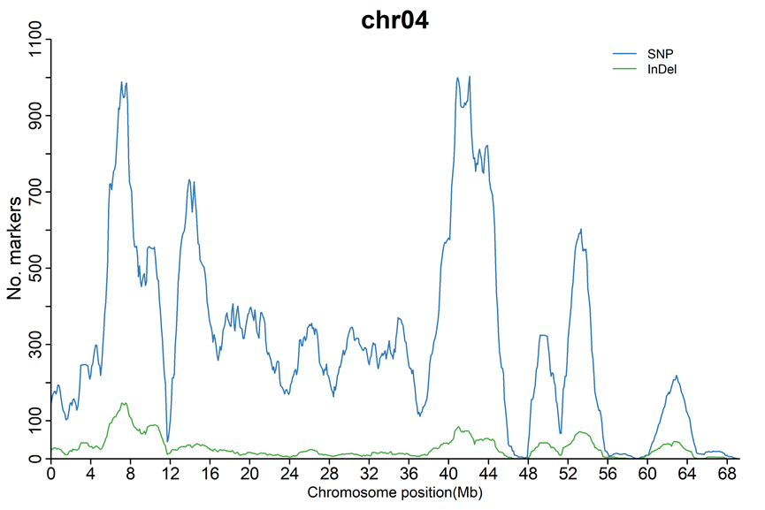
Fig. S1 Graphical representation of SNPs/InDels that conformed to the expected ratio on chromosome 4. The x-axis represents the physical distance along chromosome 4, while the y-axis indicates the number of SNP/InDels in the sliding window average of a 2 Mb interval and a 10 kb increment. The blue and green dots represent SNPs and InDels, respectively.
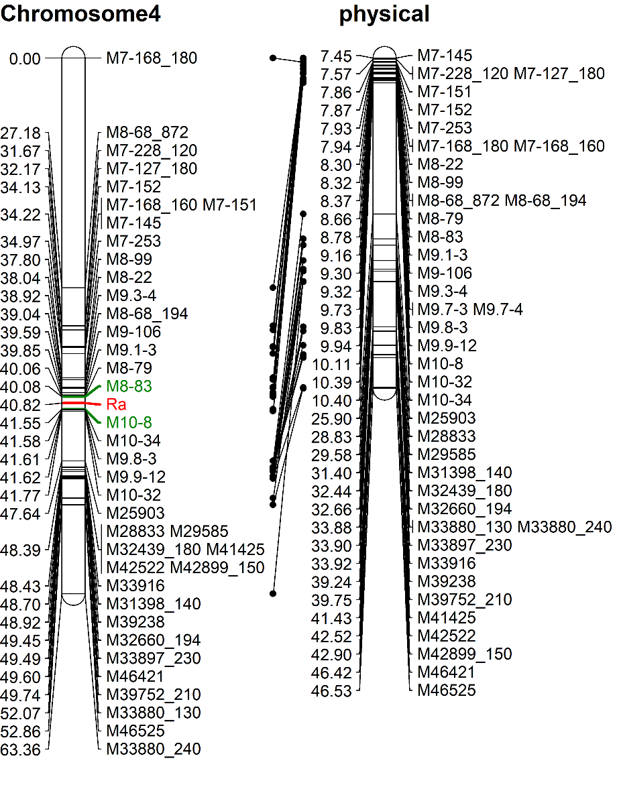
Fig. S2 Graphical representation showing the relationship between the genetic map and physical map for chromosome 4. The right side of the genetic map and physical map displays the names of molecular markers, while the left side numbers on the genetic map and physical map indicate the corresponding genetic distances (unit: cM) and physical distances (unit: Mb), respectively.

Table S1 Identification of SNPs/InDels conforming to the expected ratio on 12 potato chromosomes.
Chromosome | SNPs |  |  | InDels
Chromosome | Number | % of total SNPs |  | Number | % of total InDels
Chr01 | 946 | 4.90 |  | 147 | 6.39
Chr02 | 374 | 1.94 |  | 82 | 3.57
Chr03 | 745 | 3.87 |  | 112 | 4.87
Chr04 | 10375 | 53.79 |  | 982 | 42.70
Chr05 | 740 | 3.84 |  | 137 | 5.96
Chr06 | 462 | 2.40 |  | 85 | 3.70
Chr07 | 238 | 1.23 |  | 38 | 1.65
Chr08 | 666 | 3.45 |  | 94 | 4.09
Chr09 | 591 | 3.06 |  | 63 | 2.74
Chr10 | 274 | 1.42 |  | 30 | 1.30
Chr11 | 1505 | 7.80 |  | 262 | 11.39
Chr12 | 2373 | 12.30 |  | 268 | 11.65
Total | 19238 | 100.00 |  | 2300 | 100.00

Table S2 The sequence information of polymorphic InDel markers

Name | Forward primer | Reverse primer
M10-8 | ATCGGGCTTAACAGACCGC | GACTGACCTGCTCTTTTTGGC
M25903 | ACCCATCTTCCATAACATCAACTCT | AGGCAAATGGGTTTTTGTGAAG
M28833 | TGGTTACCTGGAAGTTGTGGG | CACTCCAGTGAGGTACCAGG
M29585 | TGATCATTATGGGTAGCAAACGG | AGGCATGGTTGTAGCACTGAT
M31398 | AGGAGTTGGAGCTGAGCAAG | TGCAAGCAACTGAGGTAGAGG
M32439 | TCCCTTGAGTTACAGCAACTTCC | TGGTTTGGGCTACTTTAGGGC
M32660 | ATGACTGGTTGCTAGAAGAGCC | TGGCATGGTCCATCTAGTCTG
M33880-2 | GGTGAAACTTGACGACCGAC | AAAGAACAAAATGACCCCAGCC
M33897 | GTGTTCATGAGAATGGCCTTTTG | CACTTGAAAGGTGGAGGTGTT
M33916 | GTGGAGATATTGTAACACCTTGGC | TATGGGCCACCTAACTCATCTTG
M39238 | CTTCACAGCCCAGTGTTTTGC | CCACTTCAGGCCAAAGATGTTG
M39752 | GGAAGAATTATCCGACCCGTG | CTACGTTAGCTTTGCCAGGATAG
M41425 | TTCGTAATCATTGCCACTGTTG | GGTCCCTGCTATAGTTTGTAGTTG
M42522 | CGGGAAATCAGAGAAATCAACC | TGTTGGGGATTTGAGTGAAGA
M42899 | ACGAACCACGTACAATTTCACA | CGAAGCTTGTTGATCACACCTA
M46421 | CCTTTTCATTTTAAATTGTGGGGAG | TCCAATACACACAGTACAATAACCT
M46525 | GATCGATGGTAAAGACACAACC | TCTCATGTGACAATTCCTGGTTA
M7-127 | TCAGCCTATTTGGTCAGGCT | CCAGGCCCAAATTACTGCAC
M7-145 | TTCTTCGTGGACATTTTGTTGC | GAACGGGTAATATGTGGCCT
M7-151 | TGGCACTTCTTCTACAAGTTACAC | CAAAGTGATGCCTGATTGTGAGA
M7-152 | CACACACACAACTGGCATTGA | TGAACAAGCTCTGTTTGCAAGG
M7-168 | GCAGGTTAAAACAGCAGCCC | ATATGATGCTGCAGCCGAGG
M7-228 | ACCACATTGTAGTTCGTCGCT | GGATCTATCTGAAATTGACTTGTCG
M7-253 | AGGTATGTCTCTTTCAGTCCCTC | TCGAATCCAGTAAGGCTATTTGT
M8-22 | AAGAGGAACTACACCCGCAA | TTGAATGCAGAAGGGGTGTG
M8-68-2 | CGATTAGGGAGGAAAGGGGG | AAGTTGCATCGGCCCCTAAC
M8-79 | GGATATCAATGTCAAGGCCGC | ACAGATGAGCGCAATAGCAG
M8-83 | ACGATTATGACGGAATATGACGTAG | TCGAGGACTTTATAGTCAAAGTGG
M8-99 | AGTCTGATATTATGCTTACAATGCC | GCAACAAGGTATTGTTCTCTTCT
M9.1-3 | TGAACAGAAAGTAAAATAGTGCAGC | GCATCTGTTCGGATGGTGTTC
M9.3-4 | GACTCTTCATGGCGTTCCAC | GGCGAAGCTGCAAAAACATAAAC
M9.7-3 | TTGTAGCAGCCTGGGAACTC | GGAGTTTTATCGCCCAACCAG
M9.7-4 | GGCGGTTTTTGACTAGGCATC | TGAAGGAGGTTGGGGATCAAC
M9.8-3 | ACGAGGCATGACATGAAAACAAG | TTAGTCAAGAGGTTTCATATGCCT
M9.9-12 | TCACTCTGCTCTGTTGCCTG | ACCAAAGTCGTGAGGGTTCG
M9-106 | GTCTCGGGGACTCCATCAATC | TGCCTCTCAAGATAGGGGTAAG

Table S3 The phenotypes and genotypes of 43 potato cultivars and advanced breeding lines
Cultivar/Clone | ELISA reading 21 dpi |  | Phenotype | M10-8 Genotype
Cultivar/Clone | Scion | Stock | Phenotype | M10-8 Genotype
F145 | 1.482 | 0.004 | R | 1
F58050 | 2.876 | 1.309 | S | 0
15AO06-4 | 2.631 | 2.065 | S | 1
15AO50-3 | 1.411 | 1.148 | S | 0
15AO16-2 | 2.130 | 0.027 | R | 1
15AO23-7 | 2.666 | 1.114 | S | 1
15AO70-3 | 3.150 | 0.718 | S | 0
15CH16-10 | 1.804 | 0.013 | R | 1
15CH19-13 | 2.167 | 0.008 | R | 1
15AO72-4 | 1.706 | 0.805 | S | 0
15CH20-9 | 1.851 | 0.004 | R | 1
15EM09-4 | 2.876 | 0.024 | R | 1
15CH72-3 | 1.482 | 1.009 | S | 0
15EM17-7 | 2.236 | 0.020 | R | 0
15EM18-2 | 3.257 | 0.059 | R | 1
15EM19-3 | 3.205 | 0.016 | R | 1
16EM04-4 | 2.784 | 1.343 | S | 0
15FF07-5 | 3.161 | 0.049 | R | 0
16FF08-1 | 2.973 | 2.321 | S | 0
16FM12-7 | 3.207 | 0.646 | S | 0
15FM051-3 | 1.733 | 0.022 | R | 0
16FM15-1 | 2.440 | 1.830 | S | 0
16FM17-2 | 3.092 | 1.316 | S | 0
16FM10-1 | 3.061 | 0.015 | R | 1
16CH02-2 | 3.164 | 2.065 | S | 1
16CH05-1 | 3.216 | 1.649 | S | 1
16CH17-4 | 2.836 | 1.689 | S | 0
16CH19-6 | 3.278 | 2.779 | S | 0
16FF06-2 | 1.066 | 0.029 | R | 1
15EM24-2 | 3.137 | 0.039 | R | 1
15FM042-2 | 1.787 | 0.002 | R | 1
15FM049-5 | 3.160 | 0.001 | R | 0
15FM047-7 | 0.944 | 0.052 | R | 0
16FM41-2 | 2.992 | 0.048 | R | 1
16FM43-2 | 1.466 | 0.020 | R | 1
16FM48-2 | 3.158 | 0.020 | R | 1
16FM58-4 | 3.088 | 0.074 | R | 0
17FT34-1 | 3.236 | 0.062 | R | 1
17FT47-2 | 1.022 | 0.010 | R | 1
17FT49-7 | 2.034 | 3.181 | S | 0
2013-010-26 | 3.031 | 0.005 | R | 1
2013-038-32 | 3.162 | 0.003 | R | 1
2013-061-19 | 2.874 | 0.031 | R | 1
2013-089-2 | 3.222 | 0.029 | R | 1
2013-105-11 | 3.072 | 2.145 | S | 0
The phenotype was determined by Enzyme-Linked Immunosorbent Assay (ELISA) test conducted at 21 days post graft inoculation, Both the scion (the upper part of the graft) and the stock (the lower part of the graft) were tested, while the genotype was determined by InDel marker M10-8.

