Supplemental Figure 1.1 Scatter plot for telomere length affecting celiac disease risk
Supplemental Figure 1.2 Funnel plot for telomere length affecting celiac disease risk
Supplemental Figure 1.3 Leave-one-out test for telomere length affecting celiac disease risk
Supplemental Figure 2.1 Scatter plot for telomere length affecting alcoholic liver disease risk
Supplemental Figure 2.2 Funnel plot for telomere length affecting alcoholic liver disease risk
Supplemental Figure 2.3 Leave-one-out test for telomere length affecting alcoholic liver disease risk
Supplemental Figure 3.1 Scatter plot for telomere length affecting cirrhosis risk
Supplemental Figure 3.2 Funnel plot for telomere length affecting cirrhosis risk
Supplemental Figure 3.3 Leave-one-out test for telomere length affecting cirrhosis risk
Supplemental Figure 4.1 Scatter plot for telomere length affecting cholelithiasis risk
Supplemental Figure 4.2 Funnel plot for telomere length affecting cholelithiasis risk
Supplemental Figure 4.3 Leave-one-out test for telomere length affecting cholelithiasis risk
Supplemental Figure 5.1 Scatter plot for telomere length affecting cholecystitis risk
Supplemental Figure 5.2 Funnel plot for telomere length affecting cholecystitis risk
Supplemental Figure 5.3 Leave-one-out test for telomere length affecting cholecystitis risk
Supplemental Figure 6.1 Scatter plot for telomere length affecting pancreatic cancer risk
Supplemental Figure 6.2 Funnel plot for telomere length affecting pancreatic cancer risk
Supplemental Figure 6.3 Leave-one-out test for telomere length affecting pancreatic cancer risk
Supplemental Figure 7.1 Scatter plot for GrimAge acceleration affecting cholelithiasis risk
Supplemental Figure 7.2 Funnel plot for GrimAge acceleration affecting cholelithiasis risk
Supplemental Figure 7.3 Leave-one-out test for GrimAge acceleration affecting cholelithiasis risk
Supplemental Figure 8.1 Scatter plot for GrimAge acceleration affecting cholecystitis risk
Supplemental Figure 8.2 Funnel plot for GrimAge acceleration affecting cholecystitis risk
Supplemental Figure 8.3 Leave-one-out test for GrimAge acceleration affecting cholecystitis risk
Supplemental Figure 9.1 Scatter plot for HorvathAge acceleration affecting chronic gastritis risk
Supplemental Figure 9.2 Funnel plot for HorvathAge acceleration affecting chronic gastritis risk
Supplemental Figure 9.3 Leave-one-out test for HorvathAge acceleration affecting chronic gastritis risk
Supplemental Figure 10.1 Scatter plot for HorvathAge acceleration affecting gastric cancer risk
Supplemental Figure 10.2 Funnel plot for HorvathAge acceleration affecting gastric cancer risk
Supplemental Figure 10.3 Leave-one-out test for HorvathAge acceleration affecting gastric cancer risk
Supplemental Figure 11.1 Scatter plot for celiac disease risk affecting telomere length
Supplemental Figure 11.2 Funnel plot for celiac disease risk affecting telomere length
Supplemental Figure 11.3 Leave-one-out test for celiac disease risk affecting telomere length
Supplemental Figure 12.1 Scatter plot for celiac disease risk affecting GrimAge acceleration
Supplemental Figure 12.2 Funnel plot for celiac disease risk affecting GrimAge acceleration
Supplemental Figure 12.3 Leave-one-out test for celiac disease risk affecting GrimAge acceleration
Supplemental Figure 13.1 Scatter plot for celiac disease risk affecting PhenoAge acceleration
Supplemental Figure 13.2 Funnel plot for celiac disease risk affecting PhenoAge acceleration
Supplemental Figure 13.3 Leave-one-out test for celiac disease risk affecting PhenoAge acceleration
Supplemental Figure 14.1 Scatter plot for cholangitis risk affecting GrimAge acceleration
Supplemental Figure 14.2 Funnel plot for cholangitis risk affecting GrimAge acceleration
Supplemental Figure 14.3 Leave-one-out test for cholangitis risk affecting GrimAge acceleration
Supplemental Figure 15.1 Scatter plot for cholangitis risk affecting HannumAge acceleration
Supplemental Figure 15.2 Funnel plot for cholangitis risk affecting HannumAge acceleration
Supplemental Figure 15.3 Leave-one-out test for cholangitis risk affecting HannumAge acceleration
Supplemental Figure 16.1 Scatter plot for ulcerative colitis risk affecting telomere length
Supplemental Figure 16.2 Funnel plot for ulcerative colitis risk affecting telomere length
Supplemental Figure 16.3 Leave-one-out test for ulcerative colitis risk affecting telomere length
Supplemental Figure 17.1 Scatter plot for gastric cancer risk affecting GrimAge acceleration
Supplemental Figure 17.2 Funnel plot for gastric cancer risk affecting GrimAge acceleration
Supplemental Figure 17.3 Leave-one-out test for gastric cancer risk affecting GrimAge acceleration
Supplemental Figure 18.1 Scatter plot for gastric cancer risk affecting HannumAge acceleration
Supplemental Figure 18.2 Funnel plot for gastric cancer risk affecting HannumAge acceleration
Supplemental Figure 18.3 Leave-one-out test for gastric cancer risk affecting HannumAge acceleration

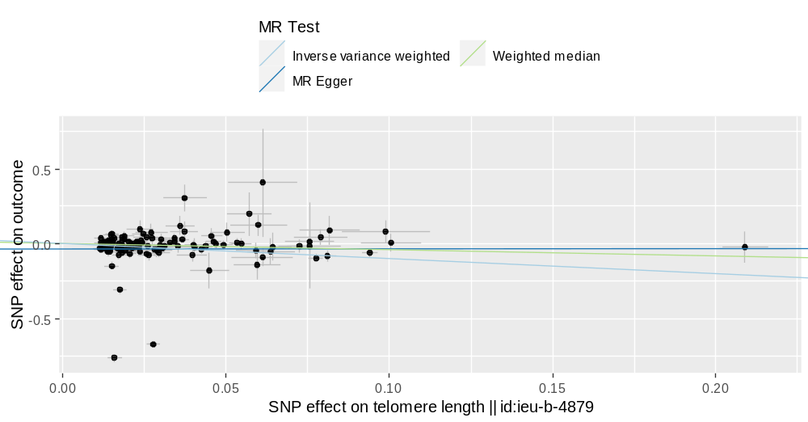
Supplemental Figure 1.1 Scatter plot for telomere length affecting celiac disease risk
Note: The scatter plot reveals the difference in the results of the three Mendelian randomization methods. The X-axis shows the SNP effect on telomere length, and the Y-axis shows the SNP effect on celiac disease risk.

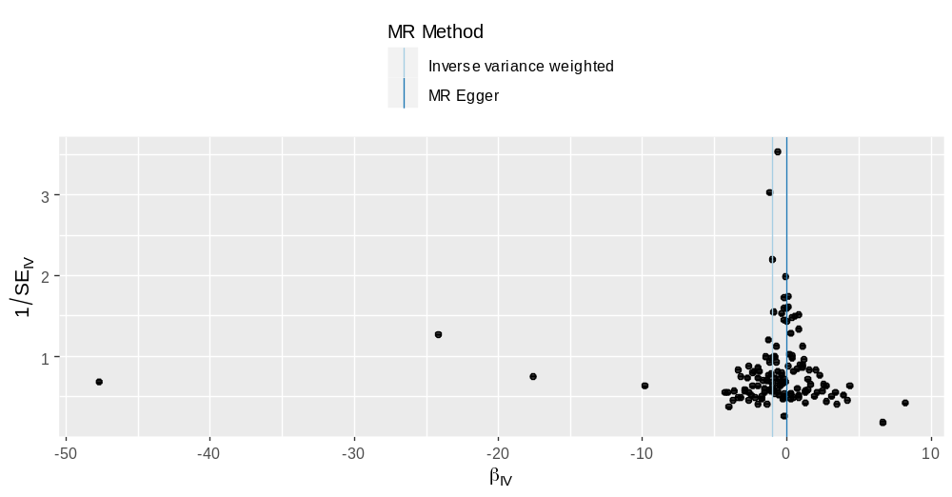
Supplemental Figure 1.2 Funnel plot for telomere length affecting celiac disease risk
Note: The funnel plot can graphically detect horizontal pleiotropy; If the plot is symmetrical on both sides of the central axis,
it indicates that there is no horizontal pleiotropy; If the plot is not symmetrical, horizontal pleiotropy exists.

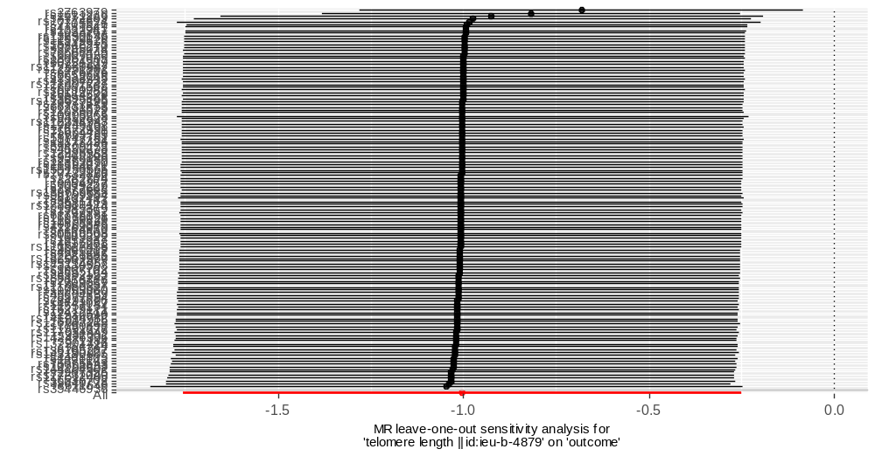
Supplemental Figure 1.3 Leave-one-out test for telomere length affecting celiac disease risk
Note: Each SNP is eliminated in turn and the Mendelian randomization analysis is re-conducted to detect the effect of each SNP on the overall result. The X-axis shows the Mendelian randomization effect of telomere length on celiac disease risk, and the Y-axis shows the SNPs included in the study.

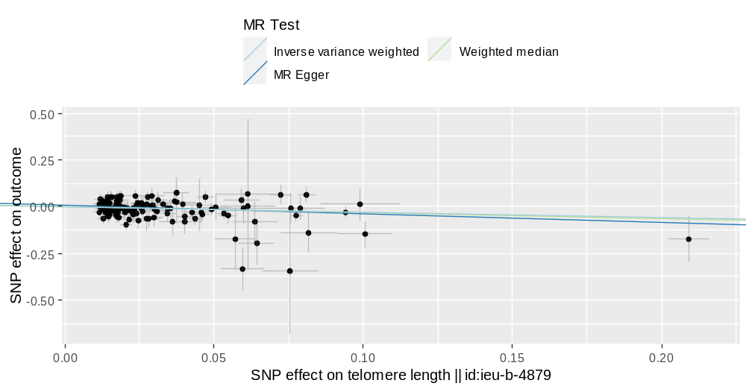
Supplemental Figure 2.1 Scatter plot for telomere length affecting alcoholic liver disease risk
Note: The scatter plot reveals the difference in the results of the three Mendelian randomization methods. The X-axis shows the SNP effect on telomere length, and the Y-axis shows the SNP effect on alcoholic liver disease risk.

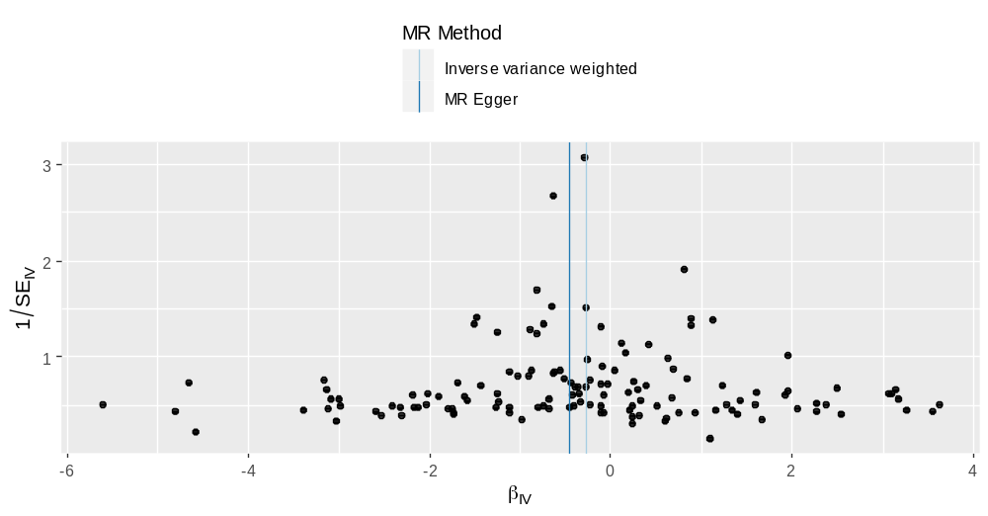
Supplemental Figure 2.2 Funnel plot for telomere length affecting alcoholic liver disease risk
Note: The funnel plot can graphically detect horizontal pleiotropy; If the plot is symmetrical on both sides of the central axis,
it indicates that there is no horizontal pleiotropy; If the plot is not symmetrical, horizontal pleiotropy exists.

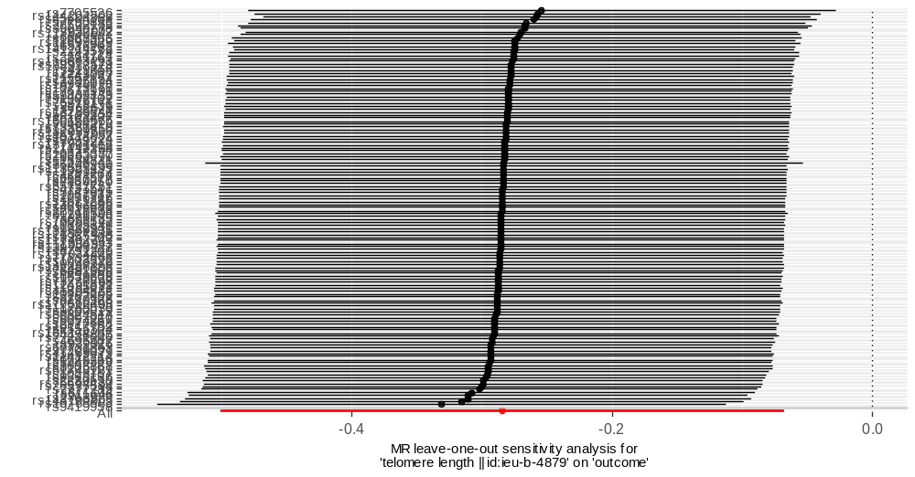
Supplemental Figure 2.3 Leave-one-out test for telomere length affecting alcoholic liver disease risk
Note: Each SNP is eliminated in turn and the Mendelian randomization analysis is re-conducted to detect the effect of each SNP on the overall result. The X-axis shows the Mendelian randomization effect of telomere length on alcoholic liver disease risk, and the Y-axis shows the SNPs included in the study.

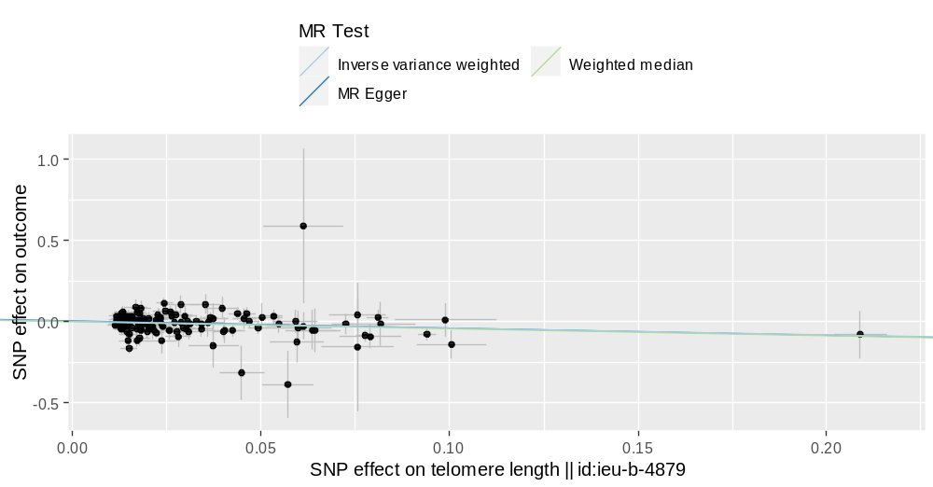
Supplemental Figure 3.1 Scatter plot for telomere length affecting cirrhosis risk
Note: The scatter plot reveals the difference in the results of the three Mendelian randomization methods. The X-axis shows the SNP effect on telomere length, and the Y-axis shows the SNP effect on cirrhosis risk.

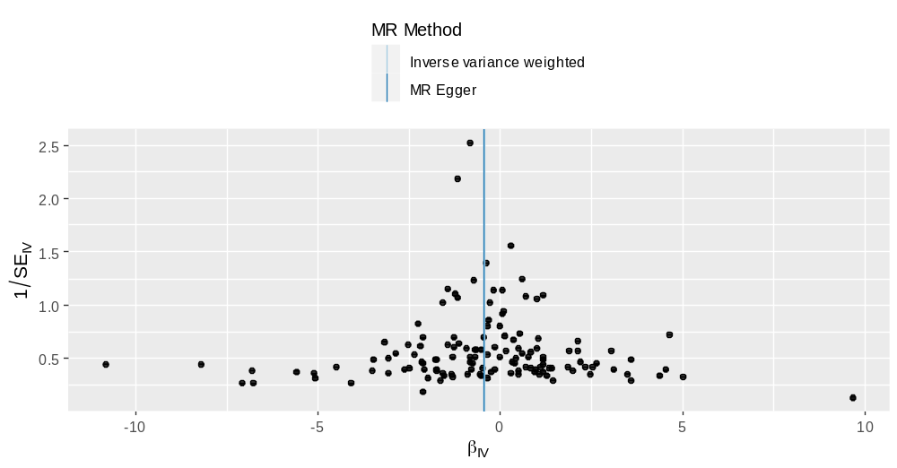
Supplemental Figure 3.2 Funnel plot for telomere length affecting cirrhosis risk
Note: The funnel plot can graphically detect horizontal pleiotropy; If the plot is symmetrical on both sides of the central axis,
it indicates that there is no horizontal pleiotropy; If the plot is not symmetrical, horizontal pleiotropy exists.

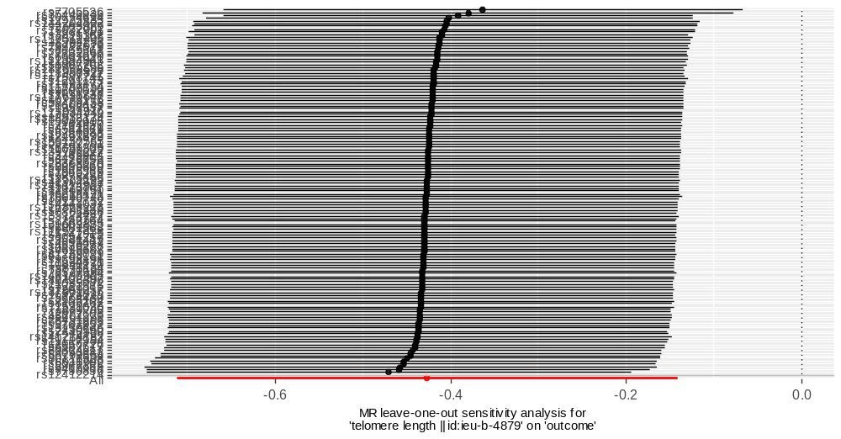
Supplemental Figure 3.3 Leave-one-out test for telomere length affecting cirrhosis risk
Note: Each SNP is eliminated in turn and the Mendelian randomization analysis is re-conducted to detect the effect of each SNP on the overall result. The X-axis shows the Mendelian randomization effect of telomere length on cirrhosis risk, and the Y-axis shows the SNPs included in the study.

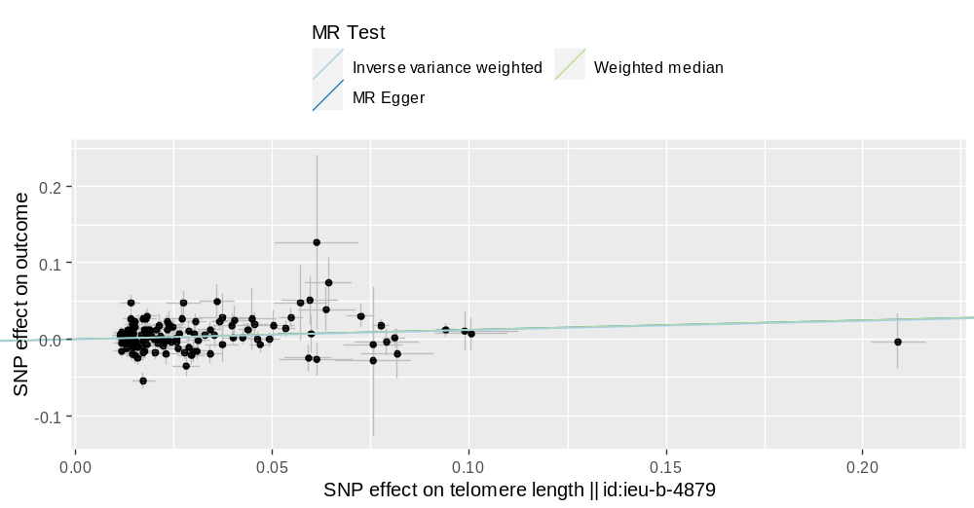
Supplemental Figure 4.1 Scatter plot for telomere length affecting cholelithiasis risk
Note: The scatter plot reveals the difference in the results of the three Mendelian randomization methods. The X-axis shows the SNP effect on telomere length, and the Y-axis shows the SNP effect on cholelithiasis risk

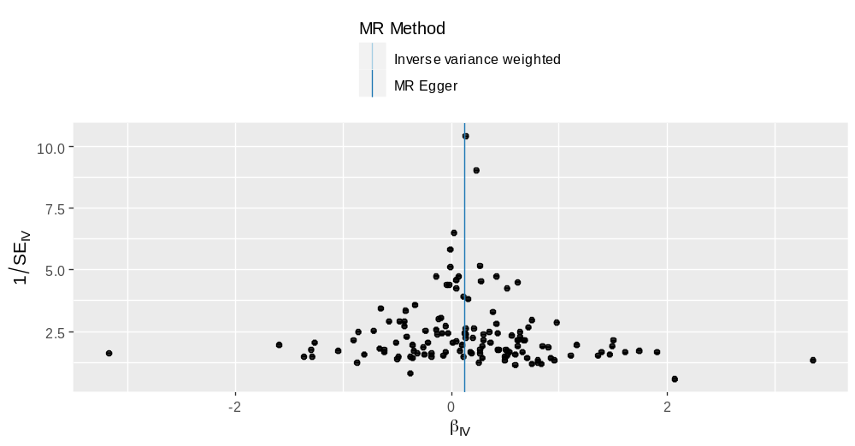
Supplemental Figure 4.2 Funnel plot for telomere length affecting cholelithiasis risk
Note: The funnel plot can graphically detect horizontal pleiotropy; If the plot is symmetrical on both sides of the central axis,
it indicates that there is no horizontal pleiotropy; If the plot is not symmetrical, horizontal pleiotropy exists.

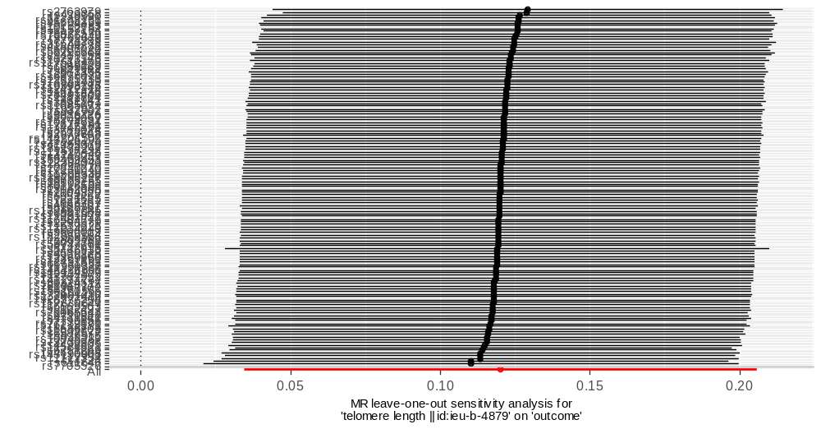
Supplemental Figure 4.3 Leave-one-out test for telomere length affecting cholelithiasis risk
Note: Each SNP is eliminated in turn and the Mendelian randomization analysis is re-conducted to detect the effect of each SNP on the overall result. The X-axis shows the Mendelian randomization effect of telomere length on cholelithiasis risk, and the Y-axis shows the SNPs included in the study.

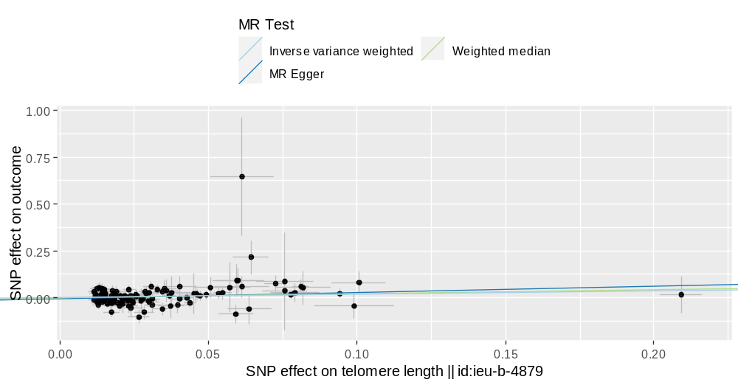
Supplemental Figure 5.1 Scatter plot for telomere length affecting cholecystitis risk
Note: The scatter plot reveals the difference in the results of the three Mendelian randomization methods. The X-axis shows the SNP effect on telomere length, and the Y-axis shows the SNP effect on cholecystitis risk

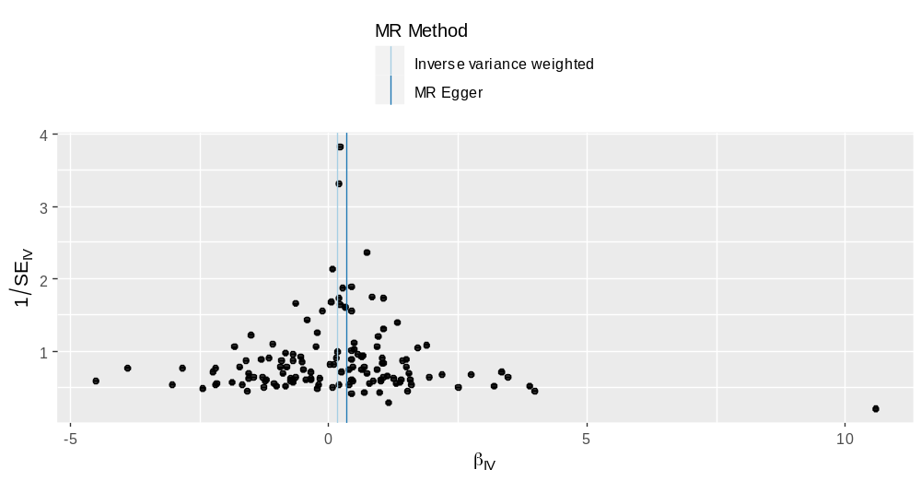
Supplemental Figure 5.2 Funnel plot for telomere length affecting cholecystitis risk
Note: The funnel plot can graphically detect horizontal pleiotropy; If the plot is symmetrical on both sides of the central axis,
it indicates that there is no horizontal pleiotropy; If the plot is not symmetrical, horizontal pleiotropy exists.

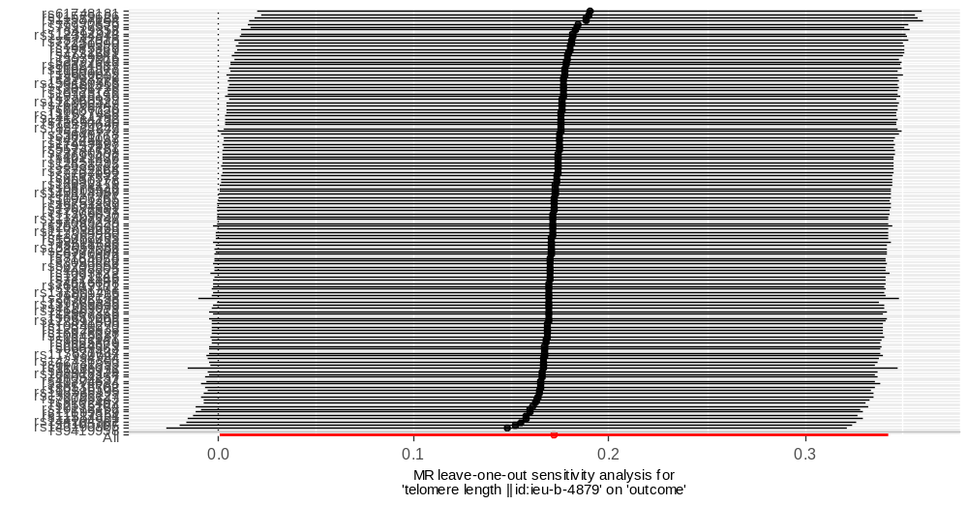
Supplemental Figure 5.3 Leave-one-out test for telomere length affecting cholecystitis risk
Note: Each SNP is eliminated in turn and the Mendelian randomization analysis is re-conducted to detect the effect of each SNP on the overall result. The X-axis shows the Mendelian randomization effect of telomere length on cholecystitis risk, and the Y-axis shows the SNPs included in the study.

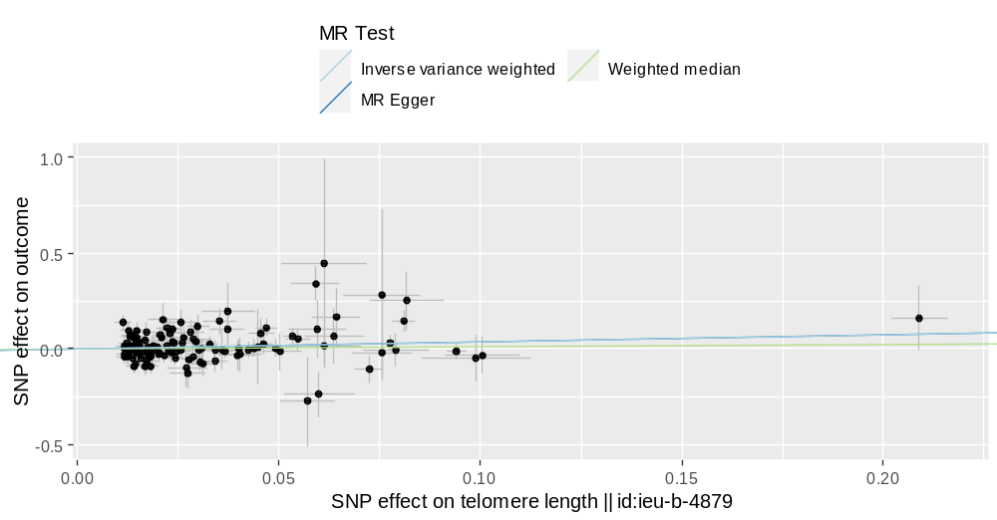
Supplemental Figure 6.1 Scatter plot for telomere length affecting pancreatic cancer risk
Note: The scatter plot reveals the difference in the results of the three Mendelian randomization methods. The X-axis shows the SNP effect on telomere length, and the Y-axis shows the SNP effect on pancreatic cancer risk.

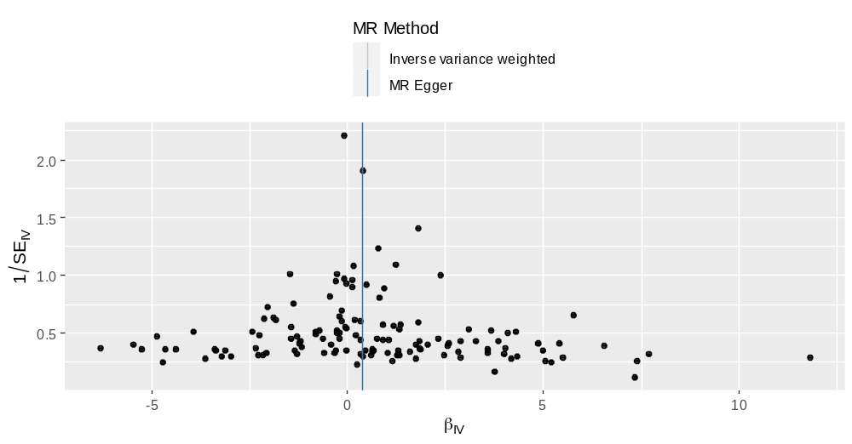
Supplemental Figure 6.2 Funnel plot for telomere length affecting pancreatic cancer risk
Note: The funnel plot can graphically detect horizontal pleiotropy; If the plot is symmetrical on both sides of the central axis,
it indicates that there is no horizontal pleiotropy; If the plot is not symmetrical, horizontal pleiotropy exists.

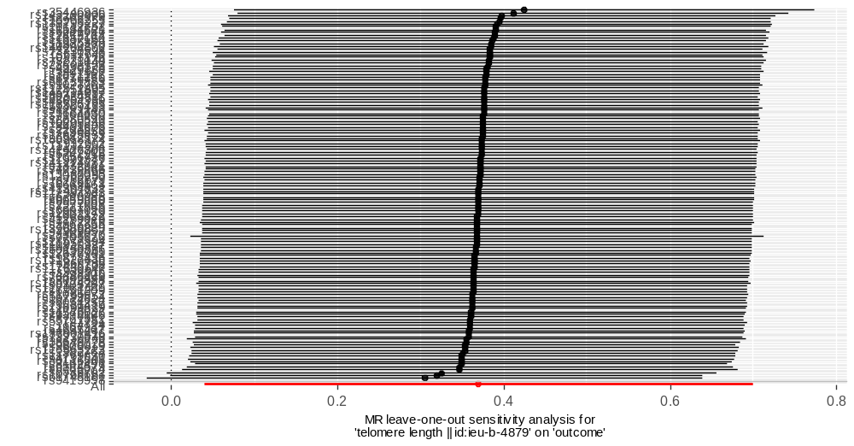
Supplemental Figure 6.3 Leave-one-out test for telomere length affecting pancreatic cancer risk
Note: Each SNP is eliminated in turn and the Mendelian randomization analysis is re-conducted to detect the effect of each SNP on the overall result. The X-axis shows the Mendelian randomization effect of telomere length on pancreatic cancer risk, and the Y-axis shows the SNPs included in the study.

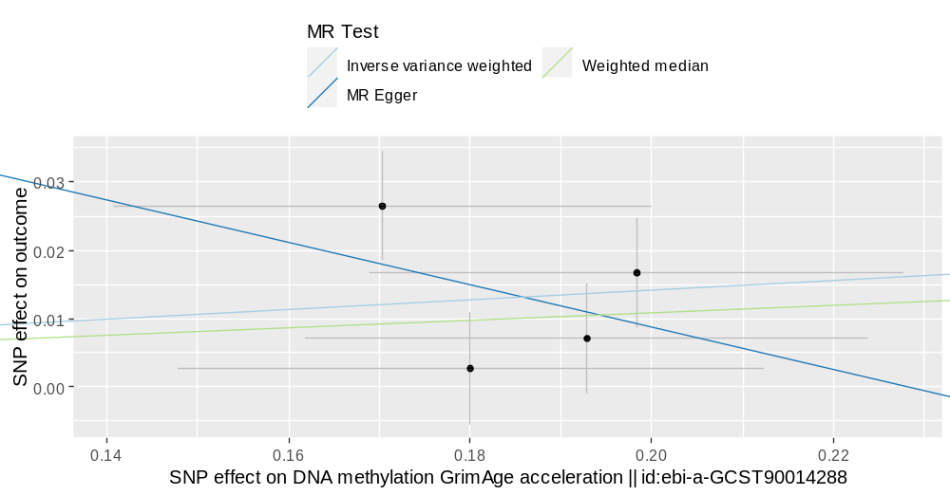
Supplemental Figure 7.1 Scatter plot for GrimAge acceleration affecting cholelithiasis risk
Note: The scatter plot reveals the difference in the results of the three Mendelian randomization methods. The X-axis shows the SNP effect on GrimAge acceleration, and the Y-axis shows the SNP effect on cholelithiasis risk.

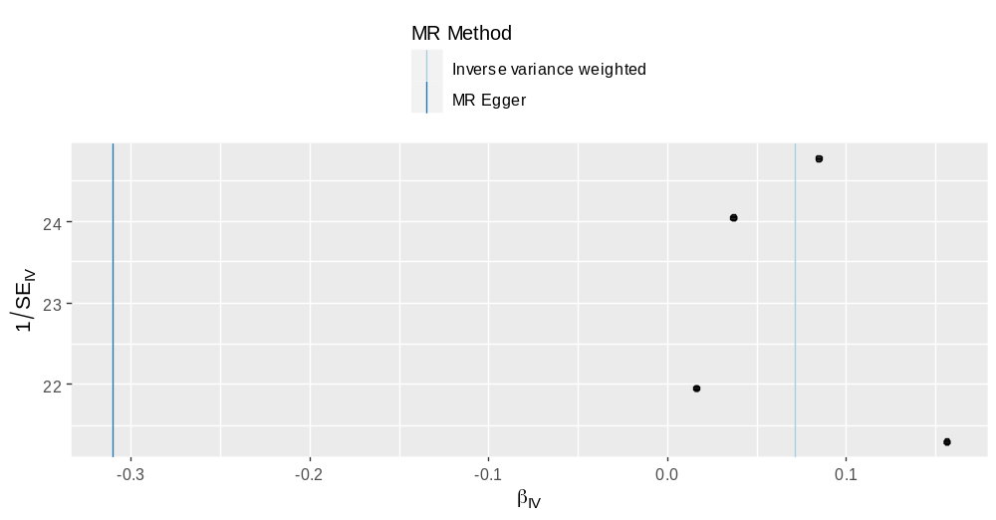
Supplemental Figure 7.2 Funnel plot for GrimAge acceleration affecting cholelithiasis risk
Note: The funnel plot can graphically detect horizontal pleiotropy; If the plot is symmetrical on both sides of the central axis,
it indicates that there is no horizontal pleiotropy; If the plot is not symmetrical, horizontal pleiotropy exists.

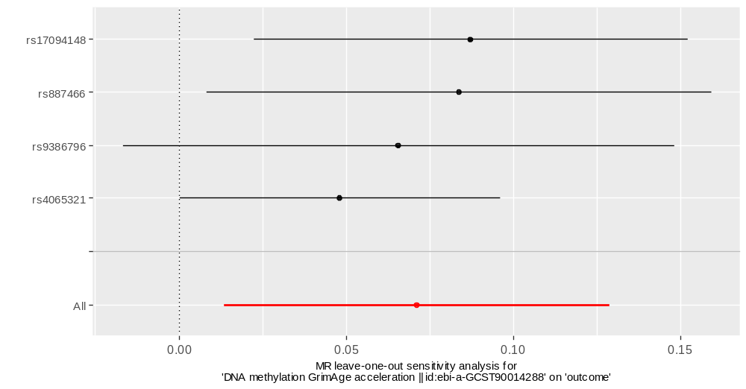
Supplemental Figure 7.3 Leave-one-out test for GrimAge acceleration affecting cholelithiasis risk
Note: Each SNP is eliminated in turn and the Mendelian randomization analysis is re-conducted to detect the effect of each SNP on the overall result. The X-axis shows the Mendelian randomization effect of GrimAge acceleration on cholelithiasis risk, and the Y-axis shows the SNPs included in the study.

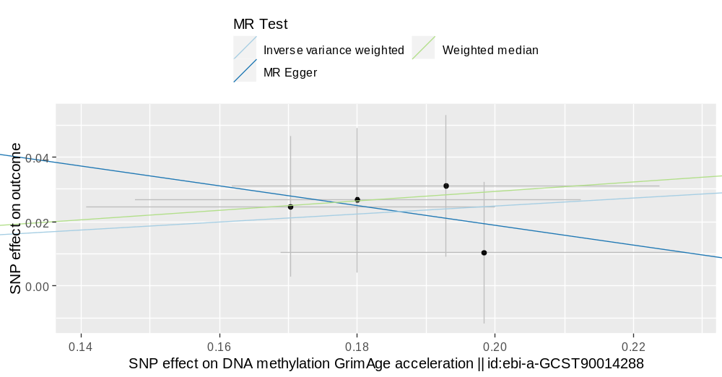
Supplemental Figure 8.1 Scatter plot for GrimAge acceleration affecting cholecystitis risk
Note: The scatter plot reveals the difference in the results of the three Mendelian randomization methods. The X-axis shows the SNP effect on GrimAge acceleration, and the Y-axis shows the SNP effect on cholecystitis risk.

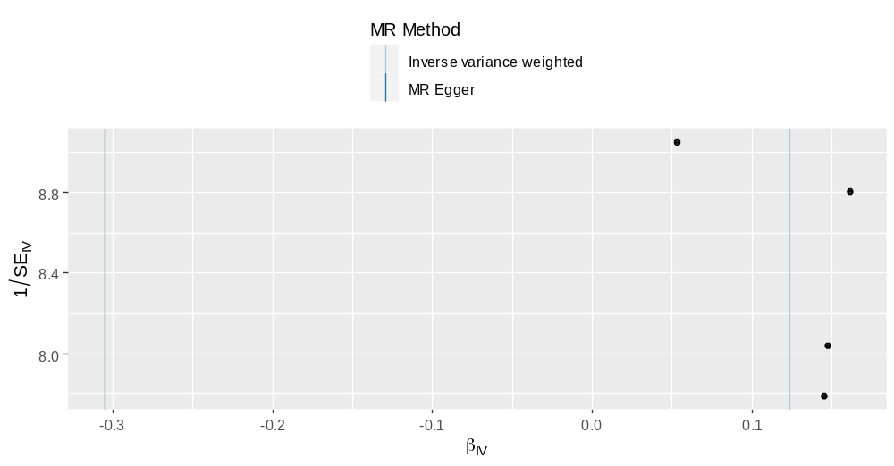
Supplemental Figure 8.2 Funnel plot for GrimAge acceleration affecting cholecystitis risk
Note: The funnel plot can graphically detect horizontal pleiotropy; If the plot is symmetrical on both sides of the central axis,
it indicates that there is no horizontal pleiotropy; If the plot is not symmetrical, horizontal pleiotropy exists.

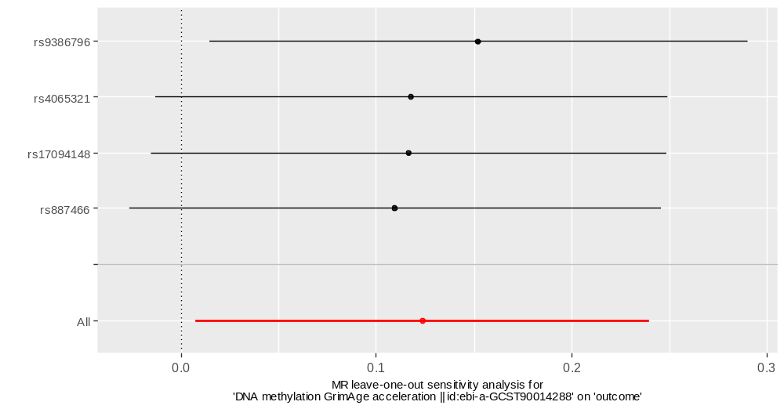
Supplemental Figure 8.3 Leave-one-out test for GrimAge acceleration affecting cholecystitis risk
Note: Each SNP is eliminated in turn and the Mendelian randomization analysis is re-conducted to detect the effect of each SNP on the overall result. The X-axis shows the Mendelian randomization effect of GrimAge acceleration on cholecystitis risk, and the Y-axis shows the SNPs included in the study.

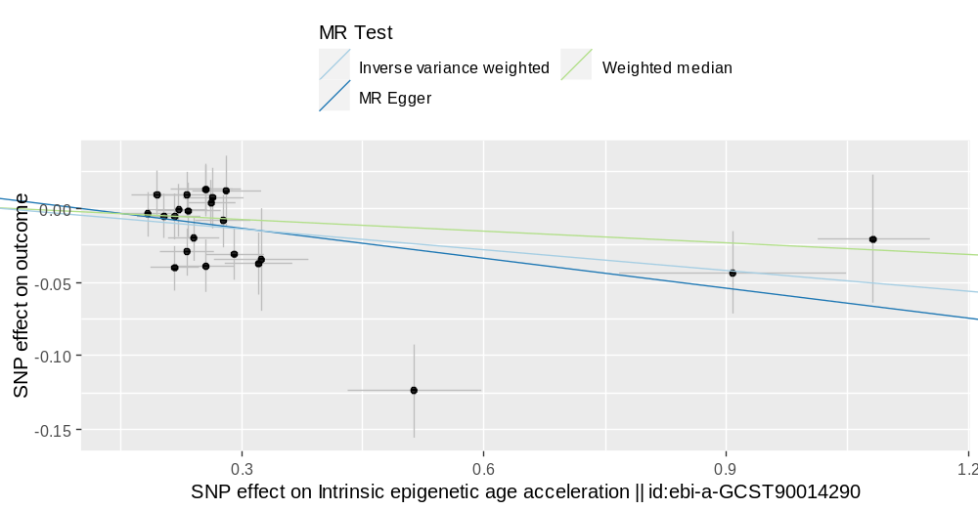
Supplemental Figure 9.1 Scatter plot for HorvathAge acceleration affecting chronic gastritis risk
Note: The scatter plot reveals the difference in the results of the three Mendelian randomization methods. The X-axis shows the SNP effect on HorvathAge acceleration, and the Y-axis shows the SNP effect on chronic gastritis risk.

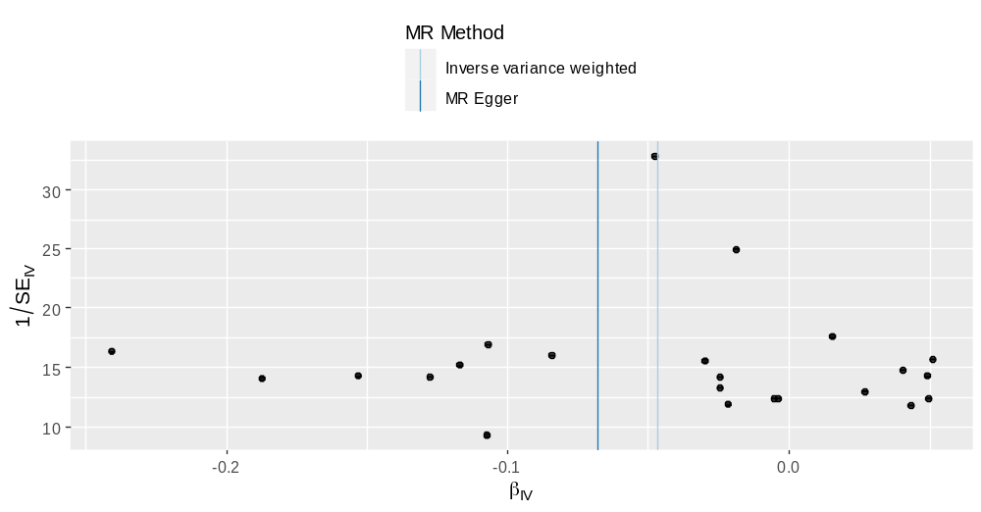
Supplemental Figure 9.2 Funnel plot for HorvathAge acceleration affecting chronic gastritis risk
Note: The funnel plot can graphically detect horizontal pleiotropy; If the plot is symmetrical on both sides of the central axis,
it indicates that there is no horizontal pleiotropy; If the plot is not symmetrical, horizontal pleiotropy exists.

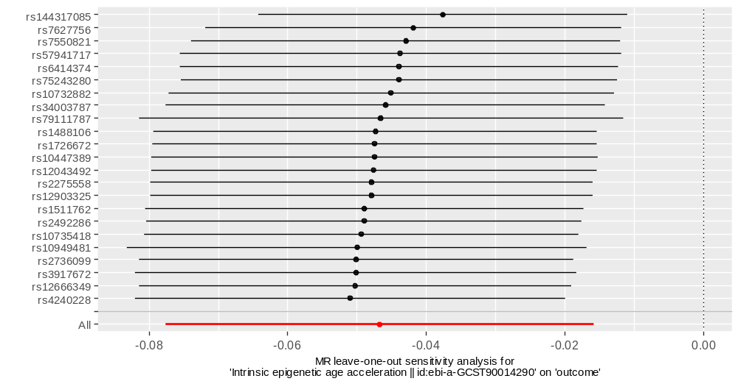
Supplemental Figure 9.3 Leave-one-out test for HorvathAge acceleration affecting chronic gastritis risk
Note: Each SNP is eliminated in turn and the Mendelian randomization analysis is re-conducted to detect the effect of each SNP on the overall result. The X-axis shows the Mendelian randomization effect of HorvathAge acceleration on chronic gastritis risk, and the Y-axis shows the SNPs included in the study.

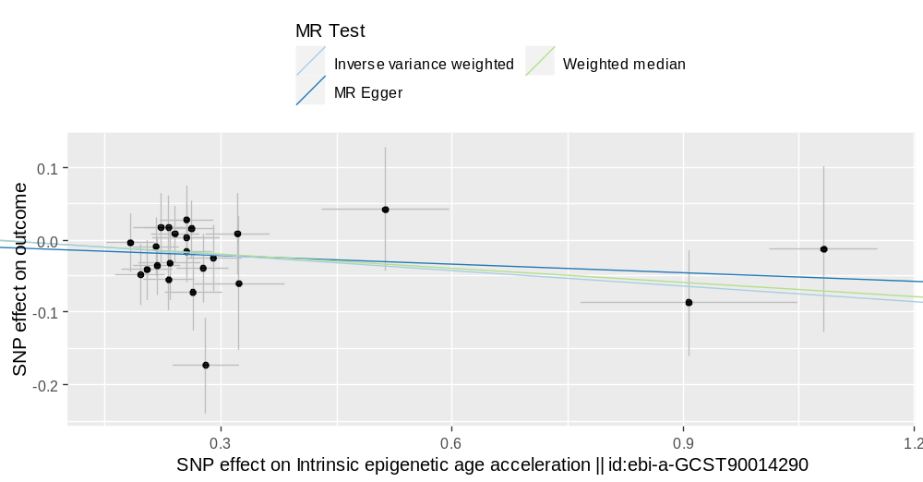
Supplemental Figure 10.1 Scatter plot for HorvathAge acceleration affecting gastric cancer risk
Note: The scatter plot reveals the difference in the results of the three Mendelian randomization methods. The X-axis shows the SNP effect on HorvathAge acceleration, and the Y-axis shows the SNP effect on gastric cancer risk.

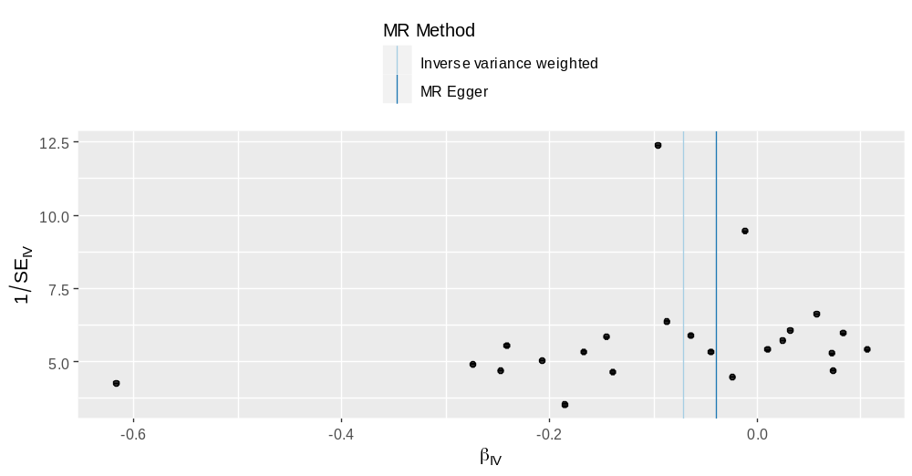
Supplemental Figure 10.2 Funnel plot for HorvathAge acceleration affecting gastric cancer risk
Note: The funnel plot can graphically detect horizontal pleiotropy; If the plot is symmetrical on both sides of the central axis,
it indicates that there is no horizontal pleiotropy; If the plot is not symmetrical, horizontal pleiotropy exists.

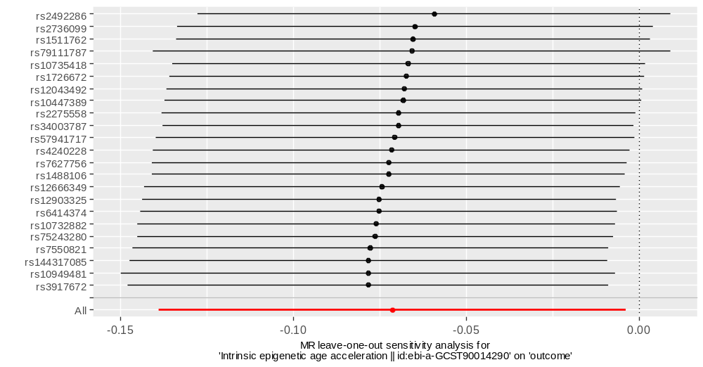
Supplemental Figure 10.3 Leave-one-out test for HorvathAge acceleration affecting gastric cancer risk
Note: Each SNP is eliminated in turn and the Mendelian randomization analysis is re-conducted to detect the effect of each SNP on the overall result. The X-axis shows the Mendelian randomization effect of HorvathAge acceleration on gastric cancer risk, and the Y-axis shows the SNPs included in the study.

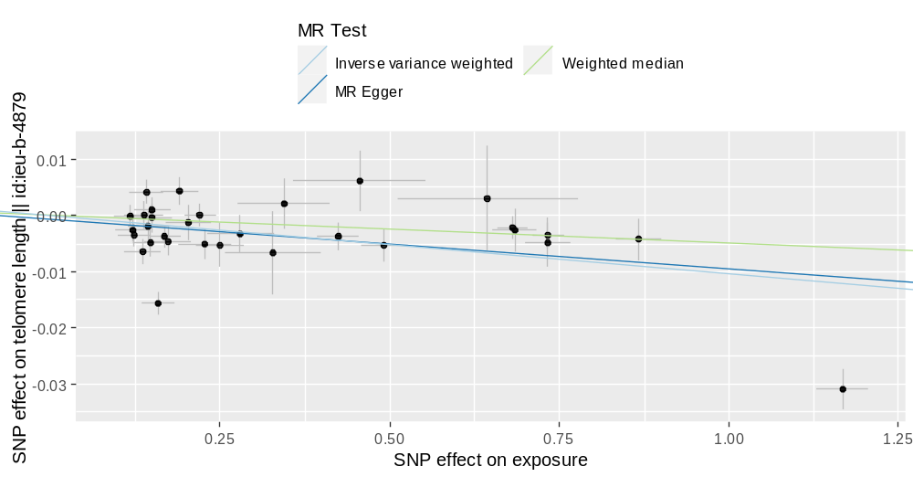
Supplemental Figure 11.1 Scatter plot for celiac disease risk affecting telomere length
Note: The scatter plot reveals the difference in the results of the three Mendelian randomization methods. The X-axis shows the SNP effect on celiac disease risk, and the Y-axis shows the SNP effect on telomere length.

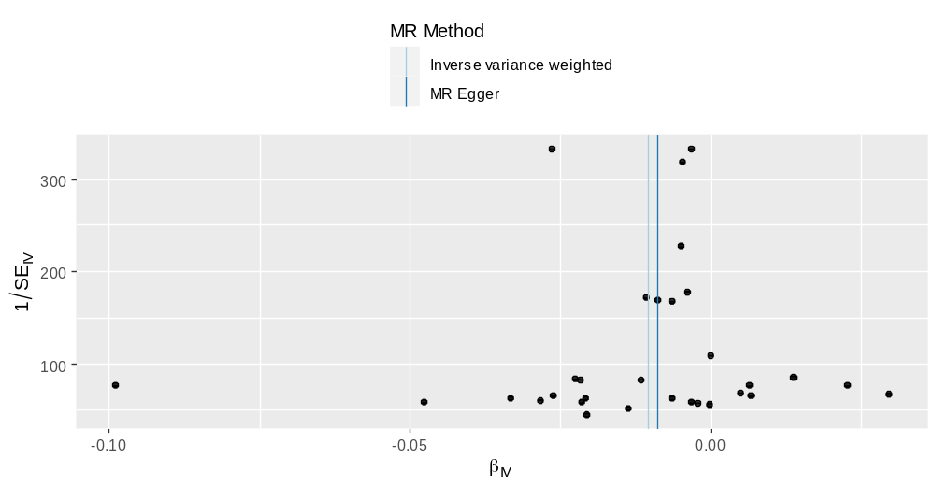
Supplemental Figure 11.2 Funnel plot for celiac disease risk affecting telomere length
Note: The funnel plot can graphically detect horizontal pleiotropy; If the plot is symmetrical on both sides of the central axis,
it indicates that there is no horizontal pleiotropy; If the plot is not symmetrical, horizontal pleiotropy exists.

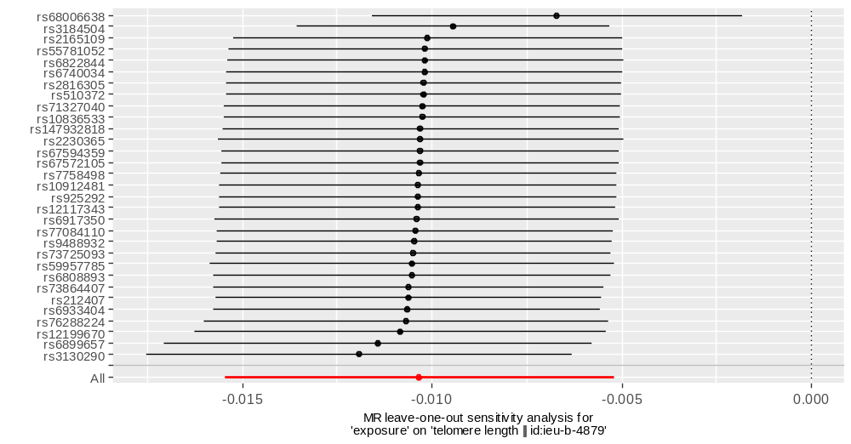
Supplemental Figure 11.3 Leave-one-out test for celiac disease risk affecting telomere length
Note: Each SNP is eliminated in turn and the Mendelian randomization analysis is re-conducted to detect the effect of each SNP on the overall result. The X-axis shows the Mendelian randomization effect of celiac disease risk on telomere length, and the Y-axis shows the SNPs included in the study.

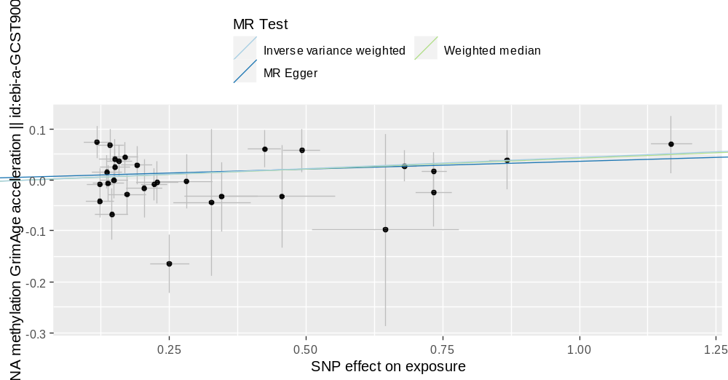
Supplemental Figure 12.1 Scatter plot for celiac disease risk affecting GrimAge acceleration
Note: The scatter plot reveals the difference in the results of the three Mendelian randomization methods. The X-axis shows the SNP effect on celiac disease risk, and the Y-axis shows the SNP effect on GrimAge acceleration.

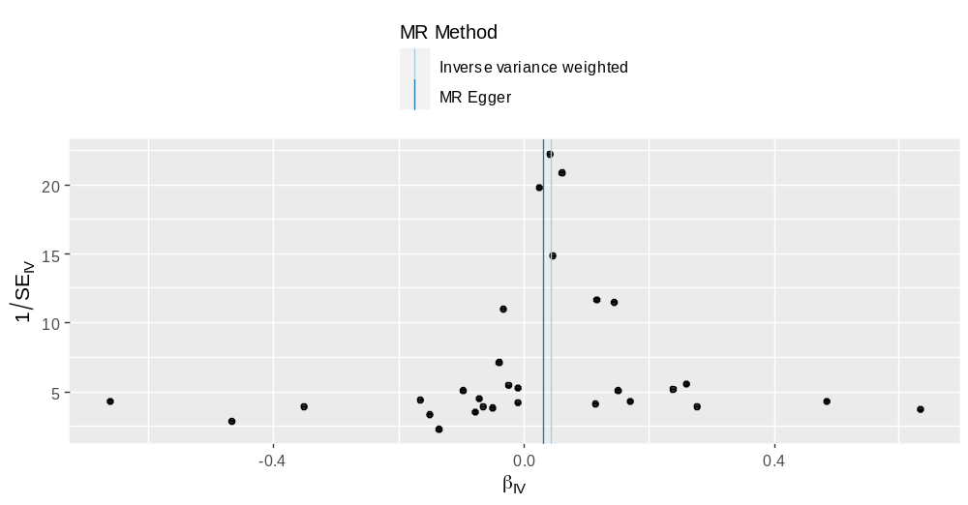
Supplemental Figure 12.2 Funnel plot for celiac disease risk affecting GrimAge acceleration
Note: The funnel plot can graphically detect horizontal pleiotropy; If the plot is symmetrical on both sides of the central axis,
it indicates that there is no horizontal pleiotropy; If the plot is not symmetrical, horizontal pleiotropy exists.

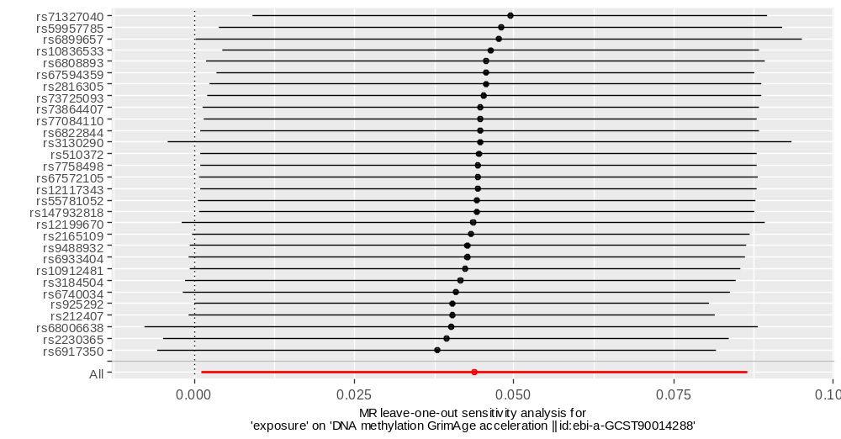
Supplemental Figure 12.3 Leave-one-out test for celiac disease risk affecting GrimAge acceleration
Note: Each SNP is eliminated in turn and the Mendelian randomization analysis is re-conducted to detect the effect of each SNP on the overall result. The X-axis shows the Mendelian randomization effect of celiac disease risk on GrimAge acceleration, and the Y-axis shows the SNPs included in the study.

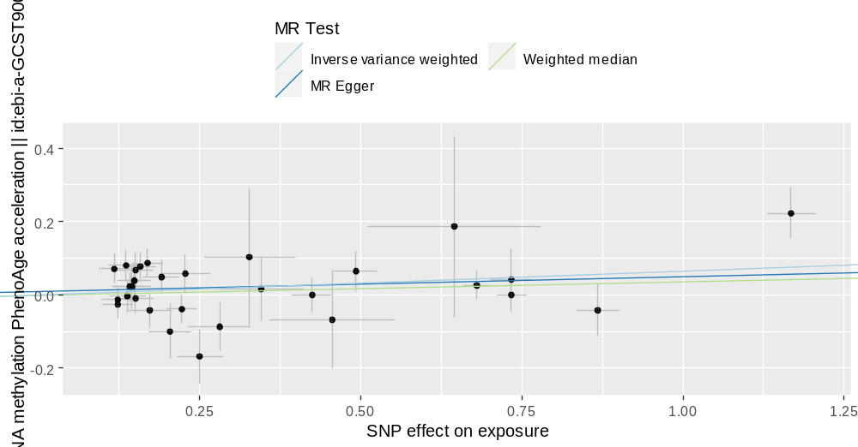
Supplemental Figure 13.1 Scatter plot for celiac disease risk affecting PhenoAge acceleration
Note: The scatter plot reveals the difference in the results of the three Mendelian randomization methods. The X-axis shows the SNP effect on celiac disease risk, and the Y-axis shows the SNP effect on PhenoAge acceleration.

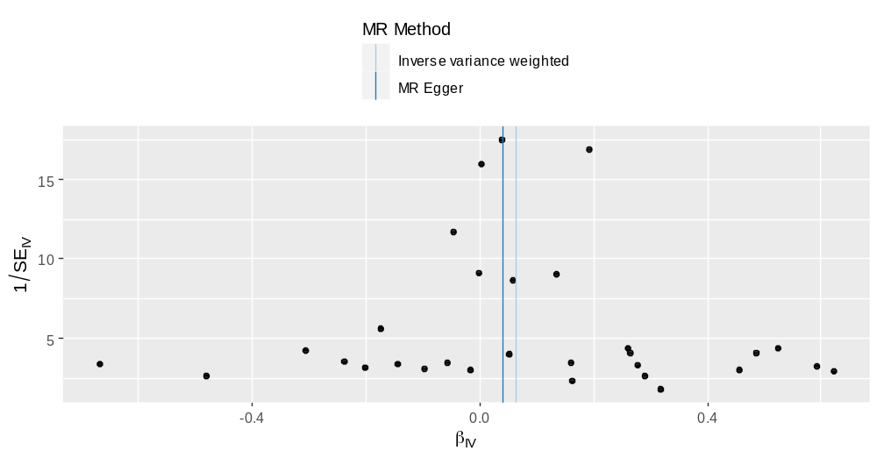
Supplemental Figure 13.2 Funnel plot for celiac disease risk affecting PhenoAge acceleration
Note: The funnel plot can graphically detect horizontal pleiotropy; If the plot is symmetrical on both sides of the central axis,
it indicates that there is no horizontal pleiotropy; If the plot is not symmetrical, horizontal pleiotropy exists.

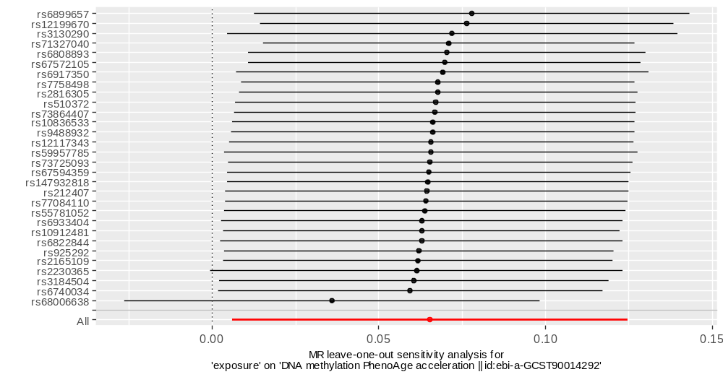
Supplemental Figure 13.3 Leave-one-out test for celiac disease risk affecting PhenoAge acceleration
Note: Each SNP is eliminated in turn and the Mendelian randomization analysis is re-conducted to detect the effect of each SNP on the overall result. The X-axis shows the Mendelian randomization effect of celiac disease risk on PhenoAge acceleration, and the Y-axis shows the SNPs included in the study.

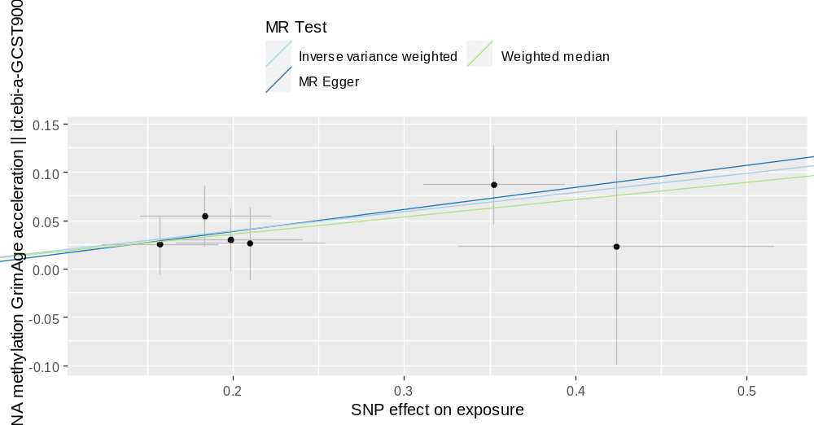
Supplemental Figure 14.1 Scatter plot for cholangitis risk affecting GrimAge acceleration
Note: The scatter plot reveals the difference in the results of the three Mendelian randomization methods. The X-axis shows the SNP effect on cholangitis risk, and the Y-axis shows the SNP effect on GrimAge acceleration.

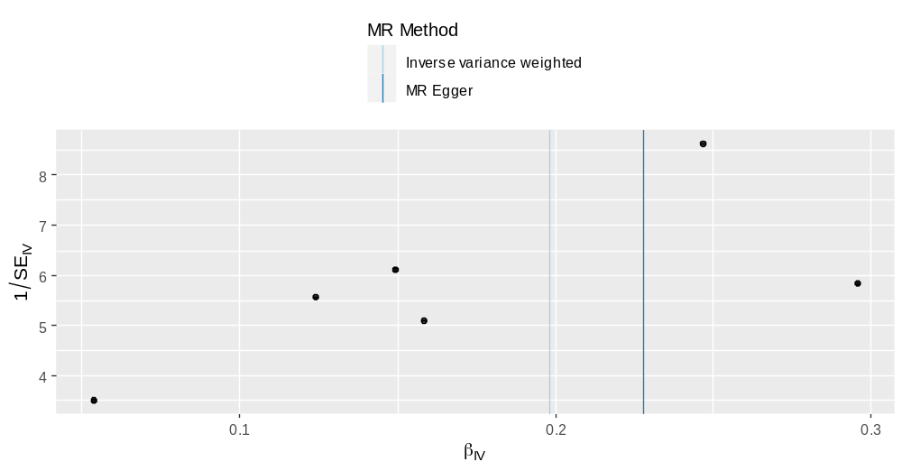
Supplemental Figure 14.2 Funnel plot for cholangitis risk affecting GrimAge acceleration
Note: The funnel plot can graphically detect horizontal pleiotropy; If the plot is symmetrical on both sides of the central axis,
it indicates that there is no horizontal pleiotropy; If the plot is not symmetrical, horizontal pleiotropy exists.

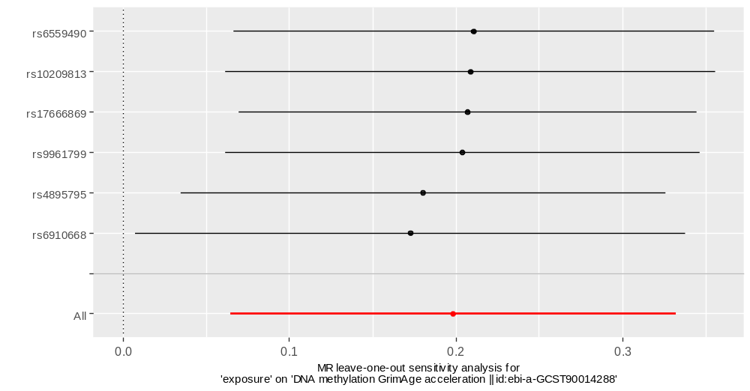
Supplemental Figure 14.3 Leave-one-out test for cholangitis risk affecting GrimAge acceleration
Note: Each SNP is eliminated in turn and the Mendelian randomization analysis is re-conducted to detect the effect of each SNP on the overall result. The X-axis shows the Mendelian randomization effect of cholangitis risk on GrimAge acceleration, and the Y-axis shows the SNPs included in the study.

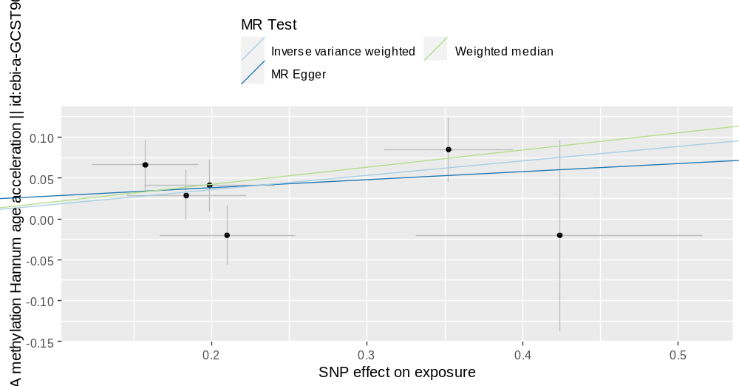
Supplemental Figure 15.1 Scatter plot for cholangitis risk affecting HannumAge acceleration
Note: The scatter plot reveals the difference in the results of the three Mendelian randomization methods. The X-axis shows the SNP effect on cholangitis risk, and the Y-axis shows the SNP effect on HannumAge acceleration.

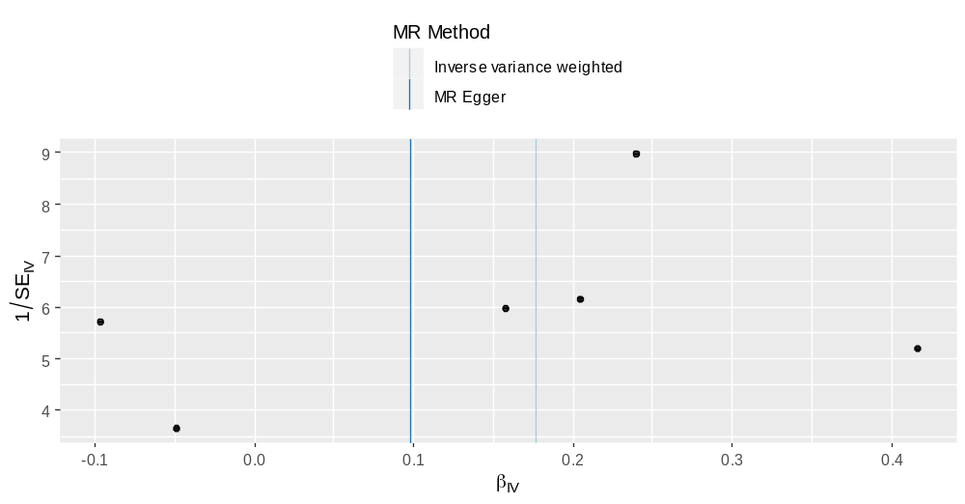
Supplemental Figure 15.2 Funnel plot for cholangitis risk affecting HannumAge acceleration
Note: The funnel plot can graphically detect horizontal pleiotropy; If the plot is symmetrical on both sides of the central axis,
it indicates that there is no horizontal pleiotropy; If the plot is not symmetrical, horizontal pleiotropy exists.

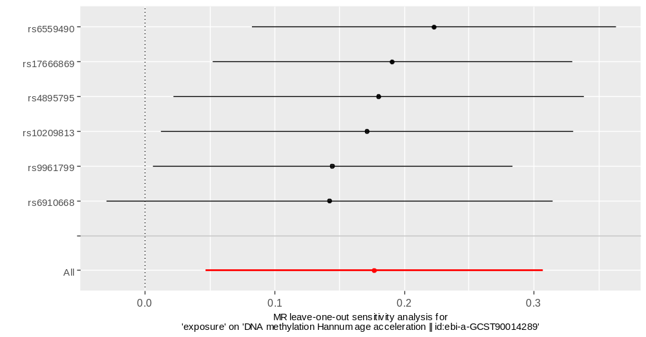
Supplemental Figure 15.3 Leave-one-out test for cholangitis risk affecting HannumAge acceleration
Note: Each SNP is eliminated in turn and the Mendelian randomization analysis is re-conducted to detect the effect of each SNP on the overall result. The X-axis shows the Mendelian randomization effect of cholangitis risk on HannumAge acceleration, and the Y-axis shows the SNPs included in the study.

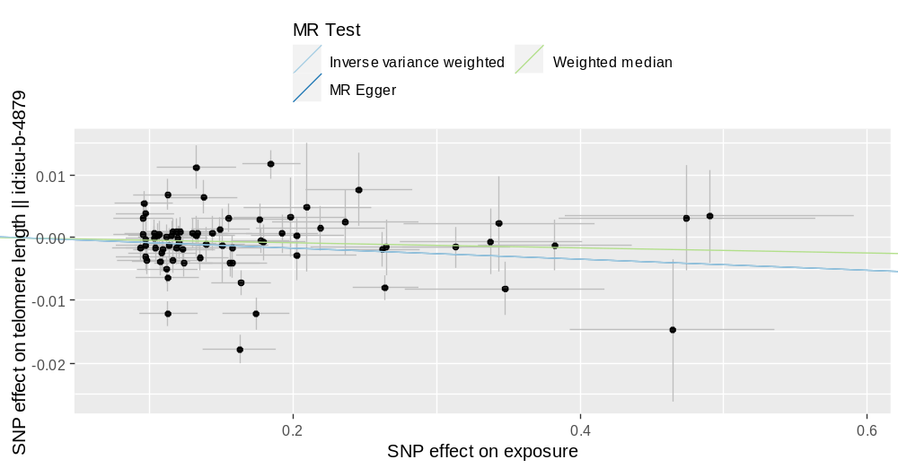
Supplemental Figure 16.1 Scatter plot for ulcerative colitis risk affecting telomere length
Note: The scatter plot reveals the difference in the results of the three Mendelian randomization methods. The X-axis shows the SNP effect on ulcerative colitis risk, and the Y-axis shows the SNP effect on telomere length.

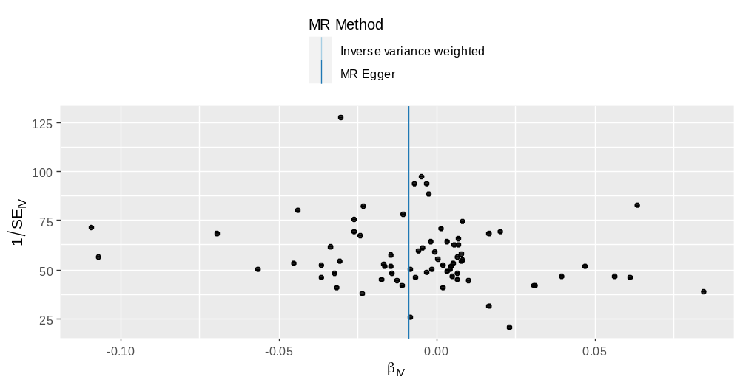
Supplemental Figure 16.2 Funnel plot for ulcerative colitis risk affecting telomere length
Note: The funnel plot can graphically detect horizontal pleiotropy; If the plot is symmetrical on both sides of the central axis,
it indicates that there is no horizontal pleiotropy; If the plot is not symmetrical, horizontal pleiotropy exists.

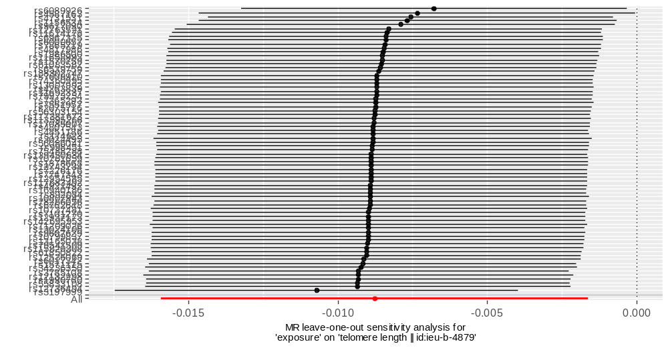
Supplemental Figure 16.3 Leave-one-out test for ulcerative colitis risk affecting telomere length
Note: Each SNP is eliminated in turn and the Mendelian randomization analysis is re-conducted to detect the effect of each SNP on the overall result. The X-axis shows the Mendelian randomization effect of ulcerative colitis risk on telomere length, and the Y-axis shows the SNPs included in the study.

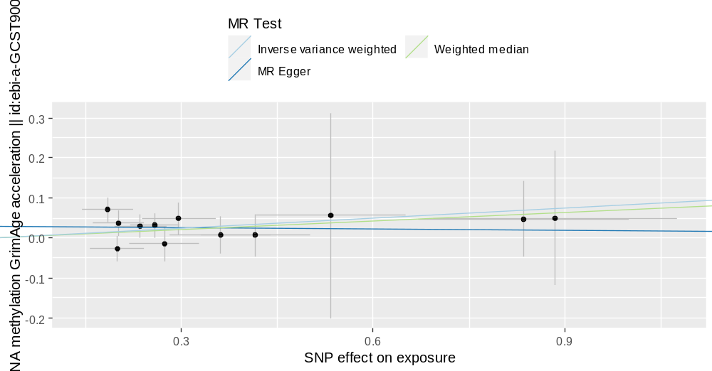
Supplemental Figure 17.1 Scatter plot for gastric cancer risk affecting GrimAge acceleration
Note: The scatter plot reveals the difference in the results of the three Mendelian randomization methods. The X-axis shows the SNP effect on gastric cancer risk, and the Y-axis shows the SNP effect on GrimAge acceleration.

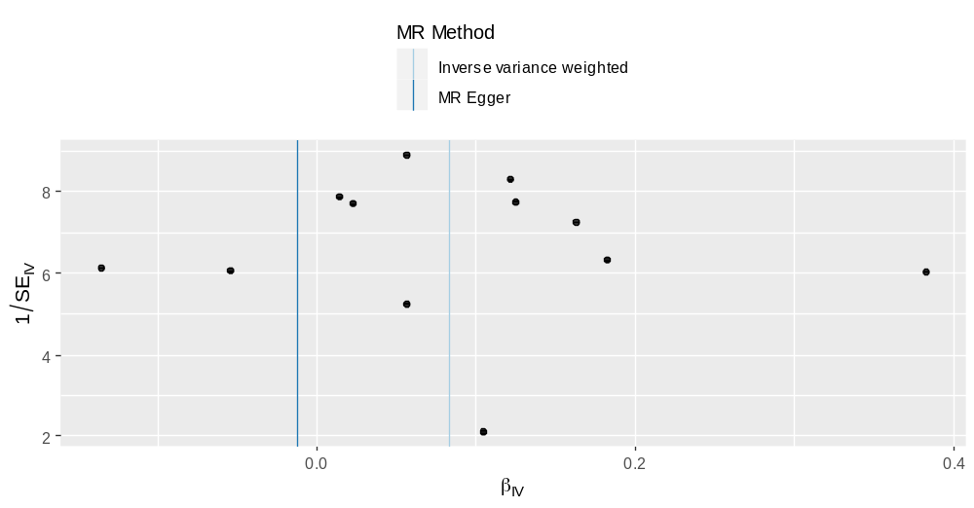
Supplemental Figure 17.2 Funnel plot for gastric cancer risk affecting GrimAge acceleration
Note: The funnel plot can graphically detect horizontal pleiotropy; If the plot is symmetrical on both sides of the central axis,
it indicates that there is no horizontal pleiotropy; If the plot is not symmetrical, horizontal pleiotropy exists.

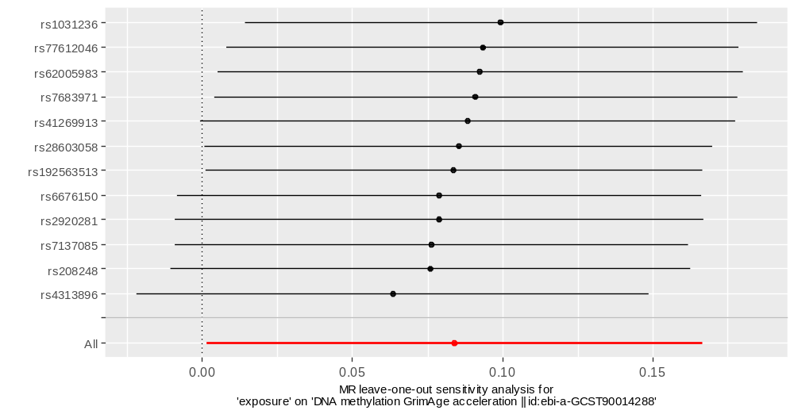
Supplemental Figure 17.3 Leave-one-out test for gastric cancer risk affecting GrimAge acceleration
Note: Each SNP is eliminated in turn and the Mendelian randomization analysis is re-conducted to detect the effect of each SNP on the overall result. The X-axis shows the Mendelian randomization effect of gastric cancer risk on GrimAge acceleration, and the Y-axis shows the SNPs included in the study.

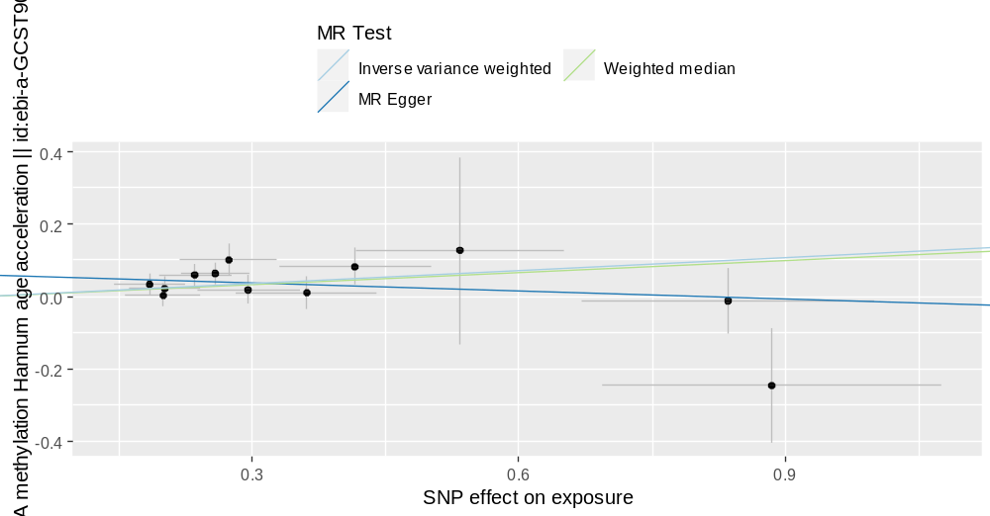
Supplemental Figure 18.1 Scatter plot for gastric cancer risk affecting HannumAge acceleration
Note: The scatter plot reveals the difference in the results of the three Mendelian randomization methods. The X-axis shows the SNP effect on gastric cancer risk, and the Y-axis shows the SNP effect on HannumAge acceleration.

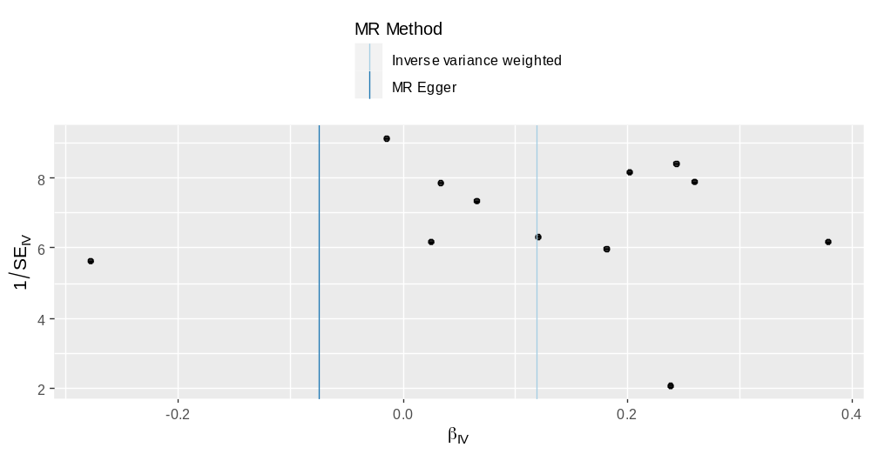
Supplemental Figure 18.2 Funnel plot for gastric cancer risk affecting HannumAge acceleration
Note: The funnel plot can graphically detect horizontal pleiotropy; If the plot is symmetrical on both sides of the central axis,
it indicates that there is no horizontal pleiotropy; If the plot is not symmetrical, horizontal pleiotropy exists.

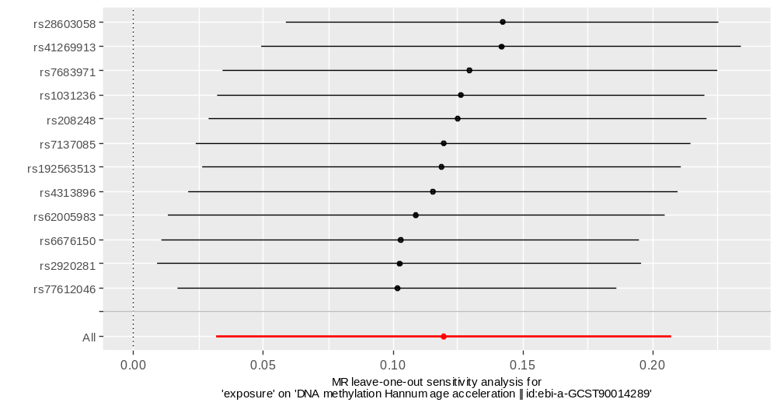
Supplemental Figure 18.3 Leave-one-out test for gastric cancer risk affecting HannumAge acceleration
Note: Each SNP is eliminated in turn and the Mendelian randomization analysis is re-conducted to detect the effect of each SNP on the overall result. The X-axis shows the Mendelian randomization effect of gastric cancer risk on HannumAge acceleration, and the Y-axis shows the SNPs included in the study.

