Electronic Supplementary Information for
Graphsene: a new porous two-dimensional carbon-based material with anisotropic behavior in electronic and mechanical properties and highly efficient ORR electrocatalytic activity
Mohammadreza Hosseiniª, Maryam Soleimani^{b}, Fazel Shojaei^{c}, Mahdi Pourfath^{b,*}
ª Department of Physical Chemistry, Tarbiat Modares University, Tehran, Iran
^{b} School of Electrical and Computer Engineering, University of Tehran, 14395-515 Tehran, Iran
^{c} Department of Chemistry, Faculty of Nano and Bioscience and Technology, Persian Gulf University, Bushehr 75169, Iran

E(θ) = $\frac{C_{11}C_{22}- C_{12}^{2}}{C_{11}\sin^{4}\left(θ\right)+\left[\frac{\left(C_{11}C_{22}- C_{12}^{2}\right)}{C_{66}}-2C_{12}\right]\sin^{2}\left(θ\right)\cos^{2}\left(θ\right)+C_{22}\cos^{4}\left(θ\right) }$ (S1)

ν(θ) = $\frac{C_{12}\sin^{4}\left(θ\right)- \left[C_{11}+C_{22}-\frac{\left(C_{11}C_{22}- C_{12}^{2}\right)}{C_{66}}\right]\sin^{2}\left(θ\right)\cos^{2}\left(θ\right)+C_{12}\cos^{4}\left(θ\right)}{C_{11}\sin^{4}\left(θ\right)+\left[\frac{\left(C_{11}C_{22}- C_{12}^{2}\right)}{C_{66}}-2C_{12}\right]\sin^{2}\left(θ\right)\cos^{2}\left(θ\right)+C_{22}\cos^{4}\left(θ\right) }$ (S2)

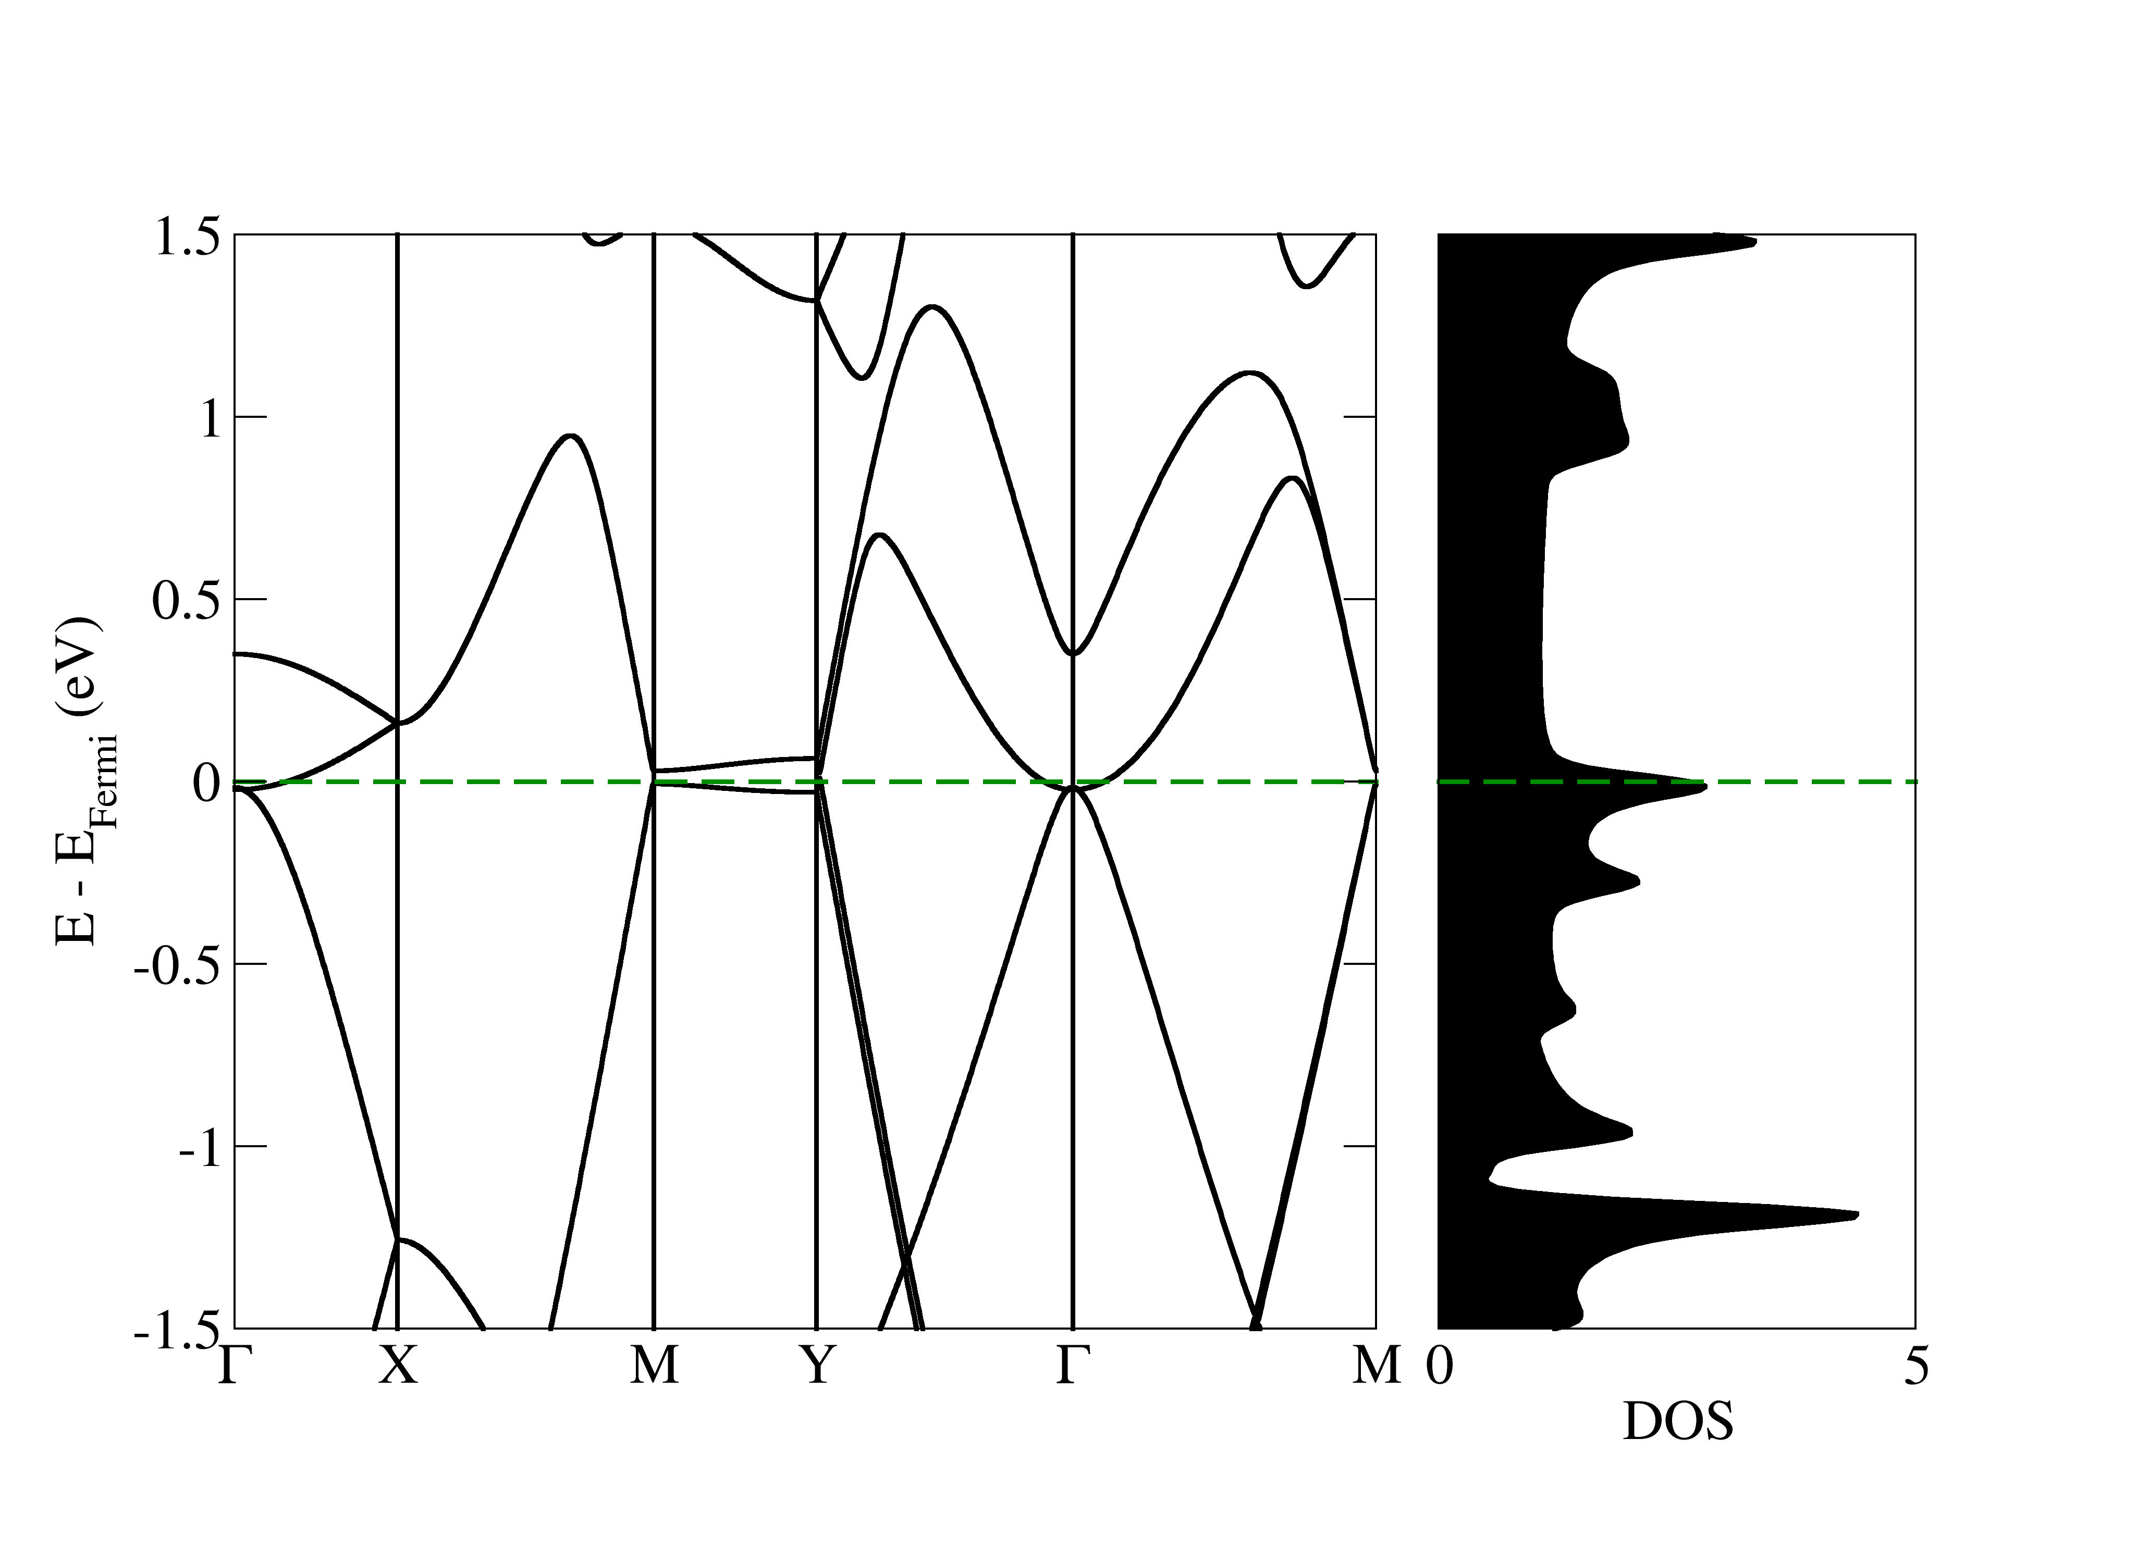
Figure S1. Electronic band structure and density of states of GrS in PBE framework

