Additional file 1:
Adjoint-based Direct Data Assimilation of GNSS time series for optimizing frictional parameters and predicting postseismic deformation following the 2003 Tokachi-oki earthquake
Masayuki Kano, Shin’ichi Miyazaki, Yoichi Ishikawa and Kazuro Hirahara

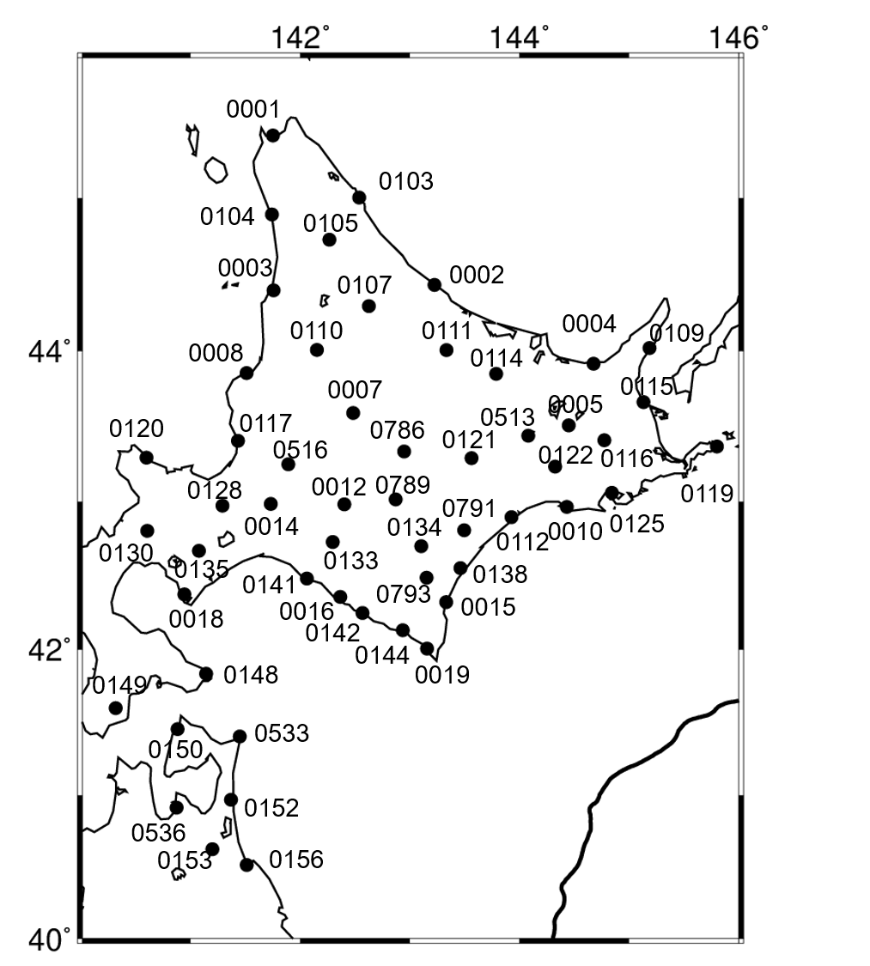
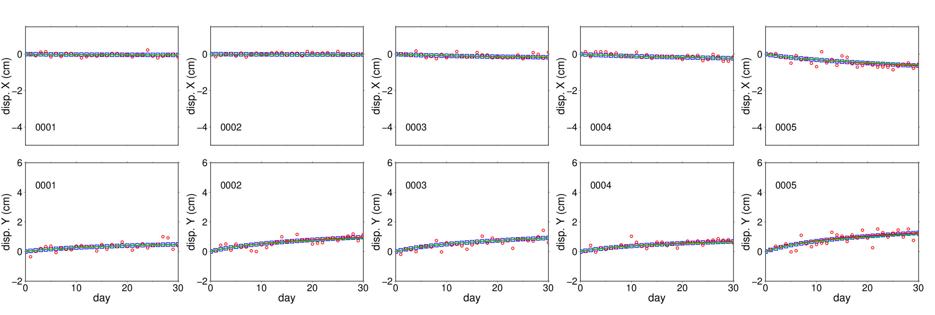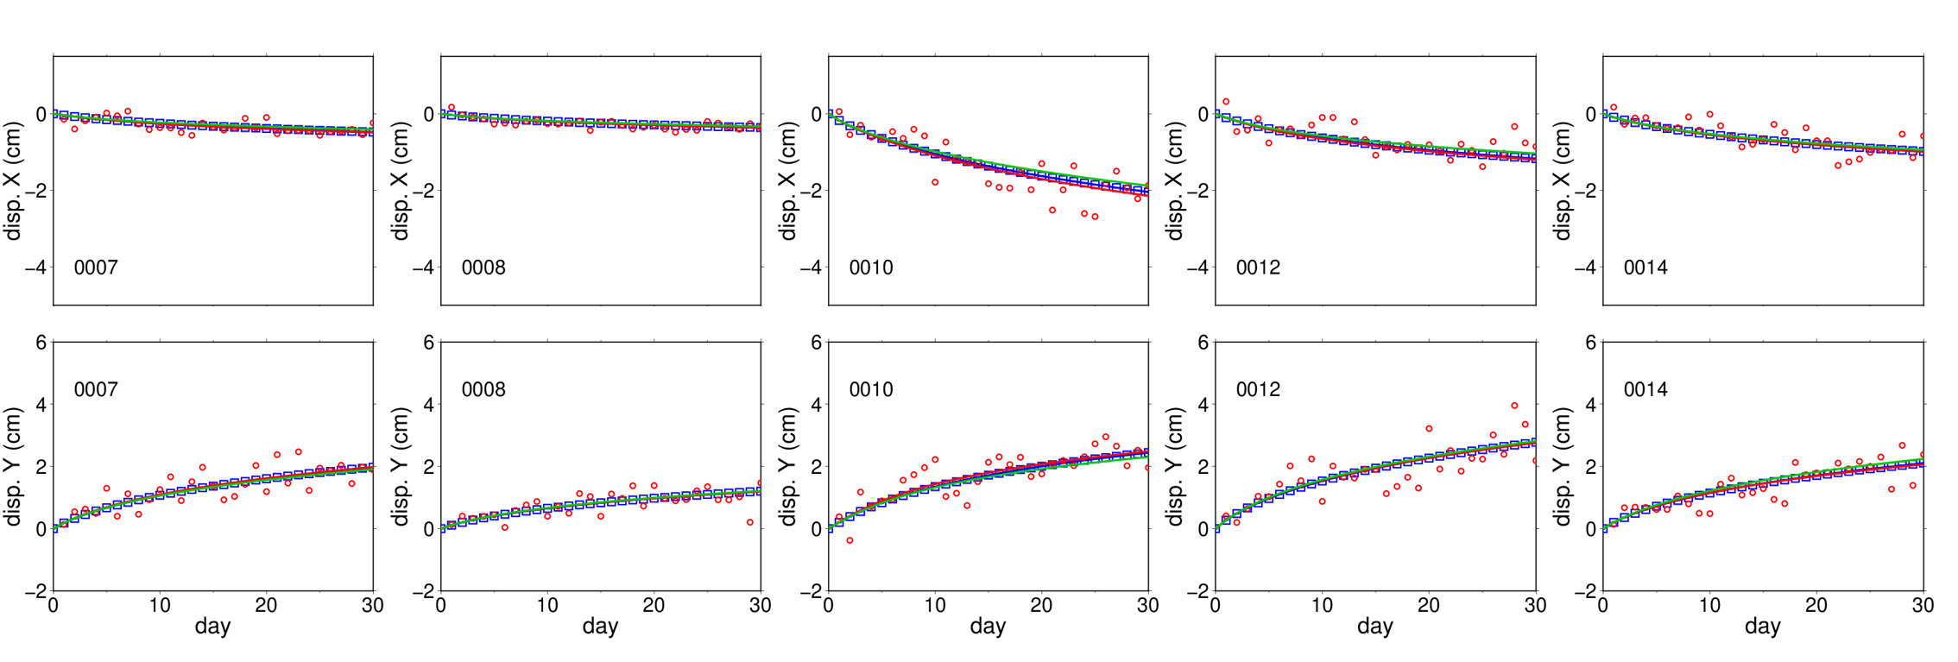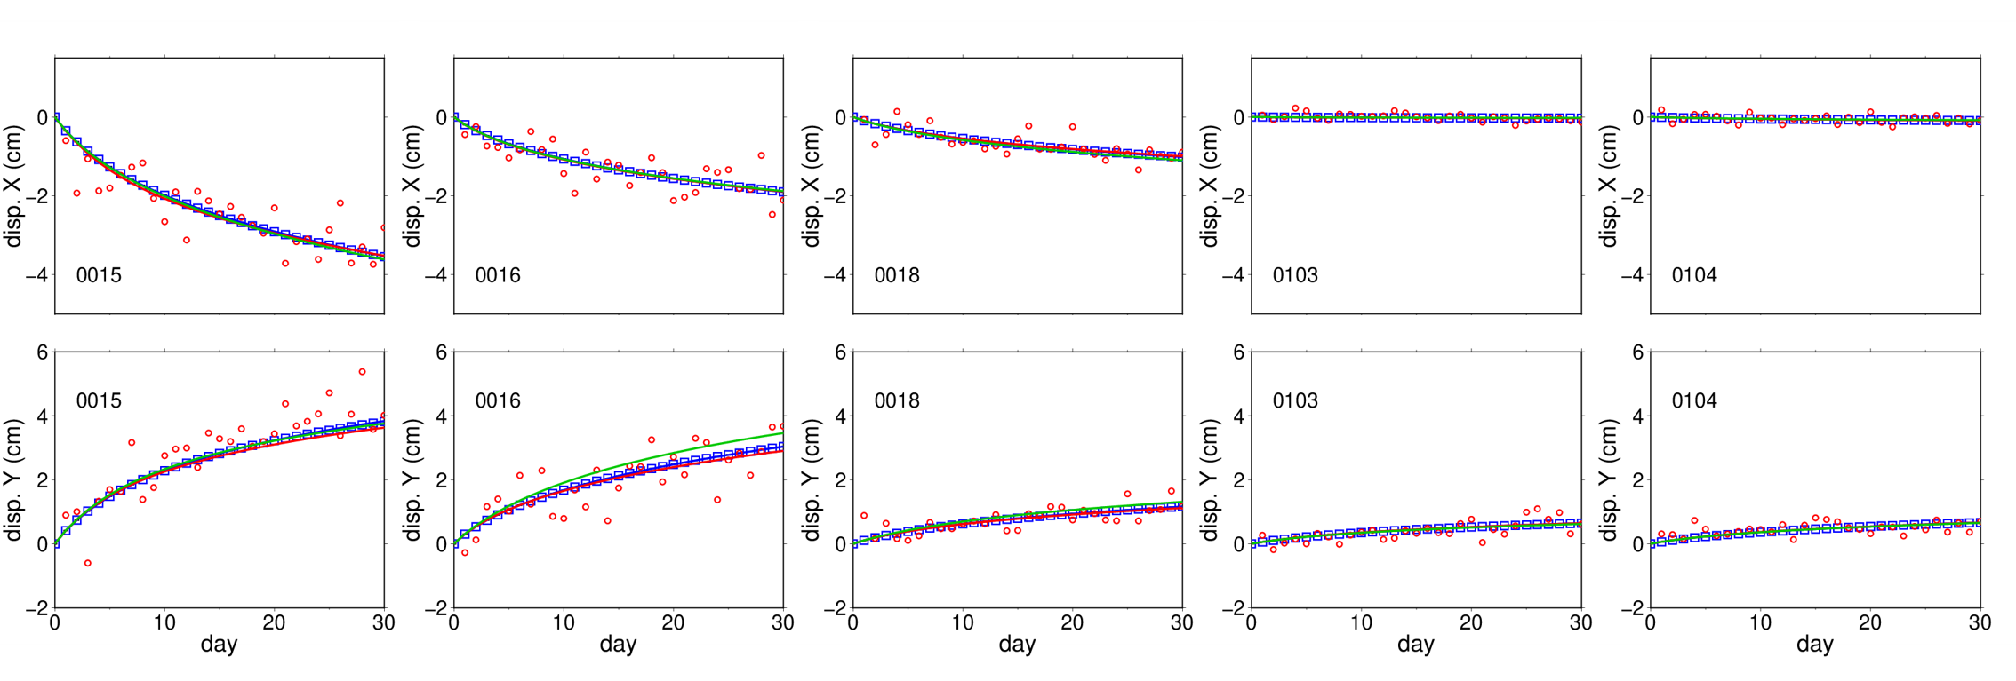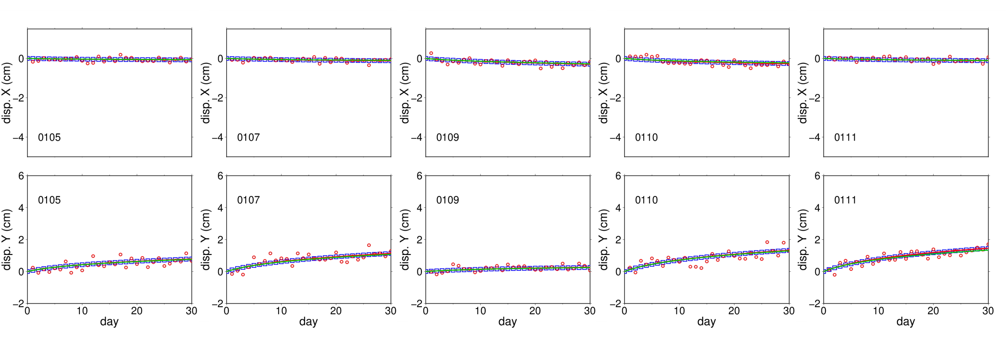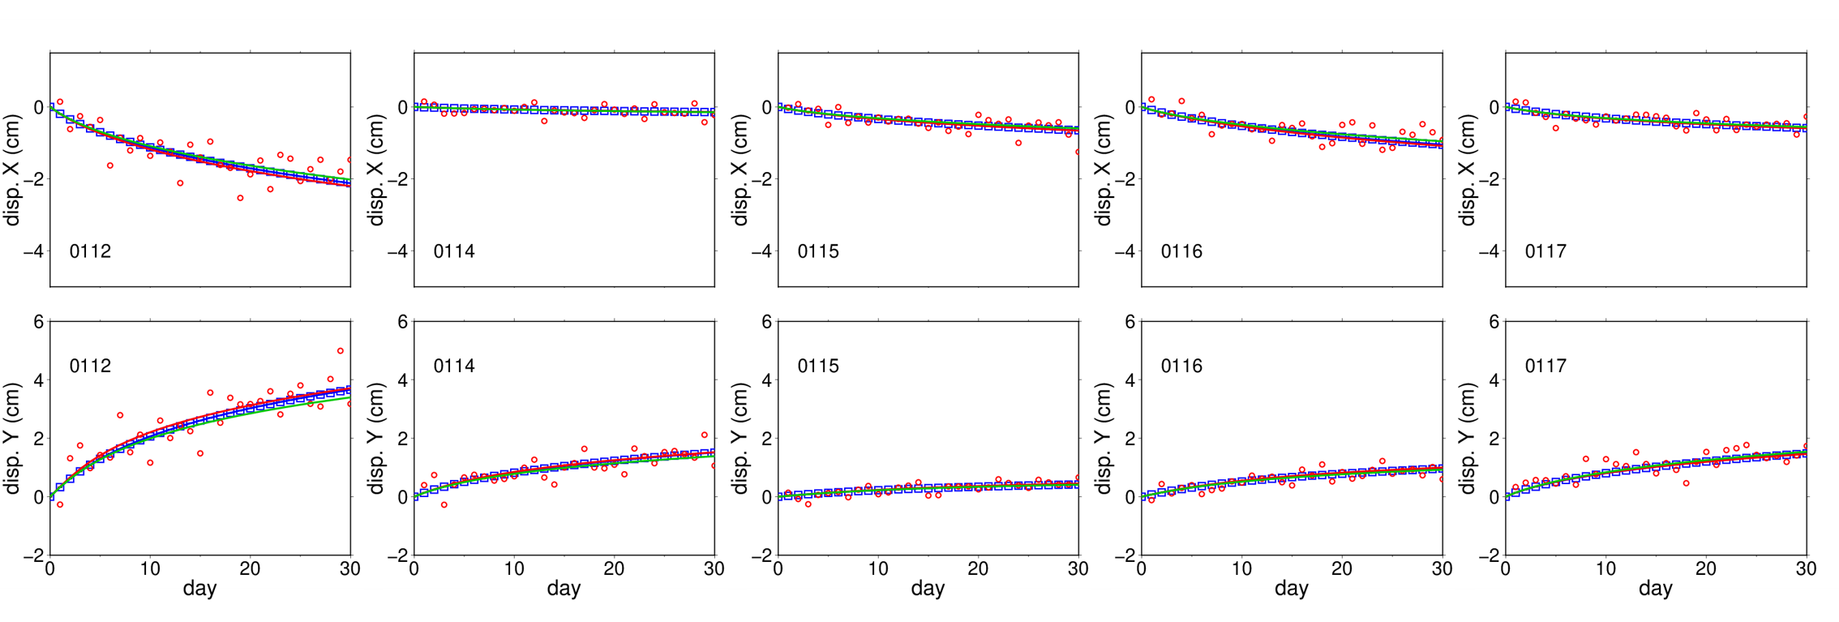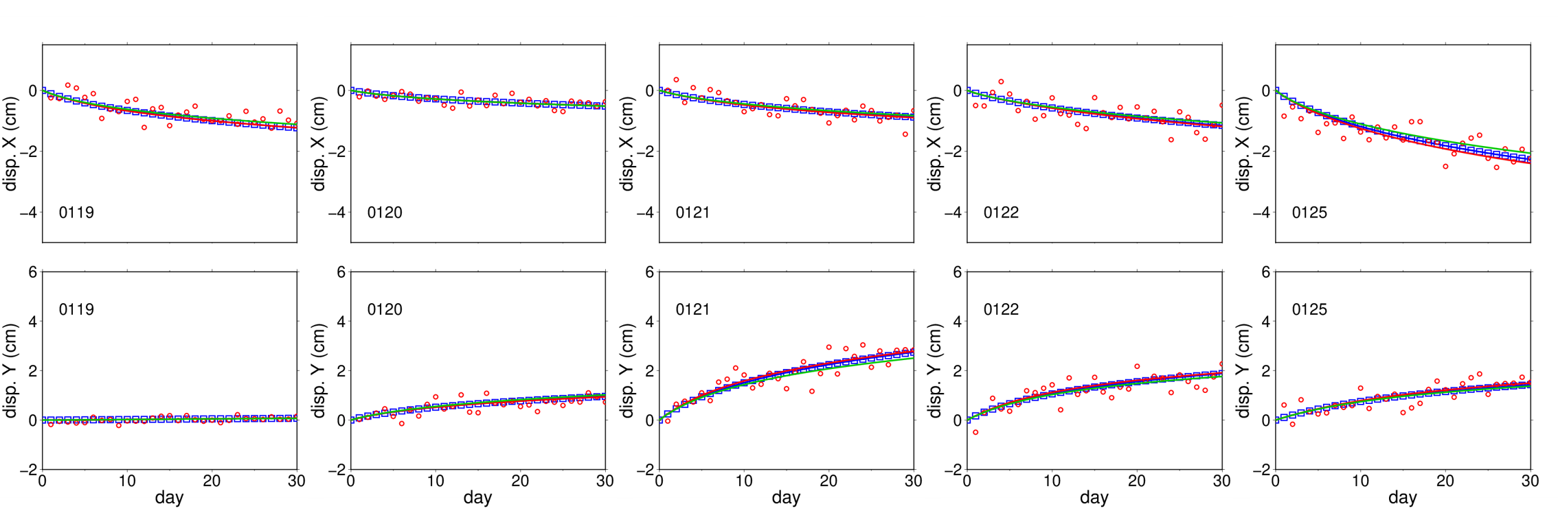
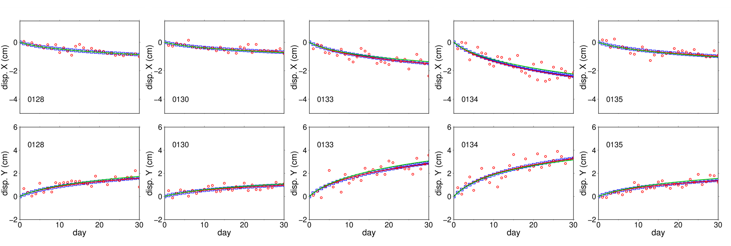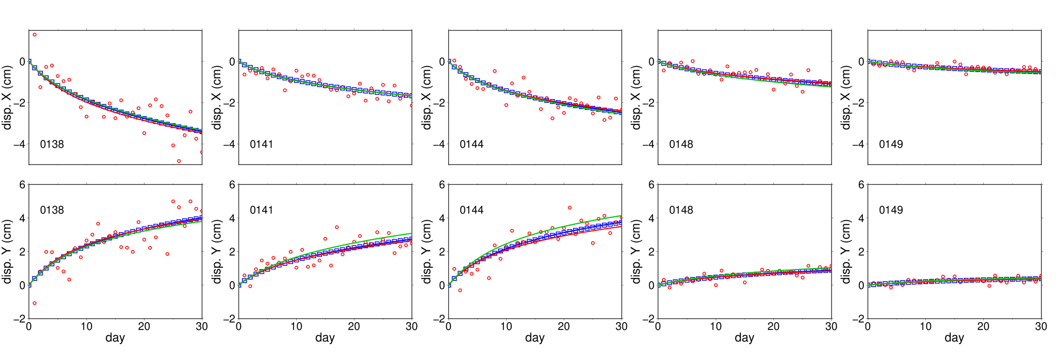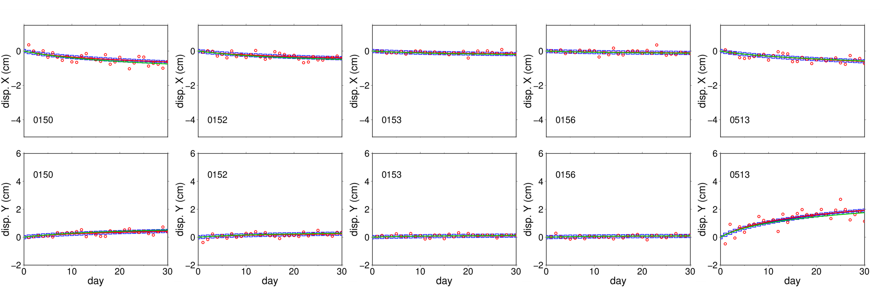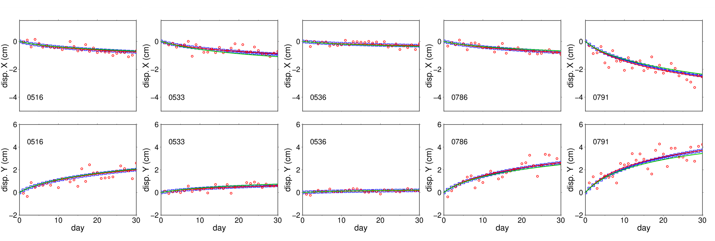

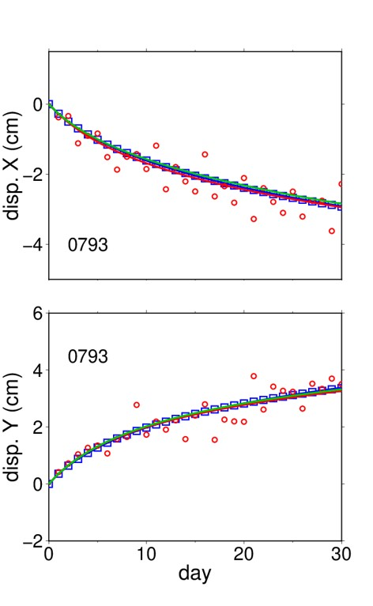
Figure S1: Postseismic time series at all stations in numerical experiments. The blue squares and red circles indicate the synthetic data in Exps. 1 and 2. The green, blue, and red lines are the theoretical time series calculated by using the first-guess and optimum frictional parameters in Exp. 1 and 2, respectively.

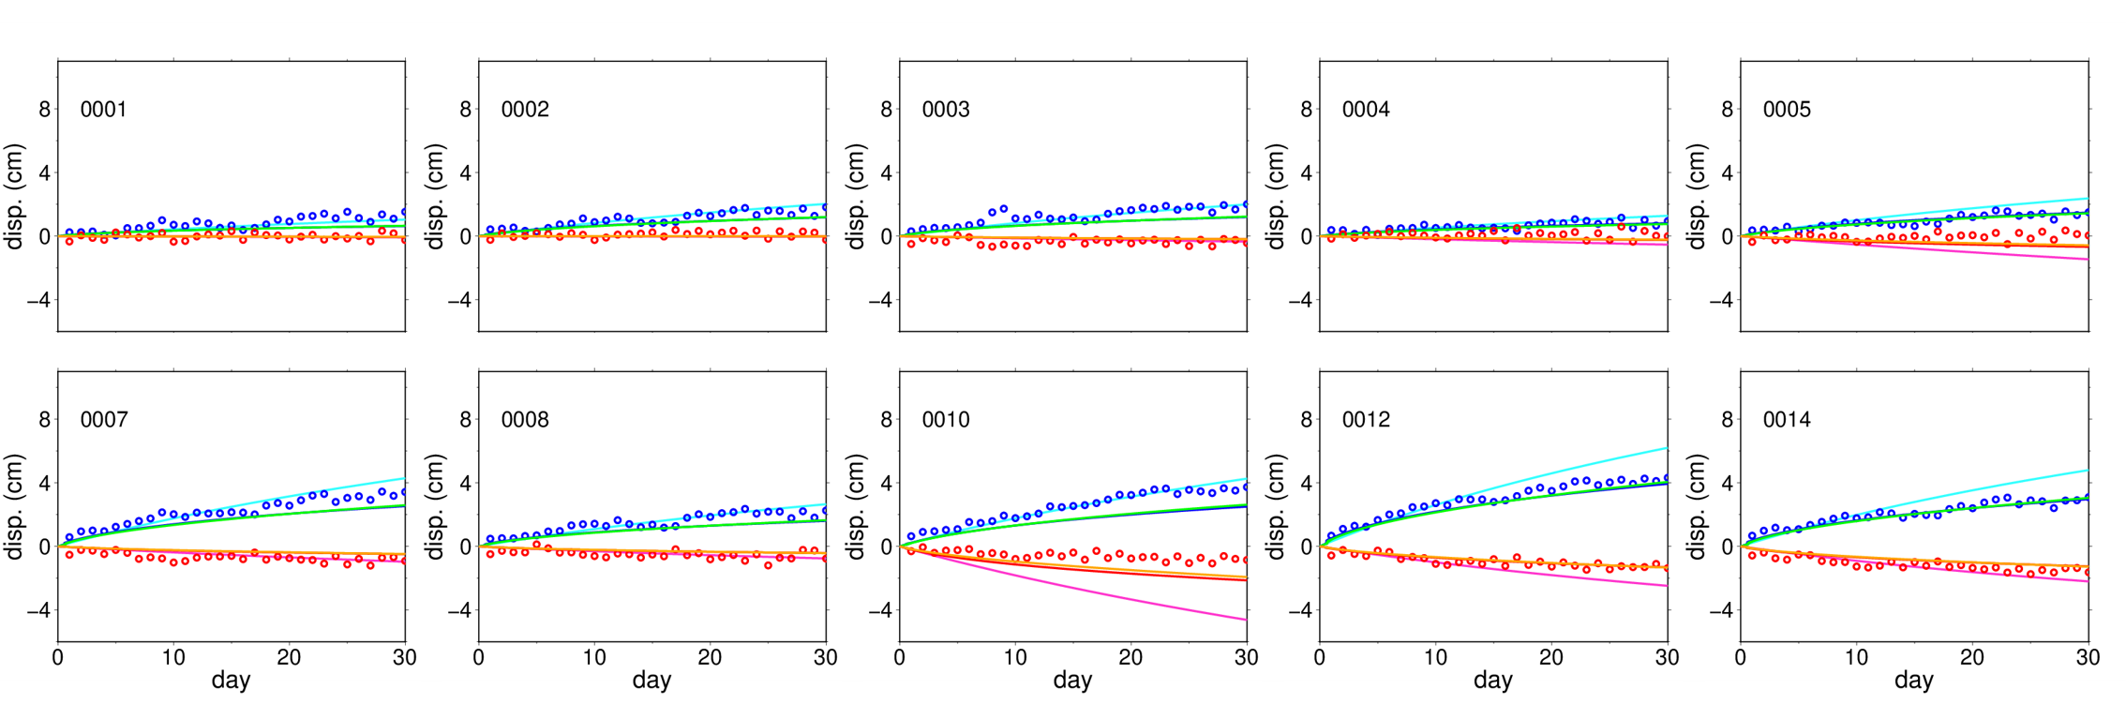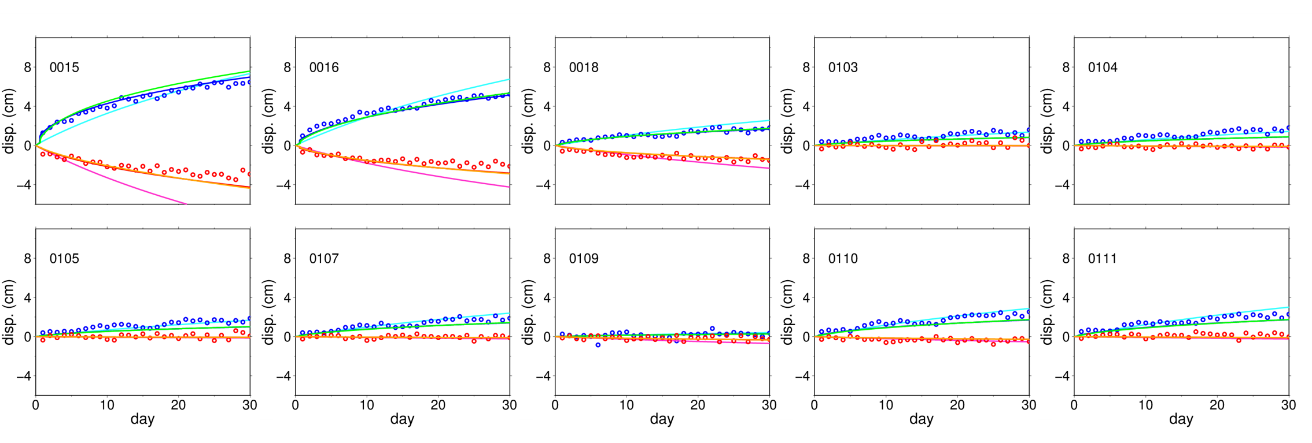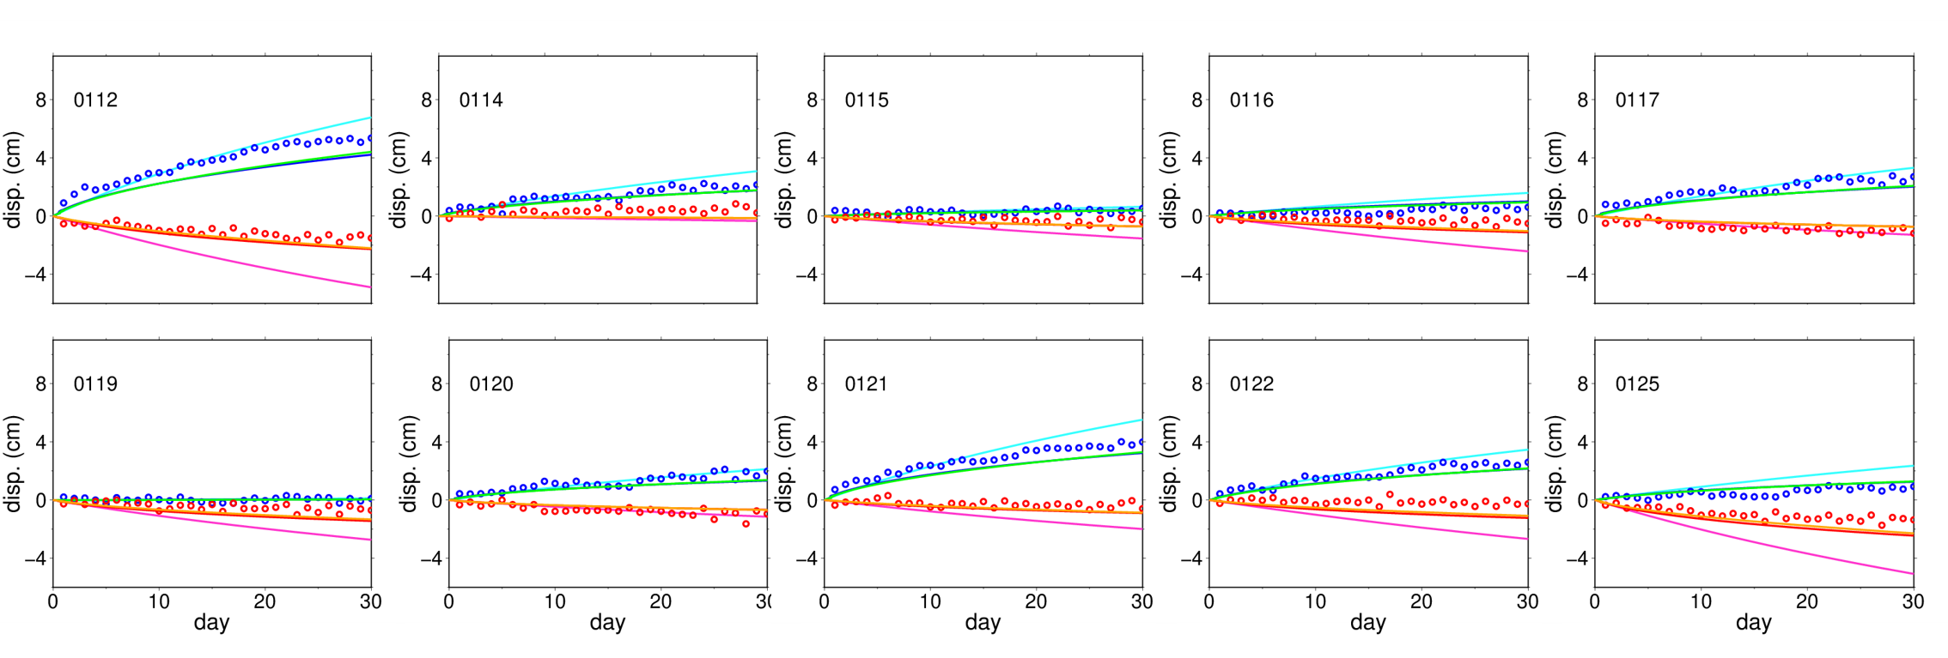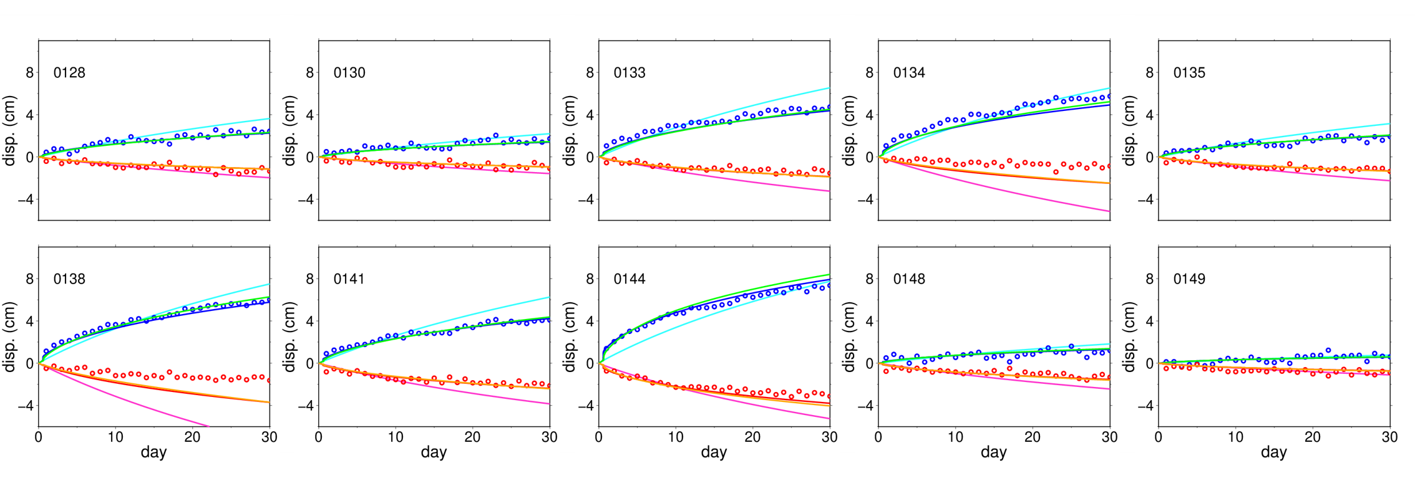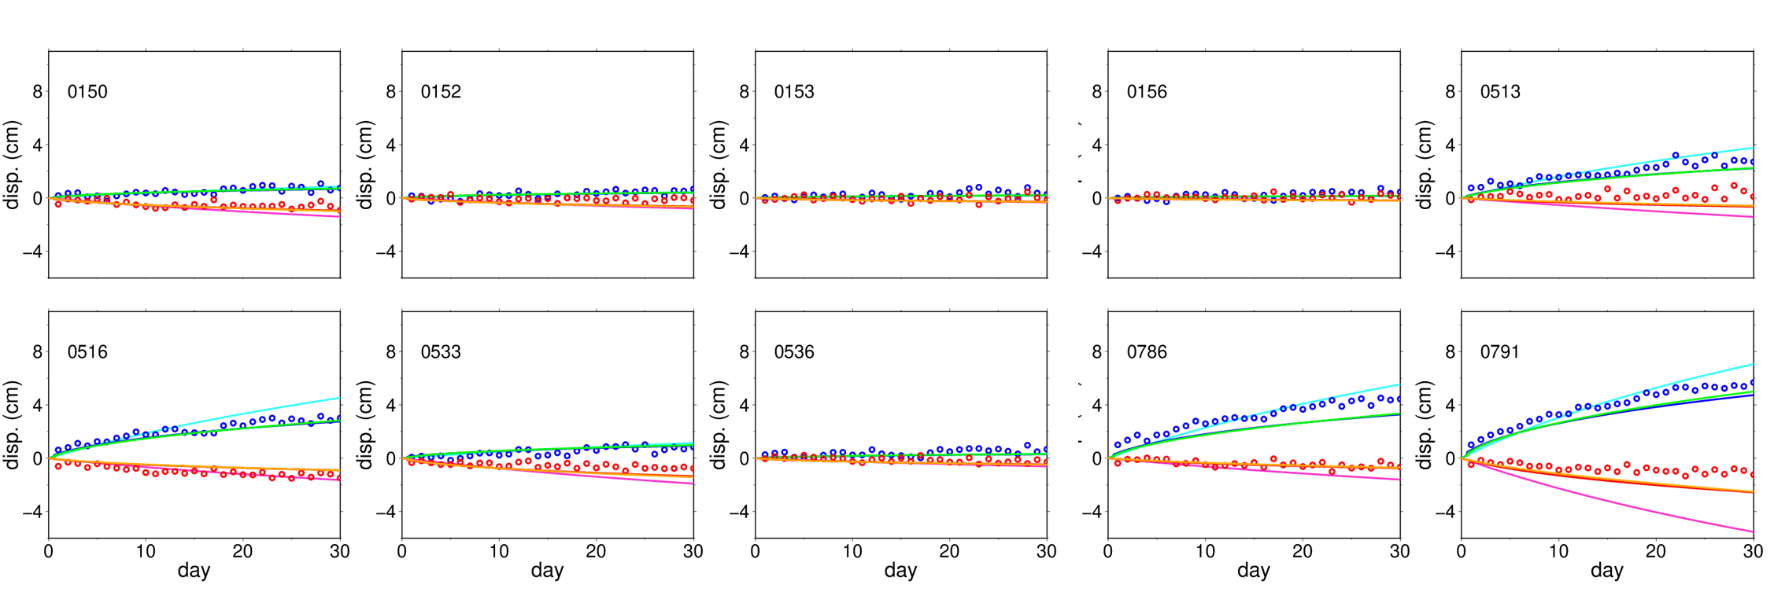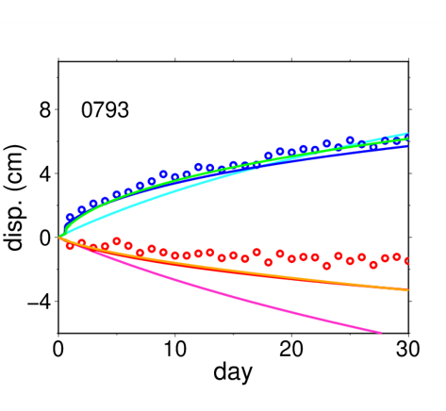
Figure S2: Postseismic time series at all stations in the application to real data. The red and blue circles indicate the GNSS time series in X and Y directions. The pink, red, and orange lines are the theoretical time series in the X direction calculated by using the first-guess values, the optimum values when only frictional parameters are optimized and the optimum values when frictional parameters and initial values are simultaneously optimized, respectively. The light blue, blue, and green lines indicate the corresponding theoretical time series in the Y direction.

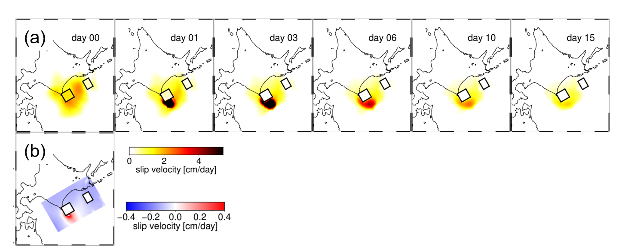
Figure S3: (a) Spatio-temporal evolution of slip velocities when the diagonal elements of error variance-covariance matrix for slip velocities are set to be the squared of the larger standard deviation of 1.0×10⁻⁷ m/s compared to the results shown in Fig. 10b. (b) Difference between the spatial distribution of the first-guess initial slip velocity and that of the optimized initial slip velocity.

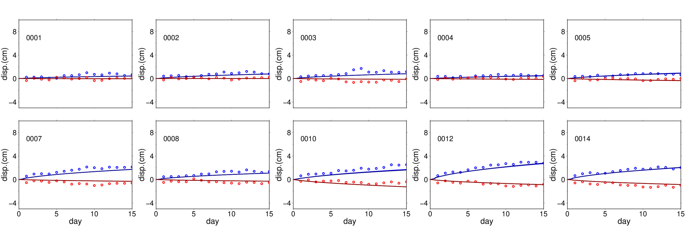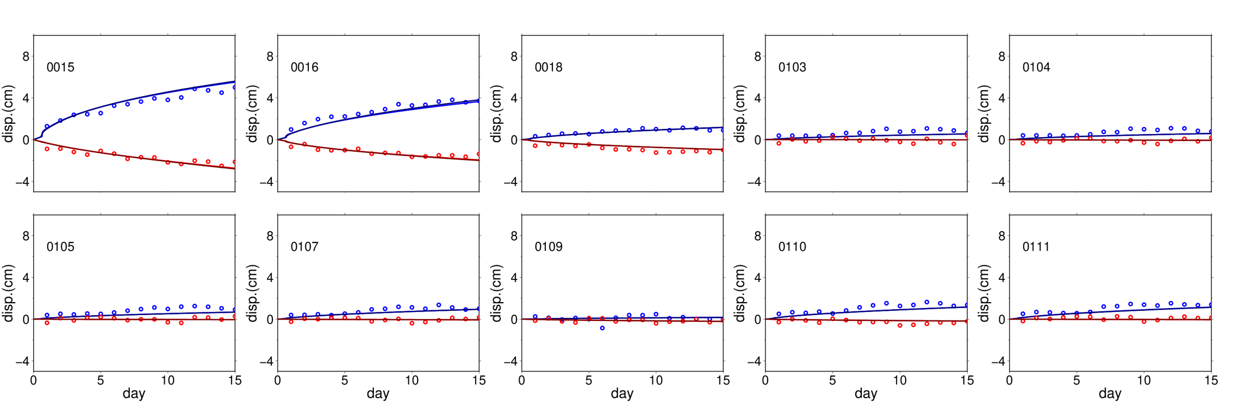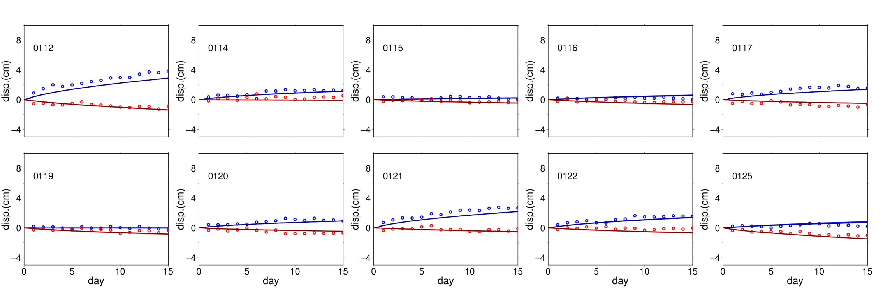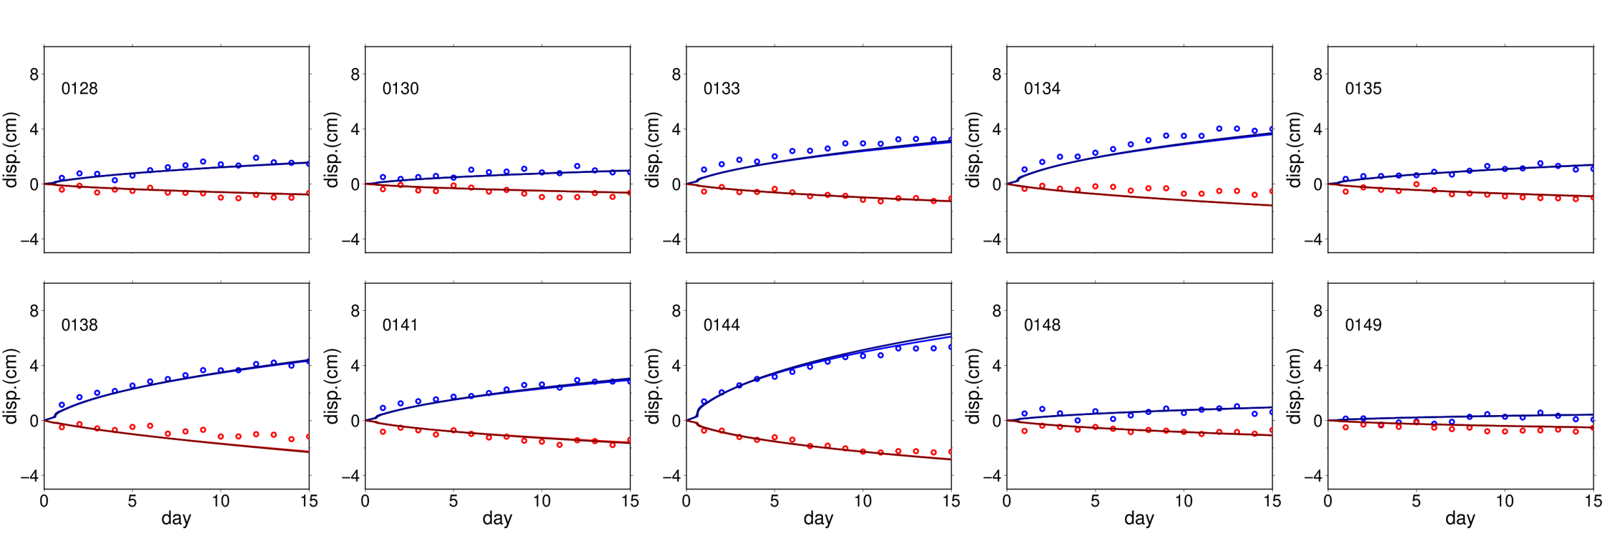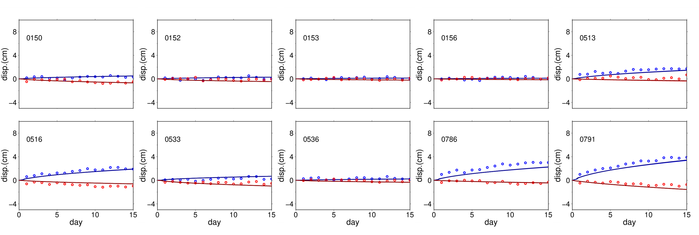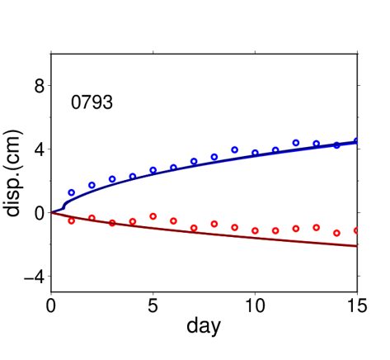
Figure S4: Postseismic time series at all stations when the diagonal elements of error variance-covariance matrix for slip velocities are set to be the squared of the larger standard deviation of 1.0×10⁻⁷ m/s compared to the results shown in Figure S2. The red and blue circles indicate the GNSS time series in X and Y directions. The red, and blue lines are the corresponding theoretical time series in X and Y directions calculated by using the optimum values.

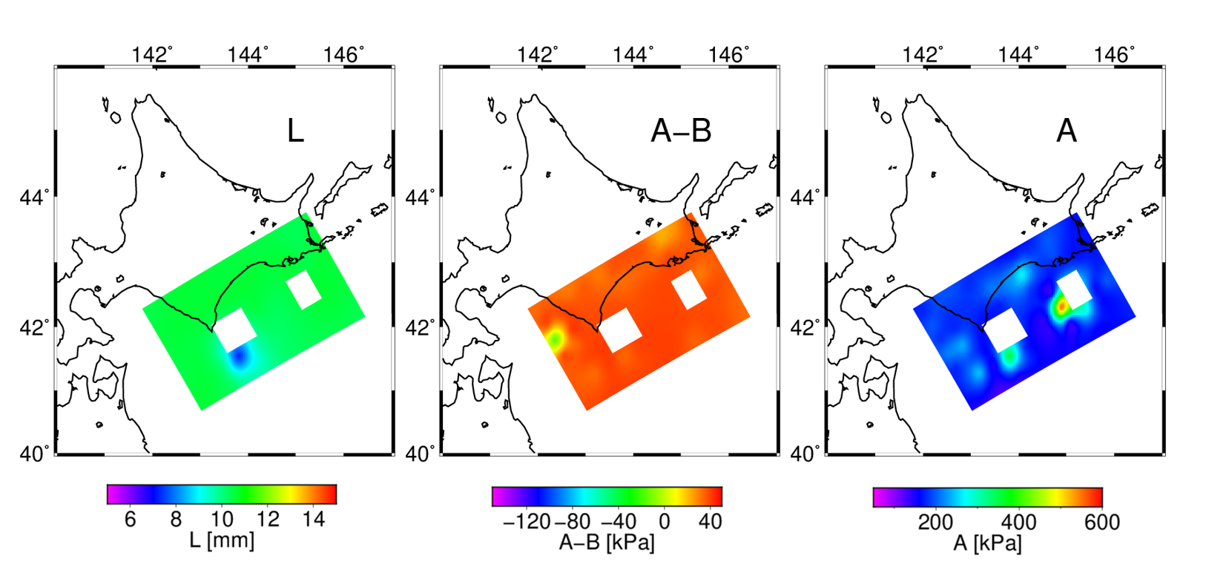
Figure S5: Spatial distribution of the optimized frictional parameters when the diagonal elements of error variance-covariance matrix for slip velocities are set to be the squared of the larger standard deviation of 1.0×10⁻⁷ m/s compared to the results shown in Fig. 9b.

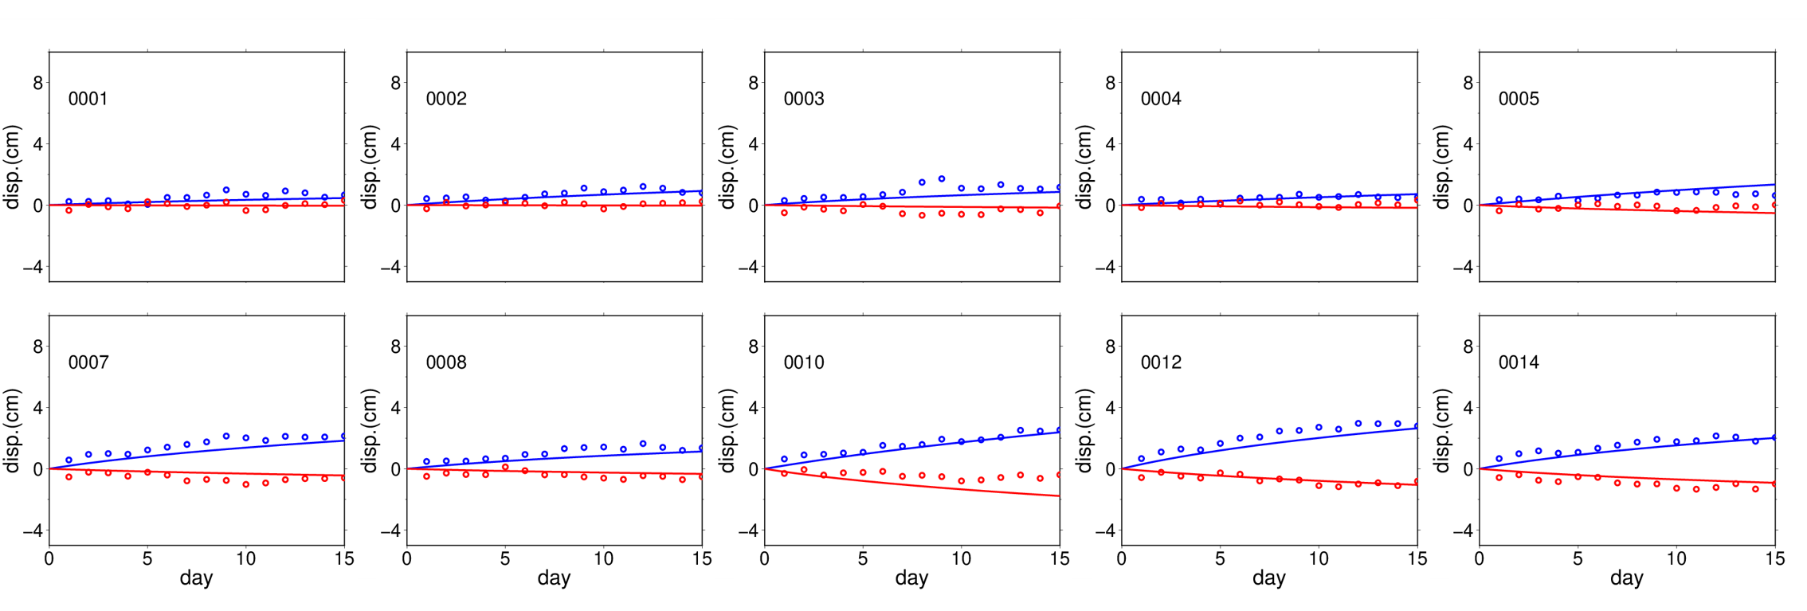
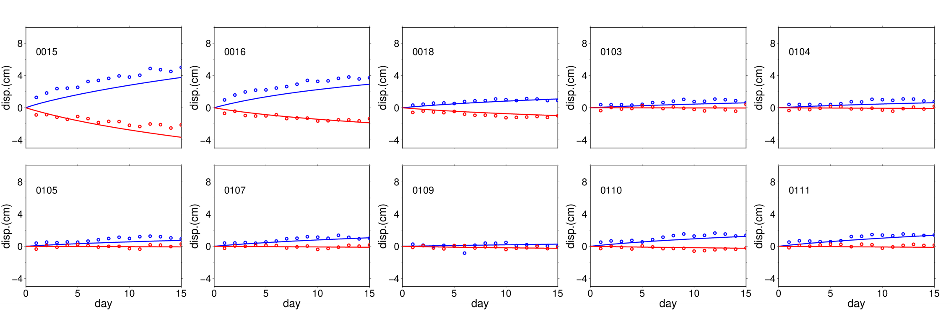
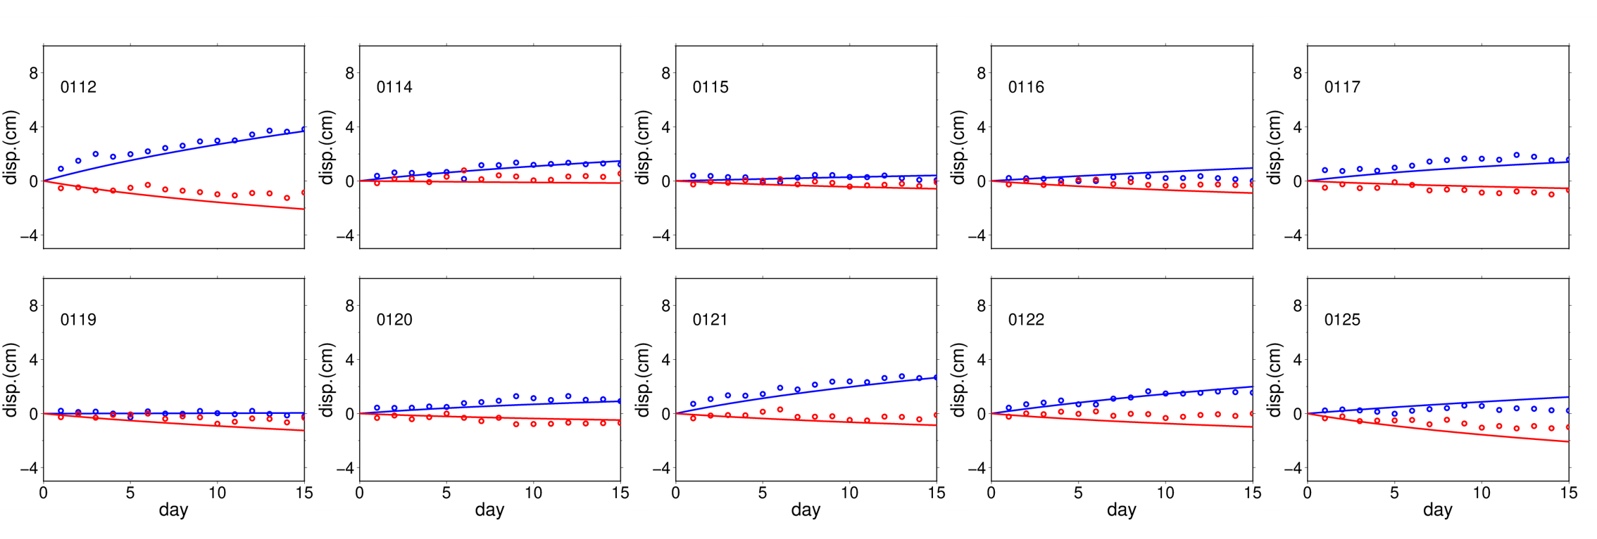
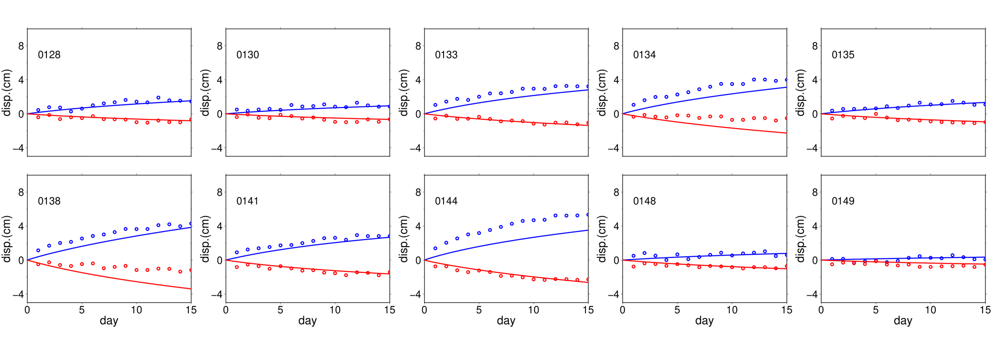
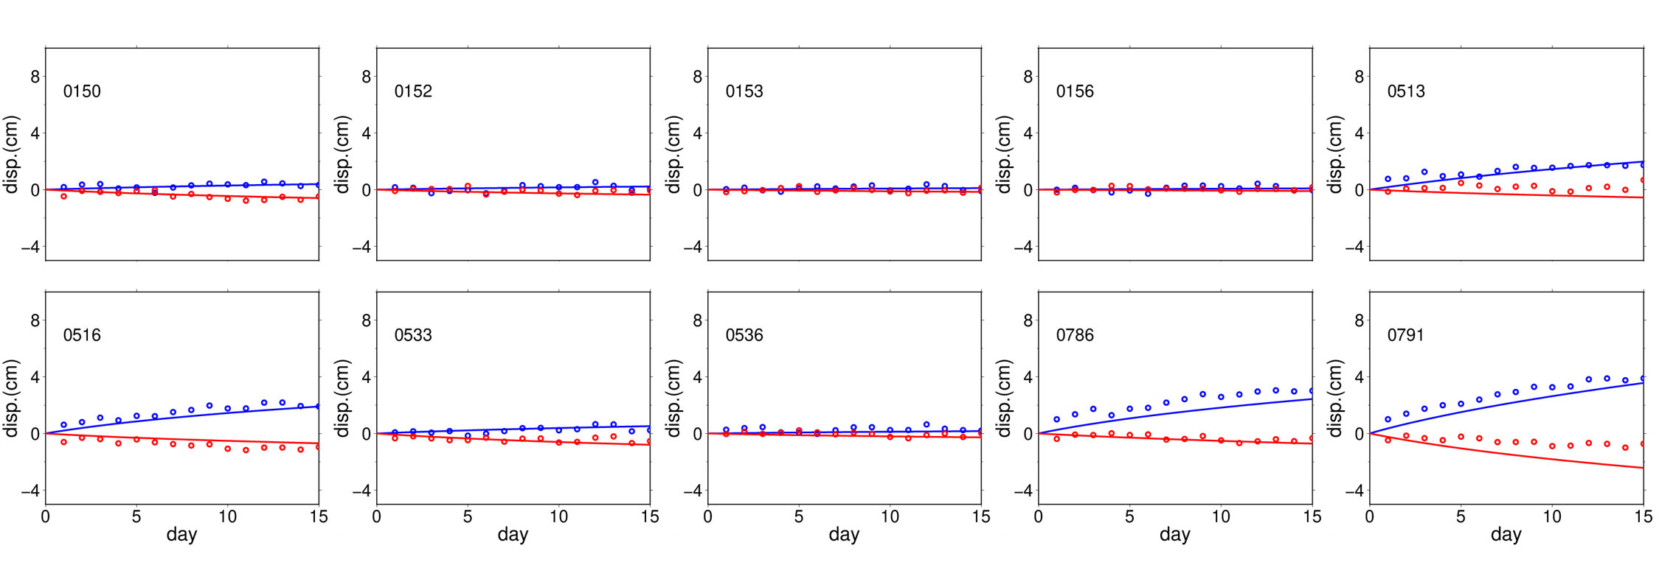
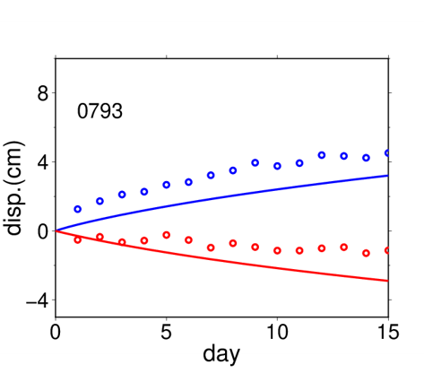
Figure S6: Postseismic time series at all stations. The red and blue circles indicate the GNSS time series in X and Y directions. The red and blue lines are the corresponding theoretical time series calculated by using the optimum values obtained in Kano et al. (2015).

