SUPPLEMENTARY DATA

Title of Paper: Calcifediol boosts the efficacy of ChAdOx1 nCoV-19 (COVISHIELD) vaccine via upregulation of key genes associated with memory T cell responses

¹Himanshu Singh Saroha MSc, ¹Swati Bhat MTech, ¹Liza Das DM, ¹Pinaki Dutta DM, ²Michael F. Holick PhD, ¹Naresh Sachdeva PhD#, ³Raman Kumar Marwaha DNB#
Departments of ¹Endocrinology, Post Graduate Institute of Medical Education and Research (PGIMER), Chandigarh 160012, India. ²Section on Endocrinology, Diabetes, Nutrition & Weight Management, Department of Medicine, School of Medicine, Boston University, Boston, MA, USA. ³Department of Endocrinology, International Life Sciences Institute (ILSI) and Society for Endocrine Health Care of Elderly, Adolescents and Children (SEHEAC), New Delhi, India.

PCA plot

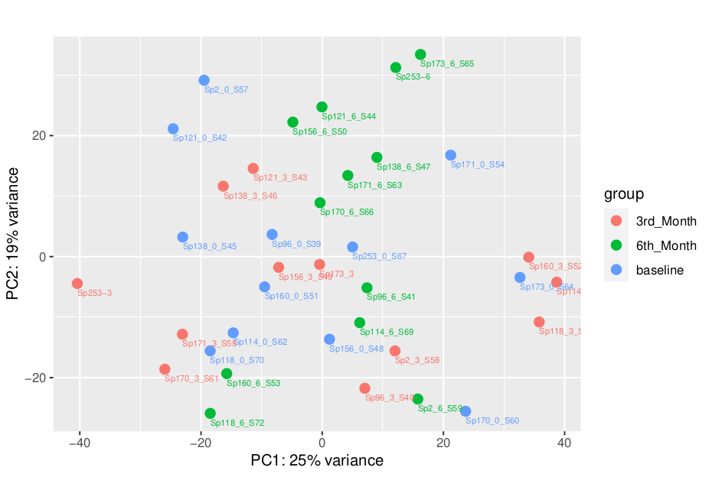
Supplementary Figure 1: Principal Component Analysis (PCA) of calcifediol supplemented (treated) cohorts where blue bubbles represent baseline; red bubbles represent 3rd month and green bubbles represent 6th month.

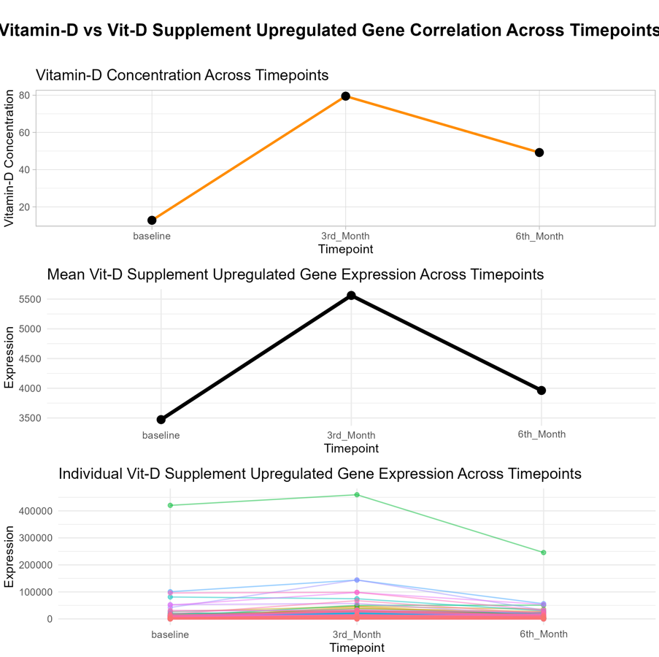

Supplementary Figure 2: Time series analysis showing the pattern of upregulation of genes related to vitamin D supplementation at baseline, 3rd and 6th month in relation to vitamin D concentration in the Calcifediol supplemented (treated) group.
Upregulated Pathways

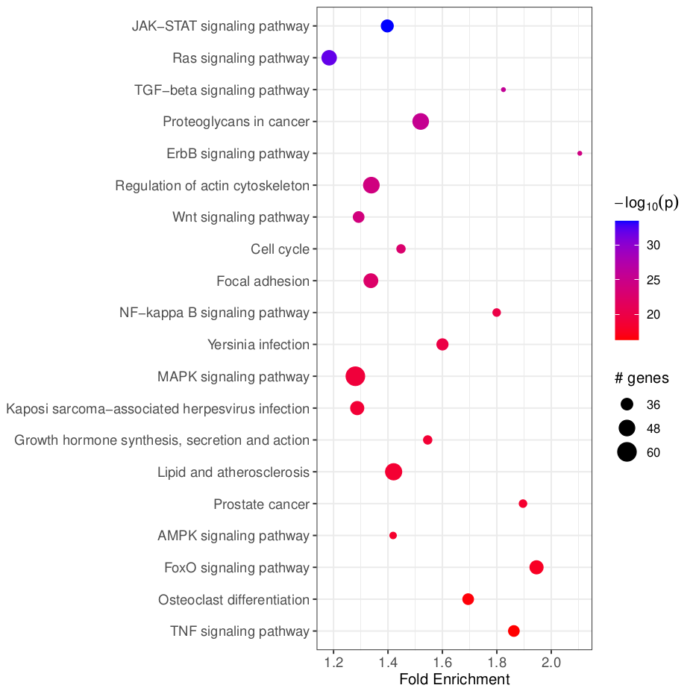

Supplementary Figure 3: Bubble plot showing KEGG analysis of upregulated pathways in calcifediol supplemented (treated) group at 6th month in comparison to baseline of the same group

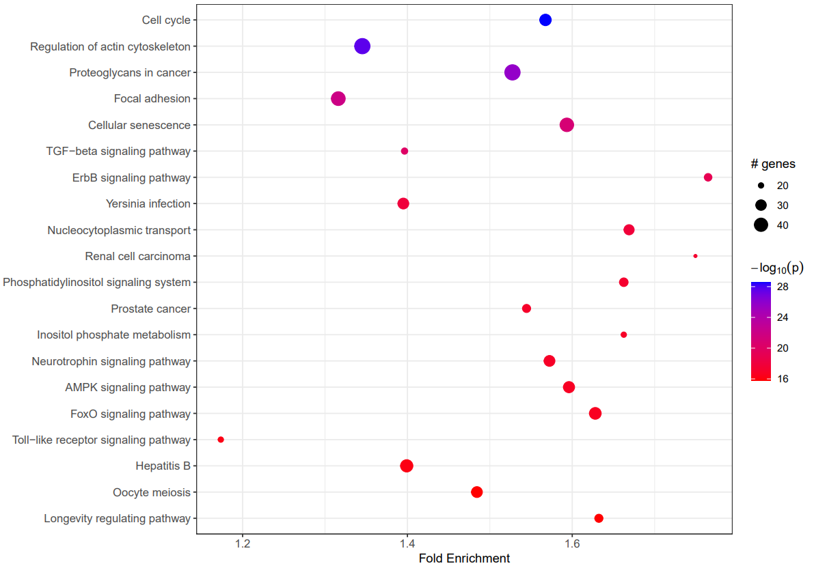
Supplementary Figure 4: Bubble plot showing KEGG analysis of upregulated pathways in calcifediol supplemented (treated) group at 6th month in comparison to 3rd month of the same group

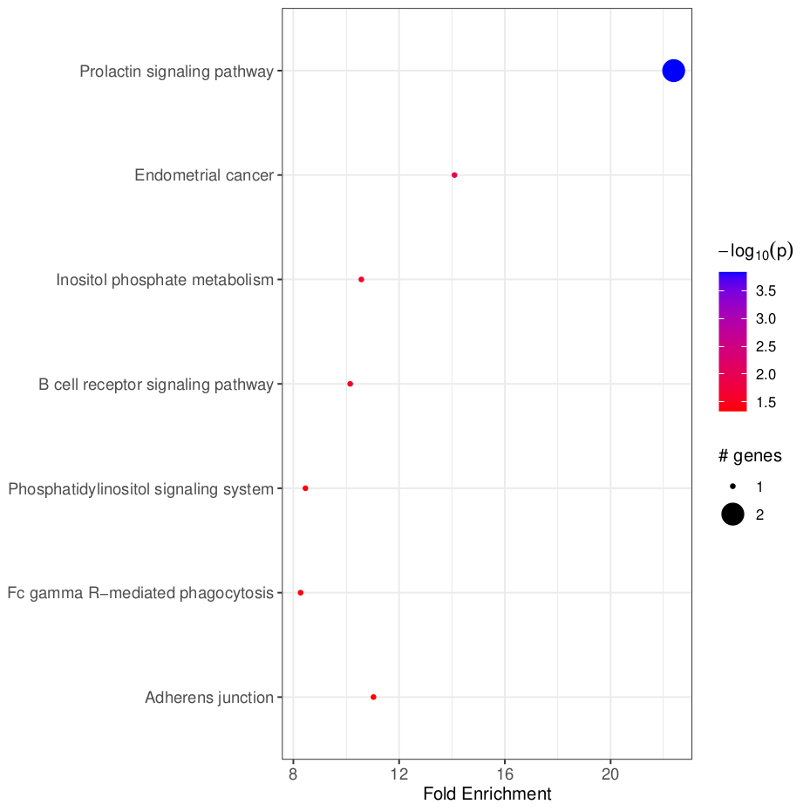
Supplementary Figure 5: Bubble plot showing KEGG analysis of upregulated pathways in the calcifediol supplemented (treated) group at 6th month in comparison to placebo group at 6th month.

Down Regulated Pathways

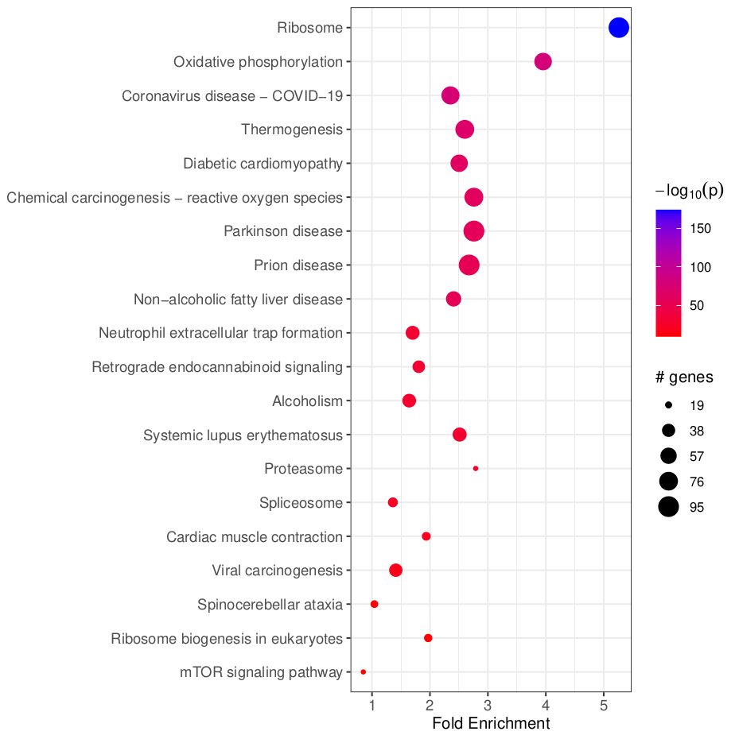

Supplementary Figure 6: Bubble plot showing KEGG analysis of downregulated pathways in calcifediol supplemented (treated) group at 6th month in comparison to baseline of the same group

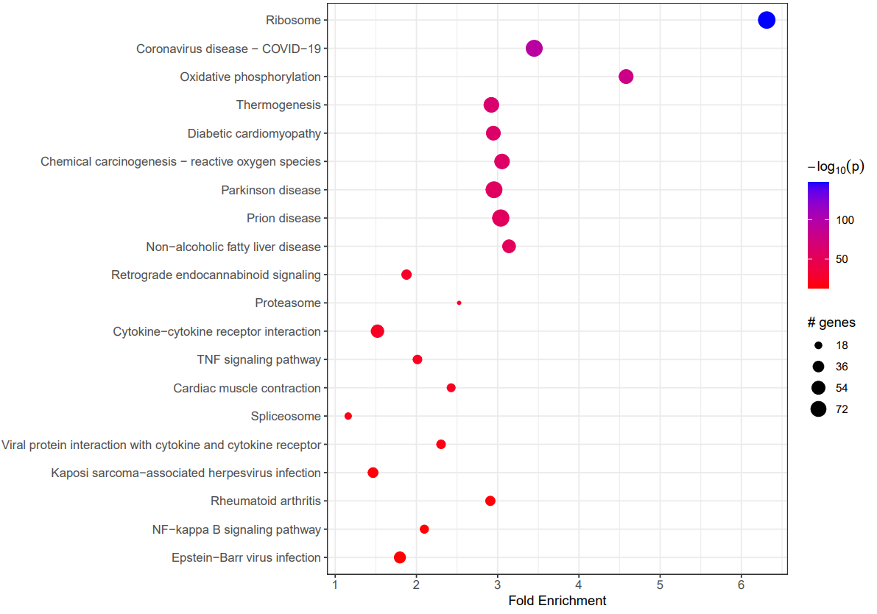
Supplementary Figure 7: Bubble plot showing KEGG analysis of downregulated pathways in calcifediol supplemented (treated) group at 6th month in comparison to 3rd month of the same group
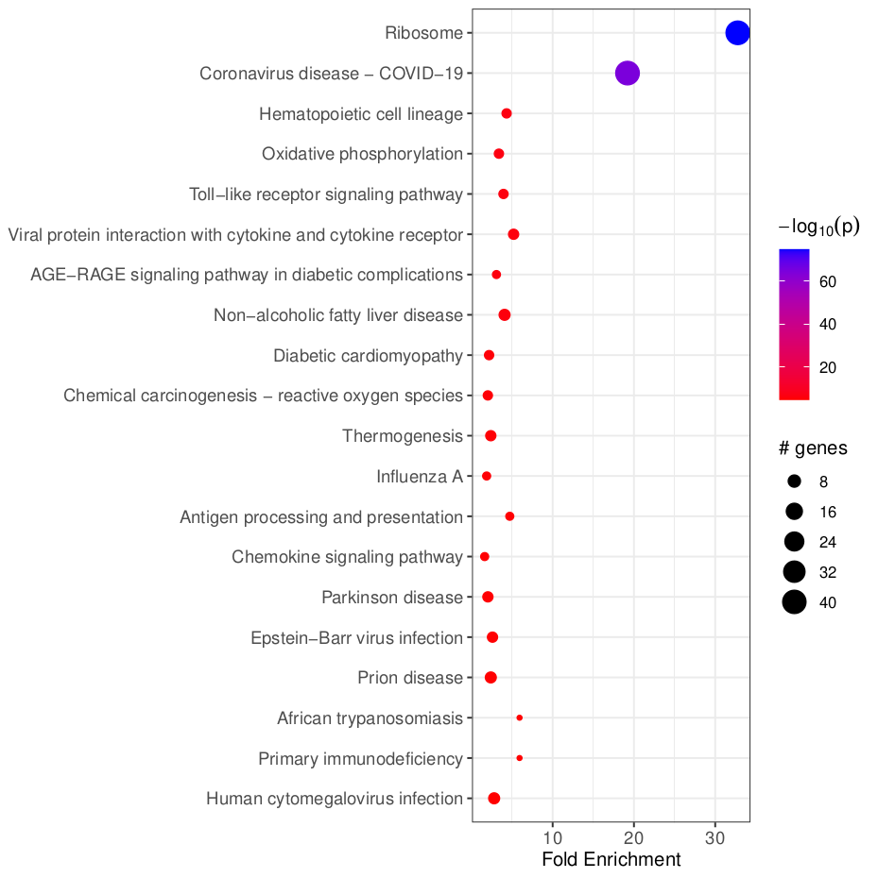
Supplementary Figure 8: Bubble plot showing KEGG analysis of downregulated pathways in the calcifediol supplemented (treated) group at 6th month in comparison to placebo group at 6th month.

Supplementary table 1: Complete List of Biological functions found differentially upregulated upon calcifediol supplementation (Treated 6 months versus Treated baseline).

Biological Process
protein deubiquitination
protein ubiquitination
cellular response to DNA damage stimulus
protein K63-linked deubiquitination
centriole replication
regulation of transcription by RNA polymerase II
chromatin remodeling
protein K48-linked deubiquitination
hippo signaling
regulation of small GTPase mediated signal transduction
ubiquitin-dependent protein catabolic process
peptidyl-serine phosphorylation
RNA splicing
COPII-coated vesicle cargo loading
regulation of DNA-templated transcription
protein autophosphorylation
regulation of cell cycle
double-strand break repair
alternative mRNA splicing, via spliceosome
miRNA processing
miRNA-mediated gene silencing by inhibition of translation
positive regulation of I-kappaB kinase/NF-kappaB signaling
clathrin coat assembly
protein localization to centrosome
protein polyubiquitination
proteasome-mediated ubiquitin-dependent protein catabolic process
mRNA export from nucleus
negative regulation of translation
regulation of alternative mRNA splicing, via spliceosome
mitotic spindle assembly
positive regulation of NF-kappaB transcription factor activity
BMP signaling pathway
intrinsic apoptotic signaling pathway
double-strand break repair via homologous recombination
DNA repair
regulation of signal transduction by p53 class mediator
intracellular signal transduction
RNA processing
microtubule cytoskeleton organization
regulation of circadian rhythm
post-transcriptional regulation of gene expression
ephrin receptor signaling pathway
nuclear pore complex assembly
SCF-dependent proteasomal ubiquitin-dependent protein catabolic process
histone H4 acetylation
cellular response to insulin stimulus
mRNA splice site selection
mRNA processing
circadian regulation of gene expression
regulation of mRNA stability
protein K11-linked deubiquitination
peptidyl-threonine phosphorylation
positive regulation of DNA-templated transcription, elongation
histone H3 acetylation
positive regulation of DNA repair
epidermal growth factor receptor signaling pathway
negative regulation of cilium assembly
cell migration
centrosome cycle
positive regulation of translation
centrosome duplication
endoplasmic reticulum to Golgi vesicle-mediated transport
positive regulation of double-strand break repair via homologous recombination
Golgi organization
positive regulation of transcription by RNA polymerase III
substrate adhesion-dependent cell spreading
response to ionizing radiation
phosphatidylinositol phosphate biosynthetic process
histone H2A acetylation
histone deacetylation
DNA duplex unwinding
mitotic cytokinesis
stress granule assembly
positive regulation of protein ubiquitination
protein acetylation
activation of GTPase activity
G1/S transition of mitotic cell cycle
positive regulation of nuclear-transcribed mRNA catabolic process, deadenylation-dependent decay
cytokine-mediated signaling pathway
mRNA transcription by RNA polymerase II
protein stabilization
DNA replication
mRNA splicing, via spliceosome
transcription initiation-coupled chromatin remodeling
RNA polymerase II preinitiation complex assembly
regulation of mRNA splicing, via spliceosome
retrograde transport, endosome to Golgi
mismatch repair
negative regulation of NF-kappaB transcription factor activity
phosphorylation
cellular response to ionizing radiation
insulin receptor signaling pathway
mRNA destabilization
protein K48-linked ubiquitination
protein K11-linked ubiquitination
protein localization to plasma membrane
intracellular estrogen receptor signaling pathway
nucleotide-excision repair
positive regulation of transcription initiation by RNA polymerase II
positive regulation of cytokinesis
actin cytoskeleton organization
regulation of cellular response to heat
histone H3 deacetylation
positive regulation of blood vessel endothelial cell migration
positive regulation of phosphatidylinositol 3-kinase signaling
positive regulation of nuclear-transcribed mRNA poly(A) tail shortening
protein sumoylation
positive regulation of extrinsic apoptotic signaling pathway
replication fork processing
mitotic G2 DNA damage checkpoint signaling
positive regulation of telomere maintenance via telomerase
cellular response to UV
positive regulation of canonical Wnt signaling pathway
protein autoubiquitination
localization
pre-miRNA processing
regulation of ventricular cardiac muscle cell action potential
positive regulation of microtubule polymerization
amyloid fibril formation
regulation of DNA replication
positive regulation of GTPase activity
positive regulation of interferon-alpha production
androgen receptor signaling pathway
negative regulation of gene expression
synaptic vesicle endocytosis
microvillus assembly
chromatin organization
positive regulation of glucose import
DNA replication initiation
insulin-like growth factor receptor signaling pathway
positive regulation of DNA-binding transcription factor activity
regulation of heart rate by cardiac conduction
mitotic spindle organization
intrinsic apoptotic signaling pathway in response to DNA damage by p53 class mediator
phosphatidylinositol 3-kinase signaling
cell adhesion
double-strand break repair via nonhomologous end joining
integrin-mediated signaling pathway
protein import into nucleus
positive regulation of mRNA catabolic process
negative regulation of proteasomal ubiquitin-dependent protein catabolic process
positive regulation of miRNA-mediated gene silencing
mitotic spindle assembly checkpoint signaling
negative regulation of anoikis
negative regulation of stress fiber assembly
negative regulation of viral genome replication
positive regulation of isotype switching
protein K63-linked ubiquitination
protein destabilization
positive regulation of lipid biosynthetic process
positive regulation of lamellipodium assembly
positive regulation of cytoplasmic translation
endoplasmic reticulum organization
autophagosome maturation
negative regulation of I-kappaB kinase/NF-kappaB signaling
interleukin-1-mediated signaling pathway
regulation of hematopoietic stem cell differentiation
telomere maintenance
mitotic cell cycle
positive regulation of transcription elongation by RNA polymerase II
cilium assembly
negative regulation of microtubule depolymerization
protein dephosphorylation
response to UV
clathrin-dependent endocytosis
MAPK cascade
positive regulation of miRNA transcription
stimulatory C-type lectin receptor signaling pathway
response to lipopolysaccharide
negative regulation of protein ubiquitination
cellular response to amino acid starvation
response to estrogen
regulation of embryonic development
cellular glucose homeostasis
ubiquitin-dependent ERAD pathway
regulation of DNA strand elongation
positive regulation of protein localization to plasma membrane
nuclear-transcribed mRNA catabolic process, nonsense-mediated decay
Golgi to endosome transport
cellular response to starvation
Notch signaling pathway
3'-UTR-mediated mRNA destabilization
transforming growth factor beta receptor signaling pathway
positive regulation of histone H3-K4 methylation
B cell receptor signaling pathway
regulation of mitotic cell cycle
cholesterol biosynthetic process
cellular response to gamma radiation
positive regulation of apoptotic process
positive regulation of SMAD protein signal transduction
cell adhesion mediated by integrin
ion transmembrane transport
transcription initiation at RNA polymerase II promoter
positive regulation of epithelial cell migration
regulation of chromosome organization
positive regulation of epithelial to mesenchymal transition
apoptotic process
cellular senescence
mitochondrion organization
negative regulation of cell growth
intracellular protein transport
protein-containing complex assembly
spliceosomal complex assembly
positive regulation of interferon-beta production
vascular endothelial growth factor receptor signaling pathway
positive regulation of angiogenesis
response to interleukin-1
positive regulation of protein kinase activity
maintenance of protein location in nucleus
post-Golgi vesicle-mediated transport
regulation of RNA splicing
negative regulation of canonical Wnt signaling pathway
peptidyl-tyrosine phosphorylation
cellular response to hypoxia
regulation of tubulin deacetylation
cytoskeleton organization
sister chromatid cohesion
positive regulation of mitotic cell cycle
monoubiquitinated histone H2A deubiquitination
positive regulation of RNA splicing
Ras protein signal transduction
positive regulation of double-strand break repair via nonhomologous end joining
SMAD protein signal transduction
cellular response to tumor necrosis factor
monoubiquitinated histone deubiquitination
protein localization to chromatin
positive regulation of peptidyl-serine phosphorylation
circadian rhythm
histone modification
peptidyl-tyrosine dephosphorylation
positive regulation of protein phosphorylation
positive regulation of rRNA processing
regulation of tumor necrosis factor-mediated signaling pathway
epithelial to mesenchymal transition
positive regulation of RIG-I signaling pathway
heterochromatin formation
lymphangiogenesis
centriole-centriole cohesion
vesicle-mediated transport
response to virus
positive regulation of bone mineralization
regulation of endocytosis
negative regulation of ubiquitin-protein transferase activity
positive regulation of protein binding
lysosome organization
regulation of glycolytic process
regulation of androgen receptor signaling pathway
regulation of epithelial to mesenchymal transition
positive regulation of filopodium assembly
cellular response to glucose starvation
macroautophagy
microtubule nucleation
establishment of protein localization
protein auto-ADP-ribosylation
mitochondrion morphogenesis
calcium ion transmembrane transport
mitotic metaphase plate congression
regulation of dendrite morphogenesis
negative regulation of double-strand break repair via homologous recombination
activation of innate immune response
positive regulation of T cell chemotaxis
nucleosome disassembly
transcription by RNA polymerase II
cellular response to glucocorticoid stimulus
DNA recombination
defense response to virus
negative regulation of translational initiation
regulation of innate immune response
bile acid biosynthetic process
chloride transmembrane transport
ribosome biogenesis
mitochondrial fission
regulation of microtubule cytoskeleton organization
exonucleolytic catabolism of deadenylated mRNA
positive regulation of T cell cytokine production
negative regulation of cell adhesion
negative regulation of mRNA splicing, via spliceosome
regulation of translation
nucleocytoplasmic transport
negative regulation of circadian rhythm
miRNA-mediated gene silencing
cellular response to exogenous dsRNA
base-excision repair
response to endoplasmic reticulum stress
negative regulation of intracellular estrogen receptor signaling pathway
positive regulation of NLRP3 inflammasome complex assembly
regulation of chromatin organization
ventricular septum morphogenesis
receptor internalization
positive regulation of G1/S transition of mitotic cell cycle
regulation of focal adhesion assembly
positive regulation of transforming growth factor beta receptor signaling pathway
establishment of endothelial intestinal barrier
negative regulation of type I interferon production
regulation of mitotic spindle assembly
regulation of autophagy of mitochondrion
primary miRNA processing
fat cell differentiation
cellular response to chemokine
positive regulation of erythrocyte differentiation
positive regulation of viral genome replication
positive regulation of pathway-restricted SMAD protein phosphorylation
CRD-mediated mRNA stabilization
regulation of Golgi organization
positive regulation of Wnt signaling pathway
cellular response to virus
positive regulation of NIK/NF-kappaB signaling
regulation of autophagy
positive regulation of JNK cascade
regulation of chromosome segregation
membrane protein ectodomain proteolysis
negative regulation of DNA replication
translesion synthesis
negative regulation of autophagy
protein deacetylation
positive regulation of cell migration
phosphatidylinositol dephosphorylation
nuclear-transcribed mRNA catabolic process
MyD88-dependent toll-like receptor signaling pathway
regulation of cytokinesis
long-chain fatty-acyl-CoA biosynthetic process
early endosome to late endosome transport
negative regulation of protein kinase activity
heart development
cellular response to estradiol stimulus
negative regulation of DNA-binding transcription factor activity
response to hypoxia
negative regulation of hippo signaling
cell-substrate adhesion
positive regulation by host of viral transcription
microtubule depolymerization
protein monoubiquitination
erythrocyte differentiation
DNA damage response, signal transduction by p53 class mediator
positive regulation of osteoblast differentiation
interleukin-6-mediated signaling pathway
membrane organization
activation of NF-kappaB-inducing kinase activity
replicative senescence
ERAD pathway
protein O-linked glycosylation
exocytosis
DNA damage checkpoint signaling
histone H4-K16 acetylation
T cell receptor signaling pathway
establishment or maintenance of cell polarity
regulation of cell population proliferation
regulation of cell growth
positive regulation of insulin receptor signaling pathway
peroxisome organization
regulation of stress fiber assembly
regulation of mitotic spindle organization
negative regulation of cysteine-type endopeptidase activity involved in apoptotic process
negative regulation of DNA damage response, signal transduction by p53 class mediator
spindle organization
positive regulation of autophagy
cell-matrix adhesion
positive regulation of transcription by RNA polymerase I
positive regulation of cysteine-type endopeptidase activity involved in apoptotic process
stress-activated MAPK cascade
establishment of epithelial cell apical/basal polarity
positive regulation of protein localization to nucleus
DNA synthesis involved in DNA repair
positive regulation of substrate adhesion-dependent cell spreading
negative regulation of cell cycle
protein modification process
cellular response to cholesterol
signal transduction in response to DNA damage
ion transport
peptidyl-threonine dephosphorylation
regulation of filopodium assembly
negative regulation of protein kinase B signaling
response to insulin
endoplasmic reticulum calcium ion homeostasis
miRNA-mediated gene silencing by mRNA destabilization
axon extension

Downregulated Biological processes

Supplementary table 2: Complete List of Biological functions found differentially downregulated upon calcifediol supplementation (Treated 6 months versus Treated baseline)

Biological_process
mitochondrial respiratory chain complex I assembly
cytoplasmic translation
rRNA processing
translation
mRNA splicing, via spliceosome
mitochondrial translation
ribosomal small subunit biogenesis
transcription by RNA polymerase II
tumor necrosis factor-mediated signaling pathway
protein N-linked glycosylation
ribosomal large subunit biogenesis
aerobic respiration
mitochondrion organization
interleukin-1-mediated signaling pathway
translational initiation
protein stabilization
protein targeting to mitochondrion
tail-anchored membrane protein insertion into ER membrane
nucleotide-excision repair
protein insertion into ER membrane by stop-transfer membrane-anchor sequence
positive regulation of NF-kappaB transcription factor activity
generation of precursor metabolites and energy
SCF-dependent proteasomal ubiquitin-dependent protein catabolic process
antigen processing and presentation of exogenous peptide antigen via MHC class II
positive regulation of DNA-binding transcription factor activity
endoplasmic reticulum to Golgi vesicle-mediated transport
positive regulation of protein phosphorylation
negative regulation of protein ubiquitination
positive regulation of NIK/NF-kappaB signaling
positive regulation of actin cytoskeleton reorganization
negative regulation of cell growth
positive regulation of mitochondrial fission
positive regulation of I-kappaB kinase/NF-kappaB signaling
release of cytochrome c from mitochondria
positive regulation of translation
extrinsic apoptotic signaling pathway via death domain receptors
RNA splicing
regulation of apoptotic process
regulation of mitochondrion organization
protein modification process
protein peptidyl-prolyl isomerization
positive regulation of protein-containing complex assembly
cell division
negative regulation of protein binding
proteolysis
antimicrobial humoral immune response mediated by antimicrobial peptide
spliceosomal tri-snRNP complex assembly
positive regulation of inflammatory response
response to oxidative stress
negative regulation of NF-kappaB transcription factor activity
positive regulation of ruffle assembly
defense response to Gram-positive bacterium
endocytic recycling
mitochondrial electron transport, NADH to ubiquinone
negative regulation of transcription elongation by RNA polymerase II
negative regulation of amyloid fibril formation
defense response to fungus
TOR signaling
protein insertion into mitochondrial inner membrane
negative regulation of protein kinase activity
positive regulation of intrinsic apoptotic signaling pathway
regulation of autophagy of mitochondrion
negative regulation of ubiquitin-dependent protein catabolic process
glycolytic process
positive regulation of leukocyte adhesion to vascular endothelial cell
ubiquitin-dependent ERAD pathway
protein folding
response to virus
mitochondrial fission
mitochondrial fusion
protein ubiquitination
phosphorylation
positive regulation of heterotypic cell-cell adhesion
Ras protein signal transduction
positive regulation of T cell mediated cytotoxicity
DNA repair
protein refolding
regulation of signal transduction by p53 class mediator
intracellular signal transduction
negative regulation of proteolysis
cellular response to oxidative stress
negative regulation of viral transcription
lysosome localization
negative regulation of phosphorylation
lipopolysaccharide-mediated signaling pathway
negative regulation of viral entry into host cell
killing of cells of another organism
cellular response to nerve growth factor stimulus
neutrophil chemotaxis
doxorubicin metabolic process
regulation of mitochondrial membrane potential
chaperone cofactor-dependent protein refolding
regulation of protein stability
chromatin remodeling
glutathione metabolic process
peptidyl-tyrosine phosphorylation
protein destabilization
negative regulation of endopeptidase activity
protein K63-linked ubiquitination
response to type II interferon
mitochondrial cytochrome c oxidase assembly
supramolecular fiber organization
macroautophagy
cellular senescence
regulation of G1/S transition of mitotic cell cycle
positive regulation of protein localization to plasma membrane
positive regulation by host of viral process
neuron apoptotic process
I-kappaB kinase/NF-kappaB signaling
cell surface receptor signaling pathway
peptidyl-serine dephosphorylation
endosome organization
mitophagy
spliceosomal snRNP assembly
positive regulation of p38MAPK cascade
regulation of cell cycle
regulation of DNA strand elongation
positive regulation of peptidyl-serine phosphorylation
protein localization to plasma membrane
antiviral innate immune response
positive regulation of cholesterol efflux
positive regulation of protein metabolic process
protein sumoylation
regulation of I-kappaB kinase/NF-kappaB signaling
negative regulation of release of cytochrome c from mitochondria
negative regulation of receptor signaling pathway via JAK-STAT
T cell chemotaxis
cellular calcium ion homeostasis
endosome to lysosome transport
regulation of chromosome organization
regulation of focal adhesion assembly
DNA damage response, signal transduction by p53 class mediator resulting in cell cycle arrest
regulation of macroautophagy
cellular response to tumor necrosis factor
positive regulation of protein localization to nucleus
response to interferon-beta
cellular response to lipopolysaccharide
positive regulation of fibroblast proliferation
cellular response to heat
histone H2A acetylation
establishment of skin barrier
positive regulation of DNA repair
regulation of circadian rhythm
MAPK cascade
negative regulation of extrinsic apoptotic signaling pathway
transmembrane receptor protein tyrosine kinase signaling pathway
T cell costimulation
positive regulation of smooth muscle cell proliferation
response to interferon-alpha
retrograde vesicle-mediated transport, Golgi to endoplasmic reticulum
regulation of mitochondrial membrane permeability
regulation of glycolytic process
defense response to Gram-negative bacterium
actin cytoskeleton organization
activation of cysteine-type endopeptidase activity involved in apoptotic process
antibacterial humoral response
positive regulation of T cell activation

Supplementary table 3: Assay ID and reporter dyes of the Taqman primers and probes used in the Gene Expression Analysis
GENE | ASSAY ID | REPORTER DYE
BCL6 | Hs00153368_m1 | FAM
EOMES | Hs00172872_m1 | FAM
ID3 | Hs00171409_m1 | FAM
IL7Rα | Hs00902334_m1 | FAM
18S | Hs03928985_g1 | FAM

