Supporting Information

Equations 1

List S1. 76 selected physicochemical properties from R library Peptides¹. 2
List S2. 8 selected physicochemical properties with DBAASP². 3
List S3. 33 selected physicochemical properties using Python package modlAMP³. 4

Figure S1. Correlations between 117 physicochemical properties (MDPs vs. MPPs). 6
Figure S2. Correlations between 117 physicochemical properties (MDPs vs. MPPs vs. PAPs). 7
Figure S3. Statistical pipeline (MDPs vs. MPPs). 8
Figure S4. Boxplots of 56 physicochemical properties. 12

Table S1. Significant physicochemical properties between 2 or 3 classes. 10
Table S2. Performances of binary classification algorithms under ROSE oversampling. 17
Table S3. Performances of binary classification algorithms under SMOTE oversampling. 18
Table S4. Performances of binary classification algorithms under ADASYN oversampling. 19
Table S5. Performances of ternary classification algorithms under ROSE oversampling. 20
Table S6. Performances of ternary classification algorithms under SMOTE oversampling. 21
Table S7. Performances of ternary classification algorithms under ADASYN oversampling. 22
Table S8. Feature importance scores of the 49 physicochemical properties used for
the predictive models 1.0-1.5. 23
Table S9. Feature importance scores of the 56 physicochemical properties used for
the predictive models 2.0-2.5. 25
Table S10. Performances of binary and ternary models based on different levels of
structure awareness. 27
Equations

$X = \frac{\left(x - x_{min}\right)}{\left(x_{max} - x_{min}\right)}$ (Eq.1)
$X_{validation} = \frac{\left(x_{val} - x_{min}\right)}{\left(x_{max} - x_{min}\right)}$ (Eq.2)

$Accuracy = \frac{TP + TN}{TP + TN + FP + FN}$ (Eq. 3)
$Precision or PPV = \frac{TP}{TP + FP}$ (Eq. 4)
$Recall or TPR or Sensitity = \frac{TP}{TP + FN}$ (Eq. 5)
$F1 = 2×\frac{Precision × Recall}{Precision + Recall}$ (Eq. 6)
$MCC = \frac{TP × TN - FP × FN}{\sqrt{ (TP + FP) × (TP +FN) × (TN + FP) × (TN +FN)}}$ (Eq. 7)
where true positive (TP) is the number of true membrane-disrupting peptides that are predicted correctly; true negative (TN) is the number of true membrane-penetrating peptides that are predicted correctly; false positive (FP) is the number of true membrane-disrupting peptides that are predicted to be membrane-penetrating peptides; true negative (TN) is the number of true membrane-penetrating peptides that are predicted to be membrane-disrupting peptides.

${Cohen's Kappa (CK)}_{} = \frac{P_{O} - P_{E}}{1 - P_{E} }$ (Eq. 8)
where P_{O} is the relative observed agreement among raters and P_{E} is the hypothetical probability of chance agreement.
$Specificity or TNR =\frac{TN}{TN + FP}$ ` (Eq. 9)

List S1. 76 selected physicochemical properties from R library Peptides¹.
aaComp, the amino-acid composition of a peptide sequence into 9 categories: Tiny (A + C + G + S + T), Small (A + B + C + D + G + N + P + S + T + V), Aliphatic (A + I + L + V), Aromatic (F + H + W + Y), Non-polar (A + C + F + G + I + L + M + P + V + W + Y), Polar (D + E + H + K + N + Q + R + S + T + Z), Charged (B + D + E + H + K + R + Z), Basic (H + K + R), and Acidic (B + D + E + Z).
boman, the Boman potential protein interaction index of a peptide sequence.
charge, the net charge of a peptide sequence based on the Henderson-Hasselbach equation.
hmoment, the hydrophobic moment of a peptide sequence proposed by Eisenberg⁴.
hydrophobicity, the GRAVY hydrophobicity index of a peptide sequence using each time one of the following 38 scales: "Aboderin", "AbrahamLeo", "Argos", "BlackMould", "BullBreese", "Casari", "Chothia", "Cid", "Cowan3.4", "Cowan7.5", "Eisenberg", "Engelman", "Fasman", "Fauchere", "Goldsack", "Guy", "HoppWoods", "Janin", "Jones", "Juretic", "Kidera", "Kuhn", "KyteDoolittle", "Levitt", "Manavalan", "Miyazawa", "Parker", "Ponnuswamy", "Prabhakaran", "Rao", "Rose", "Roseman", "Sweet", "Tanford", "Welling", "Wilson", "Wolfenden", "Zimmerman"
instaIndex, the instability of a peptide sequence.
lengthpep, the total length of a peptide sequence.
mw, the molecular weight [g/mol] of a peptide sequence.
pI, the isoelectric point of a peptide sequence.

Four properties derived from all the amino acids in the corresponding peptide sequence using factor analysis scale of generalized amino acid information (FASGAI)⁵:
F3: Bulky properties
F4: Compositional characteristic index
F5: Local flexibility
F6: Electronic properties (2)

Five properties derived from Z-scales based on the physicochemical properties of the AAs, including nuclear magnetic resonance spectroscopy and thin layer data chromatography data.
Z1: Lipophilicity
Z2: Steric properties (Steric bulk/Polarizability)
Z3: Electronic properties (1) (Polarity / Charge)
Z4 and Z5: They relate electronegativity, heat of formation, electrophilicity and hardness.
Two Cruciani⁶ properties calculated the interaction of each amino acid residue with several chemical groups, such as charged ions, methyl, hydroxyl groups:
PP2: Hydrophobicity (CP)
PP3: H-bonding

List S2. 8 selected physicochemical properties with DBAASP².
Amphiphilicity index, the amphiphilicity indices of each amino acid in a peptide sequence divided by the peptide length.
ASHR, angles subtended by the hydrophobic residues, measured using the helical wheel representation of the peptide sequence in the ideal α-helix approximation.
Disorder conformation propensity, capacity of a peptide to disorder in an aqueous media.
Linear moment, the linear moment of a peptide sequence.
In vitro aggregation: the ability of a peptide sequence to aggregate based on the physicochemical principles of β-sheet formation (TANGO).
Penetration depth, the distance between the geometrical center of the peptide and the membrane.
Propensity to PPII coil, refers to a coil structure with a degree of local order akin to the PPII helix, with short lengths interspersed with turns.
Tilt angle, orientation of the peptide sequence relative to the surface of a membrane.

List S3. 33 selected physicochemical properties using Python package modlAMP³.
Charge density, the charge density of a peptide sequence.
Instability Index, the instability of a peptide sequence based on the amino acid composition.
Aromaticity, the aromaticity of a peptide sequence.
Aliphatic index, the thermal stability based on the relative volume filled by aliphatic residues
Boman index, the Boman potential protein interaction index of a peptide sequence.
Hydrophobic ratio, the hydrophobic ratio of a peptide sequence.
AASI, an amino acid selectivity index scale for helical antimicrobial peptides⁷.
ABHPRK, features as Acidic, Basic, Hydrophobic, Polar, aRomatic, Kink-inducer.
Argos, compute hydrophobicity with the scale of Argos³.
Bulkiness, amino acid side chain bulkiness.
Charge phys, amino acid charge at pH 7.0 (histidine charge +0.1).
Charge acid, amino acid charge at acidic pH (histidine charge +1.0).
Cougar, selection of global peptide descriptors in modlAMP.
Eisenberg, the hydrophobicity of a peptide sequence proposed by Eisenberg⁴.
Ez, the potential that assesses energies of insertion of amino acid side chains into lipid bilayers.
Flexibility, amino acid side chain flexibility scale.
Grantham, amino acid side chain composition, polarity and molecular volume.
Gravy, the hydrophobicity of a peptide sequence using the GRAVY scale.
ISAECI, Isotropic Surface Area (ISA) and Electronic Charge Index (ECI) of amino acids⁸.
Janin, the hydrophobicity of a peptide sequence using the Janin scale.
Kyte Doolittle, the hydrophobicity of a peptide sequence using the Kyte Doolittle scale.
Hopp-Woods, the hydrophobicity of a peptide sequence using the Hopp-Woods scale.
Levitt alpha ^{c}, alpha-helix propensity using the Levitt scale.
MSS, a graph-theoretical index that reflects topological shape and size of AA side chains⁹.
MSW, the scale derived from the molecular surface based WHIM descriptor (MS-WHIM)¹⁰.
PEPCATS, pharmacophoric features based on PEPCATS scale.
Polarity, the polarity of a peptide sequence.
PPCALI, 143 amino acid properties derived from a PCA scale¹¹.
Refractivity, the refractivity index of a peptide sequence.
t scale, 6 different scales T1-T6 of the GRID program¹².
TM tend, amino acid transmembrane propensity scale¹³.
Z1-Z3, three amino acid scales interpreted as reflecting lipophilicity (z1), steric properties (z2), and electronic properties (z3)¹⁴.
Z4-Z5, two additional amino acid scales related to electronegativity, heat of formation, electrophilicity and hardness¹⁵.

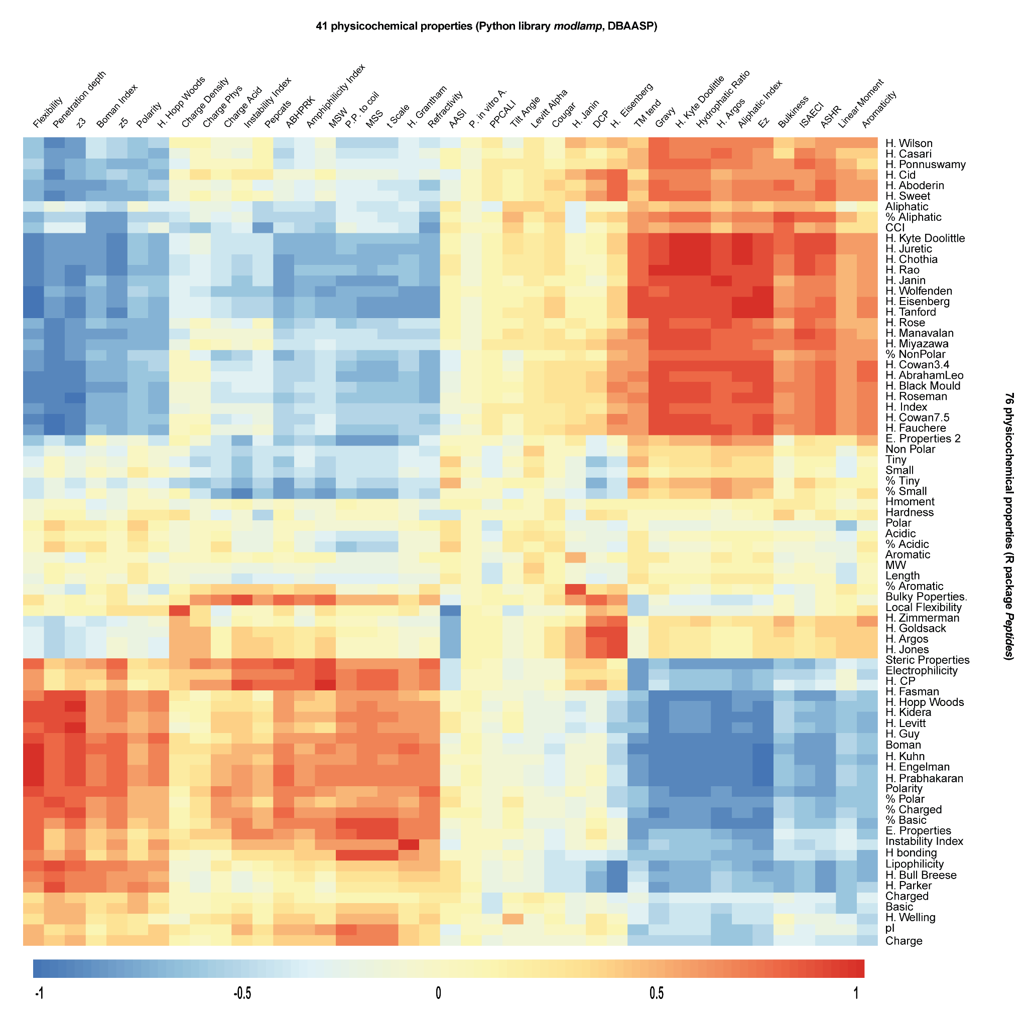
Figure S1 Correlations between 117 physicochemical properties from 749 sequences (MDPs vs. MPPs).

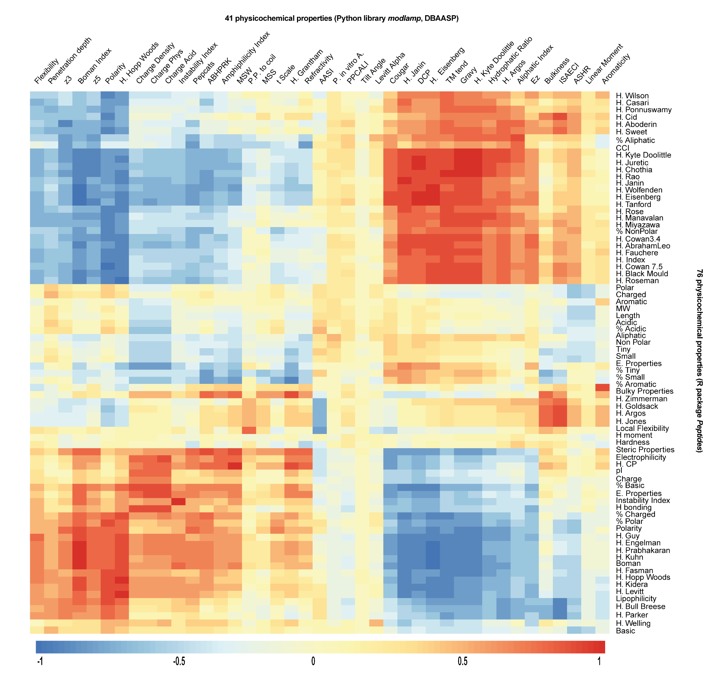
Figure S2 Correlations between 117 physicochemical properties from 1057 sequences (MDPs vs. MPPs vs. PAPs).

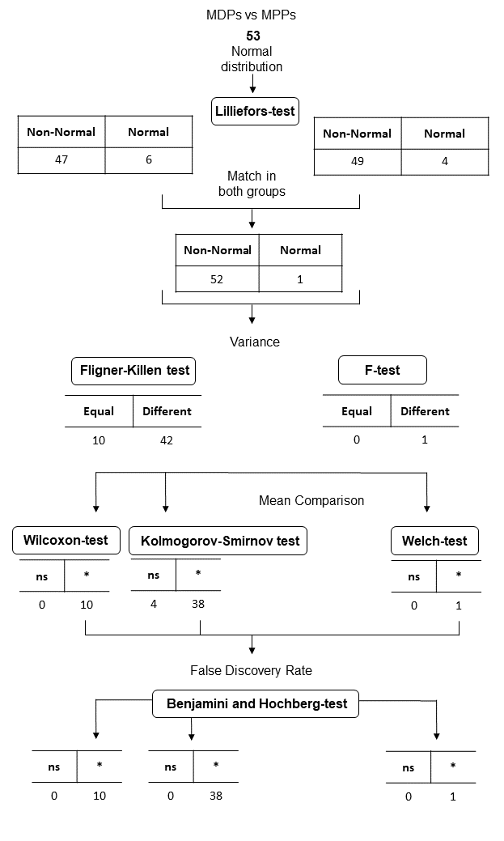
Figure S3. Statistical pipeline (MDPs vs. MPPs).
Table S1. Significant physicochemical properties between 2 or 3 classes.
Property | MDPs: MPPs |  | MAPs : PAPs
Property | Test | P-value | Test | P-value
1. H moment | Kolmogorov-Smirnov | 9.21E-06 | - | ns
2. H. Wilson | Wilcoxon | 2.57E-08 | - | ns
3. Aromatic | - | ns | Kolmogorov-Smirnov | 0
4. Basic | - | ns | Kolmogorov-Smirnov | 1.23E-09
5. % Aromatic | - | ns | Kolmogorov-Smirnov | 2.10E-05
6. % Charged | - | ns | Kolmogorov-Smirnov | 1.78E-07
7. Linear Moment | - | ns | Wilcoxon | 2.20E-14
8. H. Wolfenden | - | ns | Kolmogorov-Smirnov | 7.79E-12
9. H. Janin | - | ns | Kolmogorov-Smirnov | 2.62E-11
10. pI | - | ns | Kolmogorov-Smirnov | 0
11. H. Cid | - | ns | Kolmogorov-Smirnov | 8.43E-10
12. H. Jones | Kolmogorov-Smirnov | 0.00143 | Kolmogorov-Smirnov | 2.22E-16
13. H. Ponnuswamy | Kolmogorov-Smirnov | 0 | Kolmogorov-Smirnov | 7.55E-06
14. H. Welling | Kolmogorov-Smirnov | 2.45E-10 | Kolmogorov-Smirnov | 1.08E-06
15. H. Zimmerman | Kolmogorov-Smirnov | 1.60E-05 | Kolmogorov-Smirnov | 1.37E-10
16. Charge | Wilcoxon | 4.95E-08 | Kolmogorov-Smirnov | 0
17. MW | Wilcoxon | 9.06E-07 | Kolmogorov-Smirnov | 0
18. Aliphatic | Wilcoxon | 2.47E-27 | Kolmogorov-Smirnov | 0
19. Acidic | Kolmogorov-Smirnov | 5.03E-05 | Kolmogorov-Smirnov | 0
20. % Tiny | Kolmogorov-Smirnov | 0 | Kolmogorov-Smirnov | 1.20E-10
21. % Small | Kolmogorov-Smirnov | 2.44E-06 | Kolmogorov-Smirnov | 3.35E-09
22. % Aliphatic | Kolmogorov-Smirnov | 0 | Kolmogorov-Smirnov | 2.38E-06
23. % Polar | Kolmogorov-Smirnov | 2.57E-11 | Kolmogorov-Smirnov | 3.06E-10
24. % Acidic | Kolmogorov-Smirnov | 3.20E-05 | Kolmogorov-Smirnov | 0
25. Electronic Properties | Kolmogorov-Smirnov | 3.55E-08 | Kolmogorov-Smirnov | 1.44E-15
26. Electrophilicity | Kolmogorov-Smirnov | 0 | Kolmogorov-Smirnov | 0
27. Hardness | Kolmogorov-Smirnov | 1.98E-05 | Kolmogorov-Smirnov | 0.00107
28. Hydrogen bonding | Kolmogorov-Smirnov | 3.07E-08 | Kolmogorov-Smirnov | 0
ns = not significant.

Table S1 (suite). Significant physicochemical properties between 2 or 3 classes.
Property | MDPs: MPPs |  | MAPs : PAPs
Property | Test | P-value | Test | P-value
29. H. index | Kolmogorov-Smirnov | 0 | Kolmogorov-Smirnov | 6.71E-05
30. Bulky properties | Wilcoxon | 4.45E-15 | Kolmogorov-Smirnov | 1.22E-15
31. CCI | Wilcoxon | 2.25E-15 | Kolmogorov-Smirnov | 1.98E-05
32. Local flexibility | Kolmogorov-Smirnov | 1.95E-07 | Kolmogorov-Smirnov | 4.33E-12
33. E. Properties 2 | Kolmogorov-Smirnov | 4.44E-16 | Kolmogorov-Smirnov | 0
34. Penetration depth | Wilcoxon | 5.42E-16 | Wilcoxon | 7.48E-07
35. P. in vitro A. | Kolmogorov-Smirnov | 0 | Kolmogorov-Smirnov | 0
36. ASHR | Kolmogorov-Smirnov | 0.000238 | Kolmogorov-Smirnov | 0
37. Amphiphilicity | Kolmogorov-Smirnov | 0 | Kolmogorov-Smirnov | 2.22E-16
38. P. to P. coil | Kolmogorov-Smirnov | 1.15E-09 | Kolmogorov-Smirnov | 1.91E-10
39. Charge Density | Kolmogorov-Smirnov | 0 | Kolmogorov-Smirnov | 0
40. Instability Index | Kolmogorov-Smirnov | 0 | Kolmogorov-Smirnov | 4.96E-08
41. Aromaticity | Kolmogorov-Smirnov | 0.00159 | Kolmogorov-Smirnov | 0.000586
42. Hydrophatic Ratio | Kolmogorov-Smirnov | 0 | Kolmogorov-Smirnov | 4.51E-07
43. AASI | Kolmogorov-Smirnov | 5.96E-06 | Kolmogorov-Smirnov | 6.58E-14
44. ABHPRK | Kolmogorov-Smirnov | 0 | Kolmogorov-Smirnov | 6.28E-07
45. H. Argos | Kolmogorov-Smirnov | 0 | Kolmogorov-Smirnov | 1.33E-05
46. Bulkiness | Kolmogorov-Smirnov | 1.42E-06 | Kolmogorov-Smirnov | 2.88E-07
47. Cougar | Kolmogorov-Smirnov | 0 | Kolmogorov-Smirnov | 0
48. Ez | Kolmogorov-Smirnov | 6.49E-10 | Kolmogorov-Smirnov | 1.08E-14
49. Flexibility | Kolmogorov-Smirnov | 0 | Kolmogorov-Smirnov | 4.63E-09
50. Levitt Alpha | Kolmogorov-Smirnov | 2.22E-08 | Kolmogorov-Smirnov | 3.38E-11
51. MSS | Wilcoxon | 1.08E-09 | Kolmogorov-Smirnov | 1.27E-09
52. PEPCATS | Kolmogorov-Smirnov | 0 | Kolmogorov-Smirnov | 1.24E-05
53. PPCALI | Kolmogorov-Smirnov | 2.18E-10 | Kolmogorov-Smirnov | 2.33E-15
54. Refractivity | Wilcoxon | 4.04E-12 | Kolmogorov-Smirnov | 4.44E-16
55. t Scale | Kolmogorov-Smirnov | 0.000262 | Kolmogorov-Smirnov | 2.07E-11
56. z3 | Welch | 5.80E-25 | Kolmogorov-Smirnov | 7.23E-10

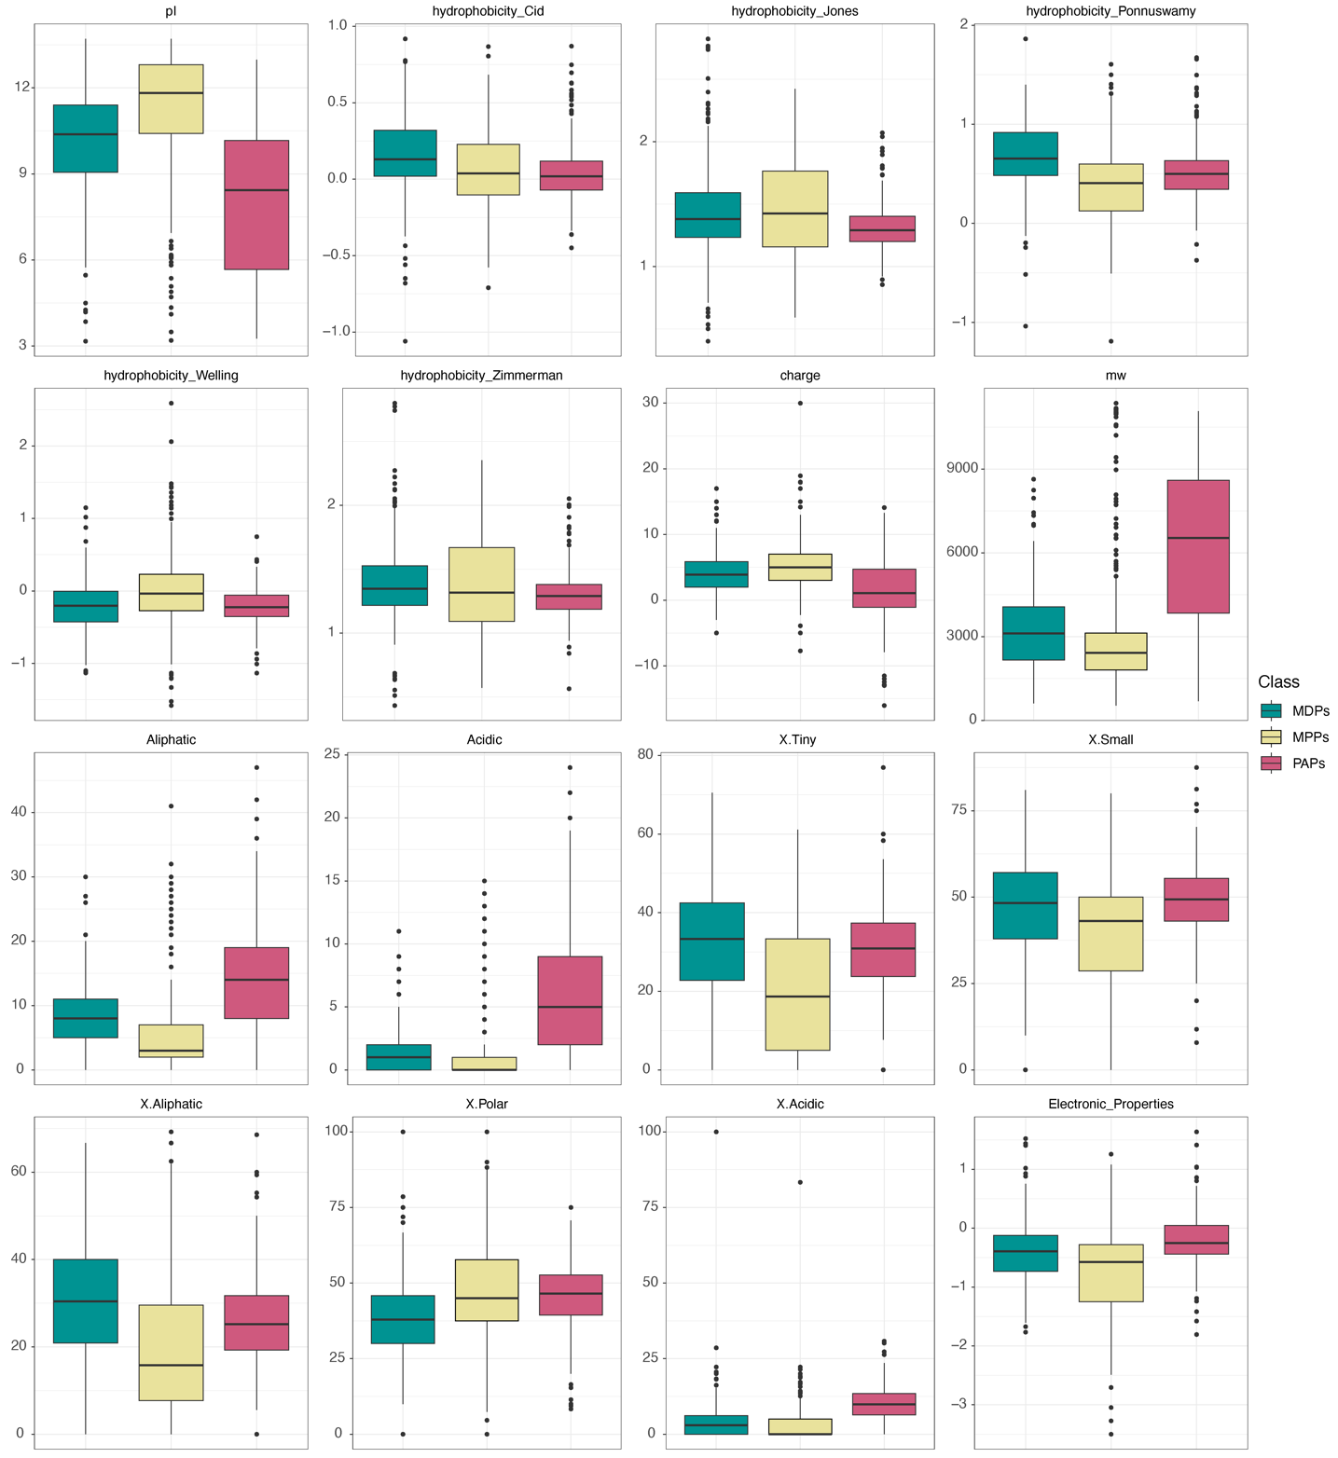
Figure S4 Boxplots of 56 physicochemical properties (1-16).
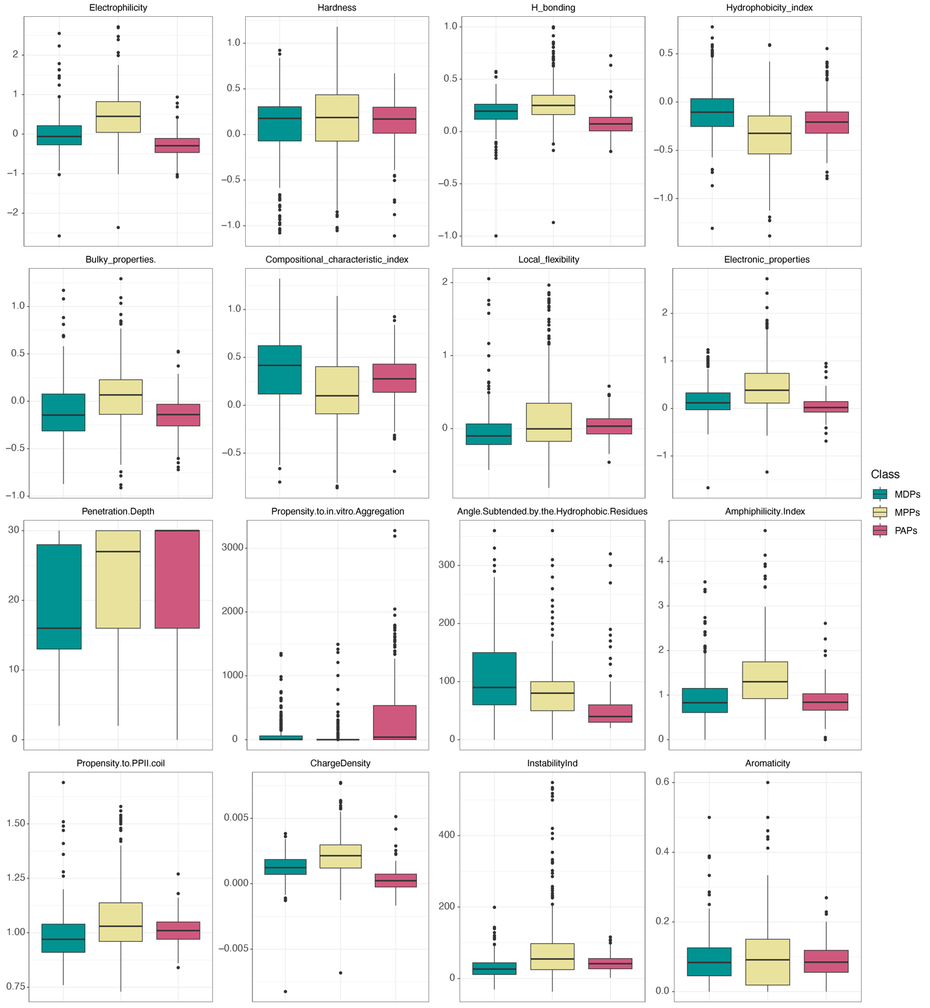
Figure S4 (suite) Boxplots of 56 physicochemical properties (17-32).

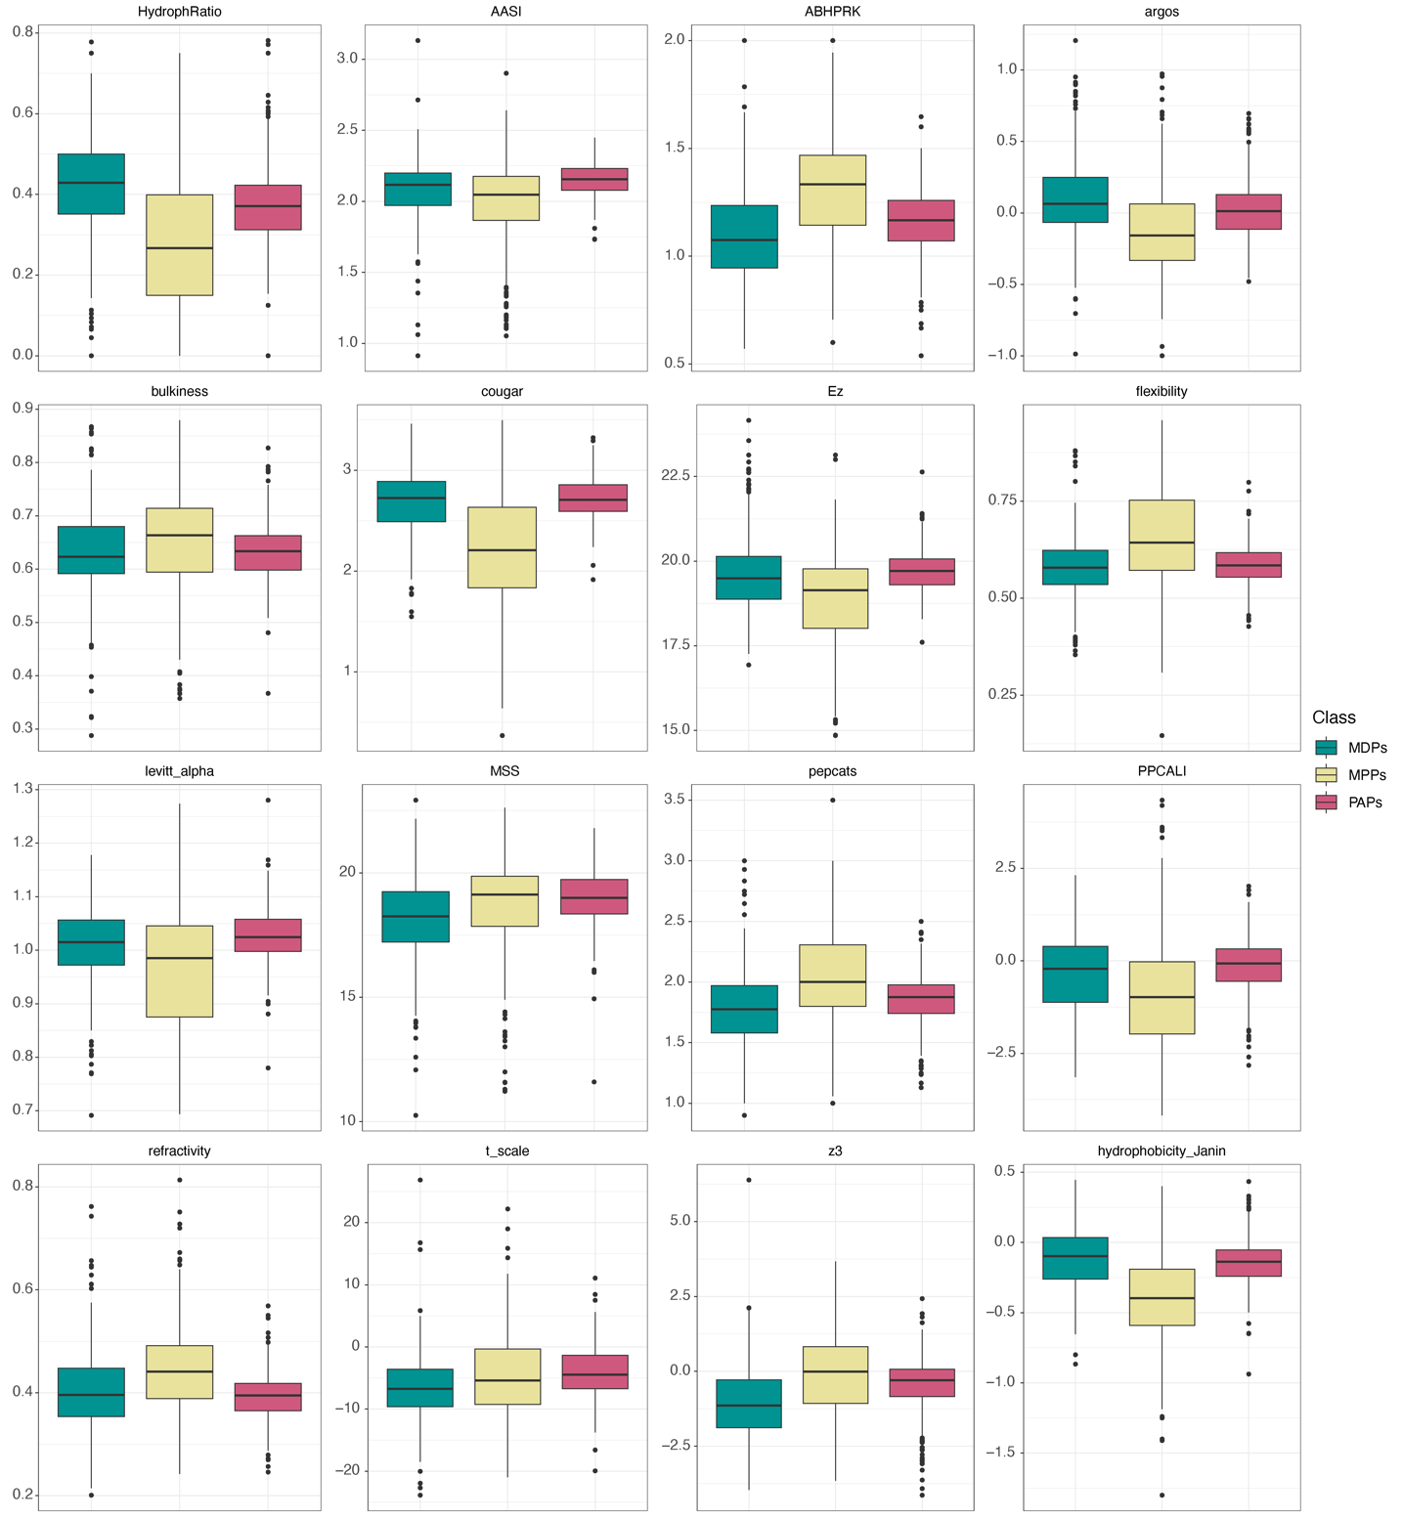
Figure S4 (suite) Boxplots of 56 physicochemical properties (33-48).

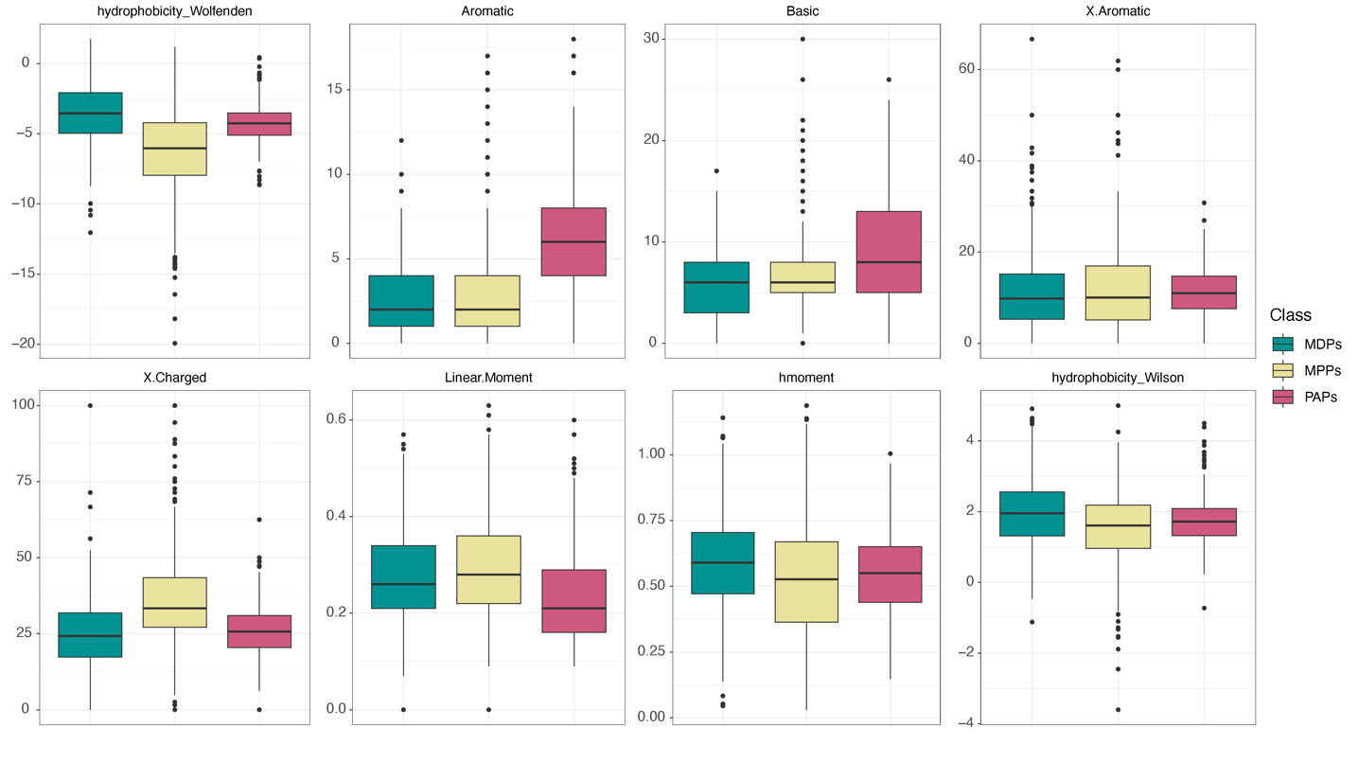
Figure S4 (suite) Boxplots of 56 physicochemical properties (49-56).

Table S2. Performance of 12 binary classifiers to predict membrane-disrupting peptides (MDPs) versus membrane-penetrating peptides (MPPs) using 49 physicochemical properties and ROSE oversampling.
Classifier | Accuracy | Precision | Recall | F1 | MCC | CK | AUC ROC
RFC | 88.0 | 90.0 | 85.5 | 0.873 | 0.761 | 0.760 | 0.939
RFC | 83.3 | 86.3 | 78.0 | 0.820 | 0.668 | 0.665 | 0.831
GBC | 86.7 | 88.0 | 85.1 | 0.863 | 0.734 | 0.733 | 0.916
GBC | 85.3 | 85.9 | 83.5 | 0.847 | 0.706 | 0.706 | 0.852
ABC | 83.4 | 85.0 | 81.6 | 0.828 | 0.669 | 0.668 | 0.884
ABC | 78.6 | 78.8 | 76.7 | 0.777 | 0.572 | 0.572 | 0.786
LDA | 77.5 | 80.1 | 72.1 | 0.760 | 0.553 | 0.550 | 0.846
LDA | 76.0 | 81.3 | 65.7 | 0.727 | 0.526 | 0.517 | 0.757
LR | 78.7 | 82.0 | 73.7 | 0.774 | 0.576 | 0.573 | 0.842
LR | 82.0 | 84.8 | 76.7 | 0.805 | 0.641 | 0.638 | 0.818
DT | 82.1 | 80.3 | 85.4 | 0.824 | 0.643 | 0.642 | 0.821
DT | 77.3 | 78.2 | 73.9 | 0.760 | 0546 | 0.545 | 0.772
KNN | 84.4 | 90.8 | 77.2 | 0.831 | 0.696 | 0.689 | 0.905
KNN | 79.3 | 80.8 | 72.6 | 0.773 | 0.589 | 0.585 | 0.791
GNB | 78.2 | 85.7 | 68.3 | 0.757 | 0.576 | 0.565 | 0.844
GNB | 78.0 | 85.7 | 65.7 | 0.744 | 0.572 | 0.557 | 0.776
SVC  kernel: RBF | 82.7 | 89.6 | 74.2 | 0.810 | 0.663 | 0.653 | 0.899
SVC  kernel: RBF | 83.3 | 87.5 | 76.7 | 0.817 | 0.670 | 0.665 | 0.831
SVC  kernel: linear | 78.9 | 83.0 | 73.0 | 0.775 | 0.583 | 0.579 | 0.846
SVC  kernel: linear | 80.0 | 86.4 | 69.8 | 0.772 | 0.608 | 0.597 | 0.797
SVC  kernel: polynomial | 85.2 | 89.1 | 80.4 | 0.844 | 0.707 | 0.704 | 0.895
SVC  kernel: polynomial | 83.3 | 90 | 73.9 | 0.812 | 0.675 | 0.664 | 0.830
SVC  kernel: sigmoid | 54.1 | 42.7 | 71.2 | 0.532 | 0.087 | 0.082 | 0.762
SVC  kernel: sigmoid | 60.0 | 55.3 | 91.8 | 0.690 | 0.274 | 0.212 | 0.608
RF: random forest, GBC: gradient boosting classifier, ABC: AdaBoost classifier, LDA: linear discriminant analysis, LR: logistic regression, DT: decision tree, K-NN: K-nearest neighbor, GNB: Gaussian Naïve Bayes, SVC: support vector machine [RBF: radial basis function]. For all algorithms, the performances on cross-validated model dataset (top lines) and those on the external validation set (bottom lines). Accuracy, precision and recall are expressed in percentages.
Table S3. Performance of 12 binary classifiers to predict membrane-disrupting peptides (MDPs) versus membrane-penetrating peptides (MPPs) using 49 physicochemical properties and SMOTE oversampling.
Classifier | Accuracy | Precision | Recall | F1 | MCC | CK | AUC ROC
RFC | 86.5 | 88.9 | 83.7 | 0.860 | 0.732 | 0.731 | 0.934
RFC | 83.3 | 84.3 | 80.8 | 0.825 | 0.667 | 0.666 | 0.833
GBC | 85.7 | 87.4 | 83.7 | 0.854 | 0.714 | 0.713 | 0.913
GBC | 84.7 | 85.7 | 82.2 | 0.839 | 0.693 | 0.693 | 0.846
ABC | 80.9 | 83.8 | 76.9 | 0.800 | 0.620 | 0.618 | 0.867
ABC | 83.3 | 83.3 | 82.2 | 0.828 | 0.666 | 0.666 | 0.833
LDA | 77.1 | 80.4 | 71.9 | 0.756 | 0.544 | 0.541 | 0.846
LDA | 77.3 | 83.1 | 67.1 | 0.742 | 0.554 | 0.544 | 0.771
LR | 76.5 | 80.7 | 70.1 | 0.747 | 0.534 | 0.530 | 0.841
LR | 82.0 | 84.8 | 76.7 | 0.806 | 0.642 | 0.639 | 0.819
DT | 77.5 | 77.1 | 79.6 | 0.781 | 0.551 | 0.550 | 0.775
DT | 74.0 | 75.0 | 69.9 | 0.723 | 0.480 | 0.479 | 0.739
KNN | 83.7 | 87.2 | 79.3 | 0.829 | 0.677 | 0.675 | 0.914
KNN | 81.3 | 88.1 | 71.2 | 0.788 | 0.636 | 0.625 | 0.811
GNB | 76.3 | 84.7 | 64.8 | 0.731 | 0.541 | 0.527 | 0.822
GNB | 78.7 | 86.0 | 67.1 | 0.754 | 0.584 | 0.571 | 0.784
SVC  kernel: RBF | 81.2 | 88.3 | 72.5 | 0.794 | 0.634 | 0.624 | 0.891
SVC  kernel: RBF | 82.0 | 85.9 | 75.3 | 0.803 | 0.643 | 0.639 | 0.818
SVC  kernel: linear | 78.7 | 83.8 | 71.6 | 0.768 | 0.580 | 0.574 | 0.853
SVC  kernel: linear | 82.0 | 88.3 | 72.6 | 0.767 | 0.648 | 0.638 | 0.818
SVC  kernel: polynomial | 84.0 | 87.6 | 79.6 | 0.832 | 0.683 | 0.680 | 0.895
SVC  kernel: polynomial | 84.0 | 90.2 | 75.3 | 0.821 | 0.687 | 0.678 | 0.838
SVC  kernel: sigmoid | 53.8 | 42.4 | 72.4 | 0.533 | 0.083 | 0.077 | 0.752
SVC  kernel: sigmoid | 60.0 | 55.4 | 91.8 | 0.691 | 0.274 | 0.213 | 0.608

Table S4. Performance of 12 binary classifiers to predict membrane-disrupting peptides (MDPs) versus membrane-penetrating peptides (MPPs) using 49 physicochemical properties and ADASYN oversampling.
Classifier | Accuracy | Precision | Recall | F1 | MCC | CK | AUC ROC
RFC | 86.5 | 86.9 | 86.0 | 0.864 | 0.730 | 0.730 | 0.934
RFC | 84.0 | 84.5 | 82.2 | 0.833 | 0.680 | 0.680 | 0.840
GBC | 82.4 | 83.7 | 80.7 | 0.819 | 0.648 | 0.647 | 0.898
GBC | 84.0 | 83.6 | 83.6 | 0.836 | 0.680 | 0.680 | 0.840
ABC | 77.0 | 83.6 | 83.6 | 0.836 | 0.680 | 0.680 | 0.840
ABC | 81.3 | 82.6 | 78.1 | 0.803 | 0.627 | 0.626 | 0.812
LDA | 73.6 | 76.9 | 67.7 | 0.713 | 0.476 | 0.472 | 0.811
LDA | 78.0 | 81.3 | 71.2 | 0.759 | 0.562 | 0.558 | 0.778
LR | 74.4 | 78.3 | 67.4 | 0.718 | 0.492 | 0.487 | 0.807
LR | 82.0 | 84.8 | 76.7 | 0.806 | 0.642 | 0.639 | 0.819
DT | 78.4 | 77.6 | 80.4 | 0.788 | 0.568 | 0.567 | 0.784
DT | 74.7 | 72.7 | 76.7 | 0.747 | 0.494 | 0.494 | 0.747
KNN | 82.5 | 85.1 | 79.2 | 0.816 | 0.652 | 0.650 | 0.902
KNN | 81.3 | 82.6 | 78.1 | 0.803 | 0.627 | 0.626 | 0.812
GNB | 72.3 | 79.9 | 58.2 | 0.660 | 0.464 | 0.446 | 0.788
GNB | 79.3 | 86.2 | 68.5 | 0.763 | 0.596 | 0.584 | 0.791
SVC  kernel: RBF | 78.8 | 83.7 | 71.2 | 0.763 | 0.583 | 0.576 | 0.865
SVC  kernel: RBF | 84.7 | 86.8 | 80.8 | 0.837 | 0.694 | 0.693 | 0.846
SVC  kernel: linear | 74.8 | 79.9 | 66.8 | 0.721 | 0.503 | 0.496 | 0.812
SVC  kernel: linear | 80.7 | 83.3 | 75.3 | 0.791 | 0.615 | 0.612 | 0.805
SVC  kernel: polynomial | 81.6 | 84.6 | 77.2 | 0.804 | 0.635 | 0.633 | 0.887
SVC  kernel: polynomial | 85.3 | 89.2 | 79.5 | 0.841 | 0.710 | 0.706 | 0.852
SVC  kernel: sigmoid | 51.6 | 16.0 | 25.2 | 0.195 | 0.036 | 0.030 | 0.718
SVC  kernel: sigmoid | 51.3 | 0.0 | 0.0 | 0.000 | 0.000 | 0.000 | 0.050

Table S5. Performance of 9 ternary classifiers to predict peptide sequences that can disrupt microbial membranes (MDPs), solely penetrate these membranes (MPPs) to reach intracellular targets or present affinity to larger proteins (PAPs) using 56 physicochemical properties and ROSE oversampling.
Classifier | Accuracy | Precision | Recall | F1 | MCC | CK
RFC | 86.7 | 87.1 | 0.866 | 0.866 | 0.800 | 0.800
RFC | 83.5 | 84.6 | 0.832 | 0.835 | 0.752 | 0.749
ETC | 78.7 | 78.9 | 0.787 | 0.784 | 0.680 | 0.680
ETC | 70.3 | 70.2 | 0.701 | 0.701 | 0.551 | 0.551
GBC | 85.5 | 86.1 | 0.854 | 0.855 | 0.782 | 0.782
GBC | 79.7 | 80.0 | 0.798 | 0.796 | 0.696 | 0.694
DT | 77.9 | 78.5 | 0.780 | 0.777 | 0.670 | 0.669
DT | 68.4 | 68.6 | 0.693 | 0.684 | 0.531 | 0.527
KNN | 78.3 | 79.0 | 0.783 | 0.782 | 0.677 | 0.675
KNN | 76.8 | 78.1 | 0.766 | 0.769 | 0.652 | 0.694
RNC | 33.6 | 34.8 | 0.339 | 0.293 | 0.004 | 0.004
RNC | 33.5 | 35.3 | 0.346 | 0.347 | 0.002 | 0.002
GNB | 71.2 | 72.4 | 0.712 | 0.709 | 0.573 | 0.569
GNB | 74.0 | 74.6 | 0.742 | 0.739 | 0.611 | 0.608
MNB | 67.8 | 69.5 | 0.678 | 0.678 | 0.512 | 0.518
MNB | 75.4 | 76.2 | 0.752 | 0.754 | 0.629 | 0.627
LDA | 74.0 | 75.2 | 0.740 | 0.739 | 0.615 | 0.611
LDA | 75.0 | 75.1 | 0.751 | 0.747 | 0.625 | 0.622
RFC: random forest classifier, ETC: extra tree classifier, GBC: gradient boosting classifier, DT: decision tree classifier, KNN: K-nearest neighbor, RNC: radius neighbors classifier, GNB: Gaussian Naïve Bayes, MNB: multinomial Naïve Bayes, LDA: linear discriminant analysis. For all algorithms, the performances on the cross-validated model dataset (top lines) and those on the external validation set (bottom lines).
Table S6. Performance of 9 ternary classifiers to predict peptide sequences that can disrupt microbial membranes (MDPs), solely penetrate these membranes (MPPs) to reach intracellular targets or present affinity to larger proteins (PAPs) using 56 physicochemical properties and SMOTE oversampling.
Classifier | Accuracy | Precision | Recall | F1 | MCC | CK
RFC | 84.0 | 84.4 | 0.840 | 0.839 | 0.760 | 0.759
RFC | 84.0 | 84.5 | 0.840 | 0.840 | 0.759 | 0.757
ETC | 71.4 | 71.6 | 0.714 | 0.712 | 0.570 | 0.570
ETC | 70.8 | 71.5 | 0.697 | 0.700 | 0.559 | 0.554
GBC | 83.5 | 84.2 | 0.835 | 0.835 | 0.752 | 0.752
GBC | 81.6 | 82.3 | 0.816 | 0.816 | 0.724 | 0.722
DT | 73.8 | 74.2 | 0.738 | 0.736 | 0.607 | 0.607
DT | 73.6 | 73.5 | 0.735 | 0.735 | 0.601 | 0.601
KNN | 80.7 | 81.0 | 0.807 | 0.805 | 0.710 | 0.710
KNN | 78.3 | 78.8 | 0.781 | 0.783 | 0.673 | 0.672
RNC | 33.8 | 48.1 | 0.341 | 0.296 | 0.007 | 0.007
RNC | 33.5 | 35.3 | 0.346 | 0.347 | 0.002 | 0.002
GNB | 72.0 | 73.3 | 0.720 | 0.715 | 0.584 | 0.579
GNB | 73.6 | 74.2 | 0.737 | 0.734 | 0.605 | 0.601
MNB | 68.5 | 70.1 | 0.685 | 0.684 | 0.530 | 0.527
MNB | 75.9 | 76.8 | 0.756 | 0.759 | 0.638 | 0.635
LDA | 75.2 | 76.5 | 0.752 | 0.750 | 0.631 | 0.628
LDA | 74.5 | 74.6 | 0.748 | 0.744 | 0.618 | 0.616

Table S7. Performance of 9 ternary classifiers to predict peptide sequences that can disrupt microbial membranes (MDPs), solely penetrate these membranes (MPPs) to reach intracellular targets or present affinity to larger proteins (PAPs) using 56 physicochemical properties and ADASYN oversampling.
Classifier | Accuracy | Precision | Recall | F1 | MCC | CK
RFC | 84.1 | 84.4 | 0.841 | 0.840 | 0.762 | 0.761
RFC | 83.5 | 83.9 | 0.832 | 0.833 | 0.752 | 0.750
ETC | 69.2 | 69.3 | 0.692 | 0.690 | 0.538 | 0.537
ETC | 69.3 | 69.5 | 0.698 | 0.694 | 0.542 | 0.540
GBC | 81.9 | 82.1 | 0.820 | 0.818 | 0.730 | 0.729
GBC | 79.2 | 79.2 | 0.795 | 0.792 | 0.688 | 0.687
DT | 73.6 | 74.1 | 0.736 | 0.737 | 0.604 | 0.604
DT | 73.6 | 73.6 | 0.735 | 0.735 | 0.600 | 0.600
KNN | 77.7 | 78.2 | 0.777 | 0.776 | 0.666 | 0.665
KNN | 73.6 | 73.5 | 0.741 | 0.736 | 0.604 | 0.603
RNC | 37.7 | 63.0 | 0.375 | 0.273 | 0.083 | 0.062
RNC | 44.3 | 65.7 | 0.417 | 0.353 | 0.150 | 0.122
GNB | 68.6 | 68.4 | 0.688 | 0.672 | 0.537 | 0.530
GNB | 74.5 | 75.1 | 0.749 | 0.745 | 0.619 | 0.615
MNB | 63.5 | 64.9 | 0.635 | 0.632 | 0.456 | 0.452
MNB | 75.9 | 76.1 | 0.760 | 0.760 | 0.637 | 0.636
LDA | 71.9 | 72.9 | 0.720 | 0.713 | 0.584 | 0.579
LDA | 73.1 | 73.0 | 0.737 | 0.732 | 0.597 | 0.595

Table S8. Feature importance scores of the 49 physicochemical properties used for the predictive models 1.0-1.5.
Features | Importance Scores
Features | Model 1.0 | Model 1.1 | Model 1.3 | Model 1.4 | Model 1.5
Hydrophobic Ratio | 0.051 | 0.018 | 0.048 | 0.045 | 0.054
Cougar | 0.047 | 0.053 | 0.063 | 0.005 | 0.045
Molecular weight | 0.042 | 0.030 | 0.017 | 0.044 | 0.042
Electrophilicity | 0.040 | 0.027 | 0.013 | 0.020 | 0.040
Hydrophobicity Index | 0.039 | 0.028 | 0.045 | 0.036 | 0.031
Charge Density | 0.035 | 0.043 | 0.011 | 0.003 | 0.030
Aliphatic | 0.033 | 0.012 | 0.016 | 0.018 | 0.030
Flexibility | 0.033 | 0.015 | 0.094 | 0.033 | 0.030
% Tiny | 0.030 | 0.011 | 0.025 | 0.077 | 0.033
ABHPRK | 0.030 | 0.014 | 0.049 | 0.043 | 0.044
Amphiphilicity Index | 0.028 | 0.017 | 0.012 | 0.058 | 0.027
Instability Index | 0.027 | 0.034 | 0.016 | 0.010 | 0.030
H. Ponnuswamy | 0.025 | 0.014 | 0.055 | 0.030 | 0.030
H. Welling | 0.023 | 0.048 | 0.026 | 0.026 | 0.021
Argos | 0.023 | 0.010 | 0.018 | 0.011 | 0.022
Ez | 0.022 | 0.044 | 0.014 | 0.004 | 0.017
Acidic | 0.021 | 0.009 | 0.007 | 0.010 | 0.017
% Aliphatic | 0.020 | 0.018 | 0.019 | 0.011 | 0.018
Isoelectric point | 0.019 | 0.028 | 0.037 | 0.008 | 0.021
E. properties 1 | 0.019 | 0.029 | 0.016 | 0.050 | 0.018
E. properties 2 | 0.019 | 0.063 | 0.013 | 0.029 | 0.025
H. Cid | 0.018 | 0.027 | 0.016 | 0.004 | 0.017
Levitt alpha | 0.018 | 0.022 | 0.029 | 0.021 | 0.021
Local flexibility | 0.017 | 0.019 | 0.018 | 0.004 | 0.015
H. Wilson | 0.017 | 0.009 | 0.018 | 0.013 | 0.014
MSS | 0.015 | 0.021 | 0.010 | 0.007 | 0.012
Charge | 0.015 | 0.018 | 0.020 | 0.007 | 0.015
PPCALI | 0.015 | 0.013 | 0.019 | 0.033 | 0.014
ASHR | 0.015 | 0.010 | 0.006 | 0.010 | 0.011
PPPII.coil | 0.015 | 0.019 | 0.014 | 0.016 | 0.013
Hmoment | 0.014 | 0.023 | 0.010 | 0.025 | 0.017
CCI | 0.014 | 0.023 | 0.014 | 0.035 | 0.012
H. Zimmerman | 0.014 | 0.014 | 0.012 | 0.006 | 0.014
Bulky properties | 0.014 | 0.012 | 0.013 | 0.022 | 0.018

Table S8. (suite)
Features | Importance Scores
Features | Model 1.0 | Model 1.1 | Model 1.3 | Model 1.4 | Model 1.5
Bulkiness | 0.014 | 0.023 | 0.016 | 0.023 | 0.017
Aromaticity | 0.013 | 0.008 | 0.014 | 0.015 | 0.016
Hardness | 0.013 | 0.024 | 0.012 | 0.022 | 0.013
H bonding | 0.013 | 0.012 | 0.007 | 0.017 | 0.013
% Small | 0.013 | 0.010 | 0.014 | 0.021 | 0.014
AASI | 0.013 | 0.018 | 0.019 | 0.015 | 0.013
% Polar | 0.011 | 0.009 | 0.009 | 0.018 | 0.016
T scale | 0.011 | 0.008 | 0.016 | 0.020 | 0.011
Pepcats | 0.011 | 0.018 | 0.009 | 0.005 | 0.012
P in vitro A | 0.011 | 0.024 | 0.003 | 0.005 | 0.009
z3 | 0.010 | 0.012 | 0.011 | 0.011 | 0.013
Refractivity | 0.009 | 0.014 | 0.013 | 0.005 | 0.011
H. Jones | 0.009 | 0.015 | 0.010 | 0.007 | 0.011
% Acidic | 0.009 | 0.007 | 0.009 | 0.037 | 0.009
Penetration depth | 0.008 | 0.007 | 0.023 | 0.005 | 0.008

Table S9. Feature importance scores of the 56 physicochemical properties used for the
predictive models 2.0-2.5.
Features | Importance Scores
Features | Model 2.0 | Model 2.1 | Model 2.3 | Model 2.4 | Model 2.5
Molecular Weight | 0.069 | 0.065 | 0.035 | 0.071 | 0.059
Charge density | 0.052 | 0.084 | 0.032 | 0.013 | 0.039
Acidic | 0.041 | 0.033 | 0.038 | 0.019 | 0.047
Cougar | 0.039 | 0.040 | 0.033 | 0.009 | 0.034
Electrophilicity | 0.038 | 0.031 | 0.023 | 0.028 | 0.034
H bonding | 0.029 | 0.037 | 0.013 | 0.031 | 0.037
Aliphatic | 0.027 | 0.031 | 0.011 | 0.018 | 0.028
H. Janin | 0.025 | 0.010 | 0.065 | 0.017 | 0.034
ASHR | 0.025 | 0.025 | 0.011 | 0.006 | 0.019
Local flexibility | 0.022 | 0.017 | 0.020 | 0.030 | 0.024
pI | 0.022 | 0.030 | 0.025 | 0.014 | 0.021
Aromatic | 0.022 | 0.030 | 0.005 | 0.019 | 0.015
% Acidic | 0.021 | 0.013 | 0.038 | 0.028 | 0.029
P. in vitro A. | 0.021 | 0.031 | 0.006 | 0.004 | 0.014
H. Wolfenden | 0.021 | 0.020 | 0.019 | 0.005 | 0.016
Hydrophatic Ratio | 0.020 | 0.011 | 0.026 | 0.010 | 0.032
Instability Index | 0.019 | 0.034 | 0.012 | 0.013 | 0.015
Flexibility | 0.017 | 0.011 | 0.039 | 0.023 | 0.026
% Tiny | 0.017 | 0.006 | 0.025 | 0.035 | 0.017
Charge | 0.017 | 0.019 | 0.018 | 0.010 | 0.018
MSS | 0.016 | 0.016 | 0.020 | 0.014 | 0.015
CCI | 0.016 | 0.016 | 0.020 | 0.008 | 0.011
Ez | 0.016 | 0.014 | 0.011 | 0.012 | 0.015
Argos | 0.016 | 0.008 | 0.016 | 0.009 | 0.016
z3 | 0.016 | .0.012 | 0.016 | 0.027 | 0.013
Hmoment | 0.015 | 0.026 | 0.009 | 0.013 | 0.012
Hardness | 0.015 | 0.013 | 0.019 | 0.025 | 0.014
H. Index | 0.015 | 0.010 | 0.021 | 0.020 | 0.022
Propensity.to.PPII.coil | 0.015 | 0.016 | 0.013 | 0.009 | 0.013
H. Welling | 0.015 | 0.019 | 0.013 | 0.010 | 0.015
Amphiphilicity Index | 0.014 | 0.011 | 0.007 | 0.032 | 0.017
E. Properties 1 | 0.014 | 0.020 | 0.020 | 0.019 | 0.014
ABHPRK | 0.014 | 0.008 | 0.022 | 0.014 | 0.013
Bulky properties | 0.013 | 0.013 | 0.023 | 0.016 | 0.011
Bulkiness | 0.013 | 0.008 | 0.016 | 0.025 | 0.011
H. Ponnuswamy | 0.012 | 0.008 | 0.023 | 0.023 | 0.018

Table S9. (suite)

Features | Importance Scores
Features | Model 2.0 | Model 2.1 | Model 2.3 | Model 2.4 | Model 2.5
Levitt alpha | 0.012 | 0.014 | 0.013 | 0.019 | 0.012
% Aliphatic | 0.012 | 0.015 | 0.011 | 0.010 | 0.012
H.Zimmerman | 0.012 | 0.010 | 0.009 | 0.014 | 0.013
AASI | 0.012 | 0.011 | 0.012 | 0.022 | 0.013
PPCALI | 0.011 | 0.009 | 0.016 | 0.056 | 0.011
Refractivity | 0.011 | 0.012 | 0.010 | 0.013 | 0.008
Aromaticity | 0.010 | 0.007 | 0.009 | 0.017 | 0.011
H. Cid | 0.010 | 0.007 | 0.019 | 0.010 | 0.011
E. Properties 2 | 0.010 | 0.020 | 0.015 | 0.028 | 0.011
T scale | 0.010 | 0.010 | 0.010 | 0.011 | 0.011
Penetration depth | 0.010 | 0.008 | 0.015 | 0.012 | 0.009
Basic | 0.009 | 0.016 | 0.008 | 0.015 | 0.011
% Aromatic | 0.009 | 0.008 | 0.011 | 0.019 | 0.010
Pepcats | 0.009 | 0.008 | 0.008 | 0.006 | 0.009
% Charged | 0.009 | 0.009 | 0.011 | 0.008 | 0.010
H. Jones | 0.009 | 0.009 | 0.013 | 0.010 | 0.010
H. Wilson | 0.009 | 0.006 | 0.020 | 0.014 | 0.011
% Polar | 0.009 | 0.007 | 0.012 | 0.013 | 0.012
% Small | 0.009 | 0.011 | 0.009 | 0.008 | 0.009
Linear Moment | 0.008 | 0.009 | 0.008 | 0.017 | 0.009

Table S10. Performances of binary and ternary models based on different levels of structure awareness.
Binary Models
Subset | Model | Accuracy (%) | Precision | Recall | Specificity | F1
I | 1.0 | 73.4 | 0.765 | 0.813 | 0.613 | 0.788
I | 1.1 | 81.0 | 0.804 | 0.891 | 0.697 | 0.845
III | 1.0 | 57.8 | 0.714 | 0.536 | 0.647 | 0.612
III | 1.3 | 51.1 | 0.762 | 0.485 | 0.583 | 0.593
IV | 1.0 | 80.0 | n.d. | n.d. | n.d. | n.d.
IV | 1.4 | 80.0 | n.d. | n.d. | n.d. | n.d.
Complete | 1.0 | 68.2 | 0.750 | 0.701 | 0.654 | 0.725
V | 1.5 | 68.2 | 0.750 | 0.701 | 0.654 | 0.725
Ternary Models*
Subset | Model | Accuracy (%) | Precision | Recall | Specificity | F1
I | 2.0 | 44.0 | 0.468 | 0.440 | 0.632 | 0.453
I | 2.1 | 42.9 | 0.541 | 0.429 | 0.718 | 0.478
III | 2.0 | 57.8 | 0.623 | 0.578 | 0.833 | 0.600
III | 2.3 | 55.9 | 0.616 | 0.559 | 0.781 | 0.586
IV | 2.0 | 65.2 | n.d. | n.d. | n.d. | n.d.
IV | 2.4 | 80.4 | n.d. | n.d. | n.d. | n.d.
Complete | 2.0 | 69.5 | 0.696 | 0.695 | 0.827 | 0.695
V | 2.5 | 61.8 | 0.653 | 0.618 | 0.821 | 0.635
n.d. cannot be determined, *all performance metrics were averaged out.

References
1. Osorio, D., Rondón-Villarreal, P. & Torres, R. Peptides: A Package for Data Mining of Antimicrobial Peptides. R J. 7, 4 (2015).
2. Pirtskhalava, M. et al. DBAASP v3: database of antimicrobial/cytotoxic activity and structure of peptides as a resource for development of new therapeutics. Nucleic Acids Res. 49, D288–D297 (2021).
3. Müller, A. T., Gabernet, G., Hiss, J. A. & Schneider, G. modlAMP: Python for antimicrobial peptides. Bioinformatics 33, 2753–2755 (2017).
4. Eisenberg, D., Weiss, R. M. & Terwilliger, T. C. The hydrophobic moment detects periodicity in protein hydrophobicity. Proc. Natl. Acad. Sci. 81, 140–144 (1984).
5. Liang, G. & Li, Z. Factor Analysis Scale of Generalized Amino Acid Information as the Source of a New Set of Descriptors for Elucidating the Structure and Activity Relationships of Cationic Antimicrobial Peptides. QSAR Comb. Sci. 26, 754–763 (2007).
6. Cruciani, G. et al. Peptide studies by means of principal properties of amino acids derived from MIF descriptors. J. Chemom. 18, 146–155 (2004).
7. Juretić, D., Vukičević, D., Ilić, N., Antcheva, N. & Tossi, A. Computational Design of Highly Selective Antimicrobial Peptides. J. Chem. Inf. Model. 49, 2873–2882 (2009).
8. Collantes, E. R. & Dunn, W. J. Amino Acid Side Chain Descriptors for Quantitative Structure-Activity Relationship Studies of Peptide Analogs. J. Med. Chem. 38, 2705–2713 (1995).
9. Raychaudhury, C., Banerjee, A., Bag, P. & Roy, S. Topological Shape and Size of Peptides: Identification of Potential Allele Specific Helper T Cell Antigenic Sites. J. Chem. Inf. Comput. Sci. 39, 248–254 (1999).
10. Zaliani, A. & Gancia, E. MS-WHIM Scores for Amino Acids: A New 3D-Description for Peptide QSAR and QSPR Studies. J. Chem. Inf. Comput. Sci. 39, 525–533 (1999).
11. Koch, C. P. et al. Scrutinizing MHC-I Binding Peptides and Their Limits of Variation. PLoS Comput. Biol. 9, e1003088 (2013).
12. Cocchi, M. & Johansson, E. Amino Acids Characterization by GRID and Multivariate Data Analysis. Quant. Struct.-Act. Relatsh. 12, 1–8 (1993).
13. Zhao, G. & London, E. An amino acid “transmembrane tendency” scale that approaches the theoretical limit to accuracy for prediction of transmembrane helices: Relationship to biological hydrophobicity. Protein Sci. 15, 1987–2001 (2006).
14. Hellberg, S., Sjoestroem, M., Skagerberg, B. & Wold, S. Peptide quantitative structure-activity relationships, a multivariate approach. J. Med. Chem. 30, 1126–1135 (1987).
15. Sandberg, M., Eriksson, L., Jonsson, J., Sjöström, M. & Wold, S. New Chemical Descriptors Relevant for the Design of Biologically Active Peptides. A Multivariate Characterization of 87 Amino Acids. J. Med. Chem. 41, 2481–2491 (1998).

