Extended Data Fig. 1
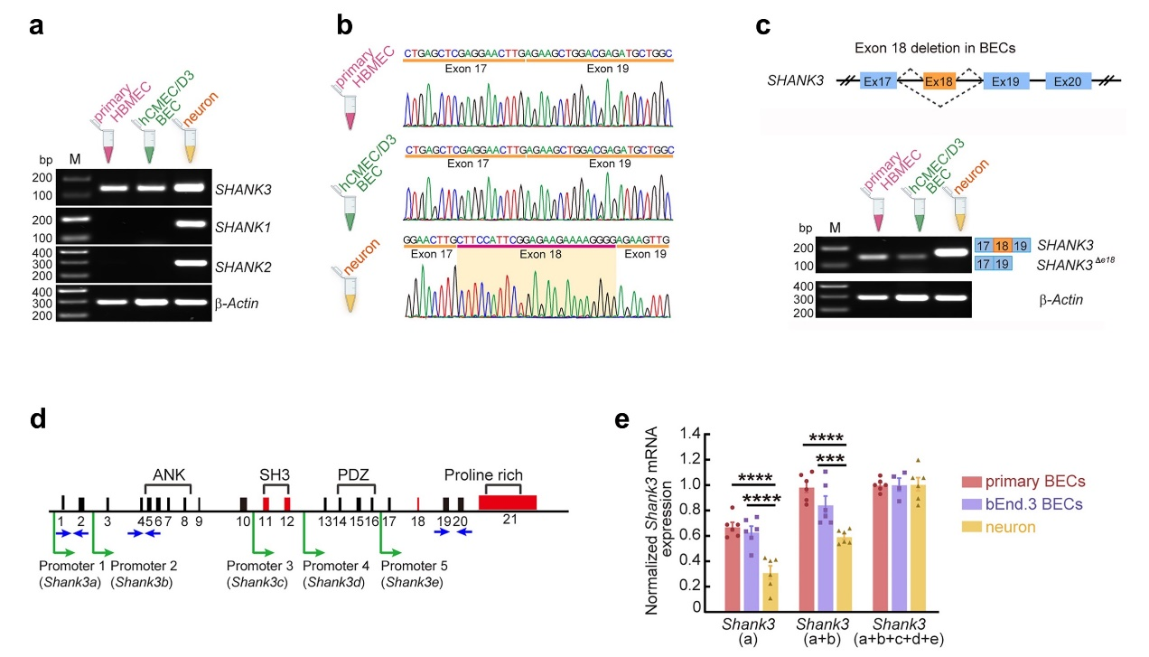
Extended Data Fig. 1: Human BECs express SHANK3 lacking exon 18.
a-c, SHANK3 expression in human BECs. cDNAs were constructed from RNA extracts of human primary HBMEC BECs, human BECs (hCMEC/D3), and mouse primary neurons. (a) PCR analysis showed the human BECs express SHANK3, not SHANK1 and SHANK2, while neurons express all Shank family. β-Actin: loading control. (b) Sequencing analysis showed the lack of exon 18 (SHANK3^{Δe18}) in human HBMECs and hCMEC/D3 BECs, while neurons express full-length Shank3. (c) PCR analysis confirmed the short form (exon 18 deletion) of SHANK3 in human HBMECs and hCMEC/D3 BECs.
d-e, qRT-PCR analysis for measuring the amount of Shank3 isoforms in mouse primary BECs, bEnd.3 BECs, and neurons. (d) Schematic illustrating the structure of Shank3 gene, highlighting intragenic promoters and alternative splicing exons. The multiple intragenic promoters are indicated in green arrows. Blue arrows indicate the target primer sites (SI.Table 3) used for qRT-PCR. (e) Relative expressions of Shank3(a), Shank3(a+b), Shank3(a+b+c+d+e) mRNAs in primary BECs, bEnd.3 BECs, and neurons. The ‘a’ and ‘b’ isoforms of Shank3 are predominantly expressed in mouse primary and bEnd.3 BECs.
Data are mean ± SEM. ***p <0.001; ****p <0.0001. Sample size and detailed statistical methods and results are described in SI.Table 1.
Extended Data Fig. 2
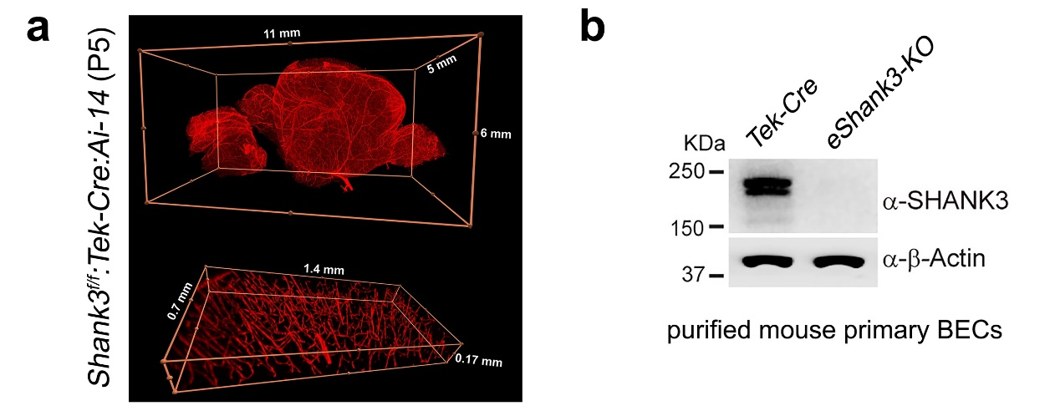
Extended Data Fig. 2: Depletion of eSHANK3 proteins in the brain endothelium of Shank3^{f/f}: Tek-Cre:Ai-14 mice.
a, Whole brain light-sheet imaging using clarified P5 Shank3^{f/f}:Tek-Cre:Ai-14 triple mutant mice presents the successful expression of Cre in the BECs/vasculature in the P5 mouse brain. The virtual reality inspection of the entire brain is provided in SI.Video 1.
b, WB analysis using anti-SHANK3 antibody targeting c-terminal epitope shows the absence of eSHANK3 protein in primary BECs purified from the P5 eShank3-KO mouse brains, while Tek-Cre control mice express eSHANK3. β-Actin: loading control.
Extended Data Fig. 3
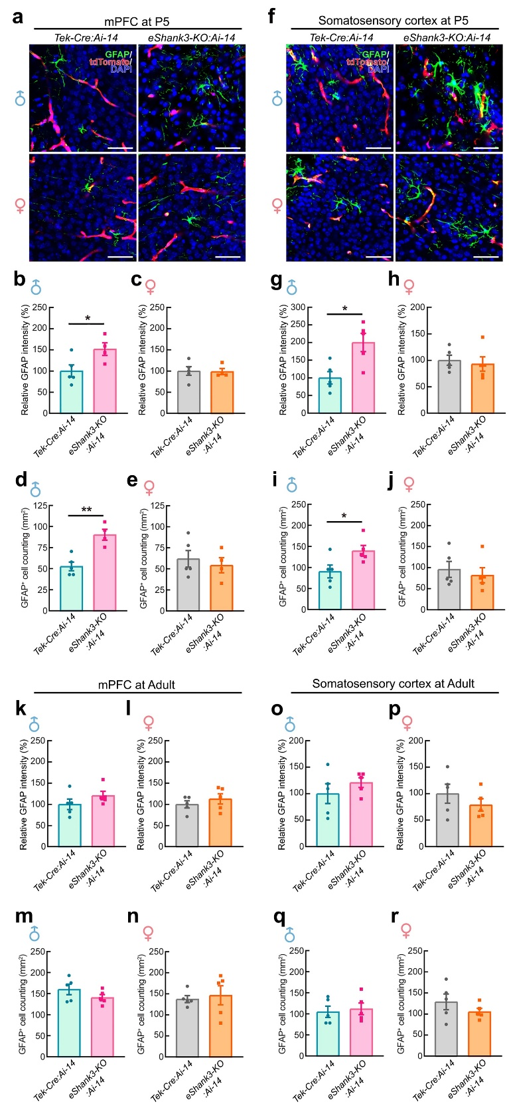
Extended Data Fig. 3: Increased glial fibrillary acidic protein (GFAP) in the mPFC and S1 regions of P5 male eShank3-KO mice.
a-j, IHC analysis assessing the reactive astrocyte levels of P5 mice by quantifying GFAP expression. (a) Representative images of GFAP expression in the mPFC region of P5 Shank3^{f/f}:Tek-Cre:Ai-14 (eShank3-KO:Ai-14) and Tek-Cre: Ai-14 male and female mice. Scale bars, 50 μm. Quantification of GFAP intensity (b-c) and GFAP⁺ cell density (d-e) in the mPFC of each group of mice. (f) Representative images of GFAP expression in the somatosensory cortical (S1) region of each group of mice at P5. Scale bars, 50 μm. Quantification of GFAP intensity (g-h) and GFAP⁺ cell density (i-j) in the S1 region of each group of mice. tdTomato expression by Ai-14 reporter was used as a BEC marker.
g-j, IHC analysis quantifying GFAP expression in adult (17-19 week-old) mice. (k-l) Quantification of GFAP intensity in the mPFC region of adult eShank3-KO:Ai-14 and Tek-Cre:Ai-14 male and female mice. (m-n) Quantification of GFAP⁺ cell density in the mPFC region of each group of mice. (o-p) Quantification of GFAP intensity in the S1 region of adult eShank3-KO:Ai-14 and Tek-Cre:Ai-14 male and female mice. (q-r) Quantification of GFAP⁺ cell density in the S1 region of each group of mice.
Data are mean ± SEM. *p <0.05; **p <0.01. Sample size and detailed statistical methods and results are described in SI.Table 1.
Extended Data Fig. 4
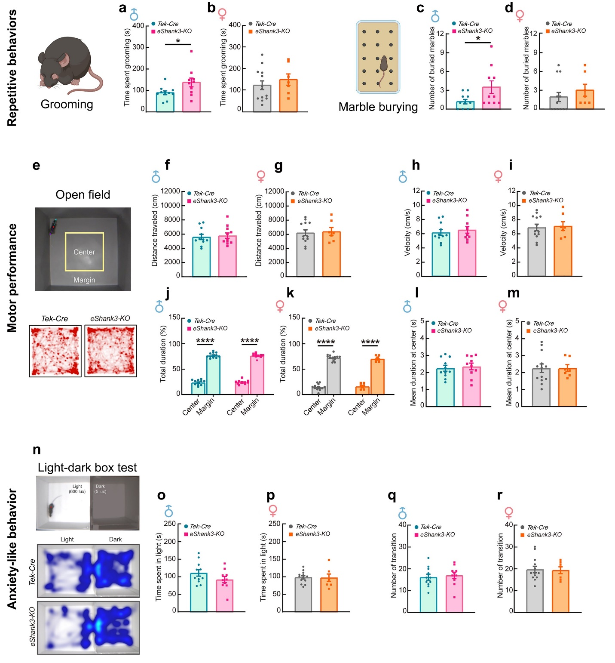
Extended Data Fig. 4: Increased repetitive response, while normal motor performance and anxiety-like behaviors in adult male eShank3-KO mice.
a-d, Self-grooming and marble burying behaviors for assessing repetitive responses of adult mice (17-19 week-old). The total time spent on grooming by adult male (a) and female (b) eShank3-KO and Tek-Cre control mice. The number of buried marbles by adult male (c) and female (d) eShank3-KO and Tek-Cre control mice.
e-m, Since some of the global Shank3-KO mice have shown various other behavioral abnormalities, including reduced motor performance and anxiety-like behaviors²⁰, we assessed the behaviors using open field and light-dark box tests at adult age . (e) A representative snapshot of open filed test operated by EthoVision XT system (upper panel) and heatmaps tracking the animals’ movements for 15 min (lower panel). Total distance traveled (f-g), velocity (h-i), total duration spent in center and margin (j-k) and mean duration in the center (l-m) of adult male (f, h, j, l) and female (g, i, k, m) eShank3-KO and Tek-Cre control mice.
n-r, Light-dark box test for assessing anxiety-like behavior in adult eShank3-KO mice. (n) A representative snapshot of light-dark box test (upper panel) and heatmaps tracking the animals’ movements for 5 min (lower panel). The time spent in the light box (o-p) and the number of transitions between light and dark boxes (q-r) in adult male (o, q) and female (p, r) eShank3-KO and Tek-Cre control mice.
Data are mean ± SEM. *p <0.05; ****p <0.0001. Sample size and detailed statistical methods and results are described in SI.Table 1.
Extended Data Fig. 5
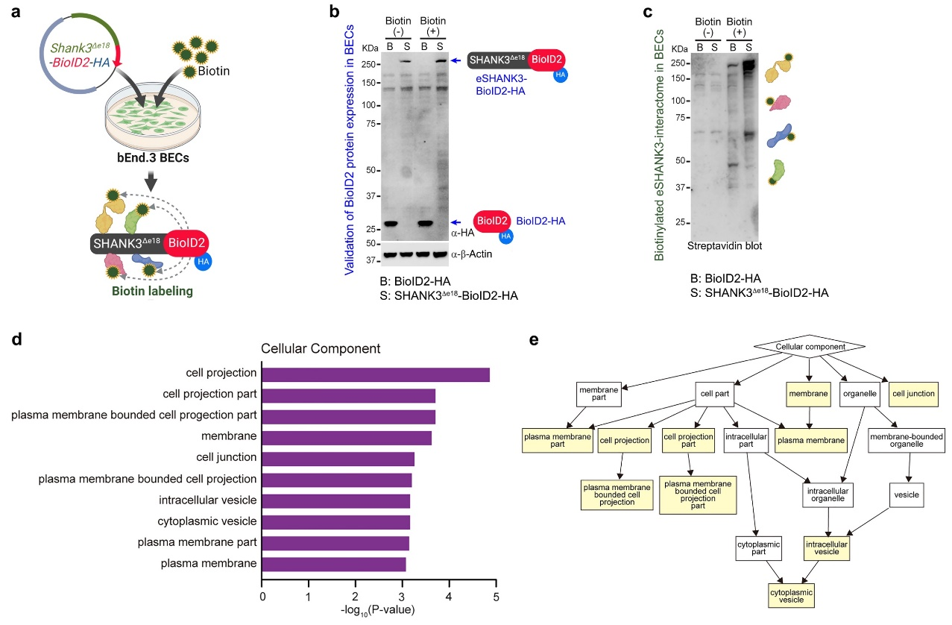
Extended Data Fig. 5: Identification of eSHANK3 interactome using BioID2 paradigm.
a, Schematic illustrating the BioID2 (proximity-dependent biotin identification 2) approach for identifying eSHANK3 interactome in the bEnd.3 BECs. Each plasmid (Shank3^{Δe18}-BioID2-HA, BioID2-HA) was transfected into the bEnd.3 BECs followed by treatment of 50 μM biotin for 24 h. SHANK3^{Δe18}-BioID2-HA biotinylates eSHANK3-interacting proteins.
b, WB analysis using anti-HA antibody validated the expression of eSHANK3-BioID2-HA (S) and BioID2-HA (B). Blue arrows: BioID2-eSHANK3-HA (upper bands), BioID2-HA (lower bands). β-Actin: loading control.
c, Streptavidin-horseradish peroxidase (HRP) blotting showed proteins bands of various sizes, confirming the successful biotin labeling on the eSHANK3-interacting proteins by Shank3^{Δe18}-BioID2-HA.
d-e, GO analysis for the eSHANK3-interacting proteins. Bar plot (d) and a tree representation (e) illustrating the GO categories related to cellular component, with significance highlighted by yellow square boxes (p<0.001). Detailed GO analysis and results are described in SI.Table 2.
Extended Data Fig. 6
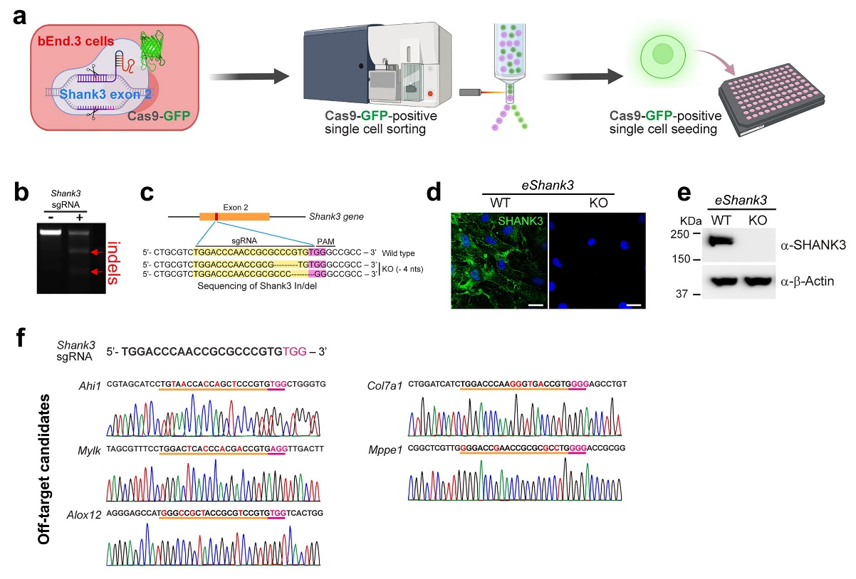
Extended Data Fig. 6: Generation of stable eShank3-KO bEnd.3 BEC line.
a, Schematic depicting the procedure of generating a single cell-origin eShank3-KO bEnd.3 BEC line using CRISPR/Cas9 system. Exon 2 was targeted for nullifying a/b isoforms of Shank3, the predominant isoforms in BECs, and then GFP-positive (Cas9 expressing) cells were sorted and clonally expanded.
b-e, Verification of Shank3 genomic DNA in/del and SHANK3 depletion in eShank3-KO bEnd.3 BECs. (b) The cleavage of Shank3 gene by T7 endonuclease I (T7E1) represents the in/del mutations induced by the single guide RNA (sgRNA) targeting Shank3. (c) Target sequences of the Shank3 sgRNA (yellow box) located on exon 2 and the sequences of nucleotides deleted in eShank3-KO bEnd.3 BECs. The PAM sequence (5'-NGG-3') for the commonly used Cas9 from S. pyogenes is highlighted in pink. ICC (d) and WB (e) analyses using a pan-SHANK3 antibody (c-terminal epitope) display a complete absence of SHANK3 in the eShank3-KO bEnd.3 BEC line. Blue: DAPI. Scale bars, 20 μm. β-Actin: loading control.
f, Sequencing analyses for the top 5 potential off-target genes of Shank3 sgRNA (Ahi1, Mylk, Alox12, Col7a1, Mppel) predicted by programs (e.g., CRISPOR, Off-Spotter). All the sequences of these 5 genes were intact. Red characters: mismatched nucleotides.
Extended Data Fig. 7
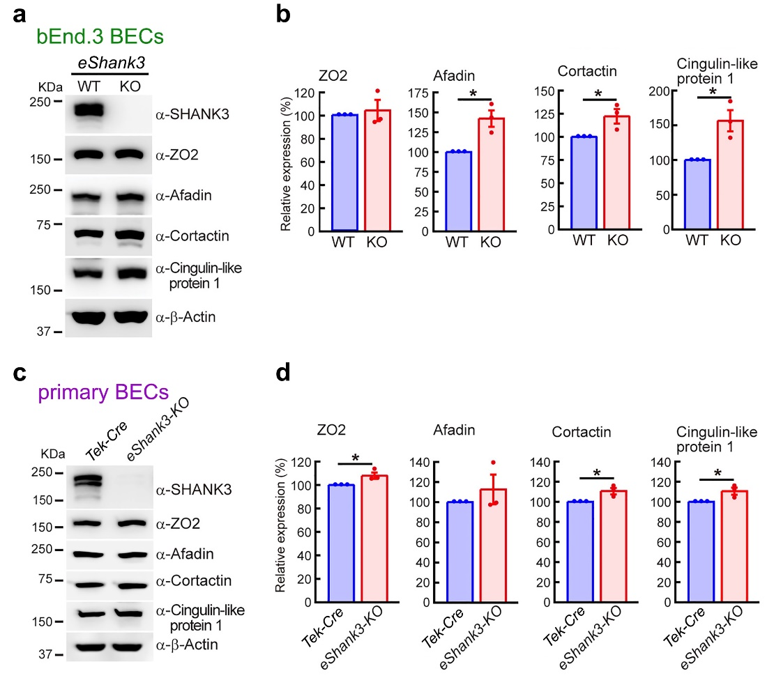
Extended Data Fig. 7: Expression patterns of eSHANK3-interacting proteins in the eShank3-KO bEnd.3 BECs and primary BECs.
a-b, WB analysis with stable eShank3-KO bEnd.3 BECs (a) followed by quantification (b) showed increased expressions of Afadin, Cortactin, Cingulin-like protein 1, while ZO2 remains unchanged in the eShank3-KO bEnd.3 BECs.
c-d, WB analysis with primary BECs (c) followed by quantification (d) show increased expressions of ZO2, Cortactin, Cingulin-like protein 1, while Afadin remains unchanged in the primary BECs isolated from brains of eShank3-KO and control Tek-Cre mice. The quantifications were normalized based on β-Actin intensity.
Data are mean ± SEM. *p <0.05. Sample size and detailed statistical methods and results are described in SI.Table 1.
Extended Data Fig. 8
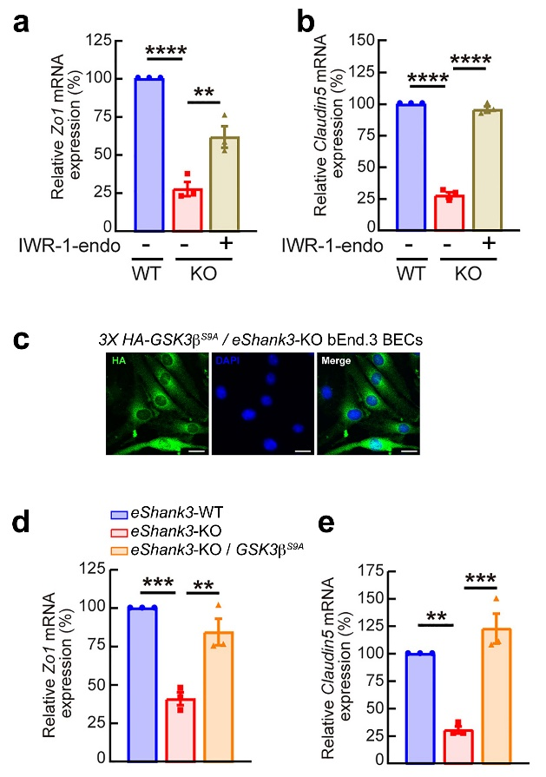
Extended Data Fig. 8: β-Catenin inhibition or GSK3β activation normalizes the diminished Zo1 and Claudin5 mRNAs in eShank3-KO BECs.
a-b, qRT-PCR analysis revealing the restoration of Zo1 (a) and Claudin5 (b) mRNA expressions in eShank3-KO bEnd.3 BECs upon IWR-1-endo (β-Catenin inhibitor) treatment.
c, ICC analysis with anti-HA antibody showing the stable expression of constitutively active 3X HA-GSK3β^{S9A} proteins in the 3X HA-GSK3β^{S9A} / eShank3-KO double mutant bEnd.3 BECs. Blue: DAPI. Scale bar, 20 μm.
d-e, qRT-PCR analysis showing the restoration of Zo1 (d) and Claudin5 (e) mRNA expressions in GSK3β^{S9A} / eShank3-KO bEnd.3 BECs.
Data are mean ± SEM. **p <0.01; ***p <0.001, ****p <0.0001. Sample size and detailed statistical methods and results are described in SI.Table 1.
Extended Data Fig. 9
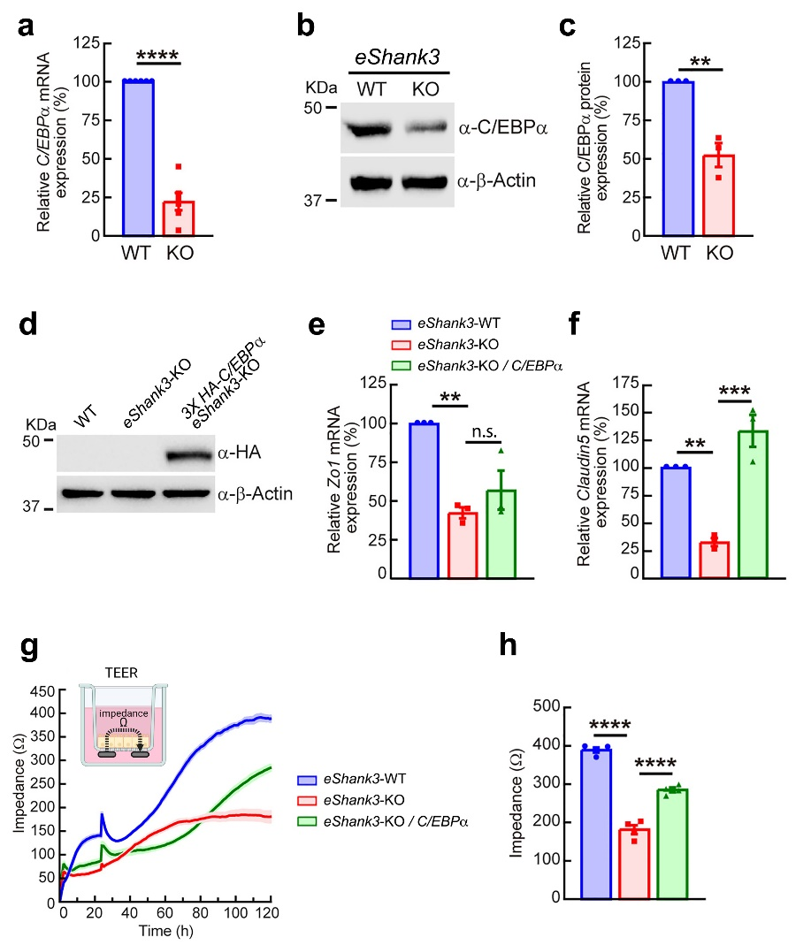
Extended Data Fig. 9: C/EBPα overexpression restores the diminished Claudin5 expression in the eShank3-KO BECs and significantly improves the barrier function of BECs.
a-c, qRT-PCR (a) and WB analysis (b-c) reveal the decreased C/EBPα mRNA and protein expression in eShank3-KO bEnd.3 BECs. The C/EBPα protein level was normalized based on β-Actin band intensity.
d-f, C/EBPα overexpression effects on eShank3-KO bEnd.3 BECs. (d) WB analysis with anti-HA antibody showed 3X HA-C/EBPα protein expression in the 3X HA-C/EBPα / eShank3-KO double mutant bEnd.3 BECs. qRT-PCR analysis revealed that Claudin5 mRNA was restored (f), while Zo1 mRNA level was not changed (e) in the double mutant BEC line.
g-h, (g) TEER assay displays significantly restored impedance in the 3X HA-C/EBPα / eShank3-KO double mutant BECs compared to eShank3-KO BECs. (h) Bar graph showing the impedance at 120 h time point.
Data are mean ± SEM. **p <0.01; ***p <0.001, ****p <0.0001. Sample size and detailed statistical methods and results are described in SI.Table 1.
Extended Data Fig. 10
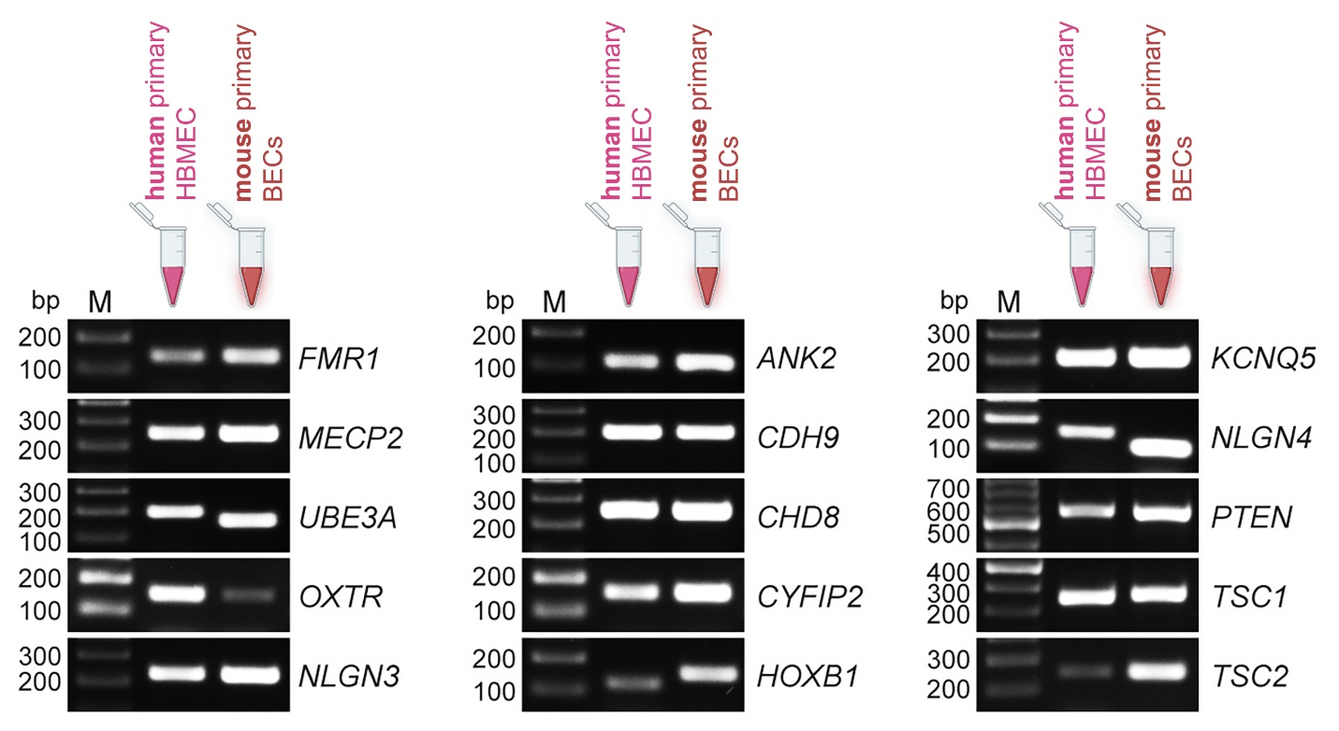
Extended Data Fig. 10: Expressions of ASD-related genes in human and mouse primary BECs.
PCR analysis conducted with cDNAs from human primary HBMEC and mouse primary BECs revealed expressions of various ASD-related genes in BECs. The primer information is described in SI.Table 3.

