SUPPLEMENTARY MATERIAL

Rasagiline neuroprotective properties
In addition to the references cited in the main text, preclinical evidence of rasagiline’s neuroprotective properties is described by Youdim et al^{1–3}.

References for diagnostic criteria and clinical endpoints
References for the secondary clinical endpoints of this clinical trial are provided below:

- NINCDS-ADRDA Work Group⁴
- Mini-Mental State Exam (MMSE)⁵
- The Alzheimer’s Disease Assessment Scale – cognitive subscale 11 (ADAS-cog)⁶
- Neuropsychiatric Inventory (NPI)⁷
- Alzheimer's Disease Cooperative Study - Activities of Daily Living (ADCS-ADL)⁸
- Digit Span (DS)⁹
- Controlled oral word association test (COWAT)¹⁰
- Clinician Global Impression of Change (CGIC)¹¹
- QoL-AD¹²

Imaging Methods
Image acquisition protocols were consistent with those used in AD Neuroimaging Initiative (ADNI)(www.adni-info.org).
MRI

Volumetric MR images of 3T field strength were acquired at three imaging sites using a 3D magnetization prepared rapid gradient echo (MPRAGE) T1 weighted scan with field of view (FOV) = 256 × 256 × 160; voxel size = 1 × 1 × 1.2 mm³; TR = 2300 ms, TE = 2.98 ms; TI = 900 ms and flip angle = 9° or similar MPRAGE parameters.
MRI scans were visually inspected for anatomical inclusion, subject motion, and other artifacts. MRI scans were processed using Freesurfer version 6.0^{13,14} to produce regional segmentation masks with measurements of volume and cortical thickness. This processing included N3 correction for nonuniformities. MRI scans were also spatially transformed to a template in Montreal Neurological Institute (MNI) space using statistical parametric mapping (SPM12)¹⁵. Freesurfer segmentation results were visually inspected, and volume values were corrected for total intracranial volume (ICV) as calculated using the gray, white, and cerebrospinal (CSF) segments determined by SPM12.

FDG PET
Image Acquisition
FDG PET scans were acquired using 5 mCi FDG with an uptake time of 20 minutes during which participants were at rest but awake in a dimly lit room with eyes and ears open. Sleep medications such as zolpidem were disallowed on the evening prior to FDG PET scans. Emission scans were acquired over a 30-minute period comprised of six five-minute frames following a transmission scan used for attenuation correction. Participants were monitored to confirm conformance to the at-rest protocol during uptake and were monitored for motion during image acquisition. At-rest requirements included refraining from movement, conversation, or sleep during FDG uptake. Reconstruction was performed using Ordered subset expectation maximization (OSEM).¹⁶

Image Processing
FDG PET scans were visually inspected for participant motion and other artifacts. Multi-frame images were motion corrected and averaged into static images that were smoothed using a Gaussian filter. The 24-week PET scans were co-registered to baseline PET scans, which had been co-registered to their respective MRI scans. Volumetric masks generated by Freesurfer 6.0 were visually inspected and used to measure the signal intensities from the co-registered PET scans, as individual or composite regions. In addition, the spatial transforms determined for the MRI scans were applied to the PET scans to enable voxel-based comparisons using images in template space.

For FDG PET SUVR measurement, the reference region was based upon spatial clusters found to be metabolically preserved during the progression of AD based upon our prior development of a voxel-based multivariate classifier (“AD Progression Classifier^{”17).} These reference clusters included paracentral gyrus and subregions of pons and cerebellar vermis, similar to preserved clusters identified by Chen et al¹⁸. However, the striatum was omitted due to reported metabolic change associated with rasagiline in this region. Longitudinal results were compared to those obtained using whole brain (minus ventricles) and subcortical white matter reference regions to verify that effects were not specific to the primary reference region.

Imaging Endpoints
FDG Standardized Uptake Value ratios (SUVRs) were measured in the following prespecified regions of interest associated with progressive hypometabolism in AD: medial temporal, lateral temporal, posterior cingulate-precuneus, inferior parietal, and middle frontal. The anterior cingulate and striatum were also prespecified given prior findings of correlation between dopamine and glucose metabolism in those regions¹⁹ and reported selegiline effects on FDG in striatum associated with clinical benefit²⁰.
Images were also evaluated using both apriori and data driven machine learning classifiers. In brief, these classifiers were developed using the NPAIRS framework^{21,22}, which performs feature reduction using Principal Component analysis followed by Canonical Variate Analysis, coupled with many iterations of split half resampling. In each iteration, the half data sets are treated as training and test data sets. The models derived from each half are compared to one another using correlation, producing a metric of reproducibility. Each half is also used as the test half for the other half, and the classification accuracy for the test subjects produces a quantitative prediction measure. These parameters are then used to determine consensus patterns of relative hypo- and hyper- (or preserved) metabolism that differentiate classes while minimizing risk of overfitting. The degree to which each individual participant scan expresses each pattern is captured by a Canonical Variate score, which can then be analyzed using descriptive statistics.
Two previously developed (apriori) FDG PET classifiers were applied at baseline to determine whether participants exhibited metabolic patterns associated with AD as compared to those of individuals with several other dementias:
- The Dementia Differentiation Classifier identifies the probability of association with a combination of patterns that characterize the following different types of dementia (or lack of disease): Normal amyloid negative, MCI amyloid positive, AD amyloid positive, Severe AD amyloid positive, frontal (behavioral) variant Frontotemporal Dementia (FTD), semantic variant FTD, and Lewy Body Disease.
- The AD Progression Classifier quantifies the degree to which a scan expresses a pattern of hypometabolism and preservation relative to whole brain that reflects the progression from cognitively normal amyloid negative status to amyloid positive MCI and AD dementia, as described in Matthews et. al.¹⁷

The data driven classifier that was included as one of the FDG primary endpoints (Figure 3 in the main manuscript) was derived by defining classes based upon study arm, stratified by younger and older age groups, and using the difference scans between 24 weeks and baseline as the inputs.
Participant Inclusion/Exclusion
Participants were excluded from longitudinal FDG PET analysis if major behavioral confounds occurred during FDG uptake, if motion was so severe that it could not be adequately corrected, or if other protocol deviation or image artifact was identified that would prevent proper signal measurement. Of the 42 participants who had baseline and 24-week FDG PET scans available, two participants from the placebo group and one participant from the rasagiline group were excluded due to major behavioral confounds during the FDG uptake period and/or severe motion during image acquisition. Longitudinal analyses were conducted using this set of 39 participants.

Flortaucipir PET

Image acquisition
Tau PET scans were acquired using 10 mCi of the radiotracer AV-1451, in four 5 minute frames from 80 to 100 minutes post tracer injection, following a transmission scan. All PET scans were acquired using a Siemens mCT PET scanner, at two sites. Reconstruction was performed using Ordered subset expectation maximization (OSEM)¹⁶.

Image processing and measurement
Flortaucipir PET scans were visually inspected, motion corrected, averaged into static images, and smoothed using a Gaussian filter. The 24-week scans were co-registered to the baseline scan, which was coregistered to the baseline MRI. Regions of interest as defined by Freesurfer 6.0 were then measured in native space. In addition, the flortaucipir scans were spatially transformed to template space by applying the transform determined for the MRI to which they were coregistered.

Baseline flortaucipir SUVRs were first evaluated using a cerebellar cortex reference region thresholded to exclude spillover from adjacent tissue and high intensity clusters that can create signal artifact²³. For longitudinal evaluation, the following reference regions were compared: cerebellar cortex, and a calculated white matter reference mean that mathematically reduces the effects of spillover from adjacent high signal tissue based on a Gaussian 2-mixture model (PERSI)²⁴. Use of white matter was motivated by previous findings demonstrating that reference regions incorporating subcortical white matter have shown lower variance and greater effect sizes than cerebellar cortex in longitudinal measurement of tau^{24,25} and amyloid^{26–29}. SUVRs derived from these reference regions were compared using th following criteria: (a) cross-sectional range for baseline values and (b) variability (signal to noise) for longitudinal measurements. Longitudinal SUVRs were evaluated using the reference region with least longitudinal variability for the study population overall.

The cerebellar cortex provided the best reference region to examine the range of cross-sectional tau burden. All reference regions produced SUVrs compatible with visually apparent tau burden. However, those referenced to white matter showed less differentiation between tau burden levels due to gray signal spillover into the white matter reference in participants with high tau burden. The PERSI approach mitigated the impact of spillover, reducing the white matter reference values by up to 26% (and thus increasing target region SUVRs). However, values for participants with extensive tau were still somewhat reduced as compared to SUVRs based on cerebellum, beyond that accounted for by the generally higher tracer signal expected in white matter. For longitudinal measurement, white matter reference regions (with or without the PERSI adjustment) were associated with less directional variability then cerebellar cortex, and the PERSI reference was used for longitudinal SUVR evaluation.

Flortaucipir SUVRs were measured in total cortical gray tissue excluding cerebellum, a composite temporal region (CTR) consisting of entorhinal cortex, amygdala, parahippocampal gyrus, inferior temporal, and middle temporal regions³⁰, the regions measured for FDG PET, and additional cortical and subcortical regions defined on MRI using Freesurfer 6.0. These included composite regions based on the six stages identified by Braak^{31,32}; and the regions measured for FDG PET. An additional adaptive region approach was evaluated in which the region of interest was comprised of suprathreshold voxels from the baseline scan “Or’d” (the union) with those in the 24 week scan. Effects of rasagiline upon flortaucipir binding were also explored by examining longitudinal change in putamen, accumbens, thalamus, and brainstem.

Partial volume correction effects were examined at baseline in some subjects using the Müller-Gärtner method³³ as implemented using PMOD software but did not impact overall results. A 24 week MRI was not acquired and partial volume correction was not applied for longitudinal analysis over this relatively short timeframe of 24 weeks.

Participant inclusion/exclusion
Participants were excluded from group analyses for tau PET if the start time for emission scan acquisition differed between baseline and 24-week visits by more than 5 minutes, due to published time-dependent increases in flortaucipir signal that occur during the acquisition time window³⁴. Adjustment for acquisition start time differences in tau PET scans, as in Pontecorvo et al³⁵, was deferred for future exploration. Four participants were excluded from the longitudinal analysis due to acquisition timing.

Secondary Outcomes

Longitudinal Tau

The 24-week effects of rasagiline on tau burden were evaluated in this study. Since rasagiline is a potent selective MAO-B inhibitor, longitudinal measurement also posed a sensitive within-subject challenge to detect potential off-target binding of flortaucipir to MAO-B.

As noted in the main manuscript text, using a PERSI white matter reference region, longitudinal flortaucipir SUVRs exhibited stability or increases in cortical regions including precuneus, inferior parietal, lateral occipital, and total cortex (not including cerebellar cortex). In subjects with very low / no tau (flortaucipir binding), some decreases were observed but no overall difference between study arms was observed. Slight mean decreases were observed in the rasagiline arm but not in the placebo arm in anterior cingulate (not significant when comparing the two study arms) and insula (trend level of p<0·08).

Decreases were noted in the rasagiline arm in several subcortical regions while mean placebo arm values were unchanged. These regions and p-values associated with the comparison of placebo change to treatment arm change included accumbens (p<0·001), putamen (p<0·003), pallidum (p<0·02), thalamus (p<0·05), and brainstem (p<0·03). Subcortical decreases in the rasagiline arm were also found when using cerebellar cortex as a reference region (Figure S1).

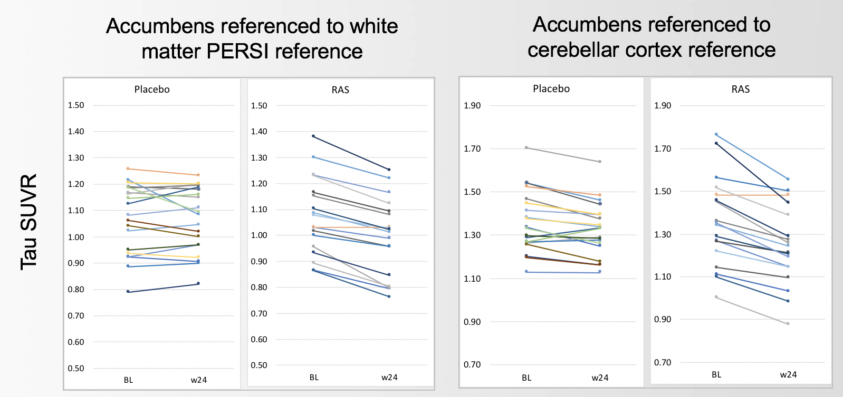

Figure S1. Longitudinal change in accumbens. Individual participant SUVRs are shown at baseline and 24 weeks, referenced to the PERSI white matter region and to cerebellar cortex for comparison. Subcortical decreases are observed in the rasagiline arm but not the placebo arm for both reference regions.

The following potential contributors to the observed subcortical decreases in the rasagiline arm were considered as discussed below: 1) removal of tau; 2) changes in SUVR associated with changes in local blood flow rate; 3) tracer interaction with MAO-B; and 4) tracer interaction with a different off-target entity.

- Removal of tau. Although tau has been identified in the putamen³⁶ of some AD patients, increases observed in flortaucipir binding in putamen, pallidum, and thalamus appear to be related to age rather than to amyloid status or AD progression³⁷. In the accumbens, where the most uniform reductions in flortaucipir signal occurred with rasagiline, only limited tau aggregation has been observed in AD³⁸. Studies have suggested that flortaucipir signal in subcortical regions may be associated with off-target binding^{39,40}. If flortaucipir reductions in the rasagiline arm are due to tau removal, reductions in cortical regions might be expected but were not observed. These considerations suggest that the subcortical reductions in flortaucipir signal may be associated with factors other than removal of tau.

- Impact of blood flow changes on SUVR. Increases in regional blood flow can decrease measured SUVR.⁴¹ However, flortaucipir decreases in the rasagiline arm in caudate, brainstem, and accumbens do not correlate with local increases in FDG, which is often but not always closely coupled with blood flow. Further, the decreases observed in the rasagiline arm are relatively uniform in contrast to the more variable changes observed in FDG or that might be expected in a treatment response. If blood flow is responsible for the SUVR decreases, the lack of correlation could be because blood flow recruitment tends to be an “on/off” event. The role of blood flow could determined using full dynamic scans and kinetic modeling but is not suggested by the present data.

- Flortaucipir binding to MAO-B. Although flortaucipir has not been found to bind strongly to MAO-B in cross-sectional comparisons^{42,43}, it binds weakly in vitro to MAO-B ^{44,45}. The decreases observed in the rasagiline arm are in regions established to be associated with higher MAO-B concentrations and with which rasagiline is known to interact as demonstrated by Freedman.⁴⁶ Within the striatum, the accumbens has been reported in preclinical evaluation to most strongly express MAO-B⁴⁷, and it was in this region that rasagiline related decreases were most uniform. However, the lack of decreases in other cortical regions where MAO-B is known to reside suggest that any MAO-B affinity is weak and superseded by that to tau.

The potential inconsistency between the findings of Smith (lack of apparent cross-sectional affinity) and those of Drake and others (weak in vitro binding) was resolved by examining differences between the placebo and rasagiline arms cross sectionally and with respect to 24-week change. The pallidum was used to approximate the globus pallidus (dorsal pallidum) used by Smith. Figure S2 illustrates the finding that for SUVRs based on either the PERSI or cerebellar reference region, within-subject decreases are not significant relative to intra-subject, cross sectional SUVR variability. Therefore, while the groups do not differ cross-sectionally, their longitudinal change differs significantly. This was also tested and confirmed in the accumbens region. Therefore, the findings by Smith et al, findings by Drake et al, and MAO-B as a possible source of rasagiline related flortaucipir decreases are not inconsistent with one another.

A comparison of these modest yet significant reductions in subcortical flortaucipir signal to the complete depletion of MAO-B by rasagiline demonstrated by Freedman⁴⁶ also suggests that MAO-B binding by flortaucipir is weak.

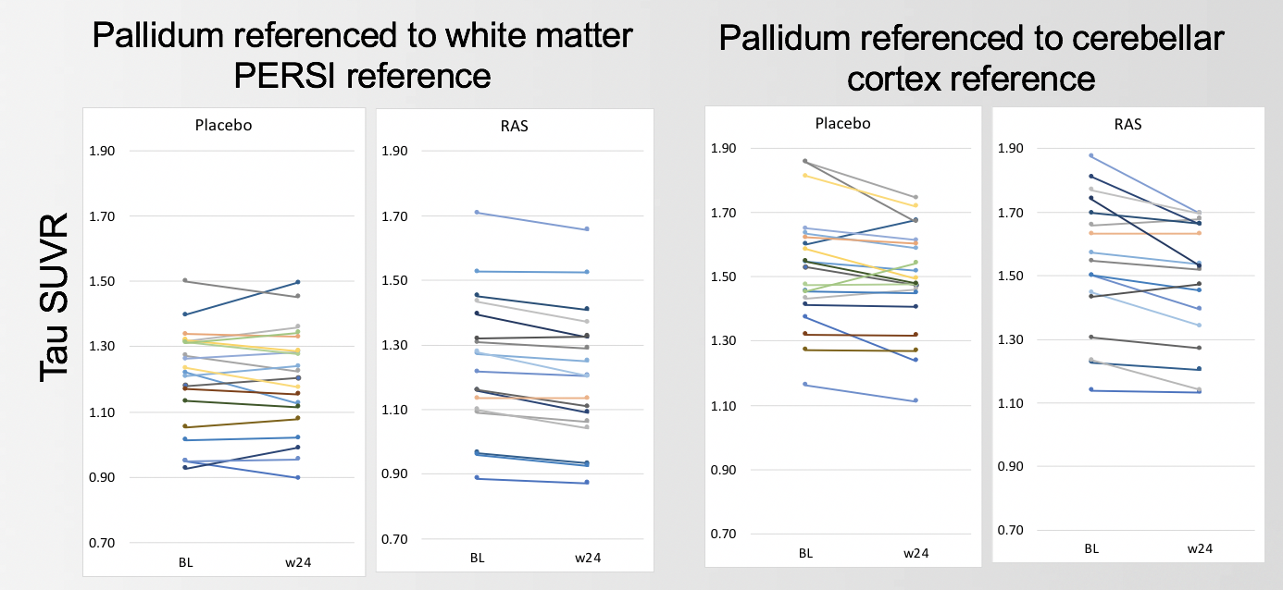

Figure S2. Baseline and 24-week SUVRs in pallidum referenced to white matter PERSI reference and cerebellar cortex reference for placebo and rasagiline arms. The longitudinal decrease in the rasagiline arm does not create a significant difference in cross sectional comparisons across study arms.

- Other off-target binding. It is less likely that another off-target entity has the same binding distribution as MAO-B and would be affected by a selective MAO-B inhibitor, unless this entity is highly similar to MAO-B.

The subcortical decreases observed do not impact baseline patient characterization or comparisons across imaging and clinical measures. They do suggest caution when interpreting changes in flortaucipir SUVR in subcortical regions in the rasagiline study.

Secondary Outcomes Measures: Supplemental Clinical Endpoint Results (Subgroup analyses)

Mild and Moderate Subgroups

Table S1. Moderate Subgroup Baseline Characteristics.

 | Placebo (N=10) | Rasagiline (N=4) | All (N=14) | p-value
Age (S.D.), range (years) | 74·3 (6·8)  (61–84) | 66·3 (5·0)  (62–73) | 72·0 (7·2)  (61–84) | 0·5
Sex (Female/Male) | 0·5/0·5 | 0·75/0·25 | 0·57/0·43 | 0·6
Education | 14·6 (2·0) | 15·3 (1·5) | 14·8 (1·8) | 0·8
MMSE | 14·6 (2·5) | 15·3 (3·4) | 14·8 (2·7) | 0·06
ADAScog-11 | 36·4 (9·9) | 29·3 (1·3) | 34·4 (8·9) | 0·06
ADL | 51·3 (7·1) | 55·8 (1·3) | 52·6 (6·3) | 0·2
COWAT | 15·8 (9·6) | 13.3 (7·4) | 15·1 (8·8) | 0·13
Digit Span | 11·9 (3·3) | 10·8 (2·6) | 11·6 (3·1) | 0·13
NPI | 8·0 (10·4) | 12·0 (9·7) | 9·1 (10·0) | 0·8
QoL-AD | 38·2 (5·0) | 30·0 (3·4) | 35·7 (5·9) | 0·02
Site (1/2/3) | 0·6/0·2/0·2 | 0·5/0·25/0·25 | 0·57/0·21/0·21 | 1·0
APOE4 (carrier/non) | 0·7/0·3 | 0·75/0·25 | 0·71/0·29 | 0·5

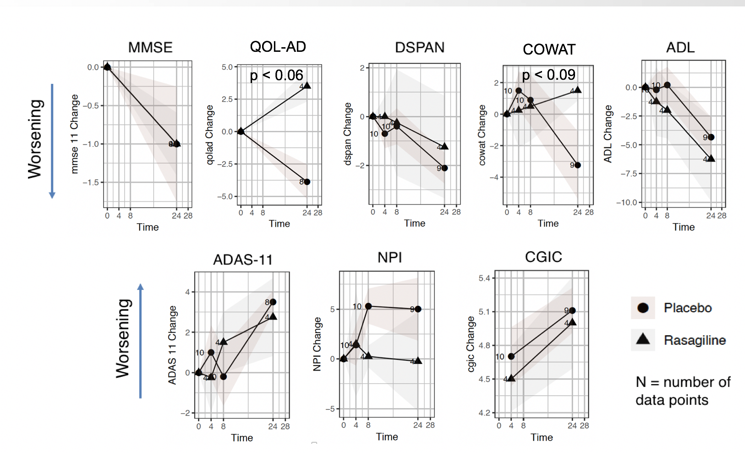

Figure S3. Longitudinal clinical endpoints in the moderate subgroup.

Table S2. Mild Subgroup Baseline Characteristics.

 | Placebo (N=15) | Rasagiline (N=21) | All (N=36) | p-value
Age (S.D.), range (years) | 72·9 (7·5)  (57–84) | 76·3 (6·6)  (63–90) | 74·9 (7·1)  (57–90) | 0·5
Sex (Female/Male) | 0·4/0·6 | 0·52/0·48 | 0·47/0·53 | 0·6
Education | 13·8 (2·5) | 14·1 (3·0) | 14·0 (2·8) | 0·8
MMSE | 22·0 (3·0) | 22·4 (2·2) | 22·2 (2·5) | 0·06
ADAScog-11 | 22·3 (6·5) | 22·1 (5·9) | 22·2 (6·0) | 0·06
ADL | 62·8 (11·0) | 63·1 (8·7) | 63·0 (9·6) | 0·2
COWAT | 24·7 (14·3) | 29·3 (11·8) | 27·4 (12·9) | 0·13
Digit Span | 11·7 (3·3) | 13·5 (2·6) | 12·8 (3·0) | 0·13
NPI | 8·5 (8·3) | 6·8 (7·1) | 7·5 (7·6) | 0·8
QoL-AD | 40·4 (5·4) | 38·2 (4·5) | 39·2 (5·0) | 0·02
Site (1/2/3) | 0·4/0·47/0·13 | 0·52/0·38/0·1 | 0·47/0·42/0·11 | 1·0
APOE4 (carrier/non) | 0·87/0·13 | 0·65/0·35 | 0·73/0·27 | 0·5

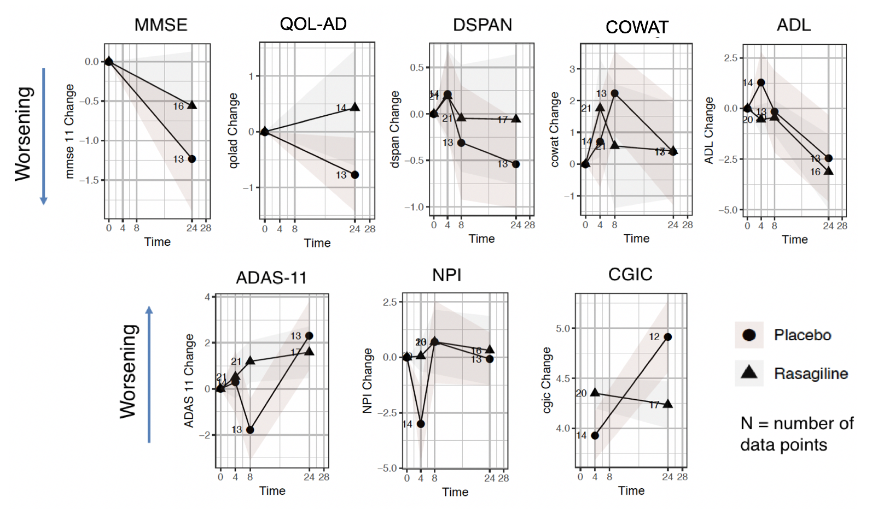

Figure S4. Longitudinal clinical endpoints in the mild subgroup.

Female and Male Subgroups

Table S3. Female Subgroup Baseline Characteristics.

 | Placebo (N=11) | Rasagiline (N=14) | All (N=25) | p-value
Age (S.D.), range (years) | 73·6 (7·4)  (61–84) | 74·8 (7·2)  (63–85) | 74·3 (7·2)  (61–85) | 0·5
Sex (Female/Male) | 1·0/0·0 | 1·0/0·0 | 1·0/0·0 | n/a
Education | 13·1 (2·0) | 13·6 (2·7) | 13·4 (2·4) | 0·8
MMSE | 18·5 (4·6) | 24·3 (6·4) | 25·9 (8·8) | 0·06
ADAScog-11 | 27·9 (11·1) | 22·1 (5·9) | 22·2 (6·0) | 0·06
ADL | 58·7 (10·3) | 59·7 (10·0) | 59·3 (9·9) | 0·2
COWAT | 19·6 (10·4) | 27·3 (14·6) | 23·9 (13·3) | 0·13
Digit Span | 11·6 (2·5) | 13·4 (3·0) | 12·6 (2·9) | 0·13
NPI | 8·1 (9·9) | 6·6 (4·3) | 7·3 (7·2) | 0·8
QoL-AD | 39·3 (5·6) | 36·1 (6·4) | 37·7 (6·1) | 0·02
Site (1/2/3) | 0·45/0·27/0·27 | 0·64/0·21/0·14 | 0·56/0·24/0·20 | 1·0
APOE4 (carrier/non) | 0·64/0·36 | 0·77/0·23 | 0·70/0·30 | 0·5

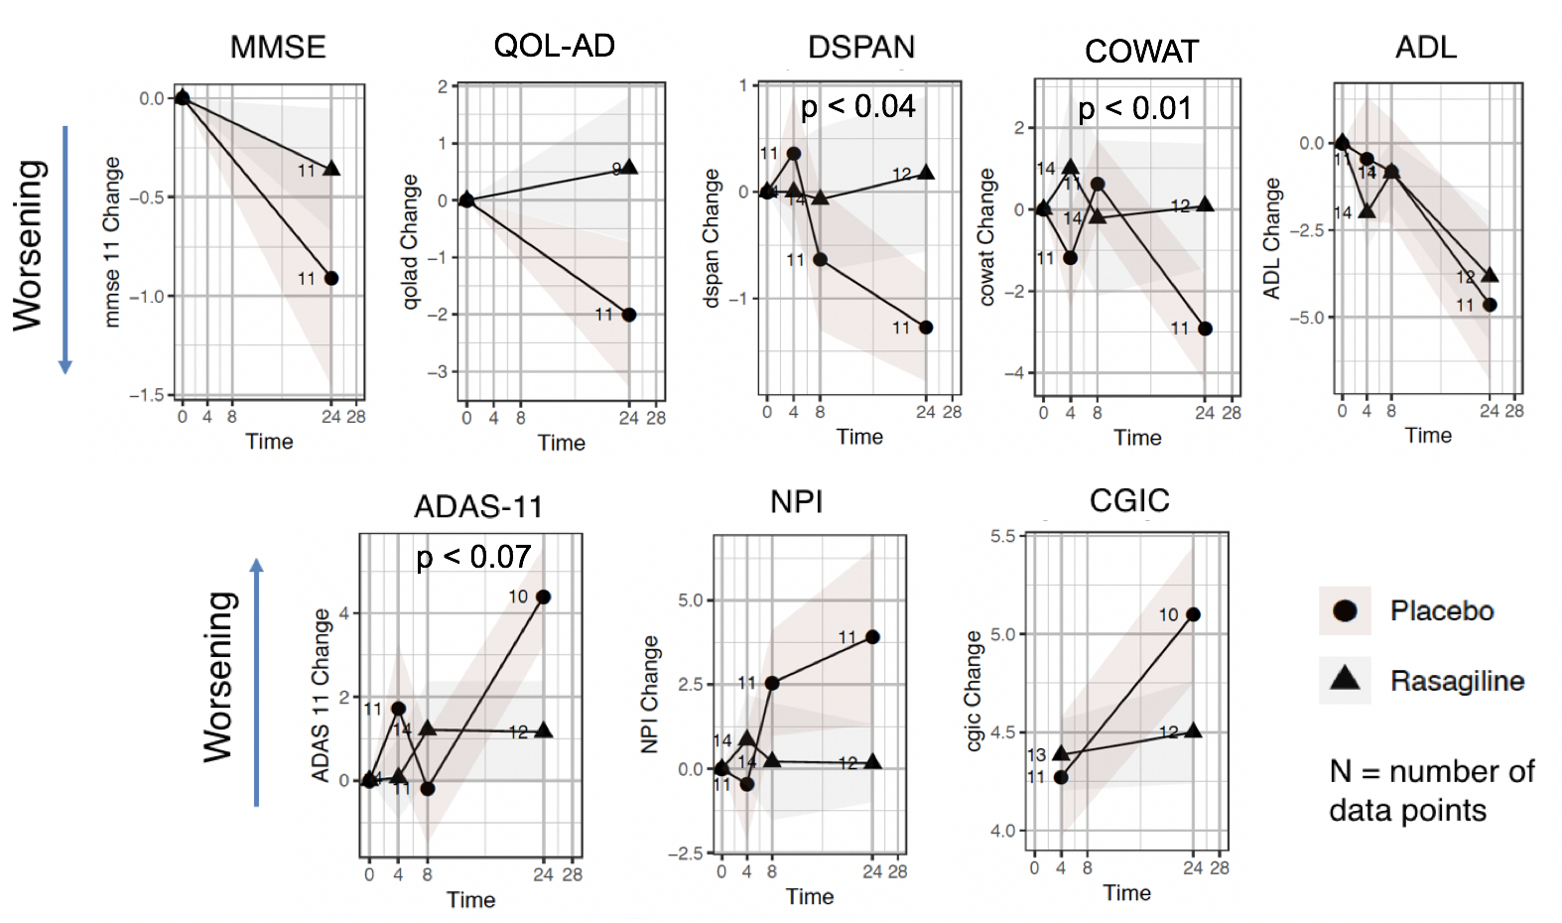

Figure S5. Longitudinal clinical endpoints in the female subgroup.

Table S4. Male Subgroup Baseline Characteristics.

 | Placebo (N=14) | Rasagiline (N=11) | All (N=25) | p-value
Age (S.D.), range (years) | 73·3 (7·2)  (57–84) | 74·6 (7·9)  (62–90) | 73·9 (7·4)  (57–90) | 0·5
Sex (Female/Male) | 0·0/1·0 | 0·0/1·0 | 0·0/1·0 | n/a
Education | 14·9 (2·2) | 15·1 (2·9) | 15·0 (2·5) | 0·8
MMSE | 19·5 (4·7) | 22·6 (2·3) | 20·9 (4·1) | 0·06
ADAScog-11 | 28·0 (10·5) | 21·8 (5·5) | 25·3 (9·1) | 0·06
ADL | 57·8 (12·1) | 64·9 (4·4) | 60·8 (10·1) | 0·2
COWAT | 22·4 (15·3) | 26·0 (10·1) | 24·0 (13·1) | 0·13
Digit Span | 11·9 (3·8) | 12·6 (2·5) | 12·2 (3·2) | 0·13
NPI | 8·4 (8·5) | 9·0 (10·9) | 8·7 (9·4) | 0·8
QoL-AD | 39·9 (5·1) | 37·4 (4·3) | 38·7 (4·8) | 0·02
Site (1/2/3) | 0·5/0·43/0·07 | 0·36/0·55/0·09 | 0·44/0·48/0·08 | 1·0
APOE4 (carrier/non) | 0·93/0·07 | 0·54/0·45 | 0·72/0·28 | 0·5

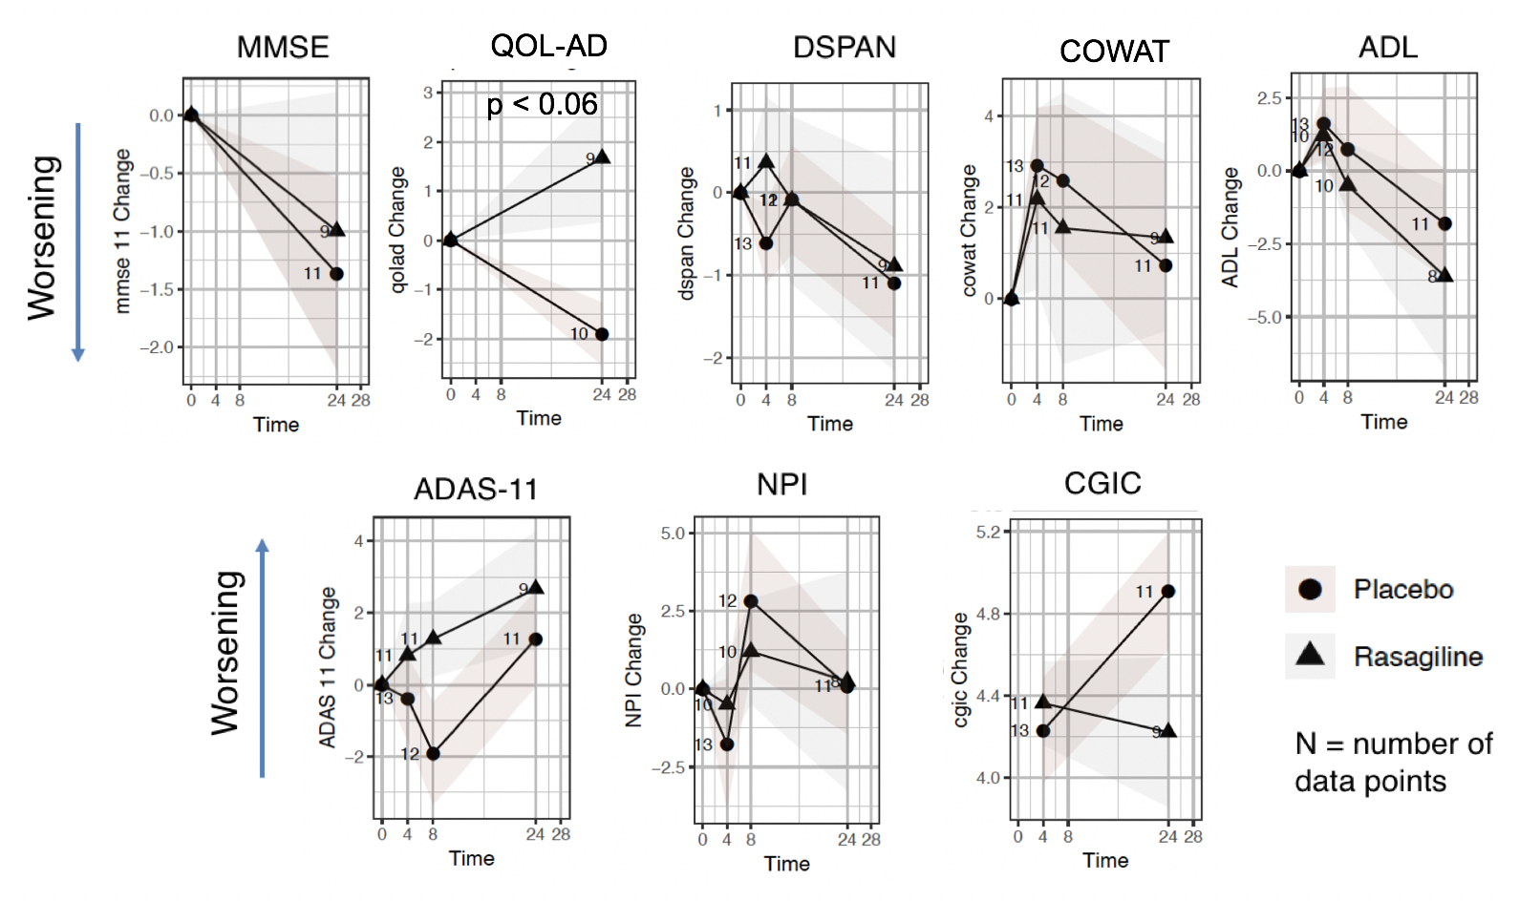
Figure S6. Longitudinal clinical endpoints in the male subgroup.

Younger and Older Subgroups

Table S5. Younger Subgroup Baseline Characteristics

 | Placebo (N=8) | Rasagiline (N=9) | All (N=17) | p-value
Age (S.D.), range (years) | 65·0 (4·8)  (57–71) | 67·0 (3·5)  (62–71) | 66·1 (4·2)  (57–71) | 0·5
Sex (Female/Male) | 0·38/0·62 | 0·44/0·56 | 0·41/0·59 | 0·6
Education | 15·3 (2·2) | 14·7 (1·7) | 14·9 (1·9) | 0·8
MMSE | 19·3 (6·1) | 19·6 (4·6) | 19·4 (5·2) | 0·06
ADAScog-11 | 29·4 (14·8) | 22·9 (6·3) | 25·9 (11·2) | 0·06
ADL | 59·3 (8·3) | 62·4 (6·6) | 60·8 (7·4) | 0·2
COWAT | 24·9 (19·0) | 23·9 (2·7) | 24·0 (13·1) | 0·13
Digit Span | 11·9 (3·8) | 12·6 (2·5) | 12·5 (3·3) | 0·13
NPI | 9·6 (10·0) | 4·4 (8·8) | 6·9 (9·5) | 0·8
QoL-AD | 40·7 (4·0) | 35·5 (5·8) | 37·9 (5·6) | 0·02
Site (1/2/3) | 0·5/0·5/0·0 | 0·44/0·33/0·22 | 0·47/0·41/0·12 | 1·0
APOE4 (carrier/non) | 0·75/0·25 | 0·78/0·22 | 0·76/0·24 | 0·5

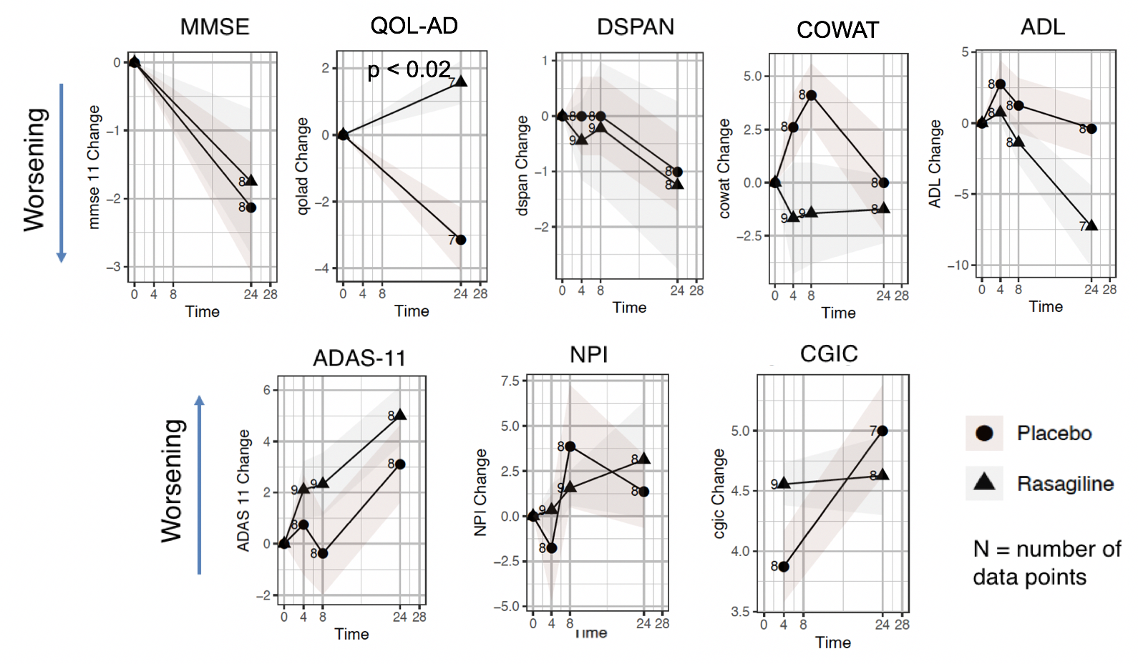
Figure S7. Longitudinal clinical endpoint in the younger subgroup.

Table S6. Older Subgroup Baseline Characteristics

 | Placebo (N=17) | Rasagiline (N=16) | All (N=33) | p-value
Age (S.D.), range (years) | 77·4 (3·7)  (72–84) | 79·1 (4·9)  (72–90) | 78·2 (4·3)  (72–90) | 0·5
Sex (Female/Male) | 0·47/0·53 | 0·62/0·38 | 0·55/0·45 | 0·6
Education | 13·6 (2·2) | 14·1 (3·3) | 13·8 (2·8) | 0·8
MMSE | 18·9 (3·9) | 22·2 (2·5) | 20·5 (3·6) | 0·06
ADAScog-11 | 27·3 (8·3) | 23·4 (6·0) | 25·4 (7·5) | 0·06
ADL | 57·7 (12·4) | 61·6 (9·4) | 59·6 (11·1) | 0·2
COWAT | 19·4 (9·6) | 28·3 (11·2) | 23·7 (11·2) | 0·13
Digit Span | 11·7 (2·9) | 13·2 (2·9) | 12·4 (3·0) | 0·13
NPI | 7·7 (8·7) | 9·5 (6·4) | 8·5 (7·6) | 0·8
QoL-AD | 39·1 (5·7) | 37·4 (5·2) | 38·4 (5·5) | 0·02
Site (1/2/3) | 0·47/0·29/0·24 | 0·56/0·38/0·06 | 0·52/0·33/0·15 | 1·0
APOE4 (carrier/non) | 0·83/0·17 | 0·60/0·40 | 0·72/0·28 | 0·5

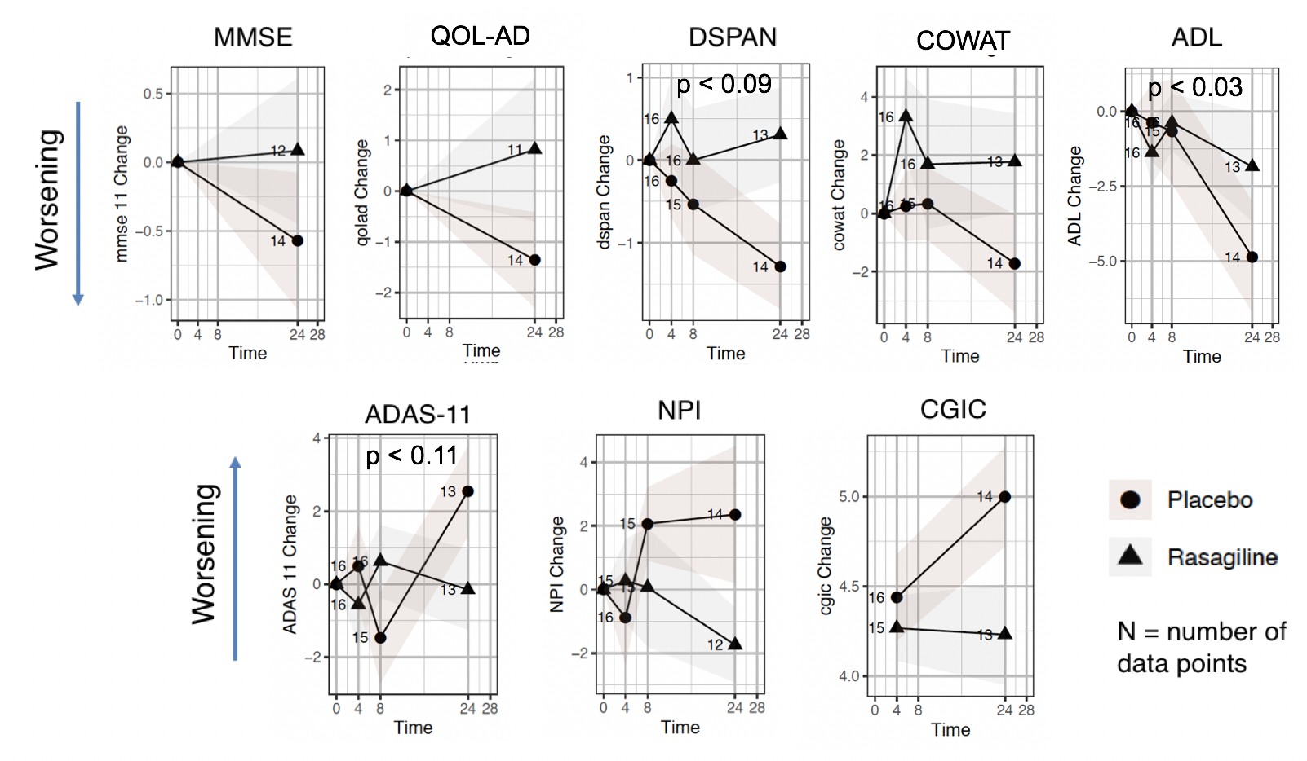

Figure S8. Longitudinal clinical endpoints in the older subgroup.

Supplemental References
- Youdim MB, Amit T, Falach-Yogev M, Bar Am O, Maruyama W, Naoi M. The essentiality of Bcl-2, PKC and proteasome-ubiquitin complex activations in the neuroprotective-antiapoptotic action of the anti-Parkinson drug, rasagiline. Biochem Pharmacol 2003;66:1635-1641.
- Youdim MB, Bar Am O, Yogev-Falach M, et al. Rasagiline: neurodegeneration, neuroprotection, and mitochondrial permeability transition. J Neurosci Res 2005;79:172-179. Review.
- Youdim MB, Weinstock M. Molecular basis of neuroprotective activities of rasagiline and the anti-Alzheimer drug TV3326 [(N-propargyl-(3R)aminoindan-5-YL)-ethyl methyl carbamate]. Cell Mol Neurobiol 2001;21:555-573.
- McKhann G, Drachman D, Folstein M, Katzman R, Price D, Stadlan EM. Clinical diagnosis of Alzheimer's disease: report of the NINCDS-ADRDA Work Group under the auspices of Department of Health and Human Services Task Force on Alzheimer's Disease. Neurology. 1984 Jul;34(7):939-44.
- Folstein MF, Folstein SE, McHugh PR. "Mini-mental state". A practical method for grading the cognitive state of patients for the clinician. J Psychiatr Res. 1975 Nov;12(3):189-98.
- Rosen WG, Mohs RC, Davis KL. A new rating scale for Alzheimer's disease. Am J Psychiatry. 1984 Nov;141(11):1356-64.
- Cummings JL1, Mega M, Gray K, Rosenberg-Thompson S, Carusi DA, Gornbein. The Neuropsychiatric Inventory: comprehensive assessment of psychopathology in dementia J. Neurology. 1994 Dec;44(12):2308-14.
- Galasko D, Bennett D, Sano M, Ernesto C, Thomas R, Grundman M, Ferris S. An inventory to assess activities of daily living for clinical trials in Alzheimer's disease. The Alzheimer's Disease Cooperative Study. Alzheimer Dis Assoc Disord. 1997;11 Suppl 2:S33-9.
- Wechsler DH. Wechsler Adult Intelligence Scale-Revised: Manual. New York: Psychological Corporation; 1981.
- Harrison J, Minassian SL, Jenkins L, Black RS, Koller M, Grundman M. A neuropsychological test battery for use in Alzheimer disease clinical trials. Arch Neurol. 2007 Sep;64(9):1323-9.
- Schneider LS1, Olin JT, Doody RS, Clark CM, Morris JC, Reisberg B, Schmitt FA, Grundman M, Thomas RG, Ferris SH. Validity and reliability of the Alzheimer's Disease Cooperative Study-Clinical Global Impression of Change. The Alzheimer's Disease Cooperative Study. Alzheimer Dis Assoc Disord. 1997;11 Suppl 2:S22-32.
- Logsdon RG, Gibbons LE, McCurry SM, Teri L. Assessing quality of life in older adults with cognitive impairment. Psychosom Med. 2002 May-Jun;64(3):510-9.
- Fischl, B., Salat, D.H., Busa, E., Albert, M., Dieterich, M., Haselgrove, C., van der Kouwe, A., Killiany, R., Kennedy, D., Klaveness, S., Montillo, A., Makris, N., Rosen, B., Dale, A.M., 2002. Whole brain segmentation: automated labeling of neuroanatomical structures in the human brain. Neuron 33, 341-355.
- Iglesias JE, Augustinack JC, Nguyen K, Player CM, Player A, Wright M, Roy N, Frosch MP, McKee AC, Wald LL, Fischl B, Van Leemput K; Alzheimer's Disease Neuroimaging Initiative. A computational atlas of the hippocampal formation using ex vivo, ultra-high resolution MRI: Application to adaptive segmentation of in vivo MRI. Neuroimage. 2015 Jul 15;115:117-37.
- Ashburner J. A Fast Diffeomorphic Image Registration Algorithm. NeuroImage, 38(1):95-113, 2007.
- Hudson, HM, Larkin, RS. Accelerated image reconstruction using ordered subsets of projection data. IEEE Trans. Medical Imaging, 1994: 13 (4), 601–609.
- Matthews DC, Lukic AS, Andrews RD, et. al. Dissociation of Down syndrome and Alzheimer's disease effects with imaging. Alzheimers Dement (N Y). 2016 Jun;2(2):69-81.
- Chen K, Roontiva A, Thiyyagura P, Lee W, Liu X, Ayutyanont N, Protas H, Luo JL, Bauer R, Reschke C, Bandy D, Koeppe RA, Fleisher AS, Caselli RJ, Landau S, Jagust WJ, Weiner MW, Reiman EM; Alzheimer’s Disease Neuroimaging Initiative. Improved power for characterizing longitudinal amyloid-β PET changes and evaluating amyloid-modifying treatments with a cerebral white matter reference region. J Nucl Med. 2015 Apr;56(4):560-6.
- Antonini A1, Leenders KL, Vontobel P, Maguire RP, Missimer J, Psylla M, Günther I. Complementary PET studies of striatal neuronal function in the differential diagnosis between multiple system atrophy and Parkinson's disease. Brain. 1997 Dec;120 ( Pt 12):2187-95.
- Kitaichi Y1, Inoue T, Mitsui N, et. al. Selegiline remarkably improved stage 5 treatment-resistant major depressive disorder: a case report. Neuropsychiatr Dis Treat. 2013;9:1591-4. doi: 10.2147/NDT.S49261.
- Strother SC, Older A, Spring R, Grady C. The NPAIRS Computational Statistics Framework for Data Analysis in Neuroimaging. Proceedings of COMPSTAT'2010 pp 111-120
- Strother SC, Anderson J, Hansen LK, Kjems U, Kustra R, Sidtis J, Frutiger S, Muley S, LaConte S, Rottenberg D. The quantitative evaluation of functional neuroimaging experiments: the NPAIRS data analysis framework. Neuroimage. 2002 Apr;15(4):747-71.
- Baker SL, Maass A, Jagust WJ. Considerations and code for partial volume correcting [18F]-AV-1451 tau PET data. Data Brief. 2017 Oct 16;15:648-657. Data Brief. 2017 Oct 16;15:648-657.
- Southekal S, Devous MD Sr, Kennedy I, Navitsky M, Lu M, Joshi AD, Pontecorvo MJ, Mintun MA. Flortaucipir F 18 Quantitation Using Parametric Estimation of Reference Signal Intensity. J Nucl Med. 2018 Jun;59(6):944-951. doi: 10.2967/jnumed.117.200006.
- Cho H, Choi JY, Lee HS, Lee JH, Ryu YH, Lee MS, Jack CR Jr, Lyoo CH. Progressive tau accumulation in Alzheimer's disease: two-year follow-up study. J Nucl Med. 2019 Mar 29.
- Fleisher AS, Joshi AD, Sundell KL, Chen YF, Kollack-Walker S, Lu M, Chen S, Devous MD Sr, Seibyl J, Marek K, Siemers ER, Mintun MA. Use of white matter reference regions for detection of change in florbetapir positron emission tomography from completed phase 3 solanezumab trials. Alzheimers Dement. 2017 Oct;13(10):1117-1124.
- Chen K, Roontiva A, Thiyyagura P, Lee W, Liu X, Ayutyanont N, Protas H, Luo JL, Bauer R, Reschke C, Bandy D, Koeppe RA, Fleisher AS, Caselli RJ, Landau S, Jagust WJ, Weiner MW, Reiman EM; Alzheimer’s Disease Neuroimaging Initiative. Improved power for characterizing longitudinal amyloid-β PET changes and evaluating amyloid-modifying treatments with a cerebral white matter reference region. J Nucl Med. 2015 Apr;56(4):560-6. doi: 10.2967/jnumed.114.149732.
- Landau SM, Fero A, Baker SL, Koeppe R, Mintun M, Chen K, Reiman EM, Jagust WJ. Measurement of longitudinal β-amyloid change with 18F-florbetapir PET and standardized uptake value ratios. J Nucl Med. 2015 Apr;56(4):567-74.
- Schwarz CG, Senjem ML, Gunter JL, Tosakulwong N, Weigand SD, Kemp BJ, Spychalla AJ, Vemuri P, Petersen RC, Lowe VJ, Jack CR Jr. Optimizing PiB-PET SUVR change-over-time measurement by a large-scale analysis of longitudinal reliability, plausibility, separability, and correlation with MMSE. Neuroimage. 2017 Jan 1;144(Pt A):113-127.
- Jack CR Jr, Wiste HJ, Schwarz CG, Lowe VJ, Senjem ML, Vemuri P, Weigand SD, Therneau TM, Knopman DS, Gunter JL, Jones DT, Graff-Radford J, Kantarci K, Roberts RO, Mielke MM, Machulda MM, Petersen RC. Longitudinal tau PET in ageing and Alzheimer's disease. Brain. 2018 May 1;141(5):1517-1528.
- Braak H, Alafuzoff I, Arzberger T, Kretzschmar H, Del Tredici K. Staging of Alzheimer disease-associated neurofibrillary pathology using paraffin sections and immunocytochemistry. Acta Neuropathol. 2006 Oct;112(4):389-404.
- Schöll M, Lockhart SN, Schonhaut DR, O'Neil JP, Janabi M, Ossenkoppele R, Baker SL, Vogel JW, Faria J, Schwimmer HD, Rabinovici GD, Jagust WJ. PET Imaging of Tau Deposition in the Aging Human Brain. Neuron. 2016 Mar 2;89(5):971-982.
- Müller-Gärtner HW, Links JM, Prince JL, Bryan RN, McVeigh E, Leal JP, Davatzikos C, Frost JJ. Measurement of radiotracer concentration in brain gray matter using positron emission tomography: MRI-based correction for partial volume effects. J Cereb Blood Flow Metab. 1992 Jul;12(4):571-83.
- Shcherbinin S, Schwarz A, Joshi A, Navitsky M, Flitter M, Shankle WR, Devous MD, Mintun MA. Kinetics of the Tau PET Tracer 18F-AV-1451 (T807) in Subjects
- Pontecorvo MJ, DeVous MD, Kennedy I, et. al. A multicentre longitudinal study of flortaucipir (18F) in normal ageing, mild cognitive impairment and Alzheimer’s disease dementia. Brain April 2019. Brain, Volume 142, Issue 6, June 2019, Pages 1723–1735.
- Hamasaki H, Honda H, Suzuki SO, Shijo M, Ohara T, Hatabe Y, Okamoto T, Ninomiya T, Iwaki T. Tauopathy in basal ganglia involvement is exacerbated in a subset of patients with Alzheimer's disease: The Hisayama study. Alzheimers Dement (Amst). 2019 Jun 6;11:415-423. doi: 10.1016/j.dadm.2019.04.008.
- Lowe VJ, Wiste HJ, Senjem ML, Weigand SD, Therneau TM, Boeve BF, Josephs KA, Fang P, Pandey MK, Murray ME, Kantarci K, Jones DT, Vemuri P, Graff-Radford J, Schwarz CG, Machulda MM, Mielke MM, Roberts RO, Knopman DS, Petersen RC, Jack CR Jr. Widespread brain tau and its association with ageing, Braak stage and Alzheimer's dementia. Brain. 2018 Jan 1;141(1):271-287.
- Kawakami I, Hasegawa M, Arai T, Ikeda K, Oshima K, Niizato K, Aoki N, Omi K, Higashi S, Hosokawa M, Hirayasu Y, Akiyama H. Tau accumulation in the nucleus accumbens in tangle-predominant dementia. Acta Neuropathol Commun. 2014 Apr 8;2:40. doi: 10.1186/2051-5960-2-40.
- Marquié M, Normandin MD, Vanderburg CR, et. al. Validating novel tau positron emission tomography tracer [F-18]-AV-1451 (T807) on postmortem brain tissue. Ann Neurol. 2015 Nov;78(5):787-800. doi: 10.1002/ana.24517. Epub 2015 Sep 25. PMID: 26344059; PMCID: PMC4900162.
- Shcherbinin S1, Schwarz AJ2, Joshi A3, Navitsky M3, Flitter M3, Shankle WR4, Devous MD Sr3, Mintun MA3. Kinetics of the Tau PET Tracer 18F-AV-1451 (T807) in Subjects with Normal Cognitive Function, Mild Cognitive Impairment, and Alzheimer Disease. J Nucl Med. 2016 Oct;57(10):1535-1542.
- van Berckel BN1, Ossenkoppele R, Tolboom N, Yaqub M, Foster-Dingley JC, Windhorst AD, Scheltens P, Lammertsma AA, Boellaard R. Longitudinal amyloid imaging using 11C-PiB: methodologic considerations. J Nucl Med. 2013 Sep;54(9):1570-6. doi: 10.2967/jnumed.112.113654.
- Smith R, Schöll M, Londos E, Ohlsson T, Hansson O. 18F-AV-1451 in Parkinson's Disease with and without dementia and in Dementia with Lewy Bodies. Sci Rep. 2018 Mar 16;8(1):4717. doi: 10.1038/s41598-018-23041-x.
- Hansen AK1, Brooks DJ2,3,4, Borghammer P. MAO-B Inhibitors Do Not Block In Vivo Flortaucipir([18F]-AV-1451) Binding. Mol Imaging Biol. 2018 Jun;20(3):356-360. doi: 10.1007/s11307-017-1143-1.
- Drake LR, Pham JM, Desmond TJ, Mossine AV, Lee SJ, Kilbourn MR, Koeppe RA, Brooks AF, Scott PJH. Identification of AV-1451 as a Weak, Nonselective Inhibitor of Monoamine Oxidase. ACS Chem Neurosci. 2019 Aug 5. doi: 10.1021/acschemneuro.9b00326.
- Vermeiren C, Motte P, Viot D, Mairet-Coello G, Courade JP, Citron M, Mercier J, Hannestad J, Gillard M. The tau positron-emission tomography tracer AV-1451 binds with similar affinities to tau fibrils and monoamine oxidases. Mov Disord. 2018 Feb;33(2):273-281. doi: 10.1002/mds.27271. Epub 2017 Dec 26.
- Freedman NM, Mishani E, Krausz Y, Weininger J, Lester H, Blaugrund E, Ehrlich D, Chisin R. In vivo measurement of brain monoamine oxidase B occupancy by rasagiline, using (11)C-l-deprenyl and PET. J Nucl Med. 2005 Oct;46(10):1618-24.
- Ikemoto K1, Kitahama K, Maeda T, Tokunaga Y, Valatx JL, De Maeyer E, Seif I. Electron-microscopic study of MAOB-containing structures in the nucleus accumbens shell: using MAOA-deficient transgenic mice. Brain Res. 1997 Oct 10;771(1):163-6.

