Supplementary Information:
An Analysis of Shear-Dependent Mechanochemical Reaction Kinetics

Resham Rana,¹ Nicholas Hopper,¹ François Sidoroff,² Juliette Cayer-Barrioz,² Denis Mazuyer,² and Wilfred T Tysoe ^{1 *}
¹ Department of Chemistry and Biochemistry, University of Wisconsin-Milwaukee, Milwaukee, WI 53211, USA
² Laboratoire de Tribologie et Dynamique des Systèmes, CNRS UMR5513, Ecole Centrale de Lyon, F-69134 Ecully cedex, France

Kinetic Analysis of Tribochemical Reaction Rates
In the case of a mechanochemical reaction initiated by a normal stress, [1] the kinetics were measured at the center of the contact from the depth of the indent formed by the normal force due to the pressure at that point. In the case of sliding-induced reactions, it is simplest to measure the reaction rate as a function of the average contact stress and to use this to calculate an activation volume for the reaction rates [2, 3]. However, the pressure at a point on the surface varies as the tip slides over that point so that using an average stress will not accurately capture the kinetics details that will provide accurate measurements of mechanochemical reaction rates. The method used in this paper for precisely analyzing the reaction rate is outlined in the following. The reaction rate is measured by rubbing the surface with an AFM tip at various loads where the rate is calculated from the depth at the center of the wear track as a function of the number of passes $n$ of the tip over the surface to measure a (first-order) rate constant. Assuming a Hertzian pressure distribution along a line that passes through the center of the contact, the average contact pressure is $\overline{P}={\frac{2}{3}P}_{0}$, where $P_{0}$ is the pressure at the center of the contact. The rate at a point on the surface at the inlet of the contact is $k_{0}$, the (slow) thermal reaction rate. As the tip moves, the tribochemical rate will increase to a maximum value at the center of the contact and then decrease once again to $k_{0}$ at the outlet. The stress distribution is investigated below. The stress distribution for a Hertzian contact is:
$σ_{N}\left(x\right)=P(x)=P_{0}{\left(1-{\left(\frac{x}{a}\right)}^{2}\right)}^{1/2}$ (S1),
where $σ_{N}$ indicates a normal stress, $a$ is the contact radius and $x$ is the distance from the center of the contact. This indicates that, as the tip passes over a particular point on the surface to induce a reaction, the time dependence of a point in the contact region depends on the contact location with the surface and is given by $\frac{x}{a}=1-\frac{2t}{t_{C}}$, the $t_{C}$ is the total time that a point on the surface is in contact with the tip and equals $t_{C}=v/2a$, where $v$ is the sliding velocity, and thus depends on the contact radius and thus also on the contact stress.
If we assume that the reaction follows first-order kinetics as found for methyl thiolate decomposition on copper, [4] then the rate of change in surface coverage $θ$ is given by $-\frac{dθ}{dt}=k(P\left(t\right))θ$. The equation can easily be adapted to other surface reaction kinetics. This equation can be integrated to yield the change in coverage from $θ_{i}$ to $θ_{f}$ per pass to give:
$-\int_{θ_{i}}^{θ_{f}}{\frac{dθ}{θ}=\int_{0}^{t_{C}}{k(P\left(t\right))dt}}$ (S2).
For a Hertzian stress distribution, $P\left(t\right)=P_{0}{\left(1-{\left(1-\frac{2t}{t_{C}}\right)}^{2}\right)}^{1/2}$, simplifying gives $P\left(t\right)=P_{0}{\left(\frac{4t}{t_{C}}\left(1-\frac{t}{t_{C}}\right)\right)}^{1/2}$. The analysis in the body of the paper gives a Bell dependence of the reaction so that $k\left(P\left(t\right)\right)=k_{0}exp\left(\frac{P\left(t\right)∆V^{‡}}{k_{B}T}\right)$. Substituting into Eqn. S2 and evaluating the integral on the left-hand side of the equation yields:
$ln⁡(\frac{θ_{f}}{θ_{i}})=-\int_{0}^{t_{C}}{k_{0}exp\left(\frac{P_{0}∆V^{‡}}{k_{B}T}{\left(\frac{4t}{t_{C}}\left(1-\frac{t}{t_{C}}\right)\right)}^{1/2}\right)dt}$ (S3).
Substituting $t^{'}=t/t_{C}$ gives:
$ln⁡(\frac{θ_{f}}{θ_{i}})={-k}_{0}t_{C}\int_{0}^{1}{exp\left(\frac{P_{0}∆V^{‡}}{k_{B}T}{\left(4t'\left(1-t'\right)\right)}^{1/2}\right)dt'}$ (S4). Now, the left-hand side of the equation can be written as $ln\left(\frac{θ_{f}}{θ_{i}}\right)=-k_{p}(P_{0})t_{C}$, because it is the coverage change per pass to yield:
$k_{p}(P_{0})=k_{0}\int_{0}^{1}{exp\left(\frac{P_{0}∆V^{‡}}{RT}{\left(4t'\left(1-t'\right)\right)}^{1/2}\right)dt'}$ (S5).
The integral does not have an anti-derivative and must be evaluated either using an expansion of the kernel or numerically. In this case, the integral was evaluated numerically for reasonable values of normal stresses and activation volumes as function of $\frac{P_{0}∆V^{‡}}{k_{B}T}$ and the results are displayed in Figure S1 and is well fitted by an exponential and the integral equals $exp\left(\frac{{0.8764P}_{0}∆V^{‡}}{k_{B}T}\right)$ and gives the rate constant per pass as $k_{p}(P_{0})=k_{0}exp\left(\frac{{0.8764P}_{0}∆V^{‡}}{k_{B}T}\right)$. According to the above equation, such a coverage decrease would occur during a reaction time $t_{C}$ calculated using a rate constant $k\left(\tilde{P}\right)$, where $\tilde{P}$ is a shear-modified normal stress, $\tilde{P}={0.8764P}_{0}=1.3146\overline{P}$. This indicates that using the average pressure to analyze shear-induced reaction rates with an AFM tip with an assumed Hertzian stress distribution can lead to substantial errors. Note that this analysis neglects coupling between the shear and normal stress.
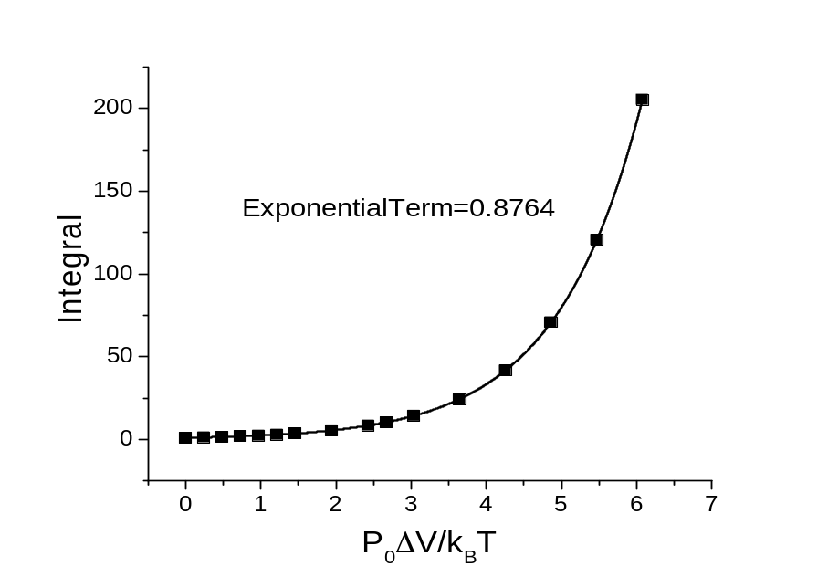
Figure S1. Results of a numerical evaluation of the integral in Eqn. S5.
If the initial coverage is taken to be unity, the first-order change in coverage as a function of the number of passes $n$ is given by $θ_{n}=exp⁡(-k\left(\tilde{P}\right)t_{C}n)$, where $k\left(\tilde{P}\right)$ is the pressure-dependent rate constant and $t_{C}=v/2a$ is the contact time for the tip to move over a point on the surface. This value depends both on the contact pressure, since it affects the value of $a$, and on the velocity of the tip. We can analyze the situation in which a reaction occurs intermittently as the tip slides over a region on the surface by calculating the coverage change from an initial value, $θ_{i}$, to a final coverage $θ_{f}$ after the tip has passed. Thus, the kinetic equation becomes $k(\tilde{P})=k_{0}exp\left(\frac{\tilde{P}∆V^{‡}}{k_{B}T}\right)$, where now the rate constant is measured as a function of time so that $k_{0}$ is a (first-order) rate constant and is the asymptote of a plot of $ln⁡(k\left(\tilde{P}\right))$ versus $\tilde{P}$. The slope is an activation volume which includes both the normal- and stress-stress contributions as outlined in the main text. Here, the asymptotic value can be compared with the thermal rate constant for the reaction measured using temperature-programmed desorption [5].

Figure S2. Distribution of the pull-off forces of the tip used to measure the shear-induced rates of saturated overlayers formed from either diethyl disulfide or ethanethiol. Both curves show identical pull-off forces of ~7 nN that indicate that both molecules form identical ethyl thiolate species on the surface.
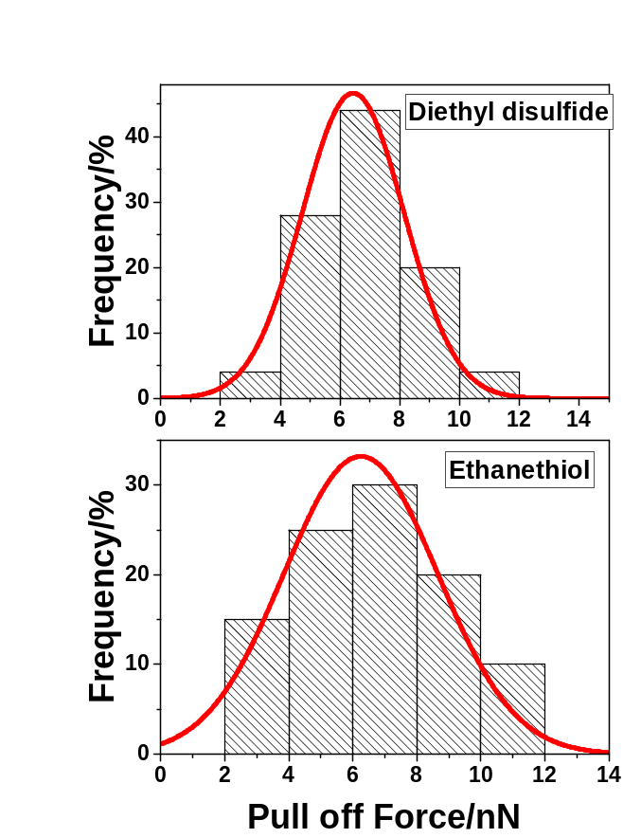

References

[1] Hopper, N., Sidoroff, F., Cayer-Barrioz, J., Mazuyer, D., Tysoe, W.T. A Molecular-Scale Analysis of Pressure-Dependent Sliding Shear Stresses. Tribology Letters 71:121 (2023).
[2] Felts, J.R., Oyer, A.J., Hernández, S.C., Whitener Jr, K.E., Robinson, J.T., Walton, S.G., et al. Direct mechanochemical cleavage of functional groups from graphene. Nat Commun 6 (2015).
[3] Gosvami, N.N., Bares, J.A., Mangolini, F., Konicek, A.R., Yablon, D.G., Carpick, R.W. Mechanisms of antiwear tribofilm growth revealed in situ by single-asperity sliding contacts. Science 348:102-106 (2015).
[4] Miller, B., Furlong, O., Tysoe, W. The Kinetics of Shear-Induced Boundary Film Formation from Dimethyl Disulfide on Copper. Tribology Letters 49:39-46 (2013).
[5] Furlong, O., Miller, B., Li, Z., Tysoe, W.T. The surface chemistry of diethyl disulfide on copper. Surf Sci 605:606-611 (2011).

