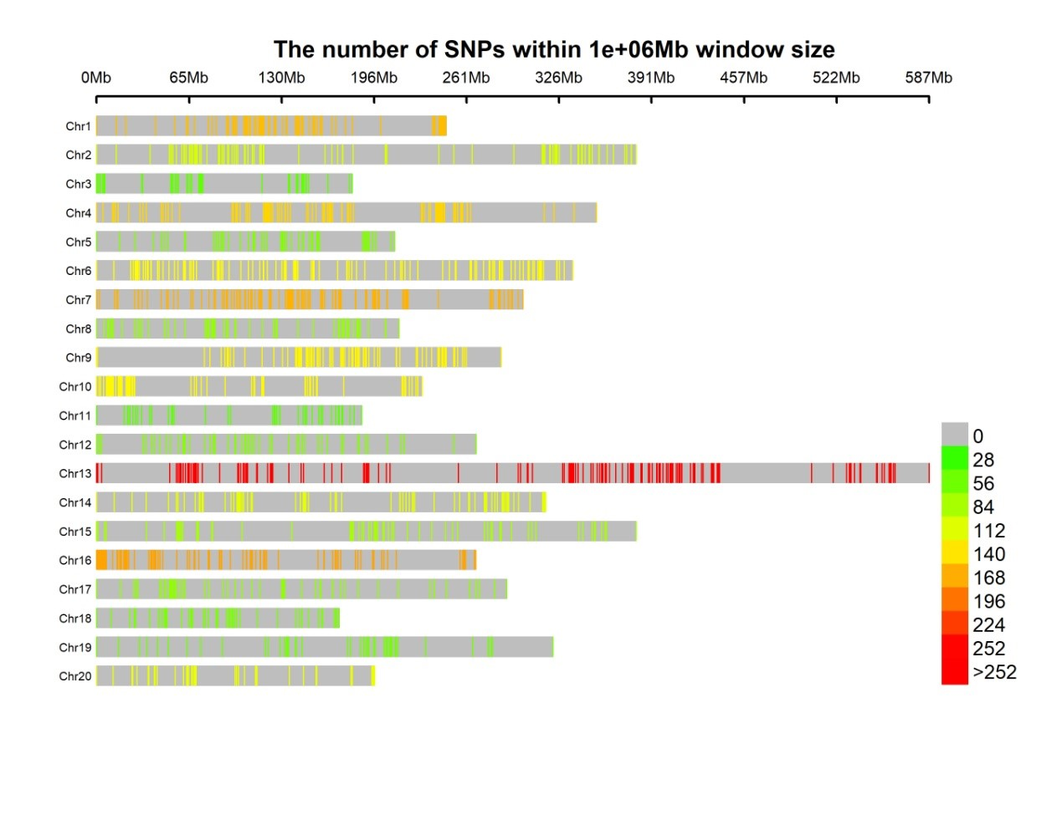
Figure S1 represent Density Map of SNP markers on integrating the two RIL populations

