Supplementary Figure 1: Infiltration of different immune cells in GSE141432(a), GSE94753(b), GSE156906(c), GSE159924(d), and GSE59034 (e).
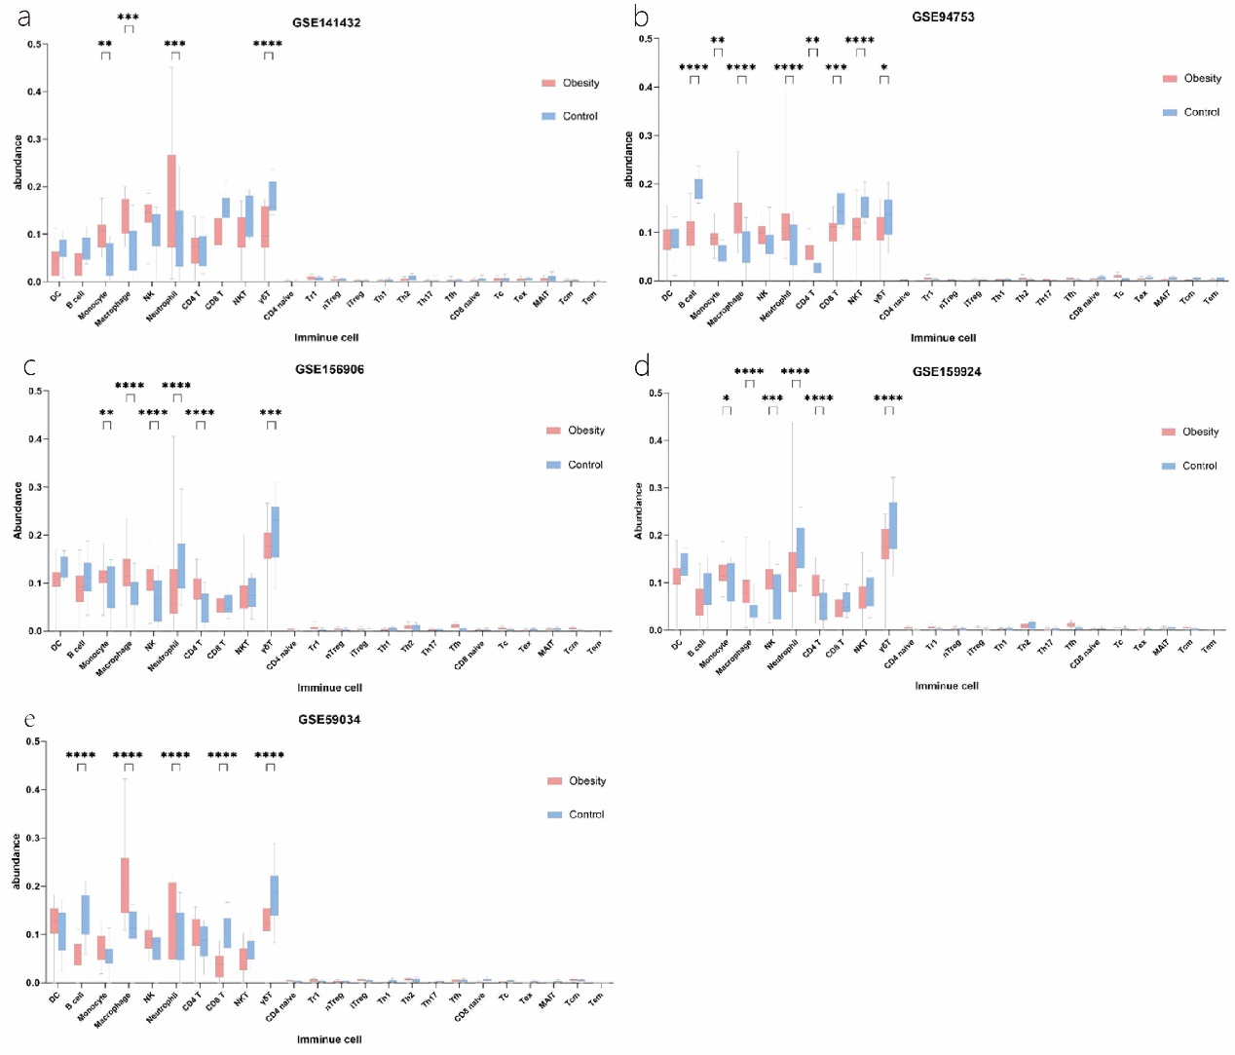

Supplementary Figure 2: Forest plot of the combined Std. Mean Difference for the abundance of iTreg cells (a), B cells (b), NK cells(c), Tr1 cells(d), Th2 cells (e), Tfh cells (f), CD8naive cells (g), Tex cells (h), and γδ T cells (i)in the obese group and control group.
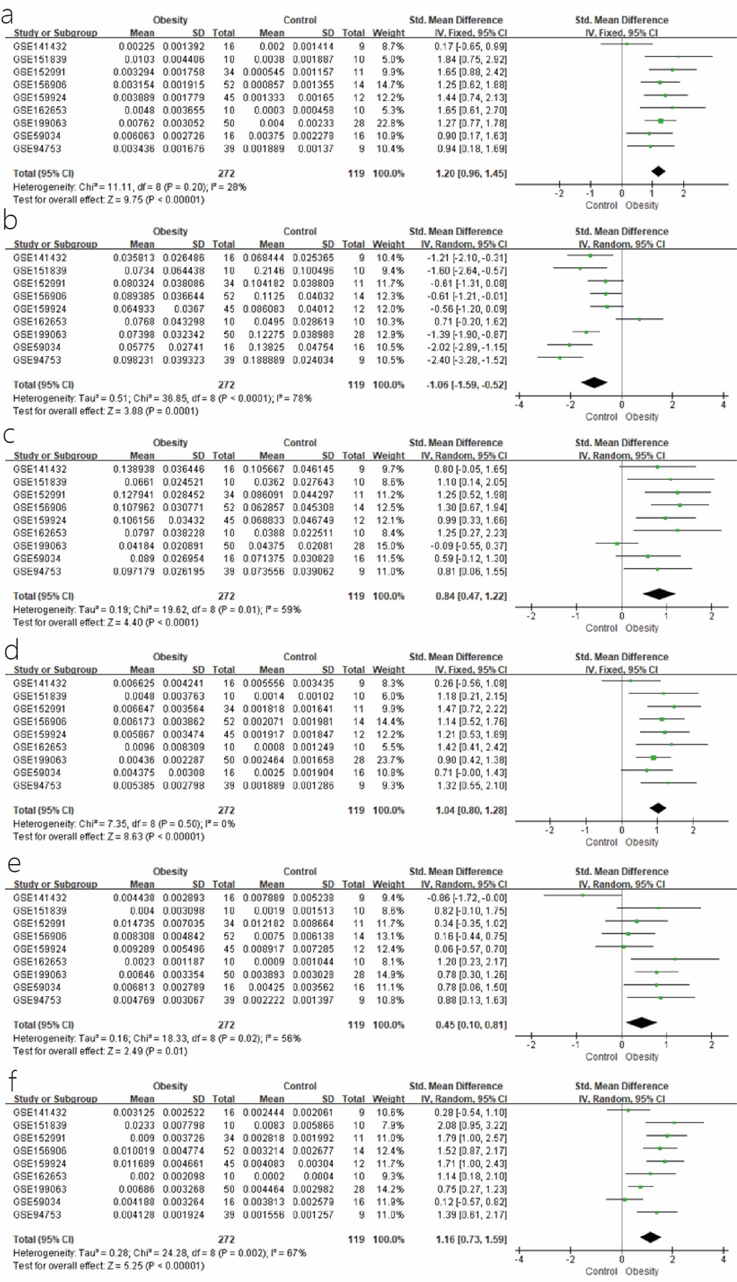
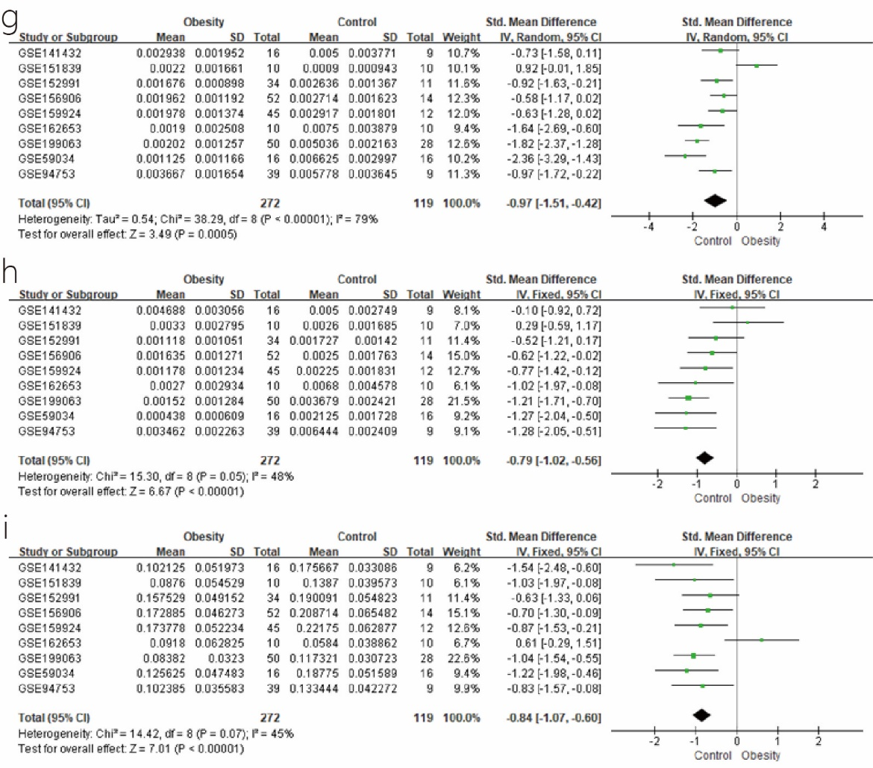

Supplementary Figure 3: Funnel plot of immune infiltration score
