Speech's syllabic rhythm and articulatory features produced under different auditory feedback conditions identify Parkinsonism.
Ángeles Piña Méndez¹, Alan Taitz², Oscar Palacios Rodríguez¹, Ildefonso Rodríguez Leyva³ & M. Florencia Assaneo^{4*}
¹ Faculty of Psychology, Autonomous University of San Luis Potosí, San Luis Potosí, México
² Physics Institute of Buenos Aires (IFIBA) CONICET, Buenos Aires, Argentina
³ Faculty of Medicine, Autonomous University of San Luis Potosí, San Luis Potosí, México
⁴ Institute of Neurobiology, National Autonomous University of Mexico, Querétaro, México.
* Corresponding author (fassaneo@inb.unam.mx)

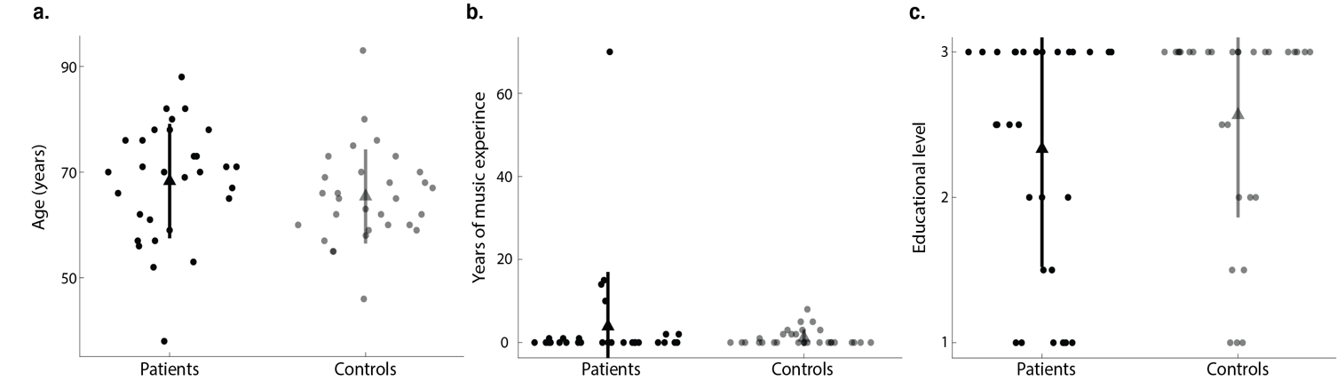

Supplementary Figure 1; Comparison between patients and controls demographic features. a. No significant difference was found in age distribution (Patients: M=68.3 years, SD=10.8; Controls: M=65.4 years, SD=8.9; p=0.12). b. No significant difference was found in years of music experience (Patients: M=3.8 years, SD=13.1; Controls: M=1.1 years, SD=2; p=0.82). c. No significant difference was found in educational level (Patients: M=2.3 years, SD=0.8; Controls: M=2.6, SD=0.7; p=0.22). 1: Completed elementary school. 1.5: Started but not finished high school. 2: Completed high school. 2.5: Started but not finished bachelor’s degree. 3: Completed bachelor’s degree. In all panels, dots represent individual subjects (opaque: patients, shaded: controls), bars represent the standard deviation and triangles represent the mean values.

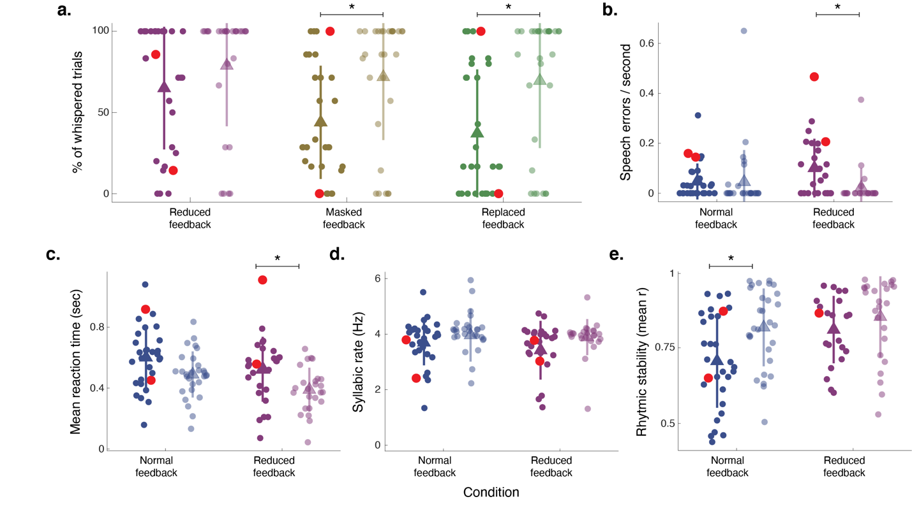
Supplementary Figure 2; Statistical comparisons between the extracted parameters of patients and healthy controls, excluding patients with atypical parkinsonism. a. Percentage of whispered trials across conditions where whispering was required (Reduced: Patients: M=66, SD=38; Control: M=79, SD=37; p=0.102 Masked: Patients: M=43, SD=33; Control: M=72, SD=38; p=0.007; Replaced: Patients: M=36, SD=38; Control: M=70, SD=41; p=0.007). b,c d & e. Errors per second (Normal: Patients: M=0.039, SD=0.069; Control: M=0.043, SD=0.126; p=0.142; Reduced: Patients: M=0.082, SD=0.092; Control: M=0.022, SD=0.076; p=0.004), mean reaction time (Normal: Patients: M=0.59, SD=0.20; Control: M=0.49, SD=0.15; p=0.088; Reduced: Patients: M=0.50, SD=0.18; Control: M=0.39, SD=0.14; p=0.044), mean syllabic rate (Normal: Patients: M=3.74, SD=0.81; Control: M=4.05, SD=0.71; p=0.175; Reduced: Patients: M=3.56, SD=0.87; Control: M=3.94, SD=0.68; p=0.175), and rhythmic stability Normal: Patients: M=0.70, SD=0.16; Control: M=0.81, SD=0.13; p=0.030; Reduced: PD: M=0.81, SD=0.11; Control: M=0.85, SD=0.13; p=0.128), respectively, across Normal and Reduced feedback conditions. In all panels, atypical parkinsonism patients are highlighted in red, other colors identify the different conditions, dots represent individual subjects (opaque: patients, shaded: controls), bars represent the standard deviation, triangles represent the mean values, and *p<0.05.

