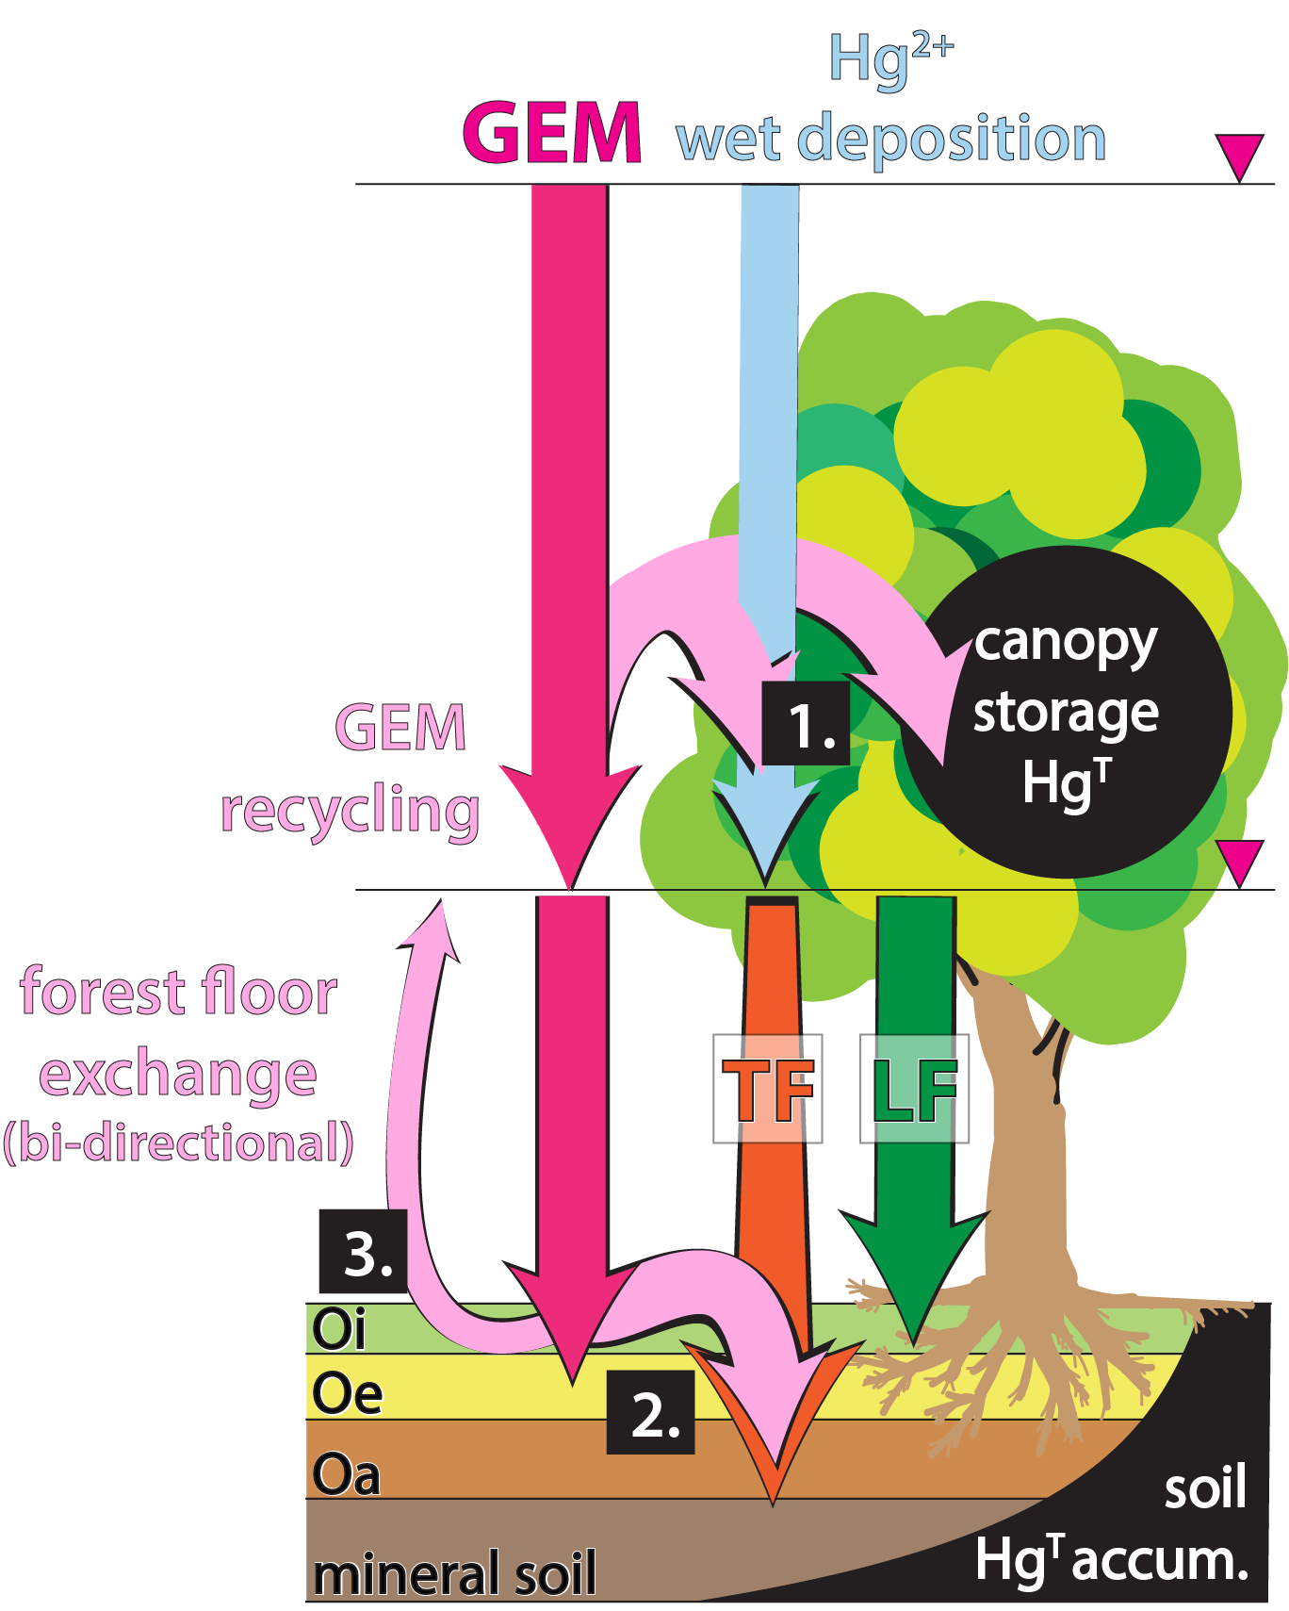
abstract art: conceptual model of atmospheric gaseous elemental mercury (GEM) dynamics in soil Hg accumulation. GEM is assimilated by foliage and enters soils through litterfall (LF). Additional pathways include the rinsing of GEM from the canopy by throughfall (TF) [1] and mobilization of GEM from forest floor to underlying mineral soil [2]. GEM may also be re-emitted from the forest floor back to the atmosphere [3] from where it may be either recycled back through TF and LF or exported to the global pool.

