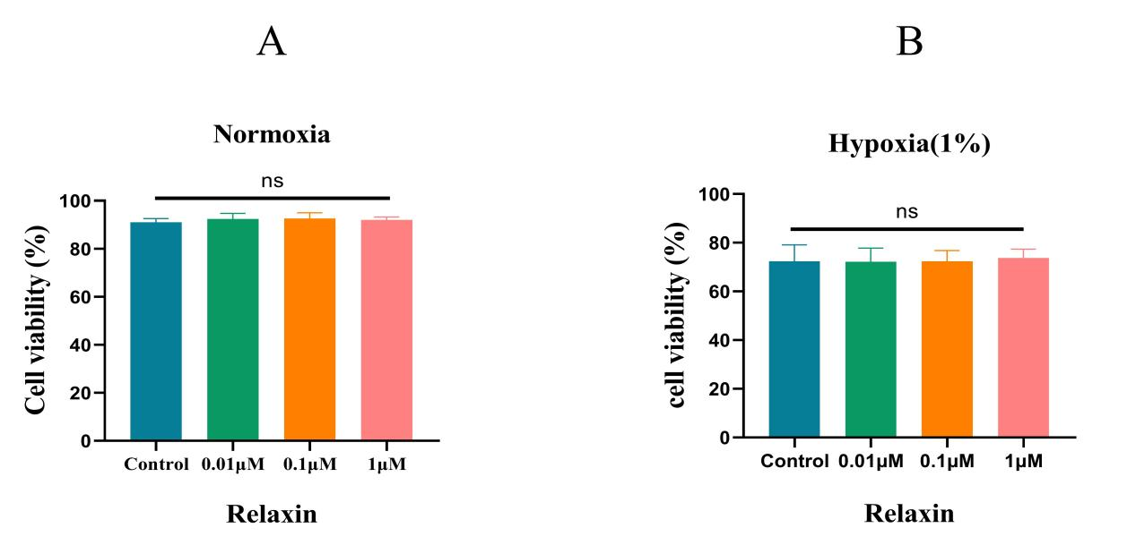

Fig. S1 RLX did not affect the proliferation of Huh-7 cells.(A), (B) the cytotoxicity of RLX (0, 0.01, 0.1, and 1 μM) on normoxia (A)/hypoxia (B) via CCK-8 on Huh-7 cells

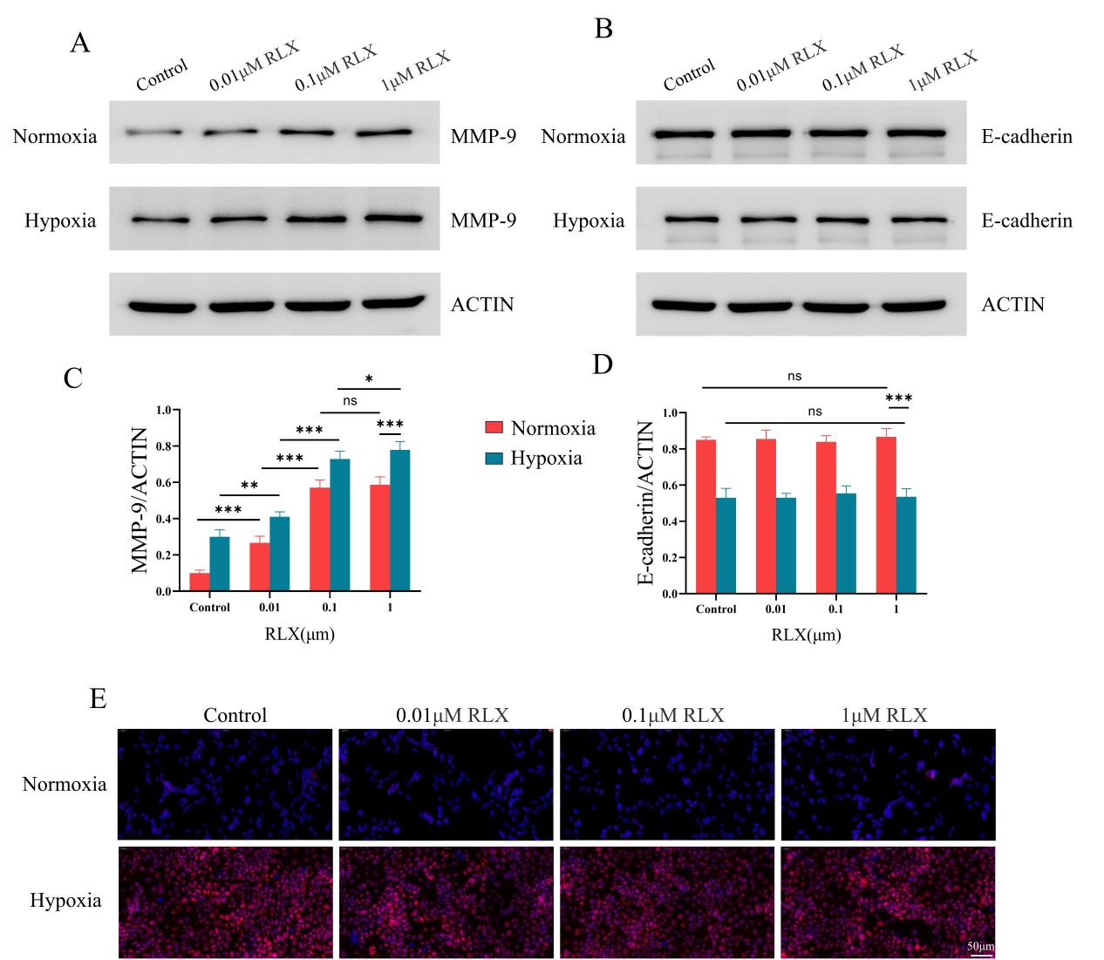
Fig. S2 RLX upregulated the expression of MMP-9 but have no impact on the expression of E-cadherin and HIF-1α in Huh-7 cells. (A) Effects of normoxia/hypoxia and administration RLX (0, 0.01, 0.1, and 1 μM) on MMP-9 expression levels in Huh-7 cells; (B) Quantitative analysis of MMP-9 levels in Huh-7 cells; (C) Effects of normoxia/hypoxia and administration RLX (0, 0.01, 0.1, and 1 μM) on E-cadherin expression levels in Huh-7 cells; (D) Quantitative analysis of E-cadherin levels in Huh-7 cells; (E) Immunofluorescence staining of HIF-1α in each group after RLX administration (0, 0.01, 0.1, and 1 μM) (ns > 0.05, *p < 0.05, **p < 0.01, ***p < 0.001).
MMP-9, matrix metalloproteinases-9; HIF-1α, hypoxia induicible factor-1alpha; RLX, relaxin.

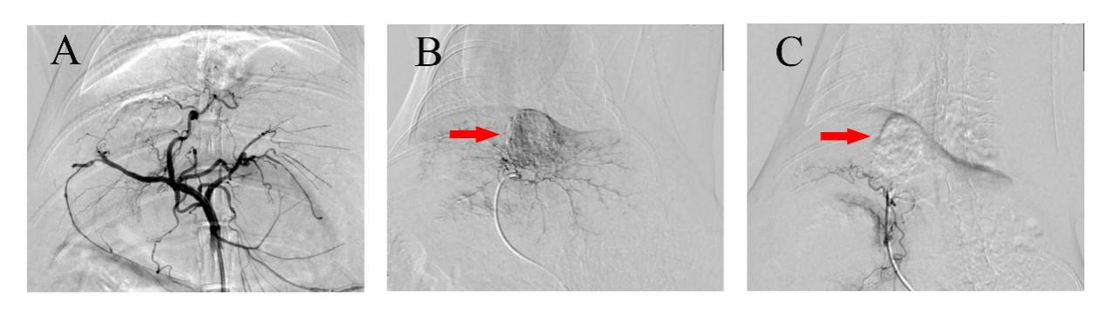
Fig. S3 Schematic diagram of TACE procedure under the guidance of digital subtraction angiography. (A) Angiography was performed to show the common hepatic artery when the catheter reached the abdominal aorta; (B) The microcatheter was super-selectively inserted into the tumor supplying artery and the angiograph displays the hypervascular tumor (red arrow) in the liver; (C) Angiography after TACE shows the lipiodol deposition (red arrow) within the tumor and the complete occlusion of the tumor-feeding artery
TACE, transarterial chemoembolization

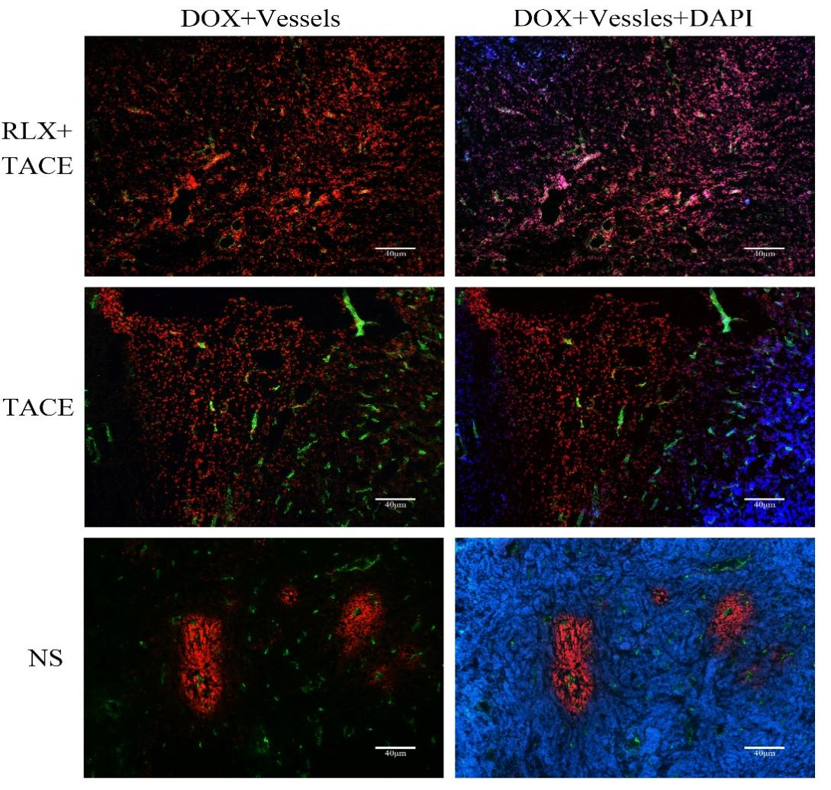
Fig. S4 Immunofluorescence was performed for image analysis to evaluate the pervasion distance of DOX within the tumor stroma in three groups. DOX had the natural red fluorescence, the blood vessels were stained with green fluorescence, and the DAIP had blue fluorescence.
DOX, doxorubicin; RLX, relaxin; TACE, transarterial chemoembolization; NS, normal saline.

Fig. S5 Liver and kidney function analysis and H&E staining of the kidney, spleen, lung, and liver. (A) Liver and kidney function analysis in the three groups before and after treatments over time (means ± SDs; ns > 0.05, *p < 0.05, **p < 0.01, ***p < 0.001)
; (B) H&E staining of kidney, spleen, lung, and liver in different groups 7 days after treatments.
RLX, relaxin; TACE, transarterial chemoembolization; NS, normal saline.

