Supporting Information for

Landslide-channel interactions amplify channel widening during floods

Georgina L Bennett^{1*}, Diego Panici^{1,2}, Francis Rengers³, Jason Kean³, Sara Rathburn⁴
¹ Faculty of Environment, Science and Economy, University of Exeter, UK
² Centre for Resilience in Environment Water and Waste, University of Exeter, UK
³ U.S. Geological Survey, Denver, Colorado, USA
⁴ Department of Geosciences, Colorado State University, Fort Collins, Colorado, USA
*Corresponding author: g.l.bennett@exeter.ac.uk

This PDF file includes:
Methods
Figures S1 to S7
Tables S1 to S2
References

Methods

Channel change analysis
Channel erosion was calculated from pre- and post-flood light detection and ranging (lidar) elevation data detailed in Rathburn et al. (2017). Details on calculation of channel erosion and widening were not provided in Rathburn et al. (2017) and so are provided here. A channel centerline was extracted in TopoToolbox 2 (Schwanghart and Scherler, 2014) from the pre-flood lidar. Points were extracted from this every 20 m, and Thiessen polygons were created around these points (Figure S2). These polygons were clipped into pre- and post-flood channel widths and valley width based on manually mapped extents of these features (Figure S2). Valley width was mapped as the floodplain and any terrace remnants (Clubb et al., 2022), although ideally would be mapped using automated tools (e.g., Clubb et al., 2022) that were less available at the time this analysis was conducted. Channel widening was calculated based on subtraction of pre from post flood channel widths. Eroded volume was calculated in each polygon using the budgeting tools in Geomorphic Change Detection (Wheaton et al., 2010) and was integrated downstream to produce the pattern of cumulative erosion in Figure 2. Channel confinement was calculated as the ratio of valley width to pre-flood channel width following Sholtes et al. (2018).
Runoff-based peak discharge (Q_{runoff}) and stream power estimation
We estimated flood peak discharge (Q_{runoff}) with daily National Centers for Environmental Information radar data routed with a 10-m digital elevation model (DEM) in Topotoolbox2 (Schwanghart and Scherler, 2014). We extracted the drainage network using standard flow-routing algorithms and applied a drainage area threshold of 1 km² to extract the stream network. The position of the stream network was validated against the lidar DEM and showed good visual agreement. We used daily rainfall data from September 11, 2013, on the basis that the main flood peak occurred late on this day once soils were saturated and in response to an increase in rainfall intensity towards the end of the day on September 11 (Gochis et al., 2015; Moody, 2016). This method assumes steady uniform runoff and zero infiltration or storage, which is a reasonable assumption based on the inference that soils became saturated on this day. Despite the coarse nature of rainfall data and the simplistic nature of our runoff modeling, the modeled discharge at the catchment outlet (682 m³/s) is in the same order of magnitude as the indirect peak discharge measurement of 385 ± 80 m³/s (Moody, 2016). Notably the indirect peak discharge estimate was not measured until March and after some of the left bank high water marks had been destroyed by blasting at the mouth of the North Saint Vrain canyon for flood repair work on U.S. Highway 36 (Moody, 2016), which may reduce reliability of this estimate. The overestimation of our modeled discharge compared to this field estimate is in line with assumptions of zero infiltration or storage and gives us a reasonable approximation of discharge and therefore stream power along the North Saint Vrain Creek with which to compare against the pattern of observed channel widening. We calculated total stream power for every 100-m reach from modeled discharge and using the 10-m DEM.

Numerical simulations using r.avaflow
The freely available software r.avaflow is a deterministic model based on the physics of interactions between solid and fluid phases (Pudasaini and Mergili, 2019). The model has been used to simulate topographic changes of the valley floor due to sediment delivery from landslides (Mergili et al., 2020; Mergili and Pudasaini, 2021), debris flows erosion (Baggio et al., 2021), and more recently for the Chamoli disaster in the Indian Himalaya (Shugar et al., 2021). The main principles of the model are based on the Voellmy-type approach, whereby the three phases (i.e., solid, fine, and liquid) interact with each other by momentum balance and energy conservation principles. Input is provided by an elevation map based on the DEM of the study area. For this paper, the DEM resolution was 2-m by 2-m. The model also requires a map (with the same resolution as the DEM) where it is indicated a depth of release (i.e., the depth of material that will initiate motion) for each of the three phases, to simulate the initiation of landsliding. Because the landslides were mostly debris-flow type of coarse size, only solid and liquid phases have been included as release depths, whilst no input has been used for the fine phase. Solid release corresponded to the areas (manually mapped) from which landslides originated and their depths extracted by the DEM of difference (DoD). For the liquid phase, a constant value of 0.20 m was provided in correspondence of the landslide areas to account for the soil saturation estimation at the time of the event. In addition, a flow input at the upstream boundary condition has been applied to both main channel and tributaries by using the estimated velocity V. The model also requires a map for the maximum erodible areas for each phase and associated elevations. In this case, the mapping was provided by the DoD and corresponded to the areas of run-out and channel change observed in the post-event and was used for both solid and liquid phases. The model also requires the definition of several parameters, notably the internal friction and the basal friction (i.e., the friction between the landslide and the basal ground). Variables that have been kept constant in all tests were: the material densities (2700 kg m⁻³ and 1000 kg m⁻³ for solid and fluid phase respectively), the tributary hydrograph (1 m of flow depth and 2.5 m s⁻¹) and the friction coefficients between phases. The main variables that have been changed across the five different tests are displayed in Table S2. These were tested to fully represent the spectrum of key physical quantities in the landslide-channel interactions phenomena and confirm that the dam formation and its subsequent burst was always observed in the simulations, irrespectively of the variation of input parameters. The simulations shown in Figure 4 were based on the parameters employed in Test 1, which has served as pilot test for the other sets of tests.

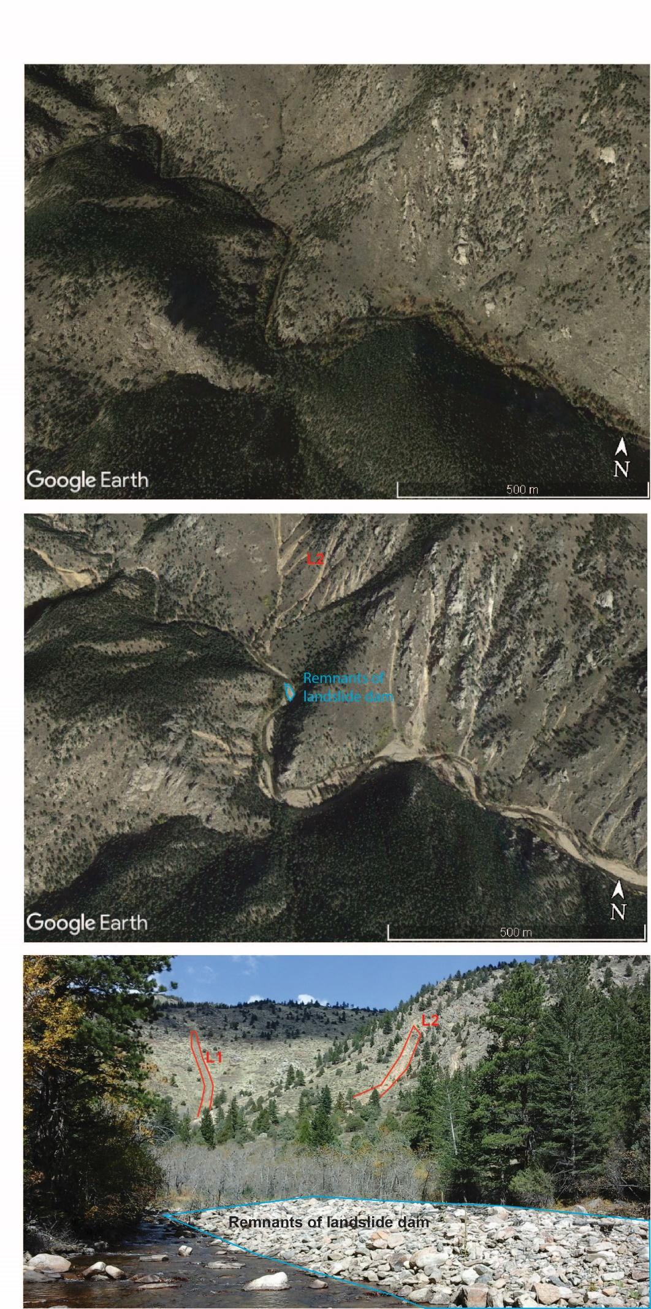
Figure S1 – Remnants of landslide dam. Top panel shows oblique view of the study reach before the flood event. Middle panel shows same view shortly after the flood in Google Earth. L2 is highlighted along with remnants of the modeled landslide dam found in the field in 2016. Lower panel shows parts of L1 and L2 and remnants of the landslide dam as photographed in 2016.

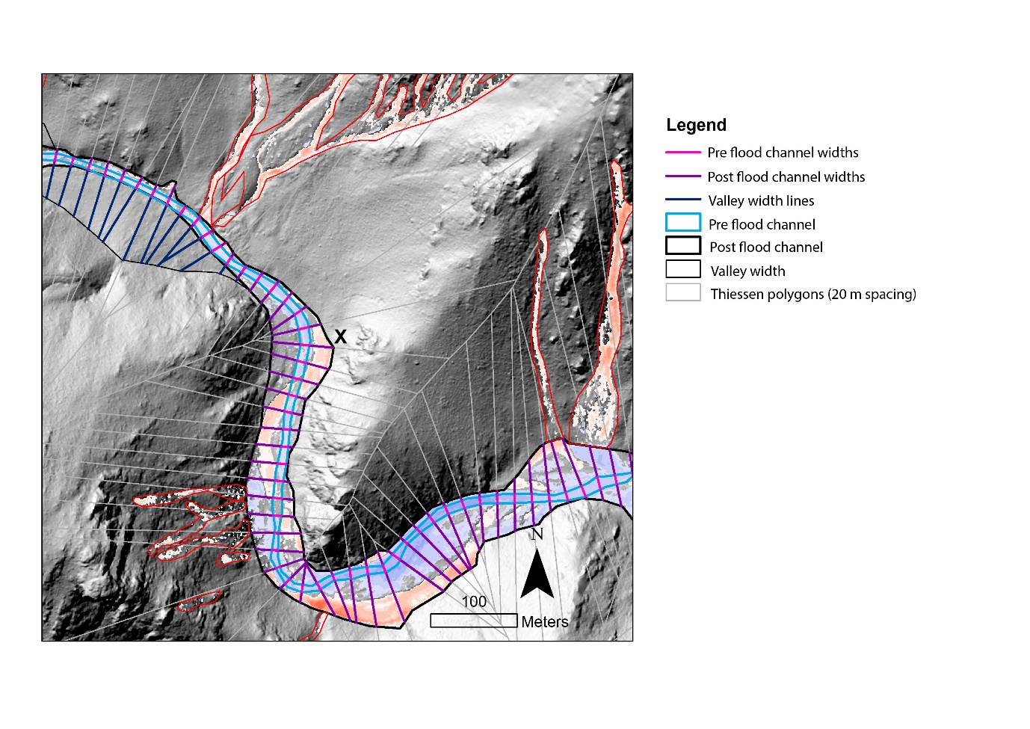

Figure S2 – Creation of channel and valley width polygons and cross sections for calculations of channel widening and channel confinement ratio shown in Figure 2. Note that cross sections in this figure created from Thiessen polygons and used to calculate channel width change are separate from those shown in Figure 1 and defined in S6 and S7 based on highwater marks collected in the field. X indicates the channel bank shown in the photograph in Figure S5.

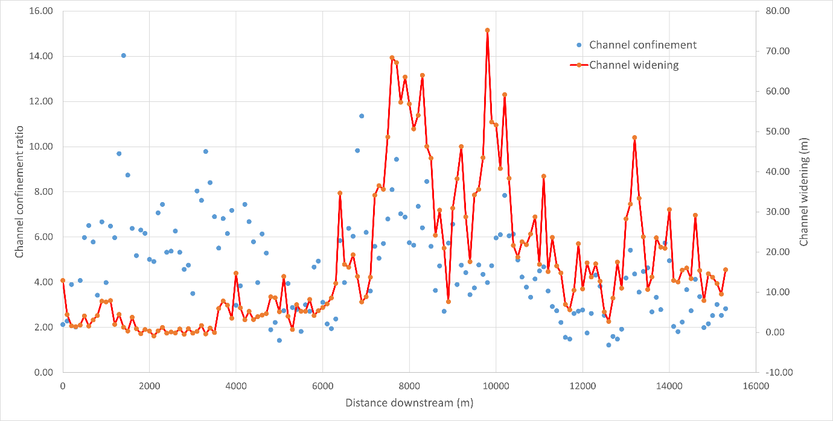
Figure S3 – Channel confinement ratio and channel widening moving downstream showing a reasonable relationship downstream from 7 km, but a poor relationship upstream from this area.
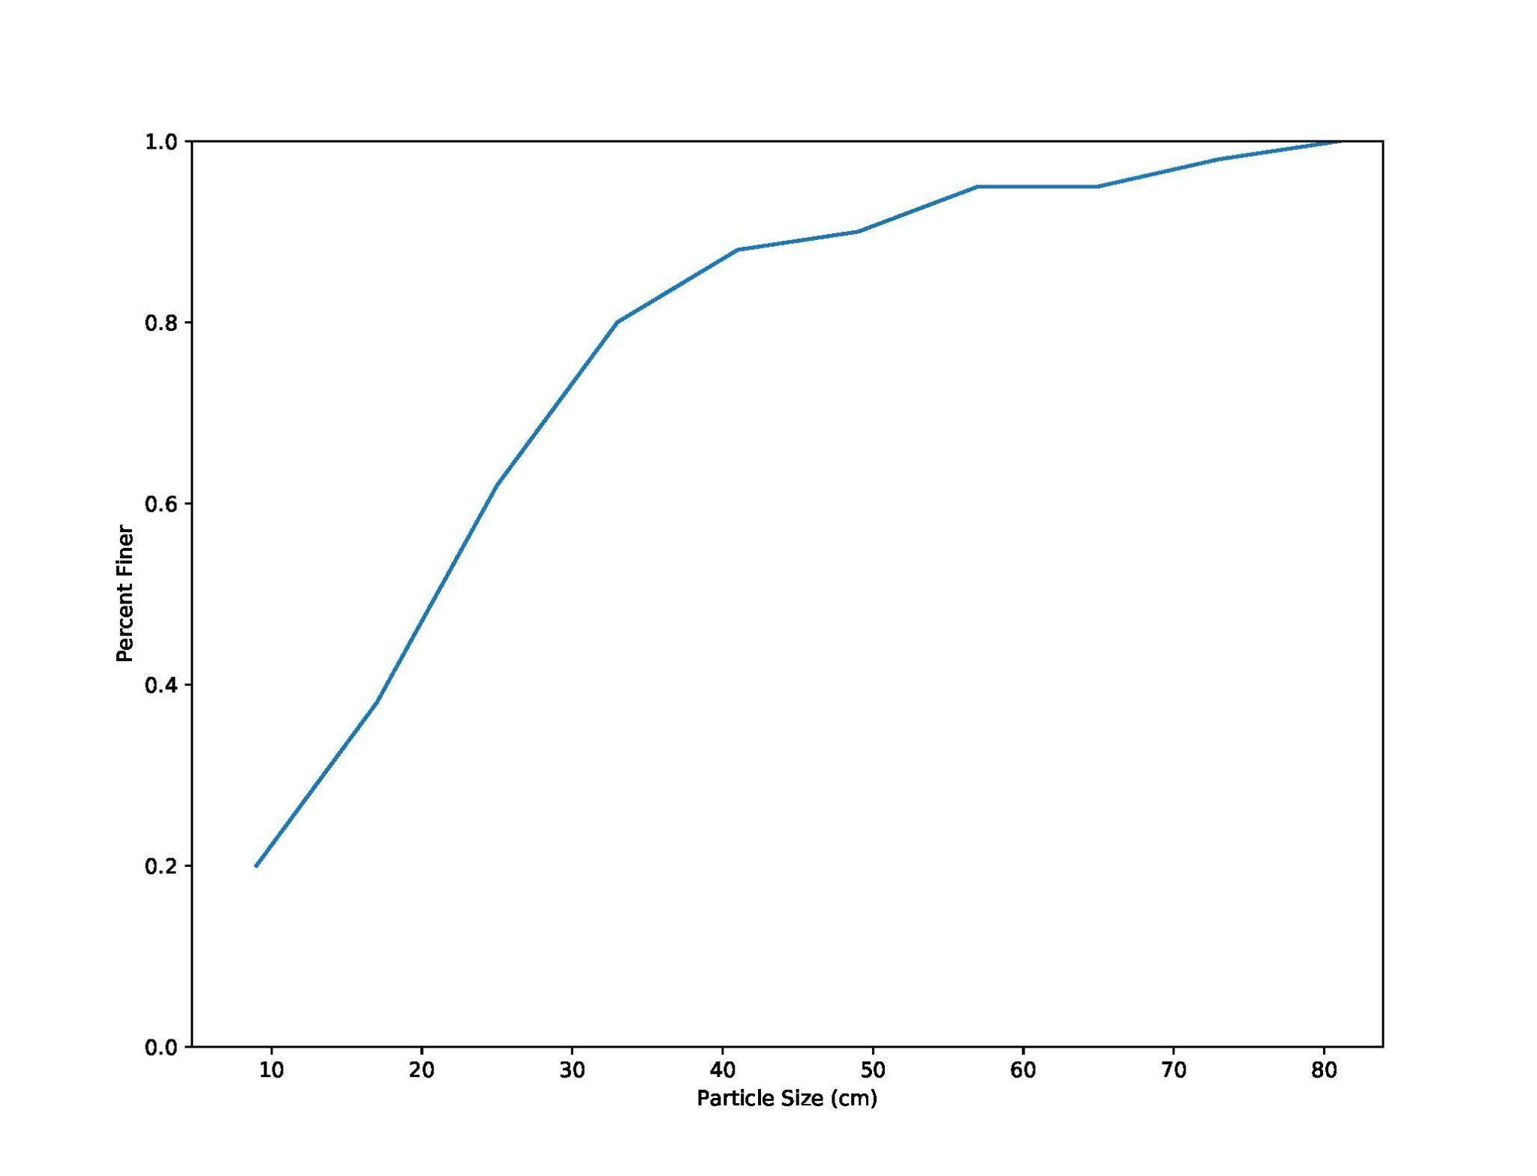
Figure S4 - Grain size distribution of 100 clasts measured from the remnants of the debris dam in 2017 using a Wolman Pebble Count.
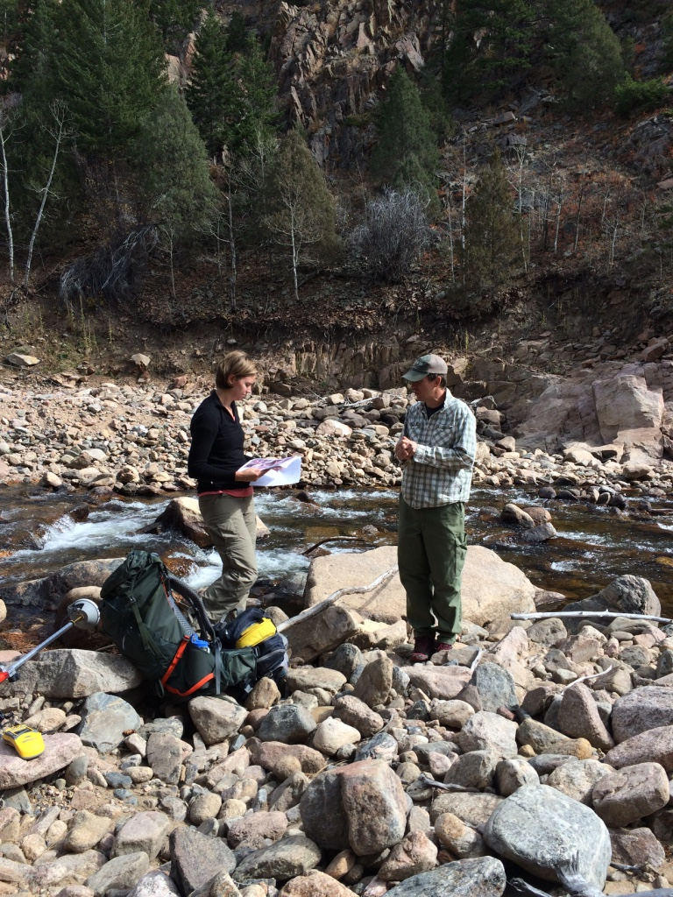
Figure S5 – Field measurements downstream from dam (refer to Figure S2 for rough location of photograph) showing exposure and possible erosion of bedrock on outer bend of the post-flood river channel.

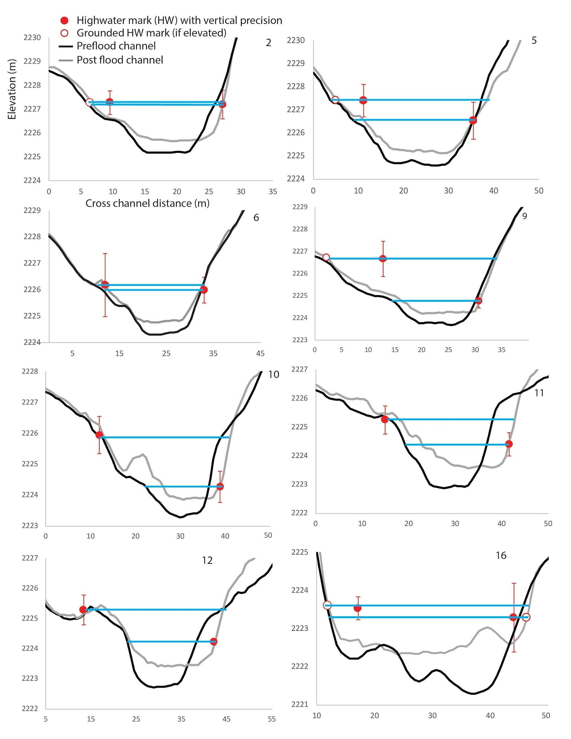
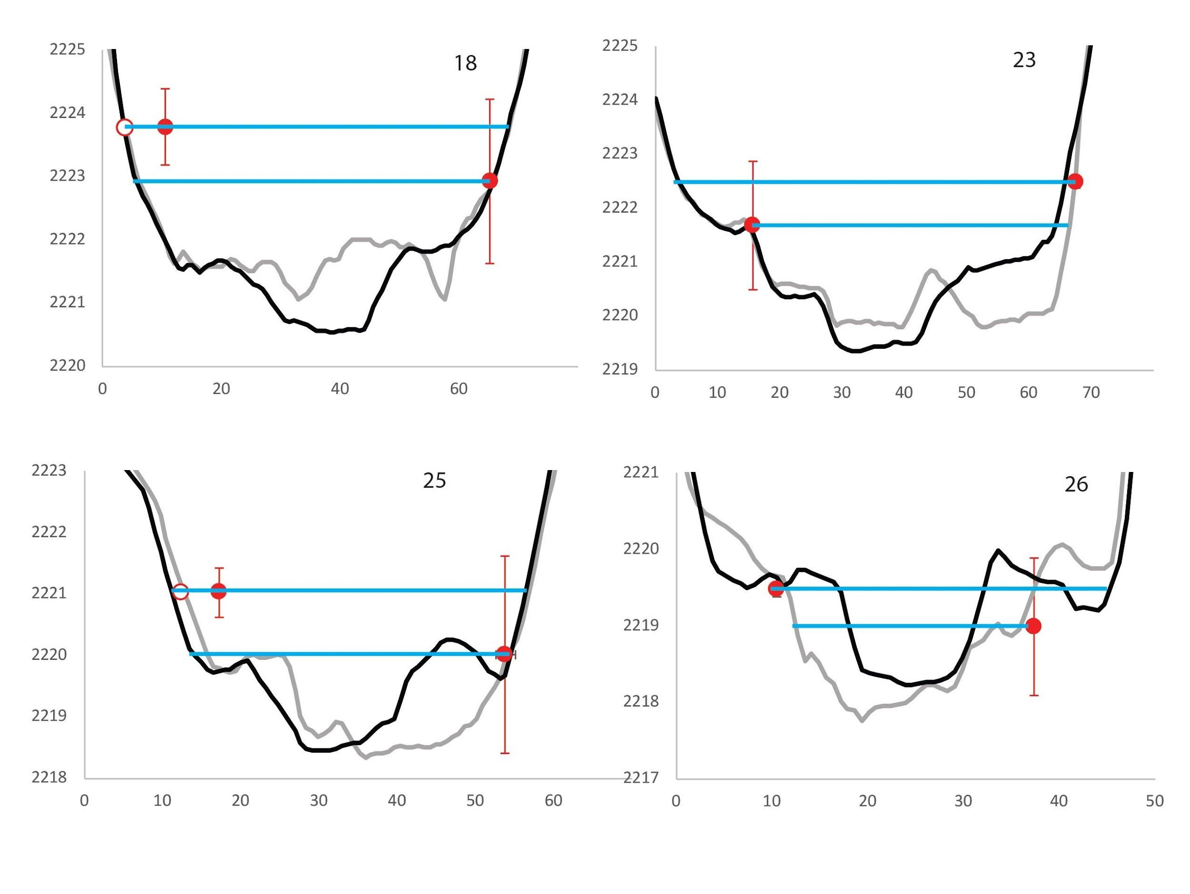
Figure S6- Cross sections constructed from highwater marks collected in 2017 with GPS, shown in Figure 1C in red, with Cross section 2 the farthest upstream. The vertical red lines around the red dots show vertical precision of the GPS elevation measurement. The two blue lines represent the upper and lower highwater levels based on the highwater marks. For each water level, two end member cross sections are extracted based on the post-flood and pre-flood lidar topography. Only cross sections with two highwater marks with a reasonable fit to the lidar surface were used in Q_{peak} estimation.

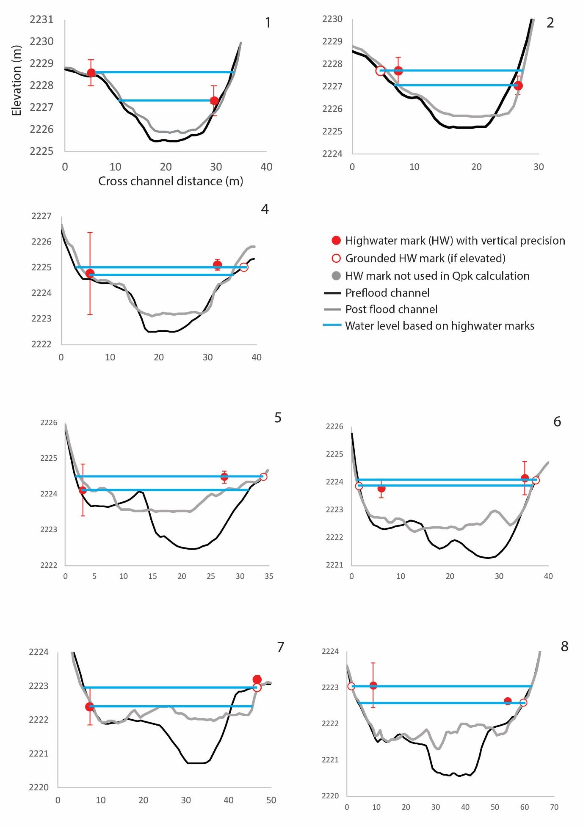
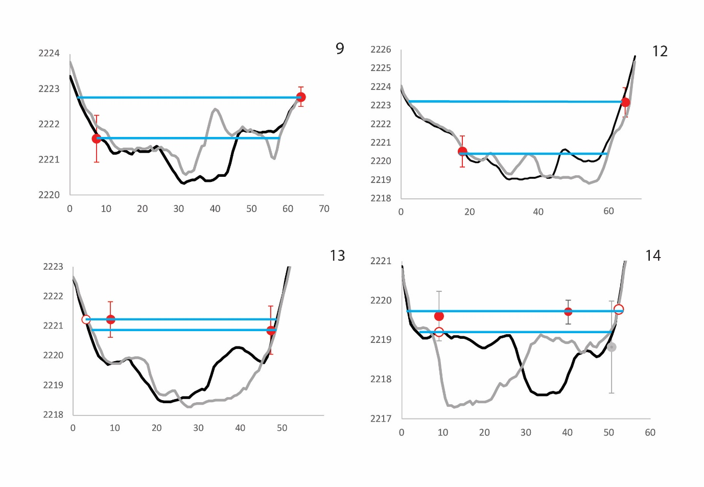
Figure S7 – Cross sections based on pre- and post-flood lidar and paired highwater marks collected in 2016, shown in black in Figure 1C, with Cross section 1 the farthest upstream.

Year | GPS Point ID | Distance downstream (m) | Q_{peak} (m3/s) | Standard Deviation | Error | Q_{runoff} (m3/s) | Ratio of Q_{peak}:Q_{runoff},C | Error in C
2016 | 1 | 6839.17 | 128.66 | 78.81 | 39.40 | 216.91 | 0.59 | 0.18
2017 | 2 | 6852.21 | 84.31 | 13.08 | 6.54 | 216.88 | 0.39 | 0.03
2016 | 2 | 6852.43 | 121.31 | 50.62 | 25.31 | 217.05 | 0.56 | 0.12
2017 | 5 | 6896.37 | 167.59 | 85.49 | 42.75 | 217.11 | 0.77 | 0.20
2017 | 6 | 6909.69 | 71.65 | 9.26 | 4.63 | 217.11 | 0.33 | 0.02
2017 | 9 | 6940.62 | 129.29 | 126.03 | 63.01 | 217.11 | 0.60 | 0.29
2017 | 10 | 6959.39 | 94.82 | 86.28 | 43.14 | 217.11 | 0.44 | 0.20
2017 | 11 | 6979.29 | 95.69 | 48.96 | 24.48 | 217.11 | 0.44 | 0.11
2017 | 12 | 6989.67 | 78.46 | 39.73 | 19.86 | 217.11 | 0.36 | 0.09
2016 | 4 | 7002.21 | 140.92 | 56.08 | 28.04 | 217.77 | 0.65 | 0.13
2016 | 5 | 7028.92 | 63.36 | 31.37 | 15.68 | 217.77 | 0.29 | 0.07
2017 | 16 | 7067.47 | 118.42 | 48.33 | 24.16 | 217.98 | 0.54 | 0.11
2016 | 6 | 7067.70 | 216.91 | 61.96 | 30.98 | 218.22 | 0.99 | 0.14
2017 | 17 | 7090.29 | 113.82 | 98.54 | 49.27 | 217.98 | 0.52 | 0.23
2016 | 8 | 7108.16 | 240.07 | 83.56 | 41.78 | 218.22 | 1.10 | 0.19
2017 | 18 | 7111.25 | 402.67 | 203.26 | 101.63 | 217.98 | 1.85 | 0.47
2016 | 9 | 7117.41 | 172.00 | 112.09 | 56.05 | 218.22 | 0.79 | 0.26
2017 | 23 | 7153.71 | 380.62 | 188.02 | 94.01 | 218.23 | 1.74 | 0.43
2016 | 12 | 7165.84 | 468.81 | 380.65 | 190.33 | 218.31 | 2.15 | 0.87
2016 | 13 | 7179.22 | 260.02 | 126.36 | 63.18 | 218.31 | 1.19 | 0.29
2017 | 25 | 7179.45 | 192.90 | 126.84 | 63.42 | 218.23 | 0.88 | 0.29
2017 | 26 | 7188.86 | 53.46 | 36.84 | 18.42 | 218.23 | 0.24 | 0.08
2016 | 14 | 7194.02 | 56.55 | 7.11 | 3.55 | 218.31 | 0.26 | 0.02
Table S1 - Discharge data shown in Figure 3. For definition of terms in the table, please see main manuscript.

Parameter | Test 1 | Test 2 | Test 3 | Test 4 | Test 5 | Units
Internal friction angle | 35 | 20 | 35 | 35 | 35 | °
Basal friction angle | 20 | 15 | 20 | 20 | 20 | °
Hydrograph velocity | 3.4 | 3.4 | 3.4 | 3.6 | 2.8 | [ms⁻¹]
Hydrograph depth | 1.5 | 1.5 | 1.5 | 1.8 | 1.2 | [m]
Drag exponent coefficient | 2 | 2 | 1 | 2 | 2 | /
Table S2 – Summary of parameters used for modelling tests.

Any use of trade, firm, or product names is for descriptive purposes only and does not imply endorsement by the U.S. Government.

References
Baggio, T., Mergili, M., & D'Agostino, V. Advances in the simulation of debris flow erosion: The case study of the Rio Gere (Italy) event of the 4th August 2017. Geomorphology. 381, 107664 (2021). https://doi.org/10.1016/j.geomorph.2021.107664
Clubb, F. J., Weir, E. F., & Mudd, S. M.: Continuous measurements of valley floor width in mountainous landscapes, Earth Surface Dynamics., 10, 437–456 (2022). https://doi.org/10.5194/esurf-10-437-2022.
Gochis, D., Schumacher, R., Friedrich, K., Doesken, N., Kelsch, M., Sun, J., … Brown, B. The great Colorado flood of September 2013. Bulletin of the American Meteorological Society, 96(9), 1461–1487 (2015). https://doi.org/10.1175/BAMS-D-13-00241.1
Mergili, M., Jaboyedoff, M., Pullarello, J., & Pudasaini, S. P. Back calculation of the 2017 Piz Cengalo-Bondo landslide cascade with r.avaflow: What we can do and what we can learn. Natural Hazards and Earth System Sciences. 20, 2, 505-520, (2020). https://doi.org/10.5194/nhess-20-505-2020.
Mergili, M., & Pudasaini, S. P. Advanced Methods for Simulating Complex Landslides. in Understanding and Reducing Landslide Disaster Risk (eds. Tiwari B., Sassa K., Bobrowsky P.T., & Takara K.) WLF 2020. ICL Contribution to Landslide Disaster Risk Reduction. Springer (2021). https://doi.org/10.1007/978-3-030-60706-7_18
Moody, J. A. Estimates of peak flood discharge for 21 sites in the Front Range in Colorado in response to extreme rainfall in September 2013. U.S. Geological Survey Scientific Investigations Report: 2016–5003 (2016). https://doi.org/10.3133/SIR20165003
Pudasaini, S. P., & Mergili, M. A multi-phase mass flow model. Journal of Geophysical Research: Earth Surface. 124, 12, 2920–2942 (2019). https://doi.org/10.1029/2019JF005204
Rathburn, S. L., Bennett, G. L., Wohl, E. E., Briles, C., McElroy, B., & Sutfin, N. The fate of sediment, wood, and organic carbon eroded during an extreme flood, Colorado Front Range, USA. Geology. 45, 6, 499–502 (2017). https://doi.org/10.1130/G38935.1
Schwanghart, W., & Scherler, D. Short Communication: TopoToolbox 2 – MATLAB-based software for topographic analysis and modeling in Earth surface sciences, Earth Surface Dynamics. 2, 1–7 (2014). https://doi.org/10.5194/esurf-2-1-2014, 2014
Sholtes, J. S., Yochum, S. E., Scott, J. A., & Bledsoe, B. P. Longitudinal variability of geomorphic response to floods. Earth Surface Processes and Landforms, 43, 3099–3113 (2018). https://doi.org/10.1002/esp.4472
Shugar, D. H., et al. A massive rock, ice avalanche caused the 2021 disaster at Chamoli, Indian Himalaya. Science. 373, 6552 (2021). https://doi.org/10.1126/science.abh4455
Wheaton, J. M., Brasington, J., Darby, S. E., & Sear, D. A. Accounting for uncertainty in DEMs from repeat topographic surveys: Improved sediment budgets. Earth Surface Processes and Landforms, 35, 136–156 (2010). doi: 10 .1002 /esp .1886.

