Supplementary materials

Neurotransmitters’ white matter mapping unveils the neurochemical fingerprints of stroke

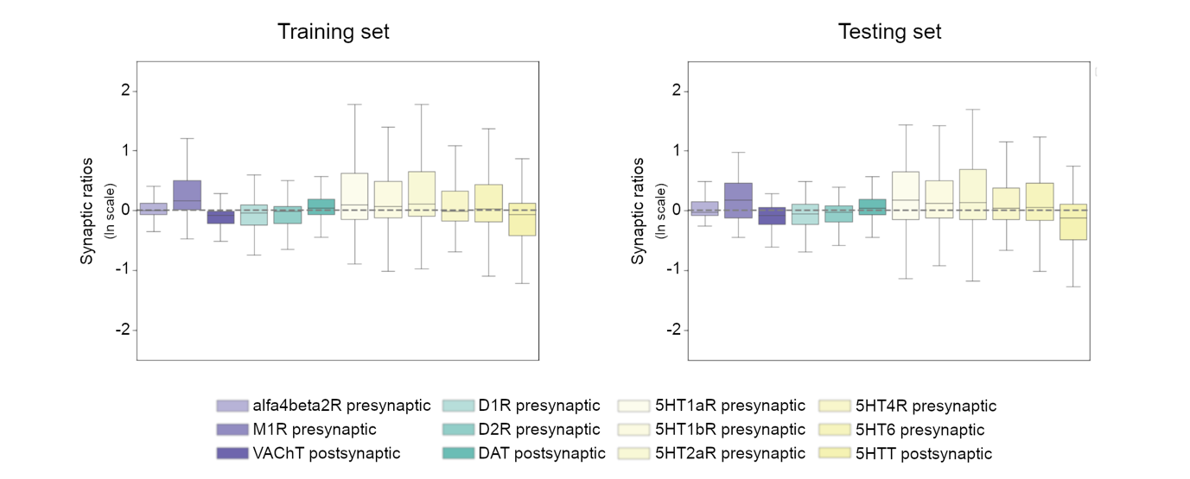
Supplementary figure 1. Distribution of the pre and postsynaptic ratios in the training and testing datasets, in a natural logarithmic scale. Data is shown in a boxplot format. 5HT1aR, serotonin receptor 1a; 5HT1bR, serotonin receptor 1b; 5HT2aR, serotonin receptor 2a; 5HT4R, serotonin receptor 4; 5HT6R, serotonin receptor 6; 5HTT, serotonin transporter; alfa4beta2R, acetylcholine receptor alfa4beta2; D1R, dopamine receptor 1; D2R, dopamine receptor 2; DAT, dopamine transporter; M1R, muscarinic 1 receptor; NAT, noradrenaline transporter; VAChT, acetylcholine vesicular transporter.

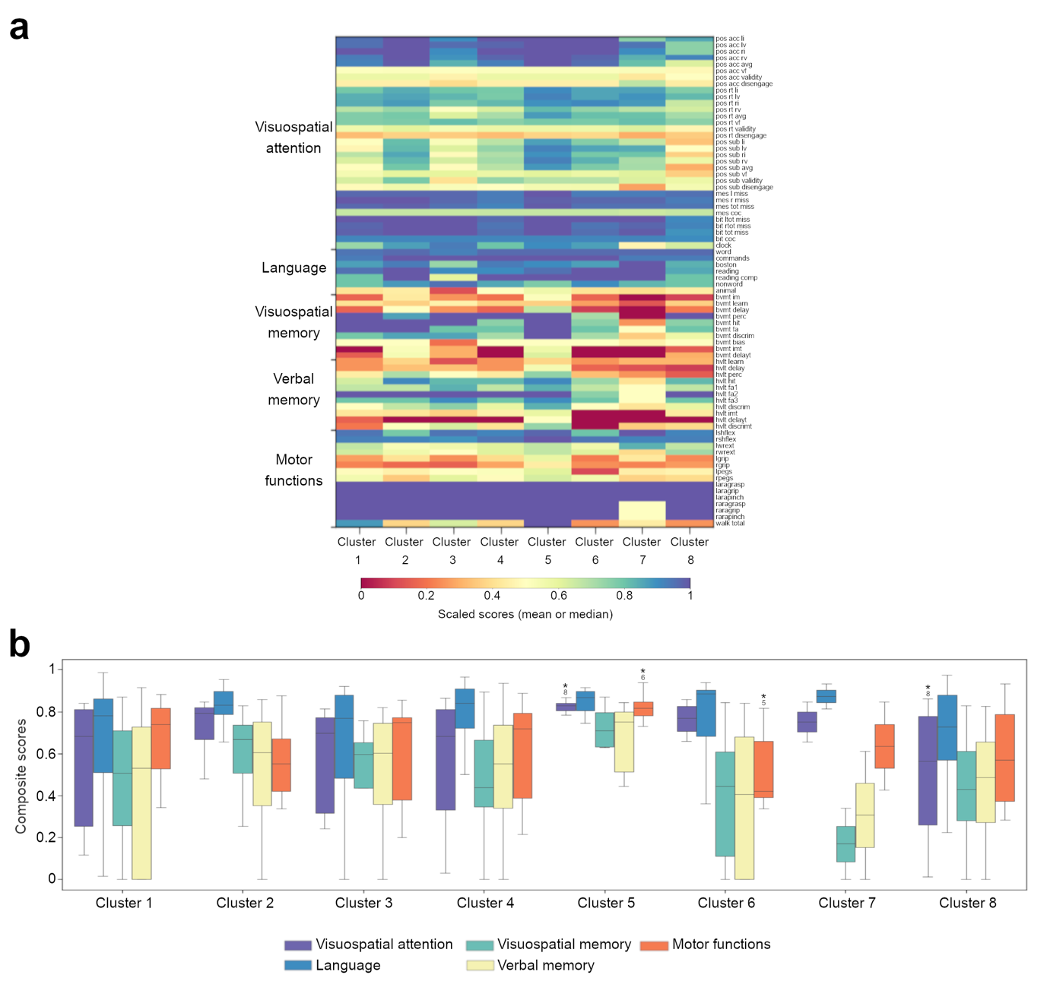
Supplementary figure 2. Behaviour and cognitive profiles by cluster (acute phase of stroke). (a) The colourmap represents the mean or median score (according to data distribution). Tests (right vertical axis) are organized by domains (left vertical axis). (b) Distribution of composite score by cluster. Data is shown in a boxplot format. Asterisks indicate the statistically significant differences in pairwise comparisons. The associated numbers represent the cluster with which a significant difference was found (Bonferroni corrected p-value<0.0018). Depression scores are not presented because the evaluation of depression was not performed in the whole sample in the acute phase. pos, Posner task; mes, Mesulam symbol cancellation test; bit, star cancellation task from the behavioral inattention test; boston, Boston diagnostic aphasia examination naming test; bvmt, brief visuospatial memory test revised; hvlt, Hopkins verbal learning test revised; gds, geriatric depression scale (the full list of abbreviations in presented in the supplementary table 1).
Supplementary table 1. List of behaviour and motor tests abbreviations.
Domain | Test | Score | Abbreviation
Visuospatial attention | Posner task | Accuracy left invalid | pos acc li
Visuospatial attention | Posner task | Accuracy left valid | pos acc li
Visuospatial attention | Posner task | Accuracy right invalid | pos acc ri
Visuospatial attention | Posner task | Accuracy right valid | pos acc ri
Visuospatial attention | Posner task | Accuracy average | pos acc avg
Visuospatial attention | Posner task | Accuracy visual effect | pos acc vf
Visuospatial attention | Posner task | Accuracy validity | pos acc validity
Visuospatial attention | Posner task | Accuracy disengagement | pos acc disengage
Visuospatial attention | Posner task | Reaction time left invalid | pos rt li
Visuospatial attention | Posner task | Reaction time left valid | pos rt lv
Visuospatial attention | Posner task | Reaction time right invalid | pos rt ri
Visuospatial attention | Posner task | Reaction time right valid | pos rt rv
Visuospatial attention | Posner task | Reaction time average | pos rt avg
Visuospatial attention | Posner task | Reaction time visual effect | pos rt vf
Visuospatial attention | Posner task | Reaction time validity | pos rt validity
Visuospatial attention | Posner task | Reaction time disengagement | pos rt disengage
Visuospatial attention | Posner task | Subbing left invalid | pos sub li
Visuospatial attention | Posner task | Subbing left valid | pos sub lv
Visuospatial attention | Posner task | Subbing right invalid | pos sub ri
Visuospatial attention | Posner task | Subbing right valid | pos sub rv
Visuospatial attention | Posner task | Subbing average | pos sub avg
Visuospatial attention | Posner task | Subbing visual effect | pos sub vf
Visuospatial attention | Posner task | Subbing validity | pos sub validity
Visuospatial attention | Posner task | Subbing disengagement | pos sub disengage
Visuospatial attention | Mesulam symbol cancellation test | Left misses | mes lmiss
Visuospatial attention | Mesulam symbol cancellation test | Right misses | mes r miss
Visuospatial attention | Mesulam symbol cancellation test | Total misses | mes tot miss
Visuospatial attention | Mesulam symbol cancellation test | Center of cancellation | mes coc
Visuospatial attention | Star cancellation task | Left misses | bit ltot miss
Visuospatial attention | Star cancellation task | Right misses | bit rtot miss
Visuospatial attention | Star cancellation task | Total misses | bit tot miss
Visuospatial attention | Star cancellation task | Center of cancellation | bit coc
Visuospatial attention | Clock-drawing test |  | clock
Language | Boston diagnostic aphasia examination | Comprehension of listen word | word
Language | Boston diagnostic aphasia examination | Performing listen commands | commands
Language | Boston diagnostic aphasia examination | Picture naming | boston
Language | Boston diagnostic aphasia examination | Sentence reading | reading
Language | Boston diagnostic aphasia examination | Nonword repetition | nonword
Language | Semantic verbal fluency test | Animal name fluency | animal
Visuospatial memory | Brief visuospatial memory test revised | Figure immediate recall | bvmt im
Visuospatial memory | Brief visuospatial memory test revised | Figure learning | bvmt learn
Visuospatial memory | Brief visuospatial memory test revised | Figure delayed recall | bvmt delay
Visuospatial memory | Brief visuospatial memory test revised | Figure percent retained | bvmt perc
Visuospatial memory | Brief visuospatial memory test revised | Figure recognition hit | bvmt hit
Visuospatial memory | Brief visuospatial memory test revised | Figure false alarm | bvmt fa
Visuospatial memory | Brief visuospatial memory test revised | Figure recognition discrimination | bvmt discrim
Visuospatial memory | Brief visuospatial memory test revised | Figure bias | bvmt bias
Visuospatial memory | Brief visuospatial memory test revised | Figure immediate recall t-score | bvmt imt
Visuospatial memory | Brief visuospatial memory test revised | Figure delayed recall t-score | bvmt delayt
Verbal memory | Hopkins verbal learning test revised | Word learning | hvlt learn
Verbal memory | Hopkins verbal learning test revised | Word recall | hvlt delay
Verbal memory | Hopkins verbal learning test revised | Word recall retained | hvlt perc
Verbal memory | Hopkins verbal learning test revised | Word recognition hits | hvlt hit
Verbal memory | Hopkins verbal learning test revised | Word recognition related false alarms | hvlt fa1
Verbal memory | Hopkins verbal learning test revised | Word recognition unrelated false alarms | hvlt fa2
Verbal memory | Hopkins verbal learning test revised | Word recognition false positive | hvlt fa3
Verbal memory | Hopkins verbal learning test revised | Word recognition | hvlt discrim
Verbal memory | Hopkins verbal learning test revised | Word immediate recall t-score | hvlt imt
Verbal memory | Hopkins verbal learning test revised | Word recall t-score | hvlt delayt
Verbal memory | Hopkins verbal learning test revised | Word recognition t-score | hvlt discrimt
Motor functions | Active range of motion test | Left shoulder flexion | lshflex
Motor functions | Active range of motion test | Right shoulder flexion | rshflex
Motor functions | Active range of motion test | Left wrist extension | lwrext
Motor functions | Active range of motion test | Right wrist extension | rwrext
Motor functions | Active range of motion test | Left hand grip strength | lgrip
Motor functions | Active range of motion test | Right hand grip strength | rgrip
Motor functions | Active range of motion test | Left hand peg replacement | lpegs
Motor functions | Active range of motion test | Right hand peg replacement | rpegs
Motor functions | Action research arm test | Left hand grasp | laragrasp
Motor functions | Action research arm test | Left hand grip | laragrip
Motor functions | Action research arm test | Left hand pinch | larapinch
Depression | Geriatric depression scale |  | gds

