Supplement 1 Figures

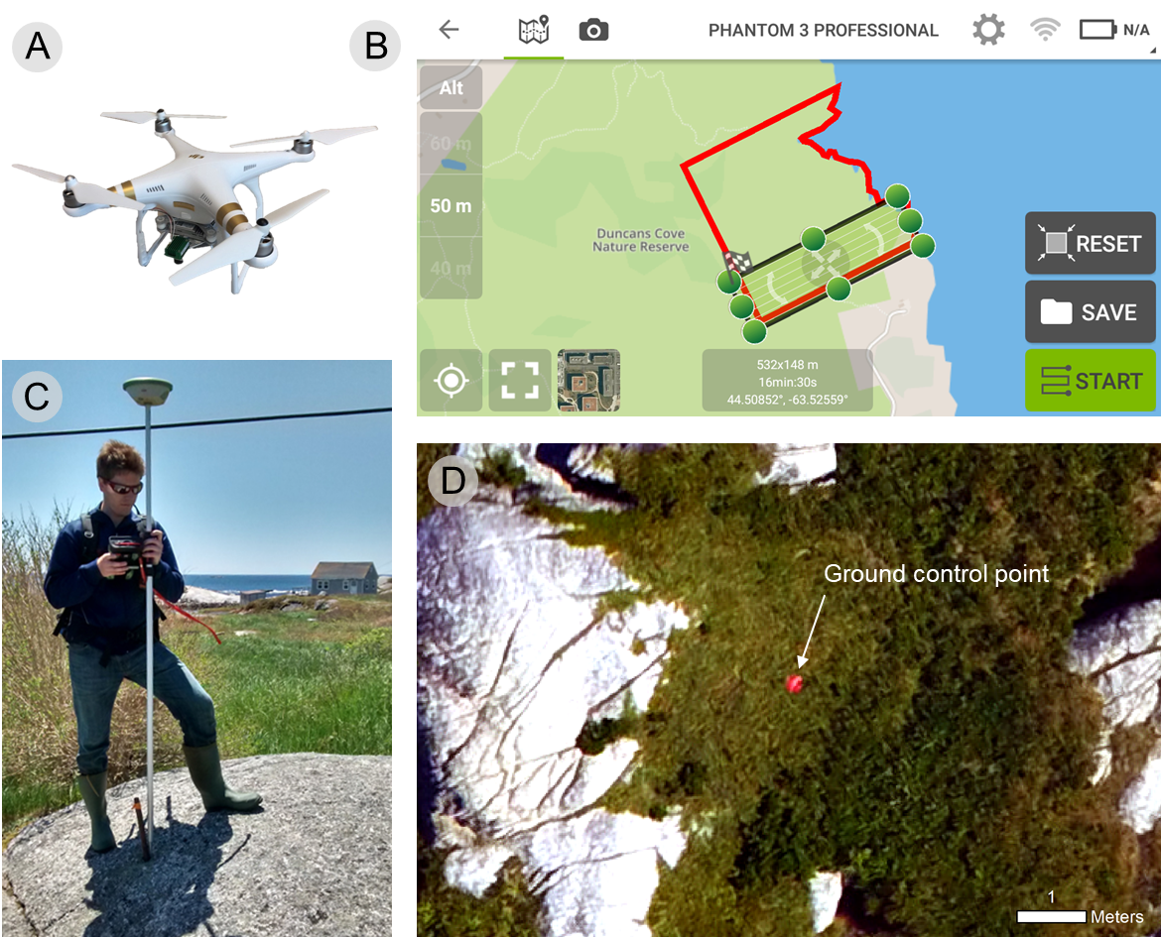
Figure S1.1. A) DJI Phantom 3 Professional quadcopter used to collect high-resolution multispectral aerial imagery at three coastal barrens sites near Halifax, Nova Scotia, Canada; B) Pix4DCapture flight planning mobile application used to autonomously control the UAV; C) A real-time kinematic used to geolocate ground control points; and, D) A ground control point viewed from an aerial image acquired by the UAV.

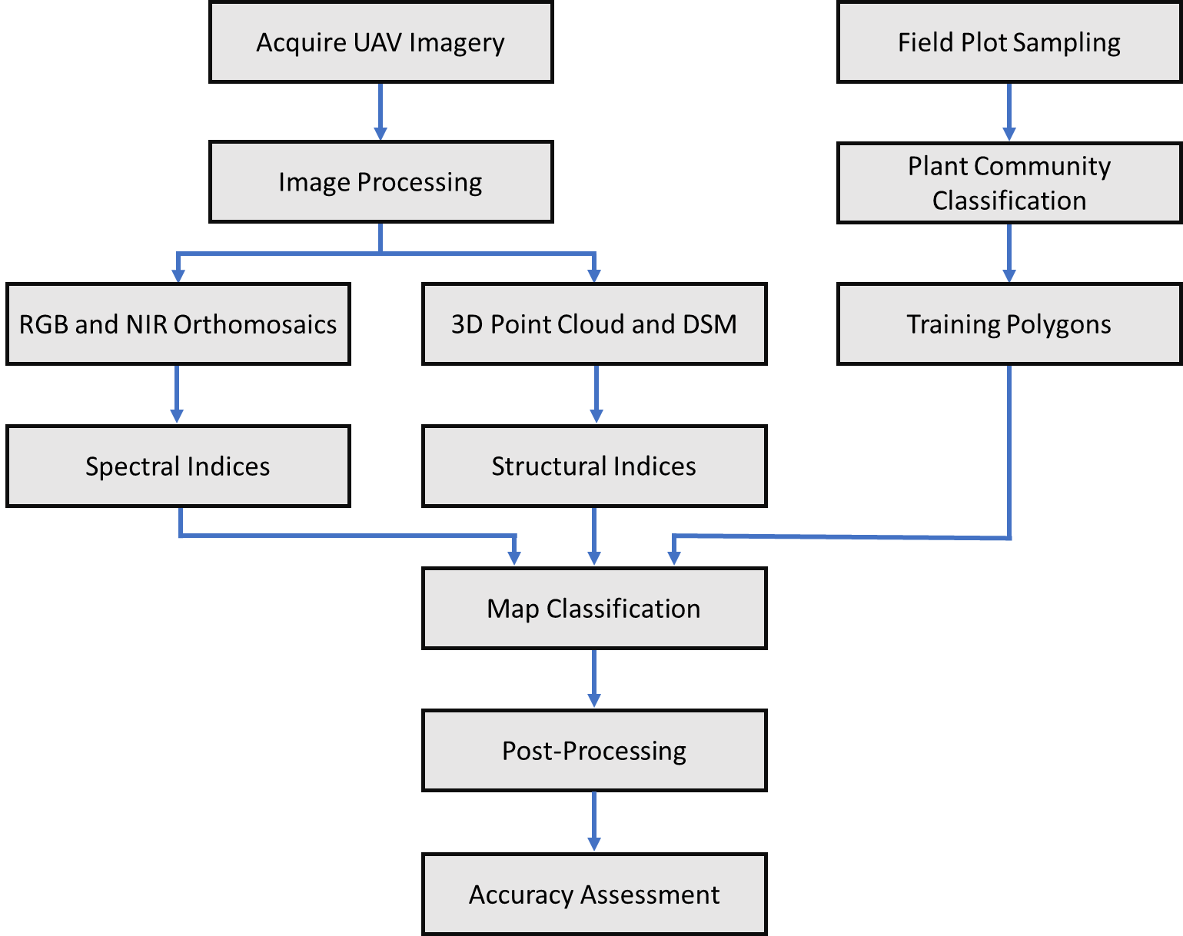

Figure S1.2. Map classification workflow used to create landcover maps of the coastal barrens in Halifax, Nova Scotia, Canada.

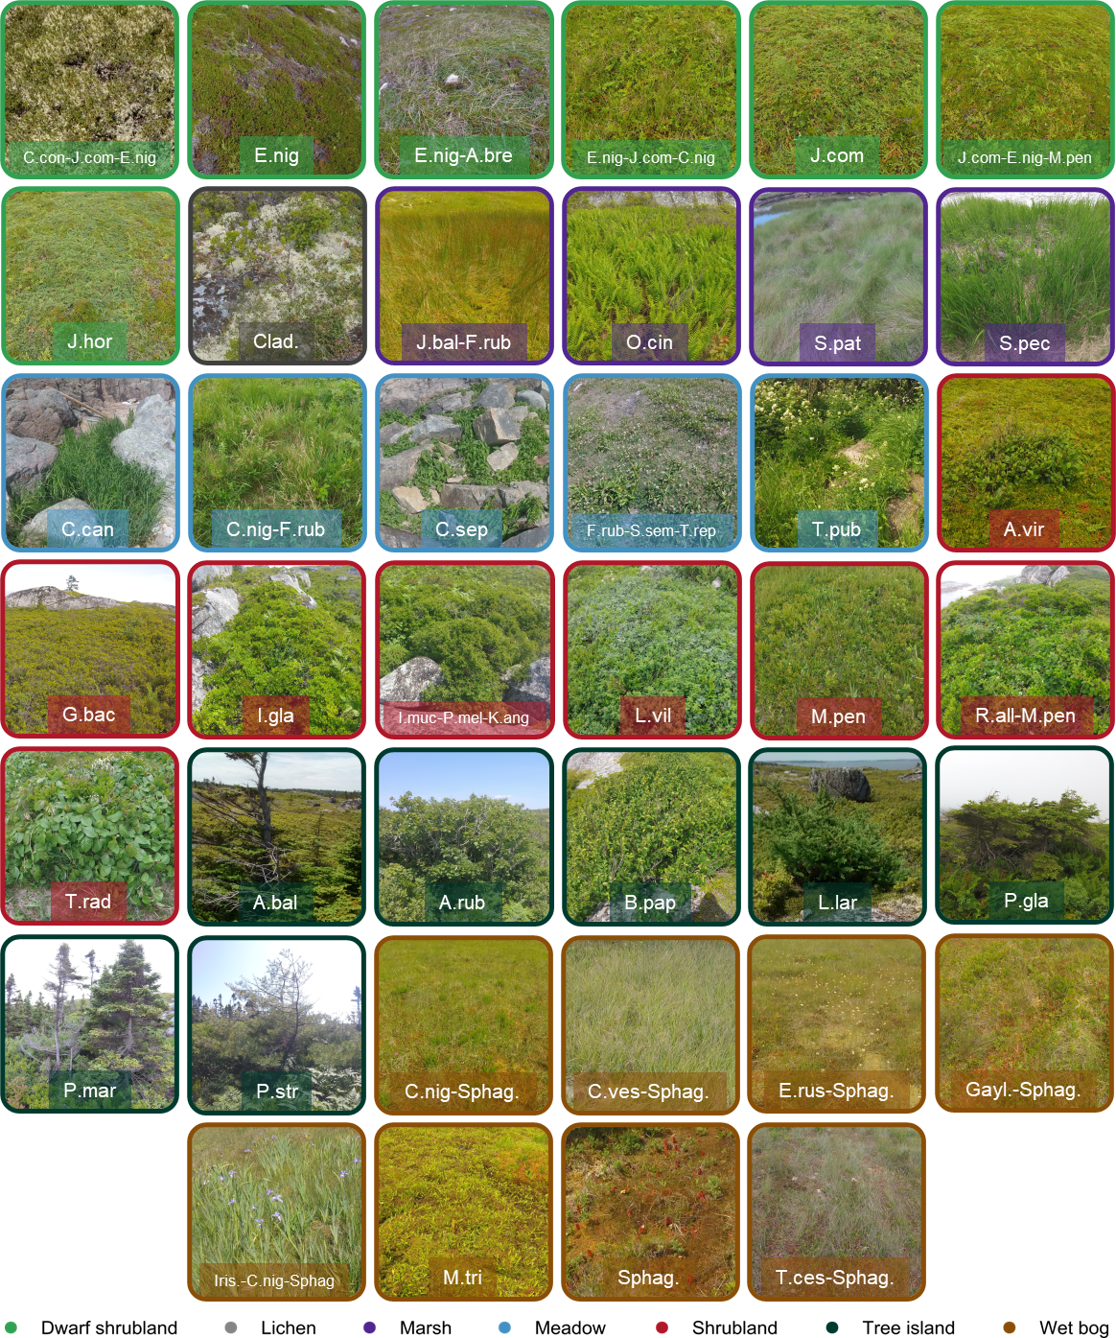
Figure S1.3. Photographs of plant communities identified from field plot sampling at Chebucto Head, Prospect Bay, and Polly’s Cove near Halifax, Nova Scotia, Canada.

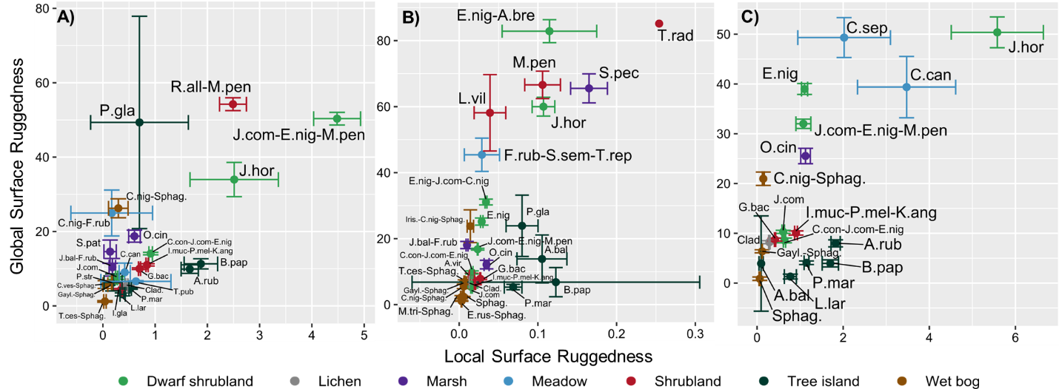
Figure S1.4. Area-weighted means and 95% confidence intervals of local surface ruggedness (LRUG) and global surface ruggedness (GRUG) for plant communities at Polly’s Cove, Prospect Bay, and Chebucto Head near Halifax, Nova Scotia, Canada.

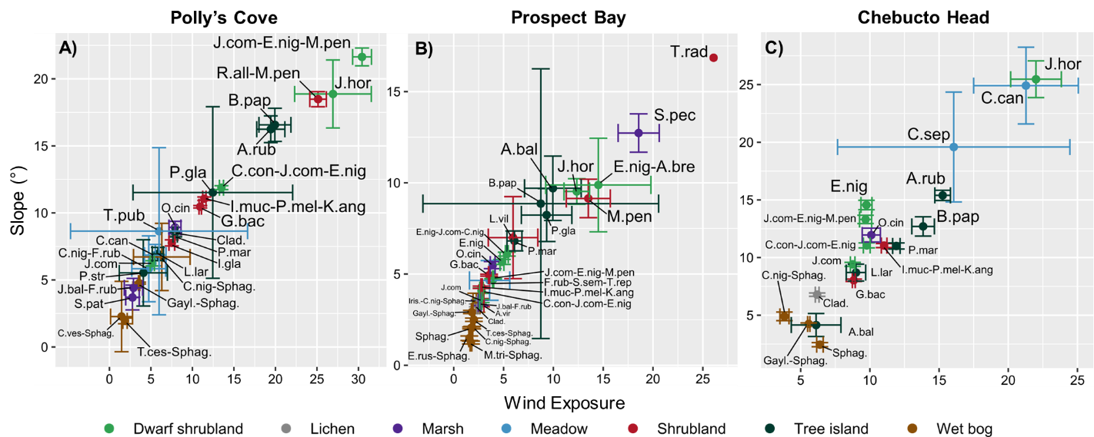
Figure S1.5. Area-weighted means and 95% confidence intervals of wind exposure (WIND) and slope (SLOPE) for plant communities at Polly’s Cove, Prospect Bay, and Chebucto Head near Halifax, Nova Scotia, Canada.

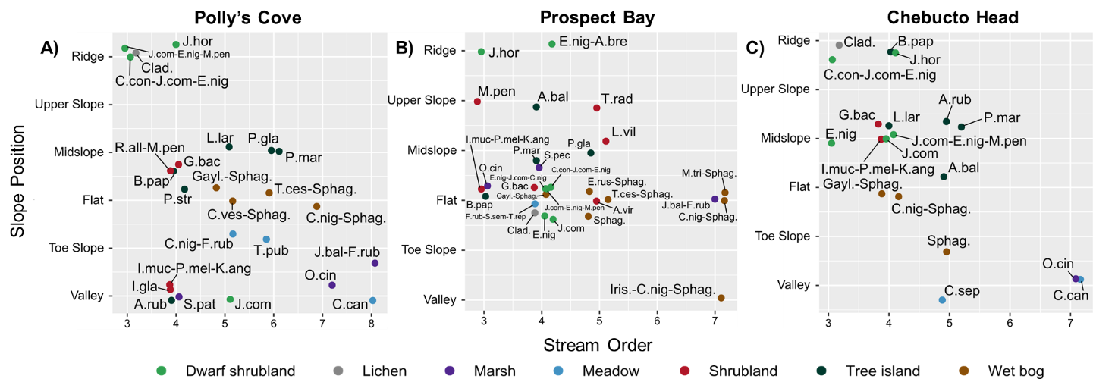
Figure S1.6. Majority of area-weighted counts of stream order (STREAM) and slope position classification (SPOS) for plant communities at Polly’s Cove, Prospect Bay, and Chebucto Head near Halifax, Nova Scotia, Canada.

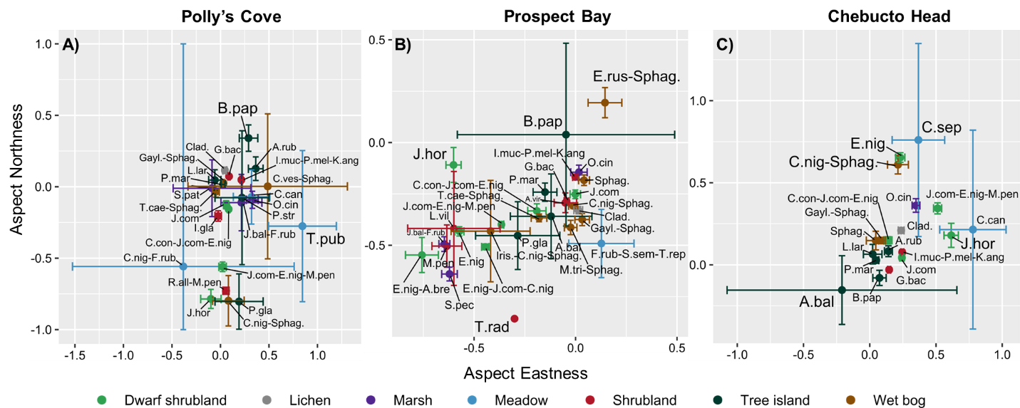
Figure S1.7. Area-weighted means and 95% confidence intervals of aspect eastness (AEAST) and aspect northness (ANORTH) for plant communities at Polly’s Cove, Prospect Bay, and Chebucto Head near Halifax, Nova Scotia, Canada.

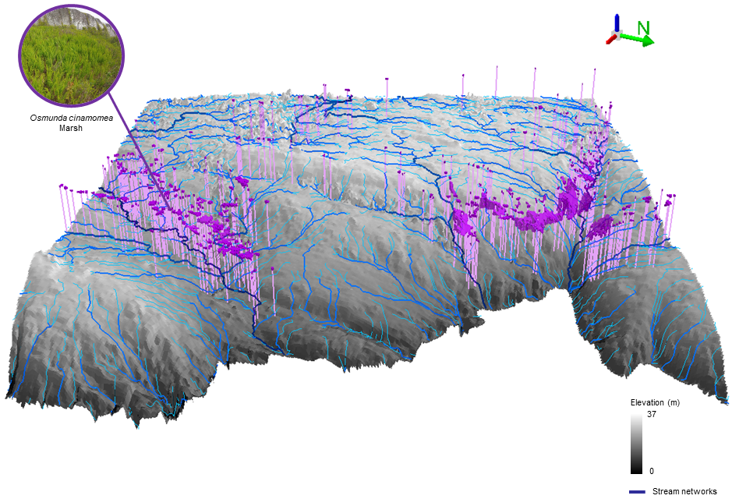
Figure S1.8. Stream networks and Osmundastrum cinnamomeum (O.cin) overlaid on a digital elevation model at Chebucto Head, Nova Scotia, Canada.

