Supplement 2 Tables and Text

Text S2.1. Environment and vegetation description (Methods section)

All three sites belong to the Eastern Shore Ecodistrict, a narrow coastal zone that is characterized by relatively high wind exposure, cool temperatures, and prolonged foggy conditions (Neily et al. 2017). These three peninsular headlands are subject to storm winds, wave run-up and salt spray (Roland 1982). In close proximity (i.e. within 30 km), the three study sites experience similar local climatic conditions (e.g. wind exposure, salt spray exposure, precipitation, mean temperatures). The sites are each underlain by granite bedrock of the South Mountain Batholith (Keppie 2000). Chebucto Head and Polly’s Cove are underlain by soils of the Rockland group (MacDougall and Hilchey 1963) consisting of thin Folisol over glacial till (Porter 2013), while Prospect Bay contains some Rockland soil, a peatland and areas with moderately stony sandy loam of the Gibraltar Soil series (MacDougall and Hilchey 1963). The sites share glacial scouring history as evidenced by a thin veneer of till and the presence of glacial erratics. Land cover within the Eastern Shore Ecodistrict is a matrix comprised of 58% forest/woodland, with barrens occupying 20.9% (Neily et al. 2017). The floristic species composition of each site is similar in terms of dominant plant species, with some notable differences such as the presence of species of more southern affinity at Prospect Bay, e.g. Poison Ivy (Toxicodendron radicans), and northern affinity eg. Alpine Bilberry (Vaccinium uliginosum) at Chebucto Head/Duncans Cove barrens complex.

Recently observed anthropogenic disturbance at the sites is limited to the presence of a small area of informal hiking and all-terrain vehicle (ATV) trails; however, human history and influence at each site is more complex. Burley and Lundholm (2010) demonstrated both the persistence of open plant communities, and forestation of successional plant communities within each site. Original Mi’kmaq names are known for places close to all three sites, suggesting a long history of human use (Bernard and Sable 2022). Europeans later established fishing settlements across the coastline of the entire peninsula, and military infrastructure at Chebucto Head (Porter 2013).

Tables

Table S2.1. UAV image acquisition and processing results for RGB using Agisoft Photoscan Professional. Error refers to the root-mean-square error of ground control points used for georeferencing models.
Site Name | Survey Date | Ground Resolution (cm) | Number of Images | X error (cm) | Y error (cm) | Z error (cm) | Total error (cm)
Chebucto Head | May, 2016 | 4.1 | 178 | 2.1 | 1.9 | 3.6 | 4.6
Chebucto Head | August, 2016 | 2.2 | 806 | 0.5 | 0.4 | 0.5 | 0.8
Prospect Bay | May, 2016 | 3.6 | 215 | 2.5 | 2.9 | 3.2 | 5
Prospect Bay | August, 2016 | 2 | 763 | 1 | 1.7 | 1.7 | 2.6
Polly’s Cove | May, 2016 | 4.3 | 218 | 4.6 | 3.2 | 4.8 | 7.4
Polly’s Cove | August, 2016 | 2.7 | 780 | 1.5 | 0.7 | 2.7 | 1.8

Table S2.2. Indices derived from UAV imagery to make landcover maps at Chebucto Head, Prospect Bay, and Polly’s Cove near Halifax, Nova Scotia, Canada. Indices were derived from UAV imagery obtained in May and August 2016.
Indices | Description
R | Red channel. The Segment Mean Shift tool in ArcGIS was used to segment the R bands from May and August into spectrally similar objects.
G | Green channel. The Segment Mean Shift tool in ArcGIS was used to segment the G bands from May and August into spectrally similar objects.
B | Blue channel. The Segment Mean Shift tool in ArcGIS was used to segment the B bands from May and August into spectrally similar objects.
NIR | Near-infrared channel
R/G | Red channel divided by green channel
R/B | Red channel divided by blue channel
G/B | Green channel divided by blue channel
NDVI | Normalized Difference Vegetation Index (Huete et al., 2002). NDVI = $\frac{NIR-R}{NIR+R}$ . Values range from -1 to +1.
CIVE | Color Index of Vegetation (Kataoka et al., 2003). CIVE = 0.441*R – 0.881*G + 0.385*B + 18.78745
Hue Northness | Hue describes color as an angle from 0° to 360°, where 0° is red, 120° is green, and 240° is blue (Ford and Roberts, 1998). Hue is a circular variable and required transforming to two linear variables for analysis: northness and eastness. Hue northness was derived by taking the cosine of the hue multiplied by $π$ and divided by 180. Values range from -1 to +1.
Hue Eastness | Eastness of Hue. Derived similarly to Hue Northness except Hue eastness was derived by taking the sine of the hue multiplied by $π$ and divided by 180. Values range from -1 to +1.

Table S2.2 (cont’d). Indices derived from UAV imagery to make landcover maps at Chebucto Head, Prospect Bay, and Polly’s Cove near Halifax, Nova Scotia, Canada. Indices were derived from UAV imagery obtained in May and August 2016.
Indices | Description
TPI 33 | Topographic Position Index (TPI). TPI 33 was calculated from the 10 cm DSM using a 33x33 pixel search window.
Intensity | Measure of lightness or darkness. Values range from 0 to 1.
DEV 5 | Deviation of Mean Elevation (DEV). DEV 5 was calculated from the 10 cm DSM using a 5x5 pixel search window.
DEV 11 | Deviation of Mean Elevation (DEV). DEV 11 was calculated from the 10 cm DSM using a 11x11 pixel search window.
DEV 33 | Deviation of Mean Elevation (DEV). DEV 33 was calculated from the 10 cm DSM using a 33x33 pixel search window.
DEV 111 | Deviation of Mean Elevation (DEV). DEV 111 was calculated from the 10 cm DSM using a 111x111 pixel search window.
TPI 5 | Topographic Position Index (TPI). TPI 5 was calculated from the 10 cm DSM using a 5x5 pixel search window.
TPI 11 | Topographic Position Index (TPI). TPI 11 was calculated from the 10 cm DSM using a 11x11 pixel search window.
TPI 33 | Topographic Position Index (TPI). TPI 33 was calculated from the 10 cm DSM using a 33x33 pixel search window.
TPI 111 | Topographic Position Index (TPI). TPI 111 was calculated from the 10 cm DSM using a 111x111 pixel search window.
Curvature | Curvature Index (concavity/convexity) was calculated from the 10 cm DSM using the Curvature tool with the Profile setting from the DEM Surface Tools toolbox in ArcGIS. (http://www.jennessent.com/arcgis/surface_area.htm)
Vegetation Height | Vegetation height in August. Vegetation height was calculated by subtracting the minimum from the maximum elevation value within a 50 cm search radius of each pixel using the 10 cm DSM.
Change in DSM | Change in the 10 cm DSM from May 2016 to August 2016. Calculated using the Raster Calculator tool in ArcGIS.

Table S2.3. Landscape metrics used to describe landscape composition.
Metric | Description
Total area (TA) | Area (hectares) of the study area.
Class richness (CR) | The number of classes or patch types.
Most dominant communities (DOM) | Top three most dominant plant communities based on percentage of landscape occupied.
Number of patches in the landscape (NL) | The total number of plant community patches in the landscape.
Patch density (PD) | Density of plant community patches in the landscape. Expressed as the number of plant community patches per hectare of land.

Table S2.4. Class-level metrics used to describe the spatial configurations of plant community patches within a landscape.
Metric | Description
Class area (CA) | Total area of a class in hectares.
Percentage of landscape (PLAND) | Percentage of landscape occupied by each class.
Number of patches in the class (NP) | The total number of patches from a class.
Patch area (AREA) | The area-weighted mean patch area (square metres) of a class.
Shape index (SHAPE) | The area-weighted mean of SHAPE for patches in a class (Patton, 1975). SHAPE is a measure of shape complexity that accounts for the size of the patch. Values range from 0 to infinity, where a value 1 indicates the simple shape of a square and increasing values indicate increasing shape complexity.
Related circumscribing circle index (CIRCLE) | The area-weighted mean of CIRCLE for patches in a class (Baker and Cai, 1992). CIRCLE is a measure of patch elongation with values ranging from 0 to 1, where a value of 0 indicates the patch is narrow and elongated and a value of 1 indicates the patch is compact and shaped like a circle.
Interspersion and juxtaposition index (IJI) | A measure of how interspersed or intermixed patch types are across a landscape (McGarical and Marks, 1995). Values are expressed as a percentage from 0 to 100, where a value of 0 indicates patches are only adjacent to one other patch type, whereas a value of 100 indicates that a patch type is equally adjacent to all other patch types.
Shared edge length (SEL) | The total length of shared edges (metres) between patch types (Martin et al., 2008). Calculated using the Polygon Neighbor tool in ArcGIS.

Table S2.5. Environmental variables used to interpret landscape patterns of plant communities.
Environmental Variable | Description
Elevation above sea-level (ELEV) | The area-weighted mean of ELEV in metres for each class. Derived from a 2 m DEM.
Distance from coastline (DIST) | The area-weighted mean of DIST for each class. Calculated using the Euclidean Distance tool in ArcGIS with a line feature delineating the coastline of each site as the input.
Local surface ruggedness (LRUG) | The area-weighted mean of LRUG for each class. Measure of topographic heterogeneity within a 3x3 cell neighborhood from a 2 m DEM. Calculated using the Roughness tool from the Geomorphometry and Gradient Metrics toolbox for ArcGIS (Evans et al., 2014). Values were scaled to range from 0 to 100, where values near 100 represent high surface ruggedness and values near 0 signify low surface ruggedness.
Global surface ruggedness (GRUG) | The area-weighted mean of GRUG for each class. Derived similarly to LRUG except with a larger cell neighborhood of 51x51.
Wind exposure (WIND) | The area-weighted mean of WIND for each class. WIND was modeled by using wind direction data from nearby weather stations, the Hillshade tool in ArcGIS, and a 2 m DEM. Hillshades are often used to model illumination across a surface; however, in this case it is used to simulate the exposure of a surface to wind (Mikita and Klimánek, 2010). Sixteen hillshades were made by adjusting the Azimuth (horizontal angle) to 16 different cardinal directions (e.g. N, NNE, NE…) while maintaining the Altitude (vertical angle) at 5º. Wind roses derived from 3-4 years of wind direction data were used to weight each hillshade. Finally, the Raster Calculator tool was executed to add the weighted hillshades together. The final WIND model was then scaled from 0 to 100, where values near 100 represent high wind exposure and values near 0 signify low wind exposure.
Slope (SLOPE) | The area-weighted mean of SLOPE for each class. Measure of slope gradient (degrees) for each cell in a 2 m DEM. Calculated using the Slope tool in ArcGIS. Values range from 0 to 90º.
Stream order (STREAM) | The majority of area-weighted counts of STREAM for each class. Stream networks were derived from a 2 m DEM using the Hydrology toolset in ArcGIS. Statistics for patches were calculated by first obtaining the maximum stream order value within a 10 m search radius of each patch followed by computing area-weighted counts of all patches for each class. Stream order values are expressed as integers and typically range from 0 to 8, where higher stream order values indicate a larger stream with more intersecting streams, whereas a value of 0 indicates a small stream with no intersections (Strahler, 1952). Stream order increases when streams of the same order intersect.
Slope position classification (SPOS) | The majority of area-weighted counts of SPOS for each class. Calculated using Slope Position Classification tool from the Topography Tools ArcGIS toolbox (Dilts, 2015) with the 2 m DEM. Possible slope positions include: valley, toe slope, flat, midslope, upper slope, and ridge.
Aspect northness (ANORTH) | The area-weighted mean of ANORTH for each class. Aspect is the horizontal direction of a slope. It is normally a circular variable with values ranging from 0º to 360º. Consequently, aspect required transforming into 2 linear variables for analysis: ANORTH (northness) and AEAST (eastness). Aspect was first derived from a 2 m DEM using the Aspect tool in ArcGIS. ANORTH was derived using the Raster Calculator tool by taking the cosine of the aspect multiplied by $π$ and divided by 180. Values range from -1 to +1, where values approaching +1 indicate the slope is facing North, whereas values approaching -1 indicate the slope is facing South.
Aspect eastness (AEAST) | The area-weighted mean of AEAST for each class. Derived similarly to ANORTH except AEAST was derived by taking the sine of aspect multiplied by $π$ and divided by 180. Values range from -1 to +1, where values approaching +1 indicate the slope is facing East, whereas values approaching -1 signify the slope is facing South.

Table S2.6. Confusion matrix of UAV image classification results for patch types at Chebucto Head. Counts represent correctly classified pixels from a randomly selected subset of training polygons at the site obtained from ground truthing, in which 50% were used to train the classification model and the remainder for testing model accuracy. Overall accuracy was 75%.
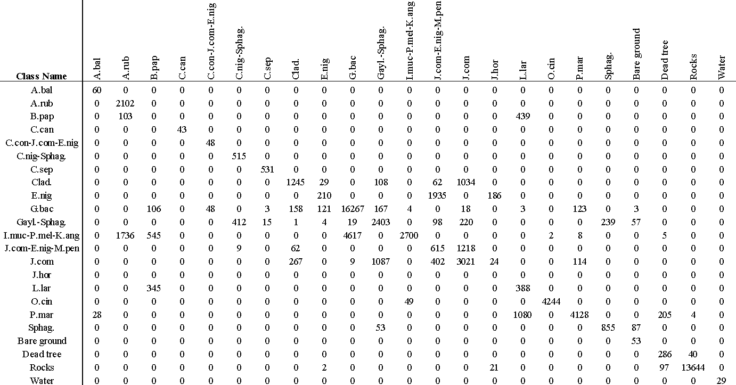

Table S2.7. Confusion matrix of UAV image classification results for patch types at Prospect Bay. Counts represent correctly classified pixels from a randomly selected subset of training polygons at the site obtained from ground truthing, in which 50% were used to train the classification model and the remainder for testing model accuracy. Overall accuracy was 76%.
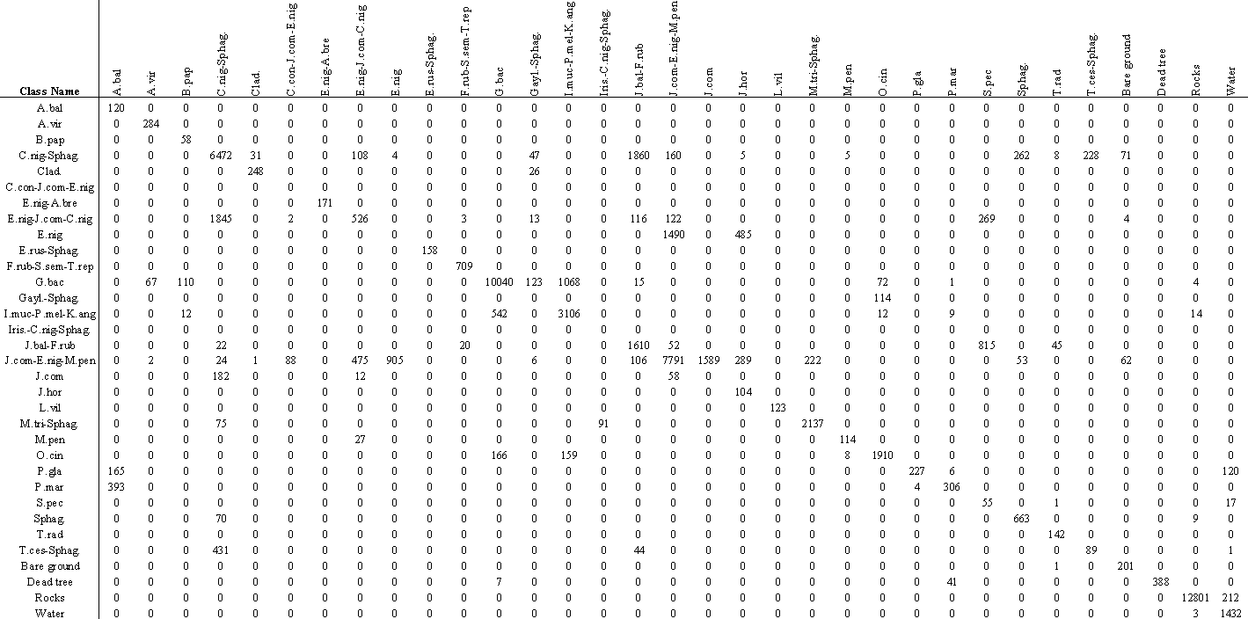

Table S2.8. Confusion matrix of UAV image classification results for patch types at Polly’s Cove. Counts represent correctly classified pixels from a randomly selected subset of training polygons at the site obtained from ground truthing, in which 50% were used to train the classification model and the remainder for testing model accuracy. Overall accuracy was 79.9%.
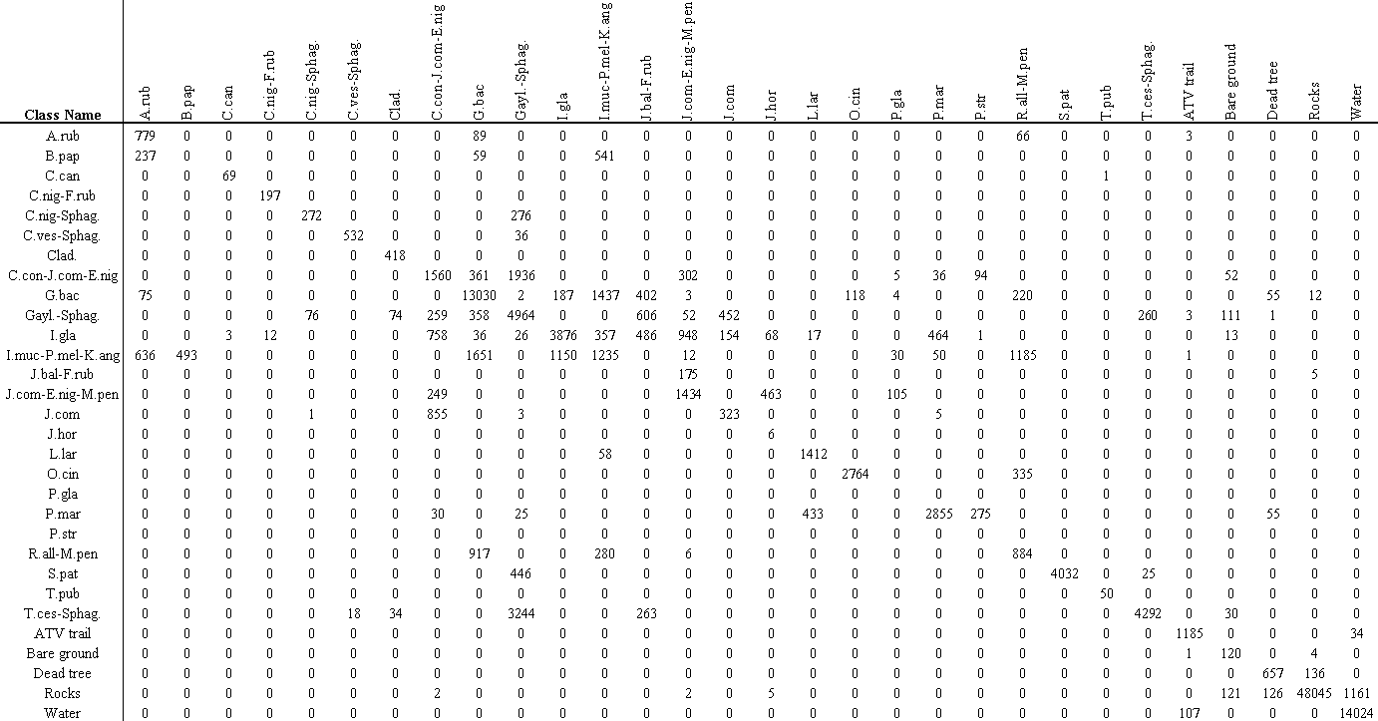

Table S2.9. The top 10 most important variables used to map plant communities at Chebucto Head, Prospect Bay, and Polly’s Cove near Halifax, Nova Scotia, Canada. Scores were calculated by using the VarImp function from the Caret package in R and were combined across all three sites, allowing a maximum possible value of 300.
Variable | Description | Combined Score
May NIR | Near-infrared band in May | 167.4
Change in Hue Eastness | Change in Hue Eastness from May to August | 163.6
Change in DSM | Change in the digital surface model from May to August | 163.3
May R | Red band in May | 147.8
May CIVE | Color Index of Vegetation in May | 123.9
Change in Hue Northness | Change in Hue Northness from May to August | 122.4
May G | Green band in May | 99.3
August TPI 111 | Topographic Position Index with window of 111 x 111 pixels in August | 84.5
May Saturation | Saturation in May | 83.9
August Vegetation Height | Vegetation Height in August | 83.0

Table S2.10. Percent of shared edge length between plant communities and other landcover types at Chebucto Head. Rows represent source patches and the columns represent neighboring patches. * ‘-‘ indicates no value.
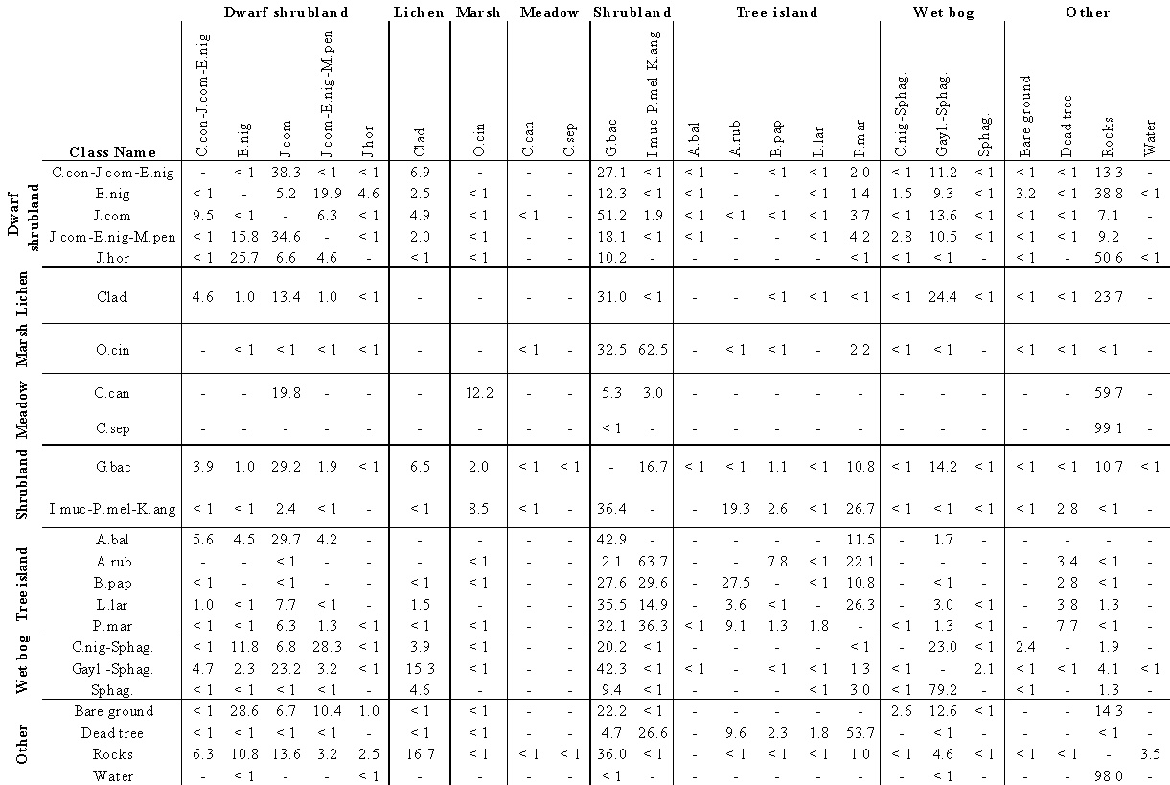
Table S2.11. Percent of shared edge length between plant communities and other landcover types at Prospect Bay. Rows represent source patches and the columns represent neighboring patches. * ‘-‘ indicates no value.
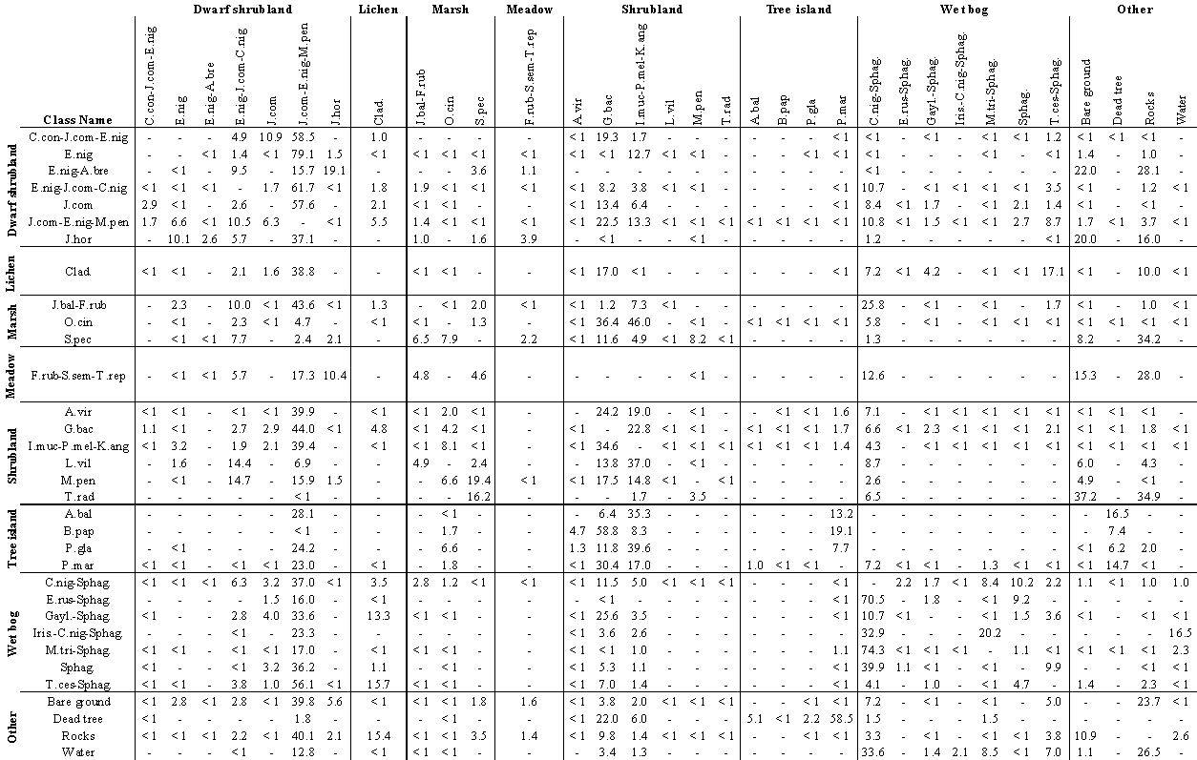

Table S2.12. Percent of shared edge length between plant communities and other landcover types at Polly’s Cove. Rows represent source patches and the columns represent neighboring patches. * ‘-‘ indicates no value.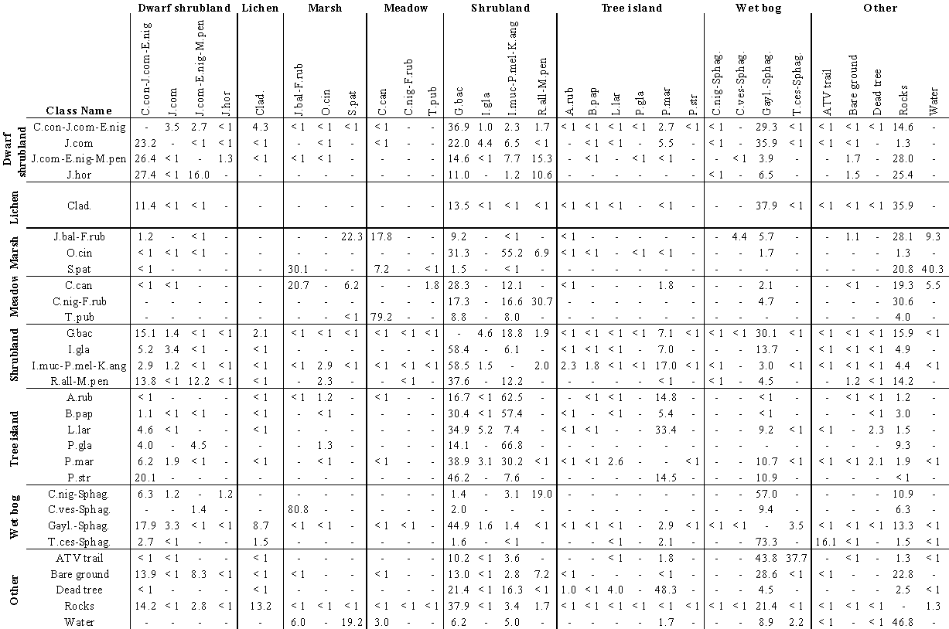
Table S2.13. Accuracy (%) of predicting plant communities using environmental variables at Chebucto Head, Prospect Bay, and Polly’s Cove near Halifax, Nova Scotia, Canada.
Class Name | Type | Chebucto Head | Prospect Bay | Polly's Cove
C.con-J.com-E.nig | Dwarf shrubland | 24.4 | 19.4 | 28.4
E.nig | Dwarf shrubland | 25.1 | 40.5 | -
E.nig-A.bre | Dwarf shrubland | - | 50.0 | -
E.nig-J.com-C.nig | Dwarf shrubland | - | 31.6 | -
J.com | Dwarf shrubland | 28.5 | 23.9 | 22.1
J.com-E.nig-M.pen | Dwarf shrubland | 22.2 | 27.3 | 25.2
J.hor | Dwarf shrubland | 32.3 | 21.0 | 20.0
Clad. | Lichen | 25.3 | 31.2 | 26.5
J.bal-F.rub | Marsh | - | 27.0 | 34.8
O.cin | Marsh | 33.2 | 26.8 | 14.5
S.pat | Marsh | - | - | 42.9
S.pec | Marsh | - | 24.4 | -
C.can | Meadow | 0.0 | - | 52.4
C.nig-F.rub | Meadow | - | - | 0.0
C.sep | Meadow | 66.7 | - | -
F.rub-S.sem-T.rep | Meadow | - | 25.9 | -
T.pub | Meadow | - | - | 50.0
A.vir | Shrubland | - | 9.3 | -
G.bac | Shrubland | 25.9 | 26.0 | 27.2
I.gla | Shrubland | - | - | 29.1
I.muc-P.mel-K.ang | Shrubland | 38.3 | 31.6 | 34.3
L.vil | Shrubland | - | 0.0 | -
M.pen | Shrubland | - | 10.0 | -
R.all-M.pen | Shrubland | - | - | 19.6
T.rad | Shrubland | - | 0.0 | -
A.bal | Tree island | 0.0 | 0.0 | -
A.rub | Tree island | 32.6 | - | 17.4
B.pap | Tree island | 11.5 | 0.0 | 0.0
L.lar | Tree island | 0.0 | - | 0.0
P.gla | Tree island | - | 0.0 | 0.0
P.mar | Tree island | 24.4 | 28.6 | 18.0
P.str | Tree island | - | - | 0.0
C.nig-Sphag. | Bog wetland | 19.7 | 31.2 | 0.0
C.ves-Sphag. | Bog wetland | - | - | 0.0
E.rus-Sphag. | Bog wetland | - | 37.8 | -
Gayl.-Sphag. | Bog wetland | 25.5 | 21.6 | 27.6
Iris.-C.nig-Sphag. | Bog wetland | - | 20.0 | -
M.tri | Bog wetland | - | - | -
Sphag. | Bog wetland | 52.0 | 26.1 | -
T.ces-Sphag. | Bog wetland | - | 34.0 | 42.5
Overall Accuracy |  | 28.4 | 29.1 | 28.2

Table S2.14. Most important environmental variables for predicting plant communities at Chebucto Head, Prospect Bay, and Polly’s Cove near Halifax, Nova Scotia, Canada. Scores were calculated by using the VarImp function from the Caret package in R and were combined across all three sites, allowing a maximum possible value of 300.
Environmental Variable | Combined Score
Distance from coastline (DIST) | 300
Elevation above sea-level (ELEV) | 220.6
Global surface ruggedness (GRUG) | 173.7
Local surface ruggedness (LRUG) | 118.7
Slope (SLOPE) | 75.9
Aspect eastness (AEAST) | 67.1
Aspect northness (ANORTH) | 61.4
Wind exposure (WIND) | 60.5
Slope position (SPOS) | 57.1
Stream order (STREAM) | 48.8

Table S2.16. Environmental statistics of plant community patches at Chebucto Head, Nova Scotia. Plant communities are sorted alphabetically by patch type and then class name. *AW = Area-weighted, C.I. = Confidence Interval.
Class Name | Type | DIST  AW Mean ± 95% C.I. | ELEV  AW Mean ± 95% C.I. | LRUG  AW Mean ± 95% C.I. | GRUG  AW Mean ± 95% C.I. | SLOPE  AW Mean ± 95% C.I. | WIND  AW Mean ± 95% C.I. | ANORTH  AW Mean ± 95% C.I. | AEAST  AW Mean ± 95% C.I. | STREAM  AW Majority | SPOS  AW Majority
C.con-J.com-E.nig | Dwarf shrubland | 180.5 ± 3.3 | 29.47 ± 0.22 | 0.64 ± 0.03 | 8.56 ± 0.47 | 11.05 ± 0.22 | 9.78 ± 0.24 | 0.15 ± 0.02 | 0.14 ± 0.03 | 3 | Ridge
E.nig | Dwarf shrubland | 41.6 ± 1.1 | 14.46 ± 0.48 | 1.10 ± 0.07 | 38.99 ± 1.10 | 14.56 ± 0.41 | 9.75 ± 0.40 | 0.65 ± 0.03 | 0.23 ± 0.04 | 3 | Midslope
J.com | Dwarf shrubland | 179.6 ± 2.5 | 25.45 ± 0.18 | 0.61 ± 0.03 | 10.29 ± 0.31 | 9.41 ± 0.17 | 8.76 ± 0.16 | 0.04 ± 0.01 | 0.24 ± 0.02 | 4 | Midslope
J.com-E.nig-M.pen | Dwarf shrubland | 46.5 ± 1.1 | 13.06 ± 0.26 | 1.08 ± 0.17 | 32.01 ± 0.94 | 13.31 ± 0.37 | 9.69 ± 0.43 | 0.34 ± 0.03 | 0.51 ± 0.03 | 4 | Midslope
J.hor | Dwarf shrubland | 32.1 ± 1.7 | 12.33 ± 0.72 | 5.58 ± 1.07 | 50.37 ± 3.09 | 25.47 ± 1.59 | 22.00 ± 1.83 | 0.18 ± 0.07 | 0.62 ± 0.05 | 4 | Ridge
Clad. | Lichen | 184.0 ± 3.2 | 27.40 ± 0.21 | 0.29 ± 0.02 | 8.22 ± 0.23 | 6.78 ± 0.14 | 6.19 ± 0.14 | 0.21 ± 0.02 | 0.24 ± 0.02 | 3 | Ridge
O.cin | Marsh | 82.0 ± 4.8 | 14.07 ± 0.35 | 1.13 ± 0.11 | 25.53 ± 1.54 | 11.95 ± 0.60 | 10.10 ± 0.66 | 0.36 ± 0.04 | 0.35 ± 0.03 | 7 | Valley
C.can | Meadow | 23.4 ± 6.3 | 5.80 ± 0.64 | 3.47 ± 1.14 | 39.38 ± 6.16 | 24.91 ± 3.33 | 21.28 ± 3.78 | 0.22 ± 0.61 | 0.78 ± 0.25 | 7 | Valley
C.sep | Meadow | 8.9 ± 4.3 | 4.24 ± 1.03 | 2.02 ± 1.08 | 49.32 ± 4.02 | 19.58 ± 4.76 | 16.06 ± 8.40 | 0.76 ± 0.59 | 0.37 ± 0.20 | 5 | Valley
G.bac | Shrubland | 207.7 ± 2.5 | 26.01 ± 0.16 | 0.42 ± 0.01 | 8.73 ± 0.28 | 8.03 ± 0.10 | 8.84 ± 0.10 | -0.03 ± 0.01 | 0.15 ± 0.01 | 4 | Midslope
I.muc-P.mel-K.ang | Shrubland | 233.4 ± 4.6 | 24.18 ± 0.19 | 0.91 ± 0.03 | 10.06 ± 0.42 | 11.04 ± 0.18 | 11.03 ± 0.20 | 0.08 ± 0.01 | 0.25 ± 0.01 | 4 | Midslope
A.bal | Tree island | 153.1 ± 95.7 | 28.73 ± 12.49 | 0.10 ± 0.05 | 3.92 ± 9.56 | 4.15 ± 1.00 | 6.12 ± 1.80 | -0.15 ± 0.21 | -0.21 ± 0.87 | 5 | Flat
A.rub | Tree island | 257.8 ± 8.6 | 26.54 ± 0.30 | 1.82 ± 0.11 | 7.98 ± 0.70 | 15.40 ± 0.44 | 15.26 ± 0.56 | 0.08 ± 0.03 | 0.14 ± 0.03 | 5 | Midslope
B.pap | Tree island | 290.8 ± 7.7 | 29.13 ± 0.35 | 1.70 ± 0.19 | 3.96 ± 0.71 | 12.70 ± 0.84 | 13.85 ± 0.82 | -0.08 ± 0.05 | 0.07 ± 0.05 | 4 | Ridge
L.lar | Tree island | 319.2 ± 11.3 | 30.94 ± 0.42 | 0.77 ± 0.14 | 1.30 ± 0.50 | 8.70 ± 0.73 | 9.00 ± 0.70 | 0.07 ± 0.06 | 0.02 ± 0.07 | 4 | Midslope
P.mar | Tree island | 280.7 ± 5.3 | 27.50 ± 0.27 | 1.15 ± 0.06 | 4.08 ± 0.36 | 11.01 ± 0.26 | 11.91 ± 0.27 | 0.03 ± 0.02 | 0.05 ± 0.02 | 5 | Midslope
C.nig-Sphag. | Bog wetland | 59.7 ± 3.7 | 12.70 ± 0.75 | 0.14 ± 0.02 | 20.96 ± 1.34 | 4.90 ± 0.37 | 3.83 ± 0.33 | 0.61 ± 0.06 | 0.21 ± 0.08 | 4 | Flat
Gayl.-Sphag. | Bog wetland | 182.1 ± 3 | 28.42 ± 0.19 | 0.12 ± 0.01 | 6.38 ± 0.31 | 4.24 ± 0.09 | 5.58 ± 0.08 | 0.15 ± 0.01 | 0.09 ± 0.02 | 4 | Flat
Sphag. | Bog wetland | 244.2 ± 14.5 | 30.41 ± 0.39 | 0.06 ± 0.02 | 0.87 ± 0.34 | 2.45 ± 0.18 | 6.39 ± 0.23 | 0.15 ± 0.06 | 0.05 ± 0.07 | 5 | Toe Slope

Table S2.17. Environmental statistics of plant community patches at Prospect Bay, Nova Scotia. Plant communities are sorted alphabetically by patch type and then class name. *AW = Area-weighted, C.I. = Confidence Interval.
Class Name | Type | DIST  AW Mean ± 95% C.I. | ELEV  AW Mean ± 95% C.I. | LRUG  AW Mean ± 95% C.I. | GRUG  AW Mean ± 95% C.I. | SLOPE  AW Mean ± 95% C.I. | WIND  AW Mean ± 95% C.I. | ANORTH  AW Mean ± 95% C.I. | AEAST  AW Mean ± 95% C.I. | STREAM  AW Majority | SPOS  AW Majority
C.con-J.com-E.nig | Dwarf shrubland | 351.3 ± 7.5 | 24.33 ± 0.33 | 0.02 ± < 0.01 | 9.76 ± 0.48 | 4.09 ± 0.15 | 2.79 ± 0.17 | -0.33 ± 0.03 | -0.19 ± 0.05 | 4 | Flat
E.nig | Dwarf shrubland | 126.2 ± 4.0 | 13.33 ± 0.17 | 0.03 ± < 0.01 | 25.17 ± 1.07 | 5.66 ± 0.14 | 4.84 ± 0.19 | -0.43 ± 0.02 | -0.57 ± 0.02 | 4 | Flat
E.nig-A.bre | Dwarf shrubland | 26.0 ± 2.7 | 7.73 ± 0.47 | 0.12 ± 0.06 | 82.87 ± 3.49 | 9.88 ± 2.57 | 14.52 ± 5.28 | -0.55 ± 0.09 | -0.76 ± 0.08 | 4 | Upper Slope
E.nig-J.com-C.nig | Dwarf shrubland | 154.1 ± 4.5 | 13.44 ± 0.22 | 0.03 ± < 0.01 | 31.10 ± 0.88 | 6.09 ± 0.11 | 5.33 ± 0.15 | -0.51 ± 0.01 | -0.45 ± 0.02 | 4 | Flat
J.com | Dwarf shrubland | 395.5 ± 5.0 | 22.95 ± 0.15 | 0.02 ± < 0.01 | 5.31 ± 0.26 | 3.52 ± 0.09 | 2.71 ± 0.12 | -0.25 ± 0.02 | -1.43E-03 ± 0.03 | 4 | Ridge
J.com-E.nig-M.pen | Dwarf shrubland | 219.8 ± 3.5 | 17.67 ± 0.11 | 0.02 ± < 0.01 | 16.81 ± 0.27 | 4.71 ± 0.04 | 3.95 ± 0.05 | -0.40 ± < 0.01 | -0.37 ± 0.01 | 4 | Midslope
J.hor | Dwarf shrubland | 32.9 ± 1.2 | 7.91 ± 0.17 | 0.11 ± 0.01 | 60.00 ± 2.85 | 9.53 ± 0.70 | 12.35 ± 1.28 | -0.11 ± 0.09 | -0.60 ± 0.04 | 3 | Midslope
Clad. | Lichen | 309.3 ± 3.7 | 22.08 ± 0.12 | 0.01 ± < 0.01 | 6.82 ± 0.24 | 3.28 ± 0.08 | 2.41 ± 0.10 | -0.33 ± 0.02 | 0.01 ± 0.02 | 4 | Flat
J.bal-F.rub | Marsh | 92.3 ± 4.3 | 9.57 ± 0.24 | 0.01 ± < 0.01 | 18.07 ± 1.08 | 3.43 ± 0.16 | 2.61 ± 0.15 | -0.49 ± 0.04 | -0.65 ± 0.03 | 7 | Flat
O.cin | Marsh | 301.6 ± 8.5 | 18.99 ± 0.36 | 0.04 ± < 0.01 | 12.14 ± 1.29 | 5.49 ± 0.20 | 3.91 ± 0.25 | -0.14 ± 0.03 | 0.016 ± 0.04 | 3 | Flat
S.pec | Marsh | 27.2 ± 0.8 | 5.53 ± 0.25 | 0.17 ± 0.02 | 65.54 ± 4.39 | 12.73 ± 1.05 | 18.56 ± 2.06 | -0.64 ± 0.03 | -0.62 ± 0.04 | 4 | Midslope
F.rub-S.sem-T.rep | Meadow | 37.8 ± 1.8 | 7.28 ± 0.30 | 0.03 ± 0.02 | 45.42 ± 5.05 | 4.65 ± 1.09 | 3.60 ± 2.03 | -0.49 ± 0.17 | 0.13 ± 0.16 | 4 | Flat
A.vir | Shrubland | 258.0 ± 9.2 | 19.80 ± 0.33 | 0.016 ± < 0.01 | 8.57 ± 0.92 | 3.43 ± 0.22 | 2.75 ± 0.28 | -0.29 ± 0.05 | -0.05 ± 0.06 | 5 | Flat
G.bac | Shrubland | 394.8 ± 3.2 | 23.58 ± 0.12 | 0.03 ± < 0.01 | 7.86 ± 0.28 | 4.94 ± 0.05 | 3.55 ± 0.06 | -0.29 ± 0.01 | -0.05 ± 0.01 | 4 | Flat
I.muc-P.mel-K.ang | Shrubland | 355.0 ± 3.5 | 20.81 ± 0.11 | 0.02 ± < 0.01 | 6.40 ± 0.38 | 4.28 ± 0.06 | 2.79 ± 0.07 | -0.17 ± 0.01 | -1.31E-03 ± 0.01 | 3 | Flat
L.vil | Shrubland | 48.6 ± 28.7 | 6.94 ± 1.75 | 0.04 ± 0.02 | 58.14 ± 11.57 | 7.00 ± 2.25 | 5.95 ± 2.49 | -0.42 ± 0.28 | -0.60 ± 0.23 | 5 | Midslope
M.pen | Shrubland | 30.6 ± 1.2 | 6.78 ± 0.17 | 0.11v± 0.02 | 66.60 ± 4.16 | 9.14 ± 1.06 | 13.51 ± 2.21 | -0.50 ± 0.10 | -0.63 ± 0.07 | 3 | Flat
T.rad | Shrubland | 24.1 ± NA | 5.89 ± NA | 0.25 ± NA | 85.16 ± NA | 16.85 ± NA | 26.08 ± NA | -0.86 ± NA | -0.30 ± NA | 5 | Ridge
A.bal | Tree island | 139.5 ± 25.1 | 18.44 ± 1.00 | 0.11 ± 0.03 | 13.85 ± 7.27 | 9.70 ± 1.76 | 9.95 ± 2.84 | -0.36 ± 0.21 | -0.12 ± 0.20 | 4 | Flat
B.pap | Tree island | 435.2 ± 117.9 | 26.32 ± 4.33 | 0.12 ± 0.18 | 6.82 ± 4.41 | 8.86 ± 7.39 | 8.74 ± 11.83 | 0.04 ± 0.45 | -0.05 ± 0.54 | 3 | Flat
P.gla | Tree island | 206.4 ± 67.8 | 18.42 ± 1.96 | 0.08 ± 0.02 | 23.89 ± 9.30 | 8.24 ± 1.45 | 9.32 ± 2.54 | -0.45 ± 0.17 | -0.29 ± 0.21 | 5 | Flat
P.mar | Tree island | 353.3 ± 15.5 | 22.08 ± 0.49 | 0.07 ± 0.01 | 5.32 ± 0.81 | 6.82 ± 0.54 | 6.09 ± 0.75 | -0.24 ± 0.04 | -0.15 ± 0.06 | 4 | Valley
C.nig-Sphag. | Bog wetland | 336.1 ± 9.5 | 19.11 ± 0.33 | 0.01 ± < 0.01 | 5.52 ± 0.66 | 2.06 ± 0.07 | 1.86 ± 0.06 | -0.31 ± 0.01 | -0.01 ± 0.02 | 7 | Flat
E.rus-Sphag. | Bog wetland | 501.2 ± 4.1 | 22.27 ± 0.05 | 3.02E-03 ± < 0.01 | 1.10 ± 0.08 | 1.48 ± 0.12 | 1.57 ± 0.05 | 0.19 ± 0.07 | 0.15 ± 0.08 | 5 | Upper Slope
Gayl.-Sphag. | Bog wetland | 395.1 ± 7.4 | 22.53 ± 0.22 | 0.01 ± < 0.01 | 6.62 ± 0.42 | 2.92 ± 0.09 | 1.82 ± 0.06 | -0.38 ± 0.03 | 0.03 ± 0.04 | 4 | Flat
Iris.-C.nig-Sphag. | Bog wetland | 107.9 ± 25.8 | 8.27 ± 1.65 | 0.01 ± < 0.01 | 23.78 ± 4.96 | 3.42 ± 0.52 | 2.27 ± 0.33 | -0.43 ± 0.25 | -0.42 ± 0.20 | 7 | Upper Slope
M.tri-Sphag. | Bog wetland | 307.4 ± 6.8 | 19.93 ± 0.31 | 2.63E-03 ± < 0.01 | 2.27 ± 0.48 | 1.25 ± 0.08 | 1.73 ± 0.08 | -0.41 ± 0.04 | -0.02 ± 0.03 | 7 | Flat
Sphag. | Bog wetland | 357.1 ± 4.5 | 21.18 ± 0.07 | 5.71E-03 ± < 0.01 | 2.40 ± 0.10 | 2.05 ± 0.05 | 1.74 ± 0.03 | -0.18 ± 0.03 | 0.04 ± 0.03 | 5 | Flat
T.cae-Sphag. | Bog wetland | 197.6 ± 5.1 | 18.43 ± 0.24 | 6.70E-03 ± < 0.01 | 6.88 ± 0.65 | 2.49 ± 0.09 | 2.02 ± 0.08 | -0.37 ± 0.02 | -0.18 ± 0.04 | 5 | Flat

Table 2.18. Environmental statistics of plant community patches at Polly’s Cove, Nova Scotia. Plant communities are sorted alphabetically by patch type and then class name. *AW = Area-weighted, C.I. = Confidence Interval.
Class Name | Type | DIST  AW Mean ± 95% C.I. | ELEV  AW Mean ± 95% C.I. | LRUG  AW Mean ± 95% C.I. | GRUG  AW Mean ± 95% C.I. | SLOPE  AW Mean ± 95% C.I. | WIND  AW Mean ± 95% C.I. | ANORTH  AW Mean ± 95% C.I. | AEAST  AW Mean ± 95% C.I. | STREAM  AW Majority | SPOS  AW Majority
C.con-J.com-E.nig | Dwarf shrubland | 214.3 ± 3.1 | 15.30 ± 0.14 | 0.92 ± 0.03 | 14.06 ± 0.34 | 11.88 ± 0.15 | 13.49 ± 0.25 | -0.16 ± 0.01 | 0.08 ± 0.01 | 4 | Valley
J.com | Dwarf shrubland | 222.2 ± 5.8 | 15.96 ± 0.27 | 0.26 ± 0.02 | 7.50 ± 0.36 | 6.24 ± 0.19 | 5.16 ± 0.25 | -0.13 ± 0.03 | 0.06 ± 0.03 | 5 | Valley
J.com-E.nig-M.pen | Dwarf shrubland | 42.6 ± 1.7 | 15.27 ± 0.45 | 4.48 ± 0.45 | 50.35 ± 1.69 | 21.63 ± 0.67 | 30.43 ± 1.14 | -0.56 ± 0.03 | 0.02 ± 0.04 | 6 | Midslope
J.hor | Dwarf shrubland | 21.3 ± 2.5 | 7.81 ± 1.06 | 2.51 ± 0.85 | 33.98 ± 4.60 | 18.87 ± 2.54 | 26.93 ± 4.62 | -0.79 ± 0.07 | -0.10 ± 0.11 | 6 | Flat
Clad. | Lichen | 340.9 ± 3.3 | 14.22 ± 0.16 | 0.46 ± 0.02 | 5.43 ± 0.17 | 8.49 ± 0.17 | 7.95 ± 0.26 | 0.12 ± 0.02 | 0.05 ± 0.02 | 4 | Ridge
J.bal-F.rub | Marsh | 145.9 ± 26.2 | 1.44 ± 0.26 | 0.18 ± 0.06 | 10.38 ± 2.35 | 4.41 ± 0.70 | 2.89 ± 1.11 | -0.11 ± 0.20 | 0.22 ± 0.21 | 3 | Ridge
O.cin | Marsh | 113.2 ± 11.4 | 10.86 ± 0.54 | 0.60 ± 0.11 | 18.74 ± 1.62 | 8.92 ± 0.46 | 7.90 ± 0.72 | -0.09 ± 0.06 | 0.33 ± 0.06 | 3 | Ridge
S.pat | Marsh | 172.4 ± 11.7 | 0.89 ± 0.02 | 0.14 ± 0.12 | 14.58 ± 3.12 | 3.69 ± 0.93 | 2.77 ± 0.82 | -0.01 ± 0.20 | -0.09 ± 0.40 | 4 | Valley
C.can | Meadow | 208.4 ± 12.7 | 1.31 ± 0.05 | 0.42 ± 0.11 | 9.02 ± 2.50 | 6.85 ± 0.79 | 5.51 ± 1.31 | -0.07 ± 0.19 | 0.32 ± 0.19 | 5 | Toe Slope
C.nig-F.rub | Meadow | 11.8 ± 12.2 | 2.07 ± 2.18 | 0.17 ± 0.78 | 24.97 ± 6.17 | 5.84 ± 2.46 | 4.74 ± 2.04 | -0.56 ± 3.73 | -0.38 ± 1.14 | 6 | Toe Slope
T.pub | Meadow | 170.8 ± 3.1 | 1.31 ± 0.15 | 0.63 ± 0.67 | 6.60 ± 0.18 | 8.64 ± 6.23 | 5.97 ± 10.67 | -0.28 ± 0.53 | 0.85 ± 0.35 | 4 | Valley
G.bac | Shrubland | 273.0 ± 3.0 | 12.76 ± 0.10 | 0.70 ± 0.02 | 9.99 ± 0.22 | 10.46 ± 0.09 | 10.94 ± 0.15 | 0.07 ± 0.01 | 0.09 ± 0.01 | 4 | Valley
I.gla | Shrubland | 350.5 ± 6.9 | 15.13 ± 0.25 | 0.35 ± 0.02 | 4.46 ± 0.21 | 7.76 ± 0.23 | 7.51 ± 0.35 | -0.21 ± 0.04 | -0.02 ± 0.03 | 6 | Midslope
I.muc-P.mel-K.ang | Shrubland | 254.6 ± 4.3 | 11.35 ± 0.16 | 0.85 ± 0.02 | 11.02 ± 0.31 | 11.06 ± 0.13 | 11.43 ± 0.20 | 0.05 ± 0.02 | 0.22 ± 0.01 | 4 | Midslope
R.all-M.pen | Shrubland | 29.5 ± 1.2 | 11.30 ± 0.41 | 2.49 ± 0.26 | 54.23 ± 1.73 | 18.48 ± 0.56 | 25.14 ± 1.00 | -0.73 ± 0.03 | 0.06 ± 0.03 | 3 | Ridge
A.rub | Tree island | 327.4 ± 16.3 | 9.23 ± 0.62 | 1.66 ± 0.17 | 9.89 ± 1.16 | 16.24 ± 1.00 | 19.44 ± 1.70 | 0.13 ± 0.08 | 0.36 ± 0.08 | 8 | Valley
B.pap | Tree island | 289.8 ± 22.9 | 13.26 ± 0.75 | 1.88 ± 0.32 | 11.31 ± 1.36 | 16.57 ± 1.24 | 19.94 ± 1.93 | 0.34 ± 0.09 | 0.29 ± 0.10 | 7 | Flat
L.lar | Tree island | 383.6 ± 11.0 | 10.66 ± 0.47 | 0.38 ± 0.05 | 3.10 ± 0.42 | 6.94 ± 0.49 | 5.83 ± 0.68 | 0.05 ± 0.07 | -0.06 ± 0.06 | 4 | Midslope
P.gla | Tree island | 42.1 ± 187.9 | 7.45 ± 3.08 | 0.70 ± 0.94 | 49.34 ± 28.56 | 11.52 ± 6.40 | 12.45 ± 9.62 | -0.80 ± 0.19 | 0.19 ± 0.25 | 5 | Flat
P.mar | Tree island | 352.0 ± 4.3 | 9.27 ± 0.16 | 0.52 ± 0.02 | 4.66 ± 0.17 | 8.38 ± 0.17 | 7.92 ± 0.26 | 0.02 ± 0.02 | 0.03 ± 0.02 | 7 | Valley
P.str | Tree island | 306.9 ± 58.2 | 12.29 ± 3.03 | 0.20 ± 0.17 | 6.31 ± 2.28 | 5.53 ± 2.47 | 4.08 ± 2.90 | -0.08 ± 0.47 | 0.22 ± 0.28 | 5 | Flat
C.nig-Sphag. | Bog wetland | 23.8 ± 4.4 | 5.57 ± 0.47 | 0.30 ± 0.19 | 26.24 ± 2.56 | 6.72 ± 2.50 | 6.31 ± 3.41 | -0.80 ± 0.18 | 0.08 ± 0.16 | 8 | Toe Slope
C.ves-Sphag. | Bog wetland | 42.3 ± 11.7 | 2.62 ± 0.47 | 0.05 ± 0.05 | 5.73 ± 1.05 | 2.27 ± 2.63 | 1.46 ± 1.33 | 2.59E-03 ± 0.51 | 0.49 ± 0.82 | 4 | Midslope
Gayl.-Sphag. | Bog wetland | 282.9 ± 2.9 | 14.63 ± 0.14 | 0.17 ± 0.01 | 6.23 ± 0.16 | 4.76 ± 0.07 | 3.57 ± 0.09 | 0.03 ± 0.01 | 0.03 ± < 0.01 | 5 | Midslope
T.ces-Sphag. | Bog wetland | 378.9 ± 12.4 | 12.29 ± 0.51 | 0.04 ± 0.02 | 1.20 ± 0.21 | 1.95 ± 0.21 | 1.88 ± 0.26 | -0.03 ± 0.039 | -0.05 ± 0.04 | 4 | Flat

Appendix 2

S2.19

R code for Map Classification

#import packages
library(rgdal)
library(raster)
library(caret)

#import raster for classification
img <- brick(<file destination of raster>)
plotRGB(img)

#important shapefile containing training samples
trainData <- shapefile<file destination of training polygons shapefile>)
responseCol <- "Classvalue" #indicate which column contains the numeric class values

#extract pixels from raster for training using the imported shapefile
dfAll = data.frame(matrix(vector(), nrow = 0, ncol = length(names(img)) + 1))
for (i in 1:length(unique(trainData[[responseCol]]))){
category <- unique(trainData[[responseCol]])[i]
categorymap <- trainData[trainData[[responseCol]] == category,]
dataSet <- extract(img, categorymap)
if(is(trainData, "SpatialPointsDataFrame")){
dataSet <- cbind(dataSet, class = as.numeric(rep(category, nrow(dataSet))))
dfAll <- rbind(dfAll, dataSet[complete.cases(dataSet),])
}
if(is(trainData, "SpatialPolygonsDataFrame")){
dataSet <- dataSet[!unlist(lapply(dataSet, is.null))]
dataSet <- lapply(dataSet, function(x){cbind(x, class = as.numeric(rep(category, nrow(x))))})
df <- do.call("rbind", dataSet)
dfAll <- rbind(dfAll, df)
}
}

#indicate the number of training pixels desired to be used to train the model
nsamples <- 147145
sdfAll <- dfAll[sample(1:nrow(dfAll), nsamples), ]

#train the xgbTree model
train_control <- trainControl(method = "cv",number=10)
system.time(modFit_rf <- train(as.factor(class) ~ .,trControl=train_control, method = "xgbTree", data = sdfAll))
modFit_rf

#Construct confusion matrix
confmatrix <- confusionMatrix(modFit_rf)
confmatrix
write.csv(confmatrix$table,'<output destination and file name for confusion matrix>.csv')

#Compute variable importance
varimport <- varImp(modFit_rf)
varimport
write.csv(varimport$importance, <output destination and file name for variable importance table>.csv')

#Classify the raster
beginCluster()
preds_rf <- clusterR(img, raster::predict, args = list(model = modFit_rf))
endCluster()

#View the classification results
preds_rf
plot(preds_rf)

#Export the classified raster
writeRaster(preds_rf, ‘<output destination and file name for classified raster>.tif')

S2.20
R code for Chord Diagrams

#import packages
library(circlize)

#import table in long format containing length of edge shared between landscape patches. Table should contain columns ‘From’, ‘To’, ‘Length’, ‘Color’(optional), and ‘Group’ (optional).
chord_table <- Table_PolygonNeighbors[,c(1:3)]

#isolate the column in the table that identifies the desired color for the chord
cols <- Table_PolygonNeighbors$Color

#create chord diagram
chordDiagram(chord_table, col = cols, transparency =

References
Baker, W. L., & Cai, Y. (1992). The r. le programs for multiscale analysis of landscape structure using the GRASS geographical information system. Landscape ecology, 7(4), 291-302.

Bernard, T., Sable, T. (2022). Ta'n Weji-Sqalia'tiek. Mi'kmaw Place Names Digital Atlas. Mi’kmawey Debert Cultural Centre. https://placenames.mapdev.ca/

Dilts, T.E. (2015). Topography Tools for ArcGIS 10.1. University of Nevada Reno. Available at: http://www.arcgis.com/home/item.html?id=b13b3b40fa3c43d4a23a1a09c5fe96b9

Evans, J.S., Oakleaf, J., Cushman, S.A., & Theobald, D. (2014). An ArcGIS Toolbox for Surface Gradient and Geomorphometric Modeling, version 2.0-0. Available at: http://evansmurphy.wixsite.com/evansspatial/arcgis-gradient-metrics-toolbox.

Huete, A., Didan, K., Miura, T., Rodriguez, E. P., Gao, X., & Ferreira, L. G. (2002). Overview of the radiometric and biophysical performance of the MODIS vegetation indices. Remote Sensing of Environment, 83(1), 195-213.

Kataoka, T., Kaneko, T., Okamoto, H., & Hata, S. (2003). Crop growth estimation system using machine vision. Advanced Intelligent Mechatronics, 2, 1079-1083.

Keppie, J (2000) Geological map of the province of Nova Scotia. Nova Scotia Department of Natural Resources Minerals nad Energy Branch. Map ME 2000-1.

MacDougall J, Hilchey J. (1963) Soil survey of Halifax County, Nova Scotia. Canadian department of agriculture. Report no 13.

Martin, B. A., Shao, G., Swihart, R. K., Parker, G. R., & Tang, L. (2008). Implications of shared edge length between land cover types for landscape quality: the case of Midwestern US, 1940–1998. Landscape Ecology, 23(4), 391-402.

Mikita, T., & Klimánek, M. (2010). Topographic exposure and its practical applications. Journal of Landscape Ecology, 3(1), 42-51.

Neily P, Basquill S, Quigley E, Keys K (2017) Ecological Land Classification For Nova Scotia. Nova Scotia Department of Natural Resources and Renewables.

Patton, D. R. (1975). A diversity index for quantifying habitat" edge". Wildlife Society Bulletin (1973-2006), 3(4), 171-173.

Roland A (1982) Geological background and physiography of Nova Scotia. The Nova Scotia Institute of Science, Halifax NS. p. 301-304

Strahler, A. N. (1952). Hypsometric (area-altitude) analysis of erosional topography. Geological Society of America Bulletin, 63(11), 1117-1142.

