Supplementary Materials
Anchoring MoS₂ microflowers on oxygen-doped g-C₃N₄ porous nanosheets
to construct Z-Scheme hybrid composites for efficient photocatalytic hydrogen production
Tiekun Jia^{1,} *, Zhao Deng², Dongsheng Yu¹, Fang Fu¹, Qian Zhang³, Yinao Wang³, Ji Hu¹, Jili Li¹,
Joong Hee Lee⁴
1. Henan Province International Joint Laboratory of Materials for Solar Energy Conversion and Lithium Sodium based Battery & School of Materials Science and Engineering, Luoyang Institute of Science and Technology, Luoyang, 471023, P. R. China.
2. State Key Lab of Materials Synthesis and Processing, Wuhan University of Technology, Wuhan, 430070, P. R. China.
3. School of Materials Science and Engineering, Guilin University of Technology, Guilin 541004, P. R. China.
4. Department of Nano Convergence Engineering, Jeonbuk National University, Jeonju 54896, Korea; jhl@jbnu.ac.kr
Corresponding author: Tiekun Jia; Email: tiekunjia@126.com

2. Experimental details
2.6 Characterization
The X-ray diffraction (XRD) patterns of the samples were recorded on a Bruker D8 advance diffractionmeter with Cu Kα radiation at room temperature. The scanning electron microscopy (SEM) images were obtained on a Hitachi S-4800 electron microscope. Transmission electron microscopy (TEM) and high-angle annular dark-field scanning transmission electron microscopy (HAADF-STEM) observations were carried out on a FEI Talos F200S transmission electron microscope. X-ray spectroscopy (EDS) elemental maps were employed with an EDX system connected to the TEM instrument. X-ray photoelectron spectroscopy (XPS) was conducted on an ESCALAB 250 Xi spectrometer. UV-visible diffuse reflectance spectra (DRS) were obtained on a TU-1901 UV-Vis spectrometer. Electron paramagnetic resonance (EPR) spectra were recorded on a Bruker MEX-nano spectrometer.
2.7 Photoelectrochemical measurements
The photoelectrochemical performance of the samples was performed on an electrochemical workstation (CHI 660E) in a three-electrode cell with the Na₂SO₄ aqueous solution (0.5 mol·L⁻¹, pH=6.8) as the electrolyte. The catalyst was deposited on FTO as the working electrode, while Ag/AgCl electrode and Pt foil were employed as the reference electrode and the counter electrode, respectively. Transient photocurrent measurements were accomplished by visible-light on and off alternately every 50s. Electrochemical impedance spectroscopy (EIS) was measured in the frequency range of 10⁵Hz to 0.1Hz with amplitude of 10mV. Mott-Schottky (M-S) plots were measured with frequency of 500, 1000 and 2000Hz in the dark, respectively.

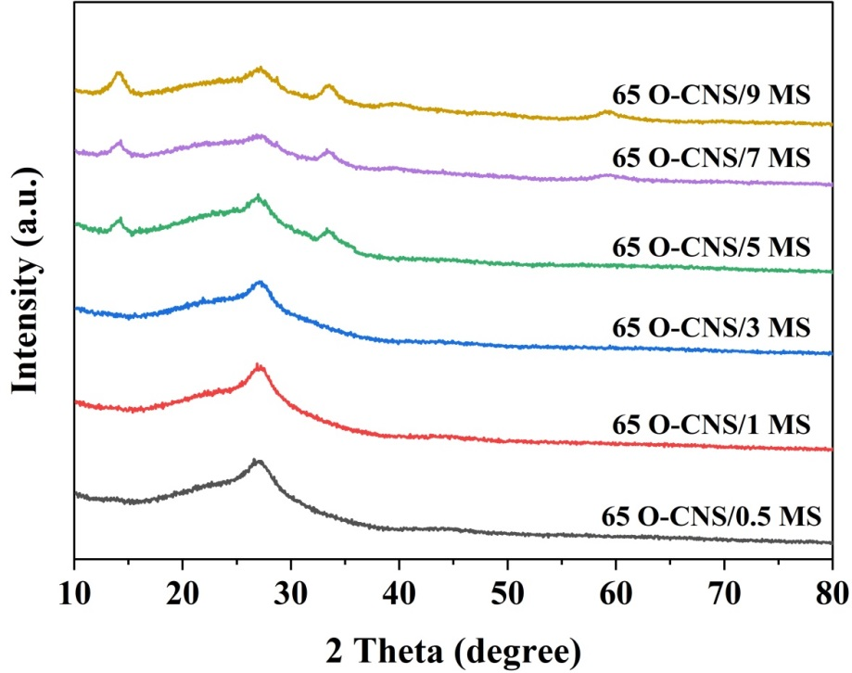

Figure S1 XRD patterns of the as-prepared O-CNS/xMoS₂ photocatalysts (x=0.5, 1, 3, 5, 7, 9)
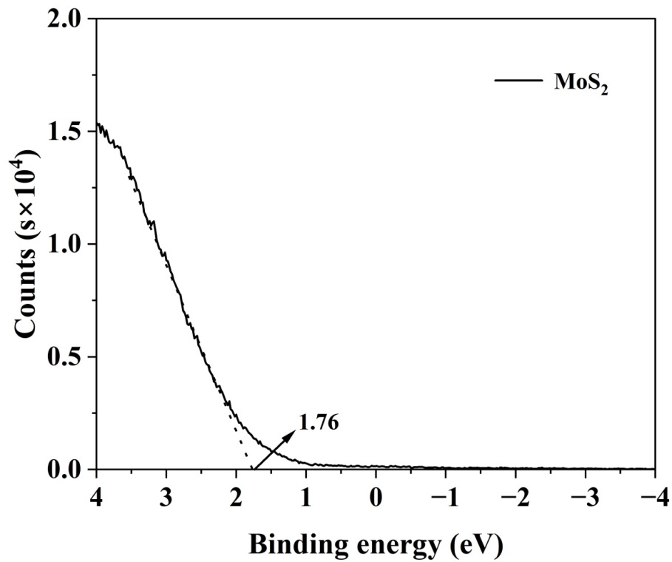

Figure S2 VB XPS analysis of MoS₂

Table S1 Comparison of hydrogen evolution of g-C₃N₄-based photocatalysts

Samples | Light source | Reactant solution | Hydrogen evolution  (μmol h-1 g-1) | Reference
VPP_{0.3}-CN | 300W Xe Lamp  (λ=400 nm) | 100 mL containing 10 vol % TEOA, 3% Pt | 2316.2 | [1]
5-CN/Au/BiVO₄ | 300W Xe Lamp  (λ> 420 nm) | 90 mL water+  10 mL TEOA, methanol,  0.5 % Au, | 2986 | [2]
Er:WO₃/CdS/g-C₃N₄ QDs | 300W Xe Lamp  (λ≥ 400 nm) | 80ml Na₂S and Na₂SO₃ | 1912.12 | [3]
g-C₃N₄/Ag/ZnO | Visible light 30KHz, 80 W | 50 mL water+  Methanol 10 % | 1637.5 | [4]
CdS/(Pt/g-C₃N₄) | 300 W Xe Lamp (λ> 420 nm) | 100 mL water+  10% TEOA, | 1465.9 | [5]
Pt_{0.5}-Au_{1.5}/CN | 300W Xe Lamp  (350<λ<580nm) | 90 mL water+  0.9g Glucose,  Certain  amounts HAuCl₄ and  H₂PtCl₆ | 3180 | [6]
3Pt/SCN | LED solar simulator  (400 - 1100 nm) | 90 mL water+  10 mL TEOA, 3% Pt | 1255.52 | [7]
N doped g-C₃N₅/TiO₂ | Natural light  1358.8 W | 50 mL water+  10% TEOA,  3% Pt | 3515.1 | [8]
Cu-Ni(OH)₂-C₃N₄ | 300 W Xe  lamp  (AM 1.5G) | 90 mL water+  10ml TEOA,  1% Cu and Ni | 2037.3 | [9]
UiO-66-D@g-C₃N₄/Ni (2.0 %) | 420W Xe Lamp  (λ> 420 nm) | 20 mL water+  10% TEOA and Eosin Y (EY) | 2621 | [10]
Pt1-HCN (0.38%) -125 | 300W Xe Lamp  (AM 1.5 G) | 50 mL water+  20% TEOA,  0.38% Pt | 2900 | [11]
Oxygen-doped g-C₃N₄ sheets | 300 W Xenon lamp (λ > 420 nm) | 100 mL aqueous solution containing 10 vol% TEOA, 3% Pt | 2200 | [12]
5%MoS₂/O-CNS | 300 W Xenon lamp (λ > 420 nm) | 100 mL aqueous solution containing 10 vol% TEOA, 3% Pt | 4570.7 | This study

[1] Pan L, Wu G, Wang X, Liu R, Yan B, Zhu X, Mo Z, Sun P, Miao Z, Xu H, (2024) Promotion of intramolecular electron transfer in g-C₃N₄ tubes by introducing pyridine structure to accelerate photocatalytic hydrogen evolution. Colloids Surf 681: 133261. https://doi.org/10.1016/ j.colsurfa.2024.133261
[2] Muthukumar R, Balaji G, Vadivel S (2023) The charge transfer pathway of g-C₃N₄ decorated Au/Bi(VO₄) composites for highly efficient photocatalytic hydrogen evolution. Int J Hydrog Energy 48: 23856-23865. https://doi.org/10.1016/j.ijhydene. 2023.03.152
[3] Hui Li, Xinyan Li, Lixin Que, Xiaoqing Xu, Jun Cao, Jiaqi Pan, Mei Zhu (2024) S-scheme core-shell nanorods heterojunction of g-CN quantum dots modified Er:WO/CdS towards visible light H evolution via up-conversion fluorescence synergism, Int J of Hydrogen Energ 51:1440-1450. https://doi.org/10.1016/j.ijhydene.2023.11.132
[4] PavanP. Gotipamul, Sondos AbdullahAlqarni , Saravanan Pandiaraj, Maheswaran Rathinam, Siva Chidambaram（2024）Initiation of piezoelectricity expands the photocatalytic H₂ production and decomposition of organic dye through g-C3N4/Ag/ZnO tri-components, Mater Sci Energ Techn 7:133-147. https://doi.org/10.1016/j.mset.2023.09.001
[5] Hu W, Zhang J, Tian J, Dang Y, Wang W, Zhan H, Ma B (2022) Greatly enhanced photocatalytic hydrogen production on CdS/(Pt/g-C₃N₄) via dual functions of Pt on semiconductors interface. Int J Hydrogen Energ 68: 29295-29304. https://doi.org/ 10.1016/j.ijhydene.2022.06.250
[6] Ding F, Yu H, Liu W, Zeng X, Li S, Chen L, Li B, Guo J, Wu C (2024) Au-Pt heterostructure cocatalysts on g-C₃N₄ for enhanced H₂ evolution from photocatalytic glucose reforming. Mater Des 238: 112678. https://doi.org/10.1016/j.matdes.2024. 112678
[7] Nguyen P, Dao Q, Dang T, Hoang T, Chung J, Shin E (2023) Highly dispersed PtO over g-C₃N₄ by specific metal-support interactions and optimally distributed Pt species to enhance hydrogen evolution rate of Pt/g-C₃N₄ photocatalysts. Chem Eng J 15:142765. https://doi.org/10.1016/j.cej.2023.142765
[8] Kamalakannan S, Balasubramaniyan N, Bernaurdshaw N, Vattikondala G (2023) Impact of nitrogen doping on triazole-based graphitic carbon Nitride-TiO₂ (P25) S-scheme heterojunction for improved photocatalytic hydrogen production. Nanoscale Adv 5(21): 5907-5922. https://doi.org/10.1039/d3na00597f
[9] Zhan D, Tian J, Fu Q, Liu P, Zhao Y, Liu W, Li D, Huang Y , Han C (2023) In situ photodeposition of Cu and Ni(OH)₂ dual cocatalyst: Synergistic effect on enhancing g-C₃N₄ photocatalytic H₂ evolution. Appl Surf Sci 641:158463. https://doi.org/10.1016/j.apsusc.2023. 158463
[10] Jamma A, Jaksani B, Vennapoosa S, Gonuguntla S, Sk S, Ahmadipour M, Moses Abraham B M, Mondal I, Pal U (2024) Defect-rich UiO-66@g-C₃N₄/Ni frameworks as efficient water splitting photocatalysts. RSC Mater Adv In press, https://doi.org/10. 1039/d3ma00880k
[11] Mahvelati-Shamsabadi T, Bhamu K, Lee S, Dang T, Khoi V, Hur S, Choi W, Kang S, Shin T, Chung J (2023) Coordinatively unsaturated atomically dispersed Pt⁺²-N₄ sites on hexagonal nanosheet structure of g-C₃N₄ for high-performance photocatalytic H₂ production. Appl. Catal. B Environ 337: 122959. https://doi.org /10.1016/j.apcatb.2023.122959
[12] Tang H, Xia Z, Chen R, Liu Q, Zhou T (2020) Oxygen doped g-C₃N₄ with nitrogen vacancy for enhanced photocatalytic hydrogen evolution. Chem-Asian J 15(21): 3456-3461. https://doi.org /10.1002/asia.202000912

