Supplementary Material:

Article Title: Percutaneous Sperm Retrieval Technique: a reliable and effective sperm retrieval procedure for intracytoplasmic sperm injection in patients with obstructive azoospermia.
Thiago Pardini Furtado MD1,2 (ORCID:0000-0001-7751-0461), Andrea Kauffmann Zeh PhD1, Marcelo Horta Furtado MD FACS MPH1,3 (ORCID: 0000-0001-7499-4202)
1 MF Fertilidade Masculina, Belo Horizonte, Brazil
2 University of California, Los Angeles, USA
3 Universidade Federal de Minas Gerais, Belo Horizonte, Brazil
Corresponding Author:
Marcelo Horta Furtado
ORCID: 0000-0001-7499-4202
MF Fertilidade Masculina
Av. do Contorno 4747, sala 1313
Belo Horizonte, Brazil 30110-027
+55 31 99621-7550
marcelo@mffertilidademasculina.com.br

Supplementary Table 1 - Literature survey on sperm retrieval successes of PESA as the first choice combined or not with TESA for later salvage performed in men with obstructive azoospermia.

Supplementary Table 2 – Literature survey on sperm retrieval successes of MESA as the first choice combined or not with TESA for later salvage performed in men with obstructive azoospermia.

Supplementary Table 3 - Literature survey on reproductive results after sperm retrieval by PESA ± TESA.

Supplementary Table 4 – Literature survey on reproductive results after sperm retrieval by MESA ± TESA.

Supplementary Table 5 - Literature survey on reproductive results using epididymal sperm.

Supplementary Table 6 - Literature survey on reproductive results using testicular sperm.

Supplementary Figure 1 - Sperm retrieval performances described in studies using MESA as the first
choice and TESA and/or TESE for later salvage performed in men with obstructive azoospermia.

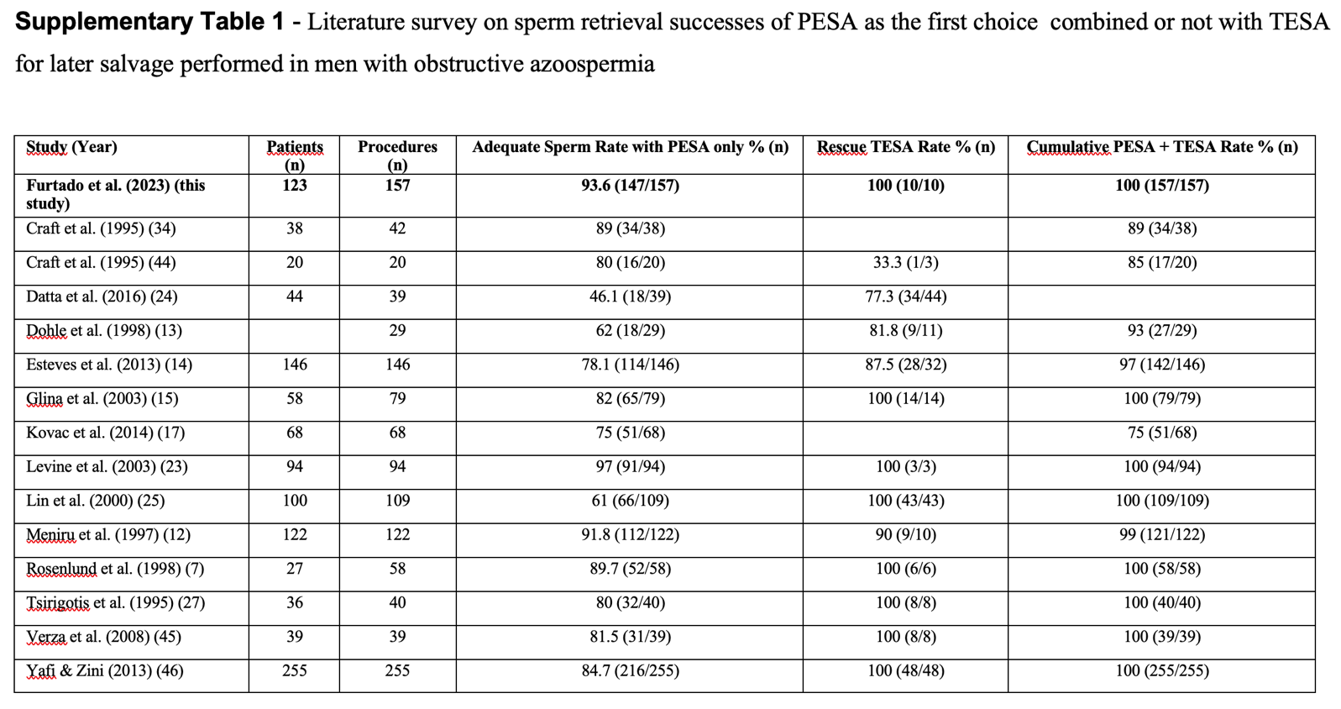

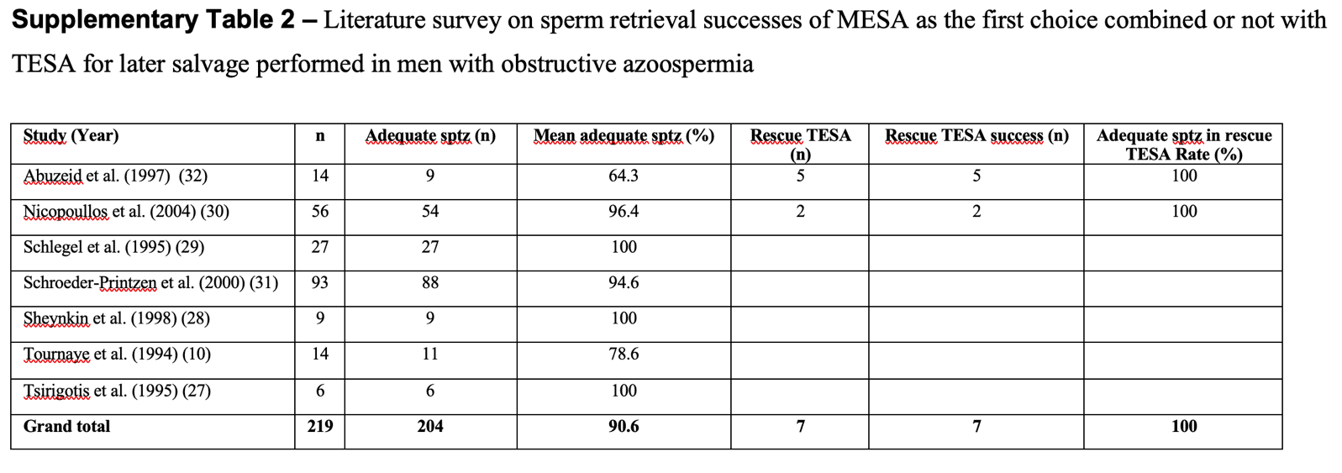

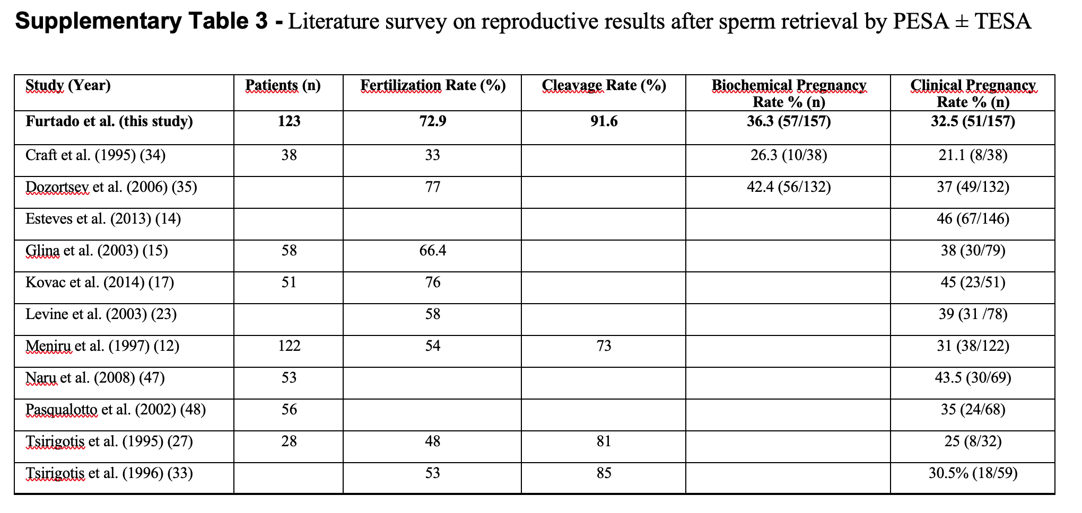

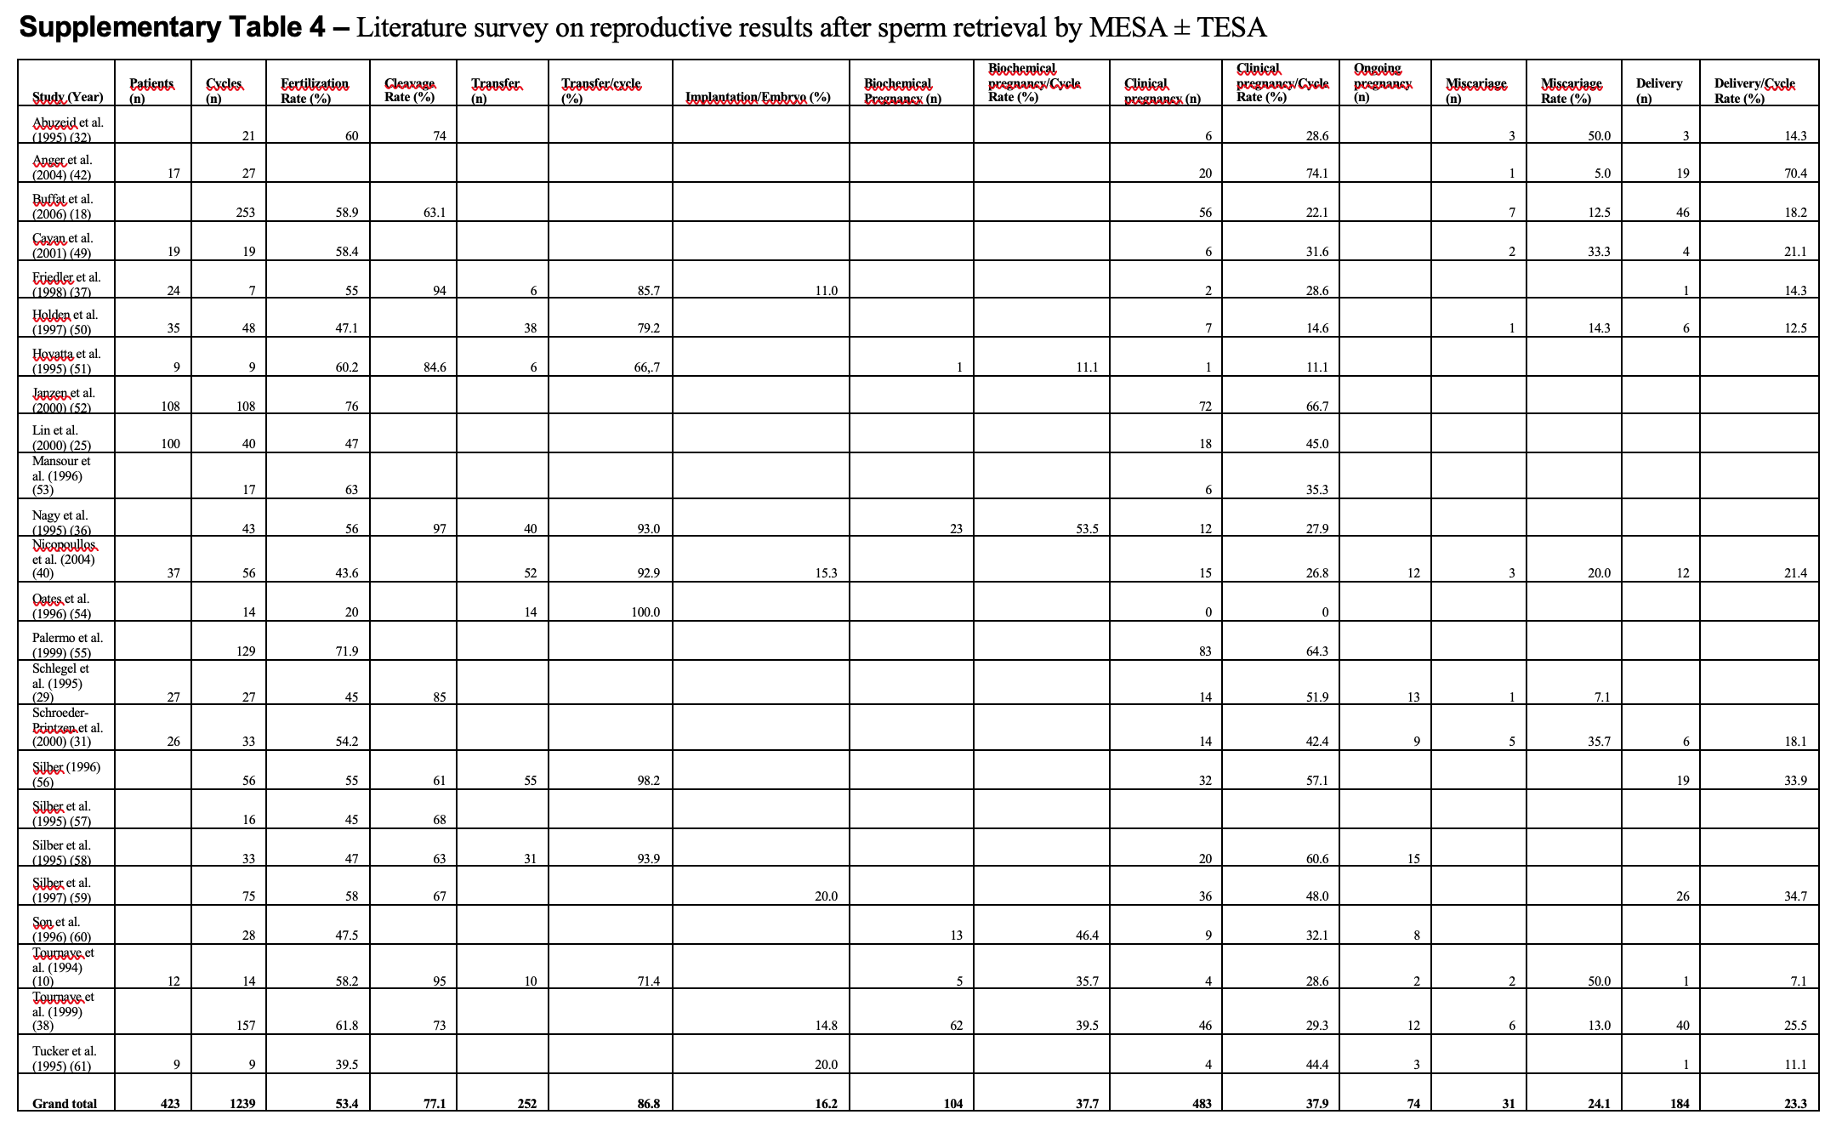

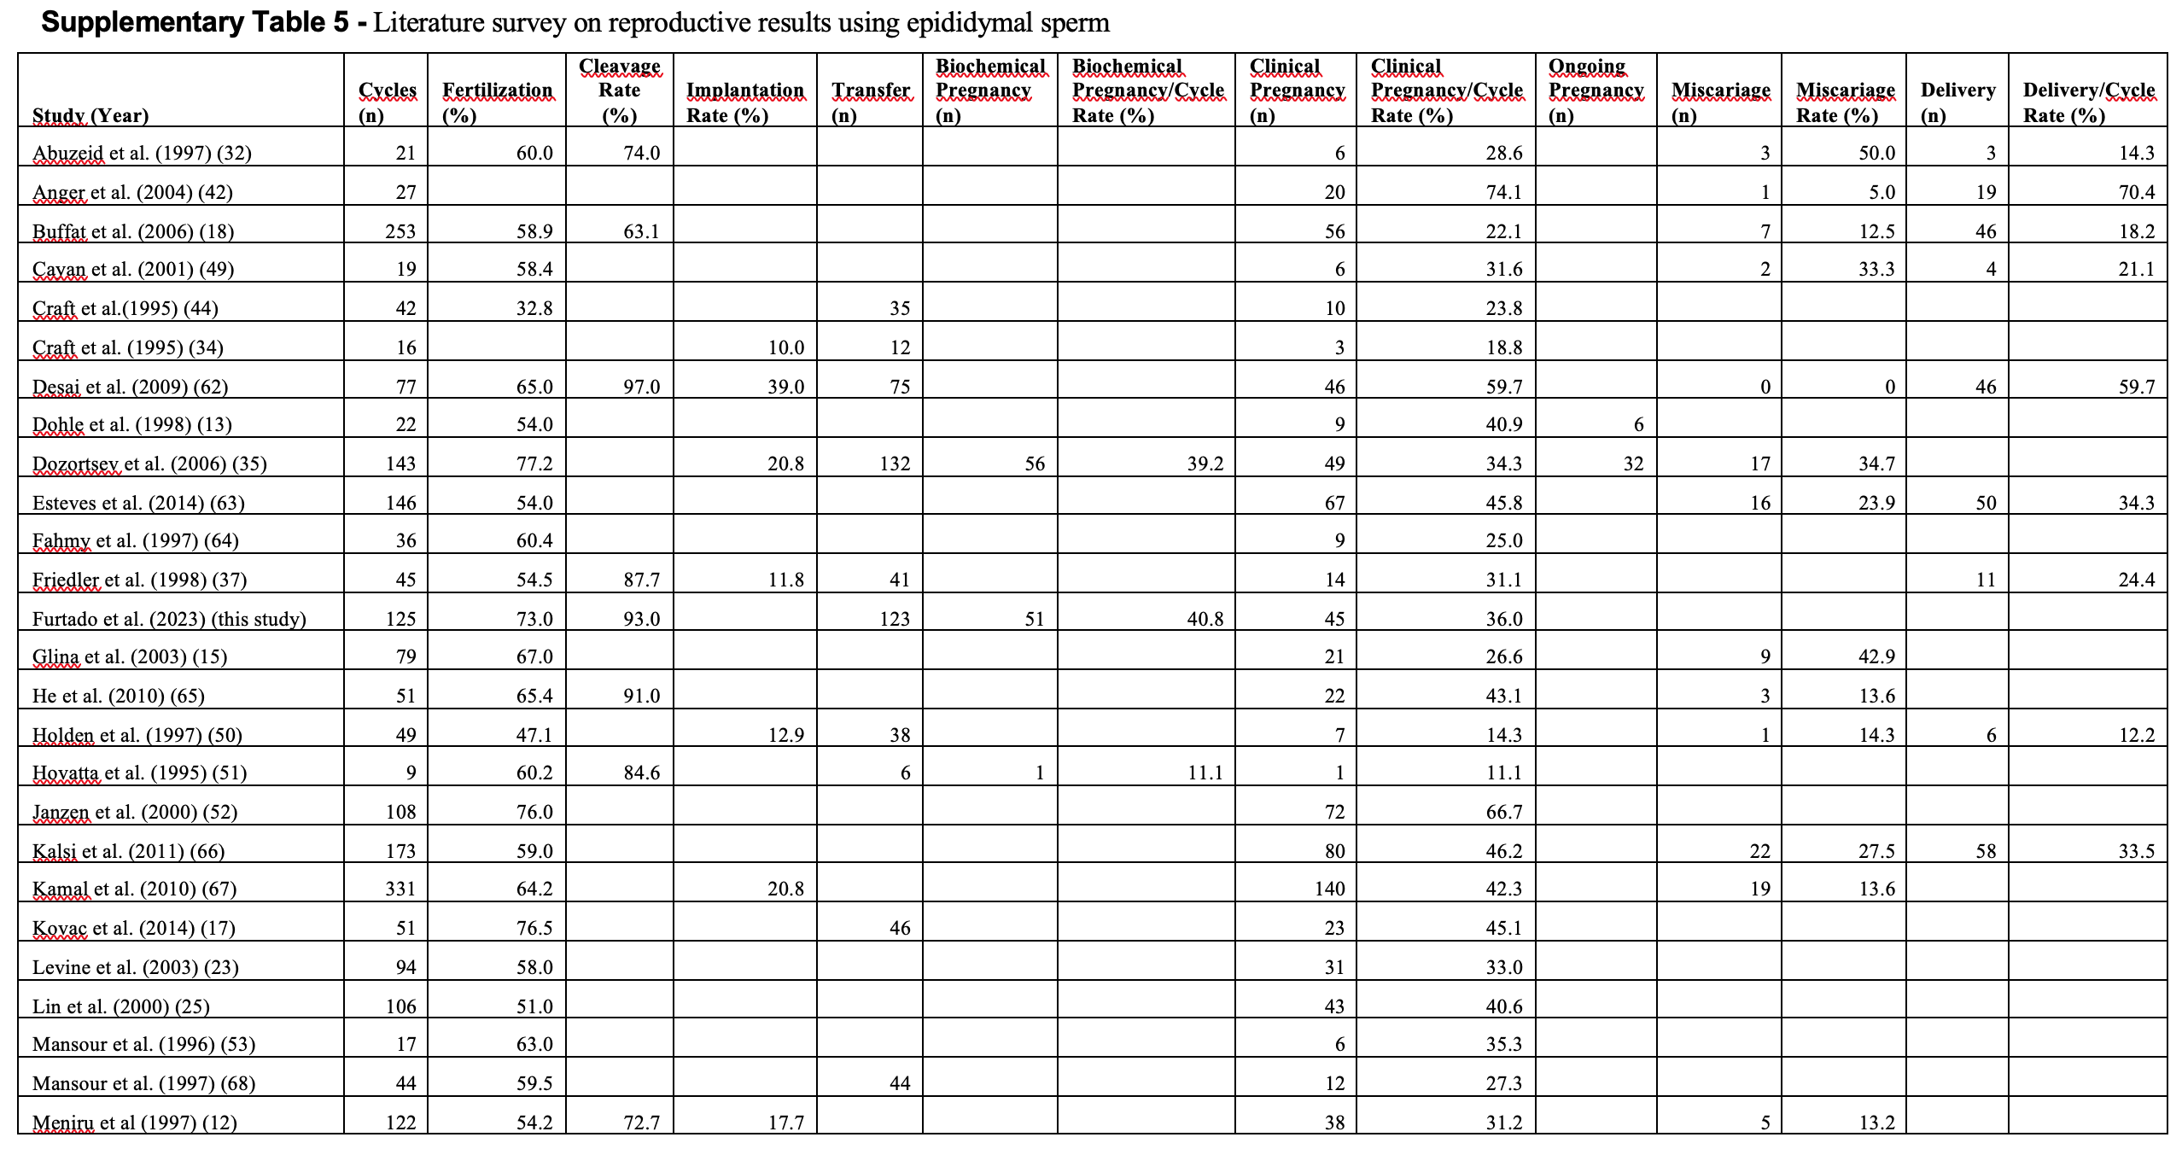
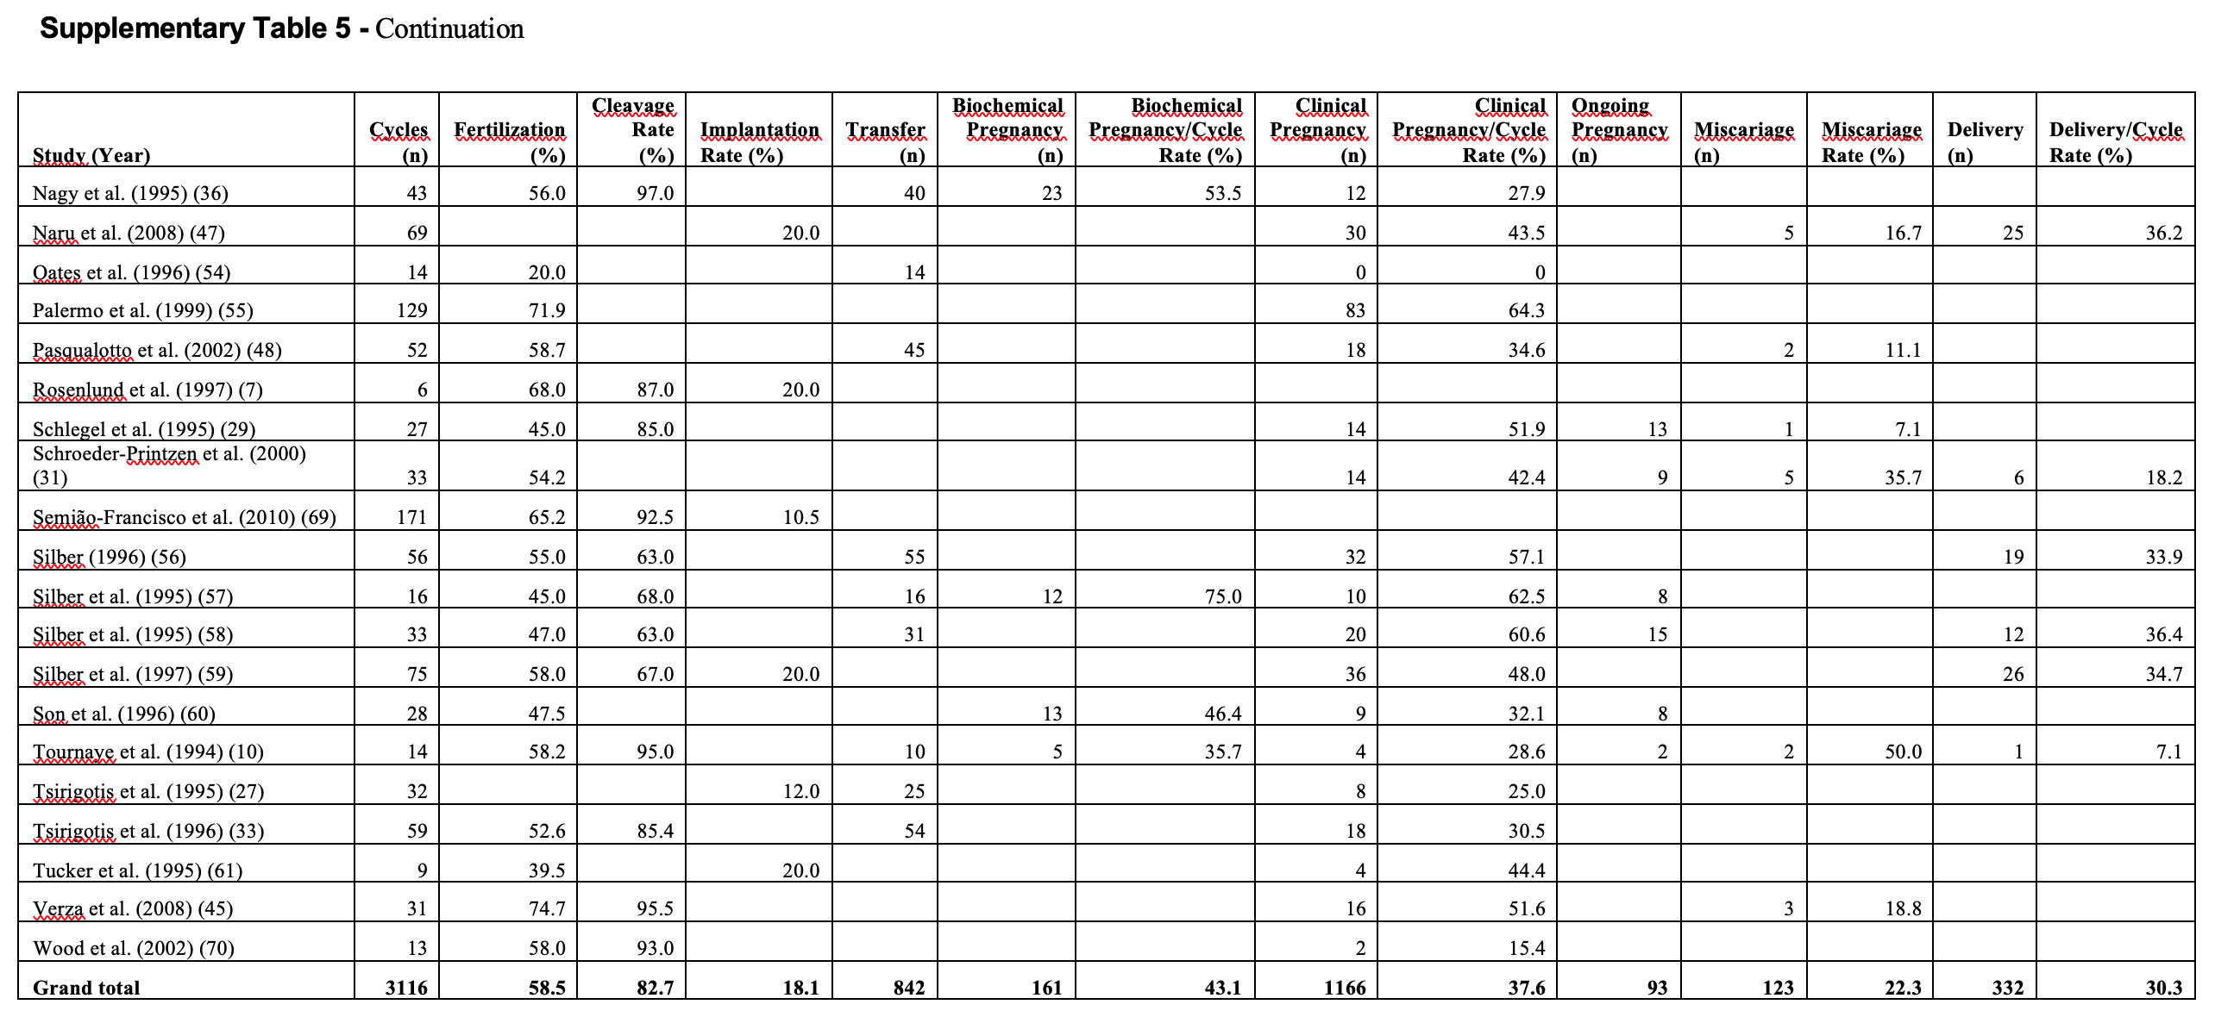
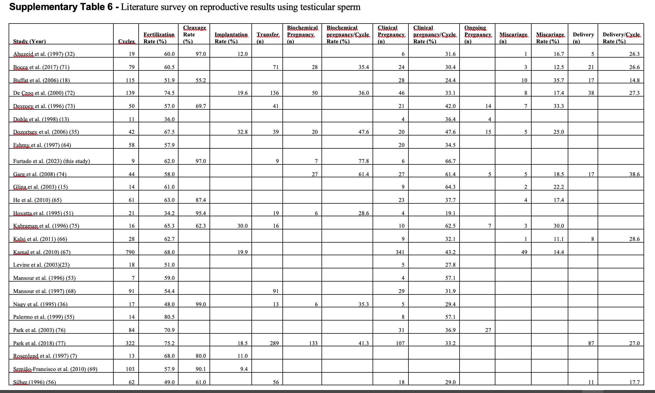
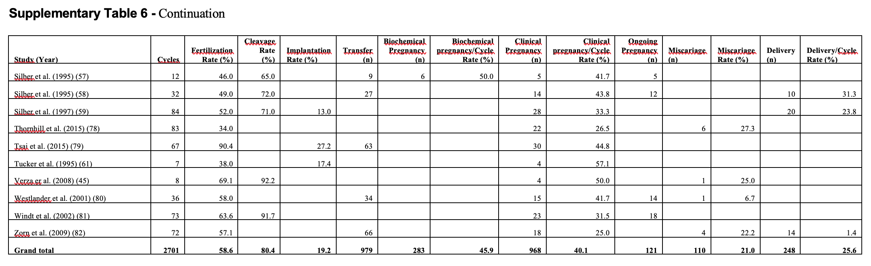

Supplementary Figure 1 - Sperm retrieval performances described in studies using MESA as the first
choice and TESA and/or TESE for later salvage performed in men with obstructive azoospermia.

