Table 1: Commercial names and chemical structures of the indigo and non-indigo dyes
CI Generic name | Commercial name | Dye structure
C.I. Vat Blue 1  (Indigo Dye) | IndigoBlu³⁰ | 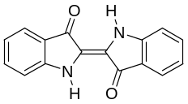
C.I. Acid Blue 74  (Indigo Carmine) | Indigo Carmine | 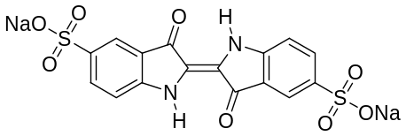
C.I. Acid Blue 193  (AB 193) | Ryian Blue T2R  (Synthesia) | 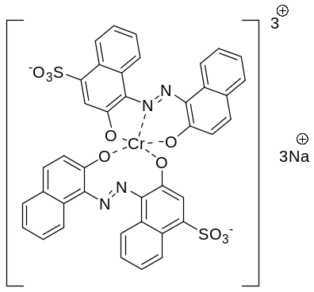
C.I. Reactive Black 5  (RB 5) | Remazol Black B  (DyStar) | 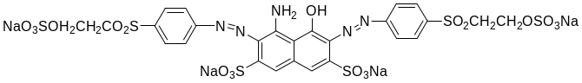

Table 2: Weave structures of the control blend denim fabrics composed of indigo dyed warp cotton yarn and un-dyed weft silk yarn
Sample Code | Weave setting | Weave Structure
DF1 | Twill 3/1 Z | 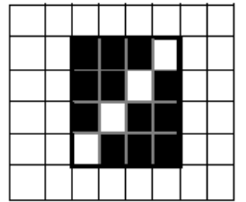
DF2 | Twill 3/2 Z | 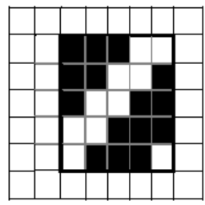
DF3 | Satin 5₃ | 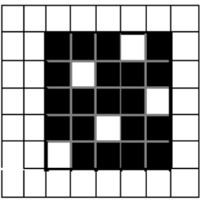

Table 10: Control blend denim fabrics of warp dyed cotton yarn and un-dyed silk yarn
Control Sample code | Weave pattern | View
Control Sample code | Weave pattern | Front | Back
DF1 | Twill 3/1 Z | 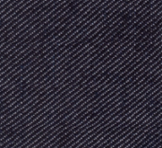 | 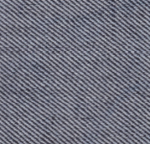
DF2 | Twill 3/2 Z | 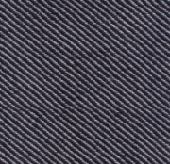 | 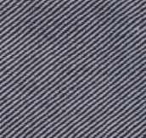
DF3 | Satin S3 | 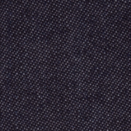 | 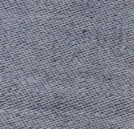

Table 11: Specifications of dyed silk weft setting in blend denim fabrics
Dye set | Sample code | View
Dye set | Sample code | Front | Back
A | DF1A | 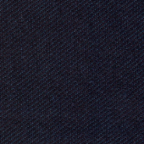 | 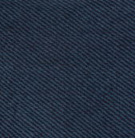
A | DF2A | 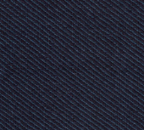 | 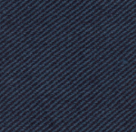
A | DF3A | 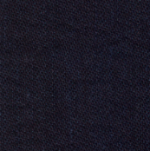 | 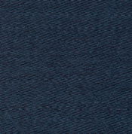
B | DF1B | 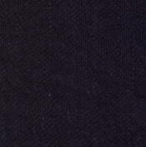 | 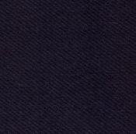
B | DF2B | 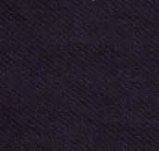 | 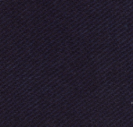
B | DF3B | 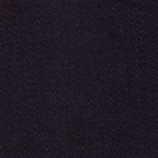 | 